Adding a COVID-19 Tag to a News Product

Purpose
At the end of this guideline, Newsroom publishers will be able to add a COVID-19 tag to a news product in Adobe Experience Manager (AEM).

Tagging a News Product with COVID-19
Step 1: Once logged into the AEM environment, navigate to the News Admin Console where you can view all of your news products. Select your news product and then click on View Properties from the top tool bar.
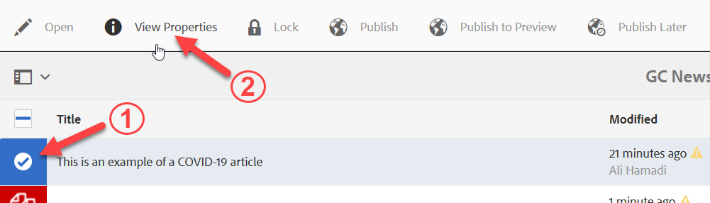
Step 2: Once the Global Properties page is loaded, scroll down to the Themes and Topics / Additional Themes and Topics properties. The COVID-19 tag can be found in both of these properties; you can choose any of the two. Click on the browse icon to search for the COVID-19 tag.
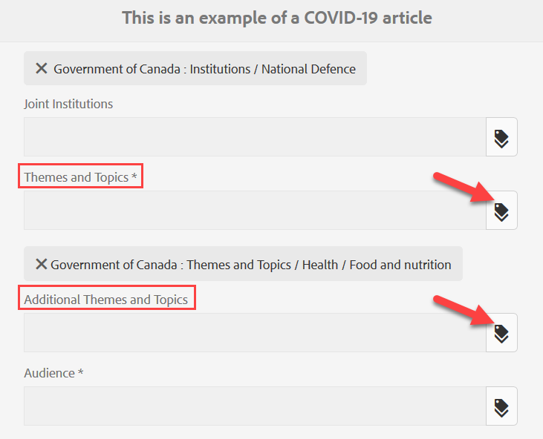
Step 3: Navigate to the COVID-19 tag by following the path below. Once the tag is selected, click the checkmark on the top right to save your changes.
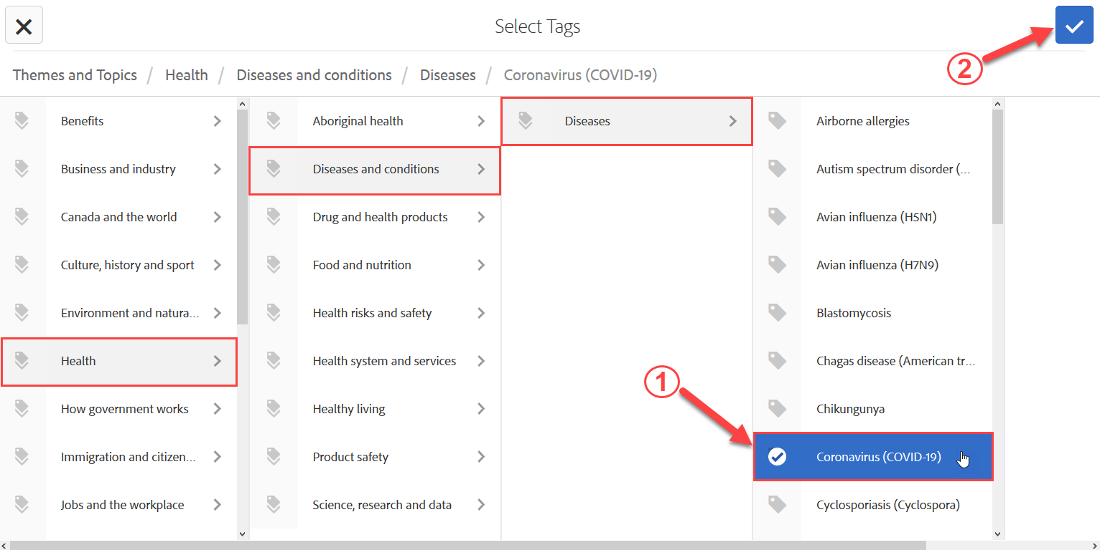
You should now see the COVID-19 tag below the global property:
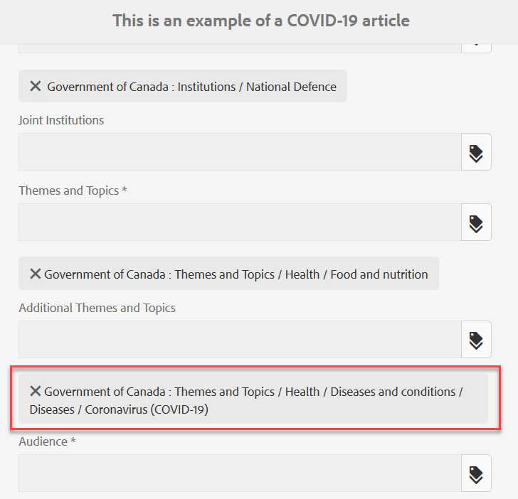
Step 4: Save your work by clicking the Save button on the top right, and wait until you see a green pop-up message, then click Close.
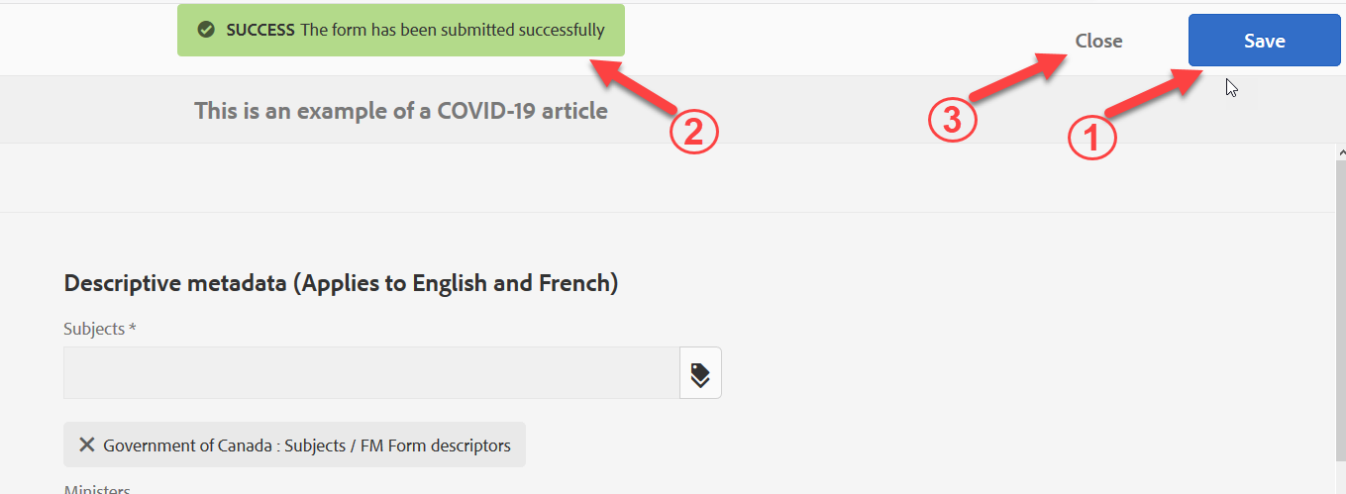

Step 5: Once the News Admin Console is loaded, re-select your news product and click on Publish from the top tool bar.
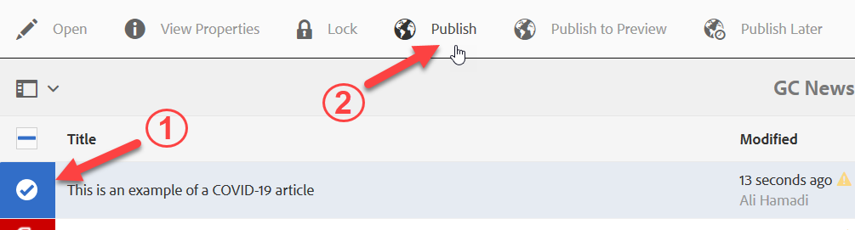

Step 6: Your news product now has the COVID-19 tag on both the English and French pages. The tag can be seen at the bottom of your news product.

