How to Claim an Employee on the TBS Applications Portal
- Log in to the TBS Applications Portal (TAP).
- Select the application myEmployees on the top right.
- Select the tab My employees.
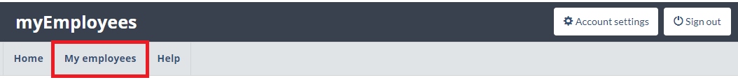
- Click on the button Add employee on the right of your employees’ list.
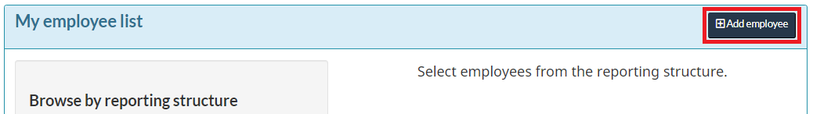
- Search for the employee using their surname within your organization on the TAP.
  - If your employee is associated to another organization than yours on the TAP, select the option All departments and search the employee with their PRI/HRMIS and surname.
- Click on the button Claim employee to send a claim request to the employee. The application will send an automatically generated email to the employee.
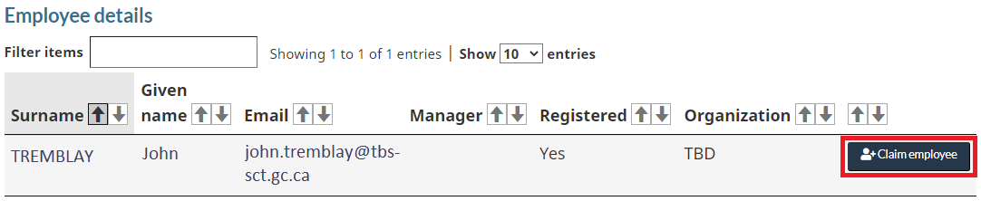
- If the mention No is displayed under the column Registered, please inform the employee that they must register to the TAP before you can send them a claim request.
- If the employee’s email address is inaccurate, please inform the employee that they are responsible to maintain their TAP profile.
- If the employee is still claimed by another manager, refer to the instructions.
- Once you have confirmed to send a claim request, you will need to wait for the employee to accept or refuse your claim request.

