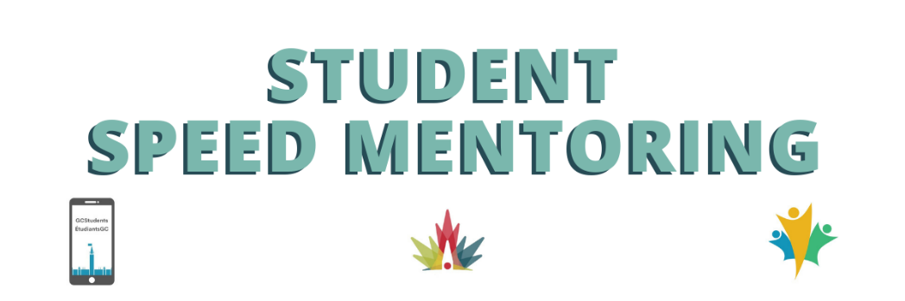

Sample Questions for Student Speed Mentoring Sessions – June 15 and 16, 2022

Description: You will only have 15 minutes in the breakroom with the mentor and the other students so to get the most out of your mentors time we have prepared a few questions you may want to ask them.
We recommend you do not use this time to ask about bridging as not all mentors were students and there are plenty of resources on this at the GC Students website:
GCStudents - ÉtudiantsGC/Employment - wiki (gccollab.ca)
- What motivates you most about your position?
- How did you gain leadership experience?
- What advice would you like to have heard when you started your career in the public service?
- How would you describe your leadership style?
- What is the greatest challenge you have faced in your career?
- Is there anything you would do differently if you could start your career over again?
- What is the best career advice you have received?
- What used to be your biggest weaknesses and how did you manage to improve yourself on theses?
- What is one of the most valuable lessons you’ve learned in your public service career?
- What is the most fulfilling aspect of your job and why?
- What is the most challenging part of your job and why?
- Did you ever take a job that turned out to be a bad fit? What did you do?
- What traits do you look for in a working professional you would consider have joining your team?
- How often have you changed positions and when did you realize that a job is no longer the right fit for you? If you don’t feel it’s the right time to leave your current role, but you don’t want to miss out on an opportunity or lose connections, how do you best manage this?
- Was there ever a role you applied for and landed, but weren’t 100% qualified to do? How did you overcome the challenges you faced?
- How can we determine our weaknesses and take the first steps towards overcoming them?
- How can I be more strategic in pursuing my career goals? What are the first steps I should take when determining my goals and career path?
- How do you ensure you prioritize the right things to ensure you are following the right path to success in your career?
- Were there points in your career where you wish you had had a mentor but didn't? How would having a mentor had helped you?
- How can I approach a mentor that I have never met but who looks interesting on social media?
- How could you ask your mentor about subjects not DIRECTLY related to work (eg. work-life balance, volunteer activities, mental health at work)?
- How can I “break up” with a mentor or manager professionally and without ruining any connections?
- What if someone wants to be my mentor but I don't respect their career goals?

