1. What is business architecture?

Officially defined according to the Federation of Enterprise Architecture Professional Organizations (FEAPO), business architecture “represents holistic, multidimensional business views of: capabilities, end-to-end value delivery, information, and organizational structure; and the relationships among these business views and strategies, products, policies, initiatives, and stakeholders.”
Business architecture is a comprehensive documentation of an organization which:
- Describes the entire scope of its ecosystem
- Represents that ecosystem at a high level of detail
- Is shareable and reusable
A business architecture is to an organization as a blueprint is to a building.
The scope of business architecture is comprised of multiple domains (shown as the ten small boxes in the diagram below) and their relationships to each other, with capabilities and value streams as the foundation. All organizations have a business architecture—it just may not be written down at an enterprise level or according to industry-standard practices. However, once an organization’s business architecture is documented in a knowledgebase, then blueprints and reports can be generated from it, to be used in support of a wide range of business scenarios. This Business Architecture Framework concept is shown below.

Business Architecture Framework
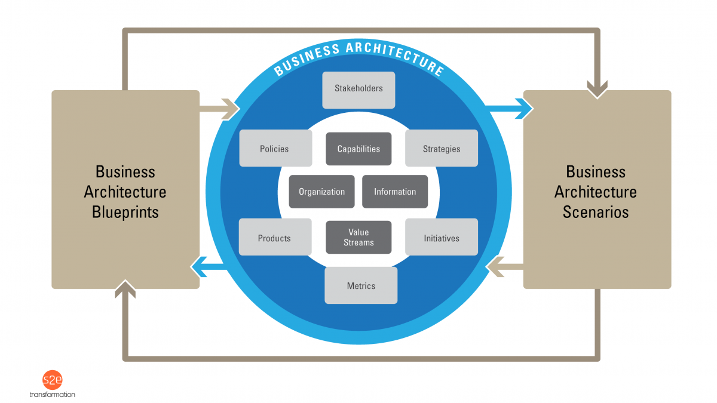

2. What is the value of business architecture?
Business architecture is about so much more than a blueprint, knowledgebase, discipline or technique. “Business architecture” as we often talk about it, is not really about the business architecture itself.
The secret is this: business architecture is actually about a much bigger vision; a shift in mindset and behavior. Business architecture is simply an enabler for the bigger picture. Modeling an organization and its ecosystem is not hard. Change is hard.
The business architecture knowledgebase is still the foundation of enabling the ultimate vision and shifts. However, it is really a means to an end, not an end in itself.
The value of leveraging business architecture is to facilitate a new vision for strategy execution and new ways of working in our organizations and ecosystems. Business architecture and business architects provide the big picture (in a common language, for a broader scope of focus, and with a longer-term perspective) and bridge silos – to facilitate effective strategy execution, decision-making and design of organizations and ecosystems.
The diagram below shows some of the key organizational mindsets which business architecture can help facilitate.

What It Means To Shift The Organizational Mindset

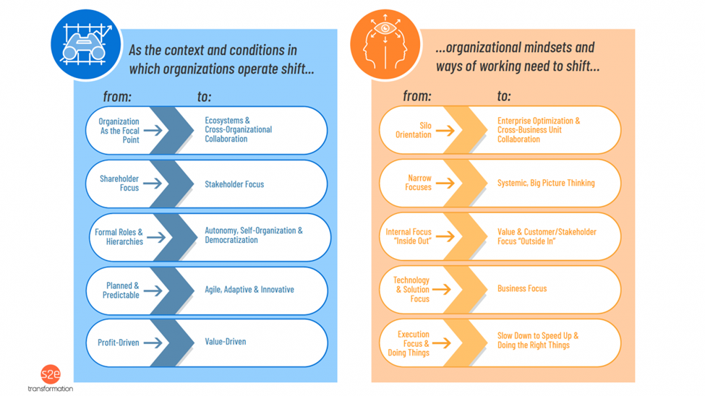
There is no one best way to describe the value of business architecture, or no one elevator pitch that works for all audiences (business architecture enables effective strategy execution is the closest). Each organization needs to define a clear and simple value proposition for their usage of business architecture. The best way to answer this question is highly personal to you as well as to whom you are talking. Adapt your answer to the person you are talking to and what they care about. Succinctly describe the value of business architecture and then describe a usage scenario or two which may be relevant to them. You may also want to describe why business architecture is essential now, which can help to provide context and diffuse any concerns (e.g., “if this is such an important thing, why don’t I know about it?”).

Additional Resources
- StraightTalk Post No. 72, The Secret: What Business Architecture Is Really About and Why It Can Be So Hard
- StraightTalk Post No. 68, Mind The Gap: How Business Architecture Breaks Down and Bridges Silos
- StraightTalk Post No. 2, Start With Why: The Value of Business Architecture
- StraightTalk Post No. 3, The Strategy Execution Metanoia: Translating Strategy Into Action With Business Architecture
- StraightTalk Post No. 55, Decisions, Decisions: How Business Architecture Facilitates Better Decision-Making
- StraightTalk Post No. 34, Business Marketecture: How to Deal With Business Architecture Socialization Challenges
- StraightTalk Post No. 37, Business Politecture: How to Deal With Business Architecture Adoption Challenges
- The Value of Business Architecture: New Mindset, New Results white paper
- The Strategy Execution Metanoia: A New Approach for Translating Strategy Into Action With Business Architecture white paper
- Part 1 of the BIZBOK® Guide (Business Architecture Guild® membership required)
- 3. Why is business architecture so important now?
- The bottom line is that we work in complex organizations that are colliding with a world where constant change is the new normal. Organizations have finite resources, including time, people and funding, and the key is to focus those resources on the essential things in the most effective way—and to have a way to move ideas into action quickly and effectively.
- Having an enterprise mindset and the ability to collaborate across business units effectively is now essential to achieve all of these things, and business architecture is a critical enabler. It allows us to find and simplify complexity, architect enterprise-wide transformations, execute change faster from end-to-end, and objectively prioritize investments. It also provides a rationalized view of an organization necessary to leverage future investments like cognitive computing.
- Business architecture helps organizations to achieve the new mindset they need to survive and thrive.
- Represented below is the progression and the current state of many of today’s organizations.

3. Why is business architecture so important now?
The bottom line is that we work in complex organizations that are colliding with a world where constant change is the new normal. Organizations have finite resources, including time, people and funding, and the key is to focus those resources on the essential things in the most effective way—and to have a way to move ideas into action quickly and effectively.
Having an enterprise mindset and the ability to collaborate across business units effectively is now essential to achieve all of these things, and business architecture is a critical enabler. It allows us to find and simplify complexity, architect enterprise-wide transformations, execute change faster from end-to-end, and objectively prioritize investments. It also provides a rationalized view of an organization necessary to leverage future investments like cognitive computing.
Business architecture helps organizations to achieve the new mindset they need to survive and thrive.
Represented below is the progression and the current state of many of today’s organizations.
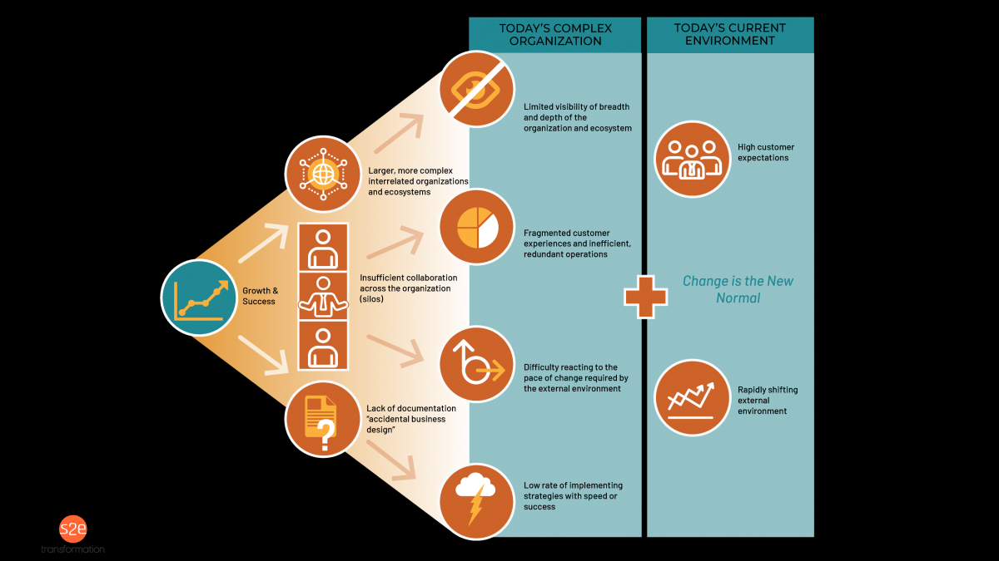

Complex Environments Meets A World of Change

Additional Resources
- StraightTalk Post No. 2, Start With Why: The Value of Business Architecture
- The Value of Business Architecture: New Mindset, New Results white paper

4. Business architecture is only used by large businesses, right?
No. While we see the greatest concentration of business architecture practices among large corporations currently, business architecture is beneficial to any size of organization—from a sole proprietor to a large global organization. It is also beneficial to any organization, be it for-profit, non-profit and governmental institutions.
No matter what an organization’s type or size, it has the best chance of success with:
- A viable and competitive business model
- An intentionally designed organization
- A way to set and execute direction
Business architecture helps with all three.
The need for business architecture is driven more by an organization’s size than by its type. Small organizations can leverage business architecture right from the beginning, but the need for the discipline grows as it eventually scales and transforms. This concept is illustrated in the diagram below.
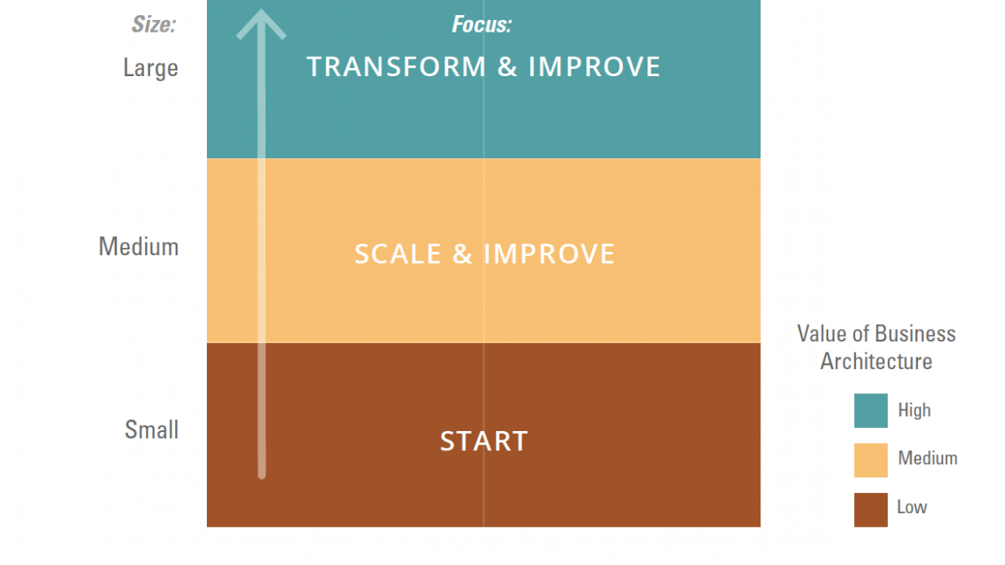

Business Architecture Need By Organization Size & Type
Key types of usage by organization size are shown below.
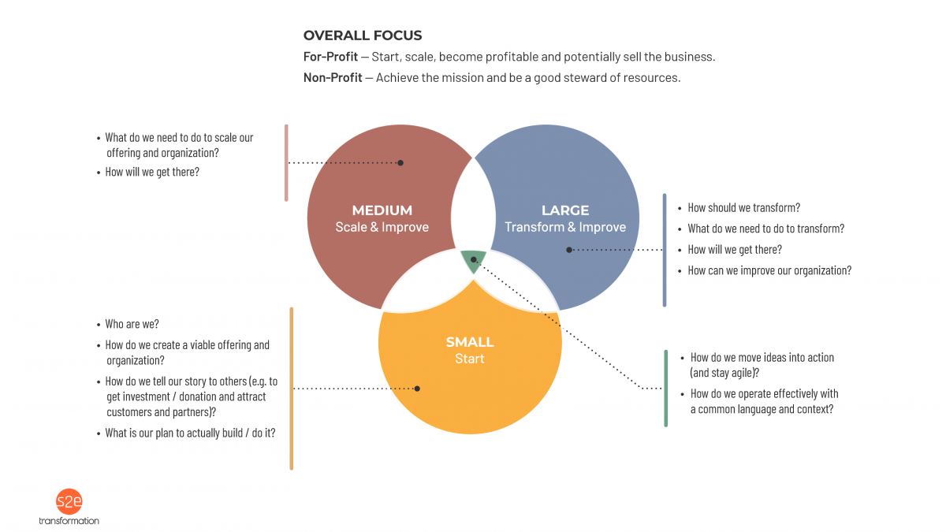

How Business Architecture Can Benefit All Sizes of Organization

Additional Resources
- Business Architecture For Non-Profits and Smaller Organizations
- StraightTalk Post No. 17, Architect the World, Part 1 — Business Architecture For Startups & Small Business
- StraightTalk Post No. 18, Architect the World, Part 2 — Business Architecture For Non-Profit Organizations
- StraightTalk Post No. 69, A Pathway To The Future For All: How Business Architecture Can Help Us Achieve Sustainable Development Goals

5. Shouldn’t we skip documenting current state and go right to a future state?
This FABAQ is based on many misconceptions. The first is that business architecture is just a set of standalone techniques and tools that can be applied in various situations (not exactly true). The second is that documenting business architecture requires a lot of time and detail (also not true and usually because there is also confusion with FABAQ #8).
The power of business architecture lies in the business architecture knowledgebase which:
- Describes the entire scope of an organization’s ecosystem (it is created top-down—not bottom-up by individual business units or projects)
- Represents that ecosystem at a high level of detail (allowing us to see the forest for the trees for new insights and targeted focus)
- Is shareable and reusable (giving everyone the same mental model about what the organization does)
Here’s how it works:
- Document your organization’s business architecture in a knowledgebase (ideally in an automated tool).
- Generate any type of blueprint or report you want from that knowledgebase.
- Apply those blueprints and reports to various scenarios in business scenarios. (This is the most important part.)
The answer to the question then is no—when building a business architecture knowledgebase, we must document the current state (though you can capture some future state where applicable) for us to have a baseline to work from. That’s the whole point of business architecture; otherwise, we are just creating more fragmented deliverables. However, business architecture is documented at a high level and there are ways to quickly get to the minimum baseline of capabilities and value streams, so documenting this “current state“ is not time-consuming as people usually think. Once we have a baseline in place, we can expand upon it and can create “target state business architectures“ as part of the strategy execution life cycle.
As shown below, building a business architecture versus using one are different activities which require different competencies. The focus of a business architecture practice should be on using the business architecture.
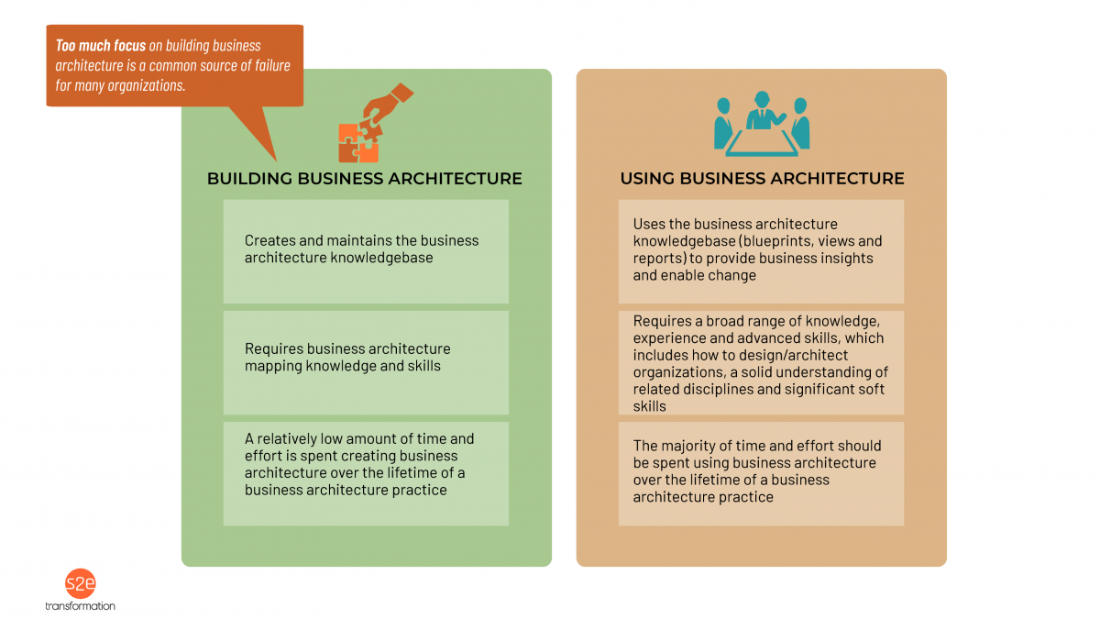

Comparing Building Vs. Using Business Architecture

Additional Resources
- StraightTalk Posts No. 1, The Unexplained Mystery of Business Architecture: What is Business Architecture
- StraightTalk Post No. 12, A Map of the World, Part 1: Back to School With Mapping the Core Business Architecture Foundation
- StraightTalk Post No. 13, A Map of the World, Part 2: Back to School With Mapping the Extended Business Architecture
- StraightTalk Posts No. 22, Speedy Business Architecture, Part 1 — Accelerating Business Architecture Development With Reference Models
- StraightTalk Posts No. 23, Speedy Business Architecture, Part 2 — Accelerating Business Architecture Development With Tools

6. Is business architecture created on a project-by-project basis? Or do we have our own business architecture for our area of the organization?

Neither! Review FABAQ #5 for clarification. In short, we create business architecture top-down for the entire scope of an organization’s ecosystem and then we can use it for many different scenarios at a business unit, product, program or project level. The sky is the limit for usage.
Business architecture (with capabilities and value streams as the foundation) gives us a way to look at our organizations differently so that we can see what is common versus what is different—and it gives us a way to work as a cohesive enterprise like never before.
Below is a perspective on how business architecture can be leveraged to scope initiatives from a coordinated enterprise perspective.
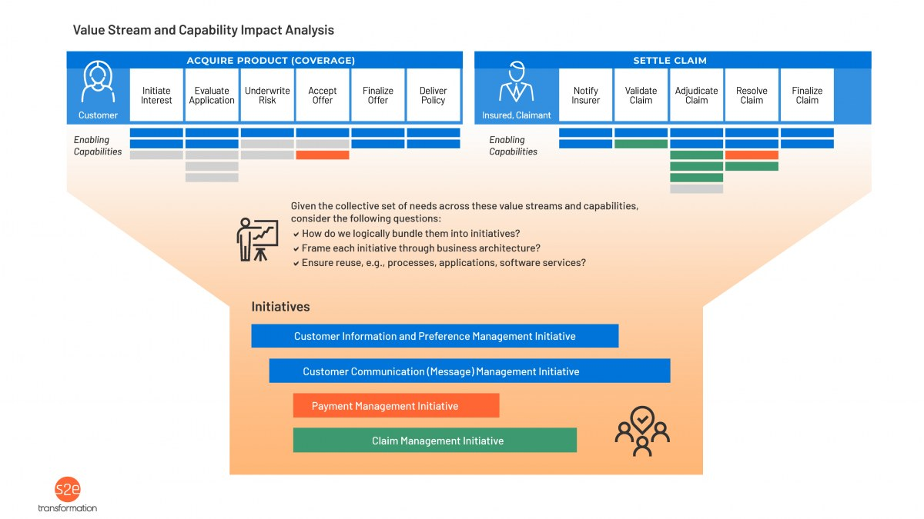

Scoping Initiatives From An Enterprise Perspective With Business Architecture

Additional Resources
- StraightTalk Post No. 71, Taking Initiative: How to Leverage Business Architecture for Initiative Planning

7. How is business architecture different than business analysis?
Business architecture and business analysis are two separate but mutually beneficial disciplines. The intentions, deliverables and corresponding roles (business architect and business analyst) are different.
Business architects work at the enterprise level and upstream in the strategy execution life cycle, while business analysts work on a more focused scope downstream. Both are critical and work together.
Business architecture provides scoped initiatives, vocabulary and a framework to tie requirements to so that they can be reused. Business analysts consume the business architecture changes related to their specific initiative(s) as well as the overall vocabulary and mental model which business architecture defines. Business analysts, in collaboration with business architects, translate business architecture changes into a set of requirements for their initiative(s) and align them with the business architecture capabilities and stakeholders.
This perspective has been informed by years of collaboration between the business architecture and business analysis communities and will continue to evolve.

Additional Resources
- StraightTalk Post No. 71, Taking Initiative: How to Leverage Business Architecture for Initiative Planning
- Business Architecture Integration: Integrating Business Architecture Into the Enterprise white paper
- Leveraging Business Architecture to Improve Business Requirements Analysis (Business Architecture Guild® white paper) (see Business Architecture Guild®Public Resources page)
- Section 3.8 of the BIZBOK® Guide (Business Architecture Guild® membership required)

8. Is process part of business architecture?
No. You will not see process as part of the scope of business architecture, per the domains listed in BIZBOK® Guide Figure 1.1. (See Business Architecture Guild®Public Resources page for Part 1 of the BIZBOK® Guide.) Business architecture and business process are two separate but mutually beneficial disciplines. The intentions, deliverables and corresponding roles (business architect and process analyst or equivalent) are different. Both are critical and work together.
Business architecture enables an organization to realize its business model. Processes enable an organization to realize its operating model (inclusive of people, process and technology). There is a many-to-many relationship between processes and capabilities (the formal link to processes), and a many-to-many relationship between processes and value streams. This traceability is very useful for bi-directional impact analysis.
In addition, business architecture can provide an enterprise-wide framework for processes (e.g., to organize them, to identify redundancy, to identify areas for best practice sharing) and help to establish priorities for process-related work.
This perspective has been informed by years of solid collaboration between the business architecture and business process communities and will continue to evolve.
Below is a perspective on how customer journeys, value streams, value chains, and processes apply within a strategy execution context.
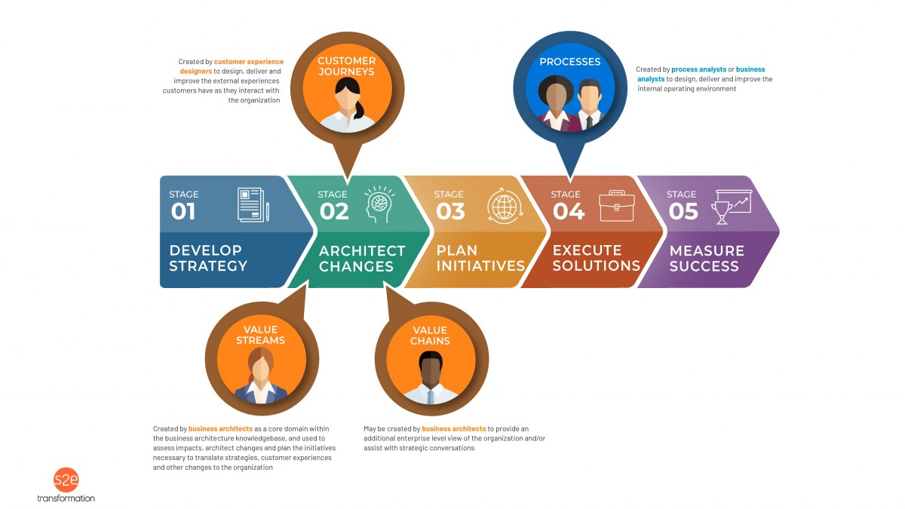

Untangling Customer Journeys, Architecture and Process Within Strategy Execution Context

Additional Resources
- StraightTalk Post No. 41, You Complete Me: How Business Architecture and Business Process Fit Together
- Business Architecture Integration: Integrating Business Architecture Into the Enterprise white paper
- Business Architecture and BPM: Differentiation and Reconciliation (Business Architecture Guild® white paper) (see Business Architecture Guild®Public Resources page)
- Value Streams and Business Processes: The Business Architecture Perspective (Business Architecture Guild® white paper) (see Business Architecture Guild®Public Resources page)
- Section 3.4 of the BIZBOK® Guide (Business Architecture Guild® membership required)

9. Can we purchase a business architecture? Or are there any reference models we can leverage?
You cannot really purchase an entire business architecture and you shouldn’t try to. However, there are a number of reference models out there that may be used to accelerate the development of your business architecture knowledgebase, but they should be used as input to the process of creating your own business architecture (e.g., capability map, information map and value streams) with a cross-functional group of business experts.
Pre-packaged perspectives such as these rarely, if ever, exactly match your organization’s vocabulary and business model nuances. In addition, creating your own business architecture in-house will create much stronger buy-in and advocacy by the business.
A practical approach for building an organization’s business architecture leveraging the industry-specific and common reference model content available from the BIZ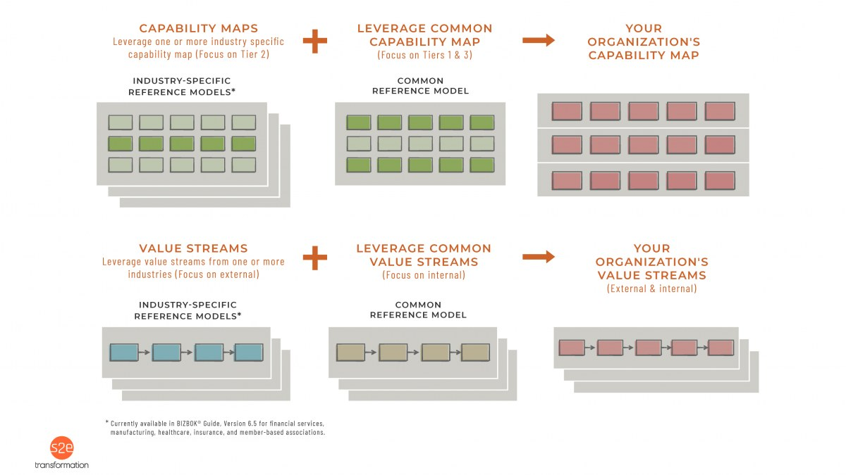BOK® Guide is below.

Leveraging Business Architecture Industry Reference Models

Additional Resources
- StraightTalk Post No. 22, Speedy Business Architecture, Part 1 — Accelerating Business Architecture Development With Reference Models
- Part 8 of the BIZBOK® Guide for industry-specific and common reference model content (Business Architecture Guild® membership required)
- Downloadable industry-specific and common reference model content is also available in the Business Architecture Guild® store (no cost to members)

10. Business architecture is an IT thing, right?
No. Business architecture represents the business, not solution, application, data or technical architectures. As a result, the business has to participate in, understand, and leverage business architecture to capitalize on the discipline.
However, business architecture is one of the domains within enterprise architecture*, so business architects must always have a foot in two worlds: one as part of the business and one as part of enterprise architecture. See FABAQ #35 for more on the relationship between business architecture and enterprise architecture.
*Enterprise Architecture = Business Architecture + IT Architecture (where IT Architecture = Application Architecture + Data Architecture + Technical Architecture)
However, business architects should have a strong working knowledge of technology, just as IT architects should have a strong working knowledge of business. This idea is especially important in today’s world where the lines between business and technology are blending, even within the business model.

Additional Resources
- StraightTalk Post No. 14, BFF: Business Architecture + IT Architecture, Part 1 — How Business Architecture Fits Within the Context of Enterprise Architecture
- StraightTalk Post No. 15, BFF: Business Architecture + IT Architecture, Part 2 — How Business Architecture Drives IT Architecture Alignment and Transformation
- StraightTalk podcasts with Mike Rosen and William Ulrich
- Business Architecture: Putting “Business” into Enterprise Architecture (Ulrich and Soley article)
- Part 6 of the BIZBOK® Guide (Business Architecture Guild® membership required)

