What are the components of the Target operating model?

Organisations tend to have different approaches to arrive at the Target Operating Model. TOMs can be different also depending on the program or project or the purpose.
Here are layers from Illinois.gov
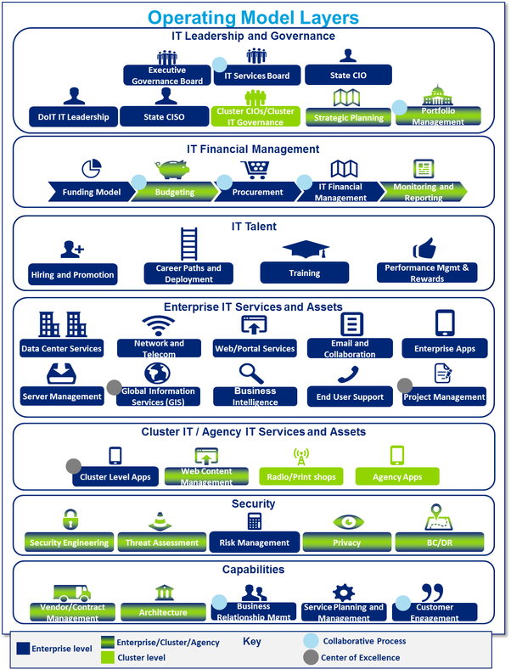
Source: Operating Model and Benefits
A version by Maddison Ward:
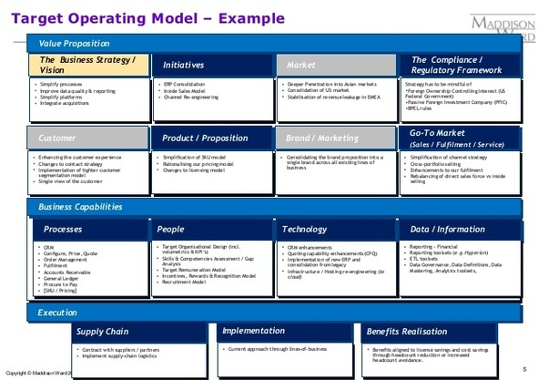
Components to note are:
- People
- Process
- Technology
- Customers
- Markets / Geographies
- Products
Source:Target operating model definition
Here are some examples and components from some key consulting firms:
Capgemini:
In this Cyber-security Target Operating Model, the following are listed as components or building blocks:
- Organisational Structure
- Governance Model
- Processes & Interfaces
- Technology systems
- Performance Metrics
- Roles & Competences

It lists the following in the AS IS analysis and TO BE designng phases.
AS IS Activities:
- Define scope of risk assessment
- Identify critical information assets
- Assess business impacts(Business impact analysis)
- Perform gap analysis and define measures
AS IS Results:
- Assessment scope
- Realistic and worst-case inherent business impact ratings
- Overview gaps/measures
TO BE Activities
- Describe procedures & interfaces
- Define roles & responsibilities and KPIs
- Develop reporting
- Profile threats and vulnerabilities
- Develop questionnaires
TO BE Results
- Policy and process description
- Role descriptions/RACI
- Reporting templates
- Risk assessment templates
See slide 37 & 38 of Information Security Benchmarking 2015 presentation
Claims Operating Model:
It says "Based on our experience, an effective Claims Operating Model encompasses the following components ":
- Governance
- Process Model(s)
- People: Skills & Competencies
- Management Processes
- Technology Enablement
See slide 5 of Capgemini Consulting Claims Ops Model Alignment Program 3 13 2015 for more details
Deloitte:
Here is an approach one of their outlets published
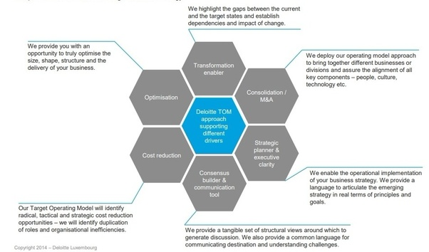
Source:Refining the target operating model | Deloitte Luxembourg | Financial Services Industry | Insights
Those supporting comments indicate the following components:
- Strategy
- People
- Culture
- Technology
- Businesses or Divisions
- Roles/Organisation

See some more information here:
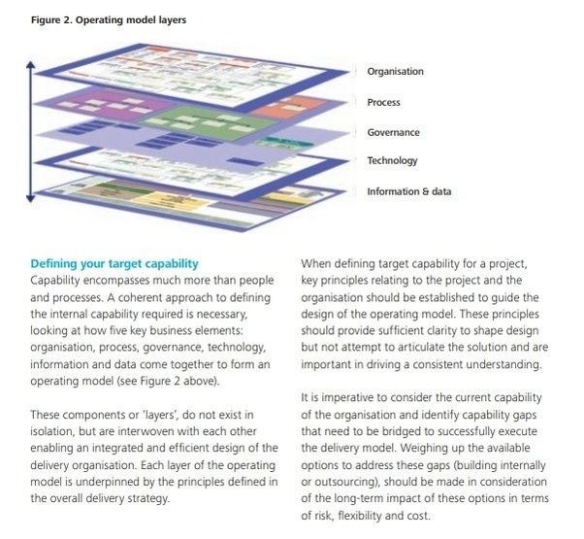
Source: https://www2.deloitte.com/content/dam/Deloitte/global/Documents/gx-icp-delivery-remodelled.pdf
Components derived from the above are:
- Organisation
- Process
- Governance
- Technology
- Information & Data
An Operating Model definition from available public information:
Operating Model is how a company configures its internal design to realise the value targeted in the Business Model. The Operating Model defines where the company will operate, what kinds of products and services it will sell, which customers and segments will it serve, what channels will be used, what are the key business processes and which will be outsourced, or handled in-house, which alliances will be most critical, and how will decisions be made and performance measured.
Source:
Business Transformation: evolving the way business is conducted - Blog | Deloitte Australia
Deloitte is also known for its 9 layers so lets visualize its components:
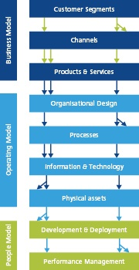
Source: Target Operating Model | Operations Excellence | Strategy & Operation…
Here is the thinking behind that:
Business Transformation: evolving the way business is conducted - Blog | Deloitte Australia
Components to note:
- Customer Segments
- Channels
- Product & Services
- Organisational Design
- Processes
- Information & Technology
- Physical Assets
- Development & Deployment
- Performance Management
KPMG
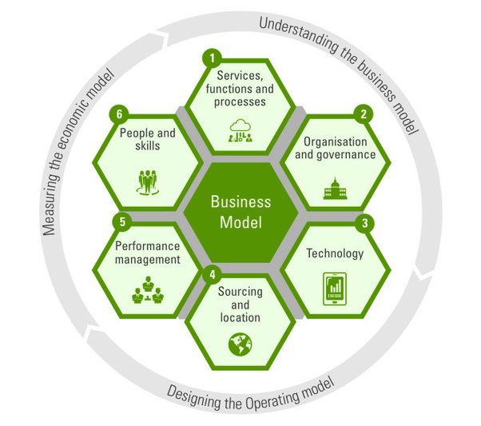
Source:Target operating model
Components to note:
- People and skills
- Services, functions and processes
- Organisation and governance
- Technology
- Sourcing and location
- Performance Model
- Business Model*
*The business model is at the center of it all.

iSolutionArchitect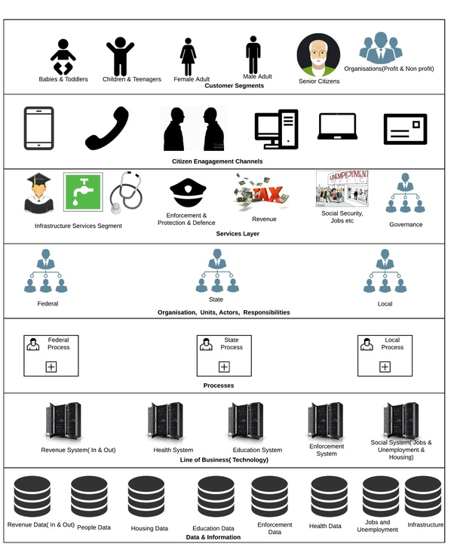
Source:Target Operating Model Consultant CV and Resume
Components to note:
- Customer Segments
- Customer Channels
- Services
- Org Units, Actors, Responsibilities
- Processes
- LOB Technology
- Data & Information
Finally the less obvious TOGAF Meta Model which can be used to build your Target Operating Model.
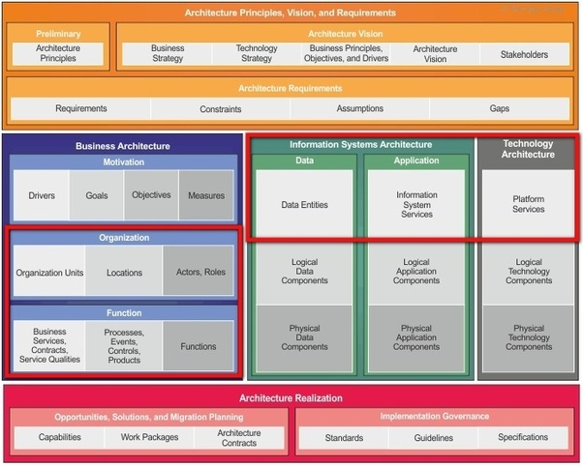
The areas I highlighted in red are:
- Organisation Units
- Locations
- Actors, Roles
- Business Services, Contracts, Service Qualities
- Processes
- Events
- Controls
- Products
- Functions
- Data Entities
- Information System Services
- Platform services

Thorogood
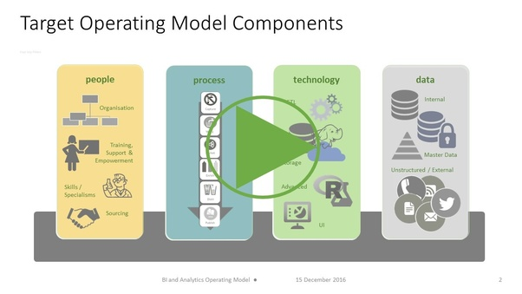
Source:Time to think about a new BI and Analytics Operating Model?
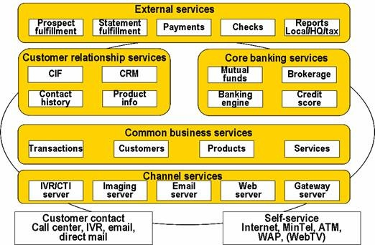
Source:http://www.ies.aust.com/ten/ten38.htm
- Components to note:
- Channels services
- Common business services
- Customer relationship services
- Core banking services
- External services
Summary:
Target Operating Models are required for different purposes, understand the purpose which your TOM is meant for, use the building blocks or elements that are constant in all models above and are relevant to your need.
E.g An Operating Model for a system can or should be different from the overall operating model of the organisation. It should tell HOW the system will operate/function. If it is for an organisation then it should tell HOW the organisation delivers its Business Model.
What specific CRM features are most important to a small business?
Blake Clark, Group Vice President at Software Advice Updated November 11

When figuring out what CRM features are most important to your specific business, you’ll want to take a step back and evaluate why you’re looking for a CRM in the first place. If you’re having a hard time maintaining consistent contact with your clients, you’ll want to look for features like contact management or lead management. If you’re focused more on driving sales, you might need something with workflow automation or pipeline management. There’s an infinite amount of potential reasons why a small business might be looking for a CRM, and there’s no one definitive list that will include a one-size-fits-all approach. That’s why I’d recommend building out a CRM feature shortlist for your specific business needs. To get you started, I’ve listed some of the most common and important CRM features. Related Questions

What is target operating model?
Why do we need a target operating model?
What is an operating model design?
What is a target operating model and how would you apply it?
How does an organization's IT strategy relate to its operating model?
What is the difference between the AS-IS process model and the to-be process model?
What is a business model and its key components?
What are the components of a system?
What are the components of system thinking?
Is target operating model a kind of organization design?
What is the propensity-to-buy model?
What is difference between purpose & capability in an operating model?
What are the major components of a modern operating system?
What are process models?
What are the components of performance?

