Annual Report- Travel, Hospitality and Conferences  
Centralized Publishing System-Training Guide

Contents

1 – The Registry 3

2 - How to register an account 3

3 - Logging in to the Registry 4

4 - Finding your organization 5

5 – Uploading your information: 5

6 - Completing your report 6

7 – Publishing your report 7

8 – Deleting a report 9

# 1 – The Registry

* [The Open Data Registry](http://registry.open.canada.ca/en/) houses all of the Government of Canada’s metadata records for all datasets across federal organizations and allows you to upload and manage all your proactive disclosures including Annual Travel, Hospitality, and Conferences.
* All proactive disclosure documents (Access to Information, Contracts, Travel and Hospitality, Annual Travel, Reclassification and Founded Wrongdoing) will be uploaded to the Registry and then published and made searchable on the [Open Government portal](http://open.canada.ca/en/search/grants).

# 2 - How to register an account

* If you don’t already have a registry account you will need to register for one.
* On the right side of the page, click on “Request an Account” and fill out the corresponding form to request an account. Please include your organization name when registering.

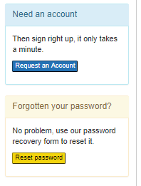

* Once you’ve applied, the Open Government Secretariat (OGS) will link your account to your department and notify you by email.
* If there are any issues with your account throughout the registration process, please contact the OGS team by sending an email to the [Open Inbox](mailto:open-ouvert@tbs-sct.gc.ca).

# 3 - Logging in to the Registry

* You now have access and can log in to the Registry by selecting the Log in tab in the menu bar.
* Once you enter your Username and Password you can select the “Remember me” checkbox to save your information in your browser.

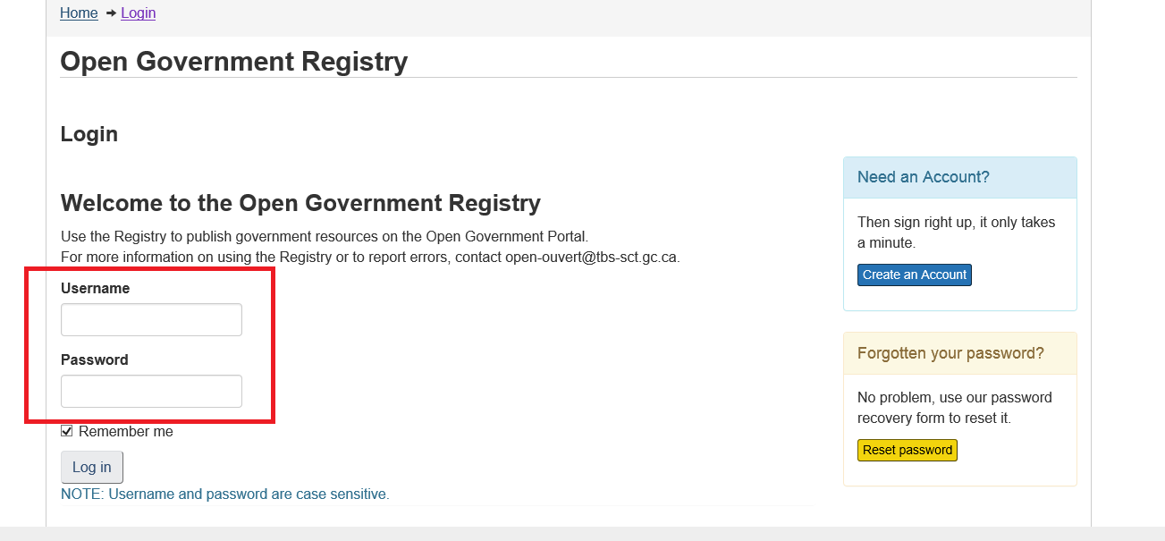

* If you have logged in successfully you will see a note at the top of the page indicating that you are logged in. You will also see the “Log Out” option in the top menu bar:

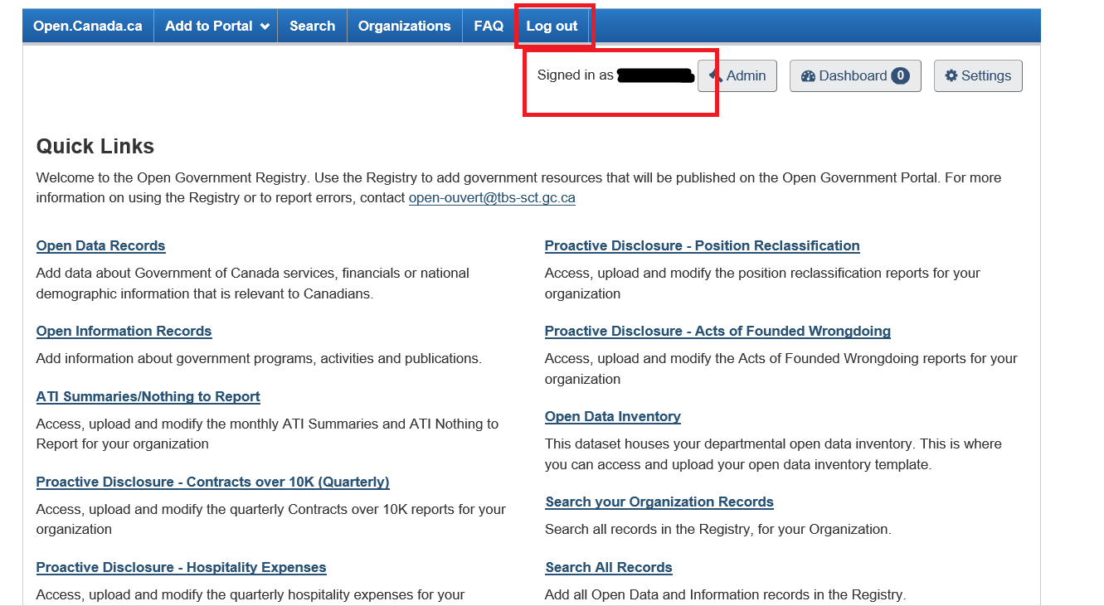

# 4 - Finding your disclosure type

* Now that you are logged into the registry, you will see the “Quick Links” menu where you can select “Proactive Disclosure - Annual Travel, Hospitality and Conferences”:

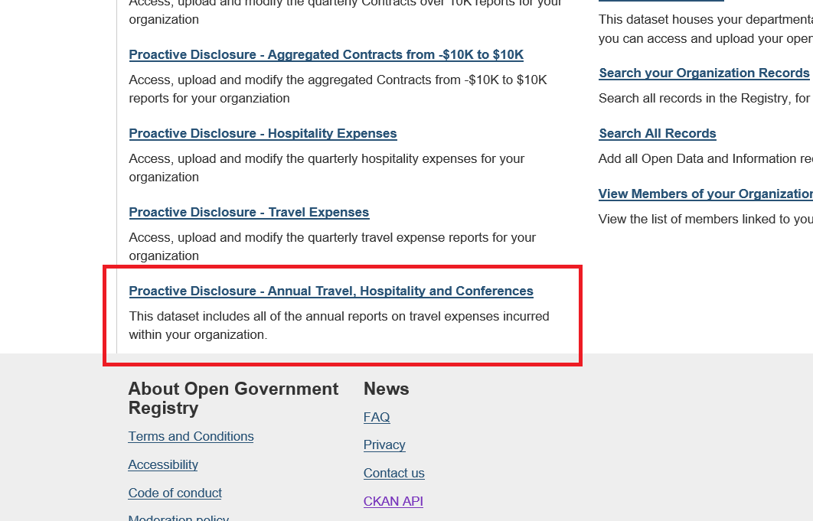

# – Accessing your template

* The Annual Travel, Hospitality, and Conferences disclosure is now entered in the template format. This entails using a Microsoft Excel template to enter the required information to be uploaded to the Open Government Registry.
* After selecting your proactive disclosure type you will be brought to the Annual Travel, Hospitality, and Conferences page where you will select your organization from the drop down menu:

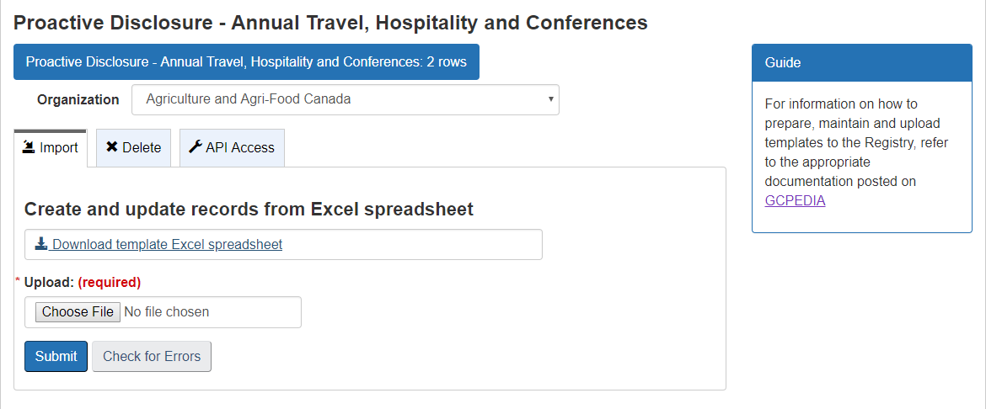

* After you’ve selected your organization from the drop down menu, you’re ready to download your template. The first step is to download the document and save it to your desktop or hard drive:



* PLEASE NOTE – it is imperative that you do not alter the file name in any way, PLEASE SAVE IT AS IS. The template is named uniquely for your department and may not allow you to upload the completed version if it has been changed.

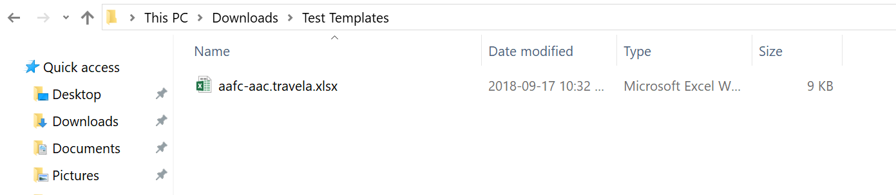

# - Completing your template

* Now that you’ve saved your organization’s template on your hard drive, you can begin to complete the document. Of note – every Annual THC proactive disclosure line item MUST have the “Fiscal Year Ending” field completed, this will allow users to modify and delete disclosures if desired. Each year must be entered in a separate row. Multiple years can be uploaded at one time:

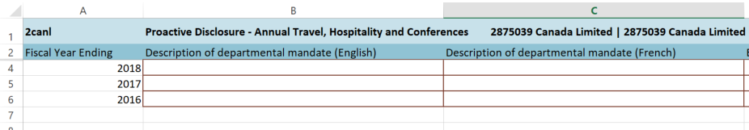

* **It is important to note that, due to changing requirements for the categories of travel which took effect with the fiscal year ended March 31, 2018, users should complete the template differently based on the year they are reporting.**
* **Disclosures for 2018 or later**: When adding a disclosure for any year 2018 or later, users should (in addition to the other columns) fill out the columns “Travel ≥2018 - Operational activities”, “Travel ≥2018 - Key Stakeholders”, “Travel ≥2018 - Training”, “Travel ≥2018 - Internal Governance”, and “Travel ≥2018 - Other” as they apply. Users should **NOT** fill out the “Travel <2018 - Public Servant” and “Travel <2018 – Non-Public Servant”.
* **Disclosures for 2017 or earlier**: When adding a disclosure for any year 2017 or earlier, users should (in addition to the other columns) fill out the “Travel <2018 - Public Servant” and “Travel <2018 – Non-Public Servant” columns as they apply. Users should **NOT** fill out the columns “Travel ≥2018 - Operational activities”, “Travel ≥2018 - Key Stakeholders”, “Travel ≥2018 - Training”, “Travel ≥2018 - Internal Governance”, and “Travel ≥2018 - Other”.
* **Transition period 2017 to 2018:** For the 2018 disclosure, travel expenses entered for year 2017 will automatically be combined and presented as total travel expenses for comparison purposes.
* Please note, if you have any questions about what information should be populating these fields, please refer to the *Data Element Profile: Annual Travel, Hospitality and Conferences* on our [GCPedia page](http://www.gcpedia.gc.ca/wiki/Proactive_Disclosure_on_Open.Canada.ca).
* Please note that all existing years disclosures have automatically been migrated over to the new format as part of the update. These disclosures can still be edited as templates uploaded with fiscal years identical to a year that already exists in the system will overwrite the older disclosure.  Be aware that if you upload a template with, for example, 2016’s disclosure while there already exists a disclosure for 2016 in the registry, the new data (and any changes) will overwrite the old data.
* If an error is present in any one of the cells, the cell will be outlined in red. If a required cell is empty the cell will turn red.
* As always, if there are any issues when completing your Annual report, please contact the OGS team through the [Open Inbox](mailto:open-ouvert@tbs-sct.gc.ca) for assistance.

# 7 – Uploading your template

* Now that you’ve completed all of the required fields, you’re almost done.
* The next step is to log back in to the registry and return to your organizations page (the same page where you downloaded the template).
* You will see the “Upload” option directly below the button where you downloaded your template. Click the “Choose File” button and select your completed template from your hard drive;

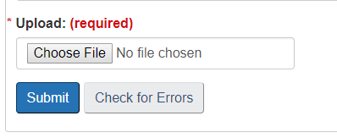

* Once you’ve selected your completed template from your computer you will see the file name in the upload box:

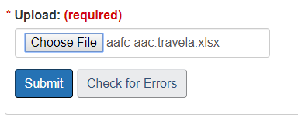

* The “Check for Errors” box allows you to check if there are any errors to be corrected in your template before you complete the upload. Checking for errors is not necessary and the system will inform you of any errors when you click “submit”.
* Click “Submit” and your template will be uploaded to the registry. You will receive a message on the top of the form indicating that your template has been successfully added to the system, and you will be able to see the information that was captured in the template on this page:

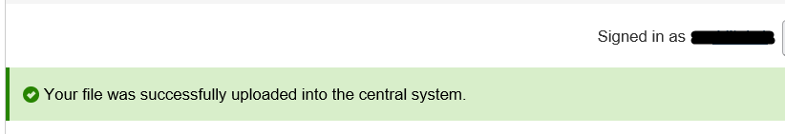

* Once your template has been successfully uploaded, you will be able to view all of the uploaded data in the “Preview” section below. You can also Search for a single line item by entering the “year” in the ***Filter items*** section:

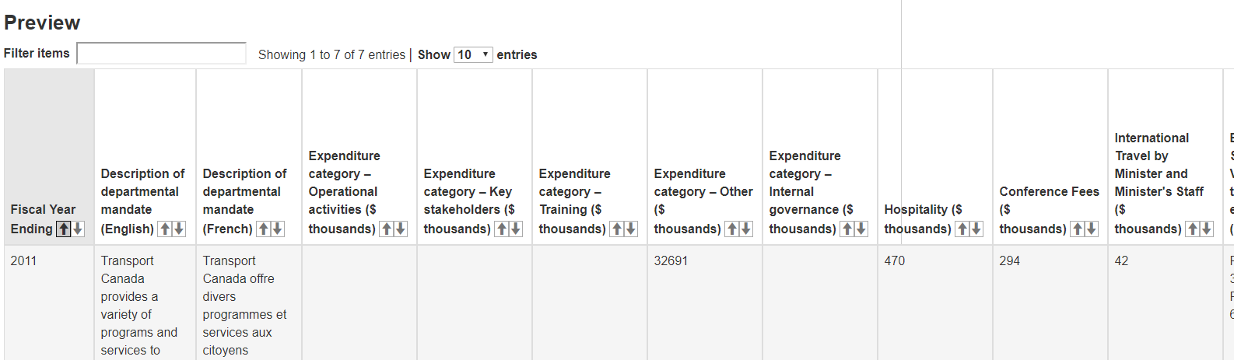

* Once you have uploaded your template it can be seen the next day here: <https://open.canada.ca/en/proactive-disclosure>

(Note: templates are harvested overnight, so you will not be able to see your completed template on the open.canada portal until the next morning)

# 8 – Adding, Modifying or Deleting an Item

* Once completed templates are uploaded, they may contain errors and omissions that need to be fixed. To delete an item, you will select the ***Delete*** tab below the Organization drop down menu:

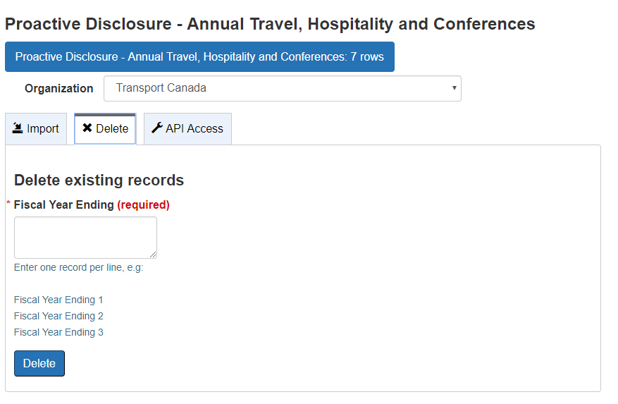

* When you have selected the Delete tab, the system will prompt you to enter the “year” of the item you wish to delete: (The year is the unique identifier in the first column of all the Annual THC Proactive Disclosure template)

(If you have multiple line items to delete, please ensure you enter only one year per line)

* You will enter the year of the item you wish to have removed and will be prompted to make sure you want to delete the record:

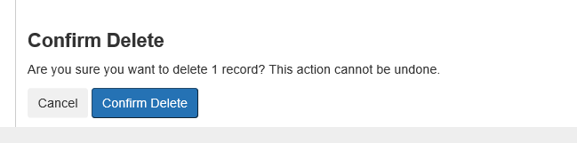

* Once you have confirmed the deletion of the record, you will be taken back to the previous page where you will see the confirmation (1). You should also see the change reflected in the number of records :

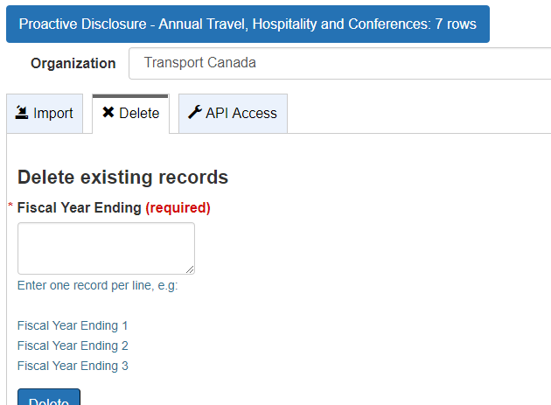

* To add or modify an item, the spreadsheet simply needs to be modified as needed and to be re-uploaded into the registry and it will add any new items or modify and existing ones.
* You will be able to preview any of these changes in the Preview section within each organization.

As always, if you are still experiencing any issues, contact the OGS team by sending an email to the [Open Inbox](mailto:open-ouvert@tbs-sct.gc.ca).