1 - Open the App Store on your phone or tablet

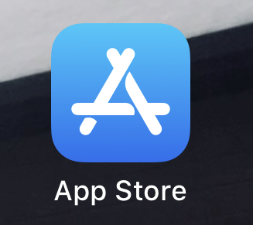

2 - Search for “Microsoft Teams”. This should bring up Microsoft teams.

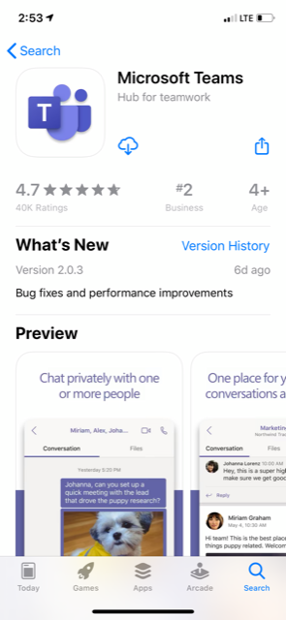

3 – Click on Install. If should create an icon on your phone.  
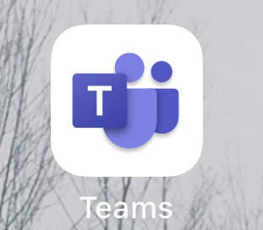

4 – Launch the Teams app. You should get a sign in page

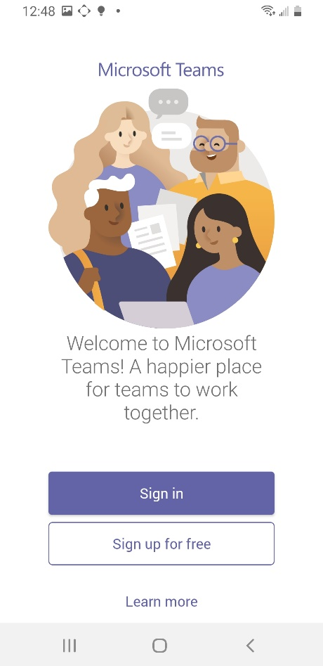

5 – Sign in with the provided username and password. You should then be directed to this page. Click next.

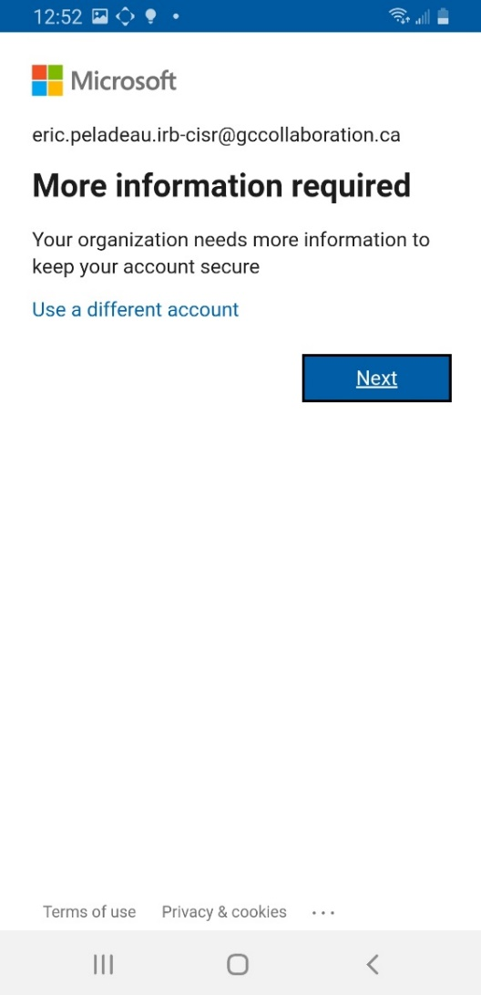

6 – Select “Authentication phone” and select “Canada” in the country or region

Then, enter a mobile phone number (it could be the same phone you are installing the app on or a personal cell phone.)

Make sure you select “Send me a code by text message”

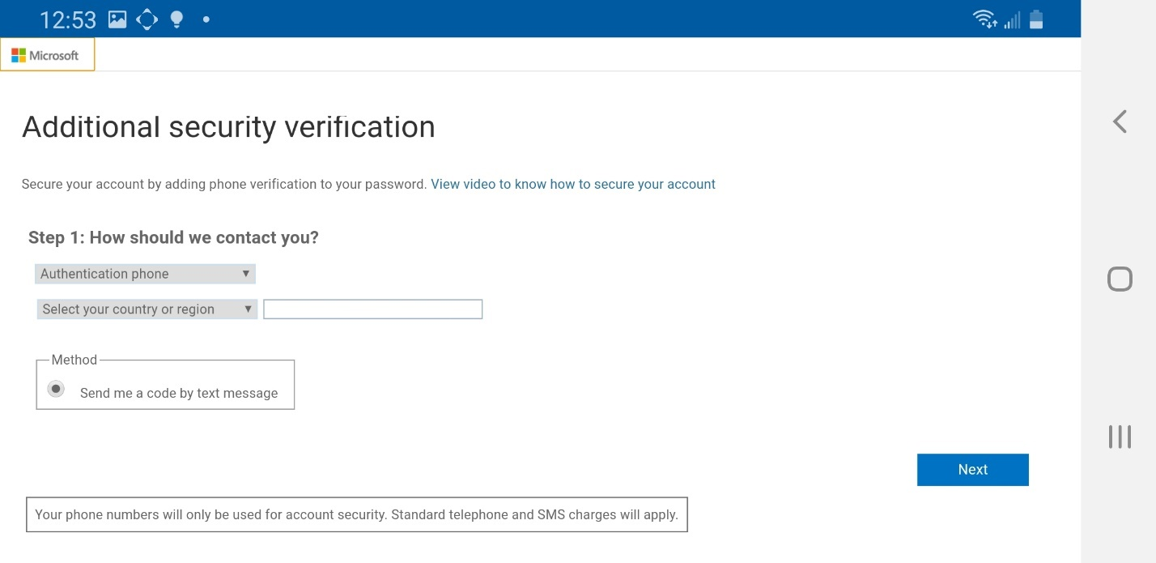

7 – You should get a text message on the cell phone you provided. This will be the code used to finish the setup of your Teams account.

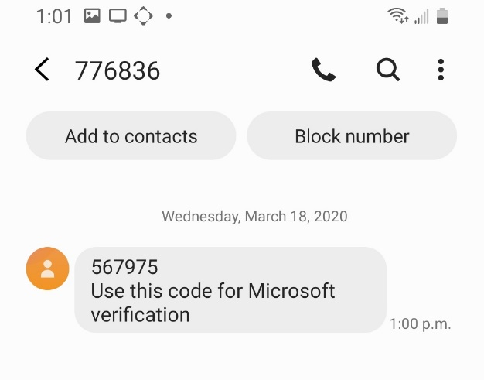

8 – type in the code you received in your text message and click Verify

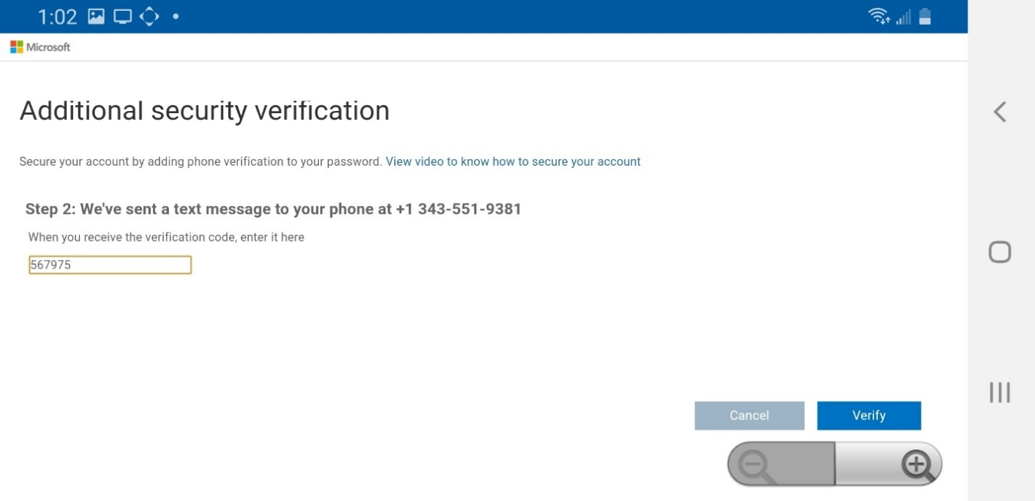

9 – Once it says successful, click “Done”

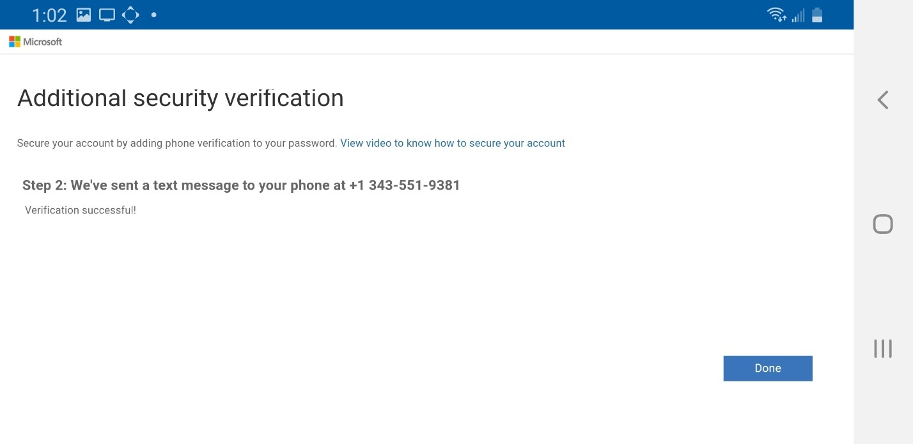

10 – you now must update your password. Type in the provided password, then select one of your own password. 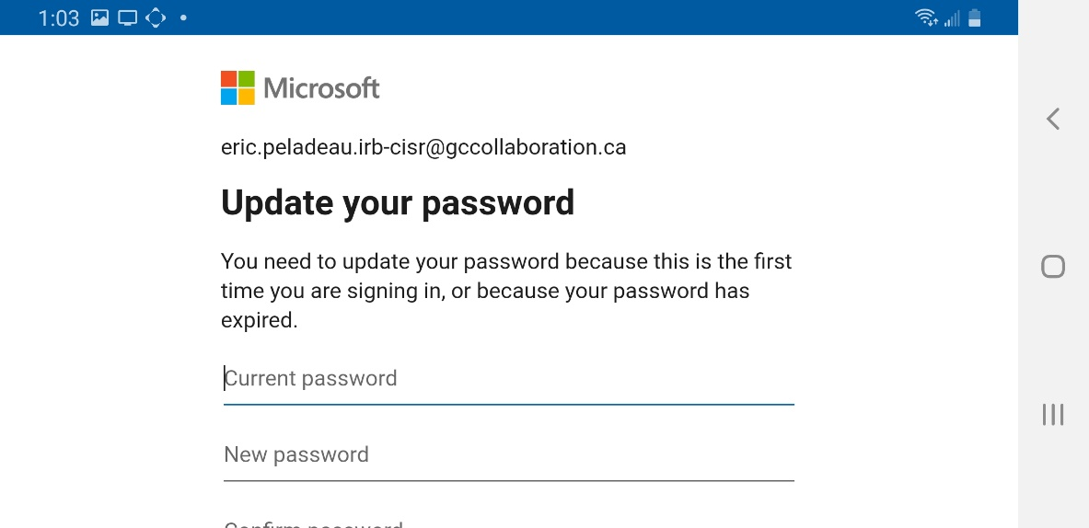

11 – you are now ready to use Teams.

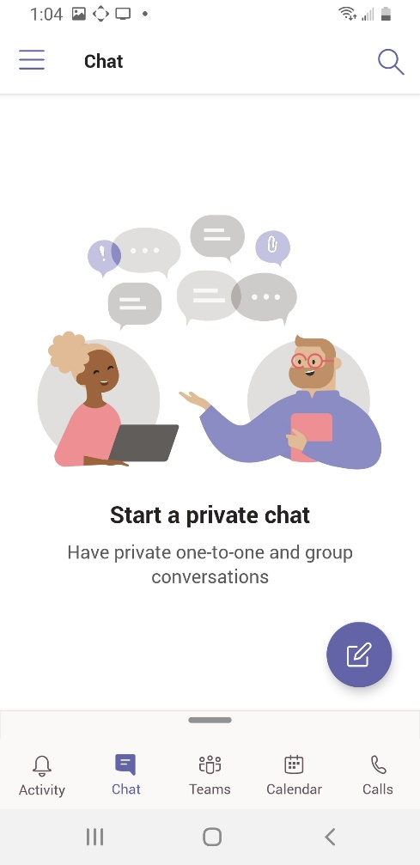

Once you’re logged in here’s some useful information on how to use Microsoft Teams on a Windows or Mac personal computer.

<https://support.office.com/en-us/article/microsoft-teams-video-training-4f108e54-240b-4351-8084-b1089f0d21d7>

Please note that most Teams functions are disabled.  It is limited to collaborate in a group chat, video conference or audio conference meeting. Some other features may not be available as shown in the training material.  However, in a near future it will be available to the IRB.

For your mobile experience, we recommend you follow the training above even if you plan to use Teams on Mobile only.

Chat will be the same as Skype For Business, you can create a single chat or group chats by pressing the pen (compose) icon on the top right.

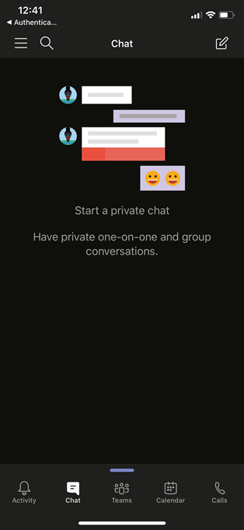¸

You can also schedule a meeting by accessing your calendar and press the calendar icon on top right to set the date and invite participant. This will send them an invitation to an email with a link to launch video / audio conferencing.

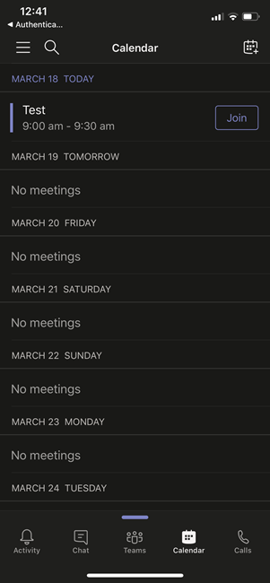

You also have the possibility to call a co-worker by going on the call tab and by searching the person you want to reach

