Identified User (IU) CST Instructions

CATEGORY 2-6

Reference: Supply Arrangement for Work Spaces, number E60PQ-140003

Welcome to the Instructions for Identified Users

These instructions are for the purpose of guiding users when procuring products using the Workspaces Supply Arrangements.

CST for Categories 2-6
For Categories 2 to 6, starting at the left use the filters on the column headings to narrow your search according to your requirement. After you have made your filter selections, enter your quantities in the QTY column. Click on the Results tab to see the Conforming Suppliers that can meet your requirement.

For example purposes, we will be purchasing 75 keyboard trays from Category 5 under the General stream. We want to purchase a keyboard tray that has a gel palm support and a mouse support.

When you open the CST for Category 5, you will see the following two tabs at the bottom of the Excel spreadsheet: “Category 5” and “Result”.

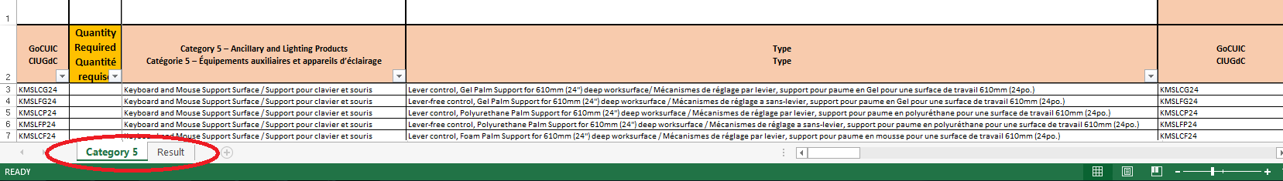

This is what our product search will look like before we use the filters:

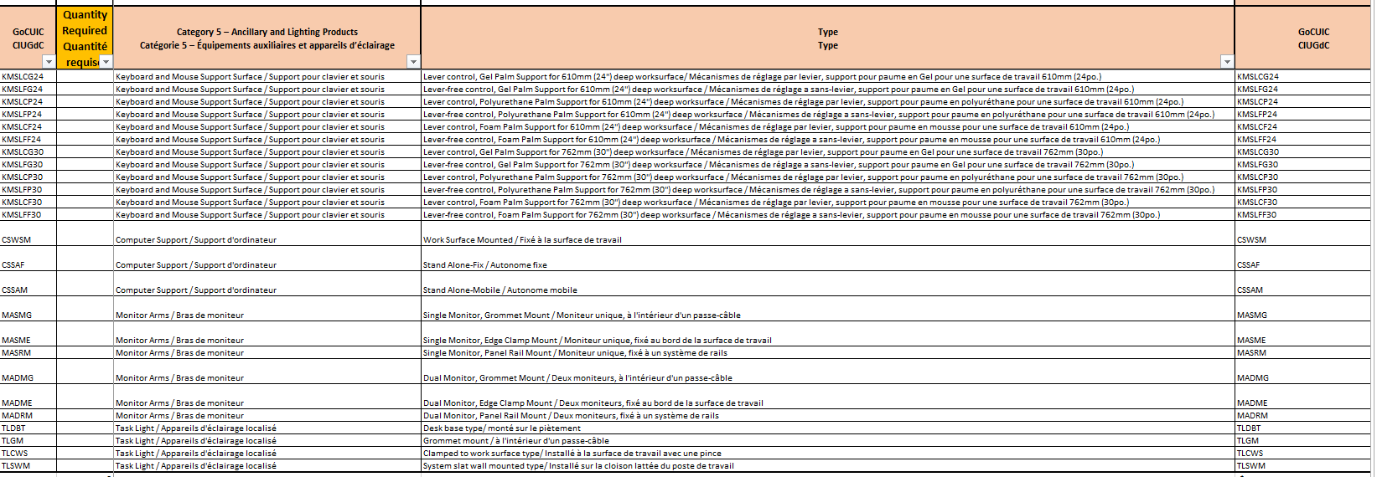

Click the filter (pull-down) button at the first applicable column heading entitled “Category 5 – Ancillary and Lighting Products / Catégorie 5 – Équipements auxiliaires et appareils d’éclairage”:

After the drop down filter is selected, choose a selection within the drop down filter. For this example we will choose the “keyboard and Mouse Support Surface / Support pour clavier et souris”. Click “Ok” when done. This action will remove/filter all other products from the listing to help narrow down your product search.

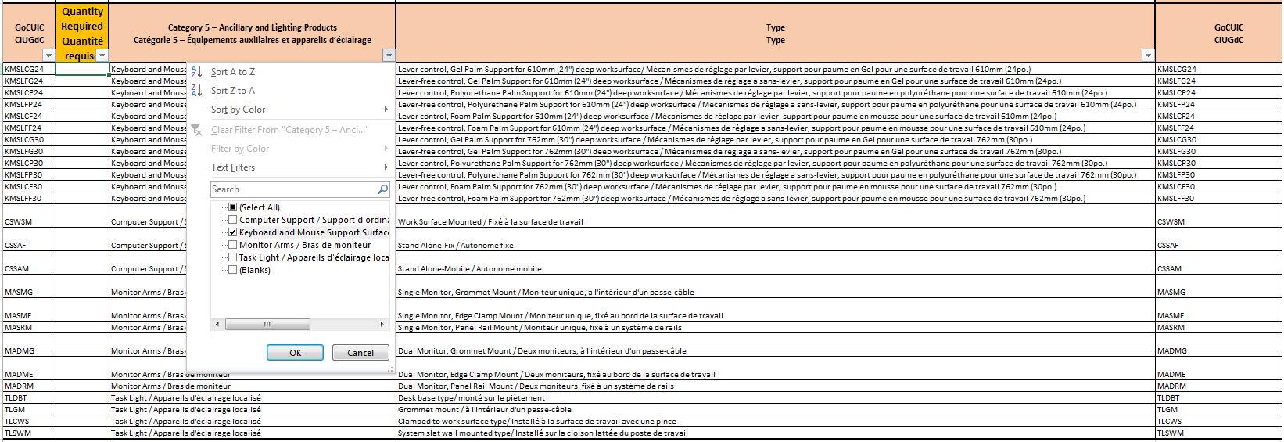

Moving to the next column at the immediate right entitled “Type”, you will repeat the same steps to use the filter at this column heading as you did for the previous column. After the drop down filter is selected, make another selection within the filter drop down. For this example we will choose the “Lever control, Gel Palm Support for 610mm (24'') deep worksurface/ Mécanismes de réglage par levier, support pour paume en Gel pour une surface de travail 610mm (24po.)”. Click “Ok” when done. This action will again remove/filter all other products from the listing to help narrow down your product search.

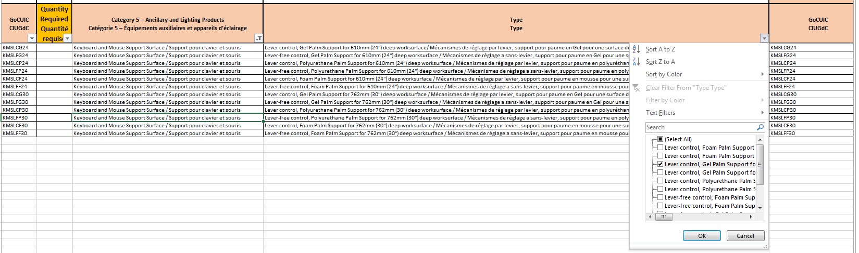

Indicate the quantity of products required. For this example we are purchasing 75ea keyboard trays. This is what our product search will look like after we use all filters and indicate our quantity required:

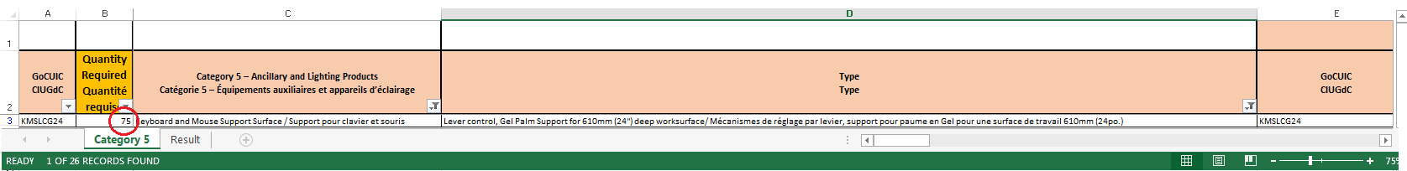

General Stream
Tier 1: Estimated Median Value $0.01 to $24,999.99  Palier 1 : valeur moyenne estimative comprise entre 0,01 $ et 24 999,99 $; |  | $ 26,005.50
Tier 2: Estimated Median Value $25,000.00 to $399,999.99  Palier 2 : valeur moyenne estimative comprise entre 25 000 $ et 399 999,99 $ | Yes | $ 780.17 | Add 3% for Delivery charges, if applicable  ajouter les frais de livraison (3 %), s’il y a lieu
Tier 3: Estimated Median Value $400,000.00 to upper PWGSC, Acquisitions Program limits  Palier 3 : valeur moyenne estimative comprise entre 400 000 $ et la valeur maximale établie dans le Programme d’approvisionnement de TPSGC. | Yes | $ 1,820.39 | Add 7%for Installation charges, if applicable  ajouter les frais d’installation (7 %), s’il y a lieu
 |  | $ 780.17 | Add 3% for Hardware  ajouter le coût du matériel (3 %)
 |  | $ 3,900.83 | Add Applicable Taxes  ajouter les taxes applicables.
2019-04-30 10:42 |  | $ 33,287.04 | Total estimated requirement value
Important: The results tab captures a total of the average prices for products that have been identified with a quantity on the product listing tab. This estimate is based on ceiling prices and clients can often obtain firm pricing with significant discounts of upto 20 to 50% during the solicitation.
Important: L'onglet Résultats contient le prix moyen des produits identifiés avec une quantité dans l'onglet Liste des produits. Cette estimation est basée sur des prix plafonds et les clients peuvent souvent obtenir des prix fermes avec des rabais significatifs allant de 20 à 50% lors d'un processus d’invitation à soumissionner

Having made a choice/selection from each filter we have completed our search for products and are now ready to see our results. As we can see, our requirement has the Estimated Value falls into Tier 2. The CST indicates this to us by automatically highlighting the Tier in green. This means we must follow the business rules associated with requesting bids for purchases under Tier 2.
At this same table you will see a drop-down options for delivery and installation. Indicate whether you require delivery and installation using the dropdown filter.

If you indicate “YES” for delivery, the CST adds 3% to your price.

If you indicate “YES” for installation, the CST adds 7% to your price.

For the purpose of this example, we are selecting “YES” to add both Delivery and Installation charges. The CST will automatically add 3% for Hardware for all requirements, and will add Applicable Taxes (at an estimated tax rate of 15%) for all requirements. The CST will sum all of these costs to give you the Estimated Value (EV) of your chosen category requirement.

