Navaratri: The Festival of Nine Nights - A Tradition of the Celebration of the Feminine
South Asia is home to a variety of multi-ethnic and multi-religious communities and celebrates many festivals and traditions. In Canada, many people are familiar with one of the major festivals of South Asia, which is Diwali. Diwali or Deepavali in Sanskrit means row of lights and is also known as the festival of lights. The festival which lasts for five days is celebrated by decorating houses with clay lamps and is a time for feasting and celebrating. Among many regional traditions for which Diwali is celebrated, one of the major traditions relates to the celebration of the return of the Prince Rama to his kingdom of Ayodhya, after his victory and killing of the demon king, Ravana. The just and the righteous prince Rama restored the cosmic order by killing Ravana and hence, the festival of Diwali also symbolizes the renewal and restoration of the cosmic order and the victory of good over evil.
Navaratri, which in Sanskrit means nine nights is a major Hindu festival dedicated to the Hindu goddess Durga. This lesser known festival is celebrated with much fanfare in various parts of South Asia. Navaratri is celebrated twenty days prior to Diwali. The nine nights of celebration relate to nine different incarnations of the goddess. Durga in Sanskrit means “the one who is invincible.” According to Hindu mythology, the goddess Durga was created through the energy of the various gods to fight the buffalo demon Mahisha. It was only Durga who could slay the demon through her power or shakti and restore the cosmic order, which had fallen into chaos due to the evil doings of Mahisha. Like Diwali, this festival symbolizes and celebrates renewal. Besides renewal, Navaratri also celebrates the feminine principle of creation known as prakriti.
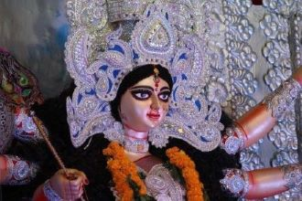
An image of the Goddess Durga. In Kolkata, Bengal, images such as these are crafted every year from clay by hereditary artisans. Photo Courtesy: Web Photo/ Pixabay.
While in the western Indian province of Gujarat, the Navaratri festival is celebrated with fasting, feasting and dancing Garba (a traditional folk dance) for the nine nights, the traditions in eastern India such as Bengal celebrates the festival with a different zeal. In Kolkata, various neighborhoods compete to set up the best pandal or a stage, which displays the image of the goddess built by hereditary artisans. For nine days, people in Kolkata worship the goddess through various rituals or puja and visit the pandals in their best dressed clothes. On the tenth day, the image of the goddess, which is typically made out of clay is taken in a procession to a nearby river or a water body where it is immersed in the water, a process known as visarjan in Sanskrit. The visarjan symbolizes the goddess’s return to her abode, which is the divine cosmos or the mount Kailash of Hindu mythology.

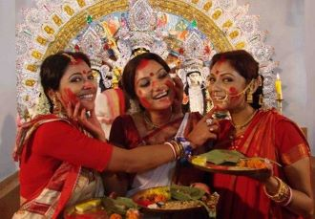
In Bengal, women smear red vermillion powder on each other after making offerings to the goddess on the tenth day and the final day of the Navaratri festival. Photo Courtesy: Indian Eagle.
Hence, every autumn, the festival of Diwali is heralded with the celebration of the feminine in the form of goddess Durga during the festival of Navaratri.

