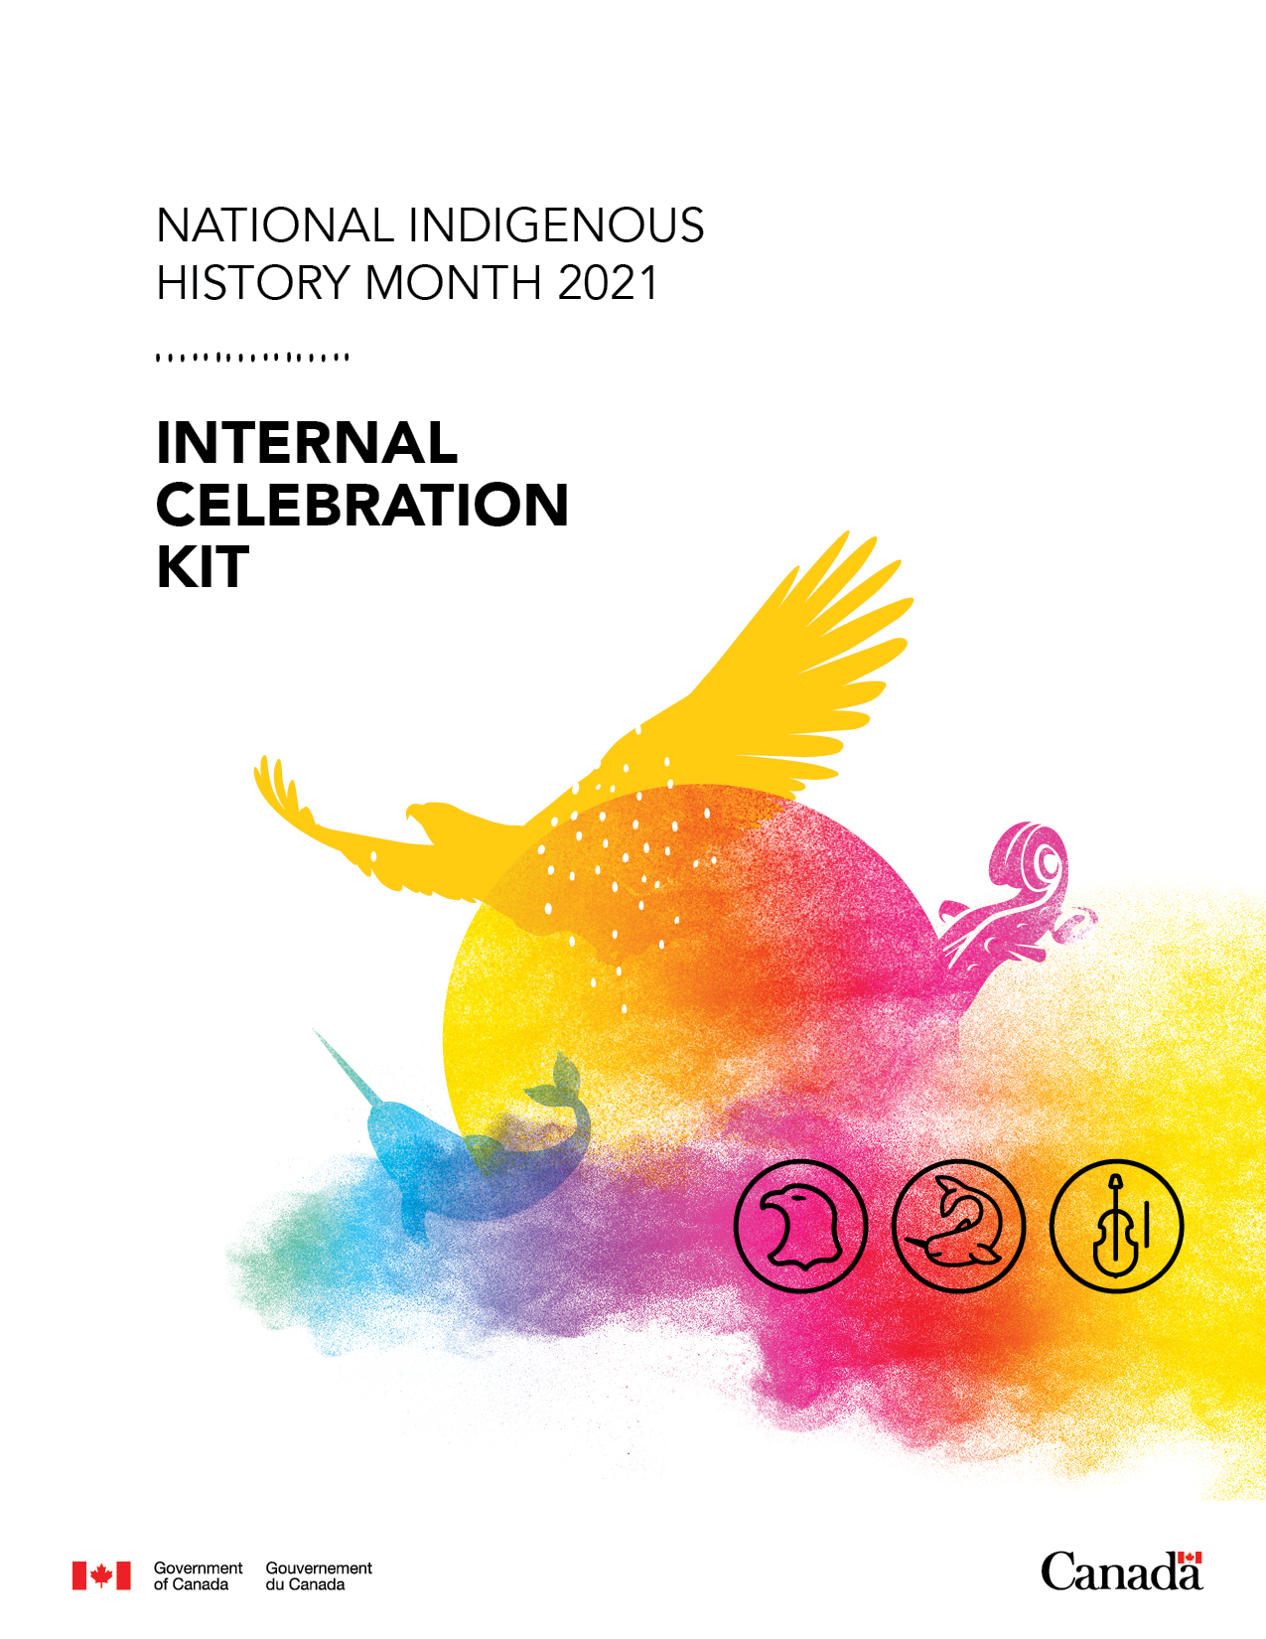

**Table of Contents**

About this toolkit 3

Internal version 3

Public web kit – *Celebrating National Indigenous History Month* 3

Campaign themes 3

Overarching theme 3

Weekly calendar themes 4

General information 4

About National Indigenous History Month 4

About National Indigenous Peoples Day 5

About Indigenous Reads 5

Contributors 5

Key messages – June 2021 6

Internal products to share 7

Template department-wide message for use on NIHM, NIPD and IR 7

Best practices and courses 8

Canada School of Public Service offerings 8

More resources 9

External products to share 9

Canada.ca – *Celebrating National Indigenous History Month* 9

Statements 10

Social media calendar 10

Shareables 10

Indigenous Reads 10

Contact 10

# About this toolkit

Our key aim is to virtually celebrate First Nations, Inuit and Métis peoples this National Indigenous History Month (NIHM) (June) and National Indigenous Peoples Day (NIPD) on June 21, 2021, by providing greater access and visibility to Indigenous-led or co-created content and learning experiences. However, many Canadians need an entry point to celebrate and start learning.

To facilitate this, Indigenous Services Canada (ISC) and Crown-Indigenous Relations and Northern Affairs Canada’s (CIRNAC) Advertising and Social Marketing communications team has consulted National Indigenous Organizations (NIOs) and partners and worked with other government departments to create and promote a celebratory, public online celebration web kit hosted on the CIRNAC website that includes shareable information, educational resources and links to resources about Indigenous culture, events and history (past and present).

## Internal version

This internal kit is directed to federal public servants to support awareness and learning opportunities, at any learning journey stage, during these important commemorative events (NIHM and NIPD) and to highlight internal, official resources available government wide.

As part of the [Truth and Reconciliation Commission Calls to Action](http://trc.ca/assets/pdf/Calls_to_Action_English2.pdf), all government departments are meant to determine a way forward on reconciliation. Although not specifically mentioned, we encourage you to observe any NIHM and NIPD as an opportunity for action.

## Public web kit – *Celebrating National Indigenous History Month*

This educational online web kit aims to disseminate resources and activities to raise awareness and facilitate celebrations among Canadians at large and contains supplementary information for other government departments to develop their own celebrations. The web kit provides content that targets the predominant ways in which the user likes to learn by Listening, Watching, Trying and Reading. As part of this learning opportunity, the #[IndigenousReads](https://www.rcaanc-cirnac.gc.ca/eng/1472674362414/1557776582786) summer campaign is an additional activity to help in the celebration of Indigenous culture.

There are **three key pillars** to ISC/CIRNAC’s approach to celebrating NIPD and NIHM this year:

* Celebrating by learning **through Indigenous voices**
* **Exploring Indigenous-led** experiences
* **Collaborating and coordinating** with other government departments.

**The *Celebrating National Indigenous History Month* web page can be accessed here:**

* [link to come May 25, 2021]

Campaign themes:

Overarching theme

**Celebrate through learning** from Indigenous voices, Indigenous-led activities and exploring content that has been co-created or developed in collaboration between government and First Nations, Inuit and Métis peoples.

### Weekly calendar themes

We are proposing weekly, external learning themes to support existing commemorative calendar days and to micro-segment by audience interest/preferred learning topics:

* WEEK 1 (June 1 to 6): Shared lands/Environmental connections: How do we demonstrate respect and how do we do better?
* WEEK 2 (June 7 to 13): History Lesson/History Makers (noting key figures that are making and have made major impacts), plus learning about your local history and the land you are on.
* WEEK 3 (June 14 to 20): Support/Celebrate Indigenous Excellence: Highlighting innovators, cultural ambassadors and trailblazers (noting key figures from sport and culture).
* WEEK 4 (June 21 to 27): Amplifying Indigenous practices and approaches (including spirituality, food, art), including learning about the Indigenous language in your region.
* WEEK 5 (June 28 to 30): What now? for Canadians: Pledge to reconciliation, how you can use social media to support reconciliation (June 30).

# General information

## About National Indigenous History Month

NIHM is celebrated each June to highlight and strengthen Indigenous contributions to Canadian history and society.

To learn about the history of First Nations, Inuit and Métis peoples across Canada from Indigenous voices, please visit the websites of the following NIOs:

* Assembly of First Nations: <https://www.afn.ca/about-afn/>
* Inuit Tapiriit Kanatami: <https://www.itk.ca/about-canadian-inuit/>
* Métis National Council: <https://www2.metisnation.ca/about/>

To learn about NIHM from ISC/CIRNAC, visit

* <https://www.rcaanc-cirnac.gc.ca/eng/1559222623218/1559222644174>.

To learn more about inspiring Indigenous artists, athletes, advocates, activists, scientists and researchers who have helped shape Canadian history and have been identified as ISC/CIRNAC Indigenous History Makers, visit

* <https://www.rcaanc-cirnac.gc.ca/eng/1559226684295/1559226709198>.

To learn more about the history of Indigenous Peoples in Canada, Indigenous contributions to the War of 1812, reconciliation and more from the GOC, visit Canadian Heritage:

* <https://www.canada.ca/en/services/culture/history-heritage/indigenous-history.html>.

We would like to acknowledge that National Indigenous History Month takes place at the same time as **the Pride Season activities in the Government of Canada**. For more information, please visit the LGBTQ2 Secretariat website:

* <https://www.canada.ca/en/canadian-heritage/campaigns/free-to-be-me.html>.

## About National Indigenous Peoples Day

June 21 is NIPD. Many First Nations, Inuit and Métis peoples and communities have celebrated their culture and heritage on or near this day because of the significance of the summer solstice as the longest day of the year. NIPD is a day to mark and celebrate these contributions and to recognize the different cultures of the First Nations, Inuit and Métis peoples of Canada. 2021 marks the Government of Canada’s 25th anniversary of celebrating National Indigenous Peoples Day and is the 26th anniversary of the provincial celebrations in Alberta.

The term “Indigenous Peoples” is used to provide the best opportunity for self-identification of First Nations, Inuit and Métis within this day, and reflects the terminology used in the framework for reconciliation in the [United Nations Declaration on the Rights of Indigenous Peoples](https://www.un.org/development/desa/indigenouspeoples/wp-content/uploads/sites/19/2018/11/UNDRIP_E_web.pdf).

To learn about NIPD from ISC/CIRNAC, visit

* <https://www.rcaanc-cirnac.gc.ca/eng/1100100013718/1534874583157#sct1>.

To try out the ISC/CIRNAC activity guide for all ages, visit

* <https://www.rcaanc-cirnac.gc.ca/eng/1528210353182/1580759773150>.

## About Indigenous Reads

Through #IndigenousReads, the Government of Canada is encouraging reconciliation by increasing Canadians’ understanding of Indigenous issues, cultures and history from Indigenous authors, poets and writers.

#IndigenousReads may take different forms. It can include poetry, graphic novels, short stories, children’s books or essays on Indigenous issues, cultures and history.

Checkout this summer’s reading list—there’s something for all ages—available here:

* <https://www.rcaanc-cirnac.gc.ca/eng/1559317815424/1559317832462>.

# Contributors

NIOs and many departments have kindly contributed to the both the web kit and internal toolkit:

* Assembly of First Nations
* Inuit Tapiriit Kanatami
* Métis National Council
* Canada School of Public Service
* Canadian Heritage
* Canadian Museum of History
* Department of National Defence
* Employment and Social Development Canada
* Environment and Climate Change Canada
* Library and Archives Canada
* Canadian Museum for Human Rights
* Parks Canada
* Treasury Board Secretariat
* Veteran’s Affairs

# Key messages – June 2021

* National Indigenous History Month is celebrated each June to highlight and strengthen Indigenous contributions to Canadian history and society.
* This year, National Indigenous Peoples Day, on June 21, celebrates its 25th anniversary of Indigenous-led, day-long celebrations sharing the diverse, rich cultures and unique traditions with Canadians.
* We encourage all Canadians to take time in the month of June—especially on June 21—to recognize, celebrate and learn about the many languages, cultures and immeasurable contributions of First Nations, Inuit and Métis peoples, including Indigenous 2SLGBTQQIA+ peoples.
* To respect the current and ongoing public health measures, local guidance and regional restrictions that are in place because of the COVID-19 pandemic, Canadians are encouraged to participate in virtual activities and celebrations taking place across the country.
* For more information on NIHM, NIPD and virtual celebrations or educational resources, please visit
* [insert *Celebrating National Indigenous History Month* web kit address on May 25, 2021].

**Additional messages:**

* You can learn more about First Nations, Inuit and Métis history, culture and experience through their own voices by
  + picking up or reading a digital copy of one the remarkable books listed on the [#IndigenousReads](https://www.rcaanc-cirnac.gc.ca/eng/1472674362414/1557776582786) book list
  + consulting *Celebrating National Indigenous History Month* [link to come May 25, 2021]
  + checking out our [National Indigenous Peoples’ Day activity guide](https://www.rcaanc-cirnac.gc.ca/eng/1528210353182/1580759773150).
* For more information on Celebrate Canada’s programming for the celebration of the 25th Anniversary of NIPD, please visit
  + <https://www.canada.ca/en/canadian-heritage/campaigns/indigenous-peoples-day.html>.

# Internal products to share

## Template department-wide message for use on NIHM, NIPD and IR

This is template text for your to use and share within your organization in advance NIHM and NIPD. Please feel free to add or edit to it to suit your own departmental needs.

**Subject:** National Indigenous History Month and National Indigenous Peoples Day 2021

Dear colleagues,

This June, we invite you to join in as we celebrate [National Indigenous History Month](https://www.rcaanc-cirnac.gc.ca/eng/1466616436543/1534874922512) and the 25th anniversary of [National Indigenous Peoples Day](https://www.rcaanc-cirnac.gc.ca/eng/1100100013248/1534872397533) (26th year of provincial celebrations in Alberta) on June 21, 2021. National Indigenous History Month is not just a time to celebrate First Nations, Inuit and Métis peoples, but also to acknowledge their immeasurable contributions to Canada, as well as the trauma, injustice and pain of our shared colonial history and its impacts that are still being felt today. We are encouraging you to participate in recognizing these important commemorative events and to broaden your understanding of the unique cultures, histories and customs of First Nations, Inuit and Métis peoples by celebrating through virtual learning.

Launching in June, Indigenous Services Canada and Crown-Indigenous Relations and Affairs Canada communications has developed a web kit, *Celebrating National Indigenous History Month* [link to come May 25] —a series of pages that showcases a myriad of publicly available learning resources from National Indigenous Organizations and their partners and other government departments. [#IndigenousReads](https://www.google.ca/url?sa=t&rct=j&q=&esrc=s&source=web&cd=&cad=rja&uact=8&ved=2ahUKEwjA9IzlpqHwAhU1ElkFHd0-CHQQFjAAegQIBhAD&url=https%3A%2F%2Fwww.rcaanc-cirnac.gc.ca%2Feng%2F1472674362414%2F1557776582786&usg=AOvVaw36iJlkkkITxxa2gybIsWIU), a summer reading campaign featuring six new books from Indigenous authors, also provides something for all ages and interests.

We encourage you to take some time each week to participate in one or more of the many learning activities made available to you:

* Watch [link to come May 25] an Indigenous film, try [link to come May 25] your hand at recipes or visit a virtual exhibit.
* Read up [link to come May 25] on Indigenous history, cultures and experiences.
* Listen [link to come May 25]to Indigenous voices inside and outside of the public service.
* Take in some of the courses provided by the Canada School of Public Service, such as
  + downloading the [Reconciliation: A Starting Point](https://www.csps-efpc.gc.ca/tools/apps/index-eng.aspx) app on your phone
  + take the [Indigenous Learning Series](https://www.csps-efpc.gc.ca/ils-eng.aspx) or [Anti-Racism Learning Series](https://www.csps-efpc.gc.ca/anti-racism-eng.aspx)
  + learn the importance of [land acknowledgement](https://www.csps-efpc.gc.ca/tools/jobaids/terr-acknowledgement-eng.aspx)
* Participate in National Indigenous History Month and National Indigenous Peoples Day 25th anniversary virtual events and educational activities happening throughout the month and on June 21.
* Download [link to come] banners, posters and other social media assets and share National Indigenous History Month on social media with the hashtag #NIHM2021 or National Indigenous Peoples Day with the hashtag #NIPD2021.
* Discuss with your teams or in your weekly meeting about our collective commitments to reconciliation and how you can work to further our commitment to a [distinctions-based approach](https://www.justice.gc.ca/eng/csj-sjc/principles-principes.html) in all of the work we do.

Let’s seize the opportunity for us all to work together to act on the Truth and Reconciliation Commission’s Calls to Action by educating ourselves further as public servants and to honour our First Nation, Inuit and Métis colleagues, communities, nations and territories and their many contributions to our lives.

Merci. Thank you. Meegwetch. Nakurmiik. Maarsi.

[signature]

## Best practices and courses

As part of our celebrating-through-learning approach, we encourage you to check out the learning resources below to enhance the practice as public servants and support cultural competency:

**A distinctions-based approach** should always be considered, as First Nations, Inuit and Métis peoples are three very different and distinct Indigenous populations Canada. Read the principles we must consider as a government to support the distinctions-based approach in all our activities:

* <https://www.justice.gc.ca/eng/csj-sjc/principles-principes.html>.

**The Kiche Anishnabe Kumik** (Kumik) is a Lodge where federal employees in the National Capital Region can learn directly from Indigenous Elders through teachings, guidance and advice. As they are hosting virtual sessions, this is also a chance to engage in cultural awareness workshops with Indigenous facilitators to enrich understanding and promote reconciliation. Learn more here:

* <https://www.rcaanc-cirnac.gc.ca/eng/1100100013748/1594319789915>.

**The Iskotew Lodge** is a teaching and healing centre at national headquarters that welcomes Indigenous and non-Indigenous employees across the department, other public servants and members of the community. The lodge is located in Room 0125C in the lower level of the Brooke Claxton Building in Tunney’s Pasture in Ottawa, Ontario. It is a great place for a meeting space that encourages participation and is ideal for sharing ideas. For more information, email

* [iskotew@hc-sc.gc.ca](https://gcdocs.intra.pri/contentserverinacproductiondav/nodes/10793113/mailto_iskotew%40hc-sc.gc.ca).

**For more information on regional lodges,** please connect with the Advertising and Social Marketing team at the email listed at the end of the toolkit.

**Connect with your local Friendship Centre** – For more information applicable to your region, please visit

* The National Association of Friendship Centres: https://www.nafc.ca/en/.

### Canada School of Public Service offerings

CSPS courses offers some great learning opportunities for all Public Servants and has a campaign running throughout the month of June. Some key learning opportunities to get you started include:

Download the **Reconciliation: A Starting Point** app for your phone and learn about Indigenous Peoples in Canada, key historical events and reconciliation initiatives:

* <https://www.csps-efpc.gc.ca/tools/apps/index-eng.aspx>.

The **Indigenous Learning Series:**

* <https://www.csps-efpc.gc.ca/ils-eng.aspx>

The **Anti-Racism Learning Series**:

* <https://www.csps-efpc.gc.ca/anti-racism-eng.aspx>
* Facilitation Essentials: Unconscious Bias: <https://www.csps-efpc.gc.ca/tools/jobaids/unconscious-bias-eng.aspx>

Tune into this **podcast series: Sitting by the Fire:**

* <https://www.csps-efpc.gc.ca/podcasts/sitting-fire-eng.aspx>

### More resources

Here are some resources to support your learning offerings:

Search ATRIS (Aboriginal Treaty Rights Information System) for information on the location of Indigenous communities and their potential or established Indigenous or treaty rights:

* <https://sidait-atris.aadnc-aandc.gc.ca/atris_online/home-accueil.aspx>.

Hear from Indigenous public servants through Employment and Social Development Canada’s podcast:

* <https://www.canada.ca/en/employment-social-development/campaigns/indigenous-perspectives-stories.html>.

To learn about the Indian Residential Schools, visit the resources shared by the Truth and Reconciliation Commission center:

* [www.trc.ca/resources.html](http://www.trc.ca/resources.html).

# External products to share

## Canada.ca – *Celebrating National Indigenous History Month*

Everyone is encouraged to take a look at our online web kit to help expand their learning. It is available to all Canadians on the ISC/CIRNAC website:

* [To be launched May 25, 2021].

## Statements

A link through to the ISC/CIRNAC ministerial statement celebrating NIHM is viewable here: [link to come once published on June 1, 2021].

A link through to the ISC/CIRNAC ministerial statement celebrating NIPD 25th is viewable here: [link to come once published on June 21, 2021].

## Social media calendar

The ISC/CIRNAC social media calendar for June is viewable here. You are encouraged to retweet, share and like any of the posts, activities or other media included therein:

* [Link to come]

## Shareables

This year’s campaign has a more inclusive and updated look. We recommend you review the design description here:

<https://drive.google.com/drive/folders/1EItpAAgUGs-WK5Iw78JxfeEJliBNPdLh?form=MY01SV&OCID=MY01SV>

If you would like to develop your own internal products to celebrate NIHM, NIPD or #IndigenousReads, we have developed a series of downloadable products here. You are encouraged to share them with your fellow employees and with Canadians:

<https://drive.google.com/drive/folders/1EItpAAgUGs-WK5Iw78JxfeEJliBNPdLh?form=MY01SV&OCID=MY01SV>

[ link to NIPD promotional product page to come May 25, 2021]

## Indigenous Reads

As part of the Indigenous Reads Summer campaign, we have a series of texts (bilingual and in EN and FR) that amplify indigenous voices, and there is something for every age:

<https://www.rcaanc-cirnac.gc.ca/eng/1472674362414/1557776582786>.

On June 15 (TBC), we will be launching our #IndigenousReads author talk. Listen to author Waubesheg Rice discuss his book *Moon of the Crusted Snow* with host Carolyn Bennett.

[Link to come]

## Contact

If you have questions or comments, you can reach the ISC Advertising and Social Marketing team at [aadnc.jnpacanada-nipdcanada.aandc@canada.ca](https://gcdocs.intra.pri/aanc-inacdav/nodes/fav:10793113/aadnc.jnpacanada-nipdcanada.aandc%40canada.ca).