Cost Benefit Identification Session (CBIS) Tool

Introduction

The CBIS is one of the first steps in doing a CBA of a proposed regulation. The primary goal of the CBIS is to bring together a group of subject matter experts on the regulation and/or knowledge of the issue/sector being regulated in order to:

- identify who the regulation will impact (the stakeholders);
- describe how they will be impacted (costs and benefits),
- ascertaining the relative degree of the impact (high, medium, or low),
- how we expect to be able to describe the impact (monetizable, quantifiable, or qualitative) and,
- where it is anticipated that the data to analyse these impacts will be available.

The CBIS, once completed, generates a template to assess impacts and material that can be incorporated into a CBA report. The output of the CBIS can also form the basis of a statement of work to CBA contractors.

The CBIS tool standardizes the process, by which first stake holders are identified, benefits and costs are assigned and described, details are fleshed out, and finally a template is produced to simplify the creation of a cost and benefit summary table. Initially, it was intended to be a tool for Centre of Regulatory Expertise (CORE) analyst to ensure that information was gathered and recorded in a transparent way and that the process was clearly understood by all parties. However, it also has the potential to act as a product for regulating departments to use independently.

These instructions have been written to impart step-by-step actions on how to use the CBIS tool. This should allow anyone familiar with the basic concepts of CBA to gather their own team of experts and get a head-start on completing a CBA.

Stages to a CBIS

There are 6 stages needed to complete a costs and benefits identification session. Each stage in the process builds on the previous one and it is very important that they are done completely and in order. The CBIS tool tracks your progress through this step by step (discussed in the next section) and enforces the proper order by not allowing you to continue until a step has been completed and confirmed. These stages can be seen in Figure 1.

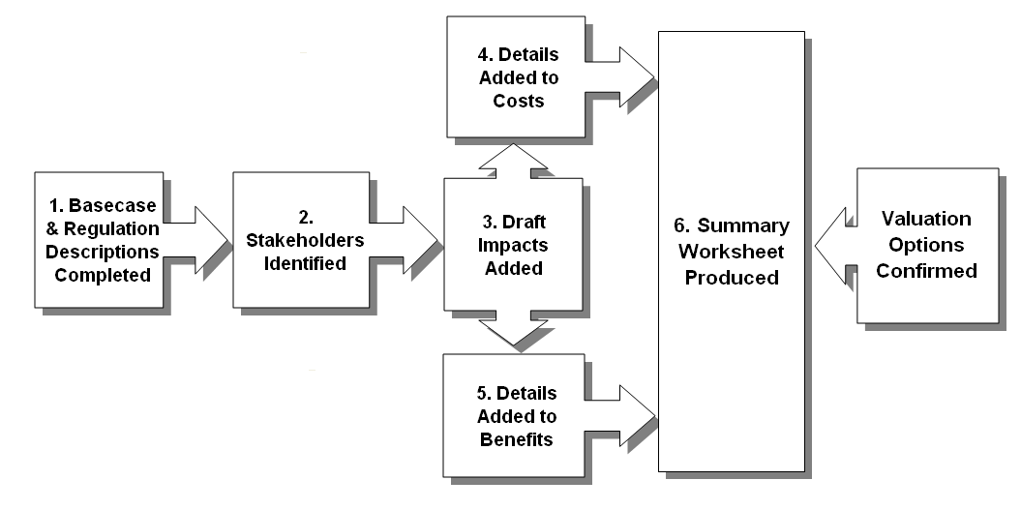
Figure 1: Stages to a CBIS

Stage 1: Baseline & Regulation Description

The CBIS process starts by clearly defining the conditions that will exist if no regulatory action is taken, the baseline. To do this properly requires a clear understanding of the problem the regulation is attempting to rectify (the issue), the underlying causes of the issue, and how these will evolve in the future. The regulation description should then clearly identify what actions are being proposed (regulatory description), and how and to what degree these actions will ameliorate the problem (the regulatory objective).

Stage 2: Stakeholder Identification

In this step each group that will be impacted by the proposed actions are named and described. Having already achieved a clear understanding of the baseline and the proposed regulation leads naturally to the identification of stakeholders. Regulatory requirements indicate the stakeholders that will be directly impacted by the proposal. The objectives of the regulation will usually indicate those that will be impacted secondarily. It is not necessary to go into the details of how they will be impacted as this will be covered in the following steps, the focus in this step is to concentrate on how to meaningfully group stakeholders to facilitate the assessment of impacts.

Stage 3: Draft Impacts

Although identifying stakeholders and impacts is represented linearly in CBIS, they are better thought of as a parallel process. To identify stakeholders requires consideration of impacts and adding impacts can reveal stakeholders. Going back and forth between the two should be taken as a given.

Impacts are initially identified as being either a cost or a benefit, associated with a stakeholder, assigned a relative rank of importance (high, medium, or low), determined as being measured qualitatively, quantitatively, or monetarily, and finally given a brief description.

Stage 4&5: Details Added to Costs & Benefits

After draft impacts have been added, the next step in a CBIS is to dig deeper by considering the information that will be required to assess them. This includes what methodologies will be used and what data. Impacts are often considered individually as if they were independent outcomes. However, keep in mind that in general costs imposed by regulatory requirements are what lead to benefits. So, if you have modelled your impacts in such a way that costs can be reduced with no noticeable consequences on the benefits, then it is likely you have oversimplified or mis-specified your model.

Stage 6: Summary Worksheet

The final stage of the CBIS is also the starting off point for the majority of the rest of the analysis that will go into the CBA. For this reason, the CBIS tool produces a template as a means of providing a roadmap for the results of the work to follow. This template also summarizes the information that has been entered in the previous steps.

Once the data from the analysis has been added to this template all the calculations needed to produce a summary table displaying the discounted present value of monetized costs and benefits will already be completed. The template also allows the user to perform sensitivity analysis around the discount rate. Spaces for summary information on quantitative and qualitative based analysis are also provided.

Valuation Options

Valuation options involves setting some of the key parameters that are used in any cost-benefit analysis. These options are the anticipated start year to assess the regulation from, the expected lifetime, in years, to assess the regulation over, and finally the default discount rate to use when calculating present values.

Using the CBIS Tool

Set up and Software Requirements

Before running the CBIS tool you will need to check security settings on Excel to assure that macros are enabled. As CBIS uses Visual Basic for Application (VBA) coding it will not work in cloud operated versions of Excel or when security settings have been set (or locked by your administrator) to not allow macros to operate.

Entering data in the CBIS tool can be achieved either by directly typing into the spreadsheet or by using customized forms. Forms are opened by pressing on control buttons found on the various tabs of the spreadsheet.

Setting the Regulation Details
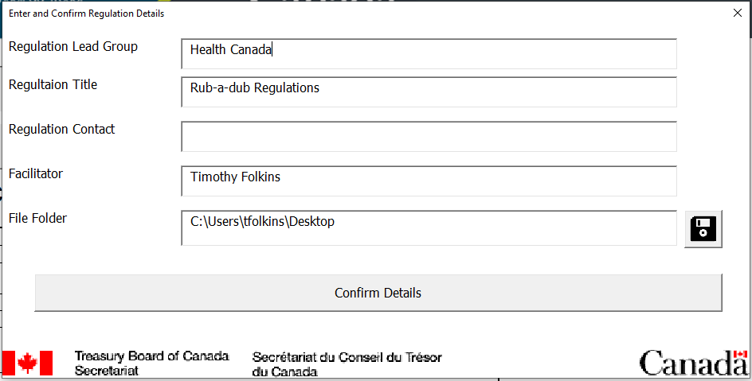
Figure 3: Regulation Details

The first step in using the CBIS tool is to add key identifying information. Not all of the fields are mandatory but at a minimum you should enter the name of the regulation (use the title of the regulation that you find on the triage document when available) and press the “Confirm Details” button to continue.

Setting and Confirming Baseline and Regulation Descriptions

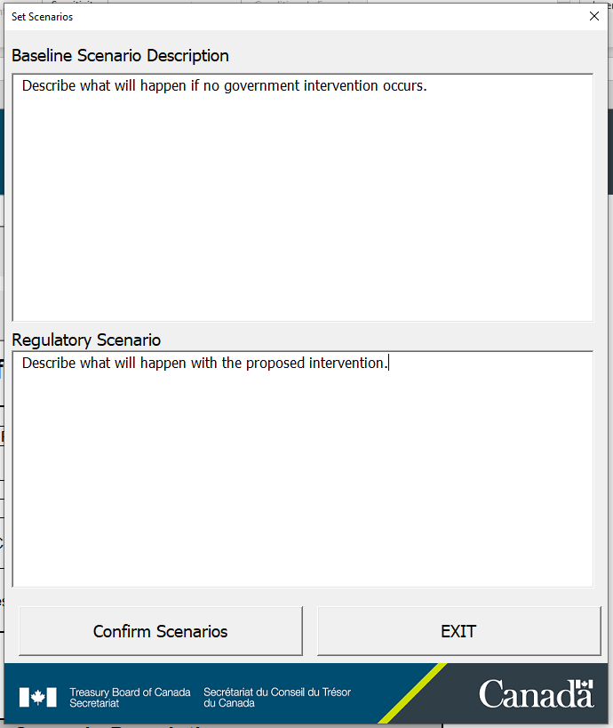
Figure 4: Base-Case and Regulation description

The form for entering the scenarios is shown above. Most of this material should be easily obtained from sources such as the regulations triage statement. Until information is entered and confirmed in the cells provided on the worksheet “1 Regulation Information” (or via the form) it is not possible to move on to identifying stakeholders.

It is very important that all participants in the CBIS fully understand how impacts are to be measured, i.e. every impact is relative to what is expected to occur without the proposed regulation only. Failure to recognize this will often result in unrelated impacts being associated with the regulation and possible mis-categorization of a regulation in the triage (e.g. a medium impact regulation being classified high). Once the information has been entered and all CBIS participants agree that the descriptions are accurate you should press the “Confirm Scenarios” button (see Figure 4) and confirm the information.

Identifying Stakeholders

After the baseline and regulation scenarios have been added and confirmed you are now able to start to add stakeholders. Obviously, stakeholders are added to the stakeholder tab of the CBIS tool. The form, Figure 5, for adding and editing stakeholders can be accessed by pressing the “Editing Stakeholders” button.

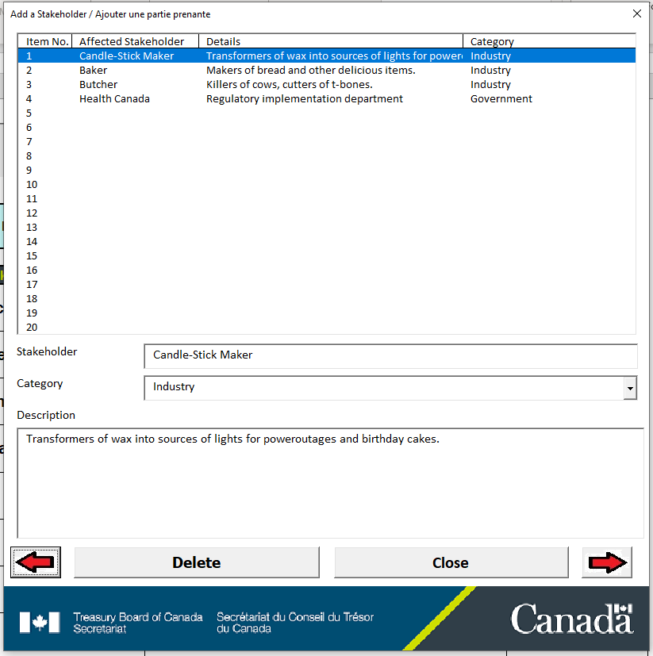

Figure 5: Adding a Stakeholder

In this form you are asked to enter a name for the stakeholder and a short description. After you have added this information you can add another by clicking on an open slot in the list of stakeholders, or you can click on the right arrow to move to the next slot.

After you are satisfied that all the stakeholders have been entered go to the “2 Stakeholders” worksheet of the excel file to see a list of all the stakeholders that have been entered. If everything seems in order use the “Confirm Stakeholders” button to confirm the stakeholders list. Until you confirm the stakeholders you will not be able to continue to the next steps.

Adding Costs
After stakeholders have been confirmed you can now proceed to adding draft costs and benefits.

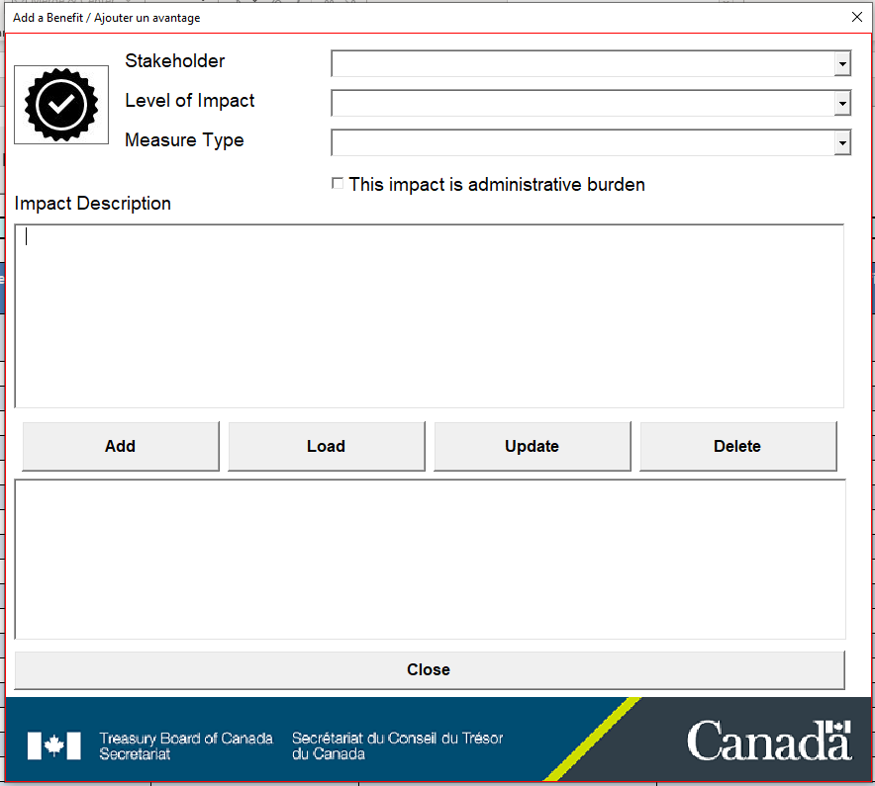
Figure 6: Adding a Costly Impact

The form for adding draft costs can be seen in Figure 6. It is opened after you click the “Edit Draft Cost” button from the toolbar. First you must select the stakeholder being impacted. The list from which a stakeholder is selected was created in the previous step. If while adding impacts you realize you have missed a stakeholder then you will need to go back to the previous step by adding a stakeholder and reconfirming the list.

After you have selected the stakeholder you will need to select the relative importance of the impact (high, medium, low) and the way you anticipate measuring the impact (qualitative, quantitative, monetizable). Finally, you should add a short description of the impact. If you want to edit existing costs, that will appear in the list of costs, click on it, press the load button, then that information will be loaded into the form where it can be edited. Pressing on ‘update’ will replace the information in a selected slot with the information contained in the form.

Adding Benefits

Adding benefits is done in the same manner as adding costs. The form that opens when you press the toolbar button for “Adding Draft Benefits”.

Adding Details
In the last two steps the draft impacts of benefits and costs were added. As with the stakeholders list once you are comfortable that all impacts have been added it will be necessary for you to confirm these impacts as finalized before continuing. To do this move to the “3 Draft Impacts” sheet and press the “Confirm Draft Impacts” button. These impacts will now be assessed according to whether they are costs or benefits and thus after you confirm the draft impacts they will be moved to sheets “5 - Costs Details” and “6 – Benefits Details”.

As described in Section 1.02(d) the next step is to add details to the draft impacts. Once these details have been added they must also be confirmed in the same manner as the draft impacts (by pressing the “Confirm Costs/Benefits” button) on sheets “5 - Costs Details” and “6 – Benefits Details”. Details added should now be associated with a more complete description of the impacts, sources of data, and possible methodologies to assess (under “additional information”). These details can be added by using the form shown below (the form appears and operates similarly for both benefits and costs). Clicking on an item in the impact list will load it into the form and allow any edits

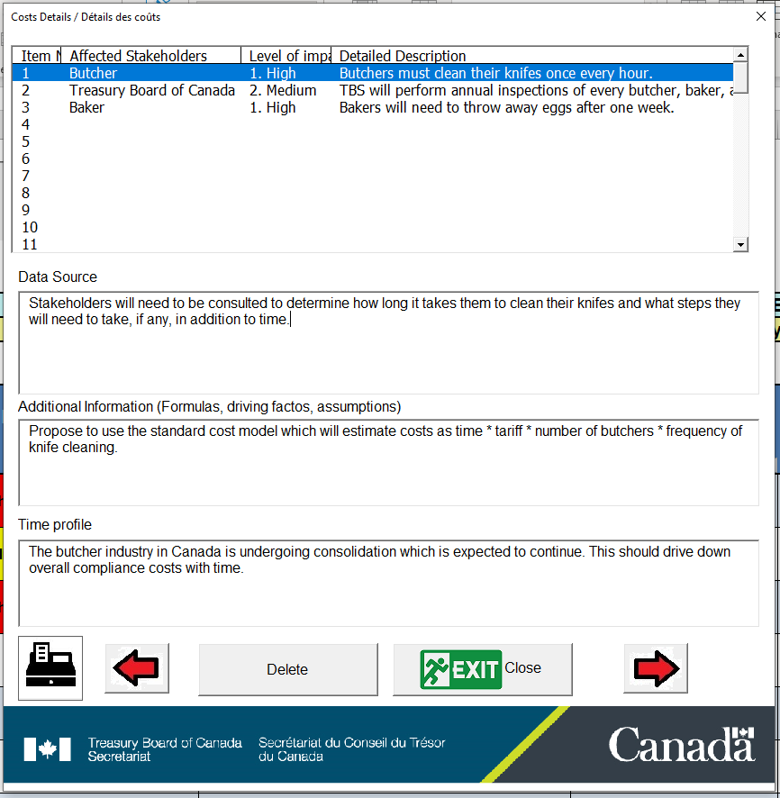

Valuation Options
If you have made it this far then you are only a few steps away from completing the CBIS. However, before the CBIS tool will allow you to create a valuation worksheet you must first verify a few details. To do this, press the “Options” button in the regulatory information tab. This will cause the form shown in Figure 8 to appear.

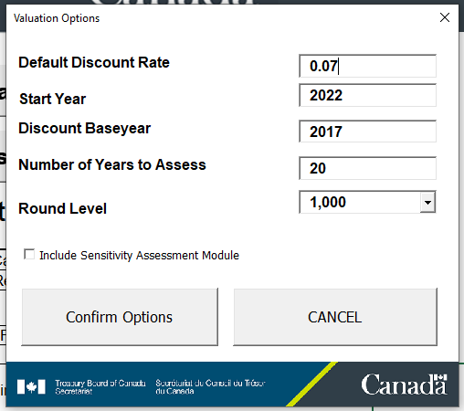
Figure 8: Setting the Valuation Options

The first options you will notice is to set the default discount rate that will be used to calculate the present values of monetizable costs and benefits. You can change these if you want either directly here or in the worksheet once it is produced..

Next, you will have the option of selecting the start year of the regulation and how many years you want to assess the regulation over. In theory you should assess the regulation over as long a period as it is anticipated the regulation will have impacts, but in reality due to the discount rate and uncertainties it may not be necessary to go much beyond 20 years (or less).

Once you press the “Confirm Options” button and all the other previous steps have been completed you should be ready to produce the valuation worksheet.

Valuation Worksheet
As discussed in Section 1.02(e) the valuation worksheet is meant to be a template for all of the follow-up analysis to the CBIS for the CBA. Figure 9 shows an example CBA Summary table that could be produced using this template. This summary table is loosely related to some impacts which may be expected from a clean-air regulation, however, the numbers are completely fictional.

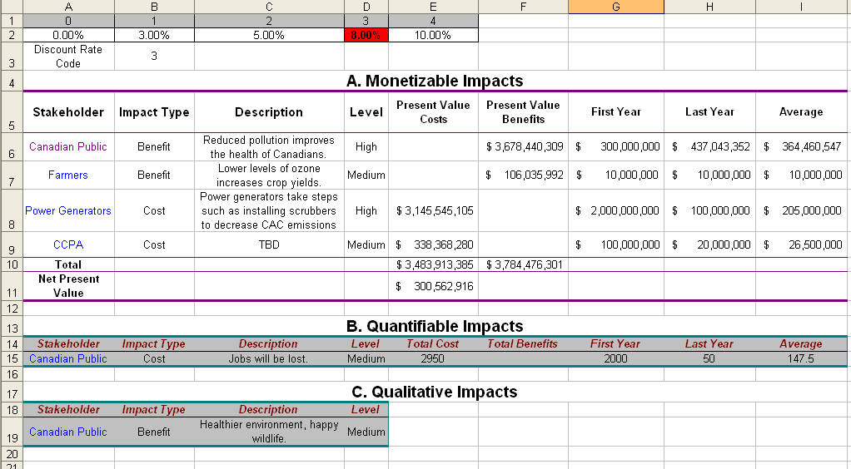
Hyperlink to worksheet.
Figure 9: CBA Summary Table

You will note that the summary table is broken down into three sections. Section A is for monetized impacts, section B for quantified impacts, and section C for qualitative impacts. As the summary sheet mostly has references to information on other sheets and predetermined formulas there is no need to actual input information here. The one exception to this is the “Discount Rate Code” which is entered in cell “B3”. The discount rate code is a number from 0 to 4 which corresponds to the discount rates listed in the table above it. These are the discount rates which were entered during the “Valuation Options” step (with the additional option of a zero discount rate). Simply changing the discount code here will allow you to do a quick sensitivity analysis around the discount rate.

Under each section, in addition to the summary information listed, items are linked to worksheets where results on valuation of benefits and costs can be entered (Figure 10).

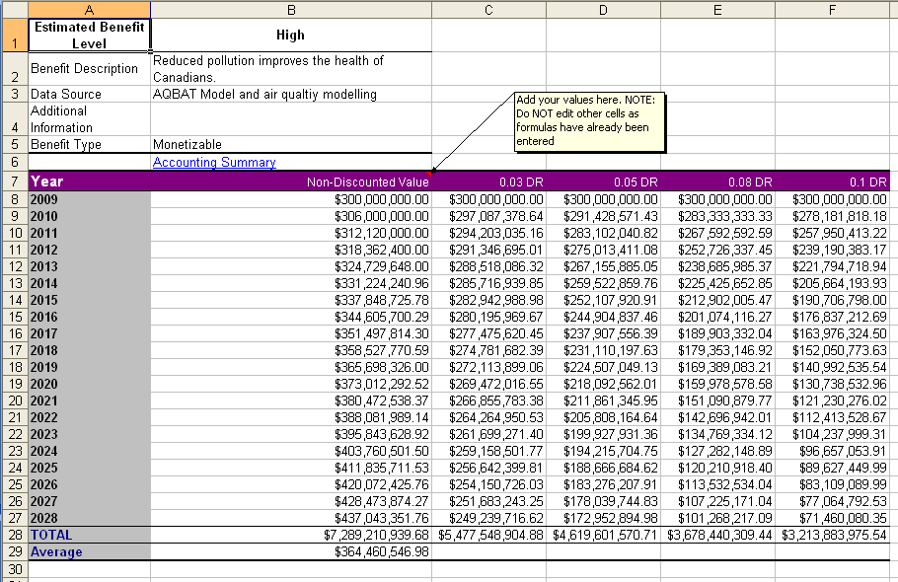
Figure 10: Impact Worksheet

The methodologies and collection of information from data sources used to fill in the information in these sheets will constitute the majority of the analysis for the CBA. This may take a considerable amount of time and effort to properly assess. The effort required to do this should not be underestimated. While the valuation summary worksheet provides a convenient way to put all of the CBA pieces together most of the heavy lifting will need to be done separately.

Showing Progress / Validation Checks
As has been mentioned the CBIS tool performs several validation checks that require the user to confirm various steps as complete before the tool will allow the user to continue on to next steps. At any time it is possible to view which stages have been completed and what stages remain by selecting the “Show Progress” button from the toolbar. When this button is pressed the worksheet “7 – Progress Summary” will appear as shown in Figure 11.
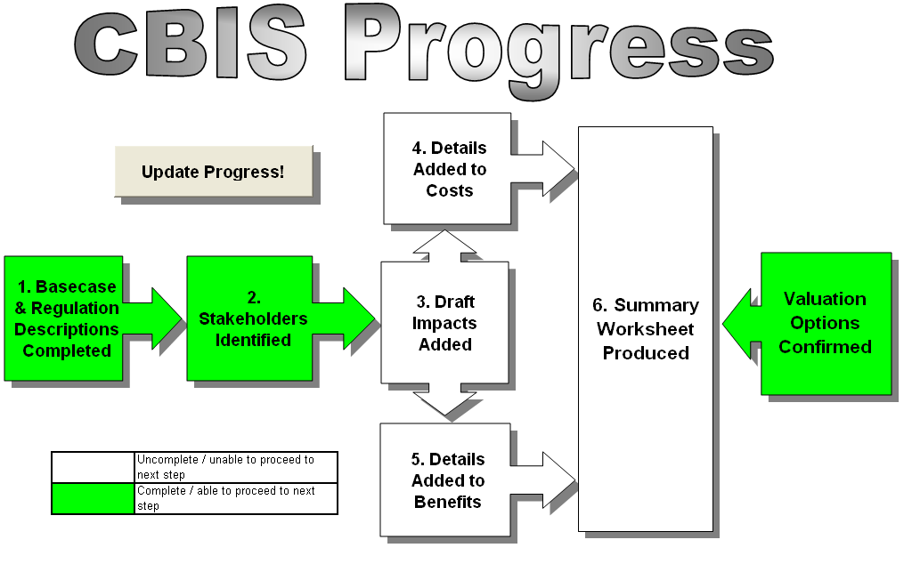
Figure 11: Viewing Progress

When a step is complete it will be marked with a green background. In this particular example the user has entered and confirmed the Basecase & Regulation descriptions, the stakeholders, and the valuation options. However, before the user can complete the CBIS and produce a valuation worksheet, they must now enter and confirm the draft impacts, move these impacts and then add details to the costs and benefits and confirm these details.

Saving Sessions
While you can save information added to the CBIS tool simply by saving it as you would any other Excel file you can also make use of the “Save Session” button in the toolbar.

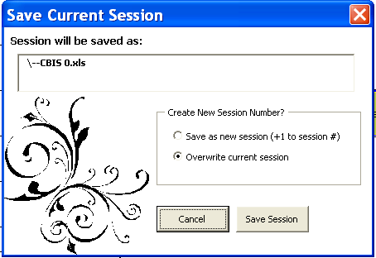
Figure 12: Saving a Session
The advantage of using this option over just saving it through Excel is that it enforces a common naming convention and tracks information related to the progress you have made in completing the CBIS. The first time you use the “Save Session” button the file will be saved automatically using the naming convention “DEPARTMENT-REGNAME SESSION 0”. The department and regulation name will be based on the information you first entered when you opened the CBIS tool, the 0 represents the session number, and this session number will be incremented in subsequent saves after the first one. Subsequent uses of the “Save Session” button will cause the form shown in Figure 12 to appear.
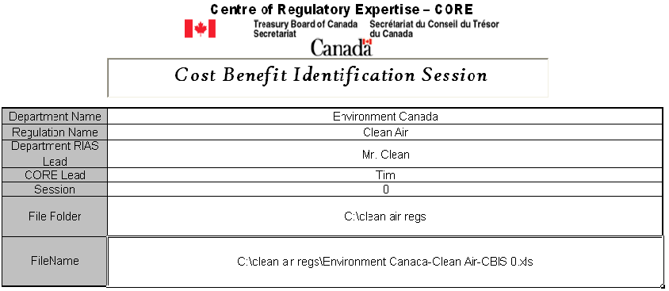
Figure 13: Setting the File Folder

Before using the “Save Session” button you will also need to set the file folder you wish to have the file saved. This information is entered in “File Folder” field on the worksheet “1 Regulation Information” as shown in Figure 13.

Resetting The CBIS Tool (OOPS!)
You may have already have noticed another button on the worksheet “1 Regulation Information”, the “OOPS” button (Figure 14). This button will clear all the details entered into the CBIS tool. The only reason why you would really want to use this button is if you have finished and saved the CBIS for the current regulation you are working on and wish to start on a new one, or if you have made so many mistakes in the current CBIS that it is easier to start over fresh.

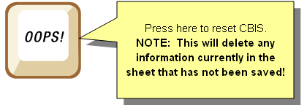
Figure 14: Resetting the CBIS Tool

Be very careful when using this button, while a confirmation dialog box will pop-up before action is taken once this has been approved there is no way to undo the deletions unless you have saved a back-up.

