GC Collaboration Microsoft Teams
Install Guide for PC

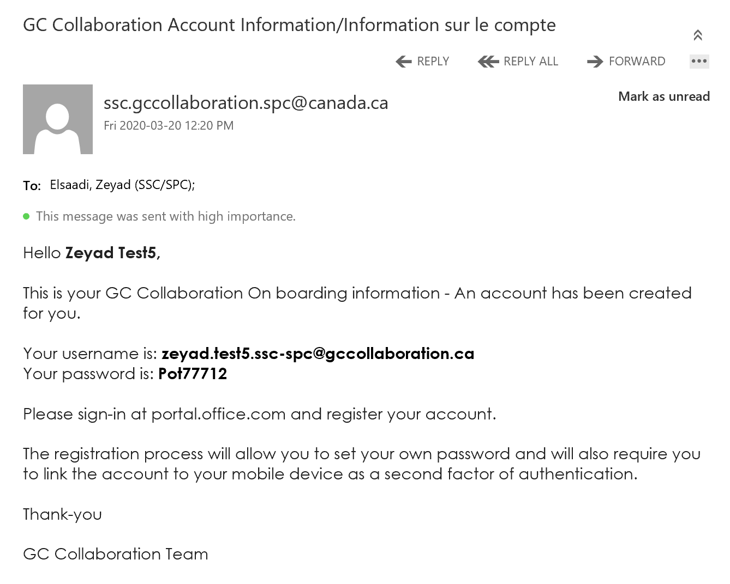

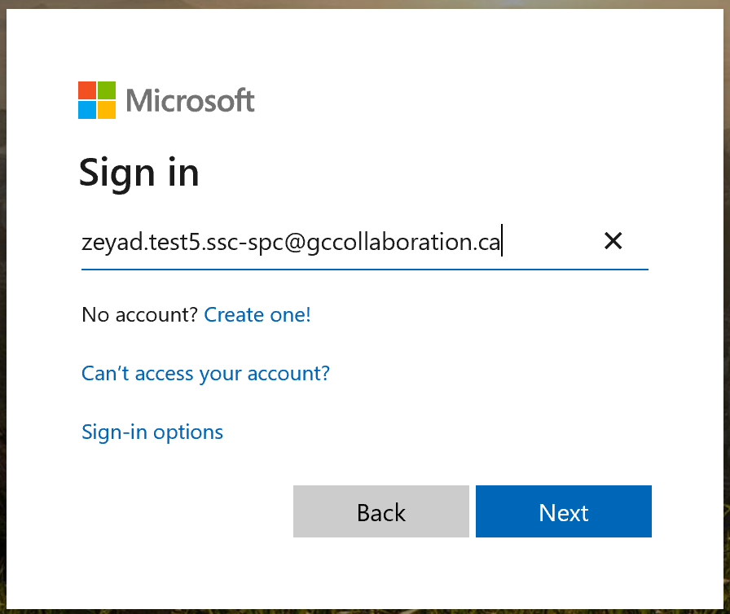

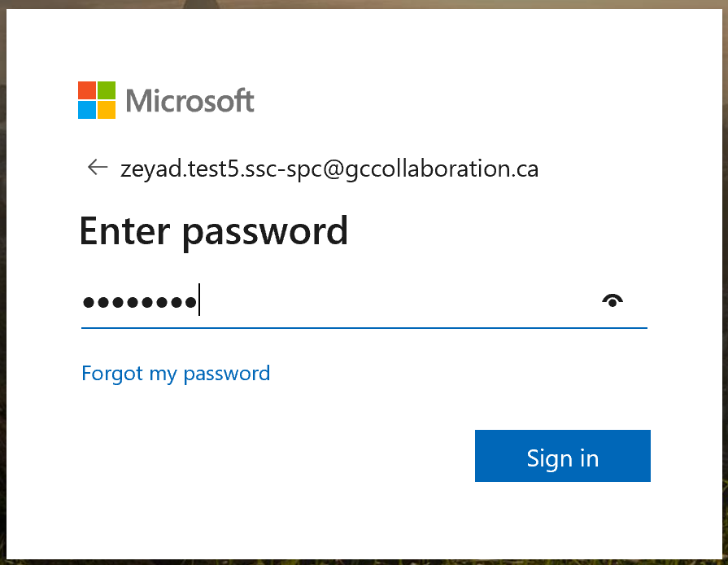

Step 1 – Email Receipt
- You will receive a Teams onboarding email from ssc.gccollaboration.spc@canada.ca with a username and password included. This username and password will be used to sign in to Teams.
- To register your Teams account, go to portal.office.com.

Step 2 – Sign In
- Enter the username provided in your onboarding email (Step 1)
- Click Next

- Enter the password provided in your onboarding email (Step 1)
- Click Sign in

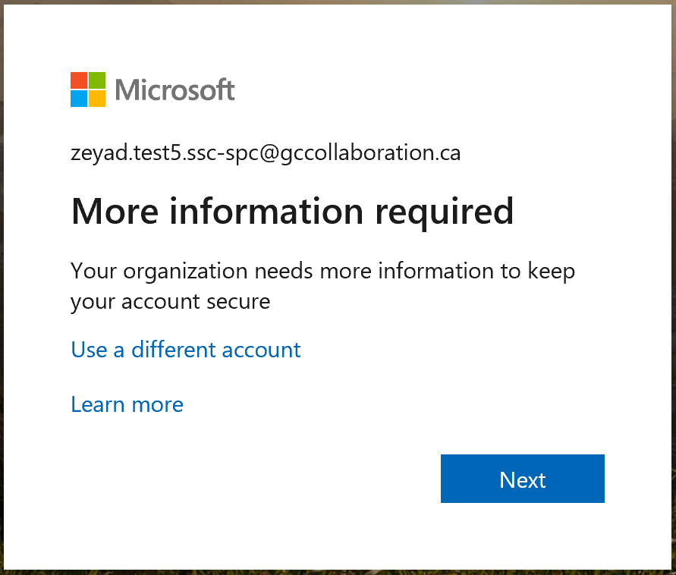
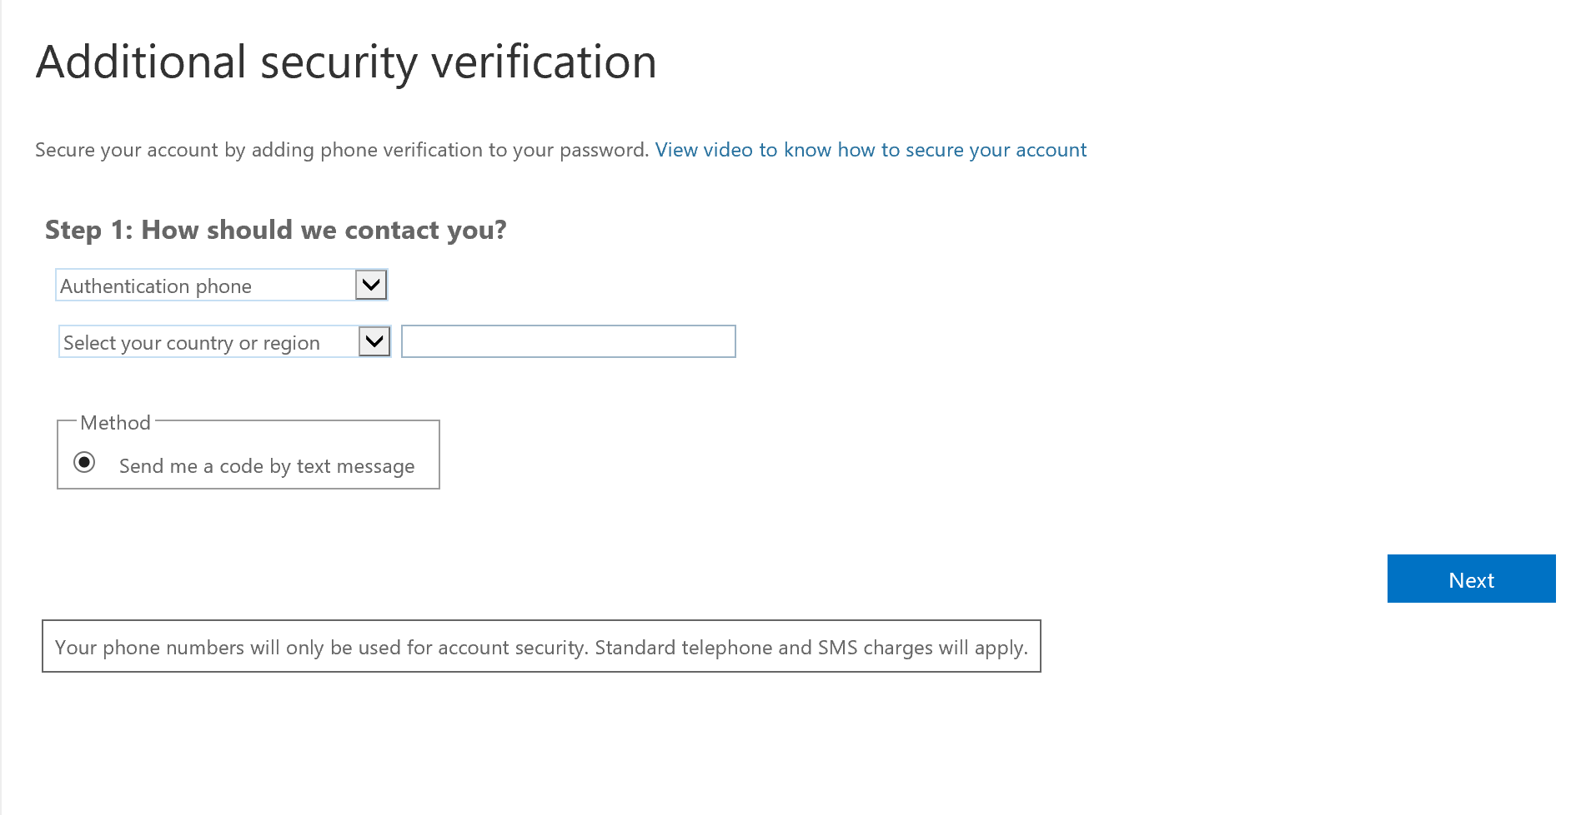
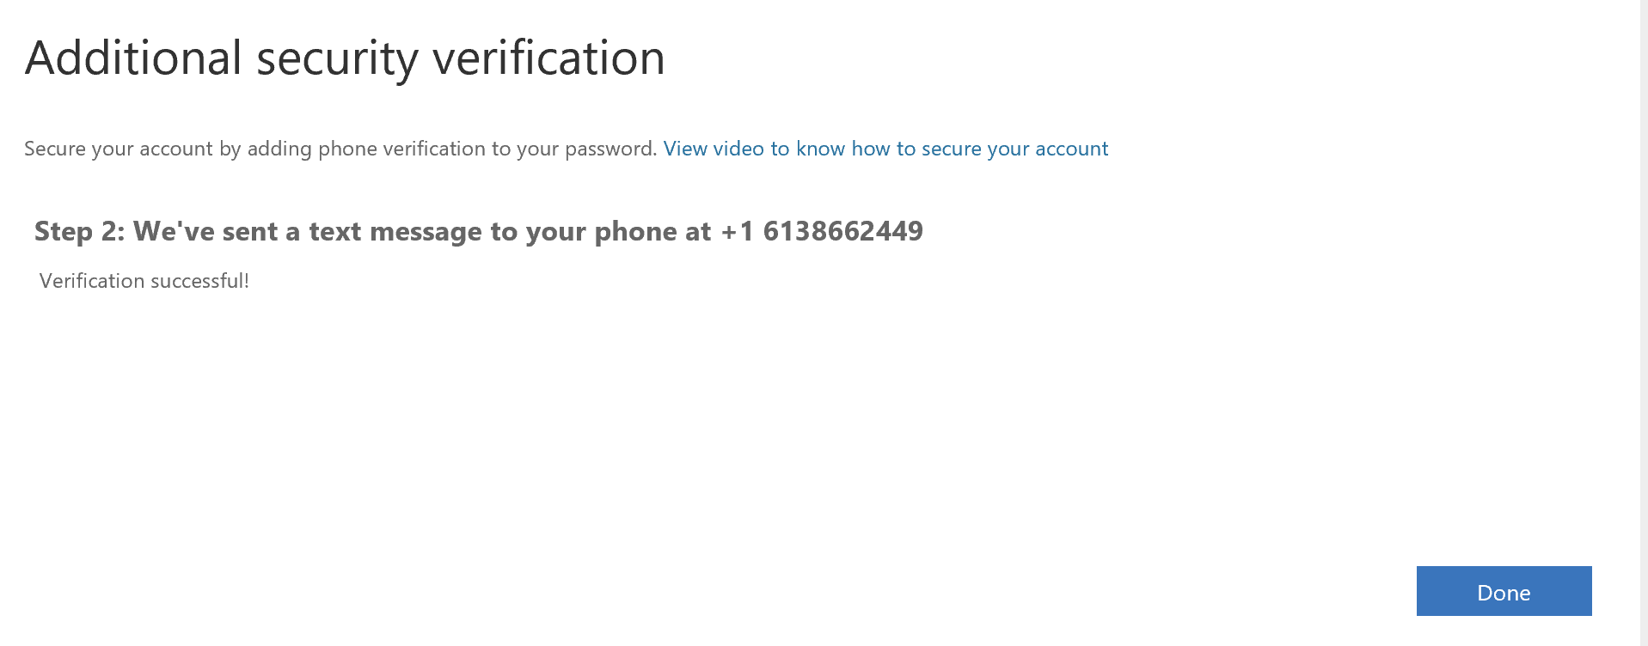
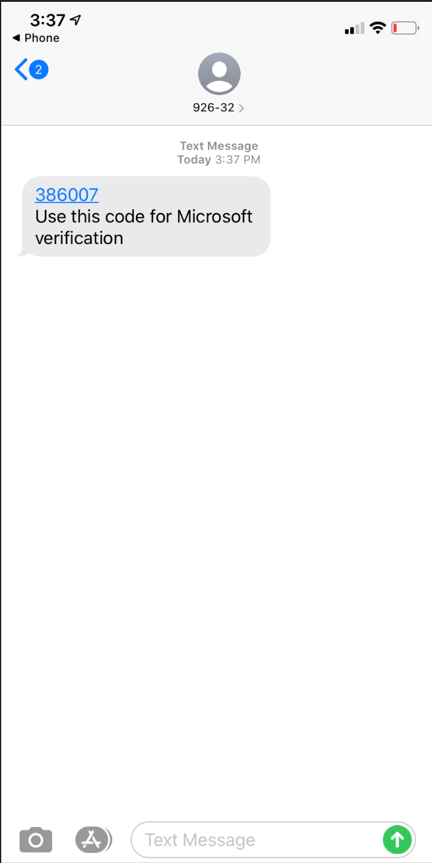
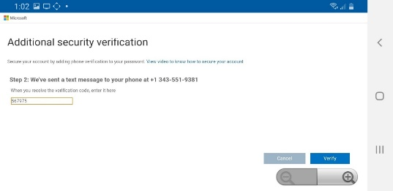
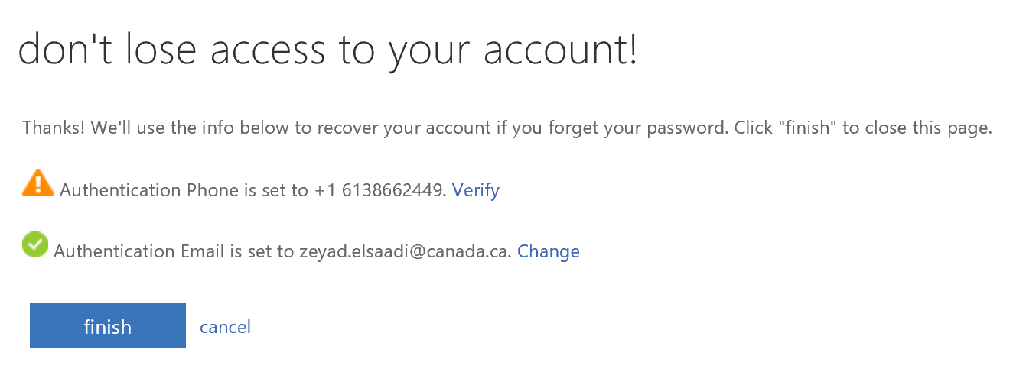
Step 3 – Additional security verification
- You will now be directed to a page that says “More Information required”
- Click Next

Step A: How should we contact you?
  - Select your Country/Region
  - Enter your mobile phone number in the field to the right of the country/region selection (area code and 7-digit phone number with no spaces, e.g. 6135555555)
  - Click Next.
Step B: Text Message
  - You will receive a text message on the mobile device phone number that you used above with a six (6) digit code
  - Type in the code you received in your text message and click Verify.

- You will receive a message confirming your phone number and email address. This is in case you need to recover your account at some point
- You need to verify your phone number
- You can also change the email address if you prefer to receive account recovery information at a different email address than the one you use for Teams.
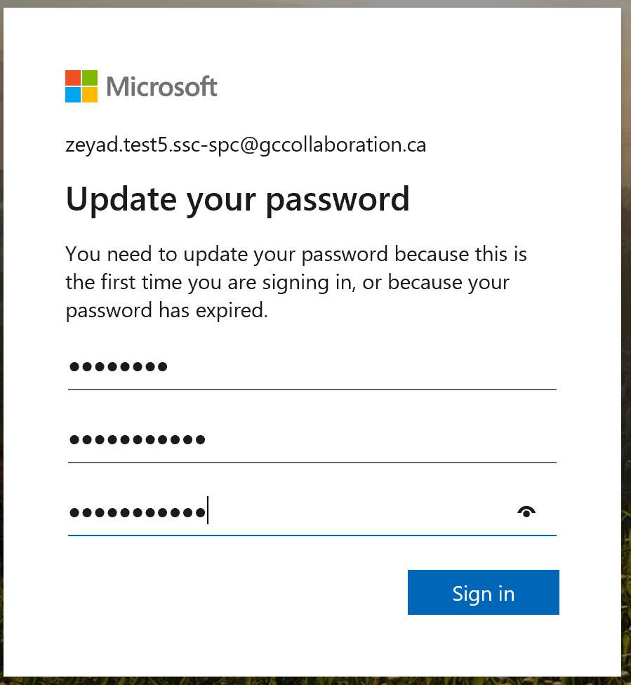
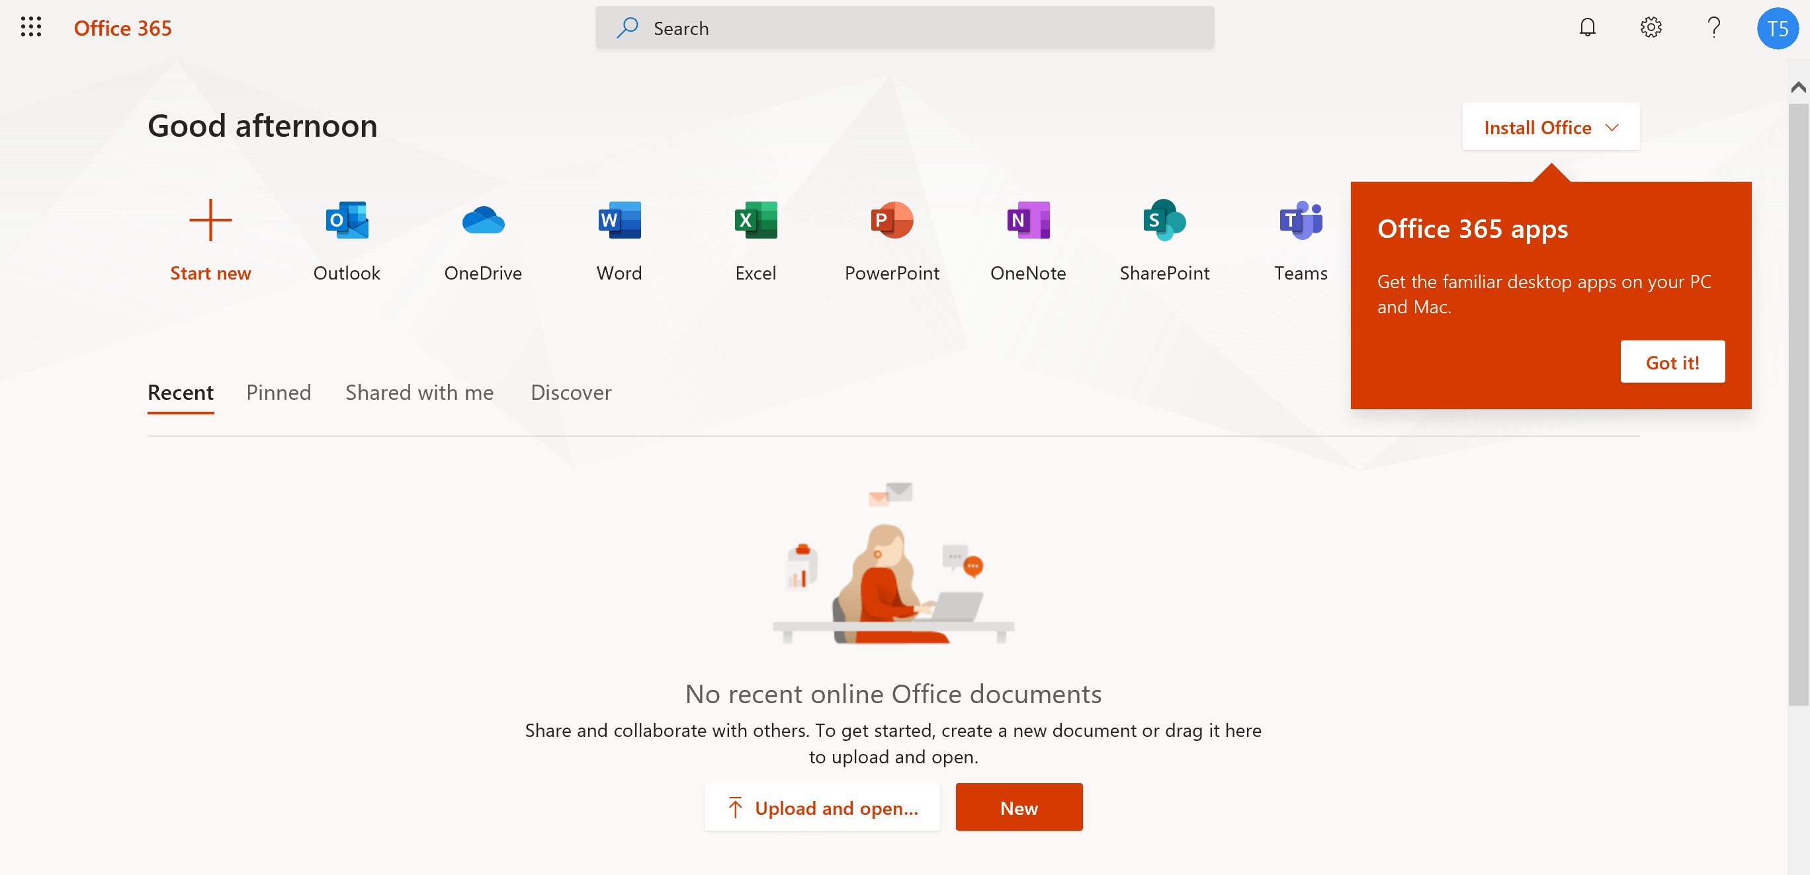
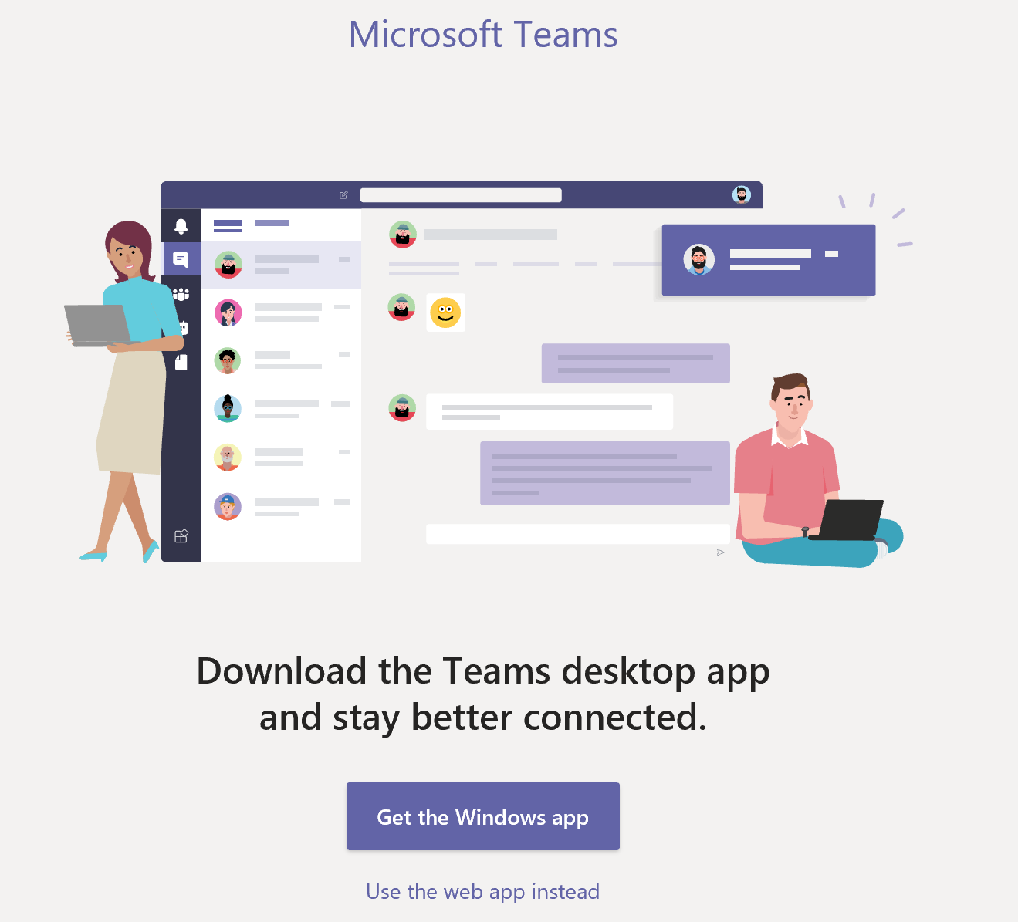

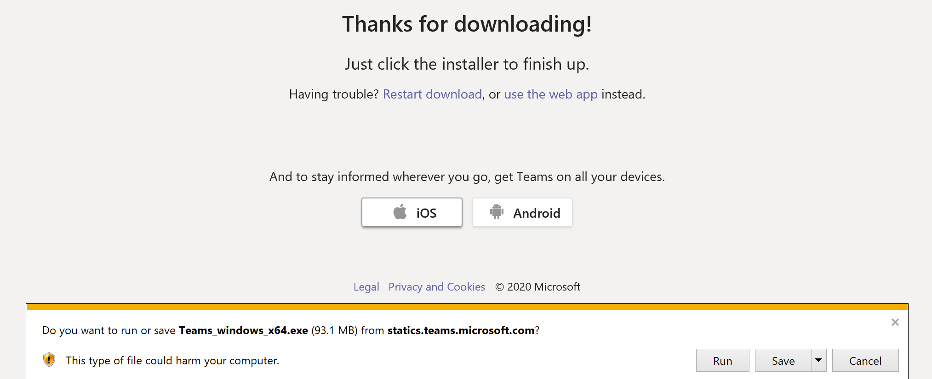

Step 4 – Update your password

- You now need to update your password
- Type in your Current Password and then type in your New Password. Click Sign In.

Step 5 – Download Teams
NOTE: Before installing, make sure you find the correct app on the webpage.
To install, click on the Teams icon

On the Download screen, click the Get the Windows App button.
NOTE: If your download fails, try a different browser, such as Google Chrome or Microsoft Edge.

After downloading, click the Run button to finish the installation.

Step 6 – Sign in to Teams
- Launch the Teams app. You should get a sign-in page
- Sign in with the @gccollaboration.ca username and updated password.

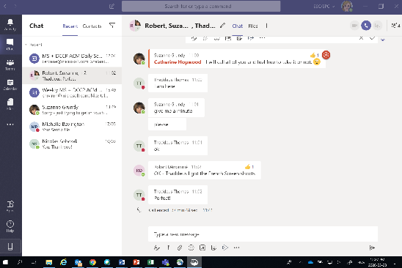
1 - Chat

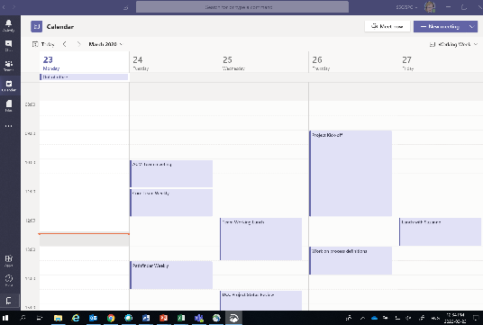
2 - Calendar

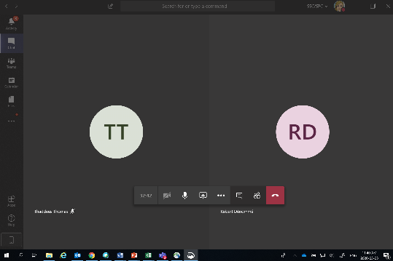
3 - Calls

Using Teams
You are now ready to use Teams.
NOTE: Most Teams functions are currently disabled. You are limited to collaborating in a group chat, video conference or audio conference meeting.
Use the menu items at the bottom of your home screen to choose what you want to do – Chat, Calendar, Calls.
Here’s some useful information on how to use Microsoft Teams on a Windows or Mac personal computer:
https://support.office.com/en-us/article/microsoft-teams-video-training-4f108e54-240b-4351-8084-b1089f0d21d7

NOTE: Some of the features shown in the training material may not be the same or available on mobile devices. We recommend you follow the training above even if you plan to use Teams on a mobile device only.

Chat
Chat is similar to Skype For Business. You can create a single chat or group chats by pressing the pen (compose) icon on the top right
Calendar
You can schedule a meeting by accessing your calendar and pressing the calendar icon on the top right to set the date and invite participants. Participants will be sent an invitation through email with a link to launch video / audio conferencing.
Calls
You can call a co-worker by going on the call tab and searching the person you want to reach.

