How to Update Section A in the PSPM Application
- Log in to the TBS Applications Portal (TAP).
- Select the application myEmployees on the top right.
- Select the tab My employees.
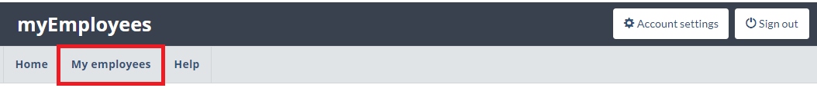
- Select the employee in your list of employees.
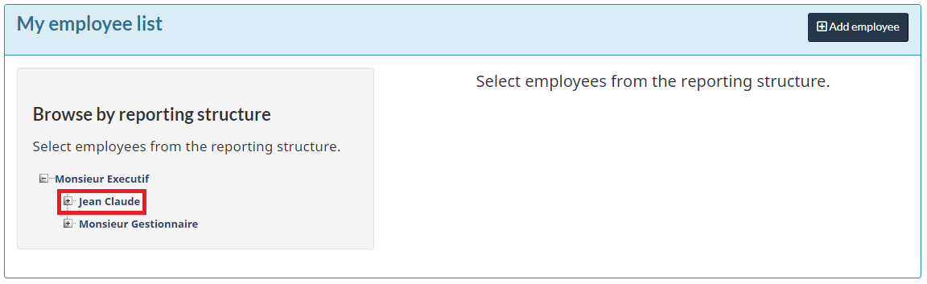
- Click on the button Update.
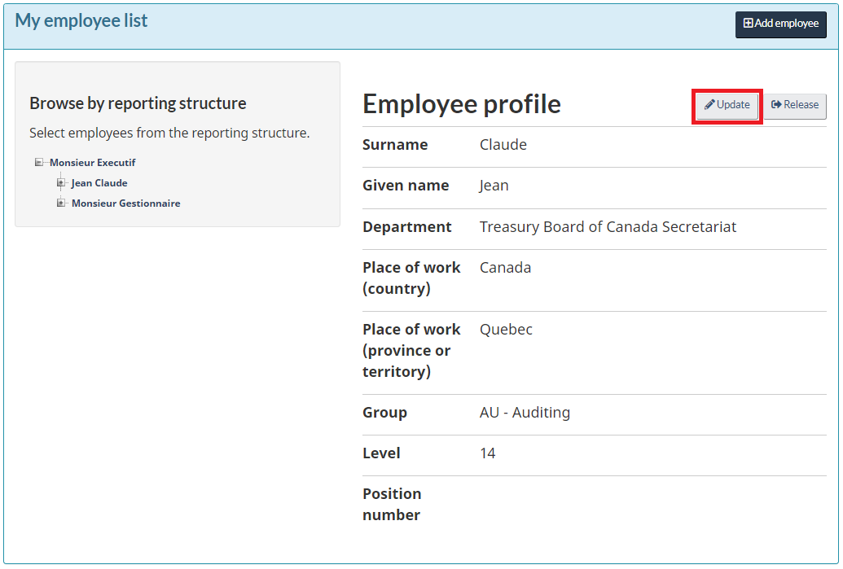
- Modify the employee’s profile as required such as their place of work, group, level and position number then click on the button Save.
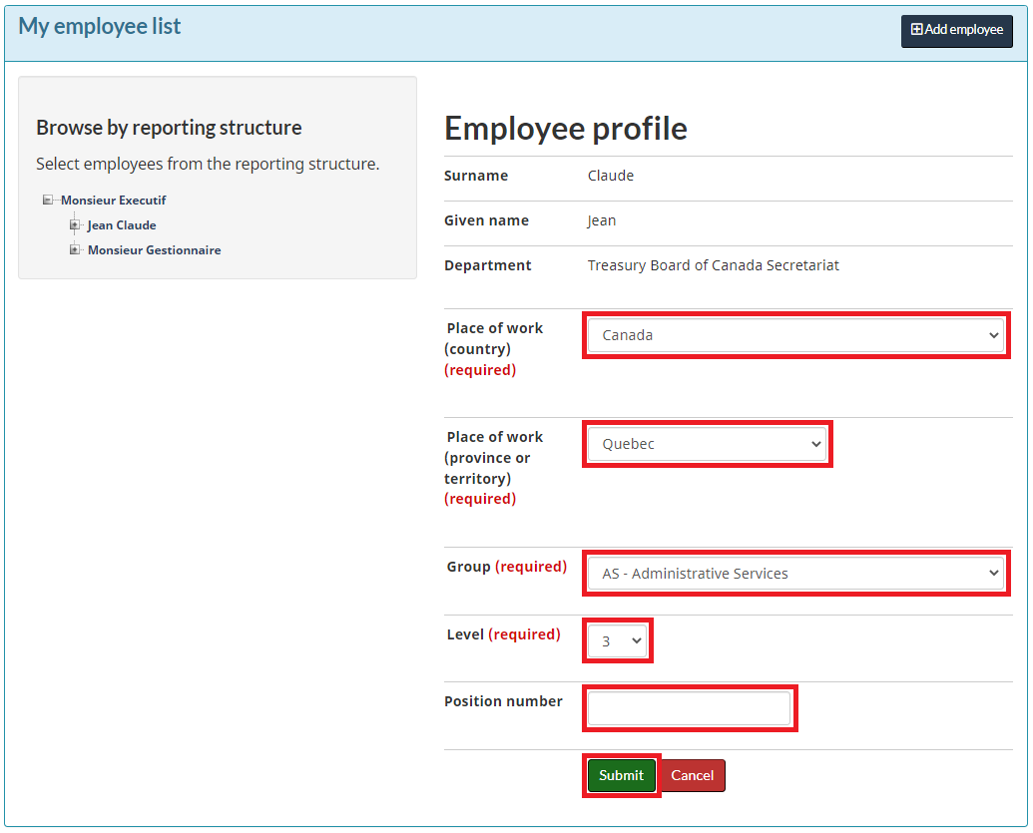
- Return on the TBS Applications Portal (TAP) and select the PSPM application.
- Click on the tab My Employee Performance Agreements.
- Select the employee in your list of employees and select the period “in progress.”
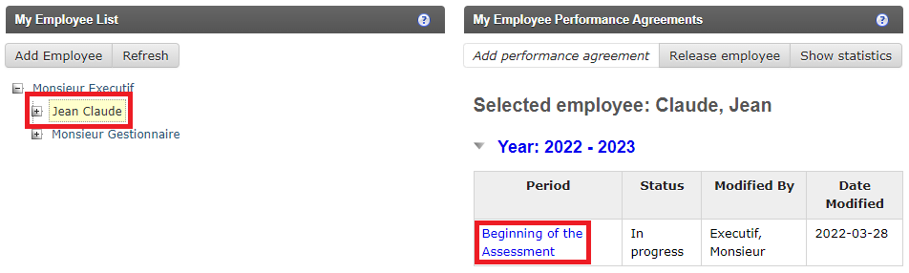
- On the disclaimer and privacy notices page, click on the button Continue.
- Click on the link Section A: Personal Information.
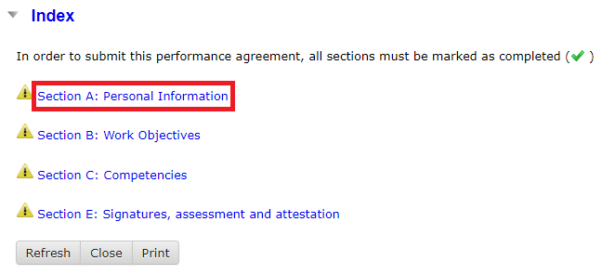
- Under the subsection Employee Information click on the button Update Employee Information.
