Activity-based working (ABW) VIRTUAL WORKSHOP IN-A-BOX
  - Facilitator Guide

  - THE WORKSHOP
Audience  Future end users of the new modernized ABW environment. Preferably from the same team or function | Objective  For participants to develop new ways of working, by:  - understanding GCworkplace;  - understanding what is an activity-based workplace;  - understanding activity-based working.

Duration
1.45 h

Recommended number of participants
20 participants (maximum)

When should you facilitate this workshop?
- Once an ABW project has been approved and announced;
- When employees have been informed that they are moving to an ABW environment

1  PICK A DATE | - Work with the project team to determine the best date to host this workshop. Multiple sessions might be required depending on the size of the group.
2  SETUP OF VIRTUAL SESSION | - Verify if you have access to a sharing application (e.g. Slido, Miro, etc.), and get familiar with it.  - Refer to your department’s instructions on how to use their preferred tool/platform (e.g. MS Teams, Zoom).  - Identify a colleague who will act as the moderator and will assist you with questions and comments from the participants, if need be.
3  PREPARE THE MATERIAL | - Excel worksheet (participants)  - Personalize the drop-down menu options of Tasks and Workpoints in the “Data(hidden)” tab to represent the type of activities the participants perform and the type of workpoints that will be available to them in their future workplace.  - NOTE: The data tab is hidden; if you are making adjustments to the data, you will need to unhide the tab and then hide it again before sending it out.  - Personalize the information available in the “Types of workpoints” tab to represent the type of workpoints that will be available to the participants in their future workplace.  - Excel worksheet (facilitator)  - Read the “Instructions” tab, in order to have an idea of what you will have to do AFTER the session.  - NOTE: If you made any adjustments to the data in the participants worksheet you will need to do the same adjustments in the facilitator worksheet.  - PowerPoint Presentation  - Slide 13: Download the video in advance so no lagging occurs, and delete the links that are not relevant.
4  SEND THE INVITATION | - Work with the project sponsor or champion to send the invitation out to employees (see Annex A).  - Make sure the pre-work requirement is included in the invitation; participants must have access to a typical 5-day work schedule or their electronic calendar, and have access to Excel to fill out the worksheet during the workshop.  - Send the invitation at least 7-10 days before the workshop.
5  REVIEW THE PRESENTATION AND THIS GUIDE | - Read and review the PowerPoint Presentation prior to the workshop.  - Read this guide in parallel to the PPT to see which modifications are required.  - Complete a “dry-run” to familiarize yourself with the rhythm of the presentation and when you will need to click for animations.  - For this guide, note that the normal text is meant to be the facilitator text, just like a script. We’ve also included notes to the facilitator in blue italics, additional information in light grey, and highlighted red text which requires to be modified by the facilitator.
6  SEND REMINDER | - Send out a simple email reminder two days before the workshop reminding participants to have access to a typical 5-day work schedule or their electronic calendar, and have access to Excel to fill out the worksheet during the workshop.
7  DAY OF THE WORKSHOP | About 15 minutes before the start of the workshop:  - Display the presentation on the screen.  - Have the sharing application open.  - Have the video on Slide 13 already downloaded in the background, with the sound on, and ready to be viewed.  - Have your facilitator guide open on another screen, for easy access.  - Set up a OneNote page for questions and comments from participants.
9  AFTER THE WORKSHOP | - Excel worksheet (facilitator)  - Read and follow the information on the “Instructions” tab.  - Send an email (see Annex B) to the participants with the “Summary Score Card” information attached in a PDF document.  - You may also ask them to complete the short Workshop Evaluation Form, if you wish.

FACILITATOR GUIDE
Slide | Slide title | Time (min.) | How to? | Comments
 | Activity-based working (ABW) workshop | 2 | Introduce the context of your project and why you are facilitating this workshop. You can also give information on the date of the move, who to contact to obtain information, introduce the project team, the change manager, etc.
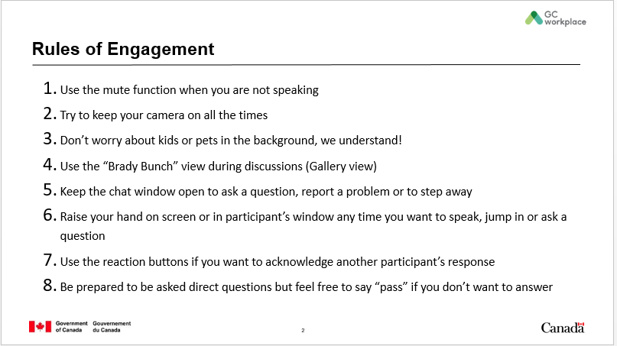 | Rules of Engagement | 2 | In order for today’s session to go smoothly, here are a few tips and rules of engagement.  - Please use the mute function if you are not talking and try to keep your camera on at all times. The reason we ask you to keep your camera on is that body language is almost as important as words. In an in-person session, we see head nods, smiles, etc. that we don’t have on virtual sessions without the camera.  - We understand we may see kids, spouses or pets in the background and we fully understand!  - If you want, use the “Brady Bunch” or Gallery view during discussions. That will allow you to see many people at once on your screen.  - Also try to keep the chat window open. You will be able to use that function to ask a question, report a problem or let us know you are stepping away for a few minutes. My colleague [insert name] will be acting as the moderator today and will be there to answer your questions or be your voice as needed.  - Whenever you want to talk, jump in, or ask a question, raise your hand at the camera or use the raised hand function in the participant’s window. You can also use the reaction buttons (thumbs up or down) to acknowledge another participant’s response.  - Be prepared to be asked direct questions but feel free to say pass if you don’t want to answer. Also, if for any reason you prefer to send your comments via the chat option, don’t hesitate to do so.  - Finally, remember to have fun!
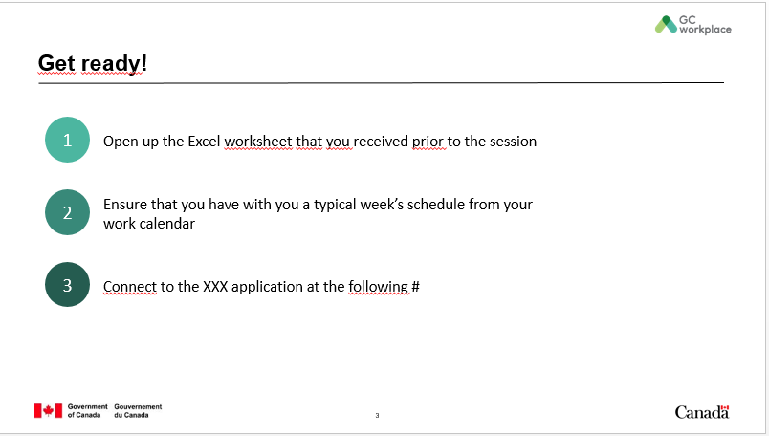 | Get ready! | 1 | Now let’s get ready!  - First, open up the Excel worksheet that you received prior to the workshop.  - Second, ensure that you have with you a typical week’s schedule from your work calendar or simply open your electronic calendar to view a typical work week.  - And lastly, connect to the [insert name of the application] application at the following # [insert the hashtag].  Now we are ready. | *This slide and content can be edited depending on what is available to the department*  If you don’t have access to a sharing application like Slido, simply delete the 3rd bullet.
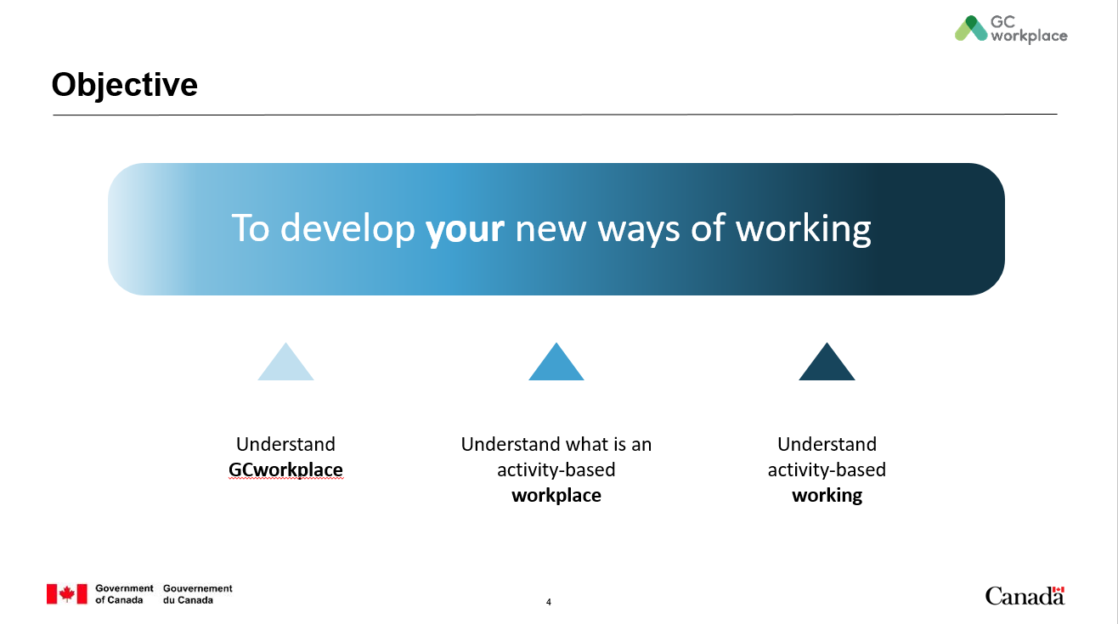 | Objective | 1 | The objective of today’s virtual workshop is ultimately to develop your new ways of working for your new workplace. To do so, you first need to understand GCworkplace, understand what an activity-based workplace is and understand activity-based working. We will cover all these topics throughout the workshop while doing exercises to help you choose where to work.
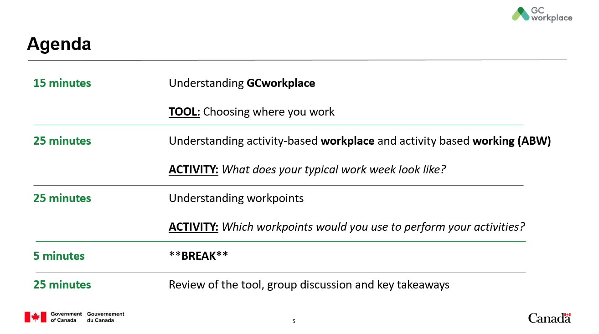 | Agenda | 2 | This is how the workshop has been laid out:  First, we will review and understand what is GCworkplace.  Then, we will have a look at a decision tree tool that was developed to help you chose where to work.  We will continue to learn about activity-based workplace and activity-based working by starting with our first activity: What does your typical work week look like?  Then, we will cover the topic of workpoints and complete the final activity: Which workpoints would you use to perform your activities?  Finally, we’ll take a quick break to come back to our tool, a group discussion and our key takeaways.  Now let’s start with GCworkplace.
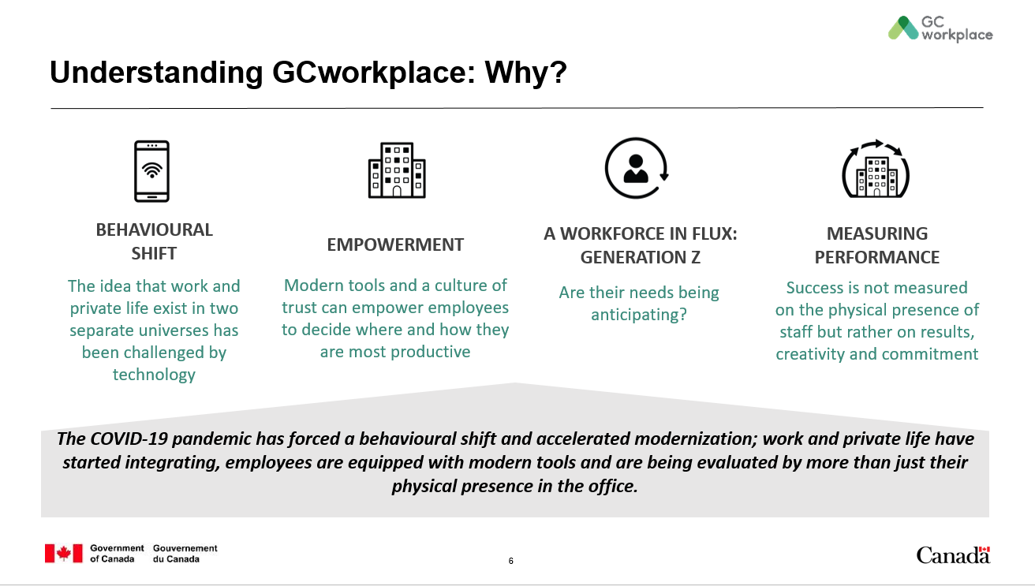 | Understanding GCworkplace: Why? | 3 | To understand what the GCworkplace vision is all about, it’s important to know WHY it exists and the context in which it was created. When we take a look at the federal government office landscape, I think we can all agree that it has been changing, it is still changing, and it will keep on changing.  A behavioural shift is happening. The world around us is changing: Citizens are connected 24/7, their expectations are high and they want services in real-time. The idea that work and private life exist in two separate universes has been challenged by technology.  There are a lot of discussions around empowerment lately. With the right tools and their organization’s support, employees can be empowered to decide where and how they want to work to be as productive as they can be. The workplace can be tailored to the needs of employees, not the other way around.  Generation Z is made of people who were practically born with a cell phone in their hands, they are competitive and are known to constantly seek new ideas and experiences. The Government of Canada needs to be able to attract and retain the new generations of workers as well as the experienced professionals who have come up through the ranks. In order to do this, their needs must be anticipated.  Are we measuring performance the right way? Managing by results and deliverables instead of by physical presence. Success should no longer be measured on the physical presence of employees but rather on results, creativity and commitment.  How can the Government of Canada keep up to stay relevant?  The COVID-19 pandemic has forced a behavioural shift and accelerated modernization; work and private life have started integrating, employees are equipped with modern tools and are being evaluated by more than just their physical presence in the office. Our future workplace needs to reflect, accommodate and support the diversity of our people and their contributions.
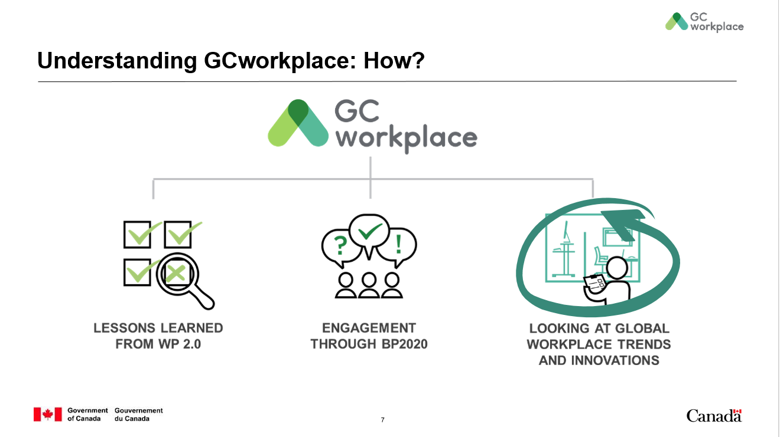 | Understanding GCworkplace: How? | 2 | In order to develop and refine a vision for a MODERN WORKPLACE for the GC, three main elements were considered:  First, lessons learned from past initiatives (i.e. Workplace 2.0)  - Key observations from WP2.0 sought to solve employee needs for quiet spaces, privacy, and concentration spaces.  - From what was learned through the delivery of the first activity-based workplace pilot projects.  Second, alignment to the BP2020 vision: In 2013, the Clerk of the Privy Council, in collaboration with public servants across the country, established a vision for public service renewal called Blueprint2020 in which one of the four key priorities was a MODERN WORKPLACE. The GCworkplace vision is, in part, the result of what was collectively heard through the BP2020 consultations and engagement sessions.  And third, global trends: it was based on global trends at the time, [CLICK TO ANIMATE SLIDE], and the vision is constantly evolving to stay relevant in this climate of change.
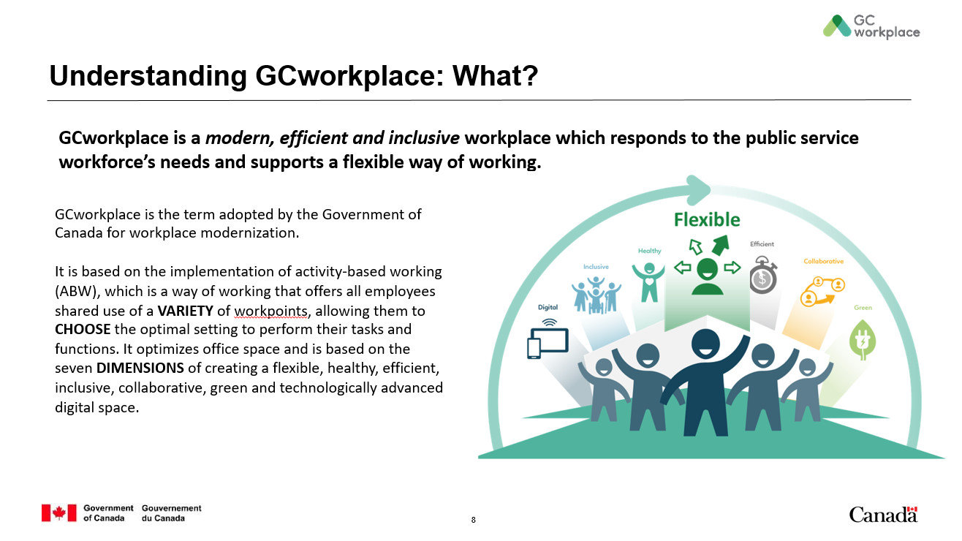 | Understanding GCworkplace: What? | 3 | When we think of a modern workplace, we think GCworkplace. But what IS GCworkplace?  Read the slide.  Through consultations, over 1,300 employees were surveyed from across Canada, and they ranked “flexibility" as the most important workplace dimension. [CLICK TO ANIMATE SLIDE]  Additional info, if required:  Strategic advantages of GCworkplace  - Recruit and retain talent with cutting-edge policies on workplace  - Offer modern, flexible, and economical workspaces that inspire people  - Empower people by offering choice and the freedom to choose  - Contribute to sustainability goals through data-informed decision making on better ways to work, design, use and manage the workplace  - Increase personal productivity by providing better technology and by creating a sense of belonging and improved team dynamics  GCWORKPLACE MYTHS: WHAT IT’S NOT.  - It’s not just unassigned individual workstations: GCworkplace recognizes that work gets done at more places than a desk or a meeting room–that’s why a wide variety of work space types (referred to as workpoints) were developed to suit a variety of tasks, whether you need a distraction-free room, a collaborative team hub, or something in between. All workpoints are unassigned and available to everyone.  - It’s not a one-size-fits-all solution: Because it’s designed to suit your organization’s specific needs, each workplace can be customized to support the type of work you do, and how you want to do it. The standard helps you get started with the most important components, then the space can be tailored to the types and quantities of workpoints and support spaces to suit your organization’s needs.  - It’s not intended as a space-saving strategy: When you have a better understanding of how you use your space, you can reduce the types of spaces that are always empty, and increase the ones that you need most. Are some of your people always in meetings, or working remotely? Take that into account during the planning phase, and you may end up with some space savings–it’s a bonus, not a driver.  - It’s not “Workplace 3.0”: Some important lessons were considered from previous workplace strategies. The move to open offices presented challenges for acoustic control and didn’t adequately support focus work. That’s why GCworkplace ensures a variety of open and enclosed, active and quiet spaces, as well as personal storage and shared amenities to support a diverse workforce.
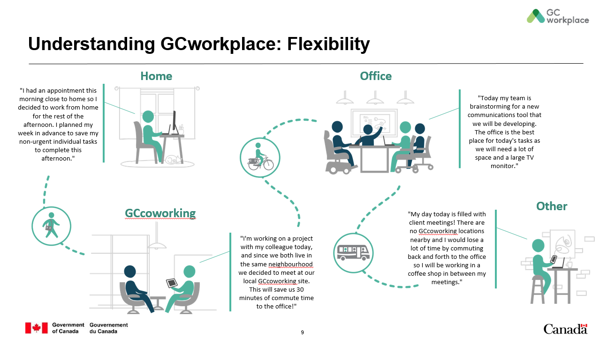 | Understanding GCworkplace: Flexibility | 5 | Flexibility means employees are empowered to decide where it makes the most sense for them to work. Let’s look at a few real-life testimonials.  [CLICK TO ANIMATE SLIDE]  "I had an appointment this morning close to home so I decided to work from home for the rest of the afternoon. I planned my week in advance to save my non-urgent individual tasks to complete this afternoon."  Can you think of other reasons why it would make more sense for you to work from home? Allow participants to answer.  [CLICK TO ANIMATE SLIDE]  "I'm working on a project with my colleague today, and since we both live in the same neighbourhood we decided to meet at our local GCcoworking site. This will save us 30 minutes of commute time to the office!"  What are other reasons why you would decide to work from a GCcoworking site? Allow participants to answer.  [CLICK TO ANIMATE SLIDE]  "Today my team is brainstorming for a new communications tool that we will be developing. The office is the best place for today's tasks as we will need a lot of space and a large TV monitor."  Can you give examples of situations where going to the office would make the most sense? Allow participants to answer.  [CLICK TO ANIMATE SLIDE]  "My day today is filled with client meetings! There are no GCcoworking locations nearby and I would lose a lot of time by commuting back and forth to the office so I will be working in a coffee shop in between my meetings."  When you think about your typical week, can you think of a moment where you would be most efficient at another location like the coffee shop? Allow participants to answer.  With these examples, we can see that having the flexibility to choose where and how you want to work allows for better productivity, and can contribute to work-life balance. Having flexibility is what allows you to define your own ways of working; working where it makes the most sense to you!  Now, there is a logic model to help you select where and how you want to work, and this is what we will be reviewing together today. | *This slide and content can be edited depending on what is available to the department*  For example, if the organization does not have access to GCcoworking sites, simply delete this information from the slide and text.
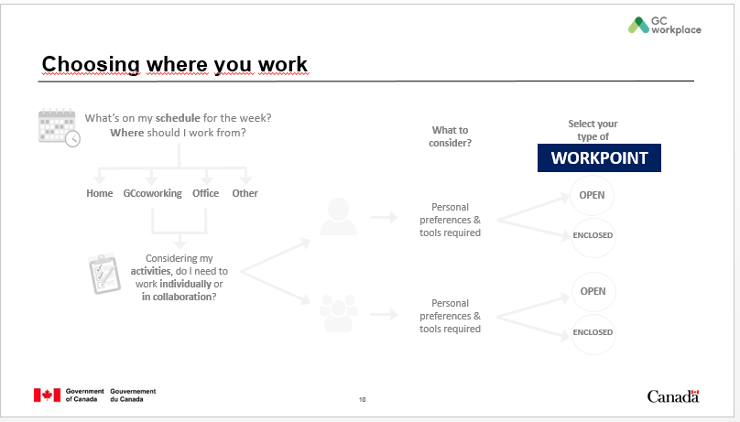 | Choosing where you work | 2 | This new way of working requires a new way of planning for which a decision tree was developed; it will help you plan your activities in a different way than you are used to.  It may be difficult to understand now, but at the end of this workshop, it will all make sense! This logic model will become a great tool to help you choose where to work and it will eventually become second nature to you.  Here are the 3 steps we will go through: [CLICK TO ANIMATE SLIDE] choosing a location, [CLICK TO ANIMATE SLIDE] deciding if you are working individually or in a collaborative way, and finally [CLICK TO ANIMATE SLIDE], the best workpoint for your task. A workpoint being any area where work can be done.
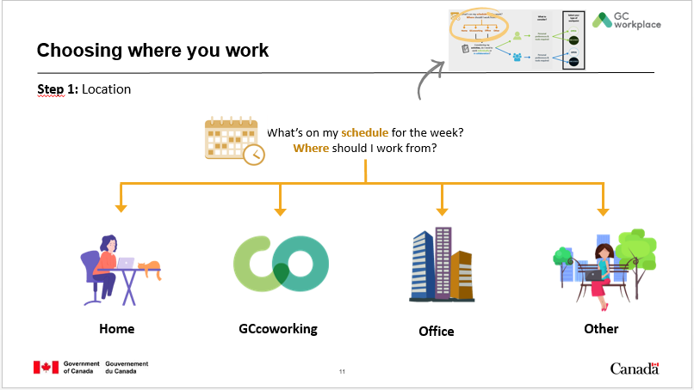 | Choosing where you work  Step 1: Location | 1 | So, let’s start with the first step, which is all about location, location, location! The first question you should ask yourself is “What’s on my schedule for the week?” The answer to that will help you choose where you should work from.  Today, we are going to concentrate on the OFFICE location [CLICK TO ANIMATE SLIDE]. As mentioned earlier when defining GCworkplace, ABW is the design concept supporting the GCworkplace vision, so let’s explore what is an activity-based workplace and what is activity-based working. | *This slide can be edited depending on what is available to the department*  For example, if the organization does not have access to GCcoworking sites, simply delete this information from the slide and text.
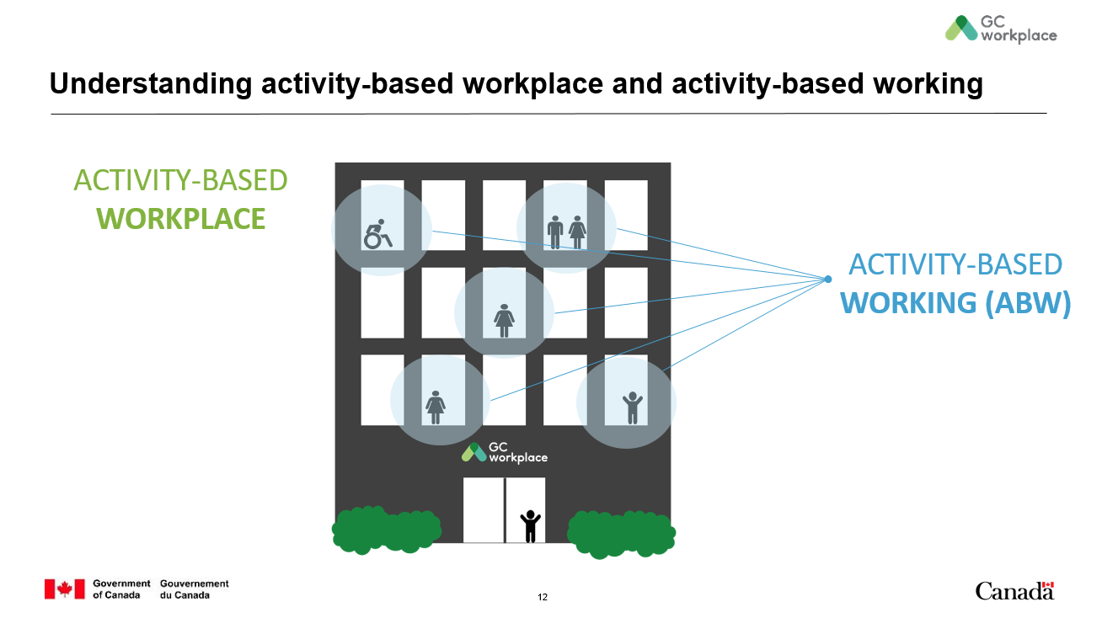 | Understanding activity-based workplace and activity-based working | 2 | This is an ACTIVITY-BASED WORKPLACE, an environment that supports a new way of working and is based on the principle of activity-based working (ABW). [CLICK TO ANIMATE SLIDE]  ACTIVITY-BASED WORKING (ABW) is a design concept that recognizes that through the course of any day, employees engage in many different activities and that they need and can choose different types of workpoints to accommodate these activities. An ABW environment focuses on the employees and provides the freedom to decide for themselves: how to work, where to work, which tools to use and with whom to collaborate to get the work done.
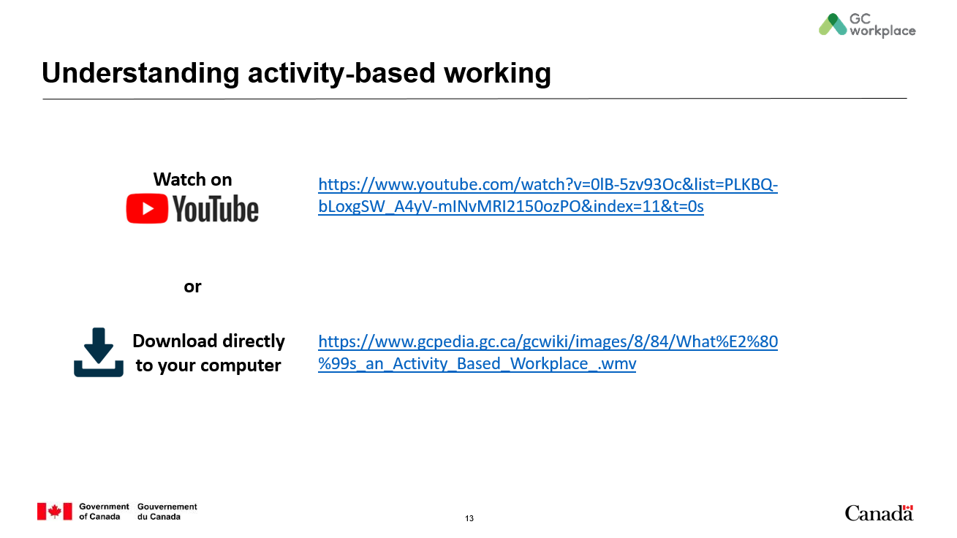 | Understanding activity-based working | 3 | Here is a short video to help you understand what this new way of working is all about.  Play the video (This is a video created by Public Services and Procurement Canada, to demonstrate ABW as the new workplace design solution for the Government of Canada.) | *This slide must be edited depending on what is available to the department*  If the organization does not have access to YouTube, choose to play the video from the GCpedia link.
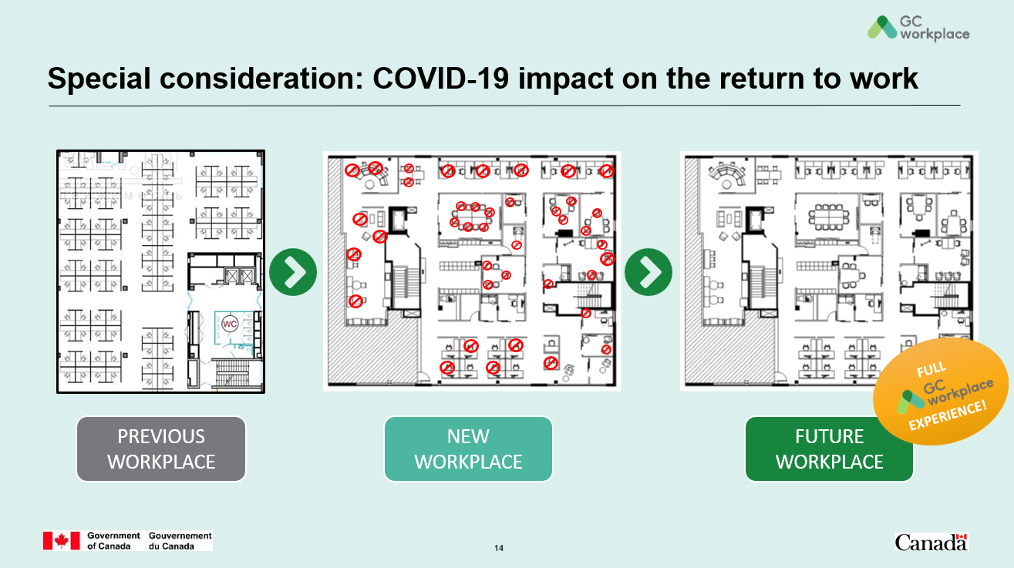 | Special consideration: COVID-19 impact on the return to work | 2 | So what you have just seen and heard is a look into your future workplace; which will be the FULL GCworkplace experience.  Although your new workplace might look more like the image in the middle due to the present situation (COVID post occupancy), let’s not lose sight of the end goal which is the future workplace.  In order to get ready for a full GCworkplace experience, you have to understand its design concept and how to use it, even if―for now―some restrictions might apply. | This slide has been added to address that some organizations might be entering/moving to their newly fitted GCworkplace environment during the COVID-19 pandemic situation where the workspace might not be available to its full capacity.  *This slide can be edited depending on what is available to the department*  Feel free to use floorplans of the actual and future workspaces.
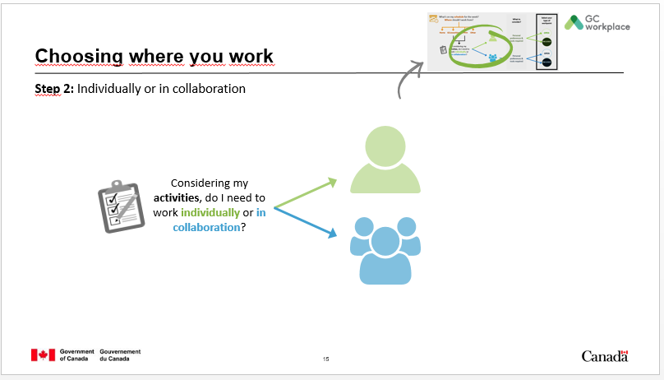 | Choosing where you work  Step 2: Individually or in collaboration | 1 | Now that we have a better idea of what an activity-based workplace is, let’s explore how you can work within that space. In Step 1, we chose the OFFICE as our work location, now what’s next? Ask yourself the following question: “Considering my activities, do I need to work individually or in collaboration?” Answering this question will help determine the best type of space to use in the office. Let’s try it!
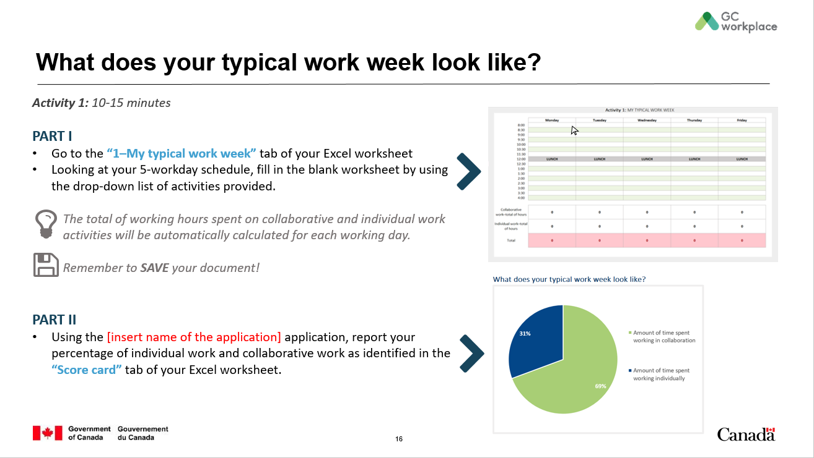 | What does your typical work week look like?  Activity 1 | 20 | For the first part of this activity,  - Go to the “1–My typical work week” tab of your Excel worksheet.  - Looking at your typical 5-workday schedule, fill in the blank worksheet by using the drop-down list of activities. If the activity you want to choose isn’t part of the drop-down menu, simply choose the “Other activity” category from the drop-down menu; making sure you choose correctly between individual or collaborative.  The total of working hours spent on collaborative and individual work activities will be automatically calculated for each working day. For the purpose of this activity, everyone’s total will add up to 37.5 hours. If, for example, you perform the same activity for 1 hour, simply select the same activity for two 30-min. timeslots. DO NOT copy-paste as it will corrupt cell formatting. You have 10 minutes to complete this activity and I will let you know when 2 minutes are left.  Let participants know when they have 2 minutes left to complete the activity.  When 10 minutes have passed, explain the following:  Remember to SAVE your document!  For the second part of this activity,  - Using the [insert name of the application… e.g. Slide, Miro, etc.] application, report your percentage of individual work and collaborative work as identified in the “Score card” tab of your Excel worksheet by simply [choose one of the following methods: copy-pasting the pie chart, using the Snipping tool or screen shot applications, writing “Ind xx% / Collab xx%”].  Have a discussion with the group to see if the results were what they were expecting.  - Do the results of the split between individual and collaborative work surprise you?  - Does your current workplace provide the right type of spaces to efficiently complete your work activities?  - Do you have the right tools to do your individual activities?  - Do you have the right tools to carry out collaborative work? | *This slide must be edited depending on what is available to the department*  Complete information on the slide and the text.  If you do not have access to a sharing application like Slido, simply skip PART II of this activity and delete the PART II information from the slide, and go directly to the discussion part.
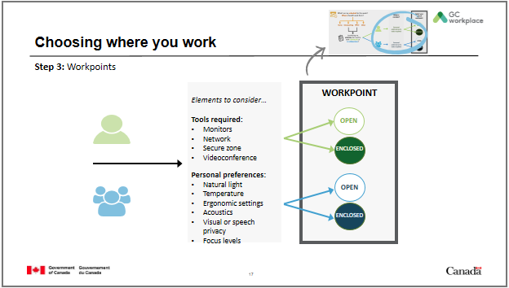 | Choosing where you work  Step 3: Workpoints | 2 | Now that you have determined whether you need to work individually (GREEN path) or in collaboration (BLUE path), the next and final step consists of choosing the best workpoint to accomplish your work. To help you choose this workpoint, there are important elements you should consider―whether you are working individually or in collaboration―like the tools you will require (monitors, network, etc.) and your personal preferences (natural light, temperature, etc.). These elements will guide you in choosing an OPEN or ENCLOSED workpoint.  It is also important to keep in mind that you can move through multiple workpoints throughout the day; once you choose a workpoint, you do not have to stay there.
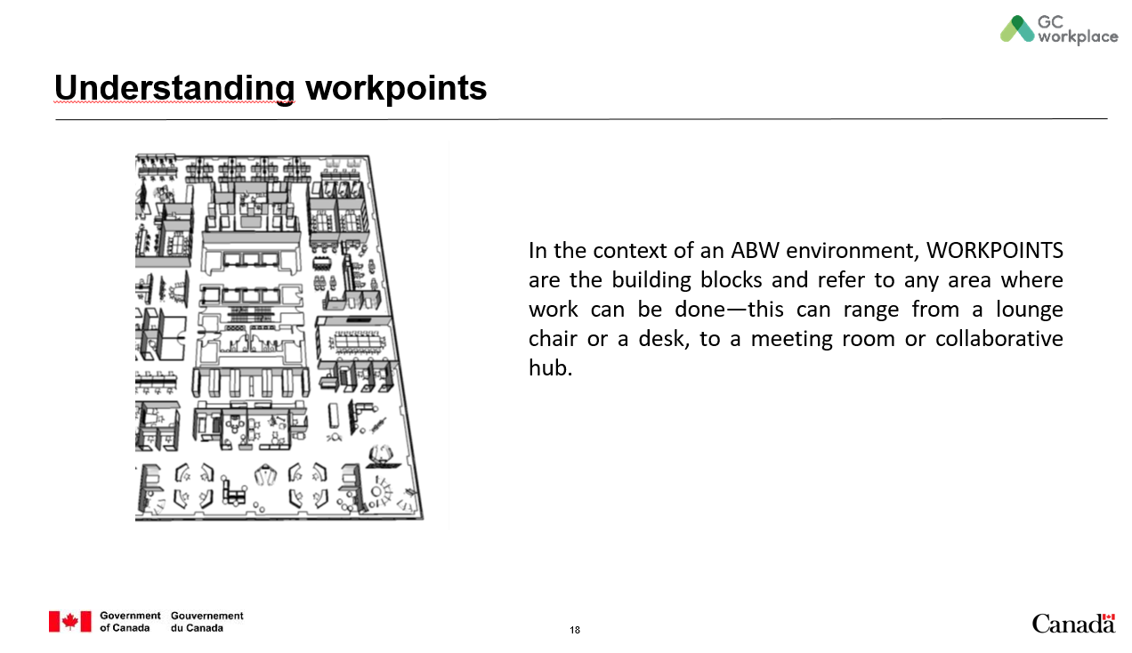 | Understanding workpoints | 1 | All this talk about workpoints and you might be asking yourself… but what IS a workpoint?  WORKPOINTS are the building blocks of an ABW environment and refer to any area where work can be done—this can range from a lounge chair or a desk, to a meeting room or collaborative hub.  Let’s explore a bit more…
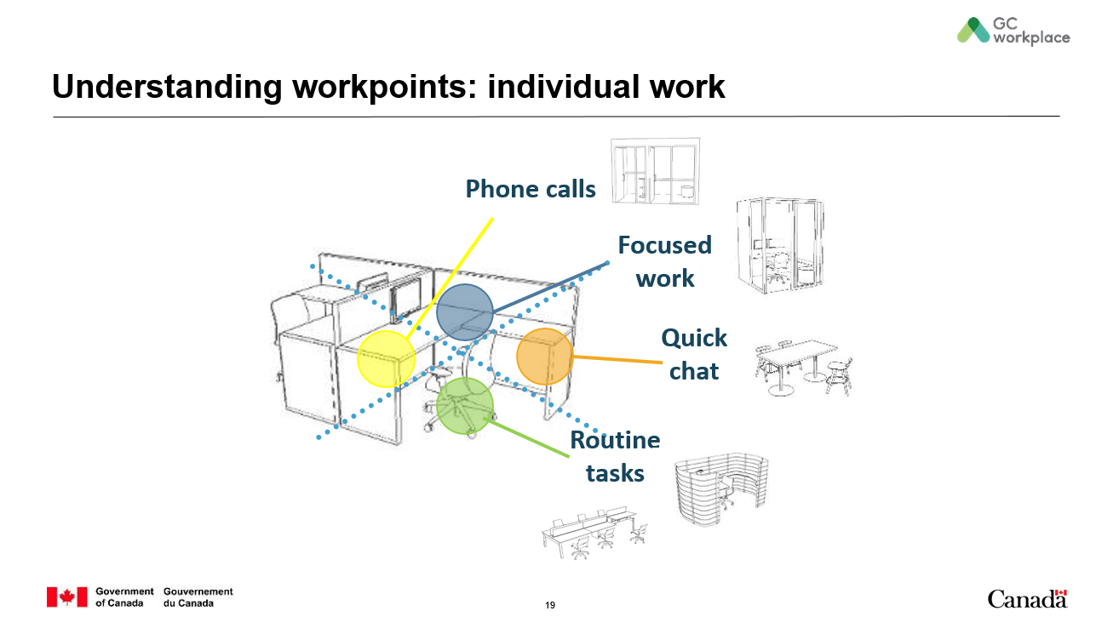 | Understanding workpoints: individual work | 2 | There used to be ONE workstation where we had to do ALL our activities [CLICK TO ANIMATE SLIDE]—take phone calls, do focus work, have a quick chat and accomplish routine tasks—always tethered to that spot. Now, we have the flexibility to choose from a variety of workpoints based on individual preferences and the tools we need. [CLICK TO ANIMATE SLIDE]  Need to take a private phone call or one that will last more than a few minutes? Get up with your mobile phone and walk to a phone booth.  Have to hand in a report and don’t want any distractions while you work? Head over to the nearest unreserved focus room. Want to get your colleague’s opinion on your presentation? Send them a quick message and agree to meet in a collaborative area like a chat point or lounge. Have 30 minutes between meetings and want to answer emails? No need for a full workstation, head over to a touchdown station where you can even choose to work standing up. Or find an active station and walk while working! | *This slide can be edited depending on what is available to the department*  Feel free to include workpoints that will be available to the organization, and adjust the text as required.
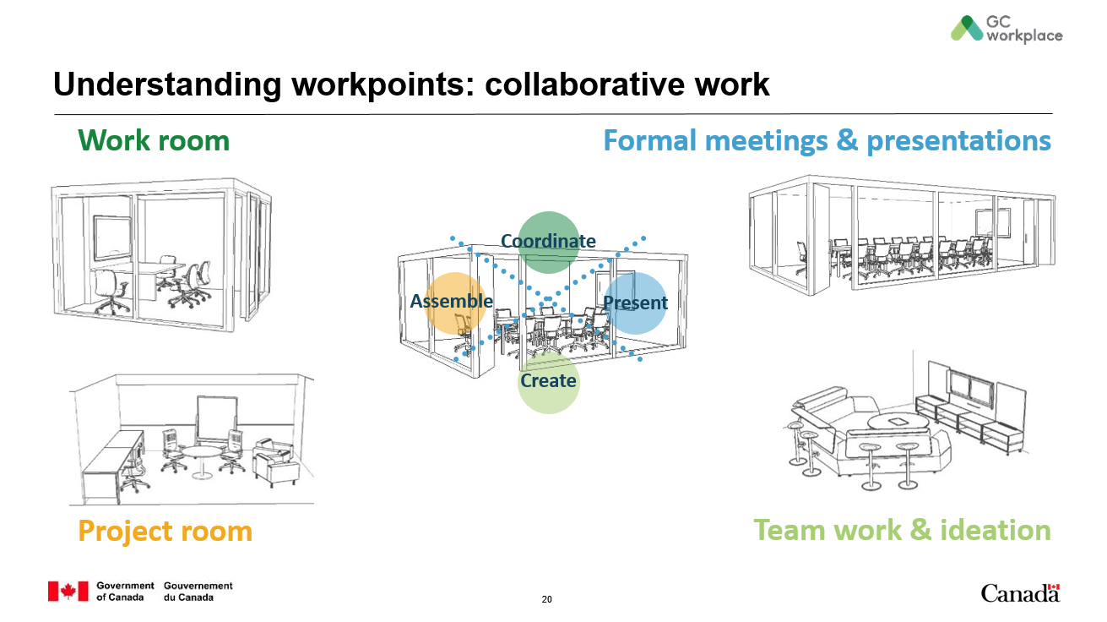 | Understanding workpoints: collaborative work | 2 | Same goes for the more collaborative type of workpoints. We used to coordinate, assemble, present and create in the same space: usually a big boardroom. But now, [CLICK TO ANIMATE SLIDE] each of those activities can be done in a workpoint that was designed for that specific activity; therefore better supporting you in the way you choose to work. | *This slide can be edited depending on what is available to the department*  Feel free to include workpoints that will be available to the organization, and adjust the text as required.
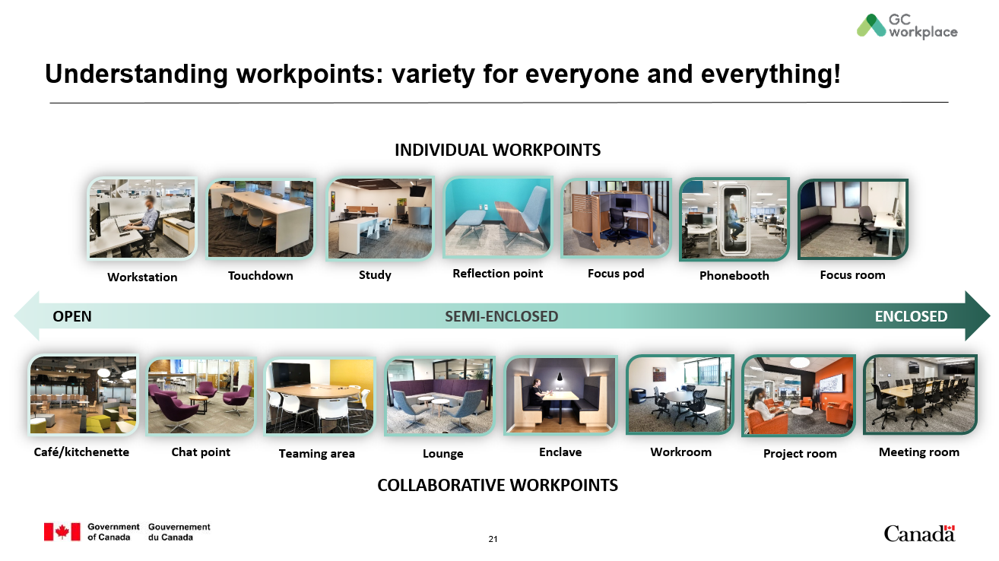 | Understanding workpoints: variety for everyone and everything! | 3 | In your future workplace, you will find a variety of workpoints available to you based on your requirement to perform individual or collaborative work—but also if an open, semi-enclosed or closed workpoint is required or preferred to perform your activity.  Go through the different workpoints by naming them and explaining that they are organized by individual/collaborative workpoints, but also by open/semi-enclosed/enclosed workpoints.  Let’s do an activity to see in which workpoints you would choose to perform your activities! | *This slide can be edited depending on what is available to the department*  In order to create the best experience for the participants, we recommend you replace the current pictures with pictures of the actual workpoints they will find in their future workplace, if possible. Also make the same changes in the “Types of workpoints” tab of the participant’s Excel worksheet by removing the workpoints that will not be part of the future workplace.  If you choose to use some or all of the pictures on this slide, you can specify that they are all pictures of real GCworkplace environments throughout the country.
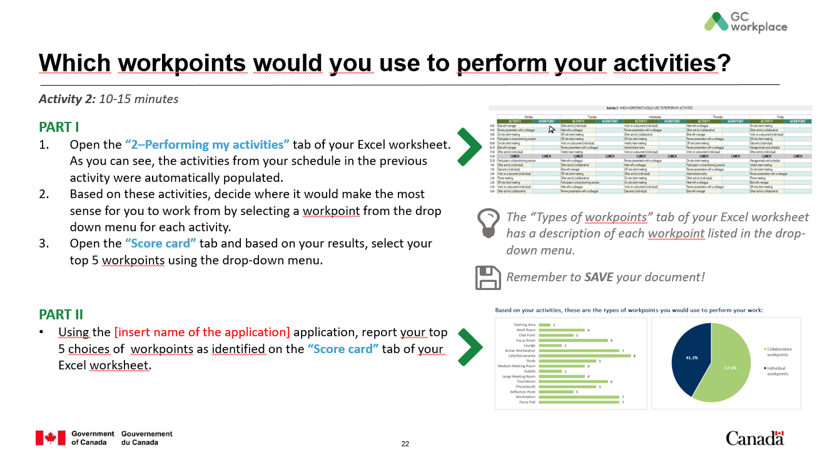 | Which workpoints would you use to perform your activities?  Activity 2 | 17 | For the first part of this activity,  - Open the “2–Performing my activities” tab of your Excel worksheet. As you can see, the activities from your schedule in the previous activity were automatically populated.  - Based on these activities, decide where it would make the most sense for you to work from by selecting a workpoint from the drop down menu for each activity. Don’t hesitate to consult the “Types of workpoints” tab of your Excel worksheet to get inspired as it has a description of each workpoint.  Please DO NOT copy-paste as it will corrupt cell formatting. You have 10 minutes to complete this activity and I will let you know when 2 minutes are left.  While the participants are doing the activity, mention the following:  In order to take full advantage of this new space, it is important to try to IMAGINE yourself working in this environment and having all these choices. Try to “get out” of your usual way of thinking and routine. Give this example: Maybe you are used to working in an enclosed office to read your emails, but why not try to take advantage of a focus pod or reflection room?  You do not have to change workpoint every time you change activity. For example, you could stay half a day at the same workpoint to perform multiple activities of the same nature. Your workstyle will help inform which workpoints you will use to create your own way of working. You could even look at your agenda a day in advance and see which workpoint you might be using in the morning to fulfill your first activity/task of the day.  Let participants know when they have 2 minutes left to complete the activity.  When 10 minutes have passed, explain the following:  - Open the “Score card” tab and based on the results shown for Activity 2 in the AUTO-POPULATED section, select your top 5 workpoints using the drop-down menu. If you have any ties in your scores, simply choose the workpoint that you would prefer most.  For the second part of this activity,  - Using the [insert name of the application… e.g. Slido, Miro, etc.] application, report your top 5 workpoints as identified in the “Score card” tab of your Excel worksheet by simply [choose one of the following methods: copy-pasting the pie chart, using the Snipping tool or screen shot applications, writing “Ind xx% / Collab xx%”].  Have a discussion with the group about preferred workpoints:  - Do you see a correlation between the results of the individual/collaborative work and the chosen workpoints?  - Do the results of the split between individual and collaborative workpoints surprise you?  - Did all participants get the same ratios?  - What do you think about your colleague’s results compared to yours?  Remember to SAVE your document! | *This slide must be edited depending on what is available to the department*  Complete information on the slide and the text.  If you do not have access to a sharing application like Slido, simply skip PART II of this activity and delete the PART II information from the slide, and go directly to the discussion part.
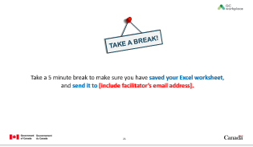 | Take a break! | 5 | Now let’s take a 5-minute break. Make sure you saved your Excel worksheet and please send it to me as an attachment at [include your email address].  When all of the files are received, they will be compiled into a Summary Score Card showcasing the overall results of the group. All participants will receive a copy of this Summary Score Card by email following the workshop. And don’t worry; your personal responses won’t be shown in the overall results; it is simply a bigger picture of our group as a whole. | Complete information on the slide and the text.
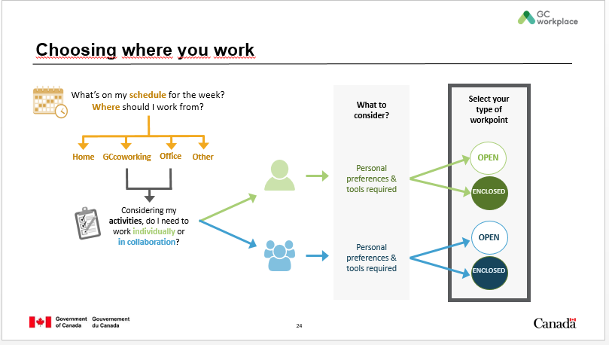 | Choosing where you work  All steps | 5 | Here we have the decision tree we initially showed you at the very beginning of this workshop. Hopefully, it makes sense to you now! Would someone want to give a concrete example of how they would use it?  If there are no volunteers, you can give the following example or one of your own: At the end of the day on Fridays, I look at my schedule and see that I have meetings all day on Monday and Tuesday, that I’m attending a virtual workshop on Wednesday morning and that I plan to work on a report on Thursday and Friday. I can already plan to go to the office for the first 2 days, then participate to the virtual workshop from home and work there the rest of the day, and go to the office to work on my report Thursday and Friday (that was STEP 1). Let’s take Monday for example; I know I’ll be in meetings all day, with different colleagues, so that I’ll be collaborating (that was STEP 2). Considering that I like to work where there is natural light and that we need a large screen and ClickShare, I will book the opened teaming area (that was STEP 3).  I strongly encourage you to keep a copy of this decision tree in your files or on your desktop to help you remember the different steps to choose where you want to work.
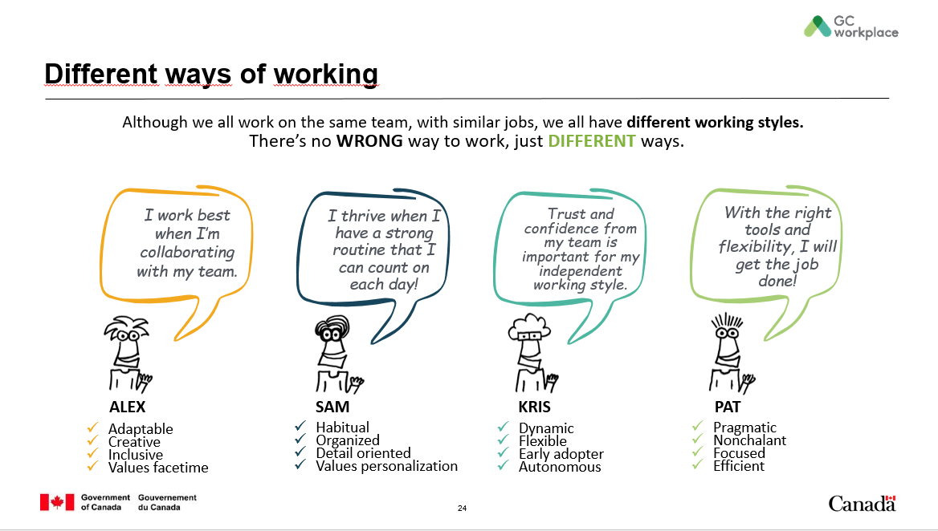 | Different ways of working | 10 | As we’ve heard in our discussions, and although you all might be part of the same team, with similar jobs, you all have your own preferences and working styles. There is no wrong way to work, just different ways.  Did you notice that colleagues who have similar jobs as yours have very different work styles? Give a few examples from the discussions that were held earlier, if possible.  Now, I would like you to meet 4 of my colleagues. They all work in the same team and perform similar activities, but are very different from each other. *Notice that these personas are non-gender specific; therefore, try to refrain from using personal pronouns.  [CLICK TO ANIMATE SLIDE] Here’s Alex. Alex is very adaptable, creative and inclusive, and values facetime; [CLICK TO ANIMATE SLIDE] so Alex works best when collaborating with the team.  [CLICK TO ANIMATE SLIDE] This is Sam. Sam is habitual, organized, detail oriented and values personalization; [CLICK TO ANIMATE SLIDE] so Sam thrives when there is a strong routine to count on each day.  [CLICK TO ANIMATE SLIDE] That’s Kris, the dynamic, flexible, early adopter and autonomous one of the group. [CLICK TO ANIMATE SLIDE] Kris finds that trust and confidence from the team is important in order to have an independent working style.  [CLICK TO ANIMATE SLIDE] And finally, he’s Pat; a pragmatic, nonchalant, focused and efficient colleague. [CLICK TO ANIMATE SLIDE] Pat feels that with the right tools and flexibility, the job can get done.  As you can see, all of them work in the same team and are very different people, but they all benefit from the flexibility of choosing where and how to work.
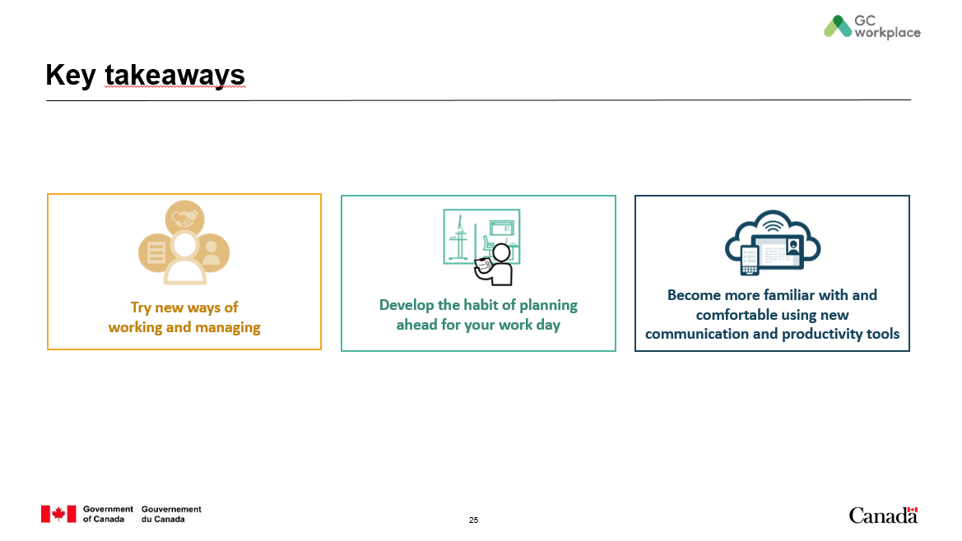 | Key takeaways | 5 | It is now time to take a look back and think about what you have learned, and share the key takeaways from this workshop.  Hold a discussion with participants on the key takeaways from this workshop. If they have trouble coming up with some, use the following list to help feed the discussion.  What have you leaned with regards to trying new ways of working and managing?  - Manage performance by results and deliverables  - Encourage your team to move around the workspace in a way that best suits them  - Determine ways to connect and keep each other up to date  - Start using various communication tools to stay in contact with employees and teams  - Develop new ways of working with your team and give yourselves some time to try them out  How can you develop the habit of planning ahead for your work day?  - Look at your agenda the week or day before and see which location and/or workpoints you might be working from the next day  - Give yourself some time to discover the different work locations, workpoints, and zones (if applicable)  - Use only one workpoint at a time  - Adopt a clean desk  How will you become more familiar with and comfortable using new communication and productivity tools?  - E.g. OneNote, MS Team, Instant Messenger, WebEx, Zoom, and more.
 | Questions | 10 | This is now the Q&A part of the session. Do any of you have any questions for me?  Answer questions from the participants.
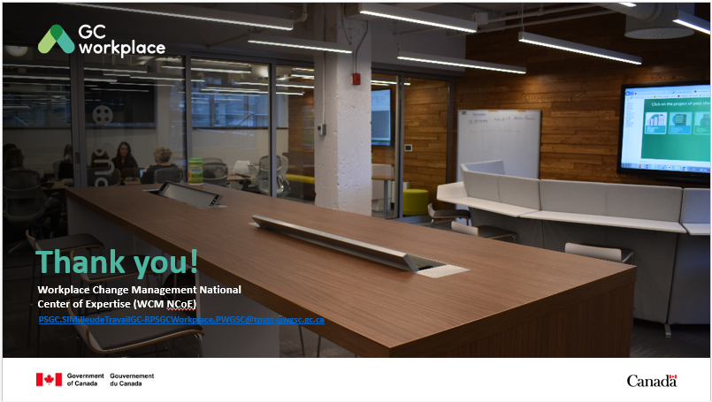 | Thank you! | 1 | Thank you for your participation today. You can expect a follow-up email in the upcoming days to which will be attached a PDF Summary Score Card grouping all of today’s results and a chance for you to complete an evaluation on today’s workshop. I hope you enjoyed this virtual workshop and have learned something new about the GCworkplace vision, what is an activity-based workplace and activity-based working. Good luck for your future move!
 | Reference |  | Example of a typical day in an ABW environment, if needed.  You could also play some “My Day in a Minute” videos from Shared Services Canada’s YouTube Channel: https://www.youtube.com/channel/UCg6yeXJtNiudgNsIrCBRJyg
Total: |  | 117 min | (environ 2 h)

ANNEX A–invitation to THE workshop TEMPLATE

Subject / Objet: ABW virtual workshop / Atelier virtuel sur les MTAA
Location / Lieu: e.g. MS Teams, Zoom, etc. (make sure to add the link to the meeting in the body of the text below) / p. ex. MS Teams, Zoom, etc. (assurez-vous d’inclure le lien à la rencontre dans le corps du courriel ci-dessous)
Start Time / Heure début:
End Time / Heure fin:

(la version française suit)

As part of your (INCLUDE YOUR PROJECT TITLE) project, I am pleased to invite you to a virtual activity-based working (ABW) workshop in view of our upcoming move into your newly modernized workplace.

The GCworkplace vision empowers employees to choose where and how they want to work, thus creating a more efficient, healthy and flexible workforce and increasing productivity. There is also a strong emphasis placed on mobility and technology. To adapt to this new workplace and enhance the mobility and flexibility that this workplace offers, employees will have to change the way they plan their day by choosing the right workpoint that will support the accomplishment of their tasks or activities. This workshop will equip you with the skills and abilities to develop efficient new ways of working and will also help you to understand the changing nature of your workplace.

As there will be some activities included in this workshop, we are asking you to have on hand a copy of a typical 5-day work schedule (or simply to have access to your e-calendar) which will be used as part of these activities. You will also find attached an Excel document you will need to complete during the workshop. Please do NOT attempt to complete the activities before the workshop.

Thank you in advance for your participation.

Dans le cadre de votre projet (INCLURE LE TITRE DU PROJET), j'ai le plaisir de vous inviter à un atelier virtuel sur les milieux de travail axé sur les activités (MTAA) en vue de votre déménagement prochain dans votre nouvel espace de travail modernisé.

La vision du Milieu de travail GC donne le pouvoir aux employés de choisir où et comment ils veulent travailler, ce qui améliore l’efficience, la santé et la souplesse de la main-d’œuvre et, par conséquent, en accroît la productivité. Une grande importance est aussi accordée à la mobilité et à la mise à profit de la technologie. Pour s'adapter à ce nouvel environnement de travail et améliorer la mobilité et la souplesse qu'offre ce milieu de travail, les employés devront modifier leur façon de planifier leur journée en choisissant le bon point de travail qui soutiendra l'accomplissement de leurs tâches ou activités. Cet atelier vous permettra d'acquérir les compétences et la capacité de développer de nouvelles méthodes de travail efficaces et vous aidera également à comprendre la nature changeante de notre milieu de travail.

Comme il y aura des activités incluses dans cet atelier, nous vous demandons d'avoir en main une copie d’un horaire typique de 5 jours (ou simplement d’avoir accès à votre calendrier électronique) qui sera utilisé dans le cadre de ces activités. Vous trouverez également ci-joint un document Excel que vous devrez compléter lors de l'atelier. Veuillez NE PAS tenter de compléter les activités avant l’atelier.

Merci d'avance pour votre participation.

ANNEX B–EMAIL TO SEND AFTER THE WORKSHOP TEMPLATE

To / À:
Subject / Objet: ABW virtual workshop / Atelier virtuel sur les MTAA

(la version française suit)

Dear participants,

Thank you for participating in the virtual activity-based working workshop on (DATE). Thank you for taking the time to listen, learn and share. The interactions and comments were insightful and thoughtful. You will find attached the Summary Score Card showcasing the complete results for the group.

You are invited to complete a short workshop evaluation form and send it back to me by (DATE). The questionnaire is attached and is available in both official languages. Thank you for taking a few minutes to complete the survey.

If you have any additional comments or questions, please feel free to contact (NAME).

_____________________________________________________________________________________________________________________

Chers participants et participantes,

Nous tenons à vous remercier d’avoir participé à l’atelier virtuel sur le milieu de travail axé sur les activités du (DATE). Votre participation, tant sur le plan de l’interaction, de l’écoute et de l’apprentissage, était fort appréciée. Vos commentaires et questions ont été très utiles. Vous trouverez ci-joint le Sommaire des fiches de pointage présentant les résultats complets du groupe.

Je vous invite à compléter un formulaire d’évaluation de l’atelier et me renvoyer celui-ci par courriel d’ici le (DATE). Le questionnaire est en pièce jointe et est disponible dans les deux langues officielles. Votre rétroaction est importante, merci de prendre quelques minutes pour la fournir.

Si vous avez des questions ou d’autres commentaires, n’hésitez-pas à communiquer avec (NOM).

