Communication plan
WORKPLACE MODERNIZATION PROJECT
[INSERT NAME OF PROJECT HERE]

VERSION 1.0
DATE:
PREPARED FOR:
DEPARTMENT:
Table of contents
1. Background 3
1.1 GCWORKPLACE 3
1.2 [INSERT PROJECT NAME] 3
2. Objectives 3
2.1 COMMUNICATION OBJECTIVES 3
2.2 PROSCI METHODOLOGY AND ADKAR (include if applicable) 4
3. Target audiences 5
4. Key messages 5
5. Products, vehicles and activities 5
6. Feedback, monitoring and evaluating 6
7. Schedule and key milestones 6
8. Contacts 6
9. Communication plan 7
Annexes 7
ANNEXE A: EXAMPLES OF KEY MESSAGES 7
ANNEXE B: CUSTOMIZING KEY MESSAGES FOR TARGET AUDIENCES 8
ANNEXE C: COMMUNICATION MODEL 8
ANNEXE D: EXAMPLES OF COMMUNICATION ACTIVITIES 9
ANNEXE E: COLLECTING AND MONITORING FEEDBACK 10
ANNEXE F: FEEDBACK STRATEGY OPTIONS 10
ANNEXE G: BUILDING ADKAR IN A COMMUNICATION PLAN 11

Background

1.1 GCWORKPLACE
GCworkplace principles were developed to align with the vision of creating a high-performing Government of Canada workplace that enables a balanced workforce. This new-age workplace is founded on the principles of flexibility, efficiency, (employee) health, collaboration and digital capacity; all of which inform GCworkplace principles.
In GCworkplace, employees can choose where and how they want to work, thus creating a more efficient, healthy and flexible workforce that also increases productivity. There is also a strong emphasis placed on mobility, recognizing that activity-based working is the way of the future and that there is no one-size-fits-all approach to office design.
The principles of GCworkplace were developed with the needs of today’s workforce, as well as those of tomorrow’s, in mind. One of the big questions facing the Government of Canada is how to attract and retain top talent, and GCworkplace takes a step towards answering that question.

1.2 [INSERT PROJECT NAME]
Insert information on your modernization project:
- Project scope
- Vision
- Key principals of the project
- Key components of your change management strategy
- Type of change and size
- Timeline

Objectives

2.1 COMMUNICATION OBJECTIVES
Communication is a critical and essential component of change management. Beyond those communication activities that support the integrated initiative and the vision (described herein), each change project under the workplace modernization project may require its own communication plan to support the change at the project level.
Overarching objectives:
- Ensuring timely and consistent communication in support of [name of project] change management and project integration activities.
- Increase employees’ understanding of [name of project], the many planned changes to the workplace, the need for change and what it means to them.
- Promote a common understanding of the change process through cross sector and cross functional activities and broad-based information sharing.
- Sustaining a dialogue with employees to help them internalize and adopt the changes associated with [name of project].
- Support the culture change and sustain the changes through reinforcement.

PROSCI METHODOLOGY AND ADKAR (include if applicable)
Prosci is an independent research organization that has developed a comprehensive change management methodology based on best practices identified through their research. As leaders in the field, their methodology is being used across multiple organizations.
Based on Prosci’s research, the foundation for organizational change is successful change at the individual level by building the elements of the ADKAR change model (Figure 1) in each individual. ADKAR stands for:
- Awareness–provides the “why” the change is happening
- Desire–environment that provides the motivation and willingness for the change
- Knowledge–is the information and learning needed to apply the change
- Ability–removes the capability obstacles that could prevent the change
- Reinforcement–sustains the change past the implementation phase
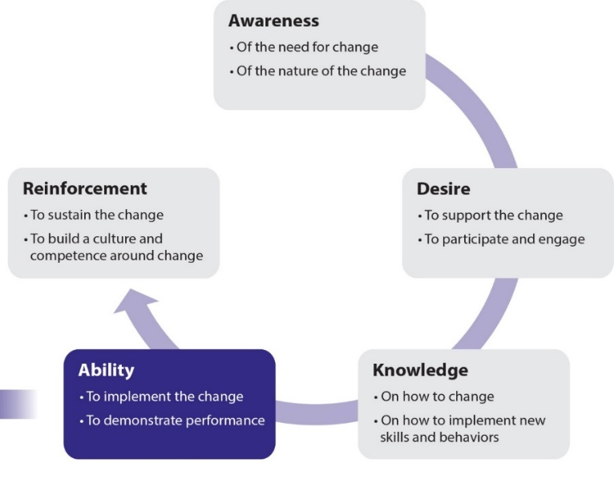
Figure 1. Prosci® ADKAR® Model
The ADKAR model is to be integrated into various tools that will be used by the team along with managers and employees, to manage change. The ADKAR model allows [name of your organization] to shape change management and communication activities to support employees while facilitating [name of your project] implementation objectives.
Successful communication with staff will be based on the ADKAR model to build the five elements of ADKAR needed for a successful change. When ADKAR is present in change management activities, the desired change happens.

Target audiences

Use the results from your stakeholder impact assessment to identify your target audiences. Examples of target audiences include employees, managers, supervisors, senior management, etc.
[Include your text here]

Key messages

[Insert key messages here]
Guidance for developing key messages:
- Develop messages addressing the current workplace situation and the rational for change.
- Develop messages about the change (vision, scope, timeframe, alignment with the organizational mandate and business, impacted stakeholders, the basic of what is changing, how it will change, and when it will change).
- Develop messages about how the new workplace will impact employees (day-to-day changes, WIIFM, behaviours, feedback, expectations).
- Develop updates and progress report messages.
- Customize each key message to each audience and to the timeframe of the project implementation.
See Annexe A for examples of key messages.
See Annexe B for guidelines to customize key messages to target audiences.
See Annexe C for a guide to help develop key messages based on the three levels of change (vision, project objectives and tactical).

Products, vehicles and activities

- Communication products, vehicles and activities should include information and messaging for each audience based on the timing of the workplace project implementation
- Specific objective of the communication including whether it is meant to communicate the vision and/or support project delivery at the project objective level or at the tactical level. You can complete an ADKAR assessment for each targeted audience to guide you in the development of the communication products and activities.
- Assessment of potential risk level of the product/activity and its impact on the sender, the message and the vehicle
- Sender including the different role the sender may have in helping manage change
- Target audience including their change readiness and the relative impact of the changes on them
- Be mindful and inclusive in the design of communications products and activities
- Timing or sequence of the product/activity in relation to project implementation and other related change management activities
See Annexe D for examples of communication activities.
[Include your text here]

Feedback, monitoring and evaluating

Feedback will be tracked to assess the effectiveness of [name of your project] change management approaches as well as to monitor the implementation of the integrated project. Feedback processes will provide the information needed to measure change adoption, integration, effectiveness of training, change saturation, as well as provide a means to continuously assess, adapt and improve the project implementation. Outputs from feedback channels may also be used to inform and guide ongoing decision making. In this section, it is important to monitor and evaluate continuously if the communication activities have been valuable to create awareness and build desire of the workplace change at all levels within the organization.
- Evaluate if the communication activities have been valuable.
- Data in this category are connected to the actual activities carried out by the change management team and included in the change management strategy.
See Annexe E for examples of tools and metrics for feedback collection.
See Annexe F for feedback strategy options.

Schedule and key milestones

[Include your project schedule here]
Keep in mind:
- Project timeline and milestones
- List of changes per sector
- Showcasing the high-level workplace timeline and the employee change impact timeline is a great visual to look at from a user/receiver perspective

Contacts

[Include workplace change contacts here]

Communication plan

Timing | Strategic objectives | Activities | ADKAR | Audience | Sender | Delivery mechanism | Feedback mechanism | Status
 |  |  |  |  | e.g. project sponsor, project team, managers, EXs, subject matter expert lead

Annexes

ANNEXE A: EXAMPLES OF KEY MESSAGES
It is important to explain the reasons behind the project, the benefits to employees and the organization, the impacts on them, what is expected from them during the project and why this workplace modernization is happening now.
Goals of workplace changes:
- Workplace changes will assist employees in their work by offering a whole office solution
- Workplace changes will enable employees to communicate and collaborate in new way
- Technological tools such as videoconference systems will support flexible HR policies that provide employees with the opportunity to work from different locations
- (…)
Benefits of workplace changes:
- Workplace changes will provide a collaborative multidisciplinary design strategy that considers the interaction of people, space, technology and business processes
- Workplace changes will allow the development of more effective and efficient work environments that accommodate individual work styles and alternative work strategies
- Workplace changes will enable employees to work when, where and how they can be most effective
- (…)
Impacts of workplace changes on employees:
- Employees will be able to choose their workspace based on their mood, needs and work requirements, therefore providing greater flexibility
- Workplace changes will facilitate mobility and greater flexibility
- (…)
Refer to the GCworkplace communications tool kit for more content.

ANNEXE B: CUSTOMIZING KEY MESSAGES FOR TARGET AUDIENCES
Prosci identifies guidelines to customize key messages for different audiences:
Customizing messages for executives:
- Reduce content to executive summary only
- Clearly articulate the objectives and scope (they will be concerned for which parts of their organization may be impacted)
- Focus on financials and alignment with the business strategy
- Identify key decision points that they would be involved with or want to know about
- Present actions you need them to take or decisions they need to make
Customizing messages for mid-level managers:
- Present those key messages that you would expect them to communicate to their employees
- Keep managers one step ahead of their employees (avoid surprises)
- Focus on the scope of the change including their explanations of what is in scope and what is out of scope (some managers will shut-out information and filter it away from their organization if they do not see a direct connection with their processes or systems)
- Be clear on the expected action you need them to take to support the change within their group or department
Customizing messages for employees:
- Focus on the impact of the change on the employee
- Be clear about what you know now and what you do not know now
- Let employees know when more information will be available
- Be clear about how employees can provide feedback about the change

ANNEXE C: COMMUNICATION MODEL
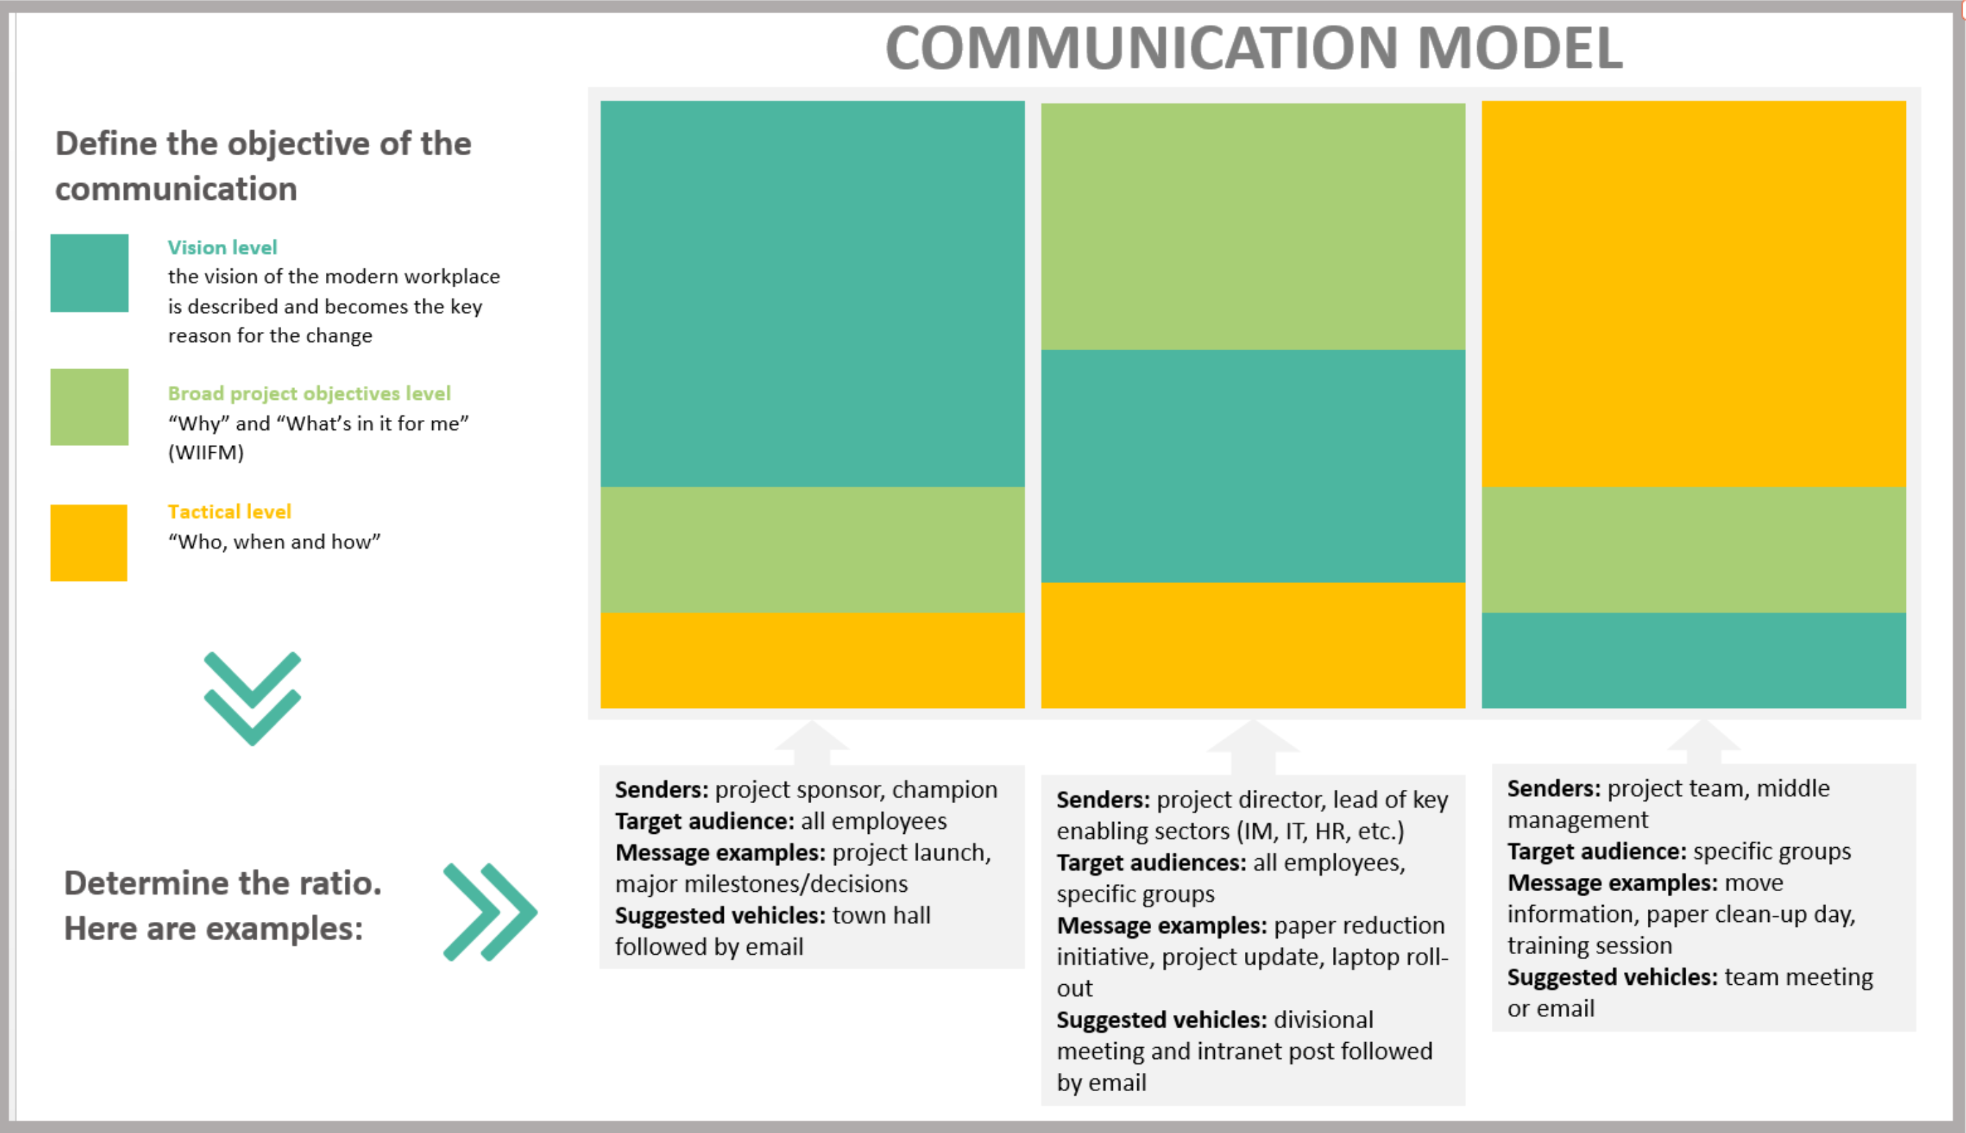

ANNEXE D: EXAMPLES OF COMMUNICATION ACTIVITIES
- Launching a one-stop GCconnex group for all move-related information
- Equipping employees (including managers) with the tools and processes they will need to be successful in the new workplace
- Ensuring that employees know about key features of the new workspace (including their office, floor location, etc.) and how to access or sign-up for the services they need (parking, showers, bike room, lockers, building access, etc.)
- Reinforcing GCworkplace objectives and preparing employees for the move
- Engaging in remaining discussion points
Examples of communication channels to use:
- Face to face
- Newsletter
- Focus group
- Meeting
- Email
- Fact sheets
- FAQs
- Townhall
- Site visits
- Intranet
- Banner
- Brown bag lunches
- Electronic screens (TV, screens)
- Information fairs
- Posters
- Testimonials
- Videoconferences

ANNEXE E: COLLECTING AND MONITORING FEEDBACK
Tools to collect feedback:
- Tracker
- Surveys
- Spot survey for events
- Observation
- Interaction with recipients
- Monitoring feedback through various channels and networks (see Annexe F)
- ADKAR Change-o-Meter
Metrics:
- Tracking of change management activities conducted according to plan
- Training participation and attendance numbers
- Communication deliveries
- Communication effectiveness
- Performance improvements
- Progress and adherence to plan
- Business and change readiness
- Project KPI measurements
- Adherence to timeline
- Speed of execution
- Number of clicks on a web page
- Number of visits to a modernized space

ANNEXE F: FEEDBACK STRATEGY OPTIONS
Mechanism | Lead | Description | Advantages
Surveys & user polls  (Qualtrics, survey monkey, etc.) | Project lead, middle management | Employee opinions matter! Use surveys and user polls to obtain the overall pulse of the change. Although user feedback is important – don’t overdo it. Be mindful of how many surveys and polls are sent throughout the modernization project. Obviously, this will vary dependent on the size and length of the project.  Keep in mind: you will need to vet the questions and test the tool selected prior to sending it off. | - A quick and easy way to get feedback  - Reaches a large number of employees  - Can be anonymous (optional)
Suggestion & comment box | Project lead, project team | An open discussion or private e-mail option on the intranet or GCconnex page. This option is beneficial post-implementation where the feedback goes directly to the process owner for continuous improvement.  Keep in mind: this option requires an individual or team who will monitor the feedback. | - Live URL available 24/7  - Can be anonymous (optional)  - May leave open indefinitely for ongoing input
1:1 meetings | Middle management & supervisors | Utilize 1:1 meetings to understand how the change is being received. Direct managers and supervisors are the best resources for this as they should already have trust and strong relationships with their employees.  Keep in mind: this option requires safety, trust and transparency amongst managers/supervisors and their employees. | - A comfortable setting that can enable vulnerability  - Gathers individual, in-depth feedback
Team meetings | Middle managers | Allows employees to surface feedback on the change in their current team environment.  Keep in mind: a strong facilitator will be required. | - Creates transparency  - Raises group issues
Focus groups (5-12 participants) | Integrated project team | Allows the project team to solicit specific feedback from key contributors on specific topics.  Keep in mind: a strong facilitator and real-time transparency of information captured will be required. | - A shared experience  - Participants react together and build off each other’s comments  - Option to curate audience based on topics
Townhalls | Project sponsor or champion | Use to summarize findings, celebrate successes and address opportunities related to the change across all key audiences. Great way to share the key objectives & vision of the project and how they are being met.  Keep in mind: a strong facilitator and prepared agenda are required. | - Reaches a large number of employees  - Creates transparency between senior management and employees  - Solicits community input

Source: This chart has been adapted from the Self-Service Feedback options in the Change Management Toolkit (page 38-39) by Berkeley, University of California.

ANNEXE G: BUILDING ADKAR IN A COMMUNICATION PLAN
Recall from the Strategize phase how individuals experience change is a process, and that you must ensure that the essential building blocks of change are present, using ADKAR. A good communication plan will mainly foster the development of the following three building blocks:
Awareness | - Include communications both about the need for the workplace change and the expected impact on employees  - Senior management should deliver the business awareness messages while managers should deliver the individual awareness messages  - Use a variety of methods and multiple deliveries to be sure that the employees are receiving the messages that you want them to be receiving
Desire | - Build thorough communication that convey the importance of the workplace change for the business as well as the positive and negative consequences for employees and the expected improvements and benefits that employees can expect (WIIFM)  - Effective content and delivery mechanisms will create buy-in from impacted employees  - Desire can be impacted if the communications are poorly developed
Reinforcement | - Communication following the implementation of a modernized workplace is important to build support for the new workplace and show success of the project (you can refer to the CM Playbook Measure Phase)

