Auto Export the Attachment Information of Incoming Emails to Excel
- At first, launch Outlook application.
- Then, go to VBA editor via “Alt + F11”.
- Next, copy the following VBA code into a module.
Sub AutoExportAttachmentInfo(objMail As Outlook.MailItem)
Dim objExcelApp As Excel.Application
Dim objExcelWorkbook As Excel.Workbook
Dim objExcelWorksheet As Excel.Worksheet
Dim nLastRow As Integer
Dim objAttachment As Outlook.Attachment

If objMail.Attachments.Count > 0 Then
'Change the path to the specific Excel file
strExcelFile = "E:\Attachment Info.xlsx"

Set objExcelApp = CreateObject("Excel.Application")
objExcelApp.Visible = True
Set objExcelWorkbook = objExcelApp.Workbooks.Open(strExcelFile)
Set objExcelWorksheet = objExcelWorkbook.Sheets("Sheet1")

'Export Attachment info to Excel
For Each objAttachment In objMail.Attachments
nLastRow = objExcelWorksheet.Range("A" & objExcelWorksheet.Rows.Count).End(xlUp).Row + 1

With objExcelWorksheet
.Cells(nLastRow, 1) = objMail.Subject
.Cells(nLastRow, 2) = objMail.SenderEmailAddress
.Cells(nLastRow, 3) = objAttachment.FileName
.Cells(nLastRow, 4) = objMail.ReceivedTime
End With
Next

objExcelWorksheet.Columns("A:C").AutoFit
objExcelWorkbook.Close True
objExcelApp.Quit
End If
End Sub
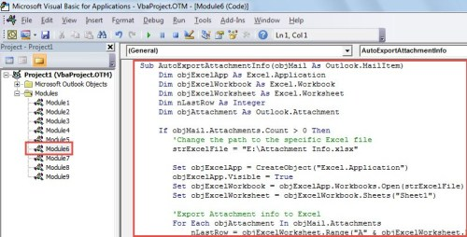
- After that, exit VBA editor.
- Subsequently, create a rule to auto run this macro on every incoming email.
- First off, go to “File” menu.
- Then, click “Manage Rules & Alerts” button.
- In the “Rules and Alerts” dialog box, click “New Rule”.
- In the “Rule Wizard” dialog box, select “Apply rule on messages I receive” and click “Next”.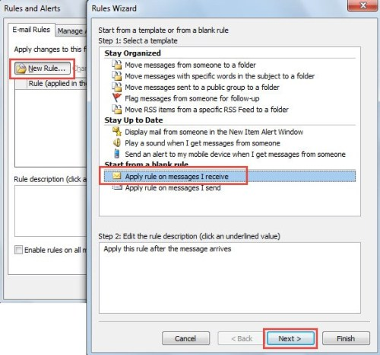
- Next, set rule conditions as per your needs and hit “Next”.
- In the “Select Actions” step, select “Run a script” and choose “AutoExportAttachmentInfo” script.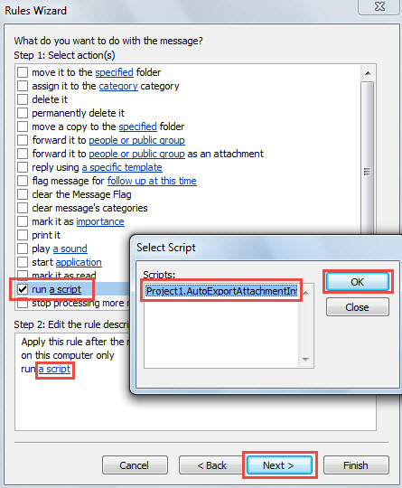
- Finally, follow onscreen wizards to finish rule setup.
- From now on, every time when a new email arrives in your mailbox, if it has any attachments, Outlook will auto export the attachment information to the predefined Excel file.