Lifting as You Lead Mentoring Circles

Inclusive Leadership Masterclass

Action Planner

Intention

What is your commitment or intention for our time together today?

Defining Inclusive Leadership

What is your own definition of inclusive leadership?

Cultivating an Inclusive Leadership Culture

Inclusive leaders cultivate an inclusive leadership culture, where people:
- Are treated equitably
- Feel a sense of belonging and value
- Have the resources and support they need to achieve their full potential

Cultivating an inclusive leadership culture requires leaders to:

Mobilizing Others | Build Strategies and Plans | Changing behaviours and habits | Reimaging Systems
Communicating a vision for the importance of diversity and inclusion, and energizing people to engage in the work | Developing strategies and plans to achieve specific DEI-goals, and including DEI-goals in existing strategic plans. DEI goals are not separate from other work. | Cultivating collective awareness of the behaviors and habits which support diversity, equity and inclusion, supporting people to change those behaviours | Changing behaviour starts with redesigning systems, and decolonizing the mental models that led to those systems being designed in the ways that they are.

Areas of Opportunity for Leading Change

Interpersonal interactions | Casual comments, actions, and assumptions that are rooted in bias (i.e. microaggressions)
Workplace norms and expectations | The set up our physical workspaces, to the hours we expect our colleagues to be available, to the software and tools we use all shape our workplace norms
Hiring | Candidates with less privilege face barriers and biases and may not be evaluated fairly or may need to work hard to prove their competence
Advancement and recognition | People with less privilege get less recognition for their ideas, are less likely to be given stretch assignments and high-profile projects, and may face biased performance reviews and promotion decisions
Mentorship and sponsorship | Support from mentors, sponsors, and senior leaders can have a significant impact on our careers, but is often provided by those with more privilege to others who are similar to themselves.
Opportunities for Inclusive Leadership: Your Own Focused Areas for Action

Instructions:

With your breakout partner(s), discuss an area of opportunity you can influence to support change within your organization:
- Interpersonal interactions
- Workplace norms and expectations
- Hiring
- Advancement and recognition
- Mentorship and sponsorship

Discussion Questions:
- What is one area where you would like to have more of an impact as an inclusive leader? Why?
- Inclusive leadership is the practice of cultivating a culture that affirms and values the identities, contributions, and perspectives of all its members. Inclusive leaders do this by mobilizing others, building strategies and plans, changing behaviors and habits, reimagining systems. What might your own inclusive leadership work look like for you, in this area of impact?

Notes:

Inclusive Leadership as an Action Learning Practice

Inclusive leadership requires action-learning: an intentional practice of taking action and learning from the results, ideally in a community of practice with other inclusive leaders.
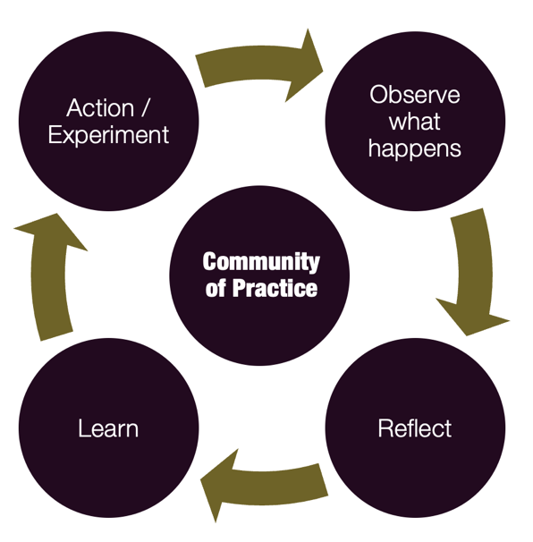
Action learning is a short cycle that looks like this:
- Action / Experiment: Trying things or taking a small step through daily choices or a shift in habits.
- Observe what happens: During the experience, pay careful attention – to yourself, to others, to your impact.
- Reflection: Reflect on that experience: consider what happened and your thinking patterns
- Learning: You update your understanding and consider what you might do next time.
- Action / Experiment: You take the next step (next choice, next habit shift) with an updated understanding.

Community of Practice: Learning community where people share their emerging insights and experiences as inclusive leaders. We learn from dialogue and feedback. Learning to be an inclusive leader cannot happen without trusting, open communication with other leaders and members of the equity-deserving groups we aim to support.

Notes:

Inclusive Leadership in Action: An Incomplete List

 | Self-Awareness | - Building capacity to hear critical feedback (and creating the safety and invitation for others to share it)  - Embracing the difficult emotions that come out of inclusive leadership, understanding that we will feel uncomfortable, challenged, and hurt  - Without expecting to be educated by others, actively seeking to learn about the oppressions experienced by others and the historical forces that shaped that current reality.  - Noticing the impact of our thoughts, biases and emotions on our capacity for inclusive leadership
 | Courageous Authenticity | - Actively acknowledging our power and privilege  - Using our power and privilege to advance change, especially when it is uncomfortable or scary – shouldering the burden so that it is not on equity-seeking groups
Others | Relationships | - Interrupting discrimination and microaggressions when we see them and hear them  - Fostering curious, caring relationships with people who are different than ourselves  - Creating space for others, listening more and speaking less  - Empathetic, active listening that validates another’s story when they share a difficult experience  - Cultivating team cultures which support psychological safety and diversity of thought
Systems | System Awareness | - Bringing critical awareness to the systems and structures and how they impact equity-seeking groups, such as schedules, physical space, meeting norms, technology, performance management systems, recruiting processes, learning and development support  - Bringing critical awareness to the culture and power dynamics within your organization and their impact on equity-deserving groups.
 | Advancing Results | - Asking for feedback from equity-deserving groups to learn whether your efforts are having their intended impact.  - Redesigning systems, structures and processes that perpetuate inequity.  - Slowing down decision-making processes in order to consider the opportunities for more inclusive leadership  - Setting equity-advancing goals with real metrics and pursuing them  - Creating strategies and plans to achieve equity-advancing goals, with real accountability structures in place.

Inclusive Leadership Action Learning Plan
What impact do you see to have through your inclusive leadership practice?

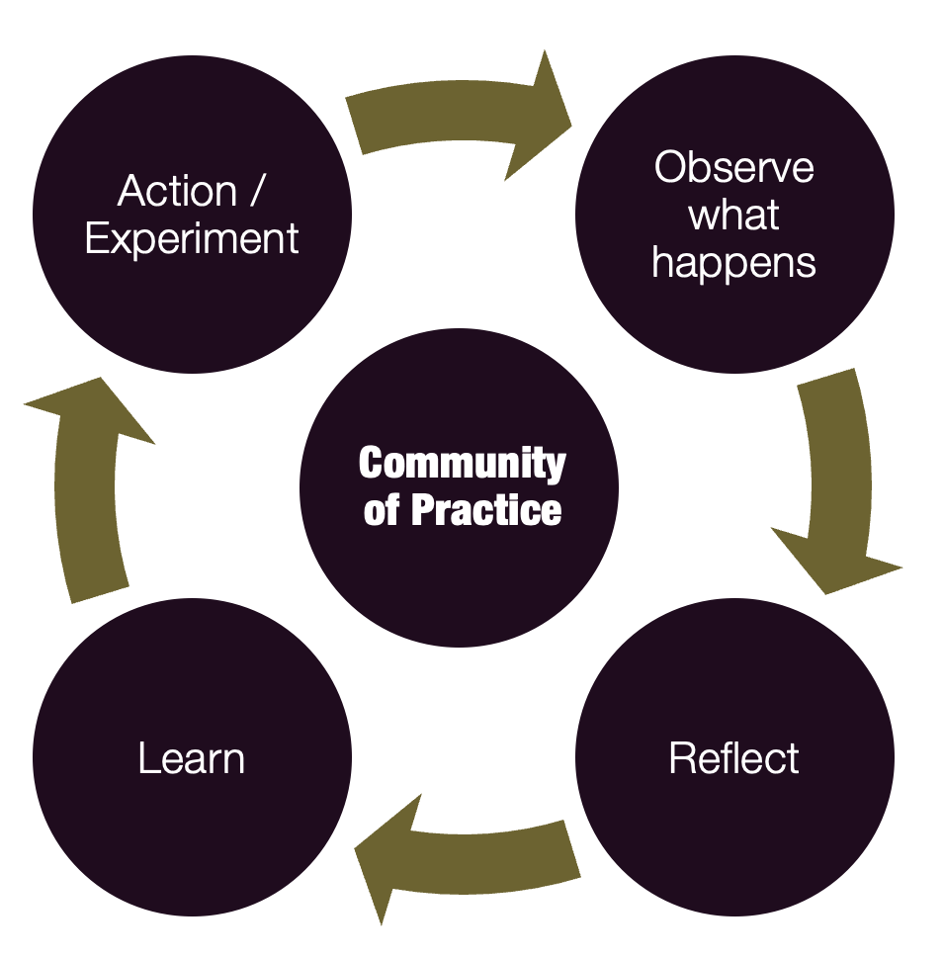

What is one change you might make in your habits, choices, and actions which can support you to have this impact?

As you look ahead to the next two weeks, what opportunities do you see to do this?

What are your intentions for how you will be present in this practice in order to be aware of yourself, others, and your impact?

What are your intentions for how you might reflect after this practice?

How might you share what you are learning and get support from a community of practice of other inclusive leaders?

Takeaway: Exploring Social Identity, Social Location, Social Power
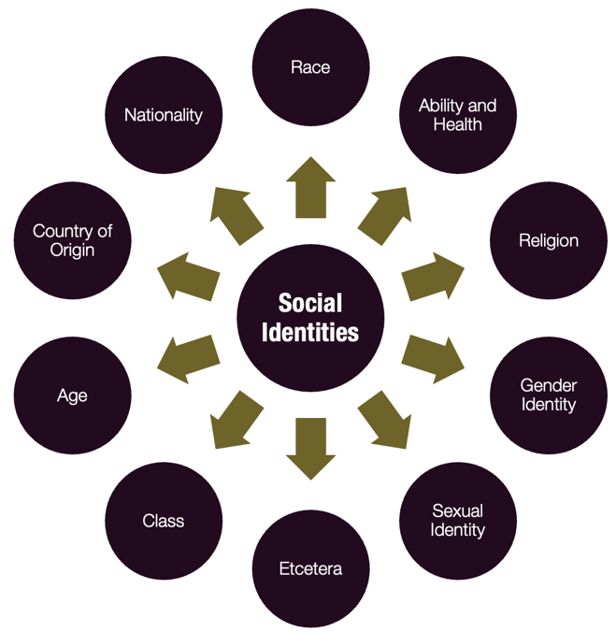
Social identity: the specific groups you belong to, such as our race, gender identity, class, country of origin, age, religion. Our identities are intersectional. Some can change. Some result in advantage, others disadvantage.

Social Location: Where our identities put us in society or in a social system, such as our workplace. Social location is what happens when your identities interact with each other and with our environment and influences the types of power and privilege we have access to and the situations in which we have more or less power and privilege.

Questions that will support you to explore your social identities and social location include:
- Which social identities feel the most salient to you at work?
- Which social identities do you think give you an advantage? What kind?
- Which do you think gives you a disadvantage? What kind?
- What are some isms (e.g., racism, colourism, sexism, classism) that you may have internalized?
- What are some possible gaps in awareness that you may have?
- What are the ways in which your identity can influence conversations?
- How does my social location impact my visibility and my ability to be heard?
- How does my social location impact my communication style?
- How does my social location impact my sphere of influence and perceptions of my expertise?
- Given my social location, how do I decenter myself and amplify the voices of more marginalized colleagues?

Adapted from: How to Talk to Your Boss About Race: Speaking Up Without Getting Shut Down. V. Hutchinson

Notes:

Takeaways

LEARNING
What I am taking away​ | A question or thought I will reflect on
DOING
Actions I will take | The outcomes I hope this action will have

Notes

About Your Facilitator

Jan Campbell, BSc, MBA, CPCC, PCC
Founder and CEO of Strategisense Consulting

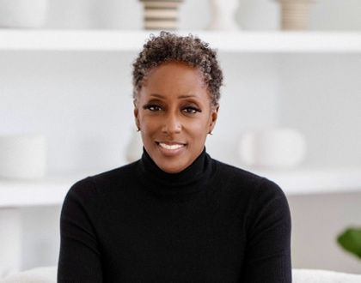
​ Jan Campbell is one of Canada’s most experienced advisors to non-profit, public agency and business leaders. The CEO and founder of Strategisense Consulting, Jan has coached, taught and consulted thousands of leaders and teams from some of the country’s most recognized and respected organizations to build cultures of resilient, curious and deeply committed leadership.

Since 2000, Jan and the team at Strategisense have increased capacity and impact in forward-thinking organizations from the public, private and non-profit sectors across North America and internationally. Strategisense’s sole focus is to support organizations to attract, grow and engage their top talent to transform organizational culture and performance. They do this by evaluating and developing organizational leadership, identify and connecting organizations with top talent, and building high performing teams. ​

Jan started her career in health care administration, had subsequent roles with one of the big 5 consulting firms and was the Executive Director of a research centre at one of the largest Canadian universities. Jan has contributed to numerous local, municipal and national boards and advisory committees related to health care and social services. She is also the founder of the Black Women’s Leadership Network, where over 1000 women from across the globe access personal and professional support to reach their full potential, on their own terms.

Jan is a member of the Canadian Association of Management Consultants and the International Coaches Federation. She is a Certified Professional Co-Active Coach from the Coaches Training Institute. She is an accredited member of the largest coach accrediting body - the International Coaches Federation and has earned the much-respected second highest designation of Professional Certified Coach.

Contact Jan at impact@strategisense.com

