GCcollab user guide for the group <Official languages consultations calendar >
User guide for how to join the group <Official languages consultations calendar> and how to add an event to the shared calendar. To begin, go to your GCcollab online account or create an account here: https:gccollab.ca/splash/
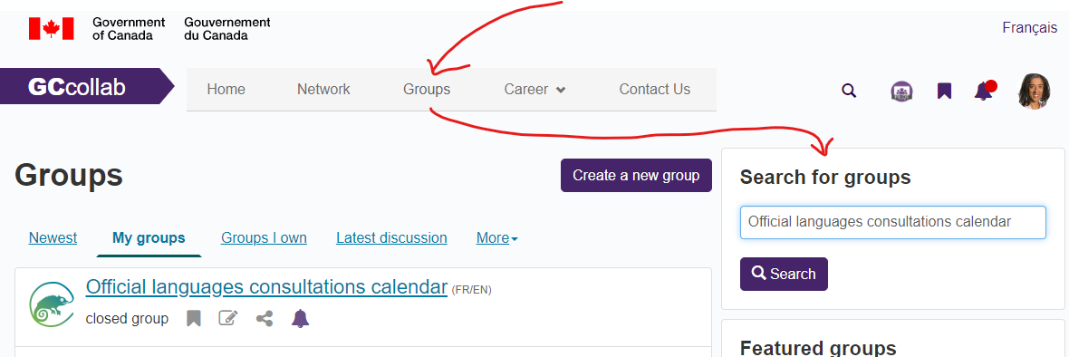
Next, select <Groups> in the top of page selection bar. In <Search for groups>, enter the name of our group <Official languages consultations calendar>. Select <Search>. See next image:

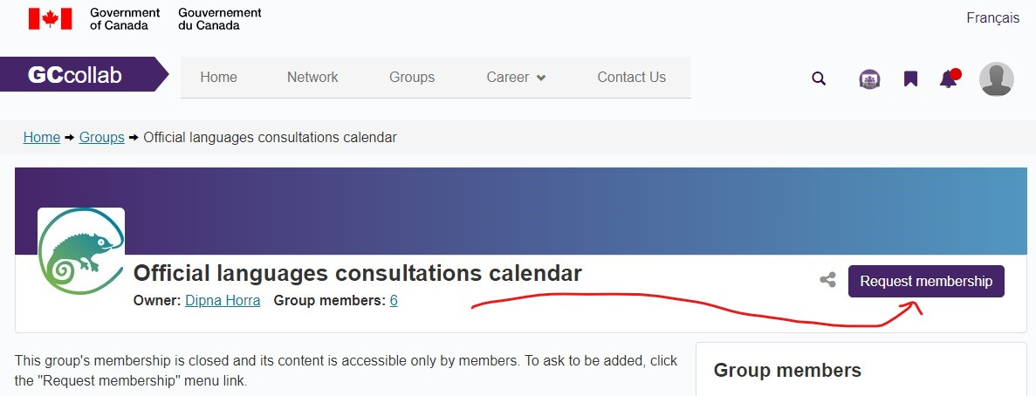
This will take you to the group page where you can select <Request membership>. See image below:

Once we receive your request, we will accept it and you can then add events in the shared calendar. From the home page for the group <Official languages consultations calendar> you will see an option for <More> with a drop-down menu. Select <Events> from the drop-down menu. See next image:

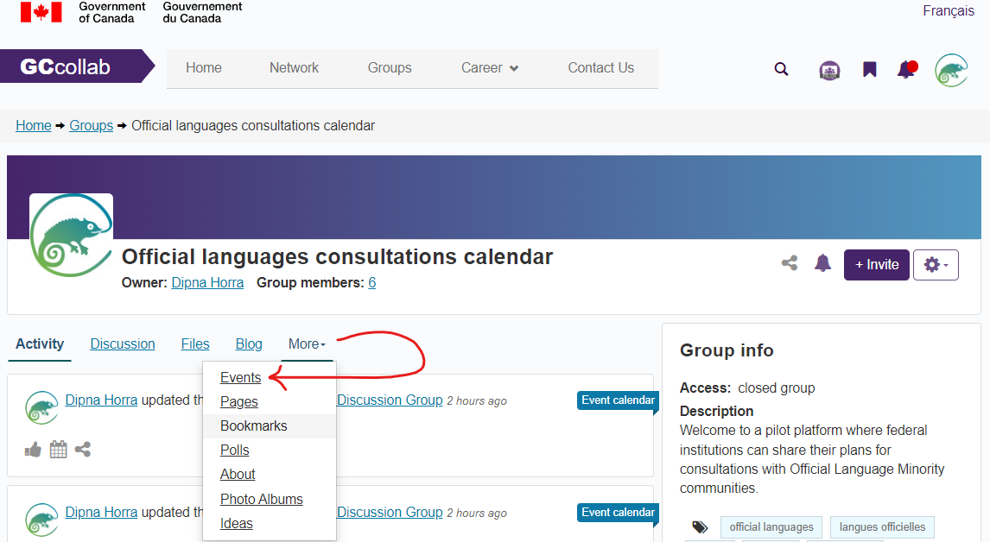
This will take you to a page where you can add an event. Select the <Add event> tab. This will take you to a page where you can add detailed information about your event. See image below:
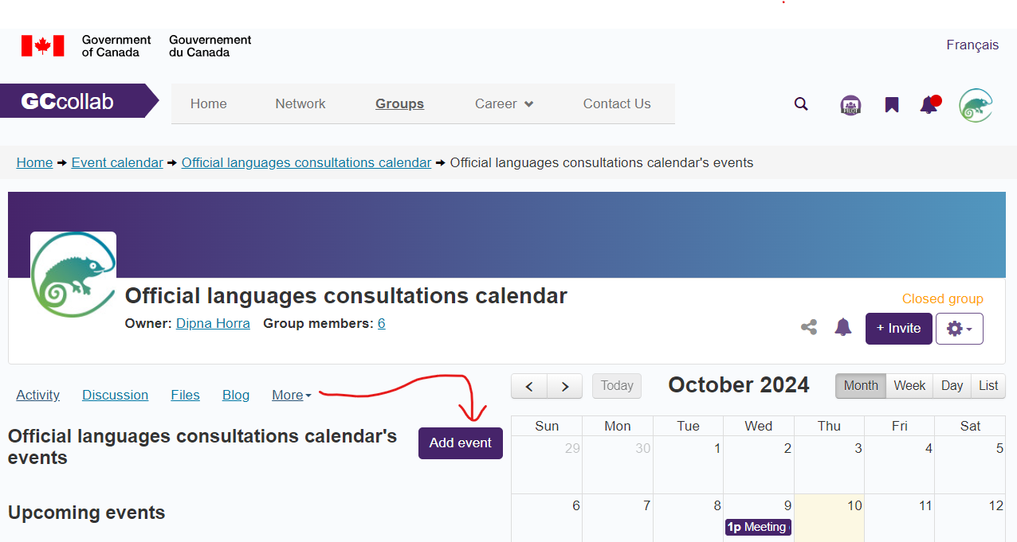
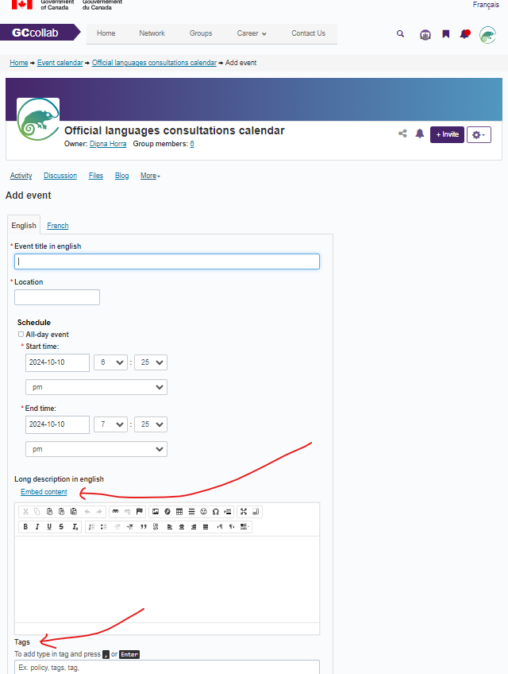
Once in the <Add event> tab, you will be able to provide detailed information. Please provide information in both official languages. Select the <English> tab to provide information in English. Select the <French> tab to provide information in French. The event information that you provide will be available to all members of the group. You can add files to your event, such as meeting agendas and background documents, by selecting <Embed content>, in the event <Long description> section. You can also add <Tags> to your event. For example, “official languages, consultations, arts, health, technology.” See guide and image below:
Please provide information in the following format:
<Event title in English>: Name of institution in acronym and title of event.
For example: PCH consultation for Action Plan
<Location>. For example: Street address; Virtual; Hybrid
Schedule:
Provide date and <Start time> and provide <End time>
Provide <Long description> in the following format. This information can be copied and pasted into the <Long description> text box. See text and image examples below:
Institution name in full:
Objective/topic/key sector(s) to be discussed:
Is this an ongoing dialogue, series of consultations or a one-time session:
Will you hold separate sessions for English-speaking and French official language minority communities on this topic:
Official language minority community stakeholders that you plan on consulting:
Other federal partners participating:
Other stakeholders: For example, researchers, consultants, majority language stakeholders, provincial/territorial governments, Indigenous groups:
What will you do with the information you collect? For example, will you inform policy/program, publish statistics, create reports, use for informal follow up:
Contact information, email address, to learn more about the event:

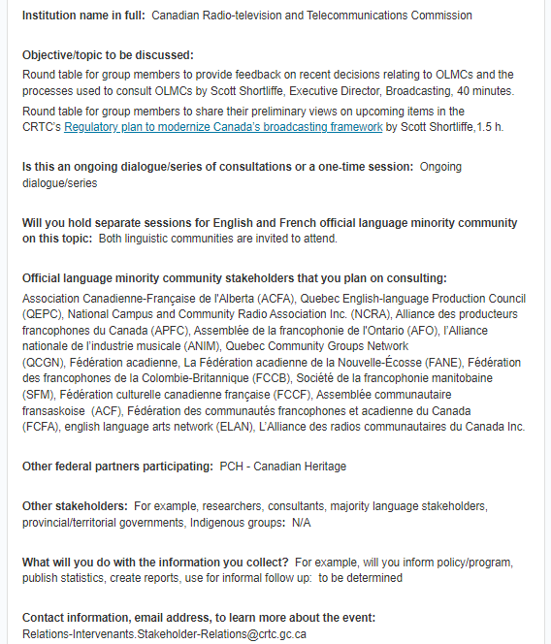
EXAMPLE:

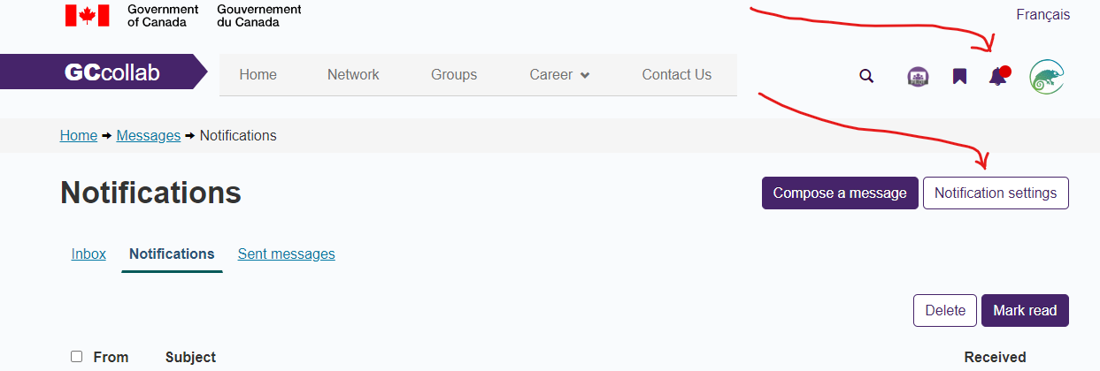
You can return to your event page at any time to make modifications to your event, to delete your event or to add information. Changes that you make to your event will be visible to all group members in the <Activity> tab of the page. To modify activity notifications that you receive from the GCcollab website, follow guide and image below. On the top right of the page, select the bell icon:

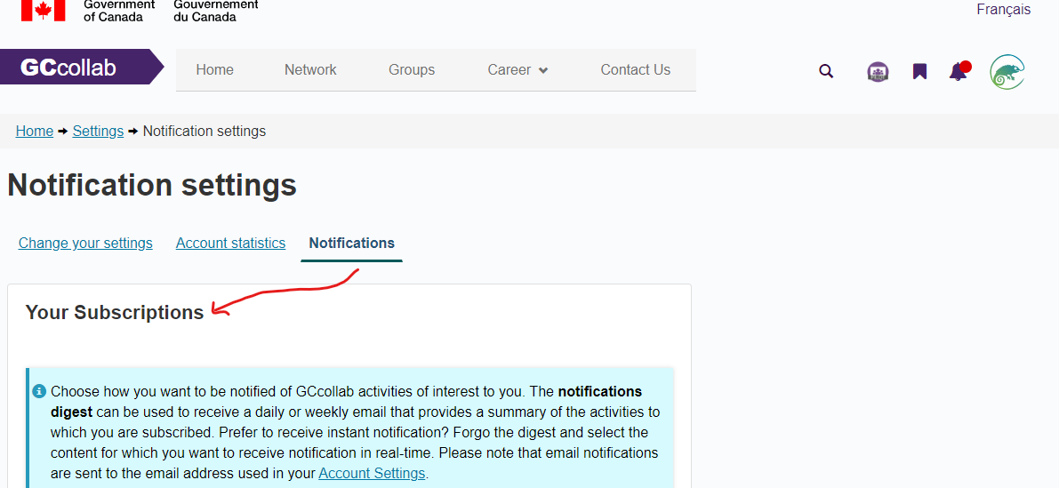
On the <Notifications> page, select <Notification settings>. Select preferences for <Notifications Digest>, <Personal Notifications>, <Colleague Notifications> and <Group Notifications>. Select <Save> to keep changes. See image below:

Contact our team for comments, questions, information on the group <Official languages consultations calendar>: partieviicollaborationpartvii@pch.gc.ca
For GCcollab website support, contact: https://gccollab.gctools-outilsgc.ca/en/support/home

