**Treasury Board Secretariat of Canada – Regulatory Affairs Sector (CORE-CCR@tbs-sct.gc.ca)**

2019

**The Regulatory Costing Calculator 3.0**

**User Manual**

# What is the Regulatory Costing Calculator?

The Regulatory Costing Calculator (the Calculator) is a tool developed by the Centre of Regulatory Expertise of the Regulatory Affairs Sector at the Treasury Board of Canada Secretariat (TBS). The Calculator is a Microsoft Excel template that uses Excel’s built-in formulas as well as customized functions, forms and Visual Basic code. The user enters key information (inputs) regarding requirements of a proposed regulation in order to estimate compliance costs imposed on stakeholders (outputs) in a manner consistent with TBS guidance and policies.

The Calculator’s purpose is to provide federal departments and agencies with a standardized tool to conduct the analysis required for the one-for-one rule (the Rule), the small business lens (SBL) and cost-benefit analysis (CBA). For the Rule, regulatory departments are to use the Calculator to quantify and monetize increases or decreases in administrative burden costs. For the SBL, the role of the calculator is to help quantify and monetize both compliance and administrative costs imposed on small business. Regulators can also use the Calculator to estimate costs of a regulation on non-business stakeholders (governments and individuals) as part of a more comprehensive cost-benefit analysis.

TBS based the Calculator’s method on the internationally recognized Standard Cost Model. The Calculator contains key data from Statistics Canada, such as the number of businesses by industry and hourly wages by National Occupation Classification. Standard default parameters are also set (such as the discount rate and number of years over which to assess impacts) to facilitate the aggregation of results across departments. As per the Treasury Board of Canada Secretariat guidance documents on the one-for-one rule and the SBL, departments are strongly encouraged to use the Regulatory Cost Calculator to monetize administrative burden costs for regulatory proposals.

# Purpose of this Guide

By reviewing and referencing this guide the reader will have:

1. A basic understanding of the theory of the Standard Cost Model that underpins the Calculator.
2. Practical instructions and advice on how to use the Calculator to estimate regulatory administrative burden and compliance costs as required under the SBL and the one-for-one rule.
3. Transparency on what the calculator is doing in the background between inputs and results.

Departments and agencies should be aware that the Calculator is only a tool, and it remains the responsibility of those using it to understand and be able to explain the estimated outcomes it produces based on the various content entered.

# Theoretical Foundation: The Standard Cost Model (SCM)[1]

The origins of the Standard Cost Model (SCM) come from the Netherlands, but various other jurisdictions and organizations, including the Organisation for Economic Cooperation and Development, have adopted and extensively applied it. Its main application has been in support of a number of initiatives aimed at measuring and consequently reducing the level of administrative burden costs imposed on businesses. According to the SCM Network, it is today, the most widely applied methodology for measuring administrative costs.

The basic idea of the SCM is a simple one. There are two key factors to cost, price and quantity. This simplicity in concept, however, can sometimes be more complicated to implement. Issues of when and how often an activity occurs, economic growth, accounting for time preference (discounting) and determining the most appropriate method to estimate model inputs all come into play. Addressing these issues appropriately and consistently helps to remove potential bias; this is a central goal of the Calculator’s implementation of the SCM.

As a starting point to further understanding how this is done, the main components of the SCM are described below:

*The SCM method breaks down regulation into a range of manageable components that can be measured: information obligations, data-requirements and activities.*

*Information obligations: Information obligations (IO) are the obligations arising from regulation to provide information and data to the public sector or third parties. An IO does not necessarily mean that information has to be transferred to the public authority or private persons, but may include a duty to have information available for inspection or supply on request. A regulation may contain many information obligations.*

*Data requirements: Each information obligation consists of one or more data requirements. A data requirement is each element of information that must be provided in complying with an IO.*

*Administrative activities: To provide the information for each data requirement a number of specific administrative activities must be undertaken (e.g. filling in information, sending information, archiving information, etc). Activities may be done internally or be outsourced (i.e. done externally).*

*The SCM estimates the costs of completing each activity on the basis of a couple of cost parameters:*

* *Price: Price consists:* 
  + *Tariff or wage (hourly) costs plus overhead for administrative activities done internally or hourly cost for external service providers.*
  + *Time, the amount of time (in hours) required to complete the administrative activity.*
* *Quantity: Quantity comprises:*
  + *Population or the number of businesses and or enterprises affected.*
  + *Frequency that the activity must be completed each year.*

***Combining these elements give the basic SCM formula:***

**Activity Cost = Price x Quantity**

**= (tariff x time) x (population x frequency)**

# Using the Regulatory Cost Calculator

## Opening and Navigating the Calculator

### Security Issues

The Calculator uses customized code and functions to complete calculations and automate features. This, depending on your security settings, can trigger warnings/notices in Excel when opening the Calculator. If this occurs Excel may require a confirmation that you want to “Enable Macros” and/or “Enable Content” of the file. If this warning appears you should enable both Macros and the content of the Calculator.

Depending on how strict your department/agency’s security settings are, you may also need to contact your IT department to receive the authorization necessaire to enable these features.

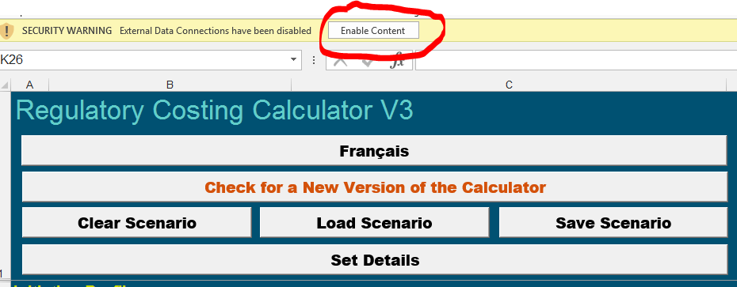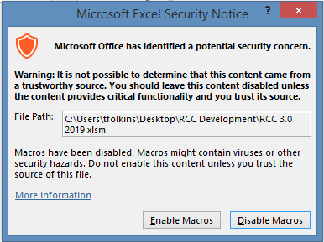

Figure 1: Enabling the Content of the RCC

### Checking for New Versions

The Centre of Regulatory Expertise continuously responds to feedback from users to improve the Calculator. So, when starting a new analysis, you should check if a new version is available. You can do this by pressing on the “*Check for a New Version of the Calculator*” button located at the top of the “*Initiative Details”* tab. Pressing this button will cause the Calculator to attempt to examine the webpage for the RCC to determine if the version number of the RCC you are using is the most recent. If a newer version is available, then the Calculator will prompt you to determine if you would like to open the website to download the newer version. If a new version is not available, you will see a message that confirms you are using the most recent one.

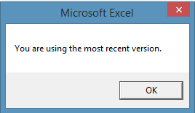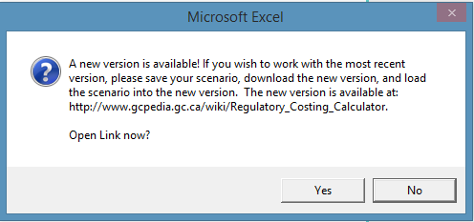

Figure 2: Checking for an update

When you check for a new version of the Calculator an update of the Consumer Price Index will also be done based on an online table (if any new data is available). The webpage which contains CPI data also contains wage data and other Calculator parameters that are set by the Red Tape Recuction Regulations. These are:

* The price year required to value costs of labour and costs for capital expenditures (currently 2012)
* The common base year to discount values back to for discounting (t=0) for values recorded under the one-for-one rule (2012)
* The discount rate to be used when calculating present values for the one-for-one rule (7%)
* The number of years over which to assess costs (10 years)

If any of these values are different from values you have set in the Calculator, they will be highlighted in red on the ***Inititive Details*** tab. The common base year value will automatically be updated to the appropriate value if the new values differs from the current value in the Calculator. This change is done automatically because, unlike the other parameters that a user may wish to change for reporting purposes under CBA or the small business lens, the common discounting base year value is only used for calculations releated to one-for-one rule reporting.

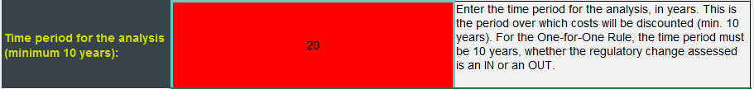

### Language Selection

Now that you have dealt with any possible security issues and have checked that you are using the most recent version, you are ready to start using the Calculator. The first thing you should do (if you haven’t already) is decide which official language you wish to work in. If you have set the default interface language of Excel as “Français” the Calculator will open with a French user interface, otherwise the RCC starts in English. If you wish to manually switch from English to French or vice-versa, you can do this by clicking on the Language button at the top of the “*Initiative Details*” tab. **We recommend costing a regulation exclusively either in French or English without switching between the two.**

### User Input

While the Calculator is an Excel application, a user can enter, edit, and delete almost all inputs via customized forms. The user can open these forms by clicking on various buttons on the various tabs of the Calculator. We will examine each of these forms and how to access them in this manual.

User can also enter inputs to the Calculator directly in the cells of the spreadsheet as one would do in a traditional Excel file. Cells for user input are formatted with teal borders and white fill (see below). Most other cells in the Calculator, contain formulas or pre-set parameters, are protected and the user may not change them. If you have need to examine these cells please contact TBS-RAS for instructions on how to unlock the Calculator.

|  |
| --- |
| User Input |

Collections of inputs in the Calculator appear in rows with both protected and unprotected content. This makes it difficult to manually delete an entry, so we recommend that collections be deleted using a form control. The form control will remove all data points in a collection without creating errors in cell references used by protected content. More information on how to do this will be discussed in this manual.

**USER TIP: When deleting a data collection item (stakeholder group or costed activity) use a form control. The form control will automatically delete all data for a data collection, leave protected content untouched, and reorder remaining collections, avoiding blank rows.**

**Note: a blank row in either the stakeholder list or cost items will cause subsequent entries to be ignored when using either scenarios or reporting features of the RCC.**

## Implementation Overview

The best way to implement the Standard Cost Model with the Calculator is to follow a series of logical steps, as laid out in Figure 1: Steps to implement the Calculator. The following sections of the guide contain further details on how to complete each of these steps and how to enter the associated information into the Calculator.

Figure 3: Steps to implement the Calculator

## Step One: Initiative Details - Initiative Profile

When using the Calculator, information that sets the regulatory context should be entered on the first tab named “*Initiative Details”*.

You can edit this information directly on the spreadsheet. If you wish to copy and paste from another document, it is best to click on the appropriate cell and press “F2”. The F2 key is a short-cut in Excel to edit the selected cell’s contents. By doing this you will retain formatting such as carriage returns, which if pasted directly into a spreadsheet adds content over multiple rows. If you are typing the results directly into the cell you can enter a carriage return in a cell by pressing “alt-enter”.

Figure 4: Initiative Profile

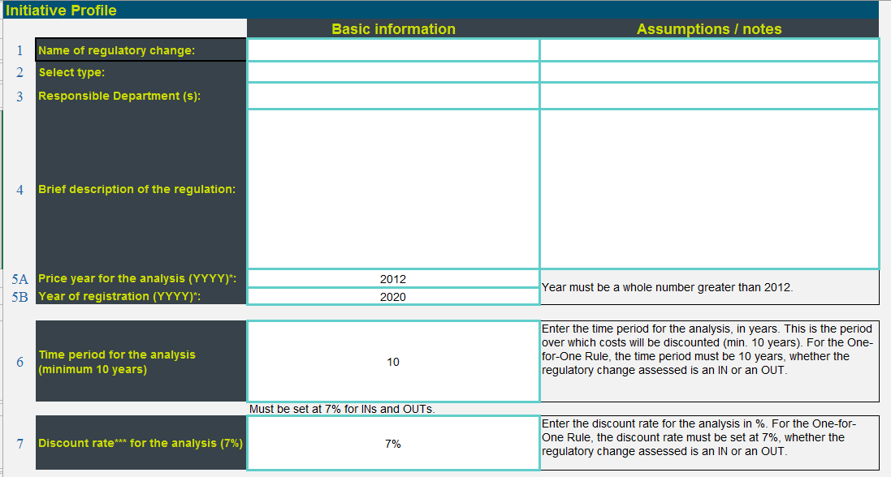

**USER TIP: When copying and pasting descriptions from another document into a cell, select the cell and press “F2” before pasting. This avoids Excel interpreting carriage returns as data to be entered in subsequent rows.**

As an alternative to entering inititive details in the cells of the spreadsheet you can trigger the appearance of the customized user form by pressing on the “*Set Detail*” button at the top of the sheet. Other buttons appearing at the top of the “*Inititive Details”* concern clearing, loading and saving scenarios, which will be discussed later.

Figure 5: Regulatory Details Form

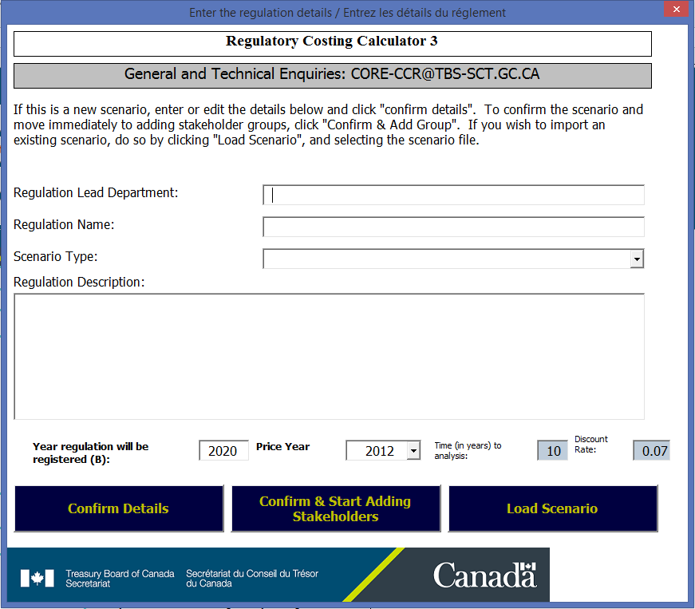

The first information you should provide (Cell **C19**) is a **clear and concise description** of the regulations that your department or agency is proposing. Because the Calculator is designed to measure incremental business impacts, this description focuses on how the proposed regulation would cause businesses to change the way they operate. For context purposes, the user may also wish to briefly describe the objectives of the regulation. Never assume that a second party, who may review the Calculator, has access to supplemental documents such as the Regulatory Impact Analysis Statement. To the extent possible, make the RCC a stand-alone product that is easy to follow. In summary, the regulatory context should briefly describe:

1. what the regulation does;
2. what is its intended outcome; and
3. how it will impact businesses.

Including the regulatory description, in total there are six inputs to enter:

1. *Name of the regulatory change* (Cell **C13**): The title the regulation will be given when published within the Canada Gazette. **For reference purposes it is advised that you add the Statutory Orders and Regulation number (SOR number) to this field after the regulation has been registered**. As regulatory titles are not unique, the SOR number will allow cross-referencing Calculator scenarios to regulations in the future.
2. Type (**C15**): Indicate if the Calculator is being used to calculate an “IN” or “OUT” under the one-for-one rule. If the Calculator is being used to cost a regulation unrelated to administrative burden, you can select “Other”. **If a regulatory proposal’s net impact is calculated in combination with other Calculator scenarios this should be documented in the assumptions/notes area**.

**USER TIP: When the scenario type selected is IN, the final result should be an increase in costs. In this case any element of the proposal that *decreases costs* should be entered with a negative parameter. This should be done by indicating a negative in the number of hours for a task or a negative for the number of units purchased.**

**Similarly, if the selected type is an OUT, this implies the final result is a decrease in cost and any element that *increases costs* should include a negative parameter.**

1. Responsible Department (**C17**): Name of the department that will recommend, make, and/or approve the regulation. **When a regulation is jointly managed by several departments, this should be mentioned in the assumptions and notes area as well as any information relevant in support of the decision of which the minister is responsible**.
2. Description (**C19**): The Regulatory context, as previously described.
3. Years
   1. Price year for the analysis (**C20**): The year of prices (cost of labour, cost of units) used in the analysis. All prices used to estimate costs must be from the same year. Prices for labour costs preloaded in the Calculator (version 3) are from 2018. If a different price year is selected the calculator will deflate or inflate these values using the Consumer Price Index to the selected price level. The price year for the one-for-one rule is determined by the [Red Tape Reduction Regulations](https://laws-lois.justice.gc.ca/eng/regulations/SOR-2015-202/index.html) (currently 2012).
   2. Year of coming into force (**C21**): The year that your department anticipates the regulation will be registered. When opening a blank version of the Calculator this value will default to the current year plus one. Analysis for costing activities in the Calculator starts from this year.

1. Time-period for the analysis (**C23**): Number of years over which you will estimate costs. TBS policy requires a minimum ten years for Cost Benefit Analysis (CBA). The Red Tape Reduction Regulations require a ten-year period for INs and OUTs under the one-for-one Rule and cost estimates.
2. Discount rate for the analysis (**C26**): The percent per year that the value of future costs will be reduced. This value should normally be set to 7% (real discount rate), as required by TBS CBA policy and the one-for-one rule and small business lens analysis. However, you can temporarily adjust this number for sensitivity analysis purposes within a CBA context.

## Identify Regulated Community – Setting Stakeholder Groups

The next step in the process is to identify, group and estimate the number of businesses that the regulatory proposal will affect.

The Calculator has built-in information from Statistics Canada on counts of businesses using categories from the North American Industrial Classification System (NAICS). This information is contained in the “*Business Counts”* tab, as can be seen in Figure 6: Selecting NAICS in the Calculator.

As there are numerous NAICS available, the Calculator requires you to short list the codes that you may need when creating stakeholder groups. In order to create this list you must enter a “**1***”* beside the NAICS codes of interest (**column A**) that you think could be included in your regulated community.

Figure 6: Selecting NAICS in the Calculator

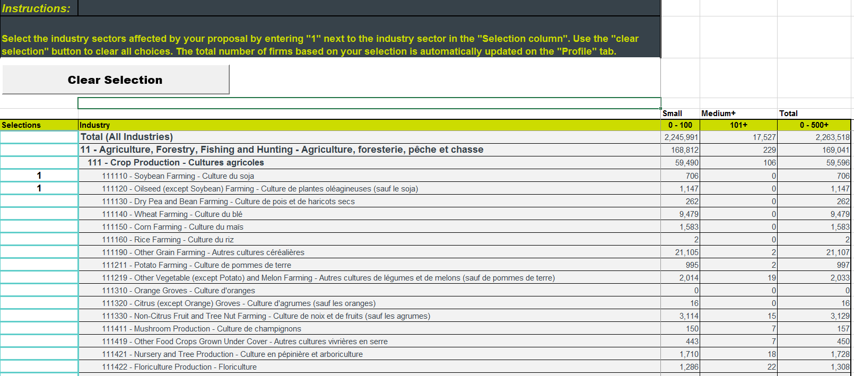

Once you have entered a “1” beside the selected industry it will be added to the short-list of industries impacted in the “Stakeholder Profile” tab as seen in Figure 7: Calculator List of Industries Impacted.

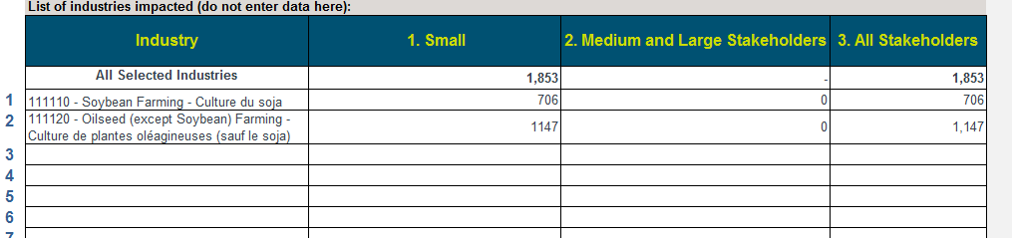

Figure 7: Calculator List of Industries Impacted

Next, you need to start creating stakeholder group. Regulations often have compliance and administrative burden cost changes that do not clearly align with NAICS or impact different stakeholder groups in unique ways. This is why the Calculator has the ability to create multiple custom *stakeholder groups***.** This function enables the user to combine several NAICS codes, or create groups with stakeholder counts that are independent of NAICS. You can access the form to create a stakeholder group by pressing the “*Create A Group”* button on the *Profile* tab.

Figure 8: Entering a Stakeholder Group

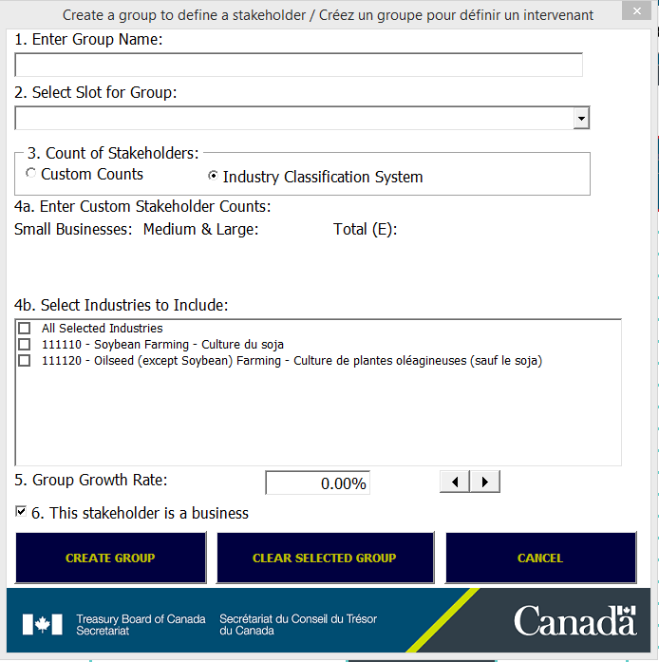

The form includes six inputs:

1. A unique name to be used to reference the stakeholder group.
2. The memory slot in the *Table of stakeholder groups and business sizes* in which the information on the group will be entered. The form will automatically select the first slot marked as “Empty/Vide” by default, but you can manually chose a different one. If a slot that already has data is selected this data will be overwritten. There is a maximum of 30 slots available for the creation of Stakeholder groups.
3. Select whether the stakeholder counts for this group will come from pre-selected NAICS codes or if they will be a custom count.
4. Business Counts:
   1. If in (3) you selected C*ustom Counts,* the fields to enter the number of small and medium and large stakeholders will become active. The Calculator will enter the required data in the *Total* field.

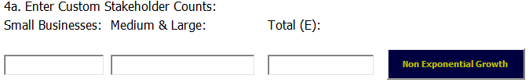

If you have a group with different numbers of stakeholders impacted by a regulatory requirement in each year of a ten-year period of analysis, you can press the *Non Exponential Growth* button. This will cause a form to appear where you can enter the number of stakeholders impacted in each year for small and medium+ sized stakeholders. Once you press the *OK* button, the calculator will estimate a single number of stakeholders that will approximate the cost estimate for this stakeholder. This result will provide reliable cost estimates for the stakeholder group under two conditions. First, that the cost **associated with the stakeholder is ongoing** (see costing section for more information on timing types), second that the growth rate of the stakeholder group is 0%.

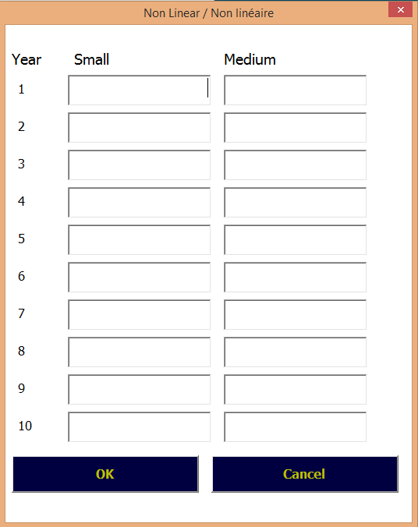

Figure 9: Non-Linear Growth

Equation 1: Calculation of non-linear growth

$$No of Business=\left(\sum_{t=1}^{10}{\frac{{Business}_{t}}{{(1+r)}^{t}}}\right)*\left(\frac{r*{\left(1+r\right)}^{t}}{{\left(1+r\right)}^{t}-1}\right)=\left(\sum_{t=1}^{10}{\frac{{Business}_{t}}{{\left(1.07\right)}^{t}}}\right)*0.1424$$

Where:

Businesst=Number of businesses in time t

r=discount rate used = 7%

* 1. If in (3), the *Industry Class Counts* was selected, the short-list of the NAICS codes selected will appear. You can select any combination of these codes as desired and the business counts for the selected codes will be aggregated.

1. If applicable, you can enter an annual growth rate for the number of businesses (exponential growth). You should base this information on evidence that the impacted sector is growing or declining. For example, a growth rate of a business can be estimated using historical trends. In absence of any such information the real growth rate of the economy may be a good proxy. If you have used the non-exponetial growth button to estimate a business count, you should keep the annual growth rate at zero.
2. The last element is to specify whether the stakeholder group you have defined is a business or not. Any costs associated with a group that you have identified as a business will be included in total cost estimates reported for the SBL and the one-for-one rule. This facilitates the use of the Calculator to estimate costs on a wider number of stakeholders for use in CBA while also reporting exclusively on business.

## Costs – Identifying and Costing Requirement Changes

This section discusses step three of the Calculator implementation process. This information can be entered manually into the spreadsheet in the ***Costs***tab, or you can opt to use forms. The form for administrative burden activities is activated by pressing the *Add Administrative Cost* button on the *Costs* tab. This form appears as below:

Figure 10: Requirement Costing Form

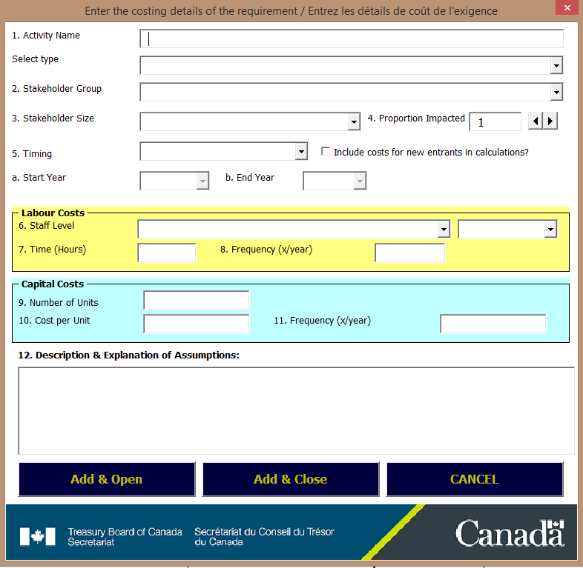

1. Activity Name (**column B**) The Calculator will add text you enter here to the spreadsheet in the first blank row of the *Costs* tab. The description should be clear and make it easy to cross-reference requirements described in the Regulatory Impact Analysis Statement.

1a. Activity Type (**column C**)provides a space to categorize the activity as being associated with an administrative burden cost or compliance cost. Only activities that have been identified as administrative burden costs and associated with business stakeholders are included in estimates for the one-for-one rule.

1. Timing (**column D – E – F**): The classic standard cost model includes two options for timing of a regulatory activity.

These are either upfront (one-time) or ongoing. In addition to these two categories, the Calculator includes an option to add greater precision by using custom timing. Each category is described in more detail below.

**USER TIP (Timing): The years set in timing are associated with January 1. This means that a regulation set to run between the years 2020 – 2030 would start January 1, 2020 and end January 1, 2030 (i.e. exclusive of costs incurred in 2030).**

**A**

* An **upfront** activity/capital cost is one that is assumed to occur only once at the very beginning of the regulation. An example of this kind of cost for administrative burden is requirements for businesses to learn about information obligations of the regulation.
* An **ongoing** activity/capital cost is one that occurs on a regular frequency over the timeframe of analysis.
* A **custom** time period for an activity/capital cost is one that occurs at a regular frequency over a sub-set of the entire time frame of analysis. For instance if a regulation had a 10 year timeframe of 2013-2023, you could set a sub-timeframe of 2013-2016 or 2015-2018. You can also use the custom timing for an activity that occurs for one year. For instance, a cost incurred for only one year in 2018 would be recorded as a custom timing from 2018 to 2019 (January 1, 2018 – January 1, 2019).

**USER TIP (Timing 2): The RCC handles custom timing by considering the population of businesses impacted in a period that occurs outside of the custom time frame to be 0 (see appendix**, **Equation 7: Population)**. **This will cause adjusted business counts in the RCC (columns AU-BF) to be below the normal populations even when you have not specified a growth rate for that stakeholder.**

1. Stakeholder Group (**column H**): Here you will link the activity with a stakeholder group. The field in this form contains a drop-down list of all the available stakeholder groups you have previously created.
2. Business Size (**column I**): This will allow you to further define the stakeholder group impacted by specifying if it impacts small, medium and large, or all stakeholders. This can be useful when a stakeholder’s size changes the way you expect they will comply with a requirement.
3. Proportion Impacted (**column J**): You can make a further refinement to the stakeholder group impacted by the activity by specifying a percentage. If a requirement will affect all stakeholders then you should enter 100%. However, if you have evidence that only a portion of all stakeholders will complete the activity then you can incorporate this information here. For instance if 25% of stakeholders voluntarily prepare information that the regulation proposes to make mandatory, then the percent impacted would be 75% (100%-25%).

**When using the form** **percentages you should enter the information in decimal form, for example 75% should be entered as 0.75. If entered as a whole number (i.e. 75), the form will automatically change this to a decimal.**

You can also use this field to represent a probability that any given stakeholder within the group may need to perform a particular action. For instance, a business may be subject to random inspection. If the probability of inspection for any given business in a year was 25%, then you would enter the value 0.25 for the proportion impacted.

5A. New Entrants (**Column K**): When you select the option to include new entrants, the manner in which the Calculator costs activities is dependent on timing of the activity:

* **Upfront**: Although an upfront cost only occurs once for currently existing businesses, you can also think of these costs as an ongoing cost incurred by new entrants. In other words, when new businesses enter the market, they incur the same upfront cost as existing businesses did when the regulatory requirement was introduced. If this box is checked, the Calculator will take this into consideration when calculating the cost for the action described.

As an example, consider a new requirement to complete and submit a registration application that a regulation has imposed on 100 businesses. When identifying this stakeholder group, you determined that the industry will grow at a rate of 10% per year over the assessment period. At time t=0, the existing businesses are all assumed to register and incur this cost. At the end of year one (t=1), 10 new businesses enter the industry and need to register (100 * 0.1), at the end of year two (t=2), 11 new businesses (110 * 0.1) and so on.

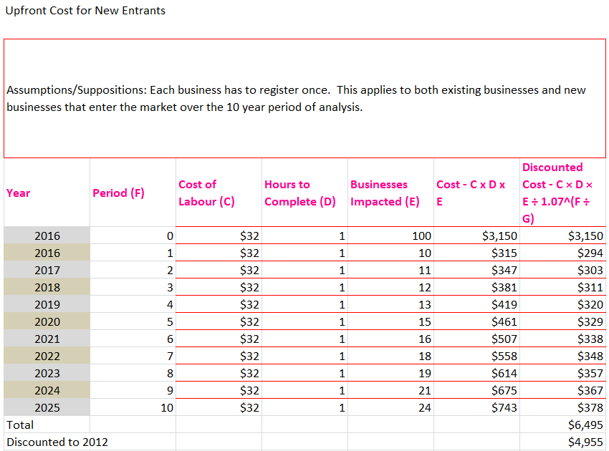

* **Ongoing and Custom**: If the timing selected is ongoing or custom then the interpretation of including entrants changes. In this case, instead of applying the cost to both existing businesses and new entrants, the calculator applies the cost **ONLY** to new entrants.

This can be useful for regulatory requirements that are introduced with a grandfathering scheme. For instance, following the previous example of businesses registering, the regulator may already have all of the information required to register existing businesses and thus exempt the 100 businesses from this requirement. However, new entrants would still need to register and submit the required information.

This can also be useful for estimating savings from regulatory modernization that make existing requirements easier to understand. As existing businesses have already spent resources to learn the old, more complex requirements, they cannot save time by “unlearning” them (a sunk cost). However, new entrants will find the requirements in the new regulations easier to understand and thus have incremental savings as compared to the old regulations.

* 1. Internal/External (**column U**): In order to further refine the *tariff*, i.e. cost of labour, you need to select whether the work to complete the activity will be completed by staff that are internal to the business or externally contracted.

In the case of internal, the RCC adjusts wages to account for overhead costs to the employer of keeping an employee on staff. If the worker is considered external then a premium is added to the wage to account for the profit margin of the company providing the service. For reference, the equations for these adjustments are provided below.

Equation 1: Internal Cost of Labour

$$Internal Cost of Labour=Wage*\left(1+Overhead\right)=Wage*1.25$$

Where:

Wage = Average wage for occupation category

Overhead = Percent of wage that is assumed to represent overhead cost of an employee = 25%

Equation 2: External Cost of Labour

$$External Cost of Labour=Wage*\left(1+Premium\right)= Wage*1.5$$

Where:

Wage = Average wage for occupation category

Premium = Additional percent cost for businesses that hire external staff to complete an activity = 50%

**USER TIP: Overhead and premium factors are added to wage rates to transfer them into costs of labour (the cost to the employer as opposed to the wage received by the employee). If you have a custom labour cost that you wish to use, it can be derived by dividing it by 1.25 (Internal) or 1.5 (External).**

**For example, if you desired to use a custom labour cost of $10 you would enter 10/1.25 = 8 as a custom wage and select Internal when costing the activity.**

**Labour Costs**

1. Staff Level (**column V**): This field provides a list of occupational categories. The occupation selected will determine the cost of labour for the regulatory activity. In SCM language this is the “tariff” component of the price equation of *tariff * hours*. The list of occupational categories and related wages are listed in the **Labour Costs** tab of the RCC.

You are also able to add up to five custom occupational wage rates in the Calculator. Custom wages can be entered and edited by pressing on the ”Custom Wages” button the on the **Costs** tab**.** These values are stored in cells **C55-C59** in the **Labour Costs** tab. Note that overhead costs are also added to the custom wages you enter according to if the resources are identified as internal or external. If you wish to change the default 25% and 50% mark-ups for overhead and consultant premiums you can do this using this form.

Figure 11: Entering Custom Wages

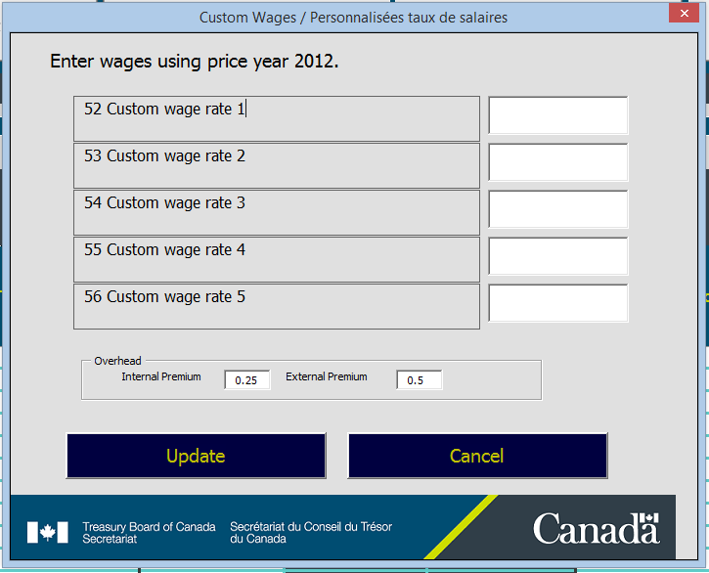

1. Time (Hours) (**column W**): The number of hours it takes to complete the activity. This, combined with the cost of labour, will determine the *price* of the activity. This time factor is supposed to be the time it takes for the *average* business to complete the task. While some businesses may take more time and others less, using the average time will give the most accurate overall estimate for the cost of all businesses to complete the requirement.
2. Frequency (x/year) (**column X**): The frequency number is the times per year the regulation requires the activity to be performed or the change in the number of times a year an existing activity is required. For instance, if a report was required four times a year and a regulatory proposal would reduce it to one time a year the change would be three times a year.

**USER TIP: In the RCC, if an activity is required at a frequency of less than once a year, this can be entered into the frequency field as a fraction. For instance, if an activity is required every 2 years than 1 time / 2 years = 0.5. Once every 5 years would be 1 time / 5 years = 0.2 and so on. Note that an activity (other than upfront) is always assumed to occur at the end of the period being assessed. This means that an activity that occurs once every two years is assumed to occur at the end of every 2 year period.**

**Capital Cost**

1. Number of Units (**column P**)**:** When a regulatory requirement can be more easily described by the number of units required rather than the number of hours of labour this option is available. In this case you can enter the number of items that an average stakeholder would need to purchase in order to comply with the regulation. This can be used for services as well as goods when there is a clear market price established for the service. While a capital cost is often associated with a compliance cost there may also be cases when you may be able to more accurately describe an administrative burden costs by units rather than time required (hours) to complete an action.
2. Cost Per Unit (**column Q**): The cost per unit in 9 can be entered here. The cost per unit should be measured in the price year of the analysis. This may be the cost per unit ($ per widgets) or a cost per service ($ per preparation of an application). Costs per unit should be entered without any sales tax added.
3. Frequency (**column R**): The number of times per year a typical stakeholder needs to purchase the service or item.

**USER TIP: For any cost item you can ascribe both labour and capital costs. For instance a cost associated with mailing an application may include labour cost associated with completing the form and a capital cost associated with mailing the package to the appropriate recipient.**

1. Explanation of Assumptions (**column V)**: It is here that you should include the explanation of what the requirement is, how you estimated the cost parameters, and any assumptions you have made in the calculation. This is very important information to enter into the Calculator for an activity/capital cost. While it is not required to arrive at a result, this enables others who view the calculator to understand the values used.

### Add & Open or Add & Close?

If, after you have completed filling out the form, you wish to immediately add another requirement using the same form you should press the ***Add & Open***button. If you wish to transfer the information to the spreadsheet and then close the form press the ***Add & Close*** button. If you wish to just close the form without transferring any information you can press the ***Cancel*** button.

### Editing and Deleting Costs

You can edit existing entries either directly in the spreadsheet or you can load the data into the customized form by pressing the ***Edit a Cost*** button (tab *Costs*).

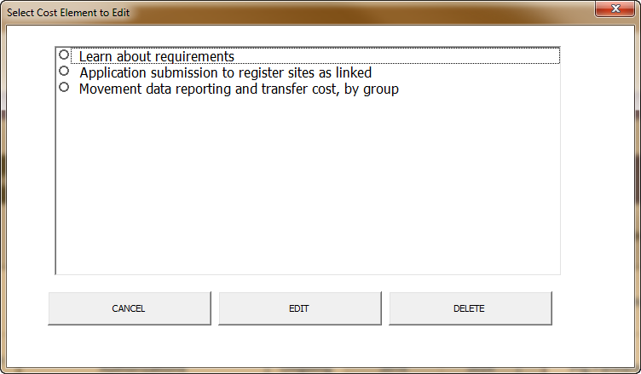

Figure 12: Editing Cost Actions

From this form, click the activity you wish to edit, then click *Edit* and the form will open with the appropriate data loaded.

If you want **to delete one cost item**, you can also select it from the list and click “DELETE”. Once you have confirmed this action, the item will be removed and any items listed below it shifted upwards to avoid blank rows. You should not have blank rows in the Calculator. A blank row signals to the application when it saves scenario files or creates reports that no more activities are listed. Activities listed after a blank will therefore not be saved in a scenario file or listed in any Calculator reports.

### Calculating Total Present Value and Annualized Values

As with cost benefit analysis, the Calculator takes into account time preference and opportunity cost of capital by using a discount rate to decrease the value of benefits or costs that occur in future. The method by which the Calculator calculates total present values and annualized values (the equivalent to a total present value expressed as an annuity or annual payments) works on discrete time periods that are normalized such that **an activity a stakeholder performs always occurs once at the end of that period**. This, as an example, would cause an activity that occurred 12 times yearly to be discounted on a monthly base using a monthly discount rate equivalent to the annual rate.

More traditional CBA methods using annual periods result in bias when the frequency of an activity is not equal to one. This is especially true for frequencies that are less than once a year, for instance once every three years. Such cases result in an upward bias (over-estimation) of administrative burden costs/savings when using annual periods.

This method used in the RCC is mathematically equivalent and produces the same results as those describe in the *Red Tape Reduction Regulations*. Equivalency can be demonstrated by running the RCC’s period report – discussed later in this manual. The technical details are included in this document in appendix 8.4Calculating Total Present Value and Annualized Values*.*

### Importing and Exporting Scenario Files

The Calculator has the ability to save and load scenarios, which are files containing all user inputs. Scenario files makes it easier to have multiple cost estimates, switch back and forth between scenarios, share them with others, and preserves disk space. In addition, having scenario files will make it easier to transfer inputs from the current version of the Calculator to future versions as compared to manually re-entering inputs. Having scenario files also makes it easier to aggregate results from multiple scenarios when you use the reporting features of the Calculator discussed in the next section.

Unfortunately, in version 3.0 of the Calculator too many changes were made to allow for continued backwards compatibility with previous versions’ scenario files. Steps have been taken to ensure this will not be a problem in the future. RCC scenario files now record the version of the calculator under which they were recorded. This information will make it easier for the Calculator to recognize different scenario file formats and treat them accordingly when loading the data.

Scenario files are saved as text files with the file extension *RCC.* This extension enables the Regulatory Costing Calculator to recognize a scenario file. A scenario text file typically takes up about 1% of the memory of the entire Calculator Excel file. The buttons that will allow you to Clear, Load, and Save a scenario from the Calculator are all included in the ***Initiative Details*** tab of the spreadsheet.



When the “*Save Scenario*” button is pressed, a dialogue box will pop-up asking the user to select the folder location and file name to use when saving the scenario. The extension *RCC* will automatically be added to the file name given by the user.

The “*Load Scenario”* button will also open up a dialogue box that will allow the user to select the folder and Calculator scenario file to import inputs from. Only files with the RCC extension will be visible for selection. When an import is done all the inputs currently entered in the spreadsheet will be cleared.

The “*Clear Scenario*” button will remove all the inputs currently in the Calculator, leaving a clean slate for a new scenario to be created.

## Review, Confirm and Report Results

### Information In the Calculator

Now that you have entered all the parameters needed it is time to review the outcomes that are summarized in the Calculator’s ***Reporting*** tab. The *Reporting* tab has two summary tables (listed below) in addition to two tables that are specific to reporting requirements for the one-for-one rule and the small business lens.

1. Total present values (*Figure 14: Total Present Value Summary Report)*
2. Annualized averages.

Within each of these tables, sub-totals of costs are provided for:

* Administrative costs total and by business and non-business stakeholders
* Compliance costs total and by business and non-business stakeholders
* Business size (Small, Medium & Large, and All stakeholders)

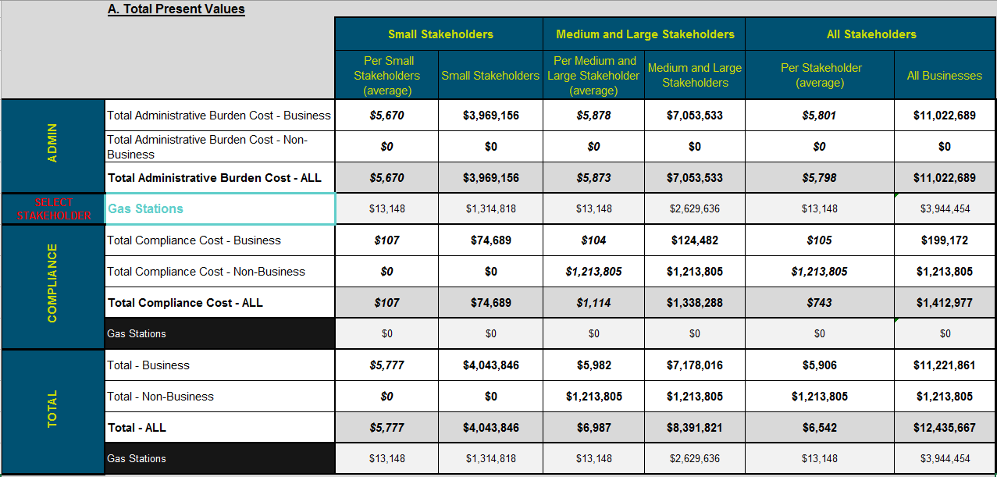

Figure 13: Total Present Value Summary Report

You can also select one of the stakeholder groups defined in step 2 to see a summary of costs for that group.

**One-for-One Rule and Small Business Reporting**

The Calculator provides tables that you will need when reporting your results within the Regulatory Impact Assessment Statement of your regulatory proposal for the one-for-one rule and the small business lens. To facilitate capturing this table there is a button “**COPY ONE-FOR-ONE TABLE**” which will select the table and copy the contents to the clipboard. You can now open your document (e.g. Regulatory Impact Analysis Statement etc.) and easily add the table by pasting the copied information.



Figure 14: One-for-One Rule Report

Totals in the one-for-one table are based on all administrative cost items that have been associated with stakeholders you have identified as businesses. You may notice that values reported in the table for the rule appear to be different from those reported in the summary of costs tables or the small business lens table (discussed later in the manual). For the one-for-one rule, INS and OUTS need to be measured consistently from an equivalent time perspective for all regulations across the Government of Canada. As such, all costs for the rule are discounted back to the same base year (t=0 is set to 2012). Thus, the reported figures for the Rule are all discounted back to 2012, the year in which the rule was introduced. How the Calculator accomplishes this is explained in the appendix, Discounting back to 2012, on page 33.

At the time of writing of this manual the required discount rate used for the One-for-One Rule was 7%. However, this rate will continue to be reviewed and updated as appropriate. If the recommended rate changes, users can adjust the Calculator by changing cell “C17” on the “Profile” tab. The changing of the discount rate for the One-for-One Rule would require an amendment to the *Red-Tape Reduction Regulations* (SOR/2015-202) made under the *Red-Tape Reduction Act*.

The Calculator also contains a table to report on results for the SBL, Figure 17: Small Business Lens Report. The SBL report contains sub-totals by cost type (compliance/administrative) and an average cost per small business. Any cost that you have scribed to a stakeholder group identified as a business and which includes small businesses are included. The information and formatting of the SBL Table matches the reporting requirements described in the TBS Guide on Limiting Regulatory Burden on Business. However, the table here only provides a summary of costs, not an itemized list of requirements, as suggest in the policy. To have this information you will need to produce the SBL Summary Report discussed later in this manual (External Reports).



Figure 15: Small Business Lens Report

The button, “**COPY SBL TABLE**”, will automatically select the table and copy its contents for easy pasting in your analysis document.

### External Reports



At the top of the ***Reporting*** tab of the Calculator you will find four buttons that trigger the reporting of information in spreadsheet files external to the Calculator. These new files are intended to be easier to navigate, share, and use for briefings by summarizing or highlighting information. In addition one of the reports is designed to demonstrate compliance with the Red Tape Reduction Regulations, and one to meet reporting requirements for the small business lens.

#### Consolidated Scenarios Report

The first external report allows for the consolidation of results from up to five scenarios. When you activate this report a dialog box will appear to allow you to browse your files and locate the scenarios you wish to consolidate. Once a file is selected you can click on the associated “**+**” button which will turn into a “**-**“(or vice-versa). If the plus symbol is selected, results from that scenario will be added to other selected scenarios in the consolidated result. If the minus symbol is selected, then the results from that scenario will be subtracted from the other selected scenarios.

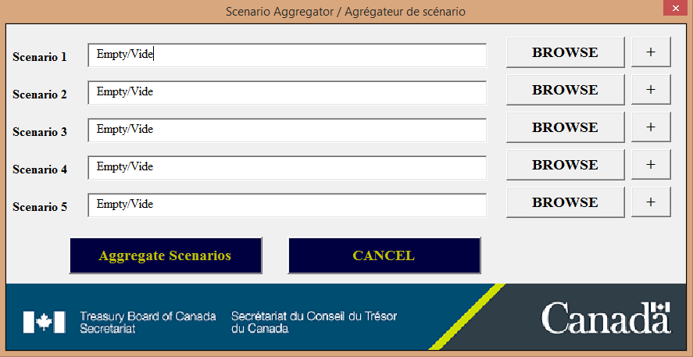

Figure 16: Consolidating Scenarios

The consolidation report can be very useful in situations where you have, for example, estimated the total cost of a new regulatory situation (the regulated scenario), and the total cost of the regulatory situation that will exist if the proposal is not accepted (the baseline). The difference between these two scenarios is the incremental impact of the proposal. This report may also be useful in situations where limitations of the Calculator require the total regulatory proposal to be described in more than one scenario.

In any case where you are attempting to achieve a final result by using multiple scenarios, it is important to document this information somewhere in the Calculator, for instance the regulatory description, such that another user would be able to replicate the results you intend to publish with the Regulatory Impact Analysis Statement.

**As the scenario consolidator needs to load the selected scenarios into the Calculator in order to produce the required results, any scenario currently in the Calculator will be cleared. For this reason, you should export any scenario you are working on before producing this report.**

#### Period Report

The period report provides the results of costs from the Calculator in a manner that is consistent with the Red Tape Reduction Regulations. It uses the same terminology and notation as used in the Regulations and reports costs by periods. We recommend that you produce this report and review results of the calculation in this report for every proposal. It gives a much better indication of how results are calculated and none of the cells are protected. This facilitates any additional calculations that you may want to perform on costs. It will also allow you to make adjustments to calculations that may not be possible within the Calculator itself. As long as you maintain the core calculations in the report, you can also be confident the methodology will still be consistent with the Red Tape Reduction Regulations.

For each single regulatory cost activity you have entered in the Calculator, a tab in a new spreadsheet excel file is created that shows the costs for each period. Labour costs of a single requirement will appear on the left side of the tab and capital costs will appear on the right. The excel file also includes a summary table sheet in the first tab. This table aggregates the results of all the activities and reports sub-totals under business and non-business stakeholders for admin and compliance costs. The businesses sub-total also includes the annualized administrative burden total discounted as required for reporting results for the one-for-one rule.

**USER NOTE:** Tabs in the Period Report include a row for each period, equal to the product of the frequency and 10. For instance, an ongoing action with a frequency of 1,000 would produce a report with 10,000 rows. Since such a report would be very lengthy and take considerable time to produce, the Calculator limits frequency to a maximum of 52, or 520 periods. This is done without affecting the cost estimate by upwardly adjusting the number of hours that the action requires.

#### Pivot Table Report

Pivot tables and pivot charts are powerful tools within excel that allow users to quickly organize, reorganize, summarize, filter and report results based on large amounts of data. In order to make use of pivot tables data has to be arranged in a specific format similar in structure to a database table with each column representing a data field and each row representing a new record of data. The Pivot Table report provides an output that is consistent with this requirement with each row representing a period assessed for a particular activity.

This allows you to perform such tasks as combine all costs within a given year, by stakeholder, and present the information in a way that facilitates the presentation of the information in a manner consistent with cost-benefit summary tables that typical used in regulatory impact analysis statements for significant regulations.

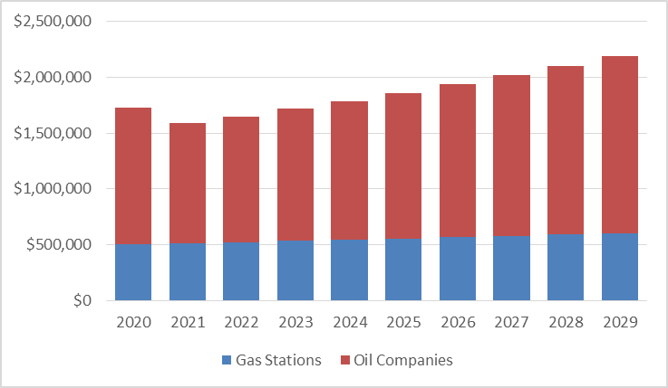

Figure 17: Example of a Pivot-Chart that can be created using outputs of the Calculator’s Pivot Table Report

When the report is created it inserts a default pivot table into the resulting spreadsheet that divides sums of present values (discounted) for action costs by years (columns) and stakeholders (rows). If you are familiar with pivot tables you will then be able to quickly reformulate the organization of this data to present results in a manner that suits your needs.

#### SBL Report

The last report that can be created by the Calculator is a detailed table for the Small Business Lens. This table provides an itemized listing of each action costed that impacts small business.



### Incorporating Results into the Cost-Benefit Analysis (CBA)

In the course of carrying out CBA for significant cost proposals with new administrative burden costs to business (i.e., INs), departments are strongly recommended to use the Calculator to monetize these costs.

The cost estimate—as well as the underlying methodology, assumptions, data and their limitations—must be included in the cost-benefit analysis report for significant cost regulatory proposals (where applicable). The Calculator should also be used to monetize the administrative burden cost savings of OUTs.

**Cost Benefit Analysis and the Rule: While results reported in the CBA and the One-for-One Rule from the Calculator for costs (INs) and benefits (OUTs) are based on consistent assumptions, the resulting values will differ. This difference will result for one or more of the following reasons:**

* **A base year for discounting in the rule of 2012 and a base year of discounting in the CBA using the current year**
* **A price year used in the CBA other than the 2012 price year required for the rule**
* **A period of assessment in the CBA longer than the 10 year assessment required for the rule**
* **A discount rate that differs from the one required for the Red Tape Reduction Regulations (currently 7%)**

**To avoid confusion, you should document the source for differences in values reported in the Regulatory Impact Analysis Statement.**

# Appendix

## Calculating Total Present Value and Annualized Values

The following equations outline step-by-step how the Calculator takes the user inputs to calculate the Total Present Value for an addition/removal or change to an administrative burden cost requirement. Values reported for a regulatory proposal are the net aggregate of all the activity changes over all periods documented in the Calculator.

**Periodic Discount Rate Explanation**: This equation transfers the annual discount rate (7%) to an equivalent discount rate for a frequency other than annual. For instance a monthly discount rate could be derived by using 1.07^(1/12)-1=0.565%, a biannual discount rate by using 1.07^(1/0.5) = 1.07^2-1=14.5%.

Equation 3: Periodic Discount (PD) Rate

$$PD={\left(1+r\right)}^{1/{Frequency}}-1$$

Where:

r = annual discount rate

Frequency = the number of times the event occurs in one year

Explanation: This equation transfers the annual growth rate for a stakeholder group to an equivalent growth rate for a frequency other than annual.

**Periodic Growth Rate Explanation**: This equation transfers an annual growth rate for a stakeholder group to an equivalent growth rate for a frequency other than annual.

Equation 4: Periodic Growth Rate (PG)

$$PG={\left(1+grow\right)}^{1/{Frequency}}-1$$

Where:

grow= the annual growth rate for the businesses being impacted by the activity

**Number of Periods Explanation**: This equation calculates the number of periods that will occur over the 10 year assessment for the cost being assessed. For instance, an activity that occurs four times a year for 10 years would have 40 periods. An activity that occurs once every five years (0.2 frequency) over 10 years would have two periods.

Equation 5: Number of Periods (Periods)

$$Periods=Frequency*TimePeriod$$

Where:

TimePeriod = the number of years over which the activities’ costs are estimated (typically 10).

**Periodic Factor Explanation**: This equation is equivalent to an annuity factor, which is an accounting principle to spread a one-time cost over annual payments for a specified period of time. In this case instead of annual payments the payments are determined by the frequency of the requirement.

Equation 6: Periodic Factor (PF)

$$PF=\frac{1-{(1+PD)}^{-Periods}}{PD}$$

**Population Explanation**: This formula creates a discount weighted average of the population of businesses impacted by an administrative burden activity.

Equation 7: Population

$$PopAdjust=\frac{\sum_{p=1}^{Periods}{\frac{{Pop}_{p}}{{\left(1+PD\right)}^{p}}}}{PF}$$

$${Pop}_{p}={Pop}_{0}{\left(1+PG\right)}^{p} or 0$$

Where:

p=the period for which the population is being calculated

Popp=the population of businesses impacted by the activity in period p. For periods that occur outside the range specified for custom timing this is counted as zero.

**New Entrants Population Explanation**: This formula creates a discount weighted average of the population of new entrant businesses impacted by an administrative burden activity

Equation 8: Population Entrants

$${PopAdjust}_{Entrants}=\frac{\sum_{p=1}^{Periods}{\frac{{Pop}_{p Entrants}}{{\left(1+PD\right)}^{p}}}}{PF}$$

$${Pop}_{p Entrants}=\frac{{Pop}_{0}*PG}{1+PG}{\left(1+PG\right)}^{p} or 0$$

Where:

Popp Entrants=the population of new entrant businesses impacted by the activity in period p. For periods that occur outside the range specified for custom timing this is counted as zero.

**Total Present Value Explanation**: This is the equation used by the Calculator to estimate the total present value for an ongoing or custom timing requirement. The first equation is used when new entrants is not selected/set to False, and the second when new entrants is selected/set to True.

Equation 9: Total Present Value (TPV) – Ongoing/Custom Timing

$${TPV}_{Ongoing/Custom}=Time*Wage*PopAdjust*PF$$

$${TPV}_{Ongoing/custom Entrants }=Time*Wage*{PopAdjust}_{Entrants}*PF$$

Where:

Time =the hours required to complete the regulatory requirement

Wage = the cost per hour to perform activities related to the regulatory requirement

PopAdjust = the discount weighted average number of businesses that will perform the regulatory requirement over the period of assessment

PopAdjustEntrants = the discount weighted average number of new entrants businesses that will perform the regulatory requirement over the period of assessment

NOTES:

* These formulas apply both to custom and ongoing costs.
* As this method translates the frequency per period equal to one, there is no need to multiply costs by frequency (1*Cost=Cost)

**Total Present Value – Upfront Costs Explanation**: Upfront costs are considered to occur at time t=0 and thus are not subjected to any discounting and follow the basic SCM equation. Normally an upfront cost would have a frequency of one so could be excluded from this equation. When new entrants are to be considered (New Entrants = True), the total present value for new entrants of ongoing/custom costs is added to the upfront cost and calculated as described in Equation 9.

Equation 10: Total Present Value – Upfront Timing

$${TPV}_{Upfront}=Time*Wage*{Pop}_{0}*Frequency+{TPV}_{Ongoing/custom Entrants }$$

**Integrated Total Present Value Explanation**: The Integrated Total Present Value is simply the sum of the TPV for upfront costs and ongoing/custom costs.

Equation 11 $: Integrated TPV$

$$TPV={TPV}_{Upfront}+{TPV}_{Ongoing/Custom}$$

**Annualized Values Explanation**: This is the equation that is used to calculate the annualized value. It is equal to dividing the TPV by the Annuity Factor, which for a 7% discount rate and 10 year time period, is approximately 7.024.

Equation 12: Annualized Values

$$Annualized=TPV* \frac{r*{\left(1+r\right)}^{t}}{{\left(1+r\right)}^{t}-1}=TPV*0.1424$$

Where:

r = the annual discount rate (7%)

t= the years in the period of assessment (10)

## Discounting back to 2012

**Adjusted Annualized Value Explanation**: The Adjusted Annualized value is the annualized cost/savings for regulatory administrative burden costs discounted back to the year 2012 as required by the “One-for-One” Guidance document.

Equation 13: Adjusted Annualized Value (AAV)

$$AAV=\frac{Annualized}{{(1+r)}^{StartYear-2012}}$$

Where:

StartYear=the year the regulatory proposal is assumed to start.

1. Excerpt from SCM Network “*Delivering reductions in administrative burdens: An executive summary of the SCM method*”