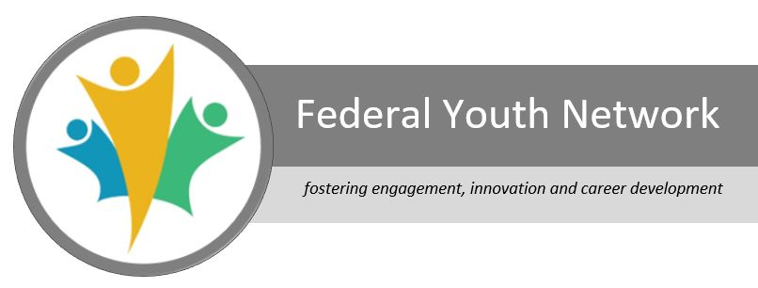

“**Networking** *is not about just connecting people. It’s about connecting people with people, people with ideas and people with opportunities.” ~Michele Jennae*

* In response the pandemic, FYN quickly launched the [**Virtual Learning Series**](https://wiki.gccollab.ca/FYN_Virtual_Learning_Series)(VLS) in March. Since then, we have presented over 25 learning events! Partnering with the innovators and leaders of the Government of Canada (GC), we offer timely, apt sessions on working from home, the environment, networking, technology, and much more!
* Over the summer, our schedule is packed with great resources for all public servants - new and experienced. Be sure to check out our Deputy Minister Highlight series, featuring high-level leaders within GC.
* The[**Interdepartmental Student Committee**](https://wiki.gccollab.ca/Interdepartmental_student_committee)(ISC) has partnered with FYN to welcome summer students across the GC. Aiding government departments in virtually onboarding students during a pandemic, they are working hard to ensure all students feel welcome and connected.
* Students, be sure to attend the [**VLS**](https://wiki.gccollab.ca/FYN_Virtual_Learning_Series)sessions this month to learn more about the Public Service! We will have a packed calendar of events to provide lots of opportunities for learning and networking.
* Want to get involved? The ISC is looking for volunteers to help organize events, maintain social channels, and share ideas. [Email](mailto:isc.ncr.rcn.cei@gmail.com) us for more info.
* The [**Federal Youth Network**](https://gccollab.ca/groups/profile/4251479/enfederal-youth-network-fynfrru00e9seau-des-jeunes-fonctionnaires-fu00e9du00e9raux-rjff) team is a collaboration of motivated public servants leading regional networks across Canada on micro-mission assignments from across the GC to support the work of the FYN. Bringing with us a variety of strengths and experiences, together we are collaborating with our partners and stakeholders to create the VLS and other key resources. We are creating other programming to help public servants manage the challenges of working from home, keeping connected and developing their careers.
* Let us know how we can support you. We are happy to help and would love to hear your ideas for future events!

**VLS**

**ISC**



**FYN**



**Like and follow us @FYN_RJFF**  