Welcome Walkthrough: Microsoft Teams Logging into MS Teams (first- time)

Welcome Walkthrough: Microsoft Teams

What is MS Teams?

The Microsoft (MS) Teams application provides a central location to communicate with colleagues who are remotely working. This specific Microsoft software bridges the gap often seen and experienced with virtual teams or working from home.
MS Teams provides the tool set you need to interact with your colleagues, which includes:
- text message
- video conference
- sharing of transitory information

WARNING: MS Teams is used for unclassified information ONLY. If you need to have a meeting or chat with a colleague containing sensitive information, you must use a boardroom or similar secure environment.

MS Teams replaces Slack, Zoom and Jabber
MS Teams will be the sole collaborative software here at OUR DEPARTMENT. It provides many of the features as previous software (Jabber, Slack, Zoom, and Skype for Business), and much more. Explore MS Teams’ features in the Help feature.

Before installing Teams on your computer
You must have the following prior to installing MS Teams:
  - A Microsoft account (THIS CAN BE MANAGED BY IT, OR BY GETTING YOUR OWN ACCOUNT IF YOUR DEPARTMENT ISN’T LEADING THE IMPLEMENTATION OF TEAMS)
  - Windows 10
Submit a ticket to your Service Desk (or INSERT YOUR OWN INSTRUCTIONS) to get MS Teams on your computer.

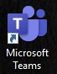
Logging into MS Teams (first- time)
    - After installing MS Teams, double-click the Microsoft (MS) Teams desktop shortcut. The MS Teams software opens.
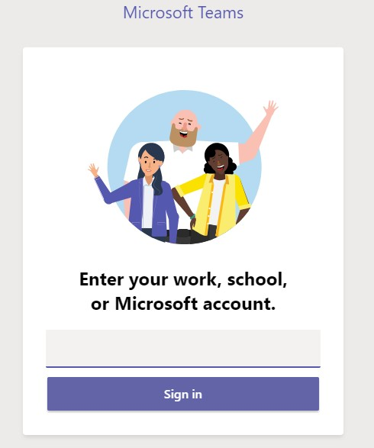
    - Remove the information in the shaded area, then type your Microsoft account username:

    - Click Sign in.

Welcome Walkthrough: Microsoft Teams Logging into MS Teams ( if SSC login window appears)

Logging into MS Teams (if SSC login window appears)
If you see the following window appear when logging into MS Teams, click X (Close), located at the top right of the window.

The Microsoft Teams log in appears, and you can log in as usual. See “Logging into MS Teams (first- time)” on page 1.

Best Practices
- You can install MS Teams from any computer via the Internet at https://teams.microsoft.com/ download.
- Don’t log out, just close the MS Teams application when shutting down your computer. This eliminates logging in all the time.
- Make sure you keep your password in a secure location, so you can access it when necessary.
- If it’s your first time logging into MS Teams, make sure to go directly to the Help feature. There are many videos and information to get you started.
- If you have any problems logging in to MS Teams, please contact your (SERVICE DESK?).
- Refer to the bilingual MS Teams Reference Guide (RDIMS #15512348) for step-by-step instructions.
- If any issues occur, please contact your TC Service Desk or regional support unit (RSU) .

Key information when working in MS Teams
- Currently only unclassified information is acceptable when working in MS Teams. If you need to have a meeting or chat with a colleague containing sensitive information (Protected B or higher), you should use encrypted email or meet in a secure environment.
- There is currently no spelling or grammar check within a chat. When you type a mistake, the MS Teams app will underline it in red, prior to you sending the text message.

Welcome Walkthrough: Microsoft Teams Accessing Help within MS Teams
- Apply the Values and Ethics Code for Public Sector during your chat, as it applies to all social media you as a government employee engage in.
- Consult the Social Media Guidelines for Employees (INSERT YOUR OWN DEPARTMENTS LINK) for help in understanding how to use social media here at Transport Canada.
- Review the Social Media at Work video to get tips on using social media here at TC and as a government employee.

Accessing Help within MS Teams
The Help feature provides information concerning most features in MS Teams, and new features. You can go to the training videos, and get training on topics such as organizing your teams list.
- In MS Teams navigation pane, click Help.

- In the menu that appears, click one of the following:

  - Topics - search for what you need or browse the available help topics.
  - Training – view the videos provided on the page.
  - What’s New – read what new features are available in the latest release
At any time, you can go to the Transport Canada (Org-Wide) team to see the available channels. It is available to everyone who has MS Teams.

Additional information about the Help feature
- Help is always available, no matter where you are in MS Teams. The navigation pane is always available to you and you can click Help at any time.
- If you need to get back to the previous Help topic or home page, click the house icon .
- Review the What’s New information to get caught up on the new features in the version you have on your computer. New features occur approximately every two weeks.
- You can get an MS Teams quick start guide from the Microsoft Office cheat sheets website.
- For those who need information about accessibility in MS Teams, see Accessibility within Microsoft Teams website.

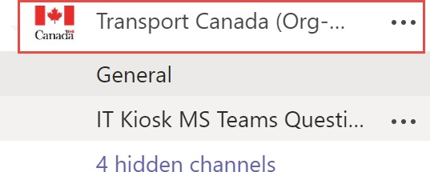
Joining existing teams in MS Teams

What is a team?
Here at TC, a Team is a directorate’s central location for each of their groups’ daily collaboration activities. Each group within the directorate has a channel, providing collaboration activities for specific tasks within that group.

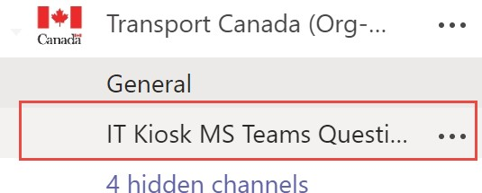
Welcome Walkthrough: Microsoft Teams Joining existing teams in MS Teams

What is a channel?
A channel is a group’s central location for all their collaboration activities they are currently working on. This includes projects or initiatives. A channel is always associated within a Team.

Directorates will have many groups, so it’s important to name the channels according to the actual name of the group. For example,
at Digital Services Directorate, the group CSSG has the channel called CSSG.

How to join an existing team

How to add an outside person to your team
- With MS Teams opened, go to Teams.

- At the bottom of the Teams pane, click the Join or create a team feature.

- In the Join or create a team pane, click on the team you want to join.

Once you’ve joined a team, you are automatically joined to the channels you are a member of. For more information, see the Help topic “Find and join a team” (Location: Help | Topics).
Before you begin, verify with the person (referred to as guest) you want to add that they have a Microsoft account. This is important because you cannot add someone who is outside of TC, without a Microsoft account.
- Go to the Teams feature, and then go to the team you want to add the guest to.

- Click the More options (elipsis) beside the team name.

- In the menu that appears, click Add member, and then enter the guest’s email address.

- After adding the guest, the word “guest” appears beside their name when posting or next to their name in the members list.

For more information, see “Add guests to a team in Teams” (Location: Help | Topics).

Best Practices for teams and channels

- Name a team according to the department’s name. For example, the Digital Services Directorate department names their team, Digital Services (DSD).
- If you need to have a channel more visible, pin it within Teams using the Pin feature. For more information, see the Help topic “Show, hide, or pin a team or channel in Teams”.
- Always provide a description for a Team or channel. You need to explain the reason behind creating the team or channel.
  - An example: The Digital Services Directorate (DSD) at TC provides network, hardware and software services to all TC. In this team, collaboration includes current projects and initiatives within DSD.

Welcome Walkthrough: Microsoft Teams Training and Resources

Training and Resources

Microsoft Support website Windows downloadable guides (Teams)
Scroll down the page to locate the guides. Locate the MS Teams guide and then click View PDF to download the MS Teams quick start guide.
Microsoft Support website Microsoft Teams training information

Microsoft Support website Instructor-lead training for Microsoft Teams
Microsoft Support website What’s new for the latest release of Microsoft Teams

Microsoft Support website Accessibil ity within Microsoft Teams
Microsoft Support website MS Teams support Microsoft Support website MS Teams Tips and Tricks Microsoft Community Blog Microsoft Teams Blog
Web site How to use Shifts in Microsoft Teams

