What we’ve learned on our digital journey…so far (text)

The personas – 3 typical users of the pension portal

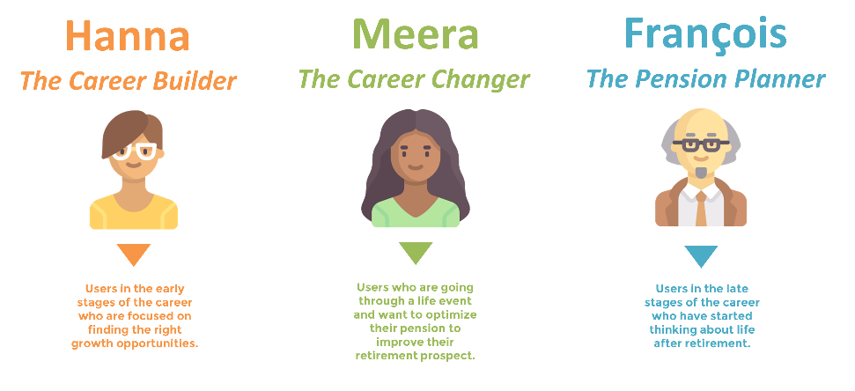

Alt text:
Three personas, or typical users, of the pension portal: Hanna, the Career Builder, Meera, the Career Changer, and François, the Pension Planner. Text version below.

Long Description:
There are three typical users of the pension portal:
- Hanna is the Career Builder. She is a user in the early stages of her career who is focused on finding the right growth opportunities.
- Meera is the Career Changer. She is going through a life event and wants to optimize her pension to improve her retirement prospects.
- François is the Pension Planner. He is in the late stage of his career and has starting thinking about life after retirement.

Meet François, who is getting closer to retirement

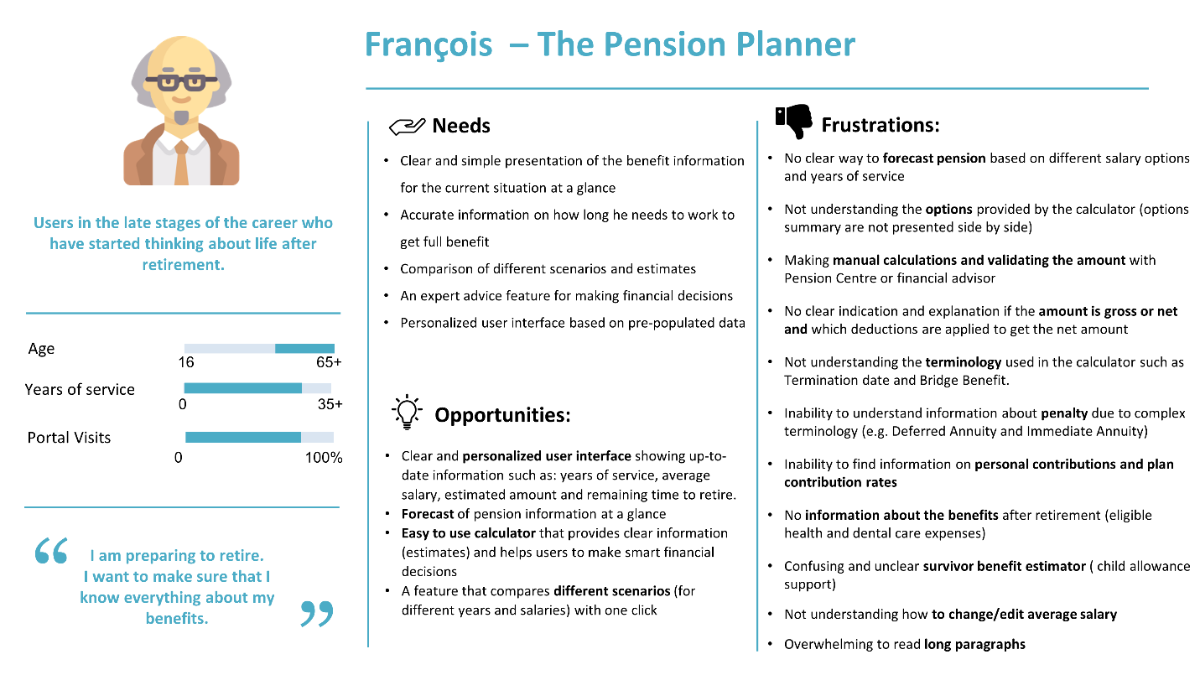

Alt Text:
A detailed persona for François, the pension planner, who is getting closer to retirement. This chart captures his age, years of service and visits to the pension portal. It also looks at his needs, frustrations and opportunities. Text version below.

Long Description:
This is the persona profile for François, the Pension Planner. François is in the late stages of his career and has started thinking about life after retirement.
- François is nearing 50 years old. He has about 30 years of experience and has visited the pension portal about 80%.
- François states: “I am preparing to retire. I want to make sure that I know everything about my benefits”.

From the pension portal François needs:
- Clear and simple presentation of the benefit information for his current situation at a glance.
- Accurate information on how long he needs to work to get the full benefit.
- Comparison of the different scenarios and estimates.
- An expert advice feature for making financial decisions.
- Personalized user interface based on pre-populated data.

François is having these frustrations with the current pension portfolio:
- No way to forecast pension based on different salary options and years of service.
- Not understanding the options provided by the calculator (options summary are not presented side by side).
- Making manual calculations and validating the amount with the Pension Centre or financial advisor.
- No clear indication and explanation if the amount is gross or net and which deductions are applied to get the net amount.
- Not understanding the terminology used in the calculator such as Termination Date and Bridge Benefit.
- Inability to understand information about penalty due to complex terminology (e.g. Deferred Annuity and Immediate Annuity).
- Inability to find information on personal contributions and plan contribution rates.
- No information about the benefits after retirement (eligible health and dental care expenses).
- Confusing and unclear survivor benefit estimator (child allowance support).
- Not understanding how to change or edit average salary.
- Overwhelming to read long paragraphs.

Opportunities for improving the pension portal to meet François’ needs include:
- Clear and personalized user interface showing up-to-date information such as years of service, average salary, estimated amount and remaining time to retire.
- Forecast of pension information at a glance.
- Easy to use calculator that provides clear information (estimates) and helps users make smart financial decisions.
- A feature that compares different scenarios (for different years and salaries) with one click.

See François’s journey map as he uses the pension portal to plan for retirement

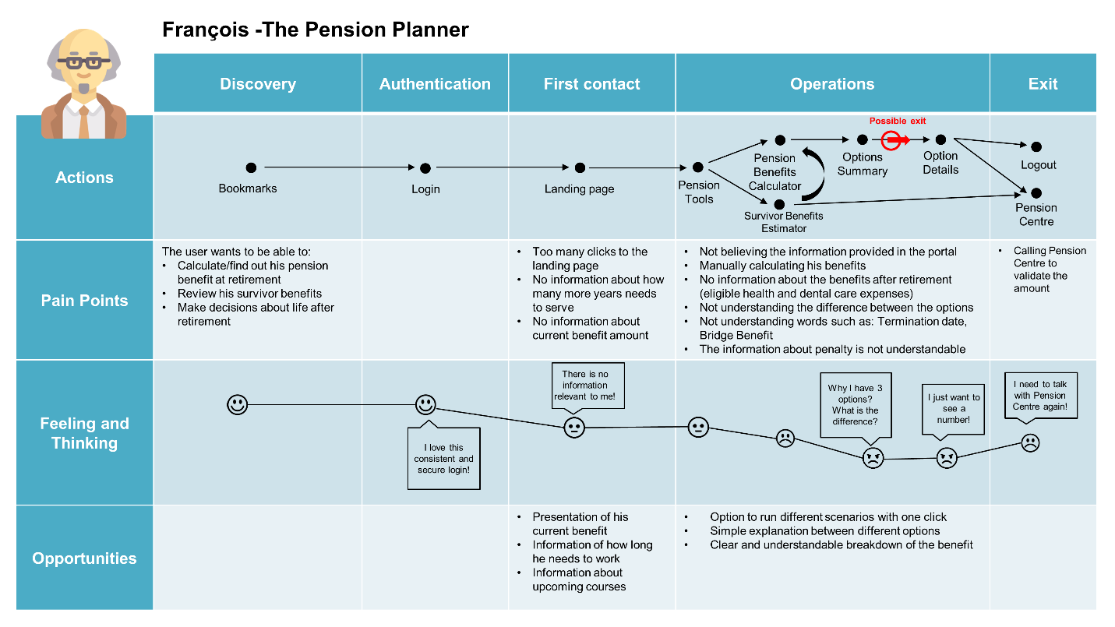

Alt Text:
This journey map captures François’ experience using the pension portal – his actions, pain points, feeling and thinking, and opportunities for 5 phases: discovery, authentication, first contact, operations and exit. Text version below.

Long Description:
This is the journey map for François, the pension planner, as he uses the pension portal. The journey map captures François’ actions, his pain points, what he is feeling and thinking, and opportunities for each stage of his journey: discovery, authentication, first contact, operations and exit.

In the discovery phase of François’ journey:
- Action: François creates a bookmark.
- Pain points: François wants to be able to:
  - Calculate or find out his pension benefit at retirement
  - Review his survivor benefits
  - Make decisions about life after retirement
- Feeling and thinking: François is happy
- Opportunities: None

In the authentication phase of François’ journey:
- Action: François logs in
- Pain points: None
- Feeling and thinking: François is happy and thinks, “I love this consistent and secure login!”
- Opportunities: None

In the first contact phase of François’ journey:
- Action: François goes to the landing page.
- Pain points:
  - Too many clicks to the landing page.
  - No information about how many more years he needs to serve.
  - No information about current benefit amount.
- Feeling and thinking: François is neutral and thinks, “There is no information relevant to me!”
- Opportunities:
  - Presentation of François’ current benefit
  - Information on how long he needs to work
  - Information about upcoming courses

In the operations phase of François’ journey:
- Action: François uses the pension tools. He uses the Pensions Benefits Calculator and the Survivor Benefits Estimator. He receives an Options Summary. He possibly exits the pension portal before looking at the Option Details.
- Pain Points:
  - Not believing the information provided in the portal.
  - Manually calculating his benefits.
  - No information about the benefits after retirement (eligible health and dental care expenses).
  - Not understanding the difference between the options.
  - Not understanding words such as: Termination Date, Bridge Benefit.
  - The information about penalty is not understandable.
- Feeling and thinking: François starts out neutral but becomes increasingly unhappy. François thinks, “Why do I have three options? What is the difference?” and “I just want to see a number!”
- Opportunities:
  - Option to run different scenarios with one click.
  - Simple explanation between different options.
  - Clear and understandable breakdown of the benefit.

In the final exit phase of François’s journey:
- Action: François either logs out of the pension portal or contacts the Pension Centre.
- Pain Points: Having to call the Pension Centre to validate the amount.
- Feeling and thinking: François is unhappy, thinking, “I need to talk with the Pension Centre again!”
- Opportunities: None.

