PSPM Reports Access Guide

Date: April 28, 2025

# Intent of these reports

These reports are intended for authorized users who have access to the data within their organization.

The reports provide visibility on employees within your organization who:

* Have an active account on the TBS Applications Portal (TAP)
* Are linked to your department or agency through their pay organization

The data helps monitor compliance with the [*Directive on Performance Management*](https://www.tbs-sct.canada.ca/pol/doc-eng.aspx?id=27146), and supports activities related to performance management, talent management, workforce planning, and employee development.

System filters are applied based on pay file information to ensure that only employees subject to the Directive are included in your reports.

# Important notes

We’re currently working to resolve three known issues:

* Employees from the following six organizations **are not included in the compliance reports**, but their data can still be found in the Agents of Parliament report:
  + Office of the Chief Electoral Officer
  + Office of the Commissioner of Lobbying of Canada
  + Office of the Commissioner of Official Languages
  + Office of the Information Commissioner of Canada
  + Office of the Privacy Commissioner of Canada
  + Office of the Public Sector Integrity Commissioner of Canada
* We are also working to **correct some text and formatting issues** across the reports.

We’ll follow up and let you know as soon as these issues are resolved.

# Changes to the reports

Several changes were made as part of the transition to Power BI:

* Not all reports have been moved to Power BI. We’re looking into adding more later this fiscal year.
* Comments have been removed from all reports following discussions with our Privacy Office.
* Two new columns have been added: organization of the performance agreement and pay organization of the employee. If an employee changed departments during the year, they may appear more than once in the reports by PRI. A tool will be shared separately to convert the compliance by PRI report into the previous CORS format.
* In the Compliance Summary report, the CPA values now reflect actual figures. A new column has also been added to display data from all organizations using the application.
* Several labels and column headers have been adjusted for clarity.
* New filters have been added to help you narrow results and customize your view.

# Reports currently available

The following reports are currently available through the new platform:

* **Compliance:** Available in summary and by PRI views. The summary view provides a snapshot of your organization’s compliance rates and allows comparisons with the core public administration (CPA). The by PRI view shows detailed employee data.
* **Work Objectives:** Available in the by PRI view only. This report shows detailed records of employees’ work objectives, including their mid-year status and year-end ratings.
* **Learning and Development Plans:** Available in the by PRI view only. This report presents data related to employee training activities, including their category, status, estimated cost, and time required.
* **Talent Management Plans:** Available in summary and by PRI views. The summary view allows comparisons with the CPA, while the by PRI view focuses on employee-level data and includes detailed information about their plan and its elements.
* **Performance Improvement Plans:** Available in summary and by PRI views. The summary view allows comparisons with the CPA, while the by PRI view focuses on employee-level data, with more detailed information for each plan.
* **Probations:** Available in the by PRI view only. This report focuses on employee-level data, including probation start and end dates and status.
* **Law Practitioners (LPs):** Available in the by PRI view only. This report focuses on employee-level data specific to the classification LP, including their own performance ratings and mid-year ratings for LP-01.
* **Agents of Parliament:** Available in the by PRI view only. This report covers data relating to agents of Parliament as well as employees of these organizations:
  + Office of the Chief Electoral Officer
  + Office of the Commissioner of Lobbying of Canada
  + Office of the Commissioner of Official Languages
  + Office of the Information Commissioner of Canada
  + Office of the Privacy Commissioner of Canada
  + Office of the Public Sector Integrity Commissioner of Canada

# How to request access

Access to the PSPM reports in Power BI is limited to authorized employees within your organization. Please note that only 3 employees per organization can obtain this access.

To request access:

1. Complete the [Access Request Form](https://wiki.gccollab.ca/images/2/29/CORS_Micro-Data_Authorization.pdf).
   1. The form must be signed by your Head of human resources.
   2. The form must be sent to our generic mailbox [EHRIassistanceISRH@tbs-sct.gc.ca](mailto:EHRIassistanceISRH@tbs-sct.gc.ca) through your organization’s authorized mailbox.
2. Once processed on our end, you will be granted access to the reports.

# How to access reports

Once your access has been confirmed, follow the steps below to access the reports:

1. Log on to the [TBS Applications Portal](https://portal-portail.tbs-sct.gc.ca/).

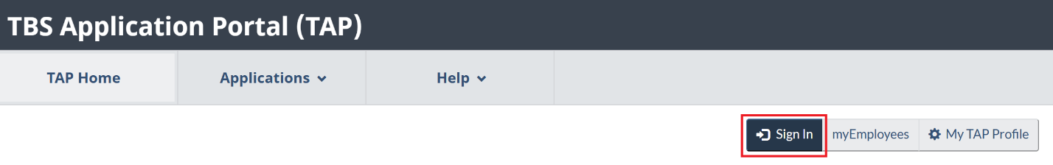

1. Click on “[HR Data Analytics and Visualization](https://hranalytics-analytiquerh.tbs-sct.gc.ca/)”.

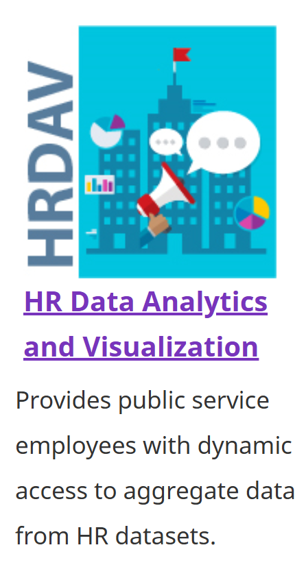

1. Click on “[Public Service Performance Management](https://hranalytics-analytiquerh.tbs-sct.gc.ca/pspm-grfp)”.

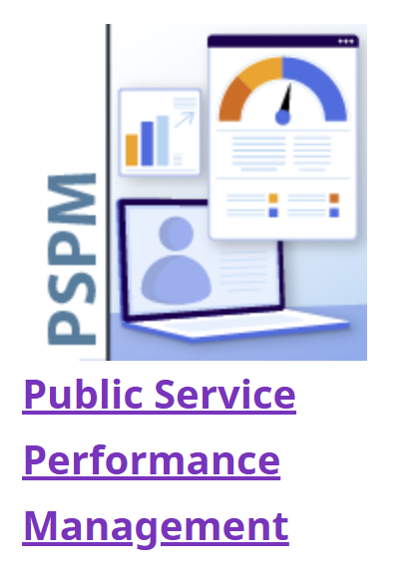

1. Scroll down and click on the report you want to open.

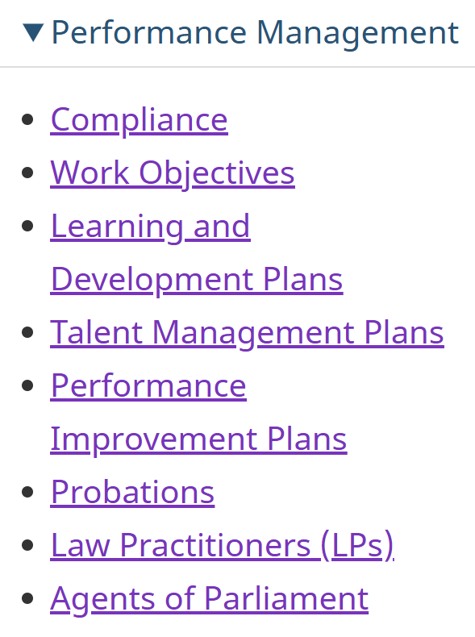

1. If the report has tabs, choose between:
   * 1. Details by PRI
     2. Summary

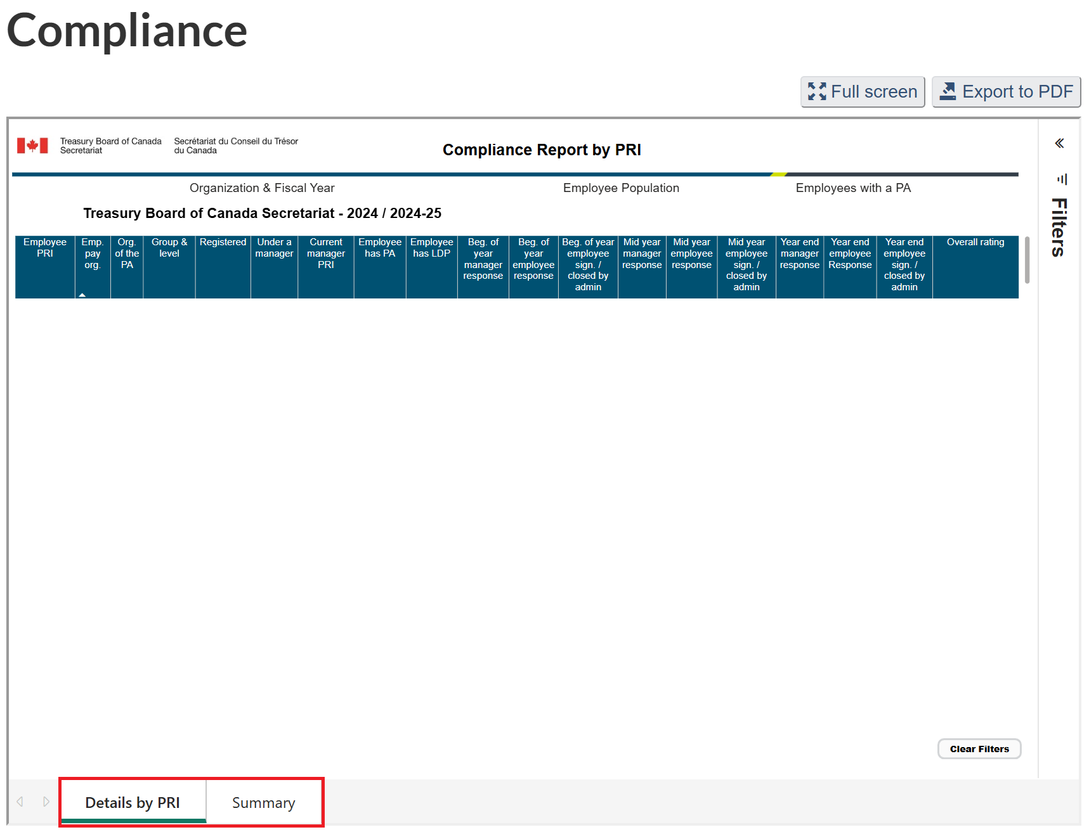

# How to extract data

You can download two types of information from the reports: PDF Summary and by PRI in Excel.

## PDF Summary

Use this option if you want a snapshot of the report:

* Open the summary tab of the report.
* Click “Export to PDF” in the top-right corner.

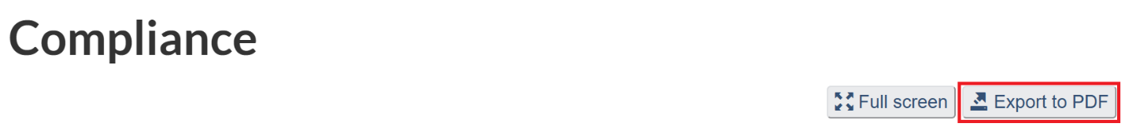

This will create a PDF version of what you see on screen.

## By PRI in Excel

Use this option if you need detailed, line-by-line data:

* Go to the by PRItab of the report.
* Hover over the table you want to download.
* Click the “...”(More options) in the top-right corner of the table.

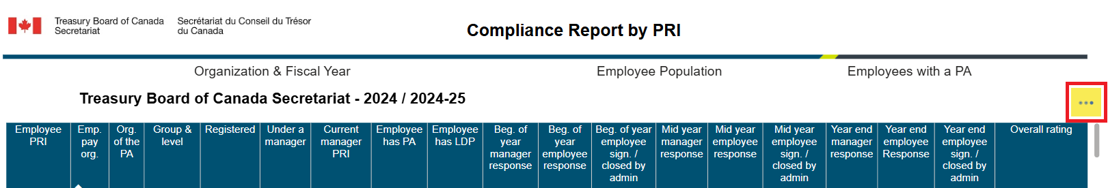

* Select “Export data.”

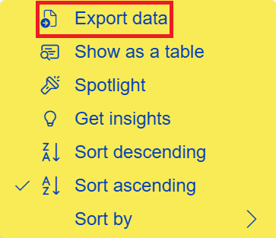

* Choose the “Data with current layout”.
* Click “Export”.

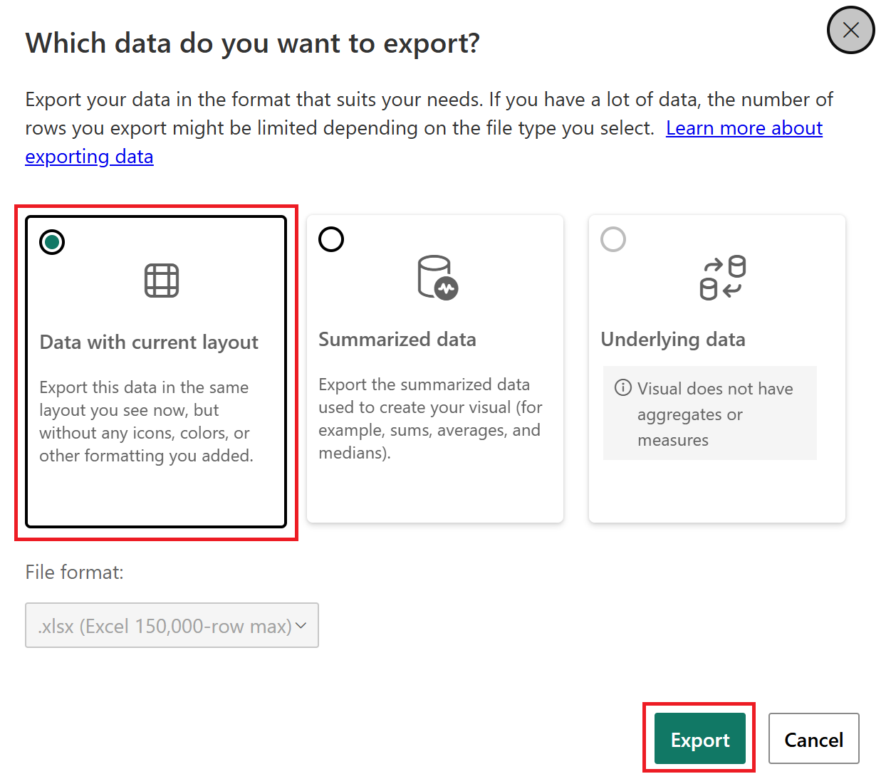

This will download an Excel file with the data shown in the table, based on the filters you’ve applied.

# General notes about the data

Here are a few important things to keep in mind when using the reports:

* The data is updated every day from the PSPM application. Updates made in the application may not appear in the reports immediately.
* The reports only include employees who have an active account on the TAP and are linked to your organization through their pay organization.
* If an employee’s pay file was recently updated, it may take 2 to 3 months before the change appears on the TAP and in the reports.
* These reports automatically filters out employees who are not covered by the [*Directive on Performance Management*](https://www.tbs-sct.canada.ca/pol/doc-eng.aspx?id=27146), based on pay file information.
* The reports are for internal use only and should not be shared outside your organization.

# Need help or have questions?

If you need support with the platform or the reports, you can contact us for:

* Help with accessing the reports
* Questions about how to use the reports
* Reporting issues or requesting improvements

Please email [EHRIassistanceISRH@tbs-sct.gc.ca](mailto:EHRIassistanceISRH@tbs-sct.gc.ca) from your authorized organizational email address.

This helps ensure that requests come from authorized users and allows us to support you more efficiently.

# Annex A: Reporting Issues Log

|  |  |  |  |  |  |
| --- | --- | --- | --- | --- | --- |
| Issue # | Short Description | Impacts | Workaround (if any) | Date Identified | Date Resolved |
| 001 | Users with access to multiple organizations only have access to their pay file | Users cannot view data for other organizations they support; multiple access is not granted properly | None | 2025-04-08 | 2025-04-11 |
| 002 | Organization filter is not selected by default for some users | Reports appear empty, leading users to believe they are broken | Manually select the organization in the filter panel | 2025-04-08 | Ongoing |
| 003 | Work objectives data are missing for some employees | Incomplete view of employee records even when performance agreements are created or completed | None | 2025-04-11 | 2025-04-24 |
| 004 | Data for employees in Agents of Parliament organizations are only available in one report | Limits visibility in other relevant reports (e.g. work objectives, talent management); affects multiple organizations (CEO, LOB, COL, IPC, OPC and INT). | None | 2025-04-11 | Ongoing |
| 005 | Compliance report does not display data for employees without a performance agreement | Registration, reporting manager, and manager PRI data are missing for these employees | Limited workaround: search in myEmployees (manager PRI not available) | 2025-04-15 | Ongoing |
| 006 | Administratively closed periods are not counted as closed in compliance report | Impacts compliance rates. | None | 2025-04 | Ongoing |