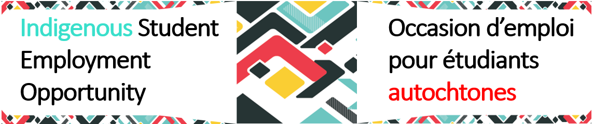 Mentor Support Tools – Do’s and Don’ts
Do:
✅ Be relational before being directional. Build trust by getting to know the mentee as a person before focusing on goals.
✅ Practice active listening. Let silence have space. Indigenous ways of communicating often value reflection.
✅ Self-assess your non-verbal communication. Body language and facial expressions can impact early relationship building.
✅ Offer flexibility. Recognize the mentee’s potential obligations to community, family, or ceremony.
✅ Be curious and open. Invite conversations about lived experience and identity, if the mentee is comfortable.
✅ Check in regularly. Create predictable touchpoints, be dependable and available.
Avoid:
❌ Assuming one Indigenous experience applies to all.
❌ Over-explaining the "right way" to succeed in the public service.
❌ Focusing solely on performance over well-being.
Quick Wins:
- Share your career story. Share a coffee or tea, chat about things other than work.
- Offer to review a resume or prep for an interview.
- Invite them to a team meeting or learning session.

