  - GCworkplace Accessibility & Inclusivity Guide
  - Public Services and Procurement Canada, Real Property Services
Date: 2024/2025
Version: 1
PLEASE NOTE:
The GCworkplace Accessibility and Inclusivity Guide (referred to herein as the Guide). The Guide is an evergreen document, designed to be updated regularly to ensure it remains aligned with evolving standards, the latest GCworkplace direction, best practices and other relevant factors.
This first version of the Guide serves as a foundational framework, based on the Mandatory CSA/ASC B651:23 Accessible Design for the Built Environment standard, GCworkplace Design Guide and GCworkplace Technical Reference Manual. It has been informed by research on public and private sector accessibility programs, in addition to incorporating feedback from consultations and engagements with persons with disabilities over the past five years. Currently, the Guide places a strong emphasis on accessibility for people with mobility disabilities. For more details on the scope and limitations of the Guide, please refer to the Methodology section.
While this initial version serves as a starting point, we acknowledge the importance of ensuring accessibility and inclusivity for all individuals in the workplace. Future updates will expand the Guide’s coverage to be more comprehensive and inclusive of diverse needs.
Thank you for your understanding.

Contents
Part 1: Introduction 9
1.1 Purpose of Guide 9
1.2 Context 9
1.2.1 The Accessible Canada Act 9
1.2.2 Accessibility Standards Canada 10
1.2.3 GCWorkplace 11
1.2.4 Government of Canada Portfolio Optimization 11
1.3 Why An Accessible And Inclusive Workplace Is Important 12
1.3.1 Obligation 12
1.3.2 The Benefits of Accessible Workspaces 13
1.4 Methodology of this Guide 14
1.4.1 Guiding Principles 14
1.4.2 Consultations and Feedback 15
1.4.3 Challenges and Limitations 15
1.4.4 Considerations for Future Iterations 17
Part 2: Glossary 17
Part 3: Regulatory Landscape 19
3.1 Accessibility in Crown Buildings 19
3.2 Accessibility in Leasing 20
Part 4: How to Use this Guide 21
4.1 Overview of Sections 21
4.2 Application 23
4.3 Engagement 24
Part 5: Accessibility Standards and Recommendations for the Workplace 24
5.1 Path of Travel 25
5.1.1 Width of Primary Paths of Travel 25
5.1.2 Width of Secondary Paths of Travel 26
5.1.3 Path of Travel in Enclosed Rooms 27
5.2 Accessible Route Termination 28
5.3 Clear Floor Space 31
5.4 Turning Diameter 33
5.5 Doors and Doorways 36
5.6 Power-Assisted Door Openers 37
5.7 Operating Controls 38
5.7.1 Clear floor Space for Operating Controls 38
5.7.2 Height for Operating Controls 40
5.7.3 Operation of Controls 41
5.8 Seating Space at Worksurfaces and Tables / Reach Distances for Controls 42
5.8.1 Seating Space at Worksurfaces and Tables 42
5.8.2 Reach Distances for Controls, Worksurfaces and Tables 45
5.8.3 Clear Floor Space for Approach and Transfer 46
5.9 Signage & Wayfinding 48
5.9.1 Signage 48
5.9.2 Wayfinding 50
5.10 Headroom 51
5.11 Protruding Objects 52
5.12 Safety 53
5.13 Environmental Sensitivity & Multiple Chemical Sensitivities (MCS) 54
5.14 Acoustics 55
5.15 Lighting 56
5.16 Finishes 58
5.16.1 General 58
5.16.2 Luminance (colour) Contrast 58
5.16.3 Flooring 59
5.16.4 Fully Glazed Doors, Walls and Sidelights 59
Part 6: Accessibility Considerations for Specific Workpoints and Support Spaces 60
6.1 General 60
6.1.1 Individual Workpoints 60
6.1.2 Collaborative and Support Spaces 61
6.1.3 Planning and Furniture Considerations 63
6.2 Workpoints & Support Space Specific 66
6.2.1 Workstations 67
6.2.2 Work Pod 75
6.2.3 Focus Room 77
6.2.4 Study 79
6.2.5 Focus Pod 82
6.2.6 Touchdown 83
6.2.7 Phonebooths and Phone Room 85
6.2.8 Teaming Area 88
6.2.9 Lounge 91
6.2.10 Work Room 94
6.2.11 Project Room 96
6.2.12 Medium Meeting Room 98
6.2.13 Large Meeting Room 102
6.2.14 Kitchenette 107
6.2.15 Wellness Room 113
6.2.16 Equipment Area 115
6.3 Personal Storage Area 118
6.3.1 Lockers 118
6.3.2 Coat Closets 121
6.3.3 Personal Storage Area In Common Space 121
6.3.4 Shared Storage 123
6.4 Waste & Recycling 124
Part 7: Key Accessibility Considerations Checklist 125
Part 8: Feedback and Enquiries 129
8.1 Share Your Feedback and Enquiries 129
8.2 Helpful Links 130
8.2.1 Design 130
8.2.2 Policy 131
8.2.3 Terminology 132
8.2.4 General 132

Introduction

Purpose of Guide

The primary objective of this Guide is to provide project teams (design managers, furniture specialist, consultants, etc.) with guidance to facilitate the delivery of accessible and inclusive fit-up projects (new construction or major renovations) in Government of Canada buildings and leased spaces across the country. It is intended to assist with the prevention of accessibility barriers while also serving as a resource for project teams in the identification and removal of existing barriers. Additionally, this guide can be used as a resource for accommodation projects that do not include a major renovation, but where project teams wish to improve the level of accessibility where they can, even if it is not mandated.

Context

The Accessible Canada Act
The Accessible Canada Act (ACA) came into effect on July 11, 2019. It is a proactive and systematic approach for identifying, removing and preventing barriers to accessibility. The purpose of the Act is to make Canada barrier-free by January 1, 2040. The Act applies to organizations under federal responsibility.
The Accessible Canada Act highlights key principles that guide the creation of barrier-free environments. These principles stress that all individuals must be treated with dignity, have equal access to opportunities, and be free to make meaningful choices in their lives. Specifically, the Act emphasizes:
- The right to barrier-free participation in all areas of society, including the workplace.
- The need for policies, structures, and services to be designed with the diverse needs of persons with disabilities in mind.
- The active involvement of persons with disabilities in the development of accessibility standards, ensuring that their lived experiences shape policies and solutions.

Accessibility Standards Canada
The Act established Accessibility Standards Canada (ASC) to help create a barrier-free Canada. ASC is mandated to:
- Develop and revise accessibility standards;
- Recommend accessibility standards to the Minister to be made into regulations;
- Provide services and information related to accessibility standards;
- Support and conduct research on accessibility; and
- Share information and best practices about identifying, removing and preventing barriers.
Standards, unlike regulations, are voluntary. However, if the Government of Canada makes a standard into a regulation, the standard becomes mandatory.
PSPC has a Memorandum of Understanding (MOU) with ASC. The MOU allows for collaboration, information exchange, and to align current practices and standards with the intent of becoming early adopters of the CAN/ASC-2.3 Model Standard for the Built Environment (ASC’s Draft Standard).
PSPC has worked closely with ASC to understand the standards of the future, how they apply to GCworkplace as well as accessibility considerations specific to a GCworkplace fit-up. A significant portion of the evolving compliance content is based on information from ASC. It has been included to help projects align with what may become Mandatory standards in the future.
ASC is currently developing many additional standards that may be of particular interest to the users of this guide, such as:
- CAN-ASC-2.2 Emergency Egress (Exit)
- CAN-ASC-2.4 Wayfinding and Signage
- CAN-ASC-2.5/ICC A118 Acoustics in the Built Environment
- CAN-ASC-2.6: Existing Built Environment
- CAN-ASC-2.7: Heritage Buildings and Sites

GCworkplace
GCworkplace is an unassigned work environment where all employees have equal access to a wide variety of workpoints and configurations to support a range of activities. Additionally, GCworkplace is designed in three functional zones – Quiet, Transitional and Interactive – which ensures that specific activities are grouped together within specific zones to manage acoustics and reduce noise disruptions. GCworkplace supports the diverse needs of the workforce by empowering employees to select suitable accommodations in a safe, accessible and inclusive workplace based on their individual needs.
Designing spaces to be accessible from the outset is more cost-effective than doing it later. Although accommodations may be needed on a case-by-case basis, continuous efforts to foster accessible and inclusive workplaces can minimize their frequency and benefit all employees.

Government of Canada Portfolio Optimization
The Government of Canada is developing its long-term real estate portfolio plan aiming to reduce the PSPC-administered office portfolio by 50% over the next 10 years. The goal is to improve and transform PSPC’s office portfolio and provide federal employees with efficient, modern, accessible and green workplaces where they can continue to deliver services to Canadians. This optimization will rely on a shift to a hybrid work model and unassigned seating as the default workplace standard for all federal public servants. This approach permits more effective utilization and sharing of space that was not possible before the pandemic when desks were assigned to public servants on a one-for-one basis.
As office space decreases, accessible circulation space requirements are increasing. Balancing these priorities along with the evolving hybrid work model will challenge project teams in designing and implementing inclusive and accessible GCworkplaces. It is crucial to prioritize accessibility and inclusivity with universal design principles from the outset and throughout each project.
1.2.5. Accessibility Strategy for the Public Service of Canada
To prepare the public service for the Accessible Canada Act, the Accessibility Strategy for the Public Service of Canada aimed for the public service to lead through example by being the most accessible and inclusive in the world. Through extensive consultations and in dialogue with thousands of Canadians, including public servants with disabilities, and in the spirit of "nothing about us without us", the strategy set out how the public service could identify, prevent, and remove physical, systemic, and attitudinal barriers faced by persons with disabilities in the public service. One of the five goals identified as being key to realize the vision is to enhance accessibility of the built environment.

Why An Accessible And Inclusive Workplace Is Important

Obligation
Creating an accessible and inclusive workspace is not only a legal obligation as described in Part 3 but also a moral imperative that recognizes the dignity and rights of all individuals, regardless of their abilities. As outlined in the Accessible Canada Act, it is essential that workplaces uphold principles of equality and dignity, ensuring that every person—regardless of disability—has the opportunity to fully participate in society.
This commitment to inclusivity is further supported by data from the 2022 Canadian Survey on Disabilities (CSD), which revealed that 27% of Canadians aged 15 and older live with one or more disabilities, a number that continues to rise. The increasing prevalence of mental health-related disabilities, particularly among working-age adults, underscores the urgent need for workplaces to be adaptable and inclusive.

The Benefits of Accessible Workspaces
Building an accessible and inclusive workspace goes beyond compliance; it delivers tangible benefits for both employees and employers. For individuals with disabilities, an inclusive workspace provides a sense of belonging and the tools and environment needed to perform at their best. In fact, nearly half of Canadians with physical disabilities who are currently employed believe they could increase their work hours if workplaces were more accessible.
For employers, the advantages are clear:
- Increased employee engagement and well-being: A more inclusive environment fosters higher levels of job satisfaction and psychological safety.
- Better recruitment and retention of talent: Employees are more likely to stay with organizations that accommodate their needs and value diversity.
- Enhanced innovation and performance: A diverse workforce brings different perspectives and approaches, driving creativity and productivity.
- Improved services: By reflecting the diversity of society, inclusive workplaces are better equipped to meet the needs of all clients.
- Becoming an employer of choice: Companies that champion accessibility and inclusivity are viewed more favorably, attracting top talent from diverse backgrounds.
By ensuring that workplaces are accessible, organizations not only comply with federal legislation but also position themselves as leaders in fostering a culture of inclusion, respect, and equity. Achieving a truly barrier-free Canada requires a collective effort, and the workplace is a pivotal space where this vision can be realized.

Methodology of this Guide

Guiding Principles
The content of this Guide has been informed by numerous sources including policies, standards, consultations and engagements, as well as with industry research into both public and private sector accessibility and inclusivity programs.
Projects (new construction or major renovation) must meet or exceed the minimum accessibility standards included in the latest version of Canadian Standards Association, B651 Accessible Design for the Built Environment (CSA/ASC B651). Refer to Part 3 – Regulatory Landscape for more details.
The CSA/ASC B651:23 standard specifies technical requirements on how to make buildings and the exterior built environment accessible and safe for those with physical, sensory, or cognitive disabilities. However, the standard generally does not address the accessibility of furnishings not permanently attached to the building as it is not within the scope of the standard. This Guide aims to fill these gaps by offering guidance to help ensure the baseline level of accessibility is consistent in all fit-ups.
The Guide is tailored to GCworkplace and is intended to:
- Clarify Mandatory accessibility standards;
- Provide suggestions on how to go above and beyond minimum standards and align with potential future standards. This Guide strives to include evolving compliance information that is reflective of Accessibility Standards Canada’s DRAFT – CAN/ASC-2.3 Model Standard for the Built Environment (ASC’s Draft Standard); and
- Provide recommendations and Considerations to improve delivery of accessible and inclusive workplaces.
The Guide provides information in a structured format to clearly distinguish between mandatory, recommendations, considerations and evolving compliance advice. Refer to Part 4: How to Use the Guide for an explanation of how information is presented.

Consultations and Feedback
Research on public and private sector accessibility programs, in addition to feedback from consultations and engagements with persons with disabilities over the past five years has been incorporated as an important foundation of the Guide.
Accessibility Consultations: Feedback from the GCworkplace Accessibility Consultation Series (2020-2022) was incorporated into the Guide. These consultations included 259 participants representing 36 departments, across six (6) regions, from people with a variety of disabilities.
Engaged with Potential Users of the Guide: In late spring 2024 two (2) engagement sessions were held with potential users of the Guide to ensure the structure and content of the Guide would result in a useful tool for them.
Consulted with GCworkplace and Accessibility Experts: During the summer of 2024 a variety of PSPC and other federal stakeholders with expertise in GCworkplace and Accessibility were engaged to request feedback and ensure the Guide was well vetted. We received feedback from over 30 individuals who provided over 300 comments. Comments were addressed within the Guide to the extent feasible.
Consulted with PSPC Persons with Disabilities Network (PWDN): In the fall of 2024 members of the PSPC PWDN were invited to engage. Over 30 comments were received and addressed within the Guide to the extent feasible. Consultations with the PSPC PWDN are ongoing.
Persons with Disabilities Champions and Chairs Committee (PwDCCC): Feedback was collected at the quarterly PwDCCC meeting on February 4, 2025. Feedback is addressed within the Guide to the extent feasible, and will continue to inform future updates to the Guide.

Challenges and Limitations
Evolving Accessibility Standards and GCworkplace Design Standards: Accessibility Standards are constantly evolving which will necessitate regular updates of this Guide. Additionally, GCworkplace workpoints may also see some changes over time. We recognize the need for this Guide to be an evergreen document, and maintaining its relevance and accuracy will require ongoing effort.
Focus on people using Mobility Devices: Currently, the Guide places a strong focus on accessibility for people who use mobility devices. It is acknowledged that accessibility for people with other disabilities is very important and it is intended that future iterations of the Guide will be more comprehensive. The reasons for the limitations in this iteration are as follows:
  - CSA/ASC B651:23 clauses relevant to GCworkplace space include quite a bit of content that addresses accessibility for people who use mobility devices, and this Standard has shaped the foundation of the Guide.
  - The 2023 release of CSA/ASC B651 introduced significant increases in circulation space requirements, including wider accessible routes and larger turning diameters. This necessitated an impact analysis of the GCworkplace Space Planning Workbook. This prompted prioritization of this area to assist project teams in aligning with the latest standards, resulting in more detailed content on this topic in the Guide.
  - There was a need for accessibility guidance, which accelerated efforts to share information as quickly as possible. Consequently, the project scope was limited. It is intended to be expanded upon in future updates.
Although the Guide places a strong focus on accessibility for people using mobility devices, many of the accessibility features highlighted also generally benefit a larger group of people. Amongst these features, we can count access ramps, wider hallways and washroom stalls, door opening force, lighting and many more.
For example, access ramps and wider washroom stalls not only benefit people using mobility devices, but also parents using strollers, people with temporary disabilities, or even people carrying suitcases or day bags. As for door opening force, what can be said! It’s always nicer to be able to give a simple push on a door instead of having to lean and put in your full weight for the door to open. This also benefits users of all statures and strengths, and those who may be travelling with a service dog. Flexibility in light sources also offer all users the opportunity to adjust intensity to support effective working and mental health. These are just a few examples of how this Guide supports many space users even if the emphasis is on mobility disabilities. Improved accessibility benefits everyone!

Considerations for Future Iterations
The Guide is designed to be an evergreen document. As standards evolve, and more information becomes available, such as feedback from users of the Guide, new research, further consultations with persons with lived experience, etc., the Guide will be updated accordingly. In the spirit of Nothing Without Us the RPS Accessibility and Inclusivity Office will continue to engage persons with disabilities with lived experiences in the improvement of this document. Engagements and consultations with additional stakeholders and equity-deserving groups will continue to ensure inclusivity in future updates.
The scope of the Guide is focused on GCworkplace design. There are many important subjects, such as washroom design, outdoor spaces, accessible technology solutions, etc., which are not specifically addressed in the Guide at this time. Future iterations of the Guide will consider how these areas, which interact with the GCworkplace, can be addressed. Nonetheless, it is always encouraged to consider accessibility and inclusivity components in all aspects of a project.

Glossary

Accessible: In the context of the built environment of workplaces, “accessible” refers to the design and implementation of spaces that are useable and navigable by all individuals regardless of their abilities.
Accessible Path of Travel: A path of travel that is without barriers, and usable by all people, including those with disabilities.
Barrier: Anything – including anything physical, architectural, technological or attitudinal, anything that is based on information or communications or anything that is the result of a policy or a practice – that hinders the full and equal participation in society of persons with an impairment, including a physical, mental, intellectual, cognitive, learning, communication or sensory impairment or a functional limitation.
Circulation Space: Space allowed for movement of personnel between workstations and throughout the workspace.
Disability: Any impairment, including a physical, mental, intellectual, cognitive, learning, communication or sensory impairment - or a functional limitation - whether permanent, temporary or episodic in nature, or evident or not, that, in interaction with a barrier, hinders a person's full and equal participation in society.
Diversity: The variety of identities found within an organization, group or society. Diversity is expressed through factors such as culture, ethnicity, religion, sex, gender, sexual orientation, age, language, education, ability, family status or socioeconomic status.
Fit-up: The preparation of accommodation for initial federal occupancy in accordance with the Government of Canada Workplace Fit-up Standards.
GCworkplace: The shared vision for the Government of Canada Workplace. GCworkplace guides the delivery of workplace modernization projects and solutions offered by Public Services and Procurement Canada (PSPC) to federal organizations. It adopts the fundamental principles of activity-based working (ABW) in a shared workplace environment that features a wide variety of open and enclosed workpoint options. ABW is a user-centric concept as it provides a range of work settings to suit diverse needs and preferences concerning how, where and when to perform different activities; employees are empowered to choose a work setting that best meets their individual needs.
Inclusion: The practice of using proactive measures to create an environment where people feel welcomed, respected and valued, and to foster a sense of belonging and engagement. This practice involves changing the environment by removing barriers so that each person has equal access to opportunities and resources and can achieve their full potential.
Major Renovation: Work undertaken to correct or delay physical or functional obsolescence and/or to extend the useful or economic life of a building. Included are improvements to the building’s structure or systems, such as HVAC, lighting, elevators, sprinkler systems.
Seat: As defined in the GCworkplace Design Guide, a seat is a usable work seat. An individual work seat is designed to enable an employee to work effectively in the same space for varying periods of time.
Unassigned Seating: Refers to the office utilization strategy where all employees share individual workpoints on any given day.
Universal Design: For the purpose of the Guide, Universal Design is the design of a building or place, product, service or technology so they can be accessed, understood and used to the greatest extent possible by all people, regardless of their age, size, ability or disability.
Wheeled Mobility Device (WMD): A piece of equipment with wheels that is designed to assist individuals with limited mobility in moving from one place to another. Examples include manual wheelchair, powered wheelchair, scooter, walking frame with wheels.
Workpoint: The locations within the activity-based workplace (ABW) from which an employee chooses to work. In an ABW, an employee may choose to work from several different work points over the course of the day depending on the task to be completed.

Regulatory Landscape

Accessibility in Crown Buildings

Departments are obligated to follow federal laws, codes, and regulations when managing or designing federal office buildings. Information provided in this Guide should be applied in conjunction with client requirements as well as all relevant codes, standards, policies, including but not limited to: National, Provincial, Territorial and Municipal building codes, CSA/ASC B651, GCworkplace Fit-up Standards. etc.
Section 3.8 of the National Building Code of Canada 2020 (NBCC) includes requirements relating to accessibility. However, it allows CSA/ASC B651 to be used instead. It is not acceptable to randomly select and apply a mix of provisions from the NBCC and the CSA B651. Refer to NBCC 3.8.3.1 and A-3.8.3.1. (1).
The PSPC Accessibility Procedure 2022 outlines how PSPC demonstrates due diligence in meeting the minimum requirements set forth in the Treasury Board Secretariate (TBS) Directive on the Management of Real Property- Canada.ca). The procedure states, “The latest CSA-B651 version of the technical standard applies to the accessibility requirements of real property acquired (including lease renewal), under construction, or undergoing major refit. It does not apply retroactively to accessibility requirements of existing federal real property acquired or rehabilitated prior to its date of publication.”

Accessibility in Leasing

Leasing adds a layer of complexity to understanding when the latest version of CSA/ASC B651 applies. The table below aims to clarify the situation. It is important to note is that there is no legal obligation for a landlord to meet federal government standards (i.e. CSA/ASC B651 standard), if their building meets municipal/provincial codes. However, it is mandated by TBS’s Directive on the Management of Real Property.
 | New Lease | Lease Renewal | Existing Leases & During Lease Term
Applicable Accessibility Standard | Must meet the latest CSA/ASC B651 Accessible design for the built environment standard. | The latest CSA/ASC B651 standard is included in lease negotiations. | The CSA/ASC B651 standard applicable at lease signing remains applicable for the term of the lease.
Accessibility Exemptions | There are no legal barriers in the negotiation, or inclusion, of CSA/ASC B651 standards in new leases/renewals.  If it is not reasonably possible to meet the latest CSA B651 accessibility standard, then the PSPC Accessibility Exemption Process must be applied. |  | During the lease tenure the terms generally remain as-is, in accordance with the negotiated terms including any accessibility exemptions(s), as applicable.
Accessibility Procedure and Accessibility Assessments | An accessibility assessment to the latest CSA/ASC B651 standard should be completed prior to the award of a lease.  In the case of new leases (including “in situ” lease renewals), where accessibility upgrades have been agreed to by a building owner, confirmation of work completion and/or inspections must be received or conducted by PSPC to ensure the work is completed in accordance with the contractual terms and conditions. Any deficiencies must be brought to the attention of the building owner for immediate corrective action. |  | The Accessibility Procedure does not require Accessibility Assessments during the lease term.  A lease extension does not trigger an Accessibility Assessment. The CSA B651 standard applicable at lease signing remains applicable for the term of a lease extension.

Duty to Accommodate

The Directive on the Duty to Accommodate provides direction with respect to the duty to accommodate, with the objective of developing an inclusive, barrier-free workplace in which all persons have equal access to opportunities in the core public administration. The GC Workplace Accessibility Passport (the Passport) is one tool available to support federal public service employees and their managers to establish the tools, supports and measures needed to allow each individual to perform at their best and succeed in the workplace.
Although this Guide provides significant opportunity to improve accessibility and inclusivity in our built and designed environments, it does not replace the need to consider a Duty to Accommodate. Departments must continue to assess these requests on a case-by-case basis.

How to Use this Guide

Overview of Sections

Parts 1 to 4: Provide context and general information on the purpose and intent of the Guide.
Part 5: Focuses on the Clauses of CSA/ASC B651:23 Accessibility Standard for the Built Environment (CSA/ASC B651:23) that are relevant to GCworkplace fit-ups (new construction or major renovations). It also explores ways to exceed CSA/ASC B651:23, offers recommendations, and highlights important Considerations. The information is organized into four categories:
- Mandatory: Information under this heading must be met. All fit-ups must meet or exceed the mandatory standards included in CSA/ASC B651:23. These standards are minimum requirements.
- Evolving compliance: Information under this heading provides suggestions for exceeding the mandatory requirements. They are not mandatory but are encouraged where feasible. Much of the evolving compliance content comes from ASC’s Draft Standard. This standard is not yet final, and the standards may change before it is published, however, the recommendations included are usually supported by other sources as well. Additionally, the content that affects circulation space has been successfully tested with the GCworkplace Space Planning Workbook and it has been found that the evolving compliance content can often be incorporated into GCworkplace fit-ups while meeting the requirements of the Workbook. Even in circumstances where evolving compliance criteria cannot be applied consistently throughout the plan, it is recommended to exceed where possible.
- Recommendations: Information provided under this heading address aspects that are either not covered by CSA/ASC B651:23 or are covered but are not mandatory and would enhance accessibility and inclusivity in the workplace.
- Considerations: Information under this heading offer guidance and key points to keep in mind when designing the space. Often, they are based on feedback from persons with disabilities or lessons learned.
Please note that some categories may be omitted in certain sections.
Part 6: This section follows the sequence of workpoints and support spaces as provided in the GCworkplace Technical Reference Manual. To minimize redundancy, sub-section “6.1 General” covers information applicable to multiple workpoints and support spaces. Sub-section “6.2. Workpoint & Support Space Specific” covers the more unique details applicable to the various workpoints and support spaces and directs users to refer back to sub-section 6.1 for additional information that may apply.
Part 7: This section is a simple checklist of key information provided in Parts 5 and 6 to help project teams ensure accessibility has been considered throughout the project. It is not intended to be a comprehensive list as there is always more that can be done and every project is different.
Part 8: Advises how you may reach out for inquiries and to provide feedback.

Application

The criteria described as “Mandatory” in parts 5 and 6 of the Guide are only mandatory to fit-ups (new construction and major renovation). It is important to note however that even though this Guide was primarily written for fit-up projects, much of the content of this Guide can and should be applied to projects which involve more furniture-based solutions or quick refreshes such as Workplace Transformation Program (WTP) projects or Workplace Improvement Projects (WIPs). It is recommended that project teams improve the accessibility of accommodation projects to the greatest extent feasible.
Consider the following for all projects (not a comprehensive list):
- Placement of furniture so that it does not obstruct clear paths of travel (e.g. space between pods of systems furniture in an open floor plan, size of meeting tables and placement within enclosed rooms.)
- Enhanced signage and wayfinding (e.g. paint and carpet choices, inclusion of landmarks, clearly defined functional zones).
- Careful finish selection: avoiding strong patterns, avoiding finishes that can cause glare (such as white surfaces, reflective materials), complying with CSA/ASC B651:23 clause 4.2 Luminance (colour) contrast when selecting new paint colours, floor finishes, furniture finishes, etc.
- Adding opaque contrasting strips to glass walls, doors, and sidelights to comply with CSA/ASC B651:23, Clause 5.8.4.
- Careful selection of furnishings that are reused and those that are procured new as well as how they are planned within the space. (e.g. installation height of whiteboards, included power modules at an accessible location, choose furniture with rounded corners, etc.).

Engagement

The Accessible Canada Act came into force in 2019 and aims to identify, remove, and prevent barriers for persons with disabilities in Canada. To respond to the Act, the Government of Canada launched the Accessibility Strategy for the Public Service of Canada, also referred to as “Nothing Without Us,” in 2019 as a roadmap to prepare the public service to lead by example and become a model of accessibility for others, in Canada and abroad. To support Goal #2: Enhance the accessibility in the built environment of the accessibility strategy, we are introducing this new engagement and communication guide and tools.
One of the guiding principles in co-developing and implementing the accessibility strategy is to focus on Nothing Without Us. This means that we will involve persons with disabilities in the development and implementation of accessibility materials, including, but not limited to the present Guide. As such this Guide recommends that project teams engage with space users, including persons with disabilities, when planning projects. To support these engagements the Accessibility and Inclusivity Office, Accommodation Management and Workplace Solutions, Real Property Branch, is developing an approach to engagement and communication to support effective, accessible, and inclusive engagements.

Accessibility Standards and Recommendations for the Workplace

Refer to article 4.1 for definitions of the following headings: Mandatory, Evolving compliance, Recommendations, Considerations.

Path of Travel

In a GCworkplace environment, “path of travel” refers to the clear pathways that enable individuals to circulate within the workspace to all workpoints and amenities. It is essential that all paths of travel within a GCworkplace be accessible, ensuring equal access for all occupants, including those with disabilities.
Building codes and standards typically only apply to permanent structures like walls, and usually do not extend to furniture which is considered moveable (including systems furniture panels which are not so easy to move). Given that GCworkplace is designed as an activity-based work environment with unassigned seating, and that furniture is often used to define pathways throughout the space, ensuring all paths of travel are accessible is crucial for inclusivity.

Width of Primary Paths of Travel
Primary paths of travel are intended for frequent two-way travel and connect with the main entry point. (i.e. ring corridor around the core of the building, egress, etc.).
Mandatory
- Refer to CSA/ASC B651:23, Clause 5.1.1.
- Clear width of 1200mm minimum with the following exceptions:
- For short restrictions in width up to 600mm in length, it shall be at least 860mm;
- For U-turns around an obstacle, it shall be at least 1200mm;
- An accessible path of travel that is more than 24m long shall have a manoeuvring zone at least 1800mm wide for a length of 1800mm at intervals not exceeding 24m.
- It is important to note that in the context of exits and egress, the National Fire Code of Canada requires that furniture be considered when ensuring a clear path of travel.
Evolving compliance
- Clear width of 1800mm minimum (ASC Draft Standard). This dimension allows for two mobility aid users to pass each other, and also benefits other users including those with service dogs, crutches, etc. It is strongly recommended that this be applied to all primary pathways, including those created by furniture such as systems furniture panels as it is very important for many users.
- Dead ends should be avoided.
Note: Testing in the summer of 2024 indicated that it is possible to design GCworkplace spaces that include 1800 mm wide primary paths of travel around the core of the building and egress routes while balancing the GCworkplace Space Planning Workbook.

Width of Secondary Paths of Travel
Secondary paths of travel are used less frequently and are intended for one-way travel. (i.e. between rows of workstations, in an enclosed room around a meeting table, etc.).
Mandatory
- Refer to CSA/ASC B651:23, Clause 5.1.1.
- Clear width of 1200mm minimum with the following exceptions:
- For short restrictions in width up to 600mm in length, it shall be at least 860mm ;
- For U-turns around an obstacle, it shall be at least 1200mm;
- An accessible path of travel that is more than 24m long shall have a manoeuvring zone at least 1800mm wide for a length of 1800mm at intervals not exceeding 24m;
- The intent of CSA/ASC B651:23, Clause 5.1.1 is for situations involving hard walls, not furniture such as between pods of systems furniture workstations with panels. However, it is important to note that in the context of exits and egress, the National Fire Code of Canada requires that furniture be considered when ensuring a clear path of travel.
Evolving compliance
- Refer to the Mandatory criteria above. It is strongly recommended that CSA/ASC B651:23, Clause 5.1 be applied to all secondary pathways, including those created by furniture. It is important that everyone be able to access all areas of a GCworkplace environment.
- The 1200mm dimension ensures adequate space for individuals using mobility aids, allowing comfortable navigation along the path of travel. Mobility aids include, but is not limited to, wheeled devices, service dogs, crutches, etc. For further reference see CSA/ASC B651:23, Figure A.7.
Note: Testing indicates that it is possible to design GCworkplace Spaces that include 1200 mm wide secondary paths of travel, including between furniture, while balancing the GCworkplace Space Planning Workbook.

Path of Travel in Enclosed Rooms
Although paths of travel within enclosed rooms is covered by section 5.1.2 of this Guide, this section has been included to help clarify and address the concerns raised by persons with disabilities. It is essential that all users be able to circulate easily within enclosed rooms and have equal access to amenities. Refer to Figure 1. Consider the experience of individuals using mobility aids (i.e. wheeled mobility devices, service dogs, etc.). Often, rooms are overcrowded with furniture, which can create obstacles and make the space difficult to navigate.
Mandatory
- Refer to section 5.1.2 of this Guide.
Recommendations
- Space around Tables: When chairs are placed at a table, provide an overall dimension of 1650mm from the edge of the table to any wall or furniture. In other words:
- 450mm in front of the table for occupied task chairs
- 1200mm minimum for a clear path of travel of travel to ensure chairs don’t impede on path of travel.
- Plan space where displaced task chairs can be relocated to ensure they don’t impede on clear path of travel.
- Ensure clear paths of travel allow wheeled mobility device users equal access to amenities such as whiteboards.
Figure 1
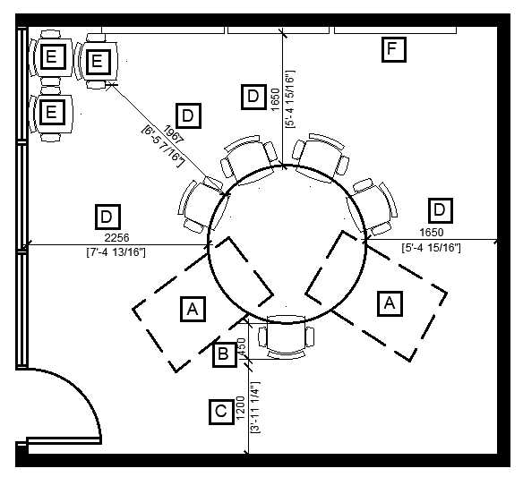
Legend for Figure 1
- A: Clear floor space for a wheeled mobility device user to participate
- B: 450mm in front of table for occupied task chair
- C: Minimum of 1200mm wide clear path of travel
- D: Minimum of 1650mm from the edge of a table to any wall or furniture to allow space for an occupied chair and clear path of travel
- E: Displaced task chairs placed where they don’t impede on the path of travel
- F: Access to whiteboard

Accessible Route Termination

Where an accessible path of travel (or route) terminates (dead end), a wheeled mobility device (WMD) user navigating that path of travel must be able to turn around and return down that path of travel. It is important that sufficient clear floor space be provided to facilitate that action. Refer to Figure 5.
Building codes and standards typically only apply to permanent structures like walls, and usually they do not extend to furniture, which is moveable, including systems furniture panels. Given that GCworkplace is designed as an activity-based work environment with unassigned seating, and that furniture is often used to define pathways throughout the space, ensuring all paths of travel are accessible is crucial for inclusivity.
Mandatory
- Refer to CSA/ASC B651:23, Clause 5.1.2 Accessible Route Termination.
- The intent of CSA/ASC B651:23, Clause 5.1.2 is for situations involving hard walls, not furniture such as systems furniture panels. Where an accessible route terminates one of the following options must be provided:
- A clear floor space that is not less than 2100mm in diameter. Refer to Figure 2.
- A clear floor space that is not less than 1700mm wide by 1500mm long. Refer to Figure 3.
- A clear floor space that is T-shaped with overall dimensions measuring a minimum of 1800mm wide by 1500mm long, where the two arms are not less than 1200mm wide and extend not less than 300mm from each side of the shaft of the “T”, and the shaft is not less than 1200mm wide for a distance of 1500mm. Refer to Figure 4.
Figure 2
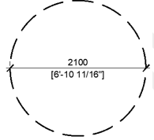
Figure 3
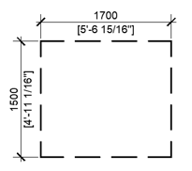
Figure 4
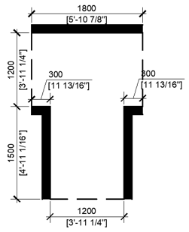
Evolving compliance
- It is strongly recommended that CSA/ASC B651:23, Clause 5.1.2 be applied to situations created by furniture as well (i.e. systems furniture panels).

Figure 5
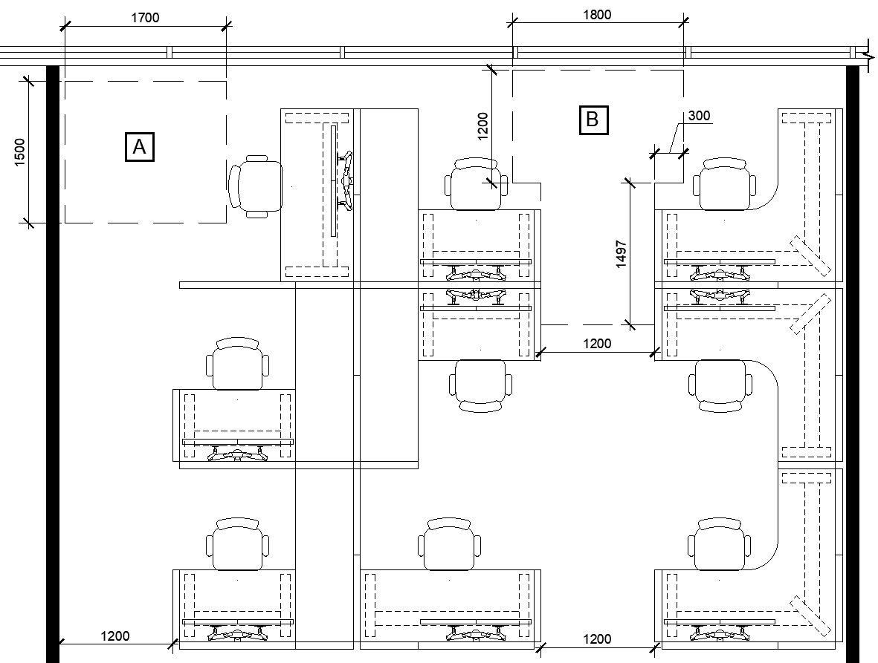
Legend for Figure 5
- A: Rectangular shaped clear floor space (Refer to Figure 3) at the end of an accessible route that terminates. Provides sufficient space for a WMD user to turn around.
- B: T-shaped clear floor space (Refer to Figure 4) at the end of an accessible route that terminates. Provides sufficient space for a WMD user to turn around.

Clear Floor Space

Clear floor spaces must be integrated into the planning when designing workspaces to ensure they are accessible to wheeled mobility device users. Refer to Figure 8. This helps to ensure:
- Sufficient clear space has been incorporated into seating arrangements for a WMD user to participate.
- Sufficient clear space has been provided for a mobility aid (i.e. WMD, walker, service dog) adjacent to seating and outside of circulation space. This provides space for someone to transfer to the seating provided, or for a service dog to be next to their handler.
According to CSA B651:23, to accommodate a WMD user, the minimum clear floor space provided must be 820mm x 1390mm. These dimensions will accommodate the 95th percentile of WMDs.
Mandatory
- Refer to CSA/ASC B651:23, Clause 4.1 a).
- Clear floor space that measures 820 mm x 1390mm. Refer to Figure 6.
Figure 6
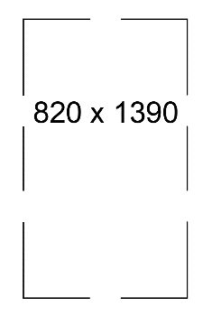
Evolving compliance
- Clear floor space that measures 900 mm x 1500 mm (ASC Draft Standard).
Note: Testing in the summer of 2024 indicated that it is possible to successfully integrate clear floor spaces of these dimensions into GCworkplace designs most of the time, while still balancing the GCworkplace Space Planning Workbook. Refer to Figure 7.
Figure 7

Figure 8
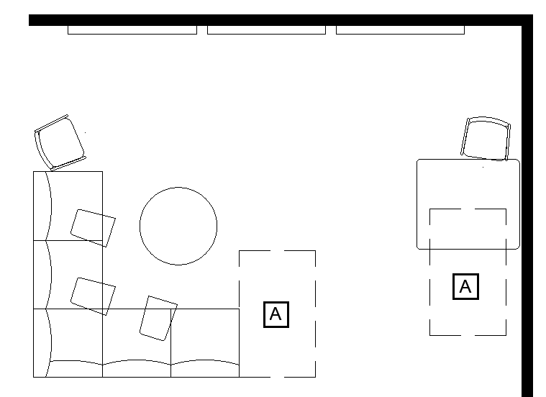
Legend for Figure 8
- A: Clear floor space for a wheeled mobility device user. The space next to the soft seating could also be used for a service dog to be next to their handler while remaining outside of circulation space.

Turning Diameter

Turning diameters allow WMD users to turn around to change direction. Consider how the space will be used to aid in determining where the turning diameters will be needed.
Mandatory
- Refer to CSA/ASC B651:23, Clause 4.1 b).
- Turning diameter that measures 2100mm minimum. Refer to Figure 9.

Figure 9
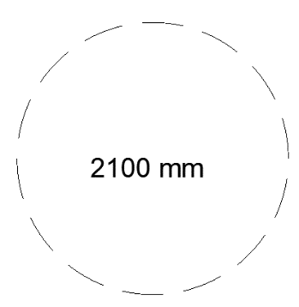
Evolving compliance
- Turning diameter that measures 2500 mm (ASC Draft Standard). Refer to Figure 10.
Note: Testing in the summer of 2024 indicated that it is difficult to incorporate 2500mm turning diameters into GCworkplace design while balancing the space within the GCworkplace Space Planning Workbook. Recommend planning with 2100 mm turning diameters and providing for 2500mm where possible.
Figure 10
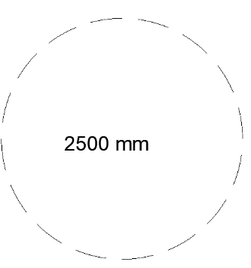
Recommendations
- Turning diameters should be provided at the following locations. This is not a comprehensive list as turning diameters may be needed in additional locations.
- All workpoints that are intended to be accessible to WMD users;
- All open and enclosed collaborative groupings (i.e. meeting rooms, teaming areas, project rooms, etc). A minimum of one turning diameter in an appropriate location should be provided, but more should be provided if needed for functionality; and
- All support spaces such as kitchenettes, locker areas, printer stations, wellness rooms.
- Turning diameters for workpoints can extend into secondary corridors but should not extend into primary corridors.
- It is best for door swings to not impede on turning diameters, but it is acceptable.
- Turning diameters can extend under surfaces that provide the required accessible clearance height, but they should be avoided. Be aware of obstructions (i.e. table bases) and ensure it absolutely does not overlap by more than 480mm.
Considerations
- In an enclosed room, locating a turning diameter near the door tends to work best.
- Floor monuments and power cords must be carefully placed and managed to ensure they do not impede on planned turning diameters. Not only would they take away from the turning space they can create tripping hazards.
- Turning diameters can be shared and are a good way of maximizing space such as in bullpen workstation groupings. Refer to Figure 11. The drawback is that privacy is reduced. Providing a variety of different types of stations with varying degrees of privacy is encouraged to help ensure everyone’s individual needs can be met.
Figure 11
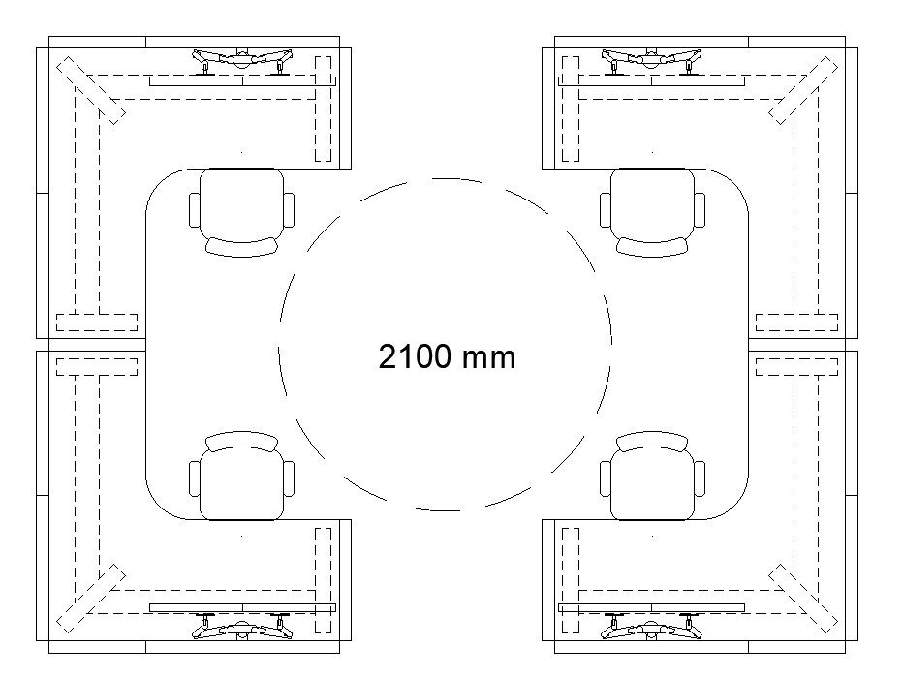

Doors and Doorways

Mandatory
- Refer to CSA/ASC B651:23, Clause 5.2 for full details of mandatory requirements for doors and doorways such as minimum manoeuvring space required at doors, maximum force to operate the door, door hardware, etc.
- Mandatory Clear Door Width: 860mm minimum.
Evolving compliance
- Evolving compliance Clear Door Width: 950mm minimum (ASC Draft Standard).
Considerations
- The requirement is for a clear door width, not the actual door width. There is a specific way to measure it. Refer to CSA/ASC B651 Standard for full details.
- It is important to consider the entire journey of the WMD user to ensure seamless accessibility. Providing ample circulation space in an enclosed room may be helpful for people that use larger WMD’s, but only if the door is wide enough to provide access.
- There have been reports of doors being heavy to operate – particularly as it relates to glass barn style doors. To address this concern, it is recommended to ensure specifications for doors require compliance with the latest version of CSA/ASC B651 and verify products supplied meet the standards. During the deficiency walkthrough, door force should be measured on-site to ensure compliance and address any issue.
- The clear floor space for manoeuvring on both sides of doors is sometimes overlooked. Refer to CSA/ASC B651:23, Clause 5.2.2 for full details.

Power-Assisted Door Openers

Mandatory
- Refer to CSA/ASC B651:23, Clause 5.2.9.
Evolving compliance
- Equip power door operator with safety sensors at a height of 500mm and 1000mm which are designed to prevent contact with any user or service dog (ASC Draft Standard).
- Mark the swing path of a power-operated door on the ground or floor surface with a high luminance contrast to the ground or floor surface (ASC Draft Standard).
Recommendations
- If manual activation is used, the vertical actuation bar style control provides a greater range of access than a button style.
- Security access systems capable of automatically opening a door through a single action are preferred.
- Power-assisted door controls should be located a minimum of 695 mm from any inside corner.
Considerations
- If motion sensors are used, their focus area must be individually adjusted to the environment in which they are used so that they are responsive to the user but avoid unintended nuisance activation.
- When installing motion sensors, it is important to be thoughtful of where the button will be located and to possibly use contrasting colours to make them visible to all users.
- When specifying a vertical actuation bar style control, ensure that the design allows the wheel of a WMD to effectively activate the control. Some vertical bar styles may include a finishing piece that can obstruct the wheel from being able to activate the control. Additionally, ensure the bottom of the control is installed between 150mm – 175mm above the finished floor. This height facilitates activation by a wider range of users, whether they are using the wheel of their device, their foot or their hand. If the installation height is not specified, it may end up being too high and reduce its effectiveness and may not be any better than the button style.

Operating Controls

Operating controls include, but are not limited to, light switches, electrical outlets, power-assisted door opener controls, handles and locks on lockers and filing cabinets, handles and controls on microwaves and refrigerators, controls for technical equipment such as printers, paper towel dispensers, soap dispensers, etc.
Note: Refer to CSA/ASC B651:23 clause 4.3 for full Mandatory requirements.

Clear Floor Space for Operating Controls
Mandatory
- Refer to CSA/ASC B651:23, Clause 4.3.2:
- Controls must be adjacent to a clear floor area which measures a minimum of 820mm by 1390mm.
- Where knee and toe space are provided, the control must be centered on either the length or the width of the clear floor space.
- Where knee and toe space are not provided, the control must be centred on the 1390mm length of the clear floor space. Refer to figure 12.
Figure 12
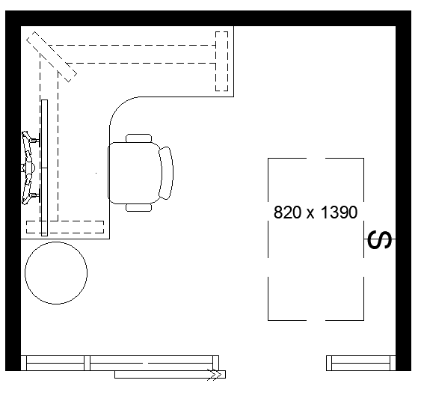
Evolving compliance
- For a forward approach, a clear floor area that measures a minimum of 900mm x 1500mm should be adjacent to control with the 900mm width centered on the control (ASC Draft Standard).
- For a parallel approach, a clear floor area that measures a minimum of 900mm by 2200mm should be adjacent to control with the longer length centered on the control (ASC Draft Standard). Refer to Figure 13.
- Operating controls should be located a minimum of 600mm from any adjacent wall (ASC Draft Standard).
Recommendation
- The path to the control should provide turning opportunities, as defined in CSA/ASC B651:23, Clause 5.1.1, to allow people to turn around to approach the control on either their right or left side.
Figure 13
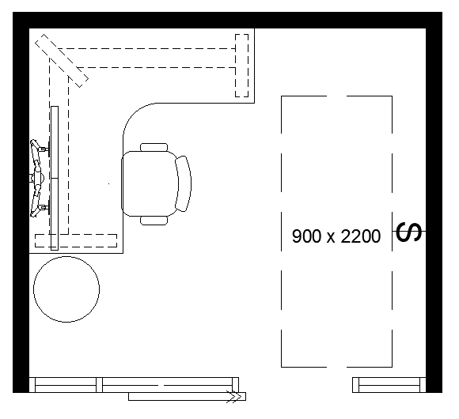

Height for Operating Controls
Mandatory
- Refer to: CSA/ASC B651:23, Clause 4.3.3.
- The centerline of any operating controls must be located within a range between 400mm and 1200mm above the finished floor.
Note: This height is not appropriate for power-assisted door opener controls. Refer to 5.6 Power-Assisted Door Openers.
Evolving compliance
- The centerline of any operating controls shall be located within a range between 400mm and 1100mm above the finished floor (ASC Draft Standard).
- Controls that require precise hand movements should be located between 750 – 1000mm above the finished floor.
- Controls that require close reading should be located between 900 – 1100mm above the finished floor so they can be seen by a person sitting or standing.

Operation of Controls
Mandatory
- Refer to: CSA/ASC B651:23, Clause 4.3.4.
- Controls must be operable with one hand, using a closed fist position or another method of operation that does not require tight grasping, pinching, or twisting of the wrist.
- The force to operate the control must not exceed 22 N.
Evolving compliance
- Automatic or electronic controls may facilitate use by a wider range of people. Automatic controls are preferred. (ASC Draft Standard).
- Push-button type controls should have a minimum surface diameter of 13mm and should not be recessed. (ASC Draft Standard).
- If not automatic, operable parts should be operable with a maximum force of 19.5 N for mechanically operable parts and 5 N for electronically operable parts. (ASC Draft Standard).
Recommendations
- CSA/ASC B651:23 advises that a control that needs to be read or adjusted should be angled in such a way that it is usable from a seated and a standing position.
Considerations (for controls in general)
- Though not actually a control, WMD users need clear floor space to utilize things like whiteboards, tackboards and recycling centres.
- Consider hanging whiteboards vertically to allow increased range for people of varying heights as well as those that need to use it from a seated position.
- Though not preferred, it is acceptable for a door swing to temporarily impede on the clear floor space for controls.
Note: Refer to section 5.8.2 Reach Distances for Controls at Worksurfaces and Tables for more information about accessing controls.

Seating Space at Worksurfaces and Tables / Reach Distances for Controls

Seating Space at Worksurfaces and Tables
A forward approach is used by WMD users to access a worksurface or table. Providing clear floor space at the worksurface as well as knee and toe clearance under the worksurfaces and tables is essential for accessibility.

Mandatory
- Refer to CSA/ASC B651:23, Clause 6.7.1. The following is a summary of accessible seating space and knee/toe clearance requirements at worksurfaces and tables. Refer to Figure 14.
- A clear floor area of 820mm x 1390mm must be provided at the worksurface/table for the WMD user to utilize the surface.
- Surface height must be between 730mm and 860mm above the finished floor
- Knee/toe clearance to be minimum of 820mm wide by 685mm minimum above the finished floor to a point 480mm from the front edge of the surface. This space may overlap the clear floor area by not more than 480mm.
Figure 14
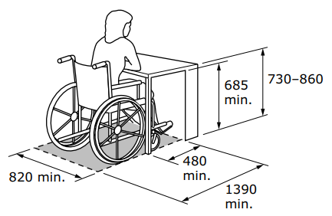
Evolving compliance
- The following is a summary from the ASC Draft Standard of accessible seating space and knee/toe clearance requirements at worksurfaces and tables. Refer to Figure 15.
  - A clear floor area of 900mm x 1500mm to be provided at the worksurface/table for the WMD user to utilize the surface.
  - Surface height to be a maximum of 865mm above the finished floor.
  - Knee clearance to be minimum of 900mm wide by 685mm minimum above the finished floor to a point 300mm minimum from the front edge of the surface.
  - Toe clearance to be minimum of 900mm wide by 350mm minimum above the finished floor to a point 500mm from the front edge of the surface. This space may overlap the clear floor area by not more than 500mm.
Figure 15
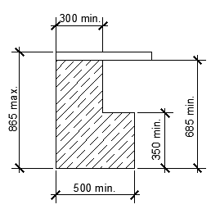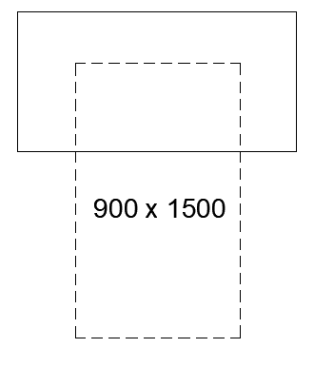
Considerations
- Table bases can create barriers.
- The width between the legs/base of narrower height adjustable tables must provide the needed clearance. It will vary by manufacturer. Consider planning with a minimum table width of 1372mm to help mitigate this concern.
- Ensure modesties & power/cable management do not impede the knee and toe clearance required.
- Tables with wide bases such as pedestal bases don’t provide the clearance required. It isn’t usually the knee and toe clearances, but rather the base on the floor that creates the barrier for wheeled mobility device users. The knee and toe clearance requirements need to extend from the worksurface to the floor. Refer to Figure 16 which shows tables with pedestal style bases that DO NOT provide the required knee and toe clearance to the floor for the tables to be accessible to WMD users.

Figure 16
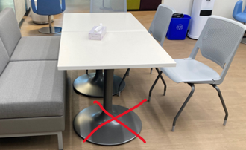
- Consider the knee/toe clearance space for all users when pulled up to a table and engaged in work. Space around a table may be more crowded than it seems. Refer to Figure 17. The image on the left demonstrates how furniture plans are typically drawn. The image on the right Shows the importance of considering the knee and toe space required for all users in relation to the table bases. Space between chairs and space for feet gets much snugger.
Figure 17
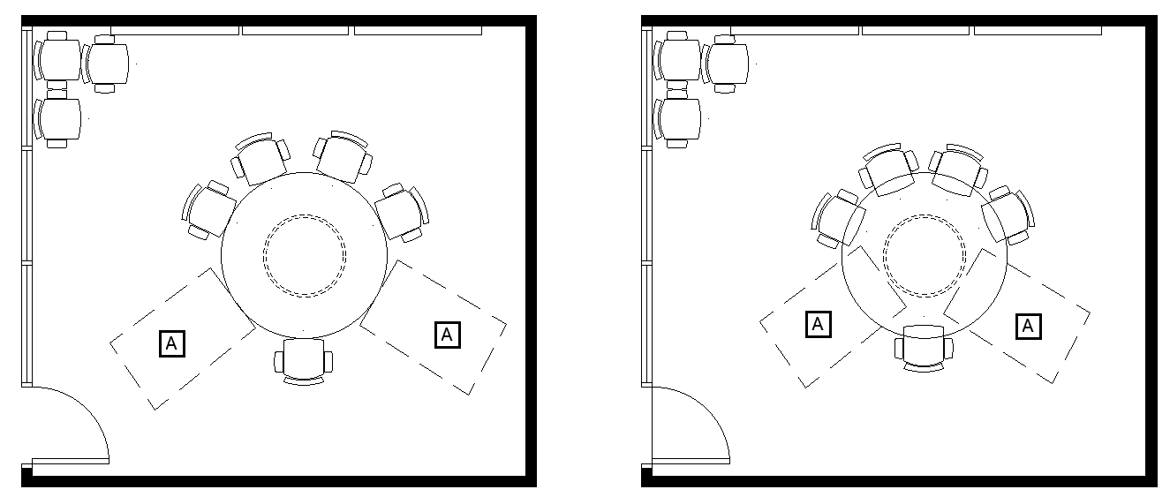
Legend for Figure 17
- A: Clear floor space for a wheeled mobility device user.

Reach Distances for Controls, Worksurfaces and Tables
Recommendations
- Refer to CSA/ASC B651:23, Annex A, Clause A.2.2 & Figure A.2. Annex A provides additional information on topics considered in the Standard, but there are no Mandatory clauses for controls at worksurfaces or tables. The following provides recommendations for the locations of power sources and other controls when using a worksurface or table:
- Elements intended to be graspable while sitting at a worksurface or table (i.e. power modules) should be a maximum height of 1100mm and should be located a maximum of 500mm from the front edge of the surface. Refer to Figure 18.
- Controls intended to be touched while sitting at a worksurface or table (i.e. table height adjustment controls, task light switches) should be a maximum height of 1100mm and should be located a maximum of 600mm from the front edge of the surface. Refer to Figure 18.
Considerations
- Some manufacturers may find it challenging to position a power module on the side of the desk as illustrated in Figure 18. An alternate solution could involve installing the power module flush to the under side of the surface at the front edge for visibility. However, it is essential to ensure that this set-up does not interfere with the required knee clearance. Additionally, for electric height adjustable tables, consideration must be given to the placement of the control for the height adjustment mechanism. Depending on the manufacturer, these controls can be quite large and significantly reduce the knee clearance while also causing obstructions for chair arms.

Figure 18
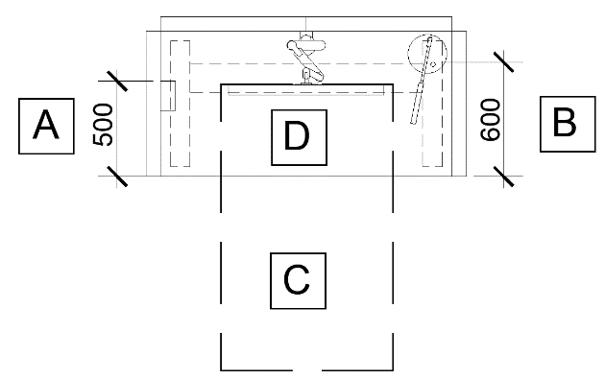
Legend for Figure 18
- A: Power module with furthest receptacle a maximum of 500mm from the front edge of the surface. This distance allows for a person to grasp a plug while sitting at the desk.
- B: Task light with the activation control a maximum of 600mm from the front edge of the surface. This distance allows a person to touch the activation control while sitting at the desk.
- C: Clear floor space for a wheeled mobility device user pulled up to a worksurface.
- D: Clear knee/toe space under surface.

Clear Floor Space for Approach and Transfer
It is important to provide a variety of ways for people to participate in all aspects of the workspace. This can be facilitated by providing the clear floor space needed for a WMD user to transfer to soft seating. CSA/ASC B651:23 doesn’t include a clause or standard relating to space for approach and transfer for furniture seating (just for toilets).
Recommendation
- Providing 2100mm x 2100mm of clear floor space adjacent to seating, allows WMD users to approach and align themselves with the seating that they wish to transfer to. Ensure there is space for the device to remain next to the person without obstructing the pathway. Refer to Figure 19.
Figure 19
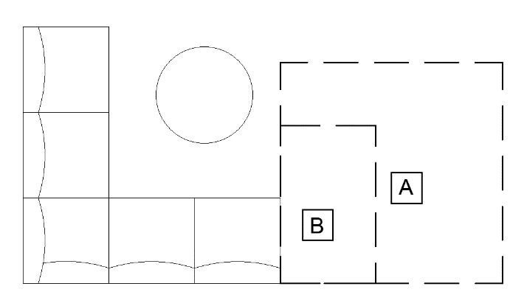
Legend for Figure 19
- A: Clear floor space for a WMD user to approach and transfer, 2100mm x 2100mm.
- B: Space out of circulation space for a WMD to be placed when the user wishes to transfer to the seat provided. This space can also be used by a service dog to be next to their handler.
Considerations
- Consider where opportunities to transfer can be provided when designing the workspace.
- The WMD must be adjacent to the user after completing their transfer. It cannot be moved. It is important to ensure that the device does not hinder the participation of others, such as allowing all participants to leave the room or access a whiteboard while in an enclosed space.
- There cannot be an armrest on the transfer side. If there is an armrest, it must be possible to move it out of the way to facilitate the transfer process.
- The seat must be firmly in place (i.e. not on casters).

Signage & Wayfinding

Signage
Mandatory
- Refer to CSA/ASC B651:23.
- The Government of Canada’s signage system is detailed in the Federal Identity Program (FIP) Manual – a mandatory Treasury Board policy instrument issued under the Policy on Communications and Federal Identity. The manual applies to federal facilities and engineered structures (owed and leased), and includes both public and restricted spaces. The manual details materials, message, colour, layout, typeface, presentation of official languages, and installation for fourteen classes of signs that comprise the federal signage system including: wayfinding, identification, regulatory, emergency, common use, pictograms, etc. The manual also outlines the roles of tenant and custodial departments with respect to planning, messaging, procurement and installation. To help ensure compliance with standards and quality control for federal signage, PSPC manages a National Master Standing Offer (NMSO) for Government of Canada signage products/components and services. This includes siting, design, production, and installation in all regions of Canada. Enquiries about the NMSO should be directed to TPSGC.SIEnseignes-RPSSignage.PWGSC@tpsgc-pwgsc.gc.ca.
- While many signs (i.e. washroom) have a fixed message and layout and are pre-stocked for ordering, other classes of signs such as wayfinding, include customized messaging to reflect the floorplan and the environment. Signs that require customized messages must be planned and designed before manufacturing. The layout and design of the sign requires knowledge of the design system as well as the layout and sizing of typography and other elements. See Direction and Area Signs.
- The Government of Canada’s signage system includes many components related to accessibility including plain language, concise messaging, high contrast colours, high-legibility typeface, illumination, and anti-glare surfaces. The use of Braille and raised lettering and raised pictograms is currently limited to the tactile class of signs which covers washrooms (men’s, women’s, and all access) and emergency egress (exits and exit stairwells). The Government of Canada signage requirements do not permit departments or facility managers to develop custom designs or alternative approaches for the use of tactile features.
Looking Forward (Evolving compliance does not apply here as FIP must be followed)
- Accessibility Standards Canada (ASC) is developing national standards for accessible signage and wayfinding. This standard is not expected to be completed until mid-2026, and the requirements will need to be integrated into updated FIP signage standard to be applied to federal facilities. Based on requests received by TBS, it’s evident that departments are looking to advance accessibility. However, to maintain a consistent and coordinated approach, TBS and ASC are recommending that departments refrain from amending current signage until ASC’s standards-development process is complete and TBS has issued updated and approved signage standards. New sign options require custom manufacturing and would lead to an inconsistent disjointed signage approach in federal buildings. Furthermore, temporary options that don’t align with future standards will need to be replaced. This will result in additional costs that could be significant.
- If a client is interested in accessible signage the department may do so as part of a research pilot initiative. This will ensure that options being considered are based on research objectives that would produce usable data for ASC in their standards development. There are certain criteria that must be followed. Should you have questions related to a pilot project, please contact the Communications and Federal Identity Policy Centre. Information regarding the new standards being developed by ASC can be found at Creating accessibility standards - Accessibility Standards Canada.
Recommendation
- Tactile adhesive labels (braille) can help to improve the accessibility of some products. They are not considered signage if they are affixed to objects, appliances or cabinets. They can make using some products easier to understand for people who read braille. i.e. identifying the on and off switches for small appliances such as kettles, identifying the features of a menstrual product dispenser, identifying buttons on an existing microwave that doesn’t have braille buttons.

Wayfinding
CSA/ASC B651:23 defines “wayfinding” as a special problem-solving process based upon consistent use and organization of definite sensory cues in the environment that individuals use to understand where they are, where their desired location is, and how to get to that destination from their present location.
A well-designed wayfinding strategy is essential for everyone, but it is especially critical for people with disabilities. For example, consider someone with a mobility disability having to travel a longer distance after going the wrong direction, a person who is blind not being able to orientate themselves, a person with a cognitive-related condition navigating a confusing or inconsistent layout, etc.
Recommendations
- Refer to CSA/ASC B651:23, Clause 4.7.1.
- Design spaces with simple and logical layouts.
- Ensuring designs include consistent features throughout, such as locating washrooms in the same place on every floor.
- Ensuring that wayfinding information is accessible in various formats (text, symbols, auditory, printed, digital, QR coded, etc.).
- The wayfinding strategy must be understood by diverse users. Consider using a multi-modal approach to help everyone navigates spaces effectively. It could include visual cues such as signage and colour coding; tactile cues such as a tactile map of the floor and tactile walking indicators or a change in flooring texture; cognitive cues such as landmarks and a workplace coordinator well positioned to offer assistance.
- Enhance site orientation and memory recall with landmarks along circulation routes. Landmarks are features that stand out by being easily distinguishable, unique, and consistent, creating reliable reference points to support travel. They may include artwork, benches, plants, different coloured doors for different sections of building. Circulation routes that are easily identifiable and include landmarks improve special orientation, wayfinding, memory and confidence.
- Clearly define functional zones (i.e. quiet, transitional, or interactive zones). The zones ensure that activities are grouped together to reduce noise disruptions which is of particular importance for some users who require silence to work effectively. Clearly cueing the functional zones helps users to understand expected behaviors. For example, the quite zone is intended for individual focus work and to support the need for quiet private spaces. It should be apparent when you enter that zone to trigger the appropriate behaviour so as not to disturb others. Refer to GCworkplace Design Guide for more information.
- Lighting is fundamental to wayfinding. Ensure sufficient lighting is provided to evenly illuminate the space without strong shadows.
- Directional signage and a logical room/station numbering system is very important in wayfinding.
- Consider the ease of locating key services and amenities such as the first aid representative, workplace coordinator, and meeting rooms.

Headroom

Mandatory
- Refer to CSA/ASC B651:23, Clause 4.5.1.
  - Clear headroom of at least 2050mm from the floor must be provided in pedestrian areas. There is an exception for doorways; height of 2050mm at doorways is preferred, but a height of 1980 mm may be used.
  - Where the headroom in a pedestrian area is reduced to less than 2050mm from the floor, a guardrail or other barrier shall be provided with its leading edge at or below 685 mm from the floor.
Evolving compliance
- Clear headroom of 2,400mm minimum (ASC Draft Standard).
- Clear doorway height of 2030mm minimum (ASC Draft Standard).
Recommendations
- Provide a guardrail or other barrier with its leading edge at or below 300mm from the floor so it can be detected sooner. Where the guard could be a tripping hazard (e.g. because it is in an open space, such as under an overhead stair landing), the guard has its lowest edge at a maximum height of 300mm above the floor, and there is a secondary rail at a height of 680mm. Refer to Figure 20.
- It is important that the barrier be permanent, for example furniture that can be moved would not be a good choice.
Figure 20
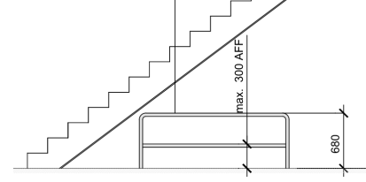

Protruding Objects

Protruding objects are potentially hazardous to persons who are blind or partially sighted and need to be avoided. When they are unavoidable, and they extend more than 100mm from the wall they must be able to be detected by those who use a long white cane. People who use a cane can detect objects with a leading edge that is 685 mm or below from above the floor.
Mandatory
- Refer to CSA/ASC B651:23, Clause 4.5.2.
Recommendations
- Provide a guardrail or other barrier with its leading edge at or below 300mm from the floor so the protruding object can be detected sooner.
- Protruding object should contrast with the background environment through distinct luminance (colour) contrast.
Considerations
- The following are examples of fit-up elements that may protrude and require consideration. This is not an exhaustive list.
- Wall mounted TV/display
- Surfaces that are hung off the back of seating
- Mobile monitor mounts
- First aid kits

Safety

Mandatory
- Refer to CSA/ASC B651:23, Clause 5.1.5.
Recommendations
- Convex mirrors should be installed near the ceiling at all hallway intersections where visibility is hindered. It aids in viewing oncoming pedestrians and can be especially helpful for persons who are deaf, deafened or hard of hearing.
- Corners and edges: rounded corners and edges on surfaces are recommended. The blunting of these sharp edges and corners reduces the impact of a collision.
- Walls at the end of corridors should be contrasted in colour or brightness with the other walls and floor. Where windows are located at the end of a corridor, minimize glare from the windows.
- Carefully plan electrical locations that feed furniture to avoid misplaced floor monuments and cords that create tripping hazards.

Environmental Sensitivity & Multiple Chemical Sensitivities (MCS)

Approximately 3% of the population (over 1 million Canadians) has been diagnosed with environmental sensitivities (ES) which include multiple chemical sensitivities (MCS) and electromagnetic hypersensitivity (EHS), and a higher proportion remain undiagnosed but affected by these disabilities (Park J and Knudson S. Medically unexplained physical symptoms. Statistics Canada. 12-1-2007). Environmental Sensitivity is recognized as a disability under the Canadian Human Rights Code, and as such, there is a duty to accommodate staff diagnosed with environmental sensitivities.
People with environmental sensitivities may experience disabling symptoms when they are exposed to a variety of chemicals or other environmental agents, even when at low levels (e.g. air born chemicals from new building materials, and/or electromagnetic radiation from Wi-Fi or cell phone towers.)
The following are a few websites that may be helpful to refer to:
- Kicking Toxic Chemicals Out of Office Furniture: A Toolkit for Choosing Healthier Furniture - Center for Environmental Health (ceh.org)
- Flooring - Center for Environmental Health (ceh.org)
- Environmental Health Association of Quebec (EHAQ)

Recommendations
- Ensure materials and products with strong scents and hazardous chemicals are avoided. CSA/ASC B651:23, Clause 4.7.2. advises “Construction, furnishing, or decorative materials should not give off gases that affect the quality of indoor air. Contaminants such as gases, dust, and volatile organic compounds should be minimized. Adequate ventilation (natural and mechanical) should be provided at the level needed to dilute any contaminants and provide fresh air to the occupants.”
- With regard to furniture, consider requesting products that meet BIFMA 7.4.4 criterion (targeted chemical elimination) or GreenScreen certified furniture or textile products.
- Include signage about the scent-free policy within the workplace as a reminder to employees.

Acoustics

Acoustics play an important role in accessible design since they can distort or enhance verbal information, as well as provide auditory information cues.
Acoustics are influenced by several factors, including layout, room shape and size, fabrics, and furnishings. In general, soft surfaces such as carpeting, curtains, ceiling tiles and upholstery will absorb sound. Hard surfaces such as concrete, brick, tile, glass, and wood tend to reflect sounds, which can create a noisy and echoing environment. Echoes and other noise reverberations should be minimized by use of materials and by thoughtful design.
There are many methods that can contribute to good acoustic management, including but not limited to: strategic space planning/zoning of activities, acoustic ceiling tiles and baffles, textured surfaces to diffuse sound such as wood slats, soft upholstery on furniture, acoustic space dividers, acoustic treatment on light fixtures, plants, air-return silencers, double or triple glazed windows (to address outside noise coming in).

Recommendations
- CSA/ASC B651:23, Clause 4.7.3 recommends that all environments be designed for sound control, both to provide auditory cues where needed and to minimize distracting or disorienting sounds such as echoes.
- CSA/ASC B651:23, Clause 4.7.1 c) recommends implementing good acoustical design measures throughout spaces to avoid excessive noise interferences.
Considerations
- Noisy HVAC systems and sound-making systems are problematic for those that use hearing aids and cochlear implants. Some users find that it distorts and competes with speech as their assistive devices amplify all sounds. The ability to control and adjust sound masking devices is an important consideration.

Lighting

Lighting can present challenges for individuals with various disabilities, making it essential for accessibility of lighting to be considered from the beginning. Providing appropriate lighting solutions is crucial for accessibility, particularly for people who lip read or use sign language, are partially sighted, or have sensitivities to light. This section of the Guide aims to encourage project teams to carefully consider lighting through an accessibility lens. However, lighting design is complex, and accessibility is one of many factors to consider. Some of the additional documents that must be referred to include the following. This is not a comprehensive list.
- PSPC Technical Reference for Office Building Design (references many more codes, standards and legislation that applies to lighting)
- Workplace_Fit-up_Standards
Mandatory
- Refer to CSA/ASC B651:23, Clause 4.3.7 which indicates that controls must be illuminated to a level of at least 100 lx, and where reading of the controls is necessary, to a level of at least 200 lx.

Recommendations
- Refer to CSA/ASC B651, Clause 4.7.1 d).
- Incorporate adjustability and dimming options wherever possible, and consider using multiple light sources. This creates versatile lighting conditions and increases user control of the environment, enhancing comfort and overall well-being.
- Avoid fluorescent lighting, as it can be problematic for people with light sensitivities and may trigger debilitating migraines.
- Paths of travel should be illuminated to an average level of 100 lx minimum (ASC Draft Standard).
Considerations
- How lighting can be designed to address diverse needs while meeting code, standard, and regulation requirements.
- Would dimmable lighting that also allows the user to control the tone of the light (cooler/warmer) be a good solution for the project? Perhaps it could be used in a small area of workstations in a quiet zone, or in enclosed rooms. Or perhaps a designated area of workstations that primarily rely on natural daylight, supplemented only by non-fluorescent emergency lighting.
- In situations where fluorescent lighting is already in place, de-lamping fixtures over a group of workstations is sometimes implemented; however, this can still be inadequate for some people; as leaving other lights in peripheral view can still provoke symptoms. It is important to block this view effectively.
- Pay careful attention to the access of controls of manually operated roller shades and blinds to ensure all users can adjust them as needed.
- Ensure light fixtures don’t produce noise or flicker.

Finishes

General
Recommendations
- Avoid finishes with strong patterns on large surfaces (i.e. wall finishes, carpet, millwork, upholstery of large pieces of furniture). Strong patterns, such as stripes and checks can create confusion and dizziness for people.
- Ensure surfaces are glare-free (i.e. floors, table surfaces, millwork). Matte finishes rather than glossy ones can help reduce glare and improve visibility for everyone.
- White worksurfaces should generally be avoided because they can be too bright for some users. Worksurfaces in colours with less reflectivity and contrast are more accessible for some employees.
- Consider the needs of those who experience colour vision deficiency. For example, red/green and blue/green combinations can be difficult to distinguish for some people.

Luminance (colour) Contrast
Mandatory
- Refer to CSA/ASC B651:23, Clause 4.2.
- Contrast must be provided between many things. Below are some examples. Refer to the standard for full details.
- Floor surfaces with base trim and base trim with walls;
- Doors and doorframes from surrounding surfaces;
- Contrast strips on glass doors, glass walls, sidelights;
- Handles on surfaces such as doors, cupboards, storage cabinets/millwork;
- Control and operating mechanisms from mounting surfaces; and
- Furniture from surrounding surfaces.

Flooring
Mandatory
- Refer to CSA/ASC B651:23, Clause 4.4. This covers general information for floor surfaces, changes in level, carpets and tactile indicator surfaces.
Recommendations
- Colour/texture contrast can be helpful in delineating the path of travel from work areas.
- Plain, light-coloured flooring or simple-patterned flooring is best. Refer to 5.16.1 General.
- Carpet can be difficult for WMD users to use. When using, choose carpet that helps to mitigate this concern. Carpets without underpadding are preferred from an accessibility perspective.

Fully Glazed Doors, Walls and Sidelights
Mandatory
- Refer to CSA/ASC B651:23, Clause 5.2.10 and applicable building codes.
Considerations
- It is acceptable to add additional decorative film provided the Mandatory requirements are met.
- In existing spaces, it is common to see glazing with etched strips or white frosted decals. It is important to note that they do not provide suitable colour contrast for people who have a vision impairment or are partially sighted. Luminance (colour) contrasting opaque strips must be added.

Accessibility Considerations for Specific Workpoints and Support Spaces

This section delves into the details of planning accessible workpoints and support spaces within GCworkplace. It is divided up into two parts “General” and “Workpoint and Support Space Specific”.

General

This section includes information that applies to many different workpoints and support spaces. The information under the General heading will not be repeated under specific workpoints.

Individual Workpoints
It is strongly encouraged to include as many individual workpoints that are accessible to wheeled mobility device (WMD) users as possible. This is particularly important in unassigned environments as it helps to ensure that WMD users have access to workpoints that meet their needs, even during peak occupancy. If an employee is unable to find a suitable workpoint, it may lead to an increased demand for accommodations of assigned workpoints, ultimately diminishing the effectiveness of the Activity-Based Work approach.
Mandatory
- At least 20% of individual workpoints of each type must be accessible to wheeled mobility device (WMD) users and include the following minimum requirements:
- Turning diameter at the workpoint.
- Accessible seating space at worksurfaces and tables and controls within reach, if applicable.
- Clear floor space for a WMD user to participate while remaining in their chair or for their WMD if they wish to transfer to a soft seating option, if applicable. This space can also be used as a space for service dogs to be next to their handler or other mobility aids to be placed.
Note: For consistency and effective data tracking, it is essential that requirements be measurable. The 20% criterion will serve as the starting point for this Guide. Testing indicated that it is feasible to include significantly more than 20% of individual workpoints that are accessible to WMD users. Some types are easier to provide than others. Feedback, success stories and lessons learned from users regarding all aspects of the Guide would be appreciated, particularly in this area. If projects using this Guide demonstrate the ability to include a higher percentage of individual workpoints accessible to WMD users, this percentage may be increased in future iterations of the Guide.
Evolving compliance
- Ensuring all individual workpoints are accessible to WMD users as described under the Mandatory category. All things considered, it may not be possible to do that and balance the GCworkplace Space Planning Workbook, it should certainly be possible to significantly exceed 20%.

Collaborative and Support Spaces
GCworkplace features a wide variety of Collaborative areas to foster spontaneous interactions as well as planned activities. Ensuring that all collaborative spaces are accessible is essential.
Mandatory
- Planning a variety of sizes and configurations of collaboration spaces supports universal design principles and promotes accessibility and inclusivity.
- At least 10% of seats within each collaborative workpoint (i.e. meeting room, work room, etc.) must be accessible to WMD users. For example, if a large meeting room accommodates 20 employees, at least 2 seats of the 20 provided must be accessible to WMD users. Every collaborative space must accommodate at least one WMD user. Minimum requirements for collaboration spaces and support spaces to be considered accessible to WMD users include:
- Turning diameter at the workpoint.
- Accessible seating space at worksurfaces and tables and controls within reach, if applicable.
- Clear floor space for WMD user to participate while remaining in their chair or for their WMD if they wish to transfer to a soft seating option, if applicable. This space can also be used as a space for service dogs to be next to their handler or other mobility aids to be placed.
- Turning diameter(s) as needed to use the space effectively.
- Clear path of travel to access workpoints, amenities, equipment, and accessible controls (i.e. light switches, whiteboards, etc.).
Note: To ensure consistency and effective data tracking, it is essential that requirements are measurable. The 10% criterion will serve as the starting point for this guide. Test plans indicate that it is possible to include 10% of workpoints that are accessible to WMD users in collaborative areas (e.g. meeting rooms, teaming areas). However, achieving this can be challenging while designing within the parameters of the GCworkplace Space Planning Workbook and Technical Reference Manual, and may impact occupancy quantities. Feedback, success stories and lessons learned from users regarding all aspects of the Guide would be appreciated, particularly in this area. If projects demonstrate the feasibility of increasing the percentage of workpoints accessible to WMD users in collaborative areas, this percentage may be adjusted in future iterations of the Guide.
Evolving compliance
- Aim to include as many workpoints accessible to WMD users as feasible within collaborative areas.
- When asked about meeting rooms, the CSA Group advised that to ensure an inclusive space, all seating opportunities should be available to a person using a WMD device.
- This approach helps avoid situations where accessible workpoint(s) are occupied by individuals who don’t require them, leaving no options for those who do, or creating the uncomfortable situation of the person with the disability having to request the accessible workpoint. While providing many accessible workpoints is encouraged, it may be challenging to exceed the minimum criterion while balancing the GCworkplace Space Planning Workbook.
Recommendations
- When providing a variety of workpoint options within a collaborative space, it is advisable to offer corresponding options for WMD users as well. For instance, in a large meeting room that includes seating at a meeting table and soft seating, there should be accessible options/space available at both types. This offers WMD users choice and equal access.

Planning and Furniture Considerations
Recommendations
Workpoint Orientation: Avoid planning workpoints with users backs to a primary pathway. While this is particularly important for workpoints on busier pathways, it is advisable to apply this principle whenever possible.
Power Management: Carefully plan the placement of power sources to align with furniture feeds and cords to minimize tripping hazards. Implement effective cable management solutions (horizontal and vertical) to keep cables contained and maintain clear floor space for accessibility.
Seat Space: Ensure there is adequate space for displaced seats when a workpoint is occupied by a WMD user, ensuring pathways remain unobstructed.
Transfer Opportunities: Provide opportunities for WMD users to transfer to soft seating by providing sufficient space for approach and transfer.
Handedness Options: Include left-handed and right-handed options or those that provide both where applicable, such as tablet chair, focus pods.
Seating Arrangement: Design seating areas to promote visual communication. A U-shape or semi-circle set-up allows for participants in a conversation to see one another. This helps everyone, but may be particularly helpful to those that read lips or use sign language.
Variety of Furnishings: Offer a variety of furnishings and ways for people to participate to accommodate different sizes, abilities and personal preferences. It’s important to remember that what is accessible for one person may not be accessible for another. For instance, providing a combination of higher (counter/bar height) and lower (seated height) tables in collaborative spaces encourages a range of postures, allowing users to choose to sit or stand.
Adjustable and flexible Furniture: Choose furniture with adjustable features to allow users to modify the furniture to suit their needs (e.g. ergonomic chairs, height-adjustable desks/tables, height adjustable laptop tables, height adjustable media tables, etc.). Flexible furniture, such as modular seating and systems furniture can be reconfigured to suit a change in needs, and furniture that is easy to move around (i.e. light weight, on casters) allows users to rearrange a space to suit their needs at any given time.
Table Bases: Ensure accessible knee and toe clearances are considered when selecting table and desk base styles. Additionally, table bases should not impede users from bringing chairs close enough. Tables with post legs may offer better stability for those that use a table for balance.
Electric Height-Adjustable Tables: Opt for electric mechanisms which are easier to adjust. Some alternative adjustment mechanisms require more effort to adjust the height, such as an older style crank mechanism. Electric mechanism are a great feature for shared tables as well, such as those included in lounges, work rooms and project rooms. In addition to being able to adjust the surface height to the needs of the user, consider electric height adjustable tables that provide a sit/stand range allow for a change in posture. This can be particularly important to people managing their pain at work.
Rounded Corners: Ensure worksurfaces and counters have rounded or blunted corners and edges.
Accessible Chairs: Consider that chairs with arm rests and adequate under-seat space (allows people to get their feet under themselves) supports users when rising.
Laptop Tables: Consider incorporating small pneumatic height-adjustable laptop tables or mobile desks with a sit/stand adjustment range. These tables are particularly beneficial in collaborative settings, allowing users to change postures without affecting others. Additionally, some models feature casters for easy repositioning, making them versatile and convenient as they aren’t tethered by power cords.
Ergonomic Stools: When a workpoint includes a table that is counter or bar height, task stools should be provided and not kitchenette style stools. These are workpoints and should therefore be ergonomic.
Chair & Stool Mobility: Ensure that chairs and stools that need to be moved can be rearranged and used with minimal effort. Some individuals may not have the strength to pull or push chairs and stools if they require too much force. Chairs and stools with casters or high-quality glides can greatly facilitate the ease of movement. Additionally, consider the type of flooring when selecting the best option for the application (glides or casters).
Accessibility of Controls: Consider the ease of use of controls on furniture and accessories, such as locks and handles on storage, controls on task lights, ergonomic chairs adjustments, adjustment mechanisms on height adjustable tables, recessed power modules. Optimal controls are those that require minimal effort (one-handed operation, low force, do not require tight grasping, pinching, or twisting of the wrist), can be seen (luminance colour contrast with background) and are intuitive.
Power Modules: Recessed power modules require careful consideration. Some include covers that require dexterity and strength to open. They often necessitate reaching down inside the table which can be challenging to see and access, particularly from a seated position. Power modules mounted under the leading edge of a surface could enhance accessibility, but may be less visible to users unfamiliar with the environment and are susceptible to being bumped by chair arms. It is essential to assess the most suitable method for providing accessible power on a case-by-case basis.
Power Within Reach: When providing power at workpoints, locate controls within easy reach. For example, an outlet in a wall behind a height adjustable desk is not accessible as it requires the user to go under the desk to access it. A surface mounted power module located within 500mm reach of a seated position is a possible solution for addressing this.
Power modules within meeting tables must be located within 500mm from the front edge of the surface in close proximity to the workpoints that are accessible to WMD users (provides knee/toe clearance and turning diameter). Too often in wider tables the power modules are located in the centre of the table, which is difficult for anyone to reach. If they are recessed it is even more challenging to see where you need to plug in, particularly from a seated position.
Task Lighting: Including task lights at individual workpoints provides the flexibility for additional lighting to those who need it.
Whiteboards & Tackboards: Position whiteboards and tackboards at appropriate heights for users of various statures, including those who would access it from a seated position. Consider mounting them vertically for increased height range or using height adjustable ones. If whiteboards are provided, at least one whiteboard in the room should be accessible.
Client’s Existing Furniture: Often clients want to bring some of their existing furniture and/or recycling centres when moving into a new space. It is essential to integrate these pieces into the design during the planning stage to ensure their placement doesn’t compromise the accessibility of the circulation space, such as clear paths of travel, turning diameters, clear floor spaces.

Workpoints & Support Space Specific

This section provides detailed information and graphics accompanied by a legend, which are specific to each of the various workpoints and support spaces. Please note the following:
- The included graphics are intended for illustrative purposes only and primarily highlight requirements for clear floor space. They do not prescribe a specific design for each workpoint. Configurations can be adapted and may include a variety of furnishings to suit the space and meet the client’s needs.
- A combination of minimum and evolving compliance dimensions are included in the graphics depending on what the design permitted. Clear floor space dimensions have not been included for this reason. Designers are encouraged to aim for the evolving compliance dimensions where feasible.
- Each workpoint includes a reference to the 6.1 General section for additional information that may apply. This approach helps avoid duplication and reduces the potential for errors.

Workstations
Recommendations
- Include workstations that maximize visual and acoustic privacy. Some of these workstations should also be accessible to WMD users.
- Ensure that monitor arm adjustments require minimal effort and dexterity.
- Refer to 6.1 General for additional information that may apply.

120-DEGREE WORKSTATIONS
- Refer to Figure 21 for an example of what a 120-degree workstation could look like.
- Refer to Figure 22 for a 2D of a conceptual plan for a 120-degree workstation which focuses on circulation space Considerations, supported by an accompanying legend.
Figure 21
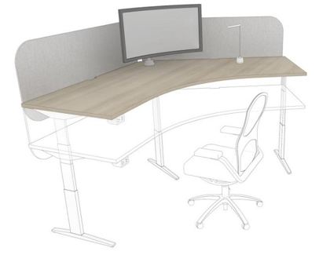
Figure 22
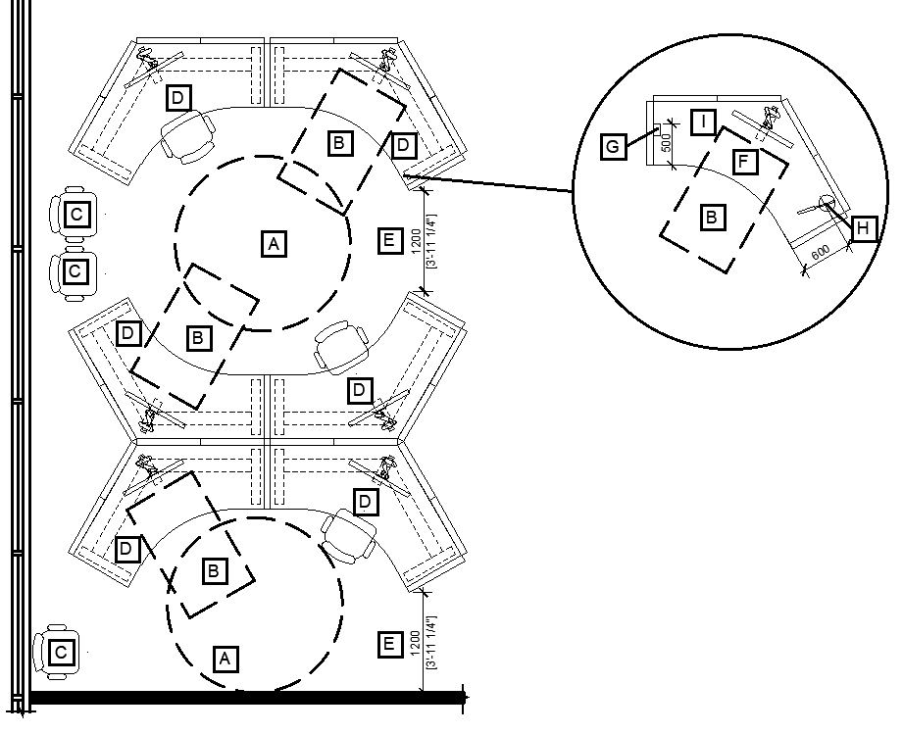
Legend for Figure 22
- A: 2100mm turning diameter which allows a WMD user to turn around when an accessible route terminates. A turning diameter must be adjacent to a workstation for it to be accessible to WMD users. Workstations that open up to each other allow for turning diameters to be shared.
- B: Clear floor space for wheeled mobility device user at a workpoint.
- C: Space for a displaced chair to be placed when a workstation is used by a WMD user should be close by. 120-degree stations lend themselves to that very well. This space may also be suitable for mobility aids if a WMD user chooses to transfer to a task chair.
- D: Workstation considered to be accessible to a WMD user.
- E: Accessible workpoints must be located on an accessible route (minimum of 1200mm wide)
- F: Knee/toe clearance
- G: Power module within reach of the user (maximum of 500mm away from user).
- H: Task light with touch controls within reach of user (maximum of 600mm from user).
- I: Electric height adjustable desk

L-SHAPED WORKSTATIONS
- Refer to Figure 23 and 24 for examples of what an L-shaped workstation could look like.
- Refer to Figure 25 for a 2D of a conceptual plan that includes many L-shaped workstations and focuses on circulation space Considerations. It is supported by an accompanying legend.
Recommendations
- Include some L-shaped workstations within the workplace design. L-shaped workstations are an ideal workstation configuration for people with service dogs. It allows for the service dog to occupy the space under the 610mm deep worksurface, while the user can benefit from the ergonomic features of the 762mm deep worksurface. Users can center themselves at the desk, which allows for optimal alignment with the monitors provided.
- When designing L-shaped workstations, consider specifying a style with a single electric height-adjustable mechanism and a three-legged base (refer to Figure 23). This style offers several accessibility and inclusivity benefits over the style of L-shaped station that provides 1 height adjustable table paired with a fixed height surface (refer to Figure 24 – Preferred option). Benefits include:
- Improved knee/toe clearance under desk. Additional legs create more obstructions.
- Eliminates “finger pinch” space concerns between surfaces and removes the possibility of items falling between the crack which can be difficult for some people with disabilities to retrieve.
- Allows all surface space to be used at an ergonomic height.

Figure 23
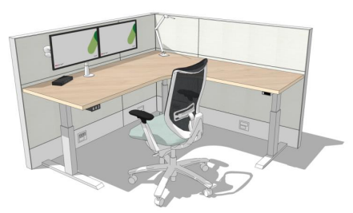

Figure 24
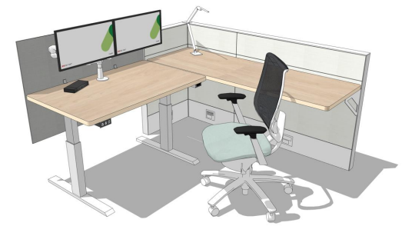

Figure 25
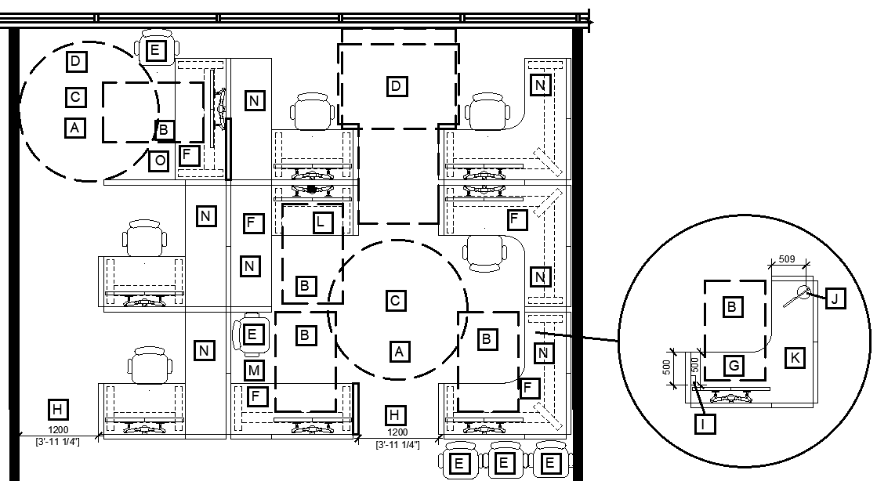
Legend for Figure 25
- A: 2100mm turning diameter
- B: Clear floor space for wheeled mobility device user at workpoint.
- C: A workstation must have a turning diameter adjacent to it for it to be accessible to WMD users. Workstations that open up to each other allow for turning diameters to be shared.
- D: When an accessible route terminates, clear floor space allows for a WMD user to turn around. (all three options are shown)
- E: Consider where a chair can be moved out of the way when a person using a WMD is using a workstation.
- F: Workstation considered accessible to WMD users.
- G: Knee/toe clearance
- H: Accessible workpoints must be located on an accessible route (minimum of 1200mm wide)
- I: Power module within reach of the user (within 500mm of user).
- J: Task light with controls within reach to facilitate adjustment (maximum 600mm from user).
- K: Electric height adjustable desk.
- L: Notice the difference in clearance the table base in this scenario provides in contrast to other workstations where a single L-shaped unit is provided. A single unit provides a much more generous clearance for accessing the workstation.
- M: Including some stations with less surface space and more open space provides a place for a displaced chair or a mobility aid such as crutches, service dog, etc.
- N: Space under the secondary part of an L-shaped desk is helpful to people with service dogs.

BENCHING/RECTANGULAR WORKSTATIONS
- Refer to Figure 26 for an example of what benching workstations could look like.
- Refer to Figure 27 for a 2D of a conceptual plan of rectangular workstations which focuses on circulation space Considerations. It is supported by an accompanying legend.
Figure 26
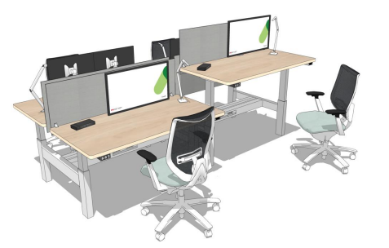
Recommendations
- Stations to have a clear turning diameter at them, even when the desk across the aisle is occupied.
- Sufficient space is provided so that when a WMD user occupies a workstation their device doesn’t extend into the pathway.
- The close proximity of the stations can be distracting. Including privacy screens mounted to the sides of the surfaces, along with a fixed-height privacy screen at the maximum acceptable height along the spine can help reduce distractions.
Figure 27
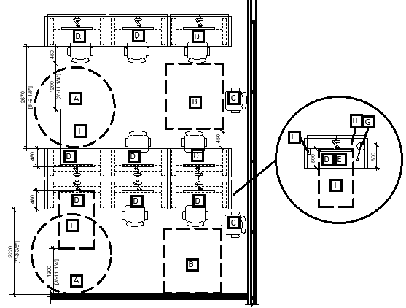
Legend for Figure 27
- A: 2100mm turning diameter. A workstation must have a turning diameter adjacent to it for it to be accessible to WMD users.
- B: When a route terminates, clear floor space allows for a WMD user to turn around.
- C: Consider where a chair can be moved out of the way when a person using a WMD is using a workstation.
- D: Workstations that are considered accessible to WMD users.
- E: knee/toe clearance
- F: Power module within reach of user (must be within 500mm of user).
- G: Task light with touch controls within reach of user (must be within 600mm of user).
- H: Electric height adjustable desk.
- I: Clear floor space for a wheeled mobility device user at workpoint.

Work Pod
- Refer to Figure 28 for an example of what a group of work pods could look like.
- Refer to Figure 29 for a 2D of a conceptual plan of work pods which focuses on circulation space Considerations. It is supported by an accompanying legend.
Figure 28
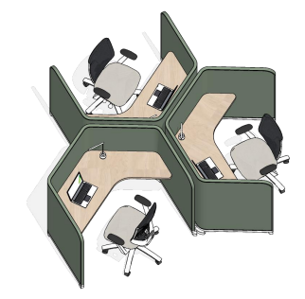
Recommendations
- Offer a choice of work pod types to offer users choice (i.e. ensure that some are accessible to WMD users and include a turning diameter). Some work pod types should include higher upholstered screens and be more enclosed to better support people who benefit from a higher degree of visual privacy and improve acoustics.
- Refer to 6.1 General for additional information that may apply.

Figure 29
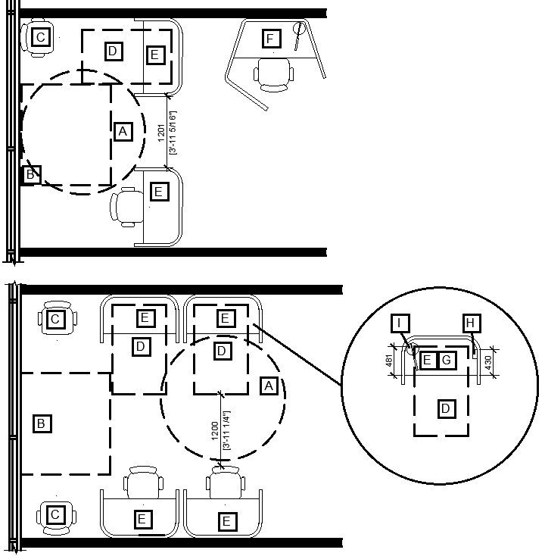
Legend for Figure 29
- A: 2100mm turning diameter. A workpoint must have a turning diameter adjacent to it for it to be accessible to WMD users.
- B: When a route terminates, clear floor space allows for a WMD user to turn around.
- C: Consider where a chair can be moved out of the way when a person using a WMD is using a workstation.
- D: Clear floor space for a WMD at a workpoint.
- E: Work Pods that are considered accessible to WMD users.
- F: Work Pod that is not accessible to a WMD user but may be accessible to someone who requires increased visual privacy.
- G: Knee/toe clearance
- H: Power module within reach of the user (maximum 500mm from user).
- I: Task light with touch controls within reach of the user (maximum 600mm from user).

Focus Room
- Refer to Figure 30 for an example of what a focus room could look like.
- Refer to Figure 31 for a 2D of a conceptual plans for focus rooms which focus on circulation space considerations. It is supported by an accompanying legend.
Figure 30
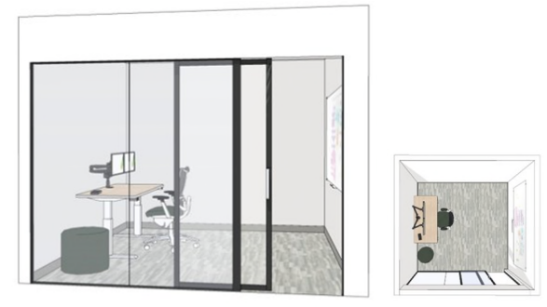

Recommendations
- Focus rooms provide visual and acoustic privacy and can be equipped with dimmable lighting which can be controlled by the user. These features are helpful to many people including, but not limited to, those who are hypersensitive to noise, sound and visual distractions, and those that use speech to text software. Women and visible minorities also report a higher need for visual and acoustic privacy. This is important, particularly in a hybrid environment. It is recommended to include as many focus rooms as is feasible and compliant with the GCworkplace Space Planning Workbook.
- Refer to 6.1 General for additional information that may apply.
Figure 31
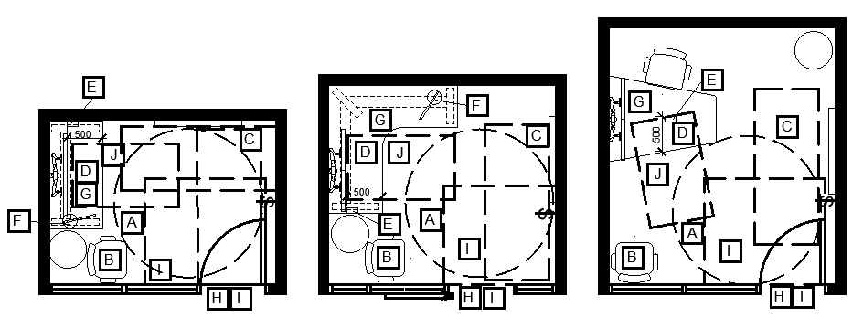
Legend for Figure 31
- A: 2100mm turning diameter. A workpoint must have a turning diameter adjacent to it for it to be accessible to WMD users.
- B: Consider where a chair can be moved out of the way when a person using a WMD is using a workstation.
- C: Clear floor space to access the whiteboard and light switch from a parallel/side approach.
- D: Knee/toe clearance
- E: Power module within reach of user (maximum of 500mm from user).
- F: Task light with controls within reach of user (maximum of 600mm from user).
- G: Electric height adjustable desk.
- H: Clear door width that meets or exceeds minimum requirements
- I: Clear manoeuvring space at door. Also required on the outside of the door.
- J: Clear floor space for wheeled mobility device user at workpoint.

Study
- Refer to Figure 32 for an example of what a study could look like.
- Refer to Figures 33 and 34 for 2Ds of conceptual plans of studies which focus on circulation space considerations. They are supported by an accompanying legend.
Figure 32
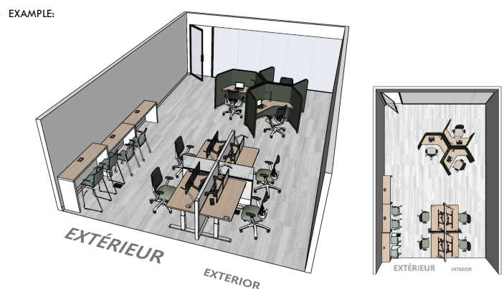
Recommendations
- Ensure turning diameters, and circulation space allows WMD users to access a variety of accessible workpoints within the study.
- Refer to 6.1 General for additional information that may apply.

Figure 33
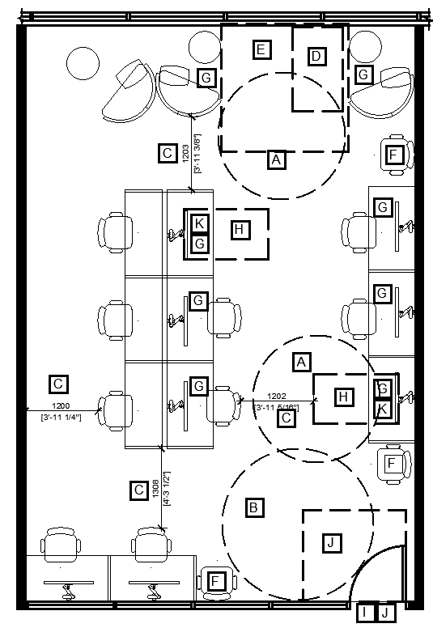
Figure 34
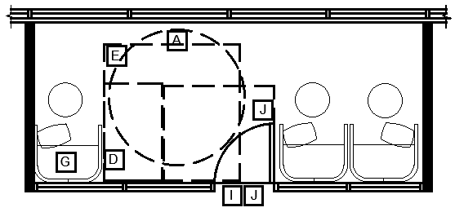
Legend for Figure 33 and 34
- A: 2100mm turning diameter. A workpoint must have a turning diameter adjacent to it for it to be accessible to WMD users.
- B: 2500mm turning diameter (evolving compliance dimension). The larger size is helpful to more people.
- C: 1200mm route clearance in an enclosed room.
- D: Space out of circulation space for a WMD to be placed while the user is occupying the Focus Pod.
- E: Clear floor space that allows a WMD user to approach and transfer to a seat.
- F: Consider where a chair can be moved out of the way when a person using a WMD is using a workstation.
- G: Workpoints that are considered accessible to WMD users.
- H: Clear floor space for WMD users.
- I: Clear door width that meets or exceeds minimum requirements.
- J: Clear manoeuvring space at door. Also required on the outside of the door.
- K: Knee/toe clearance.

Focus Pod
- Refer to Figure 35 for an example of what a focus pod could look like.
- Refer to Figure 36 for a 2D of a conceptual plan of a focus pod which focuses on circulation space considerations. It is supported by an accompanying legend.
Figure 35
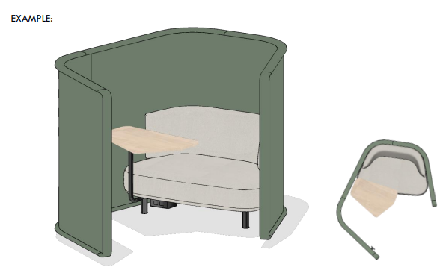
Recommendations
- Allocate space adjacent to a minimum of 20% of focus pods for turning diameter/approach, transfer space and placement of WMDs. The clear floor space for the WMD must not impede on circulation space.
- If multiple focus pods are included, try to include a variety of styles to accommodate different user preferences and accessibility needs.
- Provide left-handed and right-handed options.
- Refer to 6.1 General for additional information that may apply.
Figure 36
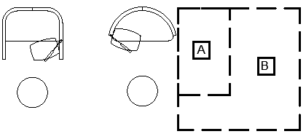
Legend for Figure 36
- A: Space outside of circulation area is necessary for a WMD to be placed while the user is occupying the focus pod.
- B: Use clear floor space for a WMD user to approach and transfer to the focus pod.

Touchdown
- Refer to Figure 37 for an example of what a group of touchdowns could look like.
- Refer to Figure 38 and 39 for 2Ds of conceptual plans for touchdowns which focus on circulation space considerations. They are supported by an accompanying legend.
Figure 37
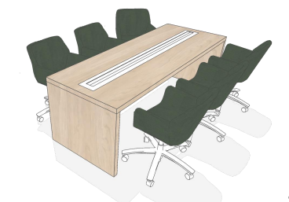
RECOMMENDATIONS
- Touchdown are compact workpoints. A person using a WMD generally requires more space than someone using a chair. If touchdowns are arranged too closely, accommodating a WMD user may necessitate moving two chairs, which can reduce the number of available seats and create a need for additional space outside of circulation areas for the displaced chairs. Please refer to Figure 38 for a drawing that illustrated this comparison.

Figure 38
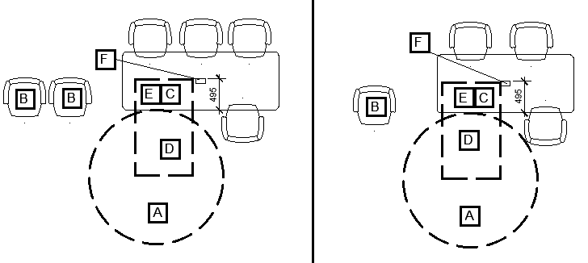
- If the intent is to provide two accessible seats across the table from one another, the two knee/toe clearances must not overlap as each user requires their own space. Refer to Figure 39.
- Refer to 6.1 General for additional information that may apply.
Figure 39
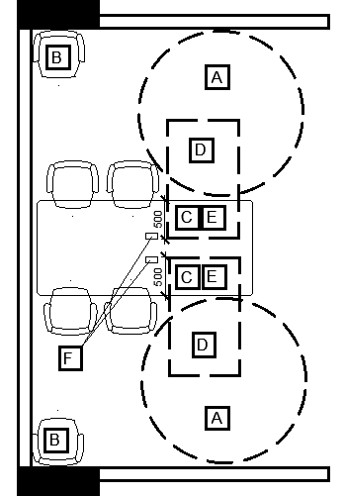
Legend for Figure 38 and 39
- A: 2100mm turning diameter. A workpoint must have a turning diameter adjacent to it for it to be accessible to WMD users.
- B: Consider where a chair can be moved out of the way when a person using a WMD is using a workpoint.
- C: Workpoint that is considered accessible to WMD users.
- D: Clear floor space for WMD user at workpoint.
- E: Knee/toe clearance
- F: Power module within reach of user (within 500mm of user).

Phonebooths and Phone Room
- Refer to Figure 40 for an example of what phonebooths and phone rooms could look like.
- Refer to Figure 41 for 2D of conceptual plans for phone room and phone booth which focus on circulation space Considerations. It is supported by an accompanying legend.
Figure 40
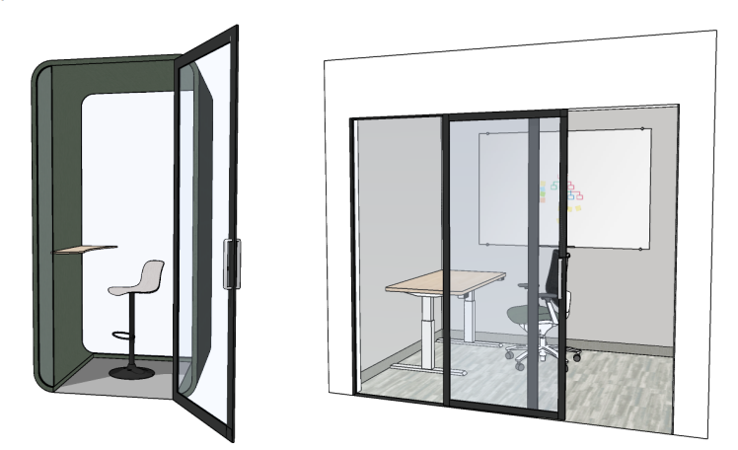

Recommendations
- Phone booths/rooms provide acoustic privacy which is crucial in a hybrid environment. They are important from a confidentiality perspective, but also help to reduce the open office noise which can be distracting to many people. With various competing pressures (i.e. space reduction, hybrid environment, accessibility) it is recommended that a combination of phonebooths (smaller and prefabricated) and phone rooms that are larger and accessible to people who use WMDs be provided. The mix of sizes helps to balance the floor space available while still providing the quantity needed to support employees in a hybrid environment. In smaller fit-ups, if only one phonebooth/phone room is provided, it must be an accessible phone room style.
- Prefabricated phonebooths that are not accessible to WMD users should still be as accessible as possible to people with other disabilities. Consider and address the following when possible:
- Accessible controls (location, function, contrast, etc): door handle, light control(s), electrical outlets;
- User controlled dimmable lighting;
- Luminance (colour) contrast between worksurface/surrounding surfaces, floor/walls, controls/background surfaces;
- Glare-free worksurface; and
- Force to open door that does not exceed 22 N.
- Refer to 6.1 General for additional information that may apply.
Considerations
- Some models of prefabricated phonebooths feature a magnet to ensure the door closes securely. However, this design may require significant force to open, potentially making it inaccessible to people with limited strength.
- The doors of premanufactured phonebooths typically swing outward, making careful planning crucial to prevent them from obstructing paths of travel. It is also important to consider the door swing direction – whether right or left-handed. Without proper space planning, these phonebooths could pose risks to people who are blind or partially sighted or distracted, as they may not notice a glass door opening in their path of travel.
- There is a concern that some prefabricated phonebooths may trigger reactions in individuals with environmental sensitivities/multiple chemical sensitivities (MCS) due to off-gassing, which could be exacerbated by the door remaining closed at all times. Therefore, it is important to take extra precautions. Please refer to section 5.13 for further information.
- Ventilation and airflow by, for example, leaving booth doors open when unoccupied, can help speed up the off-gassing.
Figure 41
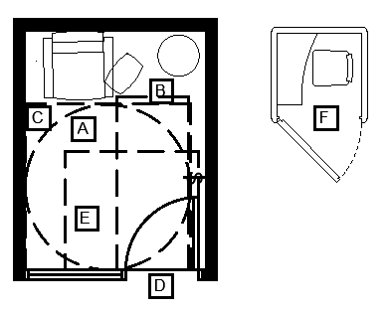
Legend for Figure 41
- A: 2100mm turning diameter.
- B: Clear floor space to access the light switch from a parallel/side approach.
- C: Clear floor space for wheeled mobility device user to approach and transfer to seating.
- D: Clear door width that meets or exceeds minimum requirements
- E: Clear manoeuvring space at door. Also required on the outside of the door.
- F: Not accessible to wheeled mobility device users.

Teaming Area
- Refer to Figure 42 for an example of what a teaming area could look like.
- Refer to Figure 43, 44 and 45 for 2Ds of conceptual plans for teaming areas which focus on circulation space Considerations. They are supported by an accompanying legend.
Figure 42
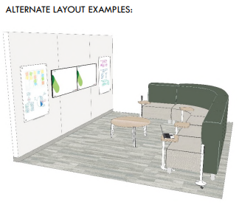
Recommendations
- If laptop tables are provided, it is recommended to choose a style that is easy to move and height adjustable requiring minimal effort and dexterity.
- Refer to 6.1 General for additional information that may apply.

Figure 43
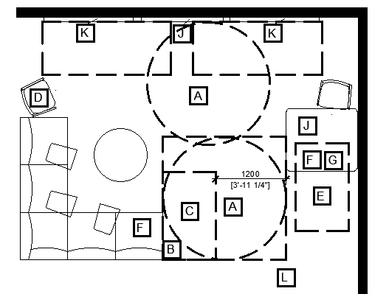
Figure 44
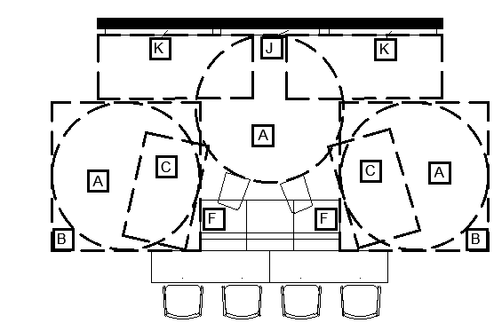

Figure 45
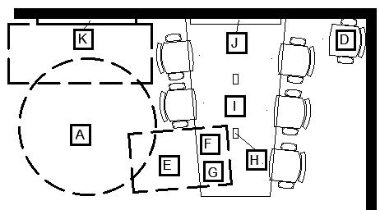
Legend for Figures 43, 44 and 45
- A: 2100mm turning diameter. A turning diameter must be adjacent to a workpoint for it to be accessible to WMD users. It is acceptable for the turning diameter to extend into a secondary pathway, but not a primary pathway. Turning diameters also allow WMD users to access the whiteboards and then turn around to return to their workpoint.
- B: Clear floor space for a wheeled mobility device user to approach and transfer.
- C: Space out of circulation space for a WMD to be placed when the user wishes to transfer to the seat provided or space for a WMD user to join the collaboration grouping but remain in their device.
- D: Space for a displaced chair to be placed when a workpoint is used by a WMD user. Chair should be easy to move.
- E: Clear floor space for a WMD user at a table.
- F: Workpoint that is considered accessible to a WMD user.
- G: Knee/toe clearance for WMD user.
- H: Power module within reach of the WMD user (within 500mm of user).
- I: Electric height adjustable table is recommended.
- J: Display/monitor
- K: Whiteboard
- L: This layout provides a few different ways for WMD users to participate such as: remaining in their device and joining the group, transferring to the soft seating provided and leaving their device adjacent to them, and remaining in their device and sitting at the table provided.

Lounge
- Refer to Figure 46 for an example of what a lounge could look like.
- Refer to Figure 49 for 2D of conceptual plan for lounge which focus on circulation space Considerations. It is supported by an accompanying legend.
Figure 46
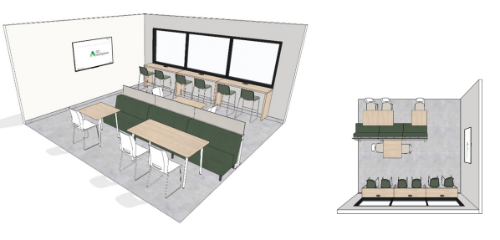
RECOMMENDATIONS
- When a kitchen island divides the space between a lounge and a kitchenette 2100mm x 2100mm clear floor space must be provided between them. Refer to Figure 47.
Figure 47
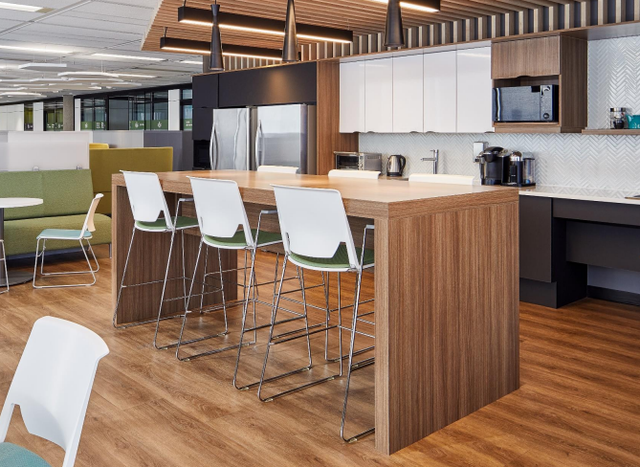
- Provide seating with and without arm rests. Providing a variety of seating types can be helpful in accommodating different needs and preferences. Consider that arms on stools can make it difficult to get onto the stool and be close enough to use the higher surface.
- Lounges adjacent to kitchenettes can sometimes be loud. Consider how acoustic design can provide a quieter environment for eating lunch. Consider if including a huddle near by would be helpful to some.
- Some people may prefer to eat alone. Consider if lounges adjacent to kitchenettes can include spaces for individual use. i.e. single sided table along a window.
- Tables in lounges adjacent to kitchenettes must be carefully considered to ensure accessible options are provided:
- Avoid sharp corners and edges.
- Ensure base style allows for the necessary knee and toe clearance. Tables with "T" legs on the ends to allow people to access the banquette seating and can be designed to ensure there is sufficient clear knee/toe space for a WMD user to sit on the other side of the table.
- A variety of width options to accommodate WMD and other users.
- Select finishes that do not have strong patterns and are glare free.
- Height adjustable tables can be helpful to WMD users. If the layout can allow for it (i.e. access to a power source), it is recommended to include one and ensure other accessibility requirements are met as well (i.e. clearances).
- When incorporating a kitchenette island style table (counter or bar height), it is recommended to include a table at an accessible height butted up next to it. Refer to Figure 48. This arrangement accommodates individuals with varying needs and preferences, allowing everyone to gather together. To maintain a cohesive look, both tables should ideally match in length and width; otherwise, the smaller table may resemble a “kids table”.

Figure 48
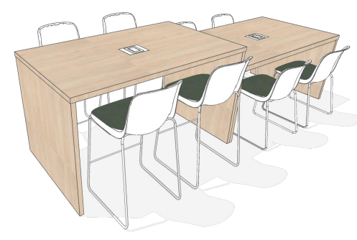
- Small tables with pedestal style bases are often used in lounges adjacent to kitchenettes. Generally they do not provide the clearance required for them to be accessible. It isn’t usually the knee and toe clearances, but rather the base on the floor that creates the barrier for WMD users. The knee and toe clearance requirements must go to the floor.
- Refer to 6.1 General for additional information that may apply.
Figure 49
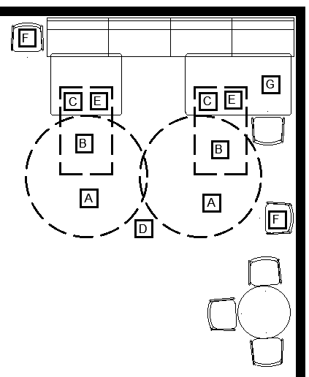
Legend for Figure 49
- A: 2100mm turning diameter. A turning diameter must be adjacent to a workpoint for it to be accessible to WMD users. It is acceptable for the turning diameter to extend into a secondary pathway, but not a primary pathway.
- B: Clear floor space for WMD user at table.
- C: Workpoint that is considered accessible to a WMD user.
- D: Accessible workpoints must be located on an accessible route (minimum of 1200m wide)
- E: Knee/toe clearance for WMD user.
- F: Space for a displaced chair to be placed when a workpoint is used by a WMD user should be close by. Chair should be easy to move.
- G: Electric height adjustable table

Work Room
- Refer to figure 50 for an example of what a work room could look like.
- Refer to Figure 51 for 2D of conceptual plans for work rooms which focus on circulation space Considerations. It is supported by an accompanying legend.
Figure 50
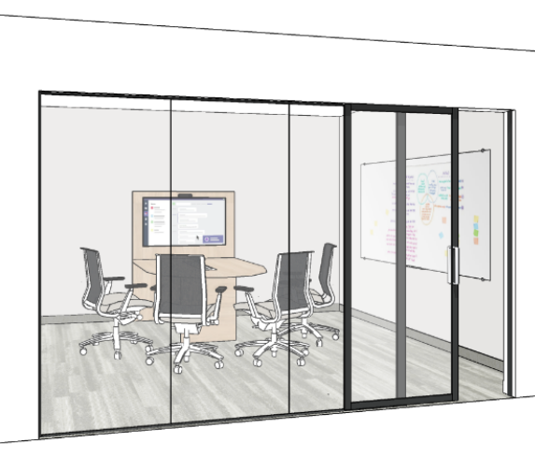

Recommendations
- Height adjustable tables should be considered as they are helpful to many. i.e. individual tables, multi-media tables, etc.
- Refer to 6.1 General for additional information that may apply.
Figure 51
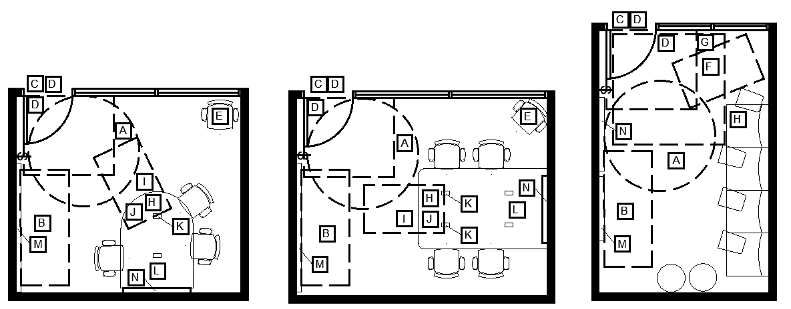
Legend for Figure 51
- A: 2100mm turning diameter. A turning diameter must be adjacent to a seat for it to be accessible to WMD users.
- B: Clear floor space to access the whiteboard and light switch from a parallel/side approach
- C: Clear door width that meets or exceeds minimum requirements
- D: Clear manoeuvring space at the door. Also required on the outside of the door.
- E: Consider where a chair can be moved out of the way when a person using a WMD is using a workstation.
- F: Space out of circulation space for a wheeled mobility device to be placed if the user wishes to transfer to a chair
- G: Clear floor space for a wheeled mobility device user to approach and transfer.
- H: Workpoint considered to be accessible to WMD users.
- I: Clear floor space for WMD user at a table
- J: Knee/toe clearance
- K: Power module within reach of user (within 500mm of user).
- L: Electric height adjustable table
- M: Whiteboard
- N: Display/monitor

Project Room
- Refer to figure 52 for an example of what a project room could look like.
- Refer to Figure 53 for 2D of conceptual plans for project rooms which focus on circulation space Considerations. It is supported by an accompanying legend.
Figure 52
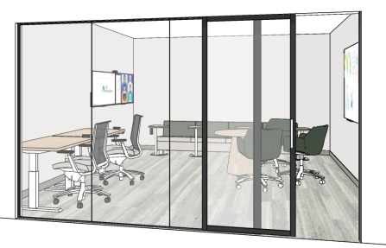
Recommendations
- Height adjustable tables are helpful in this environment. i.e. individual tables, multi-media tables, meeting tables, laptop tables, etc. Keep people with dexterity disabilities in mind when considering the various height adjustment mechanisms.
- Refer to 6.1 General for additional information that may apply.
Figure 53
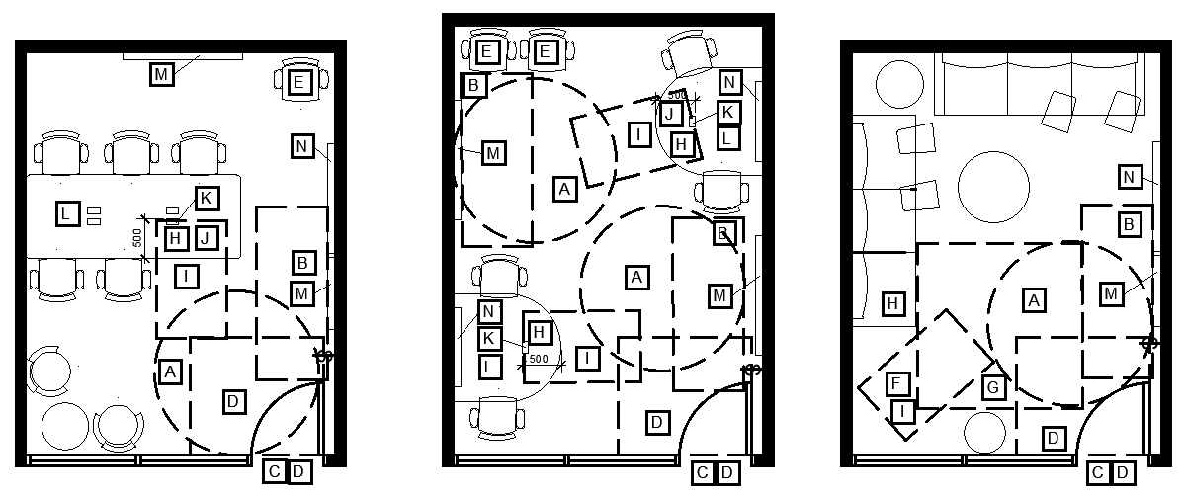
Legend for Figure 53
- A: 2100mm turning diameter. A turning diameter must be adjacent to a workpoint for it to be accessible to WMD users.
- B: Clear floor space to access the whiteboard and light switch from a parallel/side approach.
- C: Clear door width that meets or exceeds minimum requirements.
- D: Clear manoeuvring space at the door. Also required on the outside of the door.
- E: Consider where a chair can be moved out of the way when a person using a WMD is using a workpoint.
- F: Space out of circulation space for a wheeled mobility device to be placed if the user wishes to transfer to a chair or remain in their chair.
- G: Clear floor space for a wheeled mobility device user to approach and transfer.
- H: Workpoint considered to be accessible to WMD users.
- I: Clear floor space for WMD user.
- J: Knee/toe clearance
- K: Power module within reach of user (within 500mm of user).
- L: Electric height adjustable table
- M: Whiteboard (important that at least one whiteboard in the room be accessible)
- N: Display/monitor

Medium Meeting Room
- Refer to Figure 54 and 55 for examples what a medium meeting room could look like.
- Refer to Figure 56, 57, 58, 59 and 60 for 2Ds of conceptual plans for medium meeting rooms which focus on circulation space considerations. They are supported by an accompanying legend.
Figure 54
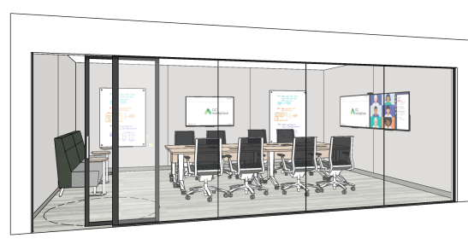
Recommendations
- Ensure there is space for displaced chairs outside of the circulation space. Don’t crowd the room with too many chairs.
- Power modules in meeting tables must be reachable, within 500mm, from a seated position at an accessible location at the table and be usable with minimal effort and dexterity.
- Consider if a second door to the room would improve accessibility/circulation.
- Consider how sightlines can be maximized for those that benefit from lip reading. i.e. round, oval, or boat-shaped tables may be helpful, but remember they must also provide knee and toe clearance. Refer to Figure 55. Additionally, when tables are too long, it can be difficult to see everyone’s faces.
Figure 55
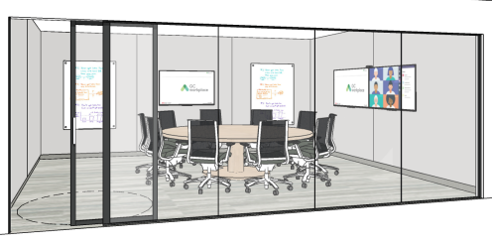
- Refer to 6.1 General for additional information that may apply.

Figure 56
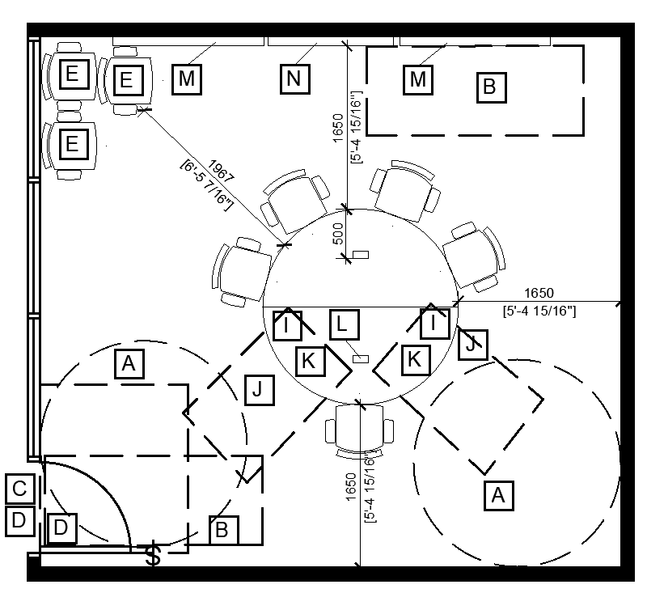

Figure 57
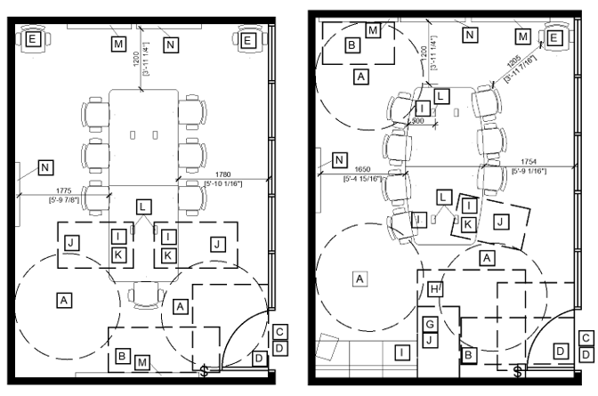
Figure 58
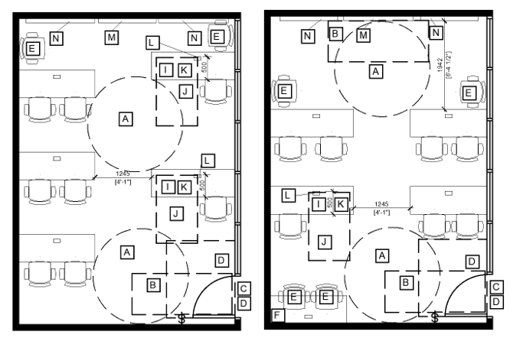
Figure 59
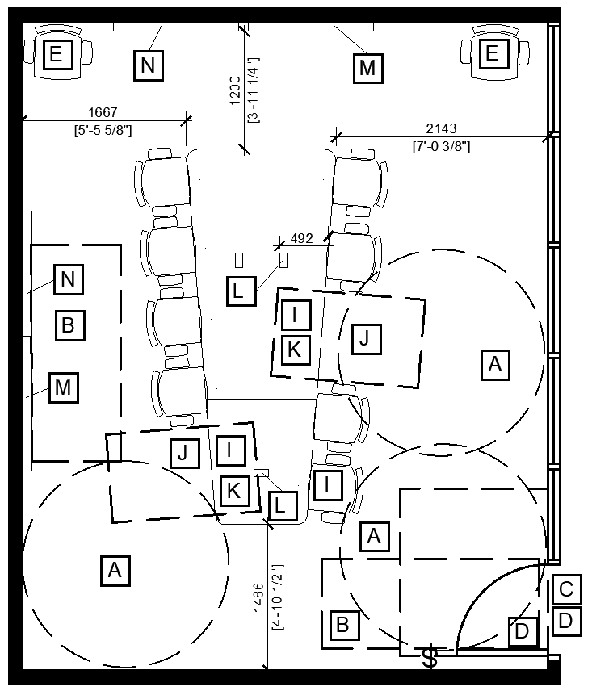
Figure 60
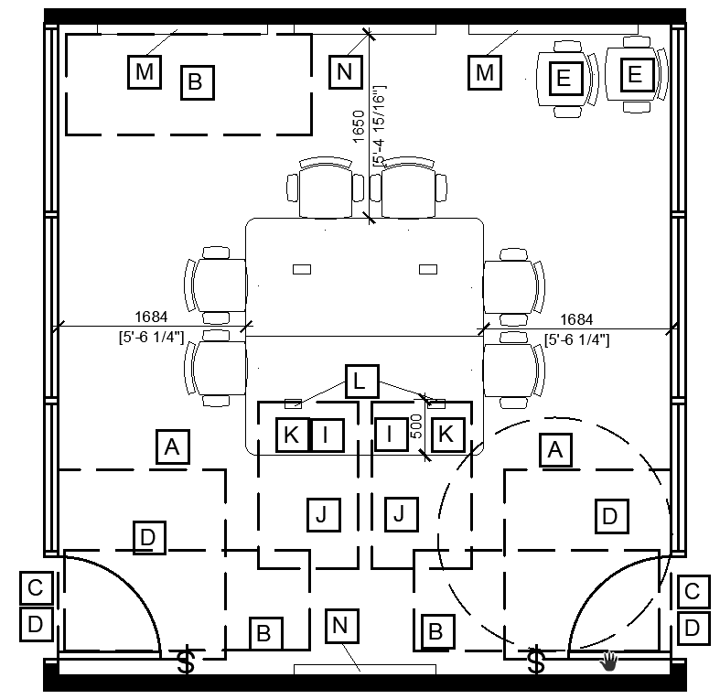
Legend for Figure 56, 57, 58, 59 and 60
- A: 2100mm turning diameter. A turning diameter must be adjacent to a workpoint for the workpoint to be accessible to WMD users.
- B: Clear floor space to access the whiteboard and light switch from a parallel/side approach
- C: Clear door width that meets or exceeds minimum requirements
- D: Clear manoeuvring space at the door. Also required on the outside of the door.
- E: Consider where a chair can be moved out of the way when a person using a WMD is using a workpoint.
- F: Surplus table can be moved out of the way when needed.
- G: Space out of circulation space for a wheeled mobility device to be placed if the user wishes to transfer to a chair or remain in their chair.
- H: Clear floor space for a wheeled mobility device user to approach and transfer.
- I: Workpoint considered to be accessible to WMD users.
- J: Clear floor space for WMD users.
- K: Knee/toe clearance
- L: Power module within reach of the clear floor space for WMD user (within 500mm).
- M: Whiteboard
- N: Display/monitor

Large Meeting Room
- Refer to Figure 61 and 62 for examples of what a large meeting room could look like.
- Refer to Figure 63 and 64 for 2Ds of conceptual plans for large meeting rooms which focus on circulation space Considerations. They are supported by an accompanying legend.
Figure 61
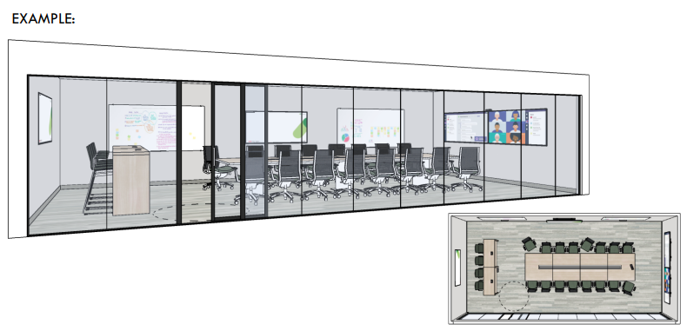
Recommendations
- Ensure there is space for displaced chairs outside of the circulation space. Don’t crowd the room with too many chairs.
- Power modules in meeting tables must be reachable, within 500mm, from a seated position at an accessible location at the table and be usable with minimal effort and dexterity.
- Consider if including 2 doors to the room would make it more accessible and improve circulation.
- Consider how sightlines can be maximized for those that benefit from lip reading. i.e. round, oval or boat-shaped tables may be helpful, but remember they must also provide knee and toe clearance. Additionally, when tables are too long it can be difficult to see everyone’s faces.
Figure 62

- Consider including an assistive listening system (ALS), identified with signage and International Symbol for Hearing Loss, to facilitate communication for people with hearing loss. Refer to CSA/ASC B651:23, Clause 6.6.1 Assistive Listening Systems and TBS FIP Standards (6.1.28 – Access for the hearing impaired symbol for signage which indicates a facility or service that is equipped to serve persons with a hearing impairment).
- D.2.2.4 of the Directive on the Management of Real Property- Canada.ca states: “Equip classrooms, auditoriums, meeting rooms and theaters of more than 100 meters with an assistive listening system encompassing the entire seating area.” That is a minimum requirement. Assistive listening devices can also enhance the accessibility and inclusivity of smaller rooms.
- Include a variety of ways to participate, i.e. soft seating. It could allow for a different posture, the opportunity to transfer to soft seating for wheeled mobility device users, a wider seat for people of a larger stature.
- When meeting rooms have folding partitions to allow for modification of the room size, ensure that the furniture layout is accessible in both arrangements.
- Refer to 6.1 General for additional information that may apply.
Figure 63
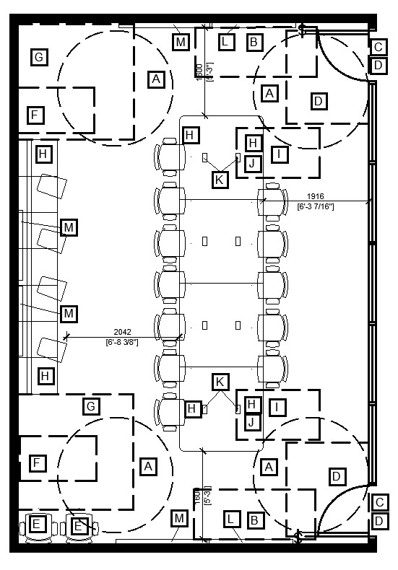
Figure 64
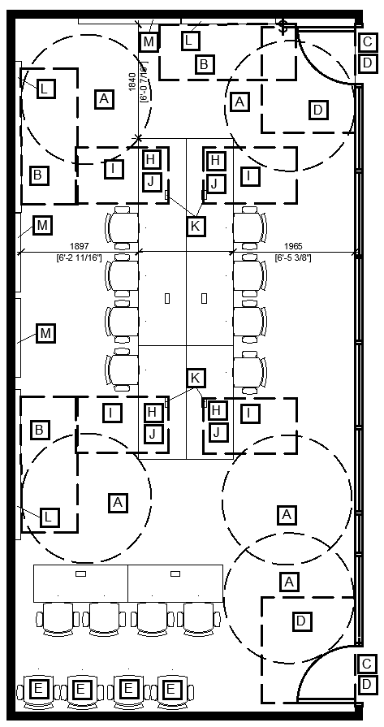
Legend for Figure 63 and 64
- A: 2100mm turning diameter. A turning diameter must be adjacent to a workpoint for the workpoint to be accessible to WMD users.
- B: Clear floor space to access the whiteboard and light switch from a parallel/side approach
- C: Clear door width that meets or exceeds minimum requirements
- D: Clear manoeuvring space at the door. Also required on the outside of the door.
- E: Consider where a chair can be moved out of the way when a person using a WMD is using a workpoint.
- F: Space out of circulation space for a wheeled mobility device to be placed if the user wishes to transfer to a chair or remain in their chair. Space can also be used for other assistive devices or service dogs.
- G: Clear floor space for a wheeled mobility device user to approach and transfer.
- H: Workpoint considered to be accessible to WMD users.
- I: Workpoint NOT considered accessible to WMD users.
- J: Knee/toe clearance
- K: Power module within reach of the clear floor space for WMD user (within 500mm).
- L: Whiteboard
- M: Display/monitor

Kitchenette
Refer to Figure 65 for a conceptual plan of a kitchenette (the final design will vary project to project) and the accompanying legend. The information provided is intended as an aid during the design process. It does not replace referencing the CSA/ASC B652:23 itself for full Mandatory standards.

Figure 65
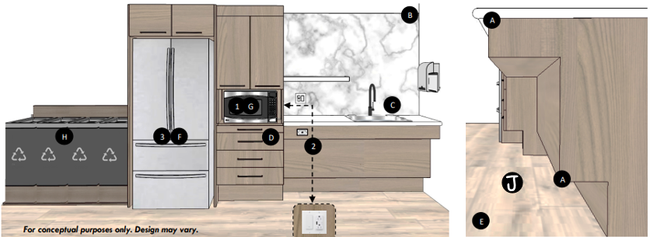
Legend for Figure 65

A – Counters:
Mandatory
- Refer to CSA/ASC B652:23, Clause 5.10.6 for full requirements.
- Provide knee and toe clearance at both work area of counter and sink area.
- Have no 90 degree edges
Recommendations
- Bullnose or rounded edges are recommended.
- A luminance (colour) contrasted front edge on the counters can help define the user space.
- A counter that contrasts with the backsplash can help people who are partially sighted to identify the extent and configuration of the counters.
- Accessible work area of counter should have accessible outlet within reach.
- Choose matte counter surface material to minimize glare.
- Clear counter space adjacent to appliances and sink is helpful to everyone to have space to put things on.
- Providing varied heights between counter and island ensures helps to accommodates as many users as possible.

B – Backsplash:
Recommendation
- Choose matte backsplash material to minimize glare.

C – Sink:
Mandatory
- Refer to CSA/ASC B652:23, Clause 4.5 for full requirements.
- A centerline at least 460mm from a side wall.
- Faucets that comply with CSA/ASC B652:23, Clause 4.5.
- Water supply pipes and drainpipes under the sink must be insulated, fully protected or otherwise protected against contact. (Also refer to section A above where it shows how the pipes can be concealed and meet the knee toe clearance requirements.)
Recommendations
- Consider including touchless faucet, soap dispenser and paper towel dispenser. All should be within reach from a seated position at the sink.
- A shallow sink with the drain offset to the rear allows for sufficient knee space and will result in the drainage pipes being out of the way.

D – Storage:
Mandatory
- Refer to CSA/ASC B652:23, Clause 5.10.8 for full requirements.
- Refer to CSA/ASC B652:23, Clause 4.5 for full requirements on handles for cabinets.
- Both open and closed storage to be provided.
- Cabinets must be drawer style when located under counter surfaces.
- Base cabinets must provide toe clearance.
- Include overhead shelves that are 300mm deep and located a maximum of 1100mm above the finished floor.
Recommendations
- Touch-and-release drawers and cupboards are universally accessible to many people, including those with dexterity disabilities.
- Pantry style cupboards with doors that open fully, using 180-degree or swing-clear hinges, will make it easier for everyone to see the contents and to reach the shelves.

E – Finishes:
Mandatory
- Refer to CSA/ASC B651:23, Clause 4.2. Floor to be luminance (colour) contrasted from the walls, millwork, and appliances.
- Refer to CSA/ASC B651:23, Clause 4.4. Floor must be slip resistant, produce minimal glare, and not have strong visual patterning.
Recommendations
- Millwork to produce minimal glare and not have strong visual patterning.

F – Refrigerators:
Mandatory
- Refer to CSA/ASC B652:23, Clause 5.10.9.1, 5.10.9.2, and 4.5 for full requirements.
- Must be counter depth fridge as it allows an individual using a WMD to access the back of the fridge.
Recommendations
- Ensure that the refrigerator is ordered with the correct door swing. Even if the correct door swing is ordered, consider that if a refrigerator is too close to a wall the door may not be able to open fully and may be difficult to access.
- If an over-and-under style of refrigerator is provided, the freezer part is best located at the bottom.

G – Microwave(s):
Mandatory
- Refer to CSA/ASC B652:23, Clause 5.10.9.1, 5.10.9.5, and 4.5 for full requirements.
- Clear counter space of at least 400mm to be provided adjacent to the latch side of the door opening. A pull-out shelf under the microwave, matching the width of the microwave or wider, and extending at least 250mm is also an acceptable solution.
- Note: The coordination between the door swing of the microwave and the clear counter space is often overlooked. A pull-out shelf under the microwave mitigates clear counter space coordination errors.
- Microwaves must be located a maximum of 860mm above the finished floor.
- Note: Microwaves placed overhead or below counter height are not accessible and can create potentially significant burn/scald hazards.
- Clause 4.5 provides the standards for the operating controls which applies to microwaves.
- Note: Microwaves are available with Braille. The text in braille is usually not very intuitive when it comes to the operation of the microwave and those that would like to take advantage of the braille feature may need some additional information upfront. Alternatively, braille stickers can be applied on to microwave buttons (and other appliances, i.e. Labeling on and off positions for an electric kettle) to aid in the operation.
Recommendations
- Consider spreading appliances out to prevent crowding.

H – Recycling Centre
- Refer to Waste & Recycling section 6.2.20.

I – Outlets & lighting:
Mandatory
- Refer to CSA/ASC B652:23, Clause 5.10.4, 5.10.5 and 4.5 for full requirements.
- All kitchenette illumination, including general and any task lighting below overhead cabinetry, shall comply with CSA/ASC B652:23, Clause 4.8.
- Access to an accessible electrical outlet and light switch(es) must be provided. Controls must be located within reach and contrast with their background.
Recommendations
- Outlets mounted on a side wall to bring them within reach of WMD users is recommended over installing them on the front of a counter. The main reason for this is that it is a less complicated installation to get right.

J - Circulation Space:
Mandatory
- Refer to CSA/ASC B652:23, Clause 5.10.1 for full requirements.
- A clear floor space of 2100mm x 2100mm must be provided within the kitchen.
- Clear floor space must be provided directly in front of kitchen fixtures and appliances and to one side where drawers or doors open.
Note: Refer to 6.1 General for additional information that may apply.

Wellness Room
- Refer to Figure 66 for examples of what a wellness room could look like.
- Refer to Figure 67 for 2Ds of conceptual plans for wellness rooms which focus on circulation space Considerations. It is supported by an accompanying legend.
Figure 66 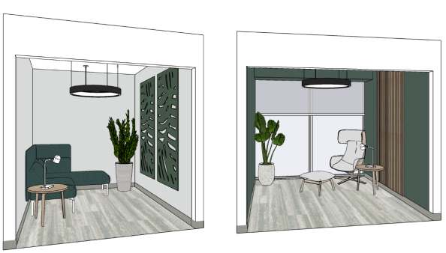

Recommendations
- If more than one wellness room is provided, ensure they are furnished differently to offer variety and accommodate different needs. Consider:
- Users of different sizes
- Some users have trouble getting out of seating if it is too low. Strong arms can also be a helpful feature.
- If glass wall is provided, ensure film is applied to provide visual privacy.
- Should be easy to locate and along a primary route to ensure it isn’t difficult to get to when it is needed.
- Acoustics should be appropriate for respite and enable all users to block out background noise. Must be a comfortable environment to be in.
- If windows are included in the wellness room (as preferred by some), ensure window coverings are adjustable and controls are accessible.
- Ensure seating and surface materials used have a matte finish without patterns. Consider providing seating with cushions of various textures.
- Provide electrical outlets within accessible reach to power personal devices.
- Ensure HVAC, lighting, or other building systems/devices emit minimal sound.
- Adequate lighting for the nature and use of the space that can be controlled by the user. i.e. direction, intensity and colour.
- Refer to 6.1 General for additional information that may apply.
- Refer to the GCworkplace Design Guide, section 3.7 Wellness Room for additional Best Practices that support accessibility such as, “create an environment that stand out from the rest of the workplace by using materials and textures to evoke nature and create a feeling of comfort and relaxation”.
Note: clients should consider providing sensory-friendly resources designed to help users regulate their sensory experiences and improve emotional well-being. These resources should be in an accessible location, and within reach of people of all statures.

Figure 67
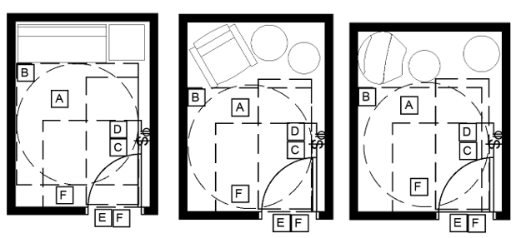
Legend for Figure 67
- A: 2100mm turning diameter. A turning diameter must be adjacent to a workpoint for it to be accessible to WMD users.
- B: Clear floor space for a WMD user to approach and transfer to seating.
- C: Clear floor space to access the lighting controls from a parallel/side approach.
- D: Clear floor space to access electrical outlet from a parallel/side approach.
- E: Clear door width that meets or exceeds minimum requirements
- F: Clear manoeuvring space at door (also required on the outside of the door)

Equipment Area
- Refer to figure 68 for an example of what an equipment area could look like.
- Refer to Figure 69 for 2D of conceptual plans for equipment area which focus on circulation space Considerations. It is supported by an accompanying legend.
Figure 68
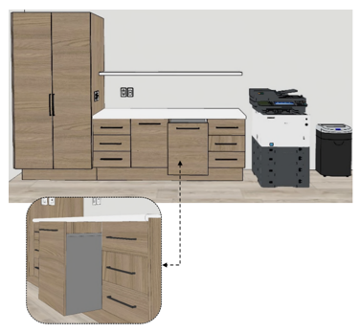

Recommendations
Counters:
- If surface will be used for collating documents, recommend including knee and toe space at a section of the counter if feasible.
- Refer to CSA/ASC B652:23, Clause 5.10.6 for recommendations as applicable.
- Counter must not have 90-degree edges and it is recommended that they be bullnose or rounded.
- Choose matte counter surface to minimize glare.
Storage:
- Refer to B652:23 Clause 5.10.8 for recommendations as applicable.
- If outlets at counter height are provided, install at least one on fascia or side wall. Refer to CSA/ASC B652:23, Clause 4.5 for recommendations as applicable.
- Recommend D-style handle. Ensure handles contrast with the cabinet door. Refer to CSA/ASC B652:23, Clause 4.5 for recommendations as applicable.
- Cabinets must be drawer style when located under counter surfaces.
- Base cabinets must provide toe space.
- Consider including overhead shelves so open and closed options are available.
Finishes:
- Floor to be luminance (colour) contrasted from the walls and millwork.
- Floor must be slip resistant, produce minimal glare, and not have strong visual patterning.
- Avoid strong visual patterning on millwork.
Circulation Space:
- Include clear floor area of 2100mm x 2100mm. Refer to B652:23 Clause 5.10.1.
General:
- Refer to 6.1 General for additional information that may apply.

Figure 69
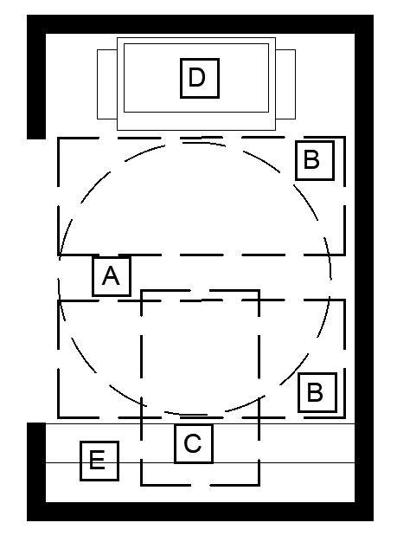
Legend for Figure 69
- A: 2100mm turning diameter.
- B: Clear floor space to access controls from a parallel/side approach.
- C: Knee/toe clearance for forward approach at surface (if provided).
- D: Multi-Functional Device
- E: Counter and storage Space

Personal Storage Area

- Refer to Figure 70 for examples of what a personal storage area could look like.
- Refer to Figure 71 for elevations of conceptual locker areas which is supported by an accompanying legend.
- Refer to Figure 72 for 2D of a conceptual plan for equipment area which focus on circulation space Considerations. It is supported by an accompanying legend.

Figure 70
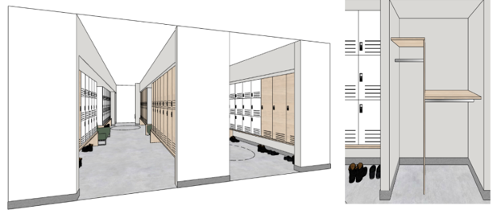

Lockers
Recommendations
- Locks and handles:
  - Comply with CSA/ASC B651:23, Clause 4.3 Operating Controls. Refer to standard for details.
  - If digital locks are used on lockers, they should include larger buttons and numbers that contrast with their background. Buttons that are arranged in a telephone-like layout with a raised dot on the central “5” key can be helpful. Some users may find a digital style with a USB user key or FOB more accessible.
- Strive to make all lockers as accessible as possible. Offering variety and choice will be essential. Keep in mind the accessibility needs of diverse users. For example:
  - People who are blind, partially sighted, have a dexterity or memory related disability may prefer a digital lock with a USB user key over a mechanical lock, but not require a turning diameter.
  - A person with a mobility disability may need a turning diameter adjacent to lockers that are at an accessible height to reach the lock and the interior features of the locker but is OK with using a mechanical lock.
  - A person with a pain disability may prefer a higher locker so they don’t have to bend over to access it.
- Provide a variety of locker sizes at accessible heights to meet diverse needs. i.e. some need to be large enough to accommodate items such as canes, crutches, personal assistive equipment, etc.
- Lockers should be available from a seated position, between 400mm – 1100mm above the finished floor. Full height lockers can achieve this by including an adjustable shelf or installing on top of millwork. Millwork used as a base can also be helpful for two-high (+) lockers in ensuring they are positioned at accessible heights.
- Hanging rods that do not exceed 1100mm in height. It is important that hangers be the type that can be fully removed from the rod.
- If hooks are provided instead, they should be located at varying heights on the side(s) of the locker, not the back so they are closer to reach, with at least one hook at or below 1100mm.
- Choose matte finishes for lockers to prevent glare and avoid strong patterns.
- Luminous (colour) contrast between lockers and benches, floors, and walls.
- Lockers should have ventilation openings to mitigate scent accumulation in lockers.
- Number signage on lockers should be consistently located and feature easy to see characters which contrast with their background.
Considerations
- Consider providing some lockers which allow for a forward approach with knee/toe clearance underneath.
- Consider using additional identifying features such as colours or symbols to aid in recognition (memory). Sometimes the location of a locker, such as being at the end of a row, can be helpful in remembering a locker location, particularly for users that are blind or partially sighted. If a choice of lock style is provided, it is recommended that the lockers at the ends of rows be equipped with a style of lock that is accessible to people who are blind or partially sighted.
- Consider if soft close features can be provided to reduce the slamming noises.

Figure 71
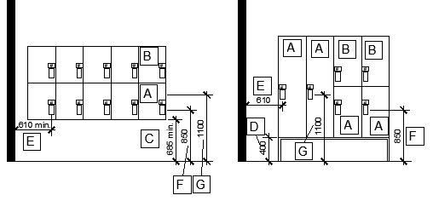
Legend for Figure 71
- A: Locker at accessible height
- B: Locker not at an accessible height
- C: Knee/toe clearance that is a minimum height of 685mm under a locker raised above the floor permits a forward approach.
- D: Minimum height of 400mm above the floor recommended for the interior of the locker to be reachable. Clear space shown allows for shoes and toe clearance. Lockers could be on the floor and an adjustable shelf be included at the bottom of the locker to ensure it is accessible.
- E: Recommend control be a minimum distance of 610mm from a wall
- F: Recommended maximum height of 850mm for a control on a locker to be accessible.
- G: Maximum height of 1100mm for a control on a locker to be accessible. Also, the maximum height for items at the back of a locker to be graspable. Refer to CSA/ASC B651:23, Figure A.1.

Coat Closets
Mandatory
- Refer to CSA/ASC B652: Accessible Dwellings, Clause 5.13 for complete details.
Recommendations
- Ensure closet doors open wide to allow for easier access or don’t include doors at all.
- Important that hangers be the type that can be fully removed from the rod.
- Refer to 6.1 General for additional information that may apply.

Personal Storage Area In Common Space
Recommendations
- Ensure turning diameter(s) are provided in front of lockers that are accessible to wheeled mobility device users to allow space for turning around to leave or access the locker from their side of choice. It is acceptable for the door swing of lockers to impede on the turning diameter.
- Verify minimum aisle width requirements per National Fire Code of Canada as well as any other applicable codes and standards. A minimum of 1200mm measured from locker door open to 90-degrees to locker door open to 90-degrees/wall is recommended from an accessibility perspective.
- Provide seating adjacent to lockers with at least one option with arms and a backrest. If more, provide a variety of seating types at different heights.
- Avoid dead end corridors.
- Locker areas tend to be noisy. Acoustic solutions should be carefully considered to ensure the environment is accessible to all and to prevent disruption in surrounding areas.
- Refer to 6.1 General for additional information that may apply.

Figure 72
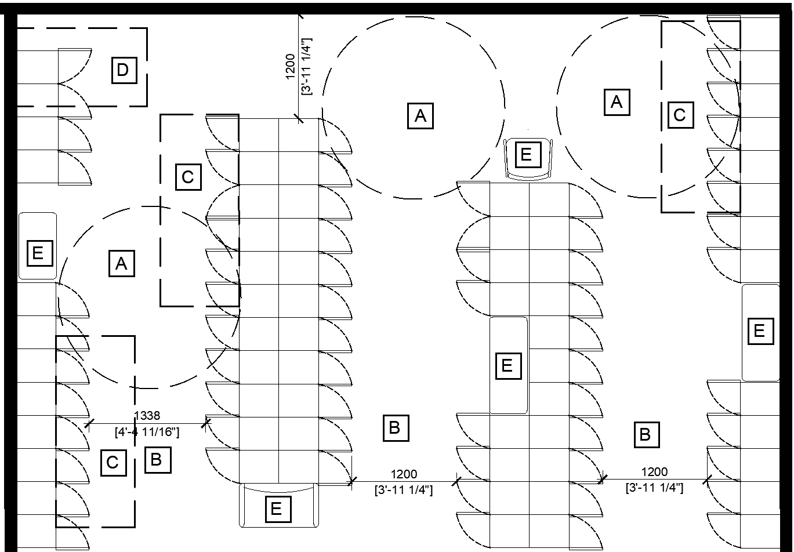
Legend for Figure 72
- A: Turning diameter.
- B: Minimum of 1200mm clearance from open locker door to open locker door.
- C: Clear floor space to access controls and inside lockers from a parallel/side approach.
- D: Knee/toe clearance under raised lockers to access controls and inside lockers from a forward approach (if provided).
- E: Variety of seating (at least one with arms and a back)

Shared Storage
- Refer to figure 73 for an example of what a shared storage area could look like.
- Refer to Figure 74 for 2D of a conceptual plan for a shared storage area which focus on circulation space Considerations. It is supported by an accompanying legend.

Figure 73
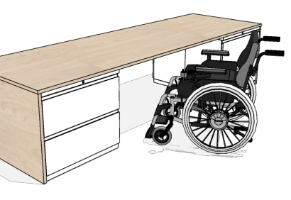
Recommendations
- Locks and handles of storage units to comply with CSA/ASC B651:23, Clause 4.3; Consider the accessibility of the lock and handle style selected. Controls should be operable with one hand, using a closed fist position or another method of operation that does not require tight grasping, pinching, or twisting of the wrist, and with a force that does not exceed 22N.
- 2-high cabinets are an accessible height, higher cabinets are not. Users must be able to see the files inside the cabinet drawers and be able to lift them up and out of the cabinet.
- If planning an accessible layout space. Refer to Figure 74. Ensure required clear floor space is provided for approach and use.
- Consider clear floor space required to access the files/supplies once the drawer has been pulled open.
- Refer to 6.1 General for additional information that may apply.
Figure 74
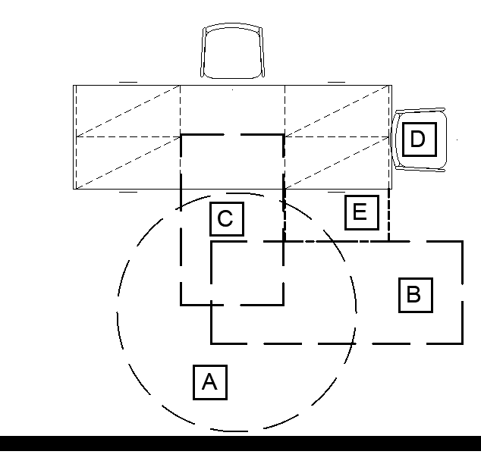
Legend for Figure 74
- A: 2100mm turning diameter.
- B: Clear floor space to access controls and inside cabinet from a parallel/side approach.
- C: Knee/toe clearance under surface for forward approach
- D: Space for displaced chair
- E: Space to accommodate drawer when it is pulled out to access files.

Waste & Recycling

Refer to Figure 75 for an example of what a recycling centre could look like.
Figure 75
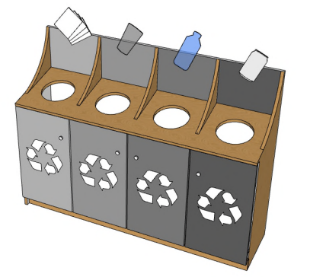
Recommendations
- Recycling Units: Signage and pictograms on the vertical surface rather than the horizontal surface provide better visibility from a seated position.
- Ensure space for a parallel approach is provided and turning diameter in front.
- The opening or lid should not be higher than 1060mm from above the ground (per CSA/ASC B651:23, Clause 8.6.11 – Exterior Spaces)
- A garbage receptacle with a lid is required in the kitchenette from a health and safety perspective. Ensure that the style and location are accessible. Garbage receptacles should be plotted in plans to ensure they don’t impede on accessible paths of travel. Electronic or automated controls may be particularly helpful in simplifying access for a range of users.
- Refer to 6.1 General for additional information that may apply.

Key Accessibility Considerations Checklist

This is not a comprehensive list. It is important to consider the users of the space and use a holistic approach in designing an accessible and inclusive workspace. Apply Universal Design principles to the extent possible.
General workspace
- Paths of travel / Accessible Routes to meet or exceed minimum width requirements. (CSA/ASC B651:23 Clause 5.1.1).
- Clear floor space provided when an accessible route terminates. (CSA/ASC B651:23 Clause 5.1.2).
- Turning diameters have been provided where needed. (CSA/ASC B651:23 Clause 4.1).
- Clear floor space has been provided at all controls, equipment, amenities. i.e. light switches, power door operators, whiteboards, corkboards, lockers, filing cabinets, etc. (CSA/ASC B651:23 Clause 4.3.2).
- Doors and doorways meet the minimum requirements, i.e. width, manoeuvring space on both sides, force to operate, accessible hardware, etc. (CSA/ASC B651:23 Clause 5.2).
- Controls are accessible. Controls include things such as light switches, locks on lockers and filing cabinets, door and millwork handles, power door operators, etc. (CSA/ASC B651:23 Clause 4.3).
- Careful thought has been put into accessible wayfinding. (CSA/ASC B651:23 Clause 4.7.1).
- Appropriate headroom clearance has been provided or addressed. (CSA/ASC B651:23 Clause 4.5.1).
- Protruding objects are cane detectible or planned so they don’t protrude. i.e. wall mounted TV’s/monitors, surfaces mounted on the back of seating, wall mounted first aid kits, etc. (CSA/ASC B651:23 Clause 4.5.2).
- Safety measures have been considered. (CSA/ASC B651:23 Clause 5.1.5).
- Considered and implemented strategies for avoiding materials and products with strong scents and hazardous chemicals. (CSA/ASC B651:23 Clause 4.7.2).
- Considered and implemented strategies that will result in good acoustic design which supports people with disabilities. (CSA/ASC B651:23 Clause 4.7.1 & 4.7.3).
- Considered and implemented strategies that will result in a space with good lighting design which supports people with disabilities such as people who are partially sighted, and or have sensitivities to lighting. (CSA/ASC B651:23 4.7.1)
- Finishes considered from an accessibility perspective:
- Avoided strong patterns on large surfaces. i.e. walls, floor, large furniture, millwork, etc…
- Selected finishes that prevent glare. i.e. matte finishes on things such as desk/table surfaces, floors, signage, etc.
- Luminance (colour) contrast has been addressed. i.e. between floors and walls, walls and door frames, doors and door frames, contrast strips on glass doors & walls, handles and background surface, furniture and surroundings. (CSA/ASC B651:23 Clause 4.2).
- Flooring choices are accessible. (CSA/ASC B651:23 Clause 4.4.3).
- Contrasting strips on fully glazed doors, walls and sidelights compliant with codes and standards. (CSA/ASC B651:23 Clause 5.2.2.10).
Specific Workpoints & Support Spaces
- Kitchenette(s) meet or exceed minimum standards. (CSA/ASC B652:23 Clause 5.10).
- Many of the kitchen clauses are transferable to millwork used for other purposes such as equipment areas and should be considered. (CSA/ASC B652:23 Clause 5.10).
- Closet(s) meet or exceed minimum standards. (CSA/ASC B652:23 Clause 5.13).
- Minimum of 20% of individual workpoints of each type are accessible to wheeled mobility device users. More is strongly recommended.
- All collaborative spaces and support spaces are accessible to wheeled mobility device users.
- A minimum of 10% of workpoints that make up the collaborative spaces (groupings) are accessible to wheeled mobility device users.
- All recommendations and Considerations for workpoints and support spaces (Part 6) have been considered including, but not limited to the following:
  - Assistive listening devices have been considered for meeting rooms and workpoints assigned individuals responsible for assisting employees, such as a workplace coordinator. (CSA/ASC B651:23 Clause 6.6.1).
  - Ensured that if large meeting room is designed to be split into two smaller rooms that both configurations are accessible.
  - Considered including at least a few L-shaped workstations with good clearance underneath (3 legs).
  - Included as many Focus Rooms and Phone Rooms/Phonebooths as feasible.
Furniture and Furniture Planning Considerations
- All recommendations and considerations relating to furniture for workpoints and support spaces have been considered. Refer to Part 6.
- Avoided planning with users’ backs to primary pathways.
- Carefully planned power sources and wire management solutions to prevent tripping hazards and cables from impeding on clear floor space.
- Ensured there is space for displaced chairs near workpoints that are accessible to wheeled mobility device (WMD) users.
- Provided opportunities for WMD users to transfer to soft seating.
- Design and specifications provide a variety of furnishings and choice.
- Left-handed and right-handed options or those that provide both have been considered.
- Adjustability, ergonomics and flexibility has been considered when specifying furniture.
- Knee/toe clearances and functionality considered when selecting table/desk base styles
- Electric mechanisms for height adjustable tables have been selected when possible, including tables in collaborative areas.
- Task lights have been considered for individual workpoints.
- If whiteboards and/or corkboards are provided, they accommodate people of different sizes, including from a seated position.
- Confirmed if client’s existing furniture is being reused in the project. If it is it has been integrated into the design; including recycling and waste receptacles.
- Worksurfaces have rounded or blunted corners and edges.
- Considered how sightlines can be maximized for those that benefit from lip reading.
- Seating has been provided adjacent to lockers and locker design strategy has been carefully considered.
- Controls are accessible and the ease of use of controls of various products has been considered, including but not limited to: power modules, locker locks and handles, height adjustable tables, task chairs, light switches, etc.
- Finishes with bold patterns (especially larger pieces) and those that cause glare are avoided.
- Considered and implemented strategies for avoiding products with hazardous chemicals (CSA/ASC B651:23 Clause 4.7.2), including fabric selection.

Feedback and Enquiries

It is important to note that this Guide is an evergreen document. As standards evolve, technology advances, and more information becomes available, the guidance for in this document will change. Future iterations of the Guide will include an executive summary which will summarize the major changes to the Guide. Additionally, the publishing of a new iteration of the Guide will be communicated extensively.

Share Your Feedback and Enquiries

Enquiries and feedback relating to this document should be directed to the Accessibility and Inclusivity Office, Workplace and Sourcing Solutions, Real Property Branch, Public Services and Procurement Canada at:
TPSGC.SIAccessibleEB-RPSBEAccessible.PWGSC@tpsgc-pwgsc.gc.ca
Did your team deliver a wonderfully accessible and inclusive project that you would like to share with us? Or maybe something didn’t go as well as it could have. We would love to hear about it! Learning about your innovations, successes and challenges would be helpful in updating future iterations of the Guide.
All feedback is welcome! Let’s work together towards an accessible Canada!

Helpful Links

Design
- CSA/ASC B651:23, Accessible design for the built environment (csagroup.org): The Guide is not a replacement for referencing this standard. The Guide aims to avoid duplicating Mandatory standards as much as possible, but sometimes it is necessary for clarity, comparison, or reinforcement purposes.
- CSA/ASC B652:23, Accessible dwellings (csagroup.org): Standard with clauses that are applicable to kitchenettes and coat closets in workplaces. The Guide is not a replacement for referencing this Standard.
- Center for Environmental Health (ceh.org) - Furniture
- DeafSpace - Campus Design and Planning | Gallaudet University
- Environmental Health Association of Quebec (EHAQ)
- Functional Direction on All Access Washrooms: Communicates PSPC’s approach to all access washrooms as interim guidance.
- GCworkplace accessibility reports - wiki (gccollab.ca)
- GCworkplace design - GCpedia
- GCworkplace Design Guide: Outline of the design principles and best practices pertaining to workplace modernization for the Government of Canada.
- GCworkplace Indigenous Design Guidelines: Provides high level direction to project teams with strategies to honour First Nations, Inuit, and Métis communities in Canada by incorporating culturally appropriate design elements and promoting Indigenous economic opportunities on GCworkplace projects.
- GCworkplace Space Planning Workbook: A tool used to determine workpoint quantities and ratios in accordance to the GCworkplace Design standard for planning.
- GCworkplace Technical Reference Manual: Outline of the various workpoints included in the GCworkplace Design Guide. The information provided includes best practices regarding workpoint dimensions, planning tips, technical data and it’s application.
- Government of Canada Workplace Fit-up Standards: Standards that respond to government programs and priorities, and are compliant with all relevant codes, life safety and accessibility standards. The Fit-up Standards provide the flexibility to create innovative workplace fit-up solutions using a common sense approach in a manner that represents best value to the Crown. It also supports the integration of measures that extend beyond base requirements in the spirit of fostering universal accessibility, but the client is to bear any additional costs. It is important to keep that in mind when considering guidance that goes beyond what is included in the bundle of goods.
- National Building Code of Canada: 2020 - NRC Publications Archive - Canada.ca
- Technical Reference for Office Building Design: Describes both the general approach to the design of PSPC custodial office buildings, and the technical aspects that apply to each major discipline involved in the design. These objectives must always be balanced against all other government objectives including, but not limited to, security, accessibility, sustainability, heritage conservation and end user requirements.

Policy
- Accessible Canada Act (justice.gc.ca)
- Accessibility Standards Canada
- Accessibility Strategy for the Public Service of Canada - Canada.ca
- Canada Occupational Health and Safety Regulations (justice.gc.ca)
- Canadian Human Rights Act (justice.gc.ca)
- Directive on the Management of Real Property- Canada.ca
- Employment Equity Act (justice.gc.ca)
- Official Languages Act (justice.gc.ca)
- Summary of the Accessible Canada Act - Canada.ca

Terminology
- Accessibility glossary - Glossaries and vocabularies - TERMIUM Plus® - Resources of the Language Portal of Canada - Languages - Canadian identity and society - Culture, history and sport - Canada.ca (termiumplus.gc.ca)
- Guide on Equity, Diversity and Inclusion Terminology (noslangues-ourlanguages.gc.ca)
- Inclusive writing – Guidelines and resources – Writing Tips Plus – Writing Tools – Resources of the Language Portal of Canada – Canada.ca (noslangues-ourlanguages.gc.ca)

General
- Accessibility at Public Services and Procurement Canada - Canada.ca
- Accessibility in the public service - Canada.ca
- Accessibility resources hub - Accessibility Office - mySource (tpsgc-pwgsc.gc.ca)
- Office of Public Service Accessibility/ Bureau de l’accessibilité au sein de la fonction publique - GCpedia

Summary of the Accessible Canada Act - Canada.ca
Summary of the Accessible Canada Act - Canada.ca
Optimizing our real property portfolio - Canada.ca
The disability rate in Canada increased in 2022 - Statistics Canada (statcan.gc.ca)
rhf-cboc-report-press-release-feb-23-2018.pdf (rickhansen.com)
The Diversity and Inclusion Action Plan 2021 to 2025 - mySource (tpsgc-pwgsc.gc.ca)
Accessible Canada Act (justice.gc.ca)
Workplace_Fit-up_Standards.pdf (gcpedia.gc.ca)
Accessible Canada Act (justice.gc.ca)
CCOHS: Diversity, Equity, and Inclusion in the Workplace
Workplace_Fit-up_Standards.pdf (gcpedia.gc.ca) (tweaked to suit the situation)
Workplace_Fit-up_Standards.pdf (gcpedia.gc.ca)
Guide on Equity, Diversity and Inclusion Terminology (noslangues-ourlanguages.gc.ca)
Workplace_Fit-up_Standards.pdf (gcpedia.gc.ca)
PSPC - 5-steps toward unassigned seating
Workplace_Fit-up_Standards.pdf (gcpedia.gc.ca)
CSA/ASC B651:23, Clause 5.2.9.4, Note #1
CSA/ASC B651:23, Clause 4.3.2
CSA/ASC B651:23, Clause 5.2.9.3, Note
CSA/ASC B651:23, Clause 4.3.2, Note #3
Universal Accessibility Best Practices, Volume 3 – Facilities and Interior, PSPC, SPIB
Universal Accessibility Best Practices, Volume 3 – Facilities and Interior, PSPC, SPIB
CSA/ASC B651:23, Figure 56a)
RHFAC Professional Handbook v4.0
RHFAC Training Student Guide v3.0
PSPC-SPIB Universal Accessibility Best Practices, Volume 3, Clause 3.7.3.5
PSPC-SPIB Universal Accessibility Best Practices, Volume 3, Clause 3.7.3.5, Figure 31
CSA/ASC B651:23
PSPC-SPIB Universal Accessibility Best Practices, Volume 3, Clause 3.7.3.6
PSPC-SPIB Universal Accessibility Best Practices, Volume 3, Clause 3.7.3.6
CSA/ASC B651:23, Clause 5.1.5, Note #2
RHFAC Training Student Guide v3.0
CSA/ASC B651:23, Clause 5.1.5, Note #1
PSPC-SPIB Universal Accessibility Best Practices – Volume 4 – Maintenance and Operations - 2022
Center for Environmental Health (ceh.org) - Furniture
CSA/ASC B651:23
RHFAC Professional Handbook v4.0
RHFAC Professional Handbook v4.0
RHFAC Professional Handbook v4.0
RHFAC Professional Handbook v4.0
RHFAC Professional Handbook v4.0
Gender-Based Analysis of GCworkplace Design, 2019
Renovating for Accessibility: Kitchens
Renovating for Accessibility: Kitchens
Renovating for Accessibility: Kitchens
Renovating for Accessibility: Kitchens
Renovating for Accessibility: Kitchens
SPIB UA Best Practices – Volume 3 Facilities and Interior, 3.15.3.8.j.

