GC Minimum Viable Business Architecture
(GC MVBA) Taskforce

Meeting date: 2022-09-20 [13h00 – 14h30]  Attendance (9):  Steven Bednikoff (HC) –Chair and notes  Anne Beausoleil (PSPC)  Johanne Bottrill (PSPC)  James Cameron (CSC)  Adam Eikenberry (CIHR) | +  Kareim Elattar (DFO)  Len Parliament (PSPC)  Roy Acres (PSPC)  Lily Au (SSC)

Meeting Summary
This meeting was mostly about regrouping and recapping where we are and the direction forward. The team discussed the July meeting and used an updated and shortened version of the 2022-04-25 to scope and orient the work ahead.

Key Notes from the discussion and in/post-meeting chat:
- A Minimum Viable Business Architecture (MVBA) practice should take into account three different scenarios for departments and agencies:
  - Low Maturity/Complexity Architecture practice
  - Med Maturity/Complexity Architecture practice
  - High Maturity/Complexity Architecture practice
- Focus of the Taskforce should be Business Architecture, not Enterprise Architecture, but within / taking into account the GC Enterprise Architecture context, framework and practice
- Business Architecture should enable the Enterprise Architecture practice to be more strategic and better connect/integrate with non-IT concerns and aspirations
- The MVBA should be about strategic AND tactical business architecture; so should also cover when and how business architecture gets leveraged by change initiatives
- We should also clearly relate business architecture with some of the key business and IT management paradigms that are established or growing within the GC:
- Digital transformation and roadmapping
- Product management and Product families
- Agile practices and DevSecOps
- Core MVBA Taskforce output: a GC Minimum Viable Business Architecture Playbook. Described by Roy as a “base set of recommendations and best practices for running a business architecture practice” offered for “voluntary adoption”. Would be built around the W5+How concept and made of:
- A common vision for Business Architecture in a GC context (WHY)
- Minimal Stakeholders and Roles (WHO)
- Minimal Services with Key Activities with their outputs / artefacts/ del;ioverables / … (WHAT)
- A set of proposed approaches, methods, guidelines and tools to develop, deliver/realize business architecture value (HOW; WHEN)
  - Ref models to use within the GC EARB presentations
  - Business architecture Use cases – examples of where business architecture worked in certain initiatives would be helpful (i.e. in a department's G&Cs project or with a specific product)
  - When and how to use the BCM? What to do / Where to go from here to favor that
- Minimal Metamodel and Knowledgebase / BA Repository (WHERE)
- Required Skillset and competencies
- Additional resources:
  - Contact lists for BA practitioners
  - Key reference resources (external to GC and internal)
- The GC MVBA Playbook should absorb and replace the one already posted on the GC Wiki site: https://wiki.gccollab.ca/GC_Enterprise_Architecture/Framework/BusinessGuide
- Business architecture, and the GC MVBA Playbook, shouldn’t only be about Business Capabilities and strategic investment roadmapping. Kareim proposed Service inventory and Application rationalization as the best places for Business Architecture artifacts
- He also mentioned how business architecture can and should be the link between business and IT and how it can be the best and most selling value.
- BCM and ACM are different models serving different purposes. The MBVA practice should relate to both.
- A shared BA/EA toolset (or at least a basic sharing platform) across Departments would be a great enabler for a cross-GC Business Architecture practice – to share models, artefacts and architecture content.
  - Len raised SAP's Best Practice Explorer as a potential tool for that and provided an example of how the Vendor (SAP) maps level 3 and below Business Architecture to Applications / Solutions. https://rapid.sap.com/bp/BP_CLD_PSM
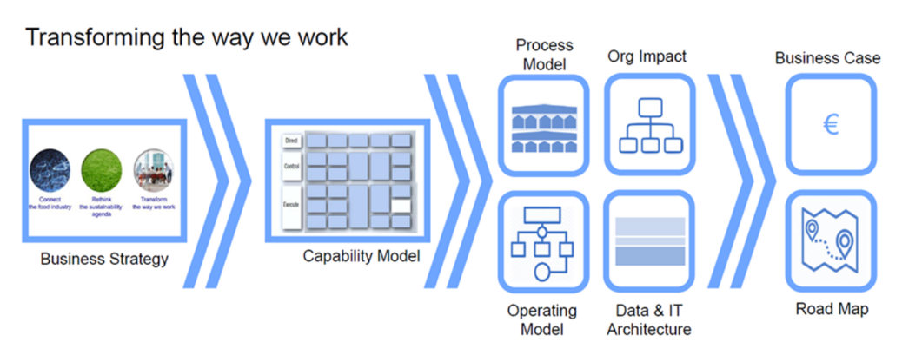

- Meetings will be kept on a bimonthly basis but work should move forward in between, with items assigned to individual members with review mechanisms from within and outside the Taskforce

Action items:
- Update the main deck (Steven)
- Create a list of individual items / tasks that Taskforce members will be able to grab
(Steven; All)
- Explore the use of GCExchange to hold and manage the Taskforce’s work items (Roy)

