Workplace Transformation Program
COMMONLY ASKED QUESTIONS
VERSION 1
Date: SEPTEMBER 2022

Commonly Asked Questions – Workplace Transformation Program
To be removed before sending

Objective: this document is intended to provide Change Managers with commonly asked questions and best practices related to the Workplace Transformation Project.
Who should use this: Change Managers should work with the integrated project team to customize this document prior to circulating to employees. Some of these responses are general best practices for Workplace Transformation Projects and may not always apply to specific.
When to use this: Change Managers can use this as a guide when addressing high level question from employees or can provide elements of this Q&A to employees for reference. As soon as the project is announced to the employees, the Q&As should be made available for reference.
How to use this: This Q&A can be used as a reference document for anybody who wishes to find more information about a specific subject. It can also be used by the change manager to disseminate information of specific topic throughout the project. You can also refer to the Guide for communication content that offers a variety of topic and related content to use as part of your ongoing communication with employees.
Note: To go in more details into some of these elements, a user guide is also available in the CM Program in-a-box which is to be used to explain how to use the various aspect of the workplace.
The French version of this document can be found here : FR version

Contents
SECTION ONE : Workplace Transformation Program 4
What is the Workplace Transformation Program (WTP)? 4
SECTION TWO : Our workplace transformation project 4
Why are we changing? 4
What is changing? 4
How will I be informed on project updates and how to participate? 4
How should I provide feedback? 4
SECTION THREE : GCworkplace 5
What is GCworkplace? 5
What is Activity-Based Working (ABW)? 5
Why are we moving to shared seating? 5
What is a workpoint? 5
What types of workpoints will be available to me and how do I use them? 6
What about enclosed offices? 6
Will I be able to reserve a workpoint? 6
SECTION FOUR : Hybrid Working 6
Does this impact flexible working arrangements? 6
SECTION FIVE : Employee Wellness 7
How does GCworkplace impact accessibility and ergonomics? 7
How do we navigate a scent free environment? 7
How does GCworkplace address noise concerns? 8
What about sanitization and hygiene? 8
SECTION SIX : Personal Belongings and Business Assets 8
Where should I store my belongings? 8
What about technology? 8
Where do we store business files and assets? 9
Additional Resources 9

SECTION ONE : Workplace Transformation Program

What is the Workplace Transformation Program (WTP)?

For information about the WTP, please refer to the official FAQ on GCpedia.

SECTION TWO : Our workplace transformation project

Why are we changing?
Over the past few years, our organization have gone through a lot of changes together, the most significant for all of us, almost certainly, being the management of the pressures created by the COVID-19 pandemic. The pandemic changed the way we work and interact with each other. We need to rethink how we use our office space over the long term and redesign the workspaces we have, the way we work and the employees experience in an hybrid ecosystem of spaces.
Our organization is dedicated to providing employees with a workplace that will suits todays needs, that will allow us to perform our work in a working environment that will be flexible and adapted to our new ways of working. Our organisation foresees the workplace as [INCLUDE YOUR VISION HERE].

What is changing?
As part of our upcoming workplace transformation, [ORGANIZATION] is making several changes to the way we work at [LOCATION]. Part of our transition will include a shift to Activity-based Working and shared seating for all employees regardless of position type or level. We are planning a work environment that will promote collaboration, team cohesion and innovation and that will support our new vision for the workplace that sustains wellbeing, inclusivity, collaboration, productivity, flexibility and mobility.

How will I be informed on project updates and how to participate?
- The integrated project team will routinely meet and provide updates to employees through various communication channels such as [INTRANET SITE, NEWSLETTERS, MS TEAMS, TOWNHALLS, ETC].
- During the implementation of the project, you will be engaged to support with office clean-up activities, including digitization and the retrieval of personal and business assets. Prior to re-occupying our space, you will be provided with an Employee Toolkit, to assist you when transitioning into our new workplace.

How should I provide feedback?
- Please discuss all questions, concerns and feedback with your direct manager. This information will be cascaded to [BRANCH REPS, CHANGE AGENTS, WORKING GROUP LEADS] to inform the integrated project team.
- You are also welcome to email [CONTACT INFO] with questions related to the project.

SECTION THREE : GCworkplace
Our new workplace will be following the GCworkplace vision and concept and will enable us to provide you with the best workplace design that support an hybrid working environment.

What is GCworkplace?
- A GCworkplace is a modern, efficient and inclusive workplace which responds to the public service workforce’s needs and supports a flexible way of working. It is based on the implementation of Activity-based Working (ABW).
- GC-wide engagement through Blueprint 2020 has allowed us to identify seven dimensions that define what modern means for our workplace. It’s about fostering a culture of innovation, improving how we leverage digital technology to encourage government-wide collaboration, flexibility, and efficiency. It’s also about putting into place actions that integrate sustainability and improve the overall health and wellbeing of employees and ensuring inclusivity for all.

What is Activity-Based Working (ABW)?
- Activity-based working is a government-solution to agile workspace design. When designing an ABW environment, designers have a deep understanding of the activities performed by you and your team. Activity-based working aims to provide diverse workpoints with equal access for all employees. It allows you to work where you want, when you want and with who you want based on your daily functions, as well as your personal work style and the team norms outlined by your organization.

Why are we moving to shared seating?
- In the absence of assigned workstations, we are moving to shared seating to support an activity-based working environment. To ensure equal access to space and the ability to choose an optimal work setting, workpoints will no longer be anchored unless otherwise approved based on a Duty to Accommodate or an approved functional need. Workpoints will no longer store business assets or personal effects*.
*See ‘Where should I store my belongings?’.

What is a workpoint?
- It’s any space where employees can perform their work, and is designed specifically to support different functional requirements. Each workpoint is equipped with furnishings and digital tools that support a variety of tasks and varying degrees of interaction or concentration.

What types of workpoints will be available to me and how do I use them?
- GCworkplace incorporates a variety of workpoints to suit diverse functions across our organization. Workpoints can be broken out into five categories: primary open individual, primary closed individual, secondary individual, open collaborative, and closed collaborative. Support spaces such as business centres and kitchens are also incorporated into GCworkplace design. The variety of workpoints that will be available in our future workplace is to be defined by the Design Survey exercise that will assess our organization activities and how we performed them.
  - Primary open individual workpoints include workstations, touchdowns, and focus pods. These spaces are intended to complete quiet focused work or routine tasking individually, such as research, reading, emailing, writing, etc.
  - Primary individual enclosed workpoints include focus rooms and phone booths. They are intended for short periods of confidential work or private calling.
  - Secondary individual workpoints include reflection points, active workstations, and study rooms. They are indented to provide alternative solutions to the primary individual open workpoint.
  - Open collaborative workpoints include chat points, huddles, teaming areas and lounges. These workpoints are intended for agile or social team meetings and quick, informal conversations between team members.
  - Enclosed collaborative workpoints include work rooms, project rooms, and meeting rooms. These workpoints are intended for private and formal meetings between team members and/or clients in groups of four or more.

What about enclosed offices?
- Focus rooms that are built for acoustic and visual privacy are provided as part of GCworkplace in place of enclosed offices. Having shared focus rooms ensures everyone has access to private space when they need it, regardless of rank or title. Executives and senior leaders with administrative teams can still sit in proximity within shared seating.

Will I be able to reserve a workpoint?
- ARCHIBUS will be used in our space for you to reserve workpoints prior to coming onsite. More information on how to use this application will be communicated.

SECTION FOUR : Hybrid Working

Does this impact flexible working arrangements?
- The implementation of GCworkplace will support our ability as an organization to offer increased flexible working arrangements for all employees; however, this does not indicate that our organization will alter its current vision for flexible working arrangements through this project. [IF APPLICABLE]: [ORGANIZATION] is still reviewing all flexible working arrangements—please stay tuned for more information to come.
- As part of building team charters, People managers will be responsible for indicating their expectations for flexible working arrangements with their teams—please stay tuned for more information related to community norms and team charters.

SECTION FIVE : Employee Wellness

How does GCworkplace impact accessibility and ergonomics?
- GCworkplace does not replace our organization’s requirements for Duty to Accommodate. Employees with existing Duty to Accommodate requests will be maintained in the new space.
- In a GCworkplace environment, furnishings and equipment should accommodate a range of ergonomic needs including height, width and angle adjustability, thus reducing individual ergonomic accommodation requests. Ergonomic needs are integrated into the overall design solution, rather than only at specific workpoints so that all employees can benefit from it. For cases where the range of typical workpoint options do not address a specific concern, special accommodations can be further developed on a case by case basis.
- GCworkplace design elements support a more inclusive and accessible environment for all, including the following:
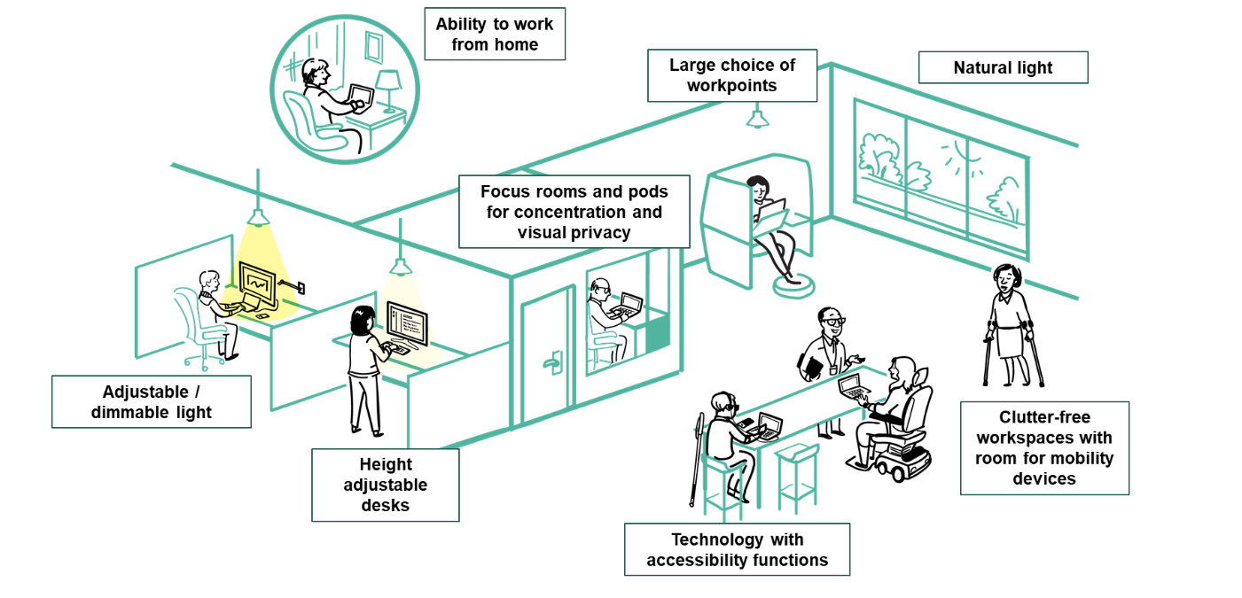

How do we navigate a scent free environment?
- [IF APPLICABLE] Dedicated scent-free coat closets will be available to all employees. Our scent-free policy still remains in our new workplace—please avoid wearing scented products to the workplace and maintain hygiene routines outside of the office. Strong smelling food should be prepared and consumed in dedicated kitchen areas.

How does GCworkplace address noise concerns?
- GCworkplace addresses concerns over noise through functional space planning. A section of our space will be dedicated to a quiet zone, where employees should be concentrating and routine tasking with little to no noise. Enclosed workpoints will also be available for employees who require acoustic privacy for short periods of time.

What about sanitization and hygiene?
- Each employee will have their own laptop and IT peripherals (keyboard and mouse) to reduce the need to share equipment in an shared environment.
- We will be following a clean desk policy, where everyone is responsible for ensuring the workpoint is cleared each day. This allows for night cleaning staff to sanitize each workpoint.
- [INSERT ANY CLIENT SPECIFIC CLEANING/MAINTENANCE PROTOCOL] – could include sanitization stations and procurement of PPE, distancing strategies, etc.

SECTION SIX : Personal Belongings and Business Assets

Where should I store my belongings?
- Your personal belongings will need to be taken home. Prior to our Workplace Transformation, we will be undergoing initiatives to clean-up and digitize our existing storage and make decisions on the future retention of our business assets. Updates around these activities will be determined and communicated with you soon.
- Day lockers will be provided as part of the program for you to store personal effects. Coat closets will also be available for larger items such as winter boots, gym bags and coats.

What about technology?
- Our new workplace will be fully equipped with GCwifi therefore all employees will be able to move freely within the workplace and connect their laptop and use cellphone to support full mobility.
- Workpoints and meeting rooms will no longer be equipped with landline phones. Business exceptions to this will be determined during the design planning stage.
- Workpoints will be equipped with universal docking station and monitors that will enable you to performed your work activities whether you need to focus or collaborate. Various set-up will be incorporated into the design.
- Meeting rooms will be equipped with audiovisual tools to support hybrid meetings. Instructions on how to use these tools will be provided to you prior to re-occupying the space.

Where do we store business files and assets?
- Business asset storage will be assessed during our information gathering portion of the Workplace Transformation Program. Working group leads will be responsible for understanding the business requirements for storage.
- Generally, each branch/directorate will be provided with assigned storage for their business assets. Senior leaders and People managers will be responsible for maintaining and managing their team’s business assets.

Additional Resources
- GCworkplace GCpedia page
- Workplace Transformation Program

