# Report - Mindful Change Leadership Development - 8 Week English Program - 2022

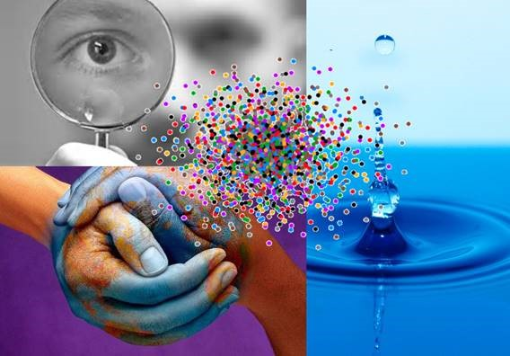The ***Mindful Change Leadership Development* 8-Week English Program** was delivered from April to June of 2022 having one session a week, the first and the last with duration of 2 hours and the rest were 1 and a half hours each; this document presents the key findings.

The goal of the program is to increase self-awareness by developing key skills: Focus, Clarity, Creativity, and Compassion in the service of others, with a positive impact on well-being and resiliency.

Studies have found that there is a strong link between mindfulness techniques and resiliency. Researchers found that “individuals with higher mindfulness have greater resilience, thereby increasing their life satisfaction.” They note that resilience “can be seen as an important source of subjective well-being,” and point out many ways mindfulness can promote this state of mind. (1)

This program was initially offered for ISC/CIRNAC employees, then opened to all other Government of Canada departments via the Interdepartmental Organizational Change Network (IOCN), which has been involved since 2013 in the creation of this program, and promoting Mindful Change Leadership tools, topics and methods via IOCN’s groups on GCConnex, GCCollab and GCXchange.

**Analysis**. The analysis of the results was obtained by using a self-assessment questionnaire from the Institute for Mindful Leadership and adapted to COVID realities, based on answers obtained from the participants.

A total of 239 registrants responded to Pre Self-assessment indicating the Department they are with, as shown here:

Percentage of Participants Registered to the Program, showing ISC, CIRNAC and Other Government of Canada Departments (n=239)

The program was completed by 130 participants, three months after the program they were asked to complete a Final Self-assessment, receiving 99 answers representing 76% response rate.

**Results.** Included in the key results, reported by participants, we observed the following benefits after 3 months of having completed the 8-week program (results rounded):

* **12.6% Increase in Employee Engagement** – respondents show a sense of clarity of mind. (2. I have difficulty distinguishing what day it is.)
* **23.0% Increase in Promoting Sounder Decision Making** - people report taking time to optimize their productivity. (7. I take time each day to optimize my personal productivity)
* **20.5% Decrease in Behavioural Risks** - participants indicated being more aware of the task at hand. (13. It seems I am running on automatic, without much awareness of what I am doing.)
* **20.8% Increase in Well-Being** – respondents feel they are more present while at work and at home. (1. I notice that I am distracted by thoughts about work after working hours or about home related things when I'm working.)
* **14.0% Increase in Resiliency** - people report an improvement in their ability to be present. (21. I find myself listening to someone with one ear, doing something else at the same time.)

20.5%

12.6%

20.8%

23.0%

14.0%

**Next Steps.** The program has proven to produce great results, the support from management helped in translating documents into the second official language, and with the help from volunteers found equivalent resources and the program was also delivered in French from October to November 2022. As for next steps, for continuing the support of the program, the following ideas are proposed:

* Invite Mindful Change Management Champions, Wellness Champions and others interested, from different Departments and Agencies, to join in sponsoring the program, by
  + Promoting the program in their Department and Networks
  + Participating in an information session and speaking about the benefits
* Create independent monthly sessions, using an adaptation of the current program
* Continue creating capacity for facilitating the program and sessions, in both official languages
* Continue collaborating with others via the [Convergence](https://wiki.gccollab.ca/Convergence) page
* Invite an indigenous lens and perspective to enrich the program

**Additional key results, as per the table**:



* For answers * "Almost Always", "Very Frequently", and "Somewhat Frequently"

**Other Details**: The Invitation, Program Details, FAQ and other resources can be accessed via this link:

<https://wiki.gccollab.ca/MCLD-DLCP>

**Map of Participation:** from the English 2022 program:

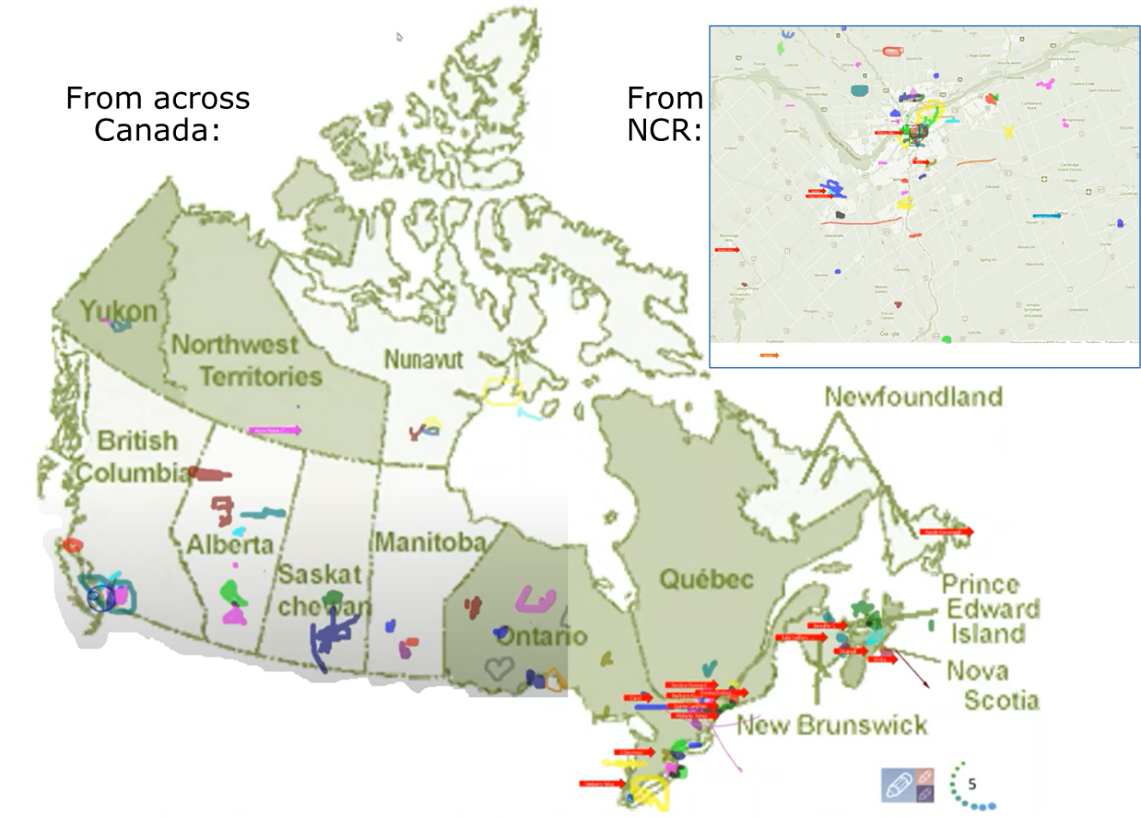

**Detailed Results**

The **Improvement** column, which represents the behavioural change on the employee, was calculated using the difference between the **Pre Assessment**, before the start of the program, and the **Final** **Assessment**, which occurred after three months of finishing the program.

|  |  |  |  |
| --- | --- | --- | --- |
| **Category** | **Q#** | **Questions** | **Improvement** |
| **Increases Employee Engagement** | 15 | I exercise regularly. | 6.11% |
| 8 | I find myself doing things without paying attention. | 9.98% |
| 23 | I am able to be fully attentive in meetings, conference calls and presentations. | 11.32% |
| 10 | I tend to quickly do the task(s) that I need to do without paying attention to the experience along the way. | 11.62% |
| 2 | I have difficulty distinguishing what day it is. | 12.56% |
| **Promotes Sounder Decision Making** | 5 | I find it difficult to stay focused on a project from beginning to end. | 9.59% |
| 4 | I feel like I am able to be myself in the (virtual) workplace. | 10.05% |
| 6 | I sleep well and enough to have energy throughout the day. | 11.93% |
| 9 | I am able to make time on most days to eliminate some tasks/meetings with limited productivity value. | 20.32% |
| 7 | I take time each day to optimize my personal productivity. | 23.01% |
| **Reduces Behavioural Risk** | 14 | I am an important contributor to the strategic plans of my organisation (Team/Unit/Branch/Directorate/Sector/Department). | 6.40% |
| 16 | I influence where I can, rather than worrying about what I can’t influence. | 7.69% |
| 12 | I am able to be fully attentive to a conversation. | 12.05% |
| 18 | I am able to respond with clarity, even under pressure. | 16.43% |
| 13 | It seems I am running on automatic, without much awareness of what I am doing. | 20.53% |
| **Resiliency** | 25 | I approach every challenge as though I can work through it somehow. | 1.02% |
| 3 | I feel I can bounce back quickly after an emotionally challenge situation. | 4.25% |
| 24 | I'm conscious to eat healthy foods. | 9.12% |
| 22 | I am able to make time on most days to prioritize my work. | 12.81% |
| 21 | I find myself listening to someone with one ear, doing something else at the same time. | 13.96% |
| **Well Being** | 19 | I rush through activities without being really attentive to them. | 11.99% |
| 20 | I recognize when I need help and that I can reach out to others. | 12.78% |
| 11 | When facing a challenge, I have difficulty trusting myself. | 13.73% |
| 17 | I am able to notice when my attention has been pulled away and redirect it to the present. | 18.32% |
| 1 | I notice that I am distracted by thoughts about work after working hours or about home related things when I'm working. | 20.77% |

**Testimonials and Comments**: the following testimonials and comments were made by participants during the various sessions delivered, as well as during the Cohort GCCollab group discussions.

* "After these several weeks that you spend in this mindfulness program... in a way, your investment in becoming medicine for yourself and for the rest of the world is something that I'm grateful to be witness to as an occasional participant in this program... any kind of investment like this in order to open your mind, your heart and your spirit to the presence of a larger world, which is either spiritual or physical, is a very important investment, and I applaud you for the investment that you've made." - Elder Malcom Saulis
* “it is so great to see the whole nation get together and just take a time to pause, breath together and just enjoying being present”
* “I love the body scan, it brings me peace”
* “thanks, this exercise [mindful breathing] brings energy, I feel more centered and focused”
* "meditating in the morning helps getting energy, being more productive, be more focus and be more centered and grounded... it helps reducing the anxiety"
* "I had fun doing the "I wish you happiness" exercise, it brought smiles to people's faces... it was awesome doing it"
* "doing these exercises in family, the level of communication with my children had changed drastically for good"
* "These 8 weeks have been profound, I'm really grateful for guiding us through, I love your calmness and your approach, we have covered a lot of ground, and in my view I think this should be mandatory for everyone. it's that powerful"
* "I found this course to be extremely powerful and grounding. I have ADD, this course really brought a new level of mindfulness and awareness to myself. I'm also new to the management ranks in government and this really helps to shape how I look at my relationships with my staff as well and to be mindful at how I interact with them and so forth, so it was excellent. Thank you!"
* "it was very powerful, very interesting, lots of insights. I learned a lot about myself. I found the exercises appropriate in me being more productive, more present in my relationships with my colleagues and also with my family. What I found really very very very interesting and intense and authentic learning experience. I agree, this should be (mandatory) strongly recommended”
* "Thank you … for this valuable opportunity to grow personally and professionally. It has been an important adjunct to the transformational work we are doing at ISC." – participant
* “I am a long-term meditator (over 30 years) and I have really appreciated being able to see how to apply my experience in a work setting.”
* “I really enjoyed this course. It was simple in a lot of ways but very deep in other ways”
* “this is such a worthwhile course. It really should be "mandatory" training we have to take”
* “I'm finding it easier to spend time with myself...thank you for this program and this community”
* “This series is life changing. I hope to participate more in the future”
* “It has been a Beautiful Experience. Lots of Sharing, Lots of Love <3”
* “I thank you for this program. I incorporated SCARF into my formal performance conversation and it was an extremely valuable framework”
* “Je n'étais pas certaine au début, mais j'ai finalement beaucoup aimé l'originalité de la forme de cette formation. Très organique, très foisonnante. Des outils et des chemins à emprunter. Beaucoup de liberté et donc, d'autonomie à développer. Merci.”

**Additional Resources and References:**

Invitation, MCL 8 week program details and FAQ: <https://wiki.gccollab.ca/MCLD-DLCP>

MCLD Cohort, CoP & CoI - <https://gccollab.ca/groups/profile/7978973/mcld-program-cohort-cop-coi-program-dlpc-cohorte-cdp-et-cdi>

(1) Article: Mediating role of resilience in the impact of mindfulness on life satisfaction and affect as indices of subjective well-being - <https://www.sciencedirect.com/science/article/abs/pii/S0191886915005784>