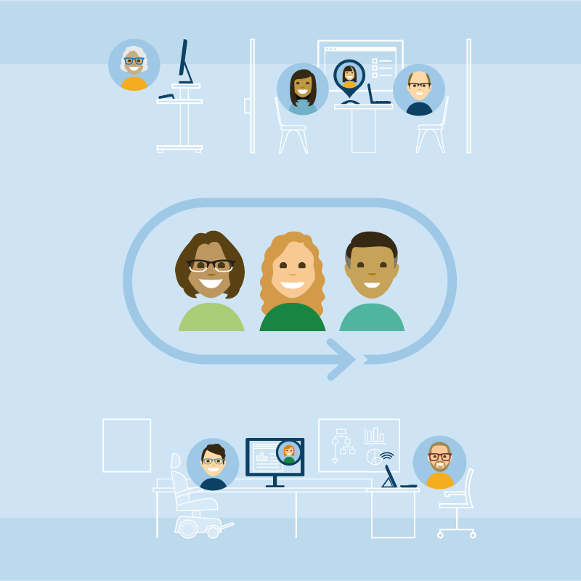

Workplace Change Management National Centre of Expertise

Table of contents
About us 4
Our role 4
Our team 4
Our story 4
Workplace change management 5
When to start 5
How to start 5
Contact us 5
Workplace Change Management Community of Practice 5
CM Playbook 7
Let’s start here 7
Strategize 8
Integrate the workplace modernization vision 8
Assess your organization 8
Determine the change management team 11
Plan 13
From strategy to plans 13
Communication plan 15
Engagement plan 16
Training plan 17
Implement 18
Communications 18
Generic messages 18
Web presence 21
FAQ 21
Key workplace modernization topics 21
Engagement 22
Demonstrate 22
Present 24
Consult 25
Involve 26
Training 27
Toolkits 27
Workshops 28
Measure 28
Measurements and metrics 28
Organizational (project) performance 29
Individual (people) performance 30
Change management (program) performance 30
Sustain the change 31
Managing “the new normal” 32
Managing resistance 33
Celebrate! 34
Glossary 34
Quick links 38
General 38
Strategize 38
Plan 38
Implement 39
Measure 39
ANNEX 40
Return to the workplace change management toolkit 40

About us
We are the Workplace Change Management National Centre of Expertise (WCM NCoE), Accommodation Management and Workplace Solutions, Real Property Services, Public Services and Procurement Canada!

Our role
- Provide clients with change management advice, guidance, support and troubleshooting throughout a workplace modernization project.
- Guide change managers in their utilization of the Workplace Change Management Playbook (CM Playbook).
- Create new—and expand on—existing strategies, tools, examples and best practices to support the implementation of change management within an organization undergoing a workplace modernization project.
- Provide a forum through the Workplace Change Management Community of Practice meetings with change managers across the Government of Canada.

Our team
We are workplace change professionals and experts with experience in a multitude of areas: delivering workplace change management programs, serving as advisors, and developing tools. We also have expertise across a wide variety of disciplines including communications, stakeholder engagement, consultation, training, facilitation, interior design, project management, and research and analysis.
Chantal Bemeur–Workplace Change Management Acting Manager and Senior Advisor
Isabelle Dupel–Workplace Change Management Senior Advisor
Carine Paré–Workplace Change Management Senior Advisor
Nadiah Sadighi–Junior Analyst

Our story
The Change Management Playbook (CM Playbook) was created out of a need to provide change management guidance and examples to clients involved in a workplace modernization project. It started in 2017 from documents that had been created during one of the first workplace modernization projects at the Treasury Board Secretariat. Then, a methodology based on the Prosci ADKAR change model was developed, examples were modified and transformed into templates and new tools were created. The first version of the CM Playbook was launched on GCpedia in 2018, and it was fully updated at the start of 2020.
Our team is very passionate about change management and enabling organizations to provide the best possible employee experience. We are constantly reviewing our existing content and tools, as well as adding to the CM Playbook. Our process typically starts from an idea, an inspiring element from a current project or a webinar, or a request we received from a member of our community. We then research the topic extensively, have group brainstorming sessions and finally a draft is born! In order to make it into the CM Playbook, each document undergoes a rigorous review process by the team, including a language review before and after it is sent to translation. It is important to us to create quality documentation that can be used with minimum effort from the change managers. We are always open to new suggestions for tools and content, so don’t hesitate to send us your ideas and requests!

Workplace change management
Workplace change management is a process for engaging with employees who are about to experience workplace change. Its goal is to help the people impacted by the change be properly equipped to understand, participate in and adopt the change successfully. What differentiates change management from project management in a workplace modernization context? Project management focuses on the physical aspects that are changing (updated hardware, new furniture, etc.) while change management is about managing the people side of those changes. In practice, that means that project management would, for example, focus on the switch from computers to laptops while change management would help explain to employees and managers WHY the change is necessary and how to adopt it successfully.
Given the challenges associated with implementing any type of change—much less one that focuses on altering the way people work—, the right approach is of vital importance. You need the right strategy and tools to ensure your workplace modernization project is a success (or, at the very least, to make sure that any resistance encountered is minimal and properly handled), which is where workplace change management comes into play.
While effective workplace change management can’t guarantee that your modernization project will be a complete success, it can ensure that the people impacted by the change are properly equipped to understand, participate in and adopt the change successfully.

When to start
The simple answer is ASAP! Workplace change management can start even before a workplace modernization project is approved. In order to start getting people ready, there is no time to waste when you are undergoing or plan to undergo a workplace modernization project. To be more specific, you should use workplace change management whenever you are embarking on any kind of workplace change (minor or major) for which people management being a significant determining factor to its success.

How to start
Workplace change management is a group effort with a lot of players involved both within and outside of your organization. As a first step, become familiar with the GCworkplace Modernization Roadmap to understand your role and how it fits into the project. Then, you can have a look at our Workplace Change Management Playbook, a guide we created to help you develop your change management program.

Contact us
To learn more about the role of the WCM NCoE and start your organization’s workplace change management process today, please contact us. We will be happy to meet with you to discuss our services and to walk you through the process of managing the people side of a workplace modernization project.

Workplace Change Management Community of Practice
The Workplace Change Management Community of Practice (WCM CoP) provides workplace change managers across the Government of Canada a forum to discuss and collaborate with colleagues about change management in the context of a workplace modernization project.
The WCM CoP’s main objective is to leverage the knowledge and different perspectives of its members to create a valuable resource for the workplace change management community.
Members have an opportunity to:
- share workplace change management approaches, tools, best practices, challenges and successes over the course of implementing a workplace modernization project;
- learn about new tools available to the community;
- create connections and opportunities for open dialog with other members involved in a workplace modernization project;
- interact, collaborate and share ideas with colleagues within and outside the public service;
- showcase completed workplace modernization projects and discuss lessons learned.

Become a member of the WCM CoP group on GCconnex to receive the most up-to-date information about WCM CoP meetings, ask questions to the WCM NCoE and fellow change managers, or start a discussion on a specific topic.

CM Playbook

Let’s start here
The content is separated in four key phases: STRATEGIZE, PLAN, IMPLEMENT and MEASURE. These four phases work in conjunction with one another. It is important to note that there is no clear end point to any of the phases of change management. For example, just because you have moved from the planning phase to the implementing phase, it does not mean that you are finished planning or even strategizing. Going back and forth between phases is to be expected.

The workplace change management approach on which this CM Playbook is based is called the ADKAR Model from Prosci, Inc. The ADKAR Model guides each of the four phases and is a recurring concept in our CM Playbook. 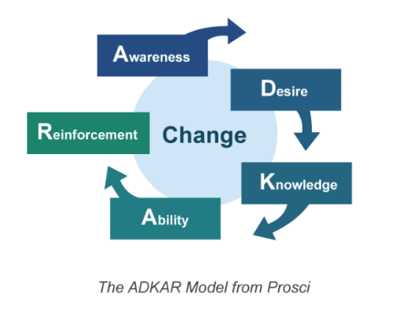
Check out the Workplace Change Management Playbook at a glance on our approach to build and implement a workplace change management program. In this tool you will find:
- an introduction to the four key phases;
- a high level step-by-step guide;
- a tools checklist.

Download the Workplace Change Management Playbook at a glance
Have any feedback about the CM Playbook? Let us know on the discussion page.

Strategize
Objectives
- Integrate your organization’s workplace vision into the change management strategy.
- Gauge your organization’s preparedness for the upcoming change as well as its ability, or lack thereof, to implement the change.
- Determine the current strengths and weaknesses of your organization as they relate to the upcoming changes (e.g. is your organization already innovative?).
- Develop a change management strategy tailored to your organization's specific needs based on the results of the assessment tools.
- Establish the change management team structure, its roles and responsibilities, as well as establish and maintain relationships with other key team members and stakeholders.
- Ensure you are prepared in the short term to carry out the next phase (planning), as well as in the long term for the final two phases (implement and measure).

Integrate the workplace modernization vision
Integrating your organization’s workplace vision into the change management strategy:
- provides the organization with guidance (the reason for the change);
- articulates the workplace objectives;
- reflects the desire to achieve the organization’s overall goals and priorities.

In order for employees to adjust to change, the workplace vision should be a tangible element, which employees can grasp. Although change management is a key element to achieving successful workplace modernization, it is not your responsibility, as a change manager, to determine the workplace vision. However, if no vision for the workplace has yet been identified, your role is to advocate to senior management for a defined and articulated vision. The vision for the workplace will guide the decision-making process and will be used to explain the WHY of the change to employees. A visioning exercise with senior management can be facilitated (by someone from your organization or a third party) to define the vision and goals for the workplace transformation. The champion of the change and senior management should be the main communicators of the workplace vision.

Assess your organization
Understanding and defining what is changing is the first step to developing a change management strategy. You will find below five tools that can be used in assessing your organization. The data gathered through this step will help feed your strategy and the results can also be used later to benchmark change adoption.

Change inventory and impact assessment
This assessment can help define what is changing and articulate the changes and their impacts for the employees. Use your knowledge of the project and collaborate with your integrated project team colleagues to fill out this assessment.

This tool has been developed in parallel with the GCworkplace Transformation Playbook. If your organization has already completed the Transformation Playbook assessment, you can simply select the changes that apply to your organization in Step 1 of that assessment.
This tool will help determine the:
- scope of changes;
- number of employees impacted by the changes;
- types of changes (on processes, tools, behaviors, etc.);
- level of effort required to manage each change;
- level of risk associated with each change.

Download the Change inventory and impact assessment

Change readiness assessment
Each organization has unique characteristics that can make change management easy or challenging. Some organizations are ready, willing and able to change while others are lacking change experience or have a bad history of change. Knowing where your organization falls within this range is critical at the beginning of the change journey. This assessment can be completed by the change management team with some responses gathered in collaboration with other partners.

This tool will enable you to:
- scan the change readiness of your organization and determine if conditions of success are in place to implement change management;
- analyze the predisposition to change of the leadership, organization and employees;
- analyze the organizational culture in terms of its adaptability to change;
- identify challenges, gaps and opportunities to be addressed.

Download the Change readiness assessment

Stakeholders map
Stakeholders are individuals or groups who will be affected by or have influence over the change. From a change management perspective, employees are typically the stakeholders most impacted by a workplace modernization project, but other groups such as members of the public or other departments can also be stakeholders. Employees can be separated into various stakeholder categories based on their functions (e.g. employees, managers, senior managers, specific community, etc.) Collaborate with your integrated project team colleagues to fill out this assessment.

This tool will:
  - identify key stakeholders, as well as the types of input they require and what kind of
communication they might need;
  - be used to develop various plans as part of the change management strategy.

Download the Stakeholders map
Project readiness assessment tool
This assessment tool is not a change management tool however, when used at the beginning of a workplace modernization project, it can identify the critical key enabling elements that are necessary to take on the project and ensure its success. It is usually completed by the project team in collaboration with the representatives of the key-enabling sectors (IT, IM, HR, Security, Facilities and Assets).

This tool provides a high-level portrait of the organization that can be used to:
- identify the organization’s readiness for change;
- identify potential challenges, gaps and opportunities that should be addressed before, or as part of, the workplace modernization project.

Download the Project readiness assessment tool

Guide to assessing the sponsor and champions, and Sponsorship assessment tool
According to nine studies conducted by PROSCI©, participants identified the number one contributor to success as being an active and visible sponsorship. Employees look to senior leaders for messages about the project’s importance and the organization’s commitment to change. The analysis you will conduct using this guide and tool will provide you with a holistic view of the health of the sponsorship coalition.
The two documents are to be used in conjunction and will help you identify who the sponsor and champions are, their positions towards the change (positive, neutral or negative), and their competency level in their roles.
Outcomes:
- The Guide to assessing the sponsor and champions (PowerPoint) will provide you with a sponsorship diagram.
- The Sponsorship assessment tool (Excel) will provide you with a detailed analysis on the sponsorship coalition to be used to build a sponsorship roadmap.
Download the Guide to assessing the sponsor and champions

ADKAR change-o-meter questionnaire and results table
You can use the questionnaire on a regular basis to keep the pulse on the adoption of change, and adjust your strategy and plans accordingly. As the data collection is manual, it is meant to be administered to representatives (no more than 30 people) who can answer for a group of people rather than the entire employee population. If you plan on sending it to all employees, you will need to consider administering the questionnaire (first document below) electronically and inputting the results into the results table (second document below) as per the instructions in that document.
This tool (which consists of two documents) has been developed in parallel with the Workplace Performance Survey. The questions in the ADKAR change-o-meter questionnaire are the same as the ones in the Workplace Performance Survey; therefore, you can benchmark the results throughout the cycle of the project.
The results of the ADKAR change-o-meter questionnaire:
- provide a benchmark for change adoption;
- can also be used for specific projects or groups.

Download the ADKAR change-o-meter

Determine the change management team
As part of your project’s integrated project structure, it is important to create a change management team. Each key player of the change management team should have clear roles, responsibilities and relationships (3Rs). You can use the change management team 3Rs template to start building your project structure. Here are important elements to include:

- a dedicated workplace change management resource or team (depending on the scope of the project);
- active and visible sponsorship and leadership;
- employee working groups;
- manager’s networks.

There are many options for recruiting a workplace change manager:
A: Look for someone within your organization or elsewhere in the public service.
→ Contact your HR advisor for guidance.
- Use our roles, functions and key activities of a change manager guide to identify the experiences, skills and abilities of a good change manager.
- Post on the following GCconnex pages (post template coming soon!)
  - Interdepartmental Organizational Change Network (IOCN)
  - Workplace Change Management Community of Practice
  - Career Marketplace
- Send a “Notice of interest” email (template coming soon!)
- Offer a micro-mission, secondment, assignment, etc.
B: Use the BGIS change management service option (as part of the RP-1 contract‒Tenant Facility Management Services).
→ Contact your property facility manager (PFM) for guidance.
- Available to all RP-1 portfolio clients in the NCR and regions (currently located in or moving to properties managed by BGIS).
C: Contract a change management consultant.
→ Contact your contracting officer for guidance.
- Use our Statement of work for change management services template.
D: Look at the available candidates within the Change Management Cloud.
→ First, contact the WCM NCoE and then your HR advisor for guidance.
Next, establish or use the various teams, committees, working groups and governance that will support the delivery of the workplace modernization project. Here are key steps to consider:
- perform an environmental scan to assess which committees are already in place;
- propose to those established groups to integrate a workplace modernization agenda item to all their meetings;
- ensure there are terms of references (ToR) for each of the groups and that roles and responsibilities are clear;
- perform a gap analysis for each of the groups to define their needs in terms of training, tools, support, coaching, etc.
Click here for additional content from OGDs and external resources
Change management team 3R template
Start building your CM project team structure.
- Common definitions of roles, responsibilities and relationships
- Fillable table customizable to your project’s requirements
- Example of an integrated project team structure

Download the Change management team 3R template

Statement of work–change management rescource template
Contract a change management consultant.
- Generic statement of work template to suit ProServices or Task-Based Supply Arrangement (TSPS) procurement vehicles
- Language grid example

Download the Statement of work–change management rescource template

Evaluation criteria template
- Example questions for mandatory technical criteria and rated technical criteria
- Submission response form example

Download the Evaluation criteria template

Draft the change management strategy
A change management strategy serves as a launching point for organizations seeking to introduce workplace changes and wanting to ensure that the impacts on employees are managed successfully. It defines the approach needed to manage change given the unique characteristics of a project. It includes an understanding of the changes, a supporting structure to implement the strategy, and an analysis of the risks of the change and potential resistance to the change.

Change management strategy template
- Executive summary
- Assessment results and analysis
- Change management team structure
- Change management strategy including communication, engagement and training frameworks
- Change management measurement

Download the Change management strategy template
Click here for additional content from OGDs and external resources

Change management strategy presentation template
- This tool allows you to present a high level view of your change management strategy

Download the Change management strategy presentation template
Click here for additional content from OGDs and external resources

Plan
Objectives
- Plan to implement your change management (CM) strategy
- Develop communication, engagement and training plans that situate your organization well for the implementing phase
- Build ADKAR in employees through the right set of products and activities
- Ensure you are equipped with the right knowledge to prepare and manage the people side at each of the three levels of the change (vision, project objectives and tactical)
- Synchronize your communication, engagement and training plan with ongoing project activities
- Establish performance indicators and a methodology to measure project success

From strategy to plans
Unlike the strategize phase, which required much higher involvement from your organization’s leadership, the planning phase is largely based on your contributions and collaboration with internal stakeholders. It is important to carefully plan when an audience will receive a message, be invited to participate in an activity, or be scheduled for training. Equally important are the steps that the sponsor will need to take to ensure effective sponsorship from other leaders. The main difference between the strategy and the plans is that the plans are action oriented and carefully scheduled rather than being a high level framework.

When developing your plans, keep in mind the timing, the senders, as well as the delivery of messages and activities. This will ensure that stakeholders are informed at the right time with the right information and that the messages and activities are always aligned with the workplace modernization vision. Based on the specific needs of your organization, decide on the best approach―whether it is to create separate plans for communications, engagement and training or one integrated plan.

At this point, it is also critical to plan which activities and performance metrics you will want to track throughout the duration of your project. You will need to measure individual (people) performance as well as change management (program) performance. Define which metrics are the most meaningful, as well as establish a cadence for collecting and reviewing data. Refer to the Measure phase for additional information on measurement and metrics.

CM/PM integrated plan template
This tool allows you to map out the change management (CM) activities against the major milestones of the project management (PM) plan, in one document. It can be used in different ways:
- In the early stages of your project, it can serve as a high-level plan to help you plan out the first steps of your change management program.
- For the duration of your project, it can serve as your main planning tool if you do not have the time or the resources to develop detailed communication, engagement and training plans, or if you do not have a CM strategy to guide you in their creation.
More precisely, you can use this tool to:
- align CM and PM activities in one document
- organize activities and deliverables in a sequential order, with or without dates
- define which activities will help you build ADKAR in employees

Download the CM/PM integrated plan template

CM approach and timeline presentation
This tool allows you to present high level information to a senior audience to gain endorsement on your proposed CM approach. It includes:
- slides on what is CM, CM approach and the value of CM
- a timeline and overview of the CM activities
- example of activities to build ADKAR in employees

Download the CM approach and timeline presentation

Sponsorship roadmap
This template outlines the key activities and responsibilities of the sponsor and champions who are needed to support the change. You can use it to:
- Prepare a plan for the sponsor
- Provide the sponsor with checklists organized by target audience and timing for the change
- Clarify your role in assisting the sponsor to follow the sponsor plan and complete the checklists

Download the sponsorship roadmap

Change management activity tracker
This planning tool* allows you to establish which change management activities you will need to track during your project. Tactical effectiveness should be measured after each activity, to ensure the activity has met its objective. Use the feedback and data gathered to enhance future iterations of the activity. The information gathered with this tool will also be used in the Measure phase to demonstrate the effectiveness of your change management program, the return on investment (ROI) and the overall value of the program.
*Data collected should be compiled in an Excel document in order to compare actual figures vs. target figures, monitor trends, etc.
Download the change management activity tracker

Workplace performance modernization tracker
This planning tool* allows you to establish which organizational (project) and individual (people) performance metrics you will need to track during your project. Organizational (project) metrics are typically defined by the project team, not the change management team. However, it is important for you to understand the workplace modernization outcomes expected and how the PM team plans on measuring success. This way, you can ensure that the individual (people) metrics are connected to the organizational (project) metrics. The information gathered with this tool will also be used in the Measure phase to determine the overall success of the workplace modernization project.

*Data collected should be compiled in an Excel document in order to compare actual figures vs. target figures, monitor trends, etc.
Download the workplace performance modernization tracker

Communication plan
Communication plays a vital role in getting stakeholders engaged in the change (both in terms of interest and in terms of participation). Effective communication products help employees understand what the changes are, why they are important and what the benefits are (WIIFM).

Clear and frequent communication is the second highest contributor to the success of a workplace modernization project, largely because of its role in building ADKAR. A strong communication plan creates awareness of the upcoming changes, builds the desire and motivation to adopt the changes, provides the knowledge and understanding needed to apply the changes, and keeps the changes in effect past completion of the workplace modernization project (i.e. reinforces the changes).

When developing your communication plan, there are some key steps to take:
- Establish clear objectives
- Develop key messages for target audiences (employee, manager and executive levels)
  - Employees are most impacted by messages and interactions from senior leadership and from their immediate supervisor or manager.
- Consider the three levels of change (vision, project objectives and tactical)
  - Each level of change will impact the timing, type of activity, audience, sender and delivery mechanism of the message. Refer to Figure 1 for guidance.
- Vary the direction and type of communication (i.e. one-way communication from managers to employees, one-way communication from employees to managers, and two-way communication between employees and managers)
  - One-way communication: email (messages to employees from managers and messages from employees to an inquiries/feedback inbox), intranet, video/multimedia, surveys, etc.
  - Two-way communication: blogs, social media, tours, discussions, etc.
- Communicate often and honestly to all levels within the organization even about the aspects of the project that are still unknown
- Begin communication as soon as senior leaders can announce the upcoming workplace modernization project, its vision and the “WHY”
- Collect feedback, monitor and evaluate the effectiveness of your communications

Communication plan template
Objectives, key messages, products, vehicles and activities
- Table to outline all activities
- Examples of key messages
- Guides to customize key messages
- Examples of communication activities

Download the communication plan template

Additional GCworkplace links:
- The GCworkplace Communications Toolkit

Click here for examples of communication plans from OGDs

Engagement plan
Engagement activities help build ADKAR by creating awareness and building desire for the change. Allowing employees to participate in the change process and seeking their feedback will drive interest for and encourage adoption of the change.

When developing your engagement plan, there are some key steps to take:
- Establish clear objectives
- Develop activities that provide an opportunity for employees to participate in the change
  - Employees should be able to have their issues heard, share insights or reactions to the change, as well as participate in the design and decision-making process.
  - Consultations can be organized in various ways and using a variety of tools.
- Consider engagement activities based on each target audience’s interest in the change
  - Stakeholders usually have varying levels of interest and impact with respect to the modernization project, and therefore will require varied engagements to suit their needs.
- Ensure strong, consistent and meaningful communication for all engagement activities
  - Well planned and executed changes with good engagement can help prevent change fatigue, loss of productivity, longer periods of adjustment, and can increase the benefits realized in relation to investments made.
- Collect feedback, monitor and evaluate the effectiveness of your engagement activities

Engagement plan template

- Objectives, stakeholder engagement and activities
- Table to outline all activities
- Examples of engagement activities

Download the engagement plan template
Click here for examples of engagement plans from OGDs

Training plan
Training is a crucial component of any workplace modernization project. It ensures all stakeholders have the necessary skills, knowledge and competencies to adopt and sustain the change. One of the most important aspects of training relates to people management, i.e. how to help manage and guide employees through the changes. Proper training and tools for managers will help them keep employees engaged during the change process which, indirectly, will help employees be better trained on aspects of the new workplace.

When developing your training plan, there are some key steps to take:
- Establish clear objectives
- Identify the skills and abilities that employees need to be successful going through the transition but also after they have moved into their new workplace
  - Look at existing training material within your organization and see if it can be used or adapted, otherwise identify the gaps and needs.
- Include change management training for the sponsor, champions and managers, if required
  - In order to be effective they will need to learn about their roles and responsibilities.
- Plan to empower managers to be good coaches
  - Employees want to hear and learn about change from the person they directly report to.
- Partner with subject matter experts within your organization to develop the training material and deliver training sessions. You may have to consider external support if there are no internal resources that can provide the training.
- Collect feedback, monitor and evaluate the effectiveness of the training

Training plan template

- Objectives and activities
- Table to outline all activities
- Examples of activities

Download the training plan template
Click here for examples of training plans from OGDs

Implement
Objectives
- Implement the change management activities defined in the communication, engagement and training plans.
- Equip the organization with the knowledge and ability to answer the “Why?” and "How?" questions from employees.
- Prepare employees, managers and senior management with tools and training to ensure they are well equipped to go work through the workplace transition and in the new work environment.

Communications

Generic messages
In order to successfully implement change management throughout a modernization project, it’s important to be transparent with all employees affected by the change. Establishing the timing, sender and delivery of the messages is key. Below you will find templates and examples from other government departments of generic messages for project launch, functional programming, project milestones and moving. You can use Figure 1 to guide you in deciding the best approach for your messages.
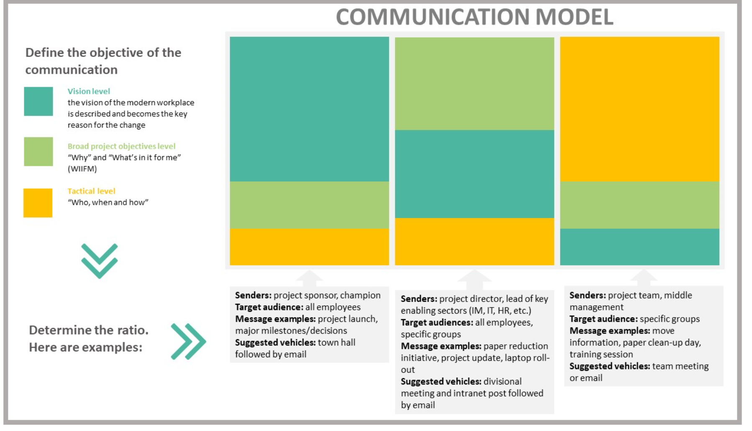
Image description:
This image describes three different communication models. Title: Communication model.
1- Define the objective of the communication
Vision level: the vision of the modern workplace is described and becomes the key reason for the change.
Broad project objectives level: why and what's in it for me? (WIIFM)
Tactical level: who, when and how.
2- Determine the ratio. Here are examples:
Example 1: senders are project sponsors and champion, target audience is all employees, message examples are project launch, major milestones and decisions, and suggested vehicles are town hall followed by email. Here, the vision level is more dominant.
Example 2: senders are project directors and leads of key enabling sectors (HR, IT, IM, etc.), target audiences are all employees and specific groups, messages examples are paper reduction initiative, project update or laptop roll-out, and suggested vehicles are divisional meeting and intranet post followed by emails. Here, the vision level and the broad project objectives level both have the same proportion.
Example 3: senders are the project team and middle management, target audience are specific groups, messages examples are move information, paper clean-up day and training session, and suggested vehicles are team meeting or email. Here, the tactical level is dominant.

Project launch
The announcement of the project launch is the first and most important message that will be sent during the workplace modernization project. To be most impactful, this announcement should be made by the project sponsor or champion(s) in a town hall setting with all the employees affected. Following the initial announcement, an email from the project sponsor or champion(s) should follow.
Template for messaging on project launch coming soon!
Click here for examples of project launch messages from OGDs.

Design consultation survey
This is often one of the first occasions employees will have to participate in the design process of the future workplace and share their perspectives. Before the GCworkplace design consultation survey is administered, there is an opportunity to communicate and engage with employees. To be efficient, the communication and engagement should include the following elements:
- Information on the GCworkplace design concept and vision
- Organization’s driver to modernize the workplace
- Objectives for the new workplace (what will a successful workplace look like)
- Alignment of the organization’s vision for the new workplace with the GCworkplace vision
- Expected input from employees’ participation in terms of providing information on their current work activities, functions and ways of working
- Context for employees to understand the framework of how they should project themselves and their team in how they could work in the future workplace
Template for messaging on the design consultation survey coming soon!
Click here for examples of messaging for the design consultation survey from OGDs.

Project updates
Constant and transparent communication should be continued throughout the project, even at times where it seems there is nothing to communicate. When no information is shared, employees will tend to fill in the blanks themselves and that is when rumours typically start. One way to avoid this is to send out a quick message on the project updates and milestones; refer to examples listed below.
- Launch of a new IT tool
- Training sessions
- Engagement opportunities
- IM paper cleanup
- Business process review
- Design decisions (colours, furniture, etc.)
Typically, most project updates can be sent out from the project director or one of the enabling sector directors; however, some more sensitive updates (location announcement, major delays, swing space, etc.) may need to be shared by the project sponsor or champions, in a face-to-face setting. Refer back to Figure 1 to determine the best means of communication.
Template for messaging on project updates coming soon!
Click here for examples of project launch messages from OGDs.

Move
Frequent, clear and honest communication is the most important success factor for a move in order to help alleviate confusion and stress for employees transitioning to a new workplace and adjusting to new ways of work.

Click here for examples of move messages from OGDs.

Digital welcome kit
A great way to ease employees’ transition to their new workplace is to provide a comprehensive kit that contains everything they need to know once they’ve moved in. It can be included as a section on your intranet page or as an interactive PDF saved in GCdocs that is easily accessible to all. Recommended information to be provided includes:
- How to use new technology (instant messaging, videoconferencing equipment in meeting rooms, etc.)
- Floor plans (zones, workpoints, wayfinding, etc.)
- Occupational health and safety information (building evacuation, location of first aid kits, etc.)
- Etiquette guide
- Amenities and services (bicycle storage, shower facility, parking, food services, etc.)

Keep in mind, this kit can also be used post-move for new employee onboarding! This is why information specific to the move should be separate (refer to the Move section above).

Digital welcome kit template coming soon!
Click here for examples of welcome toolkits from OGDs.

Web presence
Launching a dedicated intranet page can be an integral part of your communication plan for your workplace modernization project. The page should be the one-stop shop for employees to learn about all aspects of the project underway. You can use the intranet page template as a starting point. A web presence can come in alternative forms; from social media to a GCpedia page—be creative! As the change manager, you know what will benefit your organization most.
Download the intranet template
Click here for additional content from OGDs and external resources

FAQ
As part of any workplace modernization project, employees are bound to have many questions. The FAQ template is a starting point addressing key recurring topics while also helping managers and leaders prepare to answer questions from their employees. Adapt the questions and answers based on your specific project and best judgement.
Download the FAQ template
Click here for additional content from OGDs and external resources

Key workplace modernization topics
This section is a compilation of fact sheets, examples from other workplace modernization projects, and useful links on key workplace modernization elements. Use these tools to help develop your own communications surrounding these fundamental topics that trigger many behavior changes and adaptation to new ways of working.
ABW
A modern, agile and activity-based working (ABW) environment may be a completely new concept for employees, or they may not have all of the facts just yet. In this section, you will find the ABW fact sheet to help you develop the right communications for a smooth transition to ABW.

Download the ABW fact sheet

Additional tools:
- Getting the most out of GCworkplace

Additional GCworkplace links:
- GCworkplace GCpedia page
- Project story collection

Click here for additional content from OGDs and external resources

Mobile and flexible
Work is something you do, not somewhere you go. It is important for each organization to define their own guidelines and rules regarding mobility and flexibility at work. They can range from working from home to another off-site location. It is important to engage with your departmental HR colleagues to co-develop tools in support of mobile and flexible working.
Download the mobile and flexible fact sheet
Click here for additional content from OGDs and external resources

Digital and collaborative
Without the implementation of reliable effective technology and updated business processes, a workplace modernization project cannot be successful. Adapting to mobile technology or a new digital way of working all while transitioning to a new workplace can be overwhelming to employees without the right support and training.
Download the digital and collaborative fact sheet
Click here for additional content from OGDs and external

Well-being
A potential barrier to adopting a new way of working in ABW environments can be employees’ misconceptions regarding ergonomics. It is important to educate employees on the new furniture, on how it can meet their ergonomic needs, as well as taking time to understand what the employees’ needs are and their ideal way of meeting them.
Download the well-being fact sheet
Click here for additional content from OGDs and external resources

Etiquette
It may be the first time that employees within the organization will be working in a modernized workplace. One of the most successful ways (best practice) to create an etiquette is to engage the employees who are going through the modernization project (e.g. via a committee, a consultation group, etc.) to work together to determine their own code of conduct, etiquette, social contract— however they decide to name it. Engaging employees in the development of an etiquette is powerful, empowering and helps with the implementation and reinforcement of the change.
Download the etiquette fact sheet
Click here for additional content from OGDs and external resources

Engagement

Demonstrate
Live-in program
A great way to build ADKAR in employees and get them familiarized with GCworkplace is through a live-in program. Such a space offers employees the chance to live the changes and work in a space that is similar to what their new office will be like (e.g. Wi-Fi-equipped, ergonomic desks and chairs, low panel walls, variety of workpoints, etc.) which will allow them to more easily transition into their future workspace. Your current building may already have a floor that is already modernized, or you may have to travel elsewhere, but utilizing this space (even for a short period of time) can be very beneficial.

Examples of live-in program spaces available from various organizations:
- Treasury Board of Canada Secretariat
- Public Services and Procurement Canada–Promenade du Portage, phase II, 5th floor
- Public Services and Procurement Canada–Promenade du Portage, phase III–14th floor
- Department of Justice

GCworkplace across Canada
Many organizations have modernized workspaces to the GCworkplace vision. A GCworkplace environment might be available for a visit near you. To organize a visit for your project team or your senior management team, please send us an email. Keep in mind that these workplaces can only accommodate a certain amount of visits and/or amount of people per visit.
We also invite you to explore and learn more about recently modernized workplaces through our Project story collection.

GCcoworking sites
GCcoworking is a common (or shared) government of Canada (GC) workplace where GC employees may work as an alternative to their homes or to their usual central workplace locations, or as a touchdown point between meetings. There are multiple locations across Canada with more planned to open in 2020. Find out more, including locations, on the GCcoworking GCpedia page or contact the GCcoworking team to book a tour.

Pop-up GCworkplace
The Pop-up GCworkplace recreates a micro workplace to demonstrate the concept of a variety of workpoints that you can find in modern workplaces and in an activity-based working (ABW) environment. All client departments can borrow the Pop-up GCworkplace for a predetermined period and set it up in their spaces for their employees to visit and use. Find out more on the Pop-up GCpedia page or contact the GCworkplace generic mailbox to reserve the Pop-up GCworkplace for your organization.

Virtual tours
Virtual tours are a great way to engage employees and showcase the types of spaces that they will shortly be living in! Check out the links below:
- PSPC ADM Suite, Place du Portage III, 9A1
- PSPC Terrasses de la Chaudière, 25 Eddy, Suite 226

Present
GCworkplace 101: an introduction
Whether you’ve just announced an upcoming modernization project or you want to prepare employees to the idea, you can use the following presentations on your intranet, for managers to present in team meetings, in a town hall or lunch and learn type settings. Choose what is best for your project and organization.
GCworkplace presentation material

Employee-to-employee panels
Has your organization already completed a modernization project at another location? If so, you have a unique opportunity to have some employees who have gone through a modernization project and are working in a new space to speak to their colleagues about their experience, and answer any questions they may have. You can also ask employees who were part of the project team to give their testimonials and be there to answer more technical questions. If it can’t be done in person due to distance, consider a virtual session or recording a series of video testimonials.
If this is your organization’s first modernization project, consider doing a call out to employees who may have previously worked for a department with modernized spaces, or reach out to the workplace change management community on our GCconnex page to see if there is anyone from a similar department or similar type of project that could contribute. You can also visit the GCworkplace testimonials GCpedia page for a bank of employee testimonials.
Hosting an “In the ABW studio” virtual interview session (based on the “Inside the Actor’s Studio” program format) allows employees who have gone through a workplace modernization to speak with other GC colleagues about their experience in getting ready for a move and how they feel about their new ABW environment. Here are some templates to help you organize a session:
DOWNLOAD ALL (Zipped file 1328KB)
Download the TEMPLATE–Initial email invite to send to employees Word doc 126KB

Download the TEMPLATE–Agenda and instructions email to send to employees Word doc 31KB

Download the TEMPLATE–PPT presentation to use the day of the session Powerpoint 995KB

Download the TEMPLATE–Facilitation plan to use the day of the session Word doc 131KB

Download the TEMPLATE–Speaking points to use the day of the session Word doc 132KB

Expert panels
There are as many different types of “experts” as there are topics you can consider to present to employees. Be creative; there are many opportunities to engage employees and build ADKAR with these types of events. Here are a few ideas of how to get started:
- Select key executives from your organization to talk about the vision (the WHY) in a casual setting like an armchair discussion. Have them speak about their personal journey, experience and goals.
- Select a topic (e.g. OHS) and have various parties talk about it (e.g. your HR director, a member from the union local, and an employee who has worked in a modernized workplace).
- Bring together members of the integrated project team to address specific topics of interest to employees (e.g. digitalization with the head of IM, head of IT, and a director from a sector that has undergone a digital transformation).
- Bring in an expert speaker or researcher on a topic of interest to employees; this can also become a series.

Meeting in-a-box
Managers must support their employees through the process of workplace modernization, and the meeting in-a-box tool was created to help do just that. This tool outlines the manager's role in the change process, the kinds of meetings they may wish to conduct, provides key elements that exist in the majority of workplace modernization projects, and includes templates for meetings and employee feedback. The content of this tool is intended to be expanded upon based on the unique identity and needs of the organization.
Download the meeting in-a-box

Consult
Introduce the following consultation activities to employees so that their voices can be heard! Employees will welcome the opportunity to participate, provide input and make their views known.

GCworkplace design consultation survey (project-specific tool)
As part of the workplace design process of your GCworkplace, a design consultation survey (survey managed by PSPC project management team) will be administered to collect baseline data regarding individual functional requirements, activities being performed, typical patterns of interaction and mobility, and general work styles and preferences of the surveyed population.
The data and information will guide the development of the future workplace design solution. Ideally, this survey is sent to the entire population who will be affected by the workplace modernization.
For more information on the administration of this survey, please communicate with your PSPC project manager.
Consult the design consultation survey tool

Workplace performance survey
This survey gathers data to inform an evaluation of the workplace from the employee perspective. Employees are surveyed on their opinions on the importance of and their satisfaction with various workplace elements and tools, the impact of the workplace on productivity and collaboration, their overall satisfaction with the workplace, and other topics. Respondents are also asked questions on how the change was managed. Where possible, a pre-occupancy survey is administered before the move to the new workplace to provide a benchmark to measure the performance of the workplace. A post-occupancy can be administered following the move to the new workplace.
Visit the Workplace performance survey website
To find out more on how this survey can potentially be administrated for your project, please contact the GCworkplace generic mailbox.

ADKAR change-o-meter questionnaire and results table
You can use the questionnaire on a regular basis to keep the pulse on the adoption of change, and adjust your strategy and plans accordingly. As the data collection is manual, it is meant to be administered to representatives (no more than 30 people) who can answer for a group of people rather than the entire employee population. If you plan on sending it to all employees, you will need to consider administering the questionnaire (first document) electronically and inputting the results into the results table (second document) as per the instructions in that document.
Download the ADKAR change-o-meter questionnaire and results table

Involve
Strong employee involvement in the decision-making process can be part of your tactics for building desire. Below are a few examples and ideas where employees can influence project outcomes, play a role in the change or participate in key activities in a fun way.
Note: click the button below to download the PDF of this image.
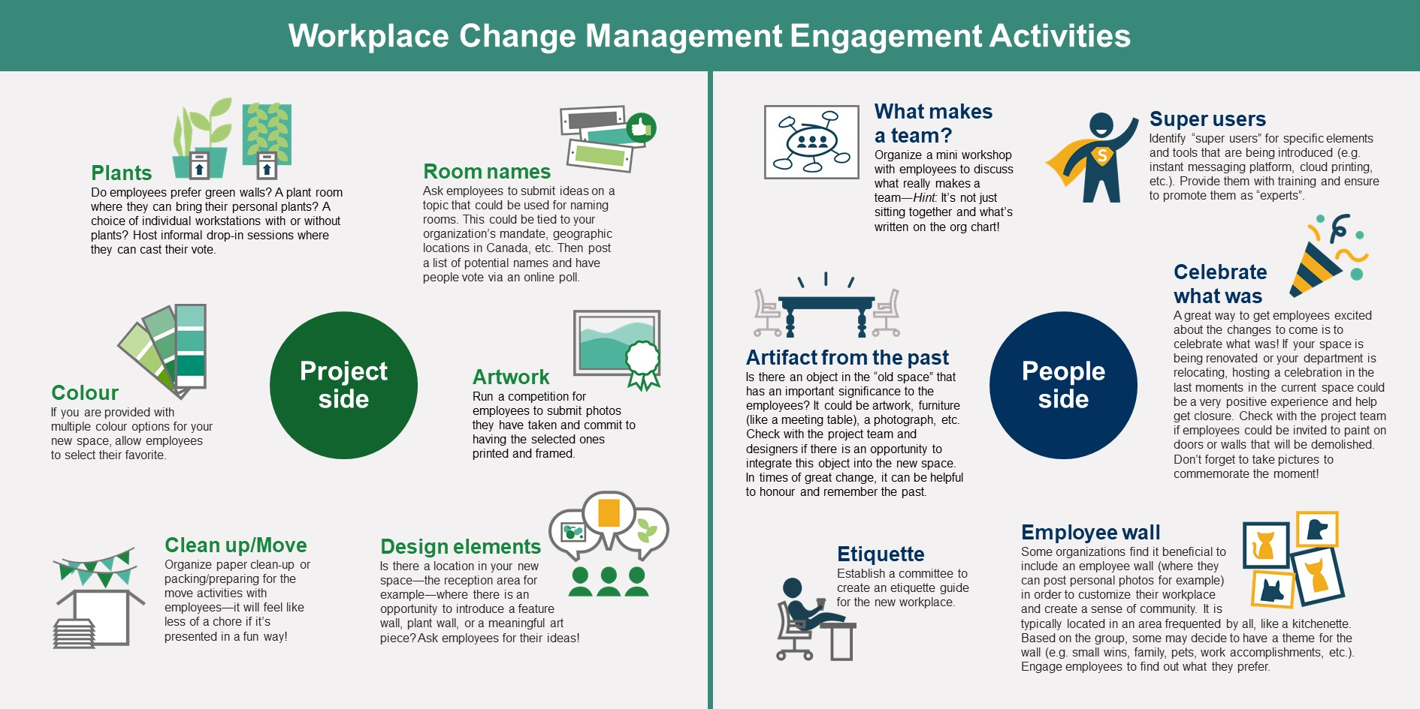
Download the PDF
Click here for additional content from OGDs and external resources

Training

Toolkits
Manager toolkit
The role of a manager during a workplace modernization project will expand beyond their daily operational duties. They will play a vital role in the employees’ adoption of the change and in the success of the project. But before they can lead their employees through the change, they must first prepare themselves. Use this toolkit to equip managers for the workplace modernization.

Download the manager toolkit

Additional tools:
- Meeting in-a-box

Leadership toolkit
Executives and senior leaders play an essential role in times of change. An organization looks to its leaders to be visible sponsors of change and to demonstrate why change is necessary. Senior leaders provide the authority and credibility necessary for successful change.
Download the leadership toolkit

Additional tool:
- Sponsor Guide–Roles and Responsibilities

Change agent toolkit
Change agents have an important and influential role. Their colleagues will look to them to better understand the change and what it really it means for them. Key tasks include actively engaging with employees, advocating support and interest for the change and communicating the most current updates.
Download the agent toolkit

Workshops
ABW Workshop
This ABW workshop in-a-box is meant to be facilitated by the change manager in the context of a workplace modernization project. The workshop can be given in person or virtually, and provides employees with the required knowledge on how to work efficiently in an activity-based working (ABW) environment and equips them with the skills they need to develop new ways of working.
Download the ABW workshop

Measure
Objectives
- Analyze change management metrics
- Monitor employee adoption of the modernized workplace and new ways of working
- Sustain the change by reinforcing new behaviors, and addressing gaps and resistance

Measurements and metrics
During the Plan phase, you established change management performance metrics and a methodology to measure project success with the help of the workplace modernization integrated project team. You defined which metrics were the most meaningful, as well as established a cadence for collecting and reviewing data. Now, you can use this data to evaluate, indicate and measure success. Considering that changes in a workplace modernization project arise from various elements (IM, IT, Security, OSH, space, new behaviors, etc.), a variety of methods may be needed to monitor specific outcomes to provide valuable insights to the change management team. This feedback can also help senior management to understand that leading employees through the change of a workplace modernization is not something that you do once in a while but something that is an ongoing process that requires continuous improvement.
When collecting metrics, there are three categories in which effectiveness can be measured:
- Organizational (project) performance–Defined by the PM team
- Individual (people) performance–Defined by the CM team
- Change management (program) performance–Defined by the CM team
Metrics defined by the CM team should measure how employees are adopting and adapting to their modernized workplace (people) and the overall effectiveness of change management (program). Adversely, metrics defined by the PM team focus more on measuring the success of the physical workplace (project). When the CM metrics compliment PM metrics, powerful insights can be drawn to determine overall project success. It is critical to see this link and the interdependencies in order to highlight the value of change. Measuring if the end state workplace was delivered successfully and if employees have adopted the new ways of working will determine overall project success. For example, if a WebEx tool has been deployed to all employees to enhance the possibility of mobility (PM metric), then all employees should have been properly trained to use this new tool (CM metric). If employees know how to use the new tool, it should increase their skills to be mobile; therefore showing the inter-relation between a highly used tool and a higher level of return on investment.

Organizational (project) performance
To successfully measure organizational performance, determine if the workplace modernization project delivered what was expected. This is measured through the success of the physical workplace, the tools available and the processes in place. Ask yourself: “Did the organization transform to reach the future desired state?”
Organizational (project) metrics are typically defined by the project team, however it is important to work with the integrated project team to ensure alignment of these metrics and the individual (people) metrics as they will need to be used together to determine overall project success.
Below is a list of metrics and data sources you can use in measuring organizational performance.
Data sources | Performance metrics
Workplace modernization performance tracker  Formal or informal surveys (e.g. Workplace performance survey – pre and post)  Project tracker (PM tool)  Assessment tools (e.g. the change readiness assessment tool, etc.)  Occupancy space study (from a business point of view; is the space better used)  Consultations and feedback through team meetings, focus groups, townhalls, etc. | Business process improvements  Adherence to project plan  Project KPI measurements  Adherence to timeline  Speed of execution  How many people are using the space (in/out)  Seating ratio

Click here for additional content from OGDs and external resources

Individual (people) performance
Individual progress is a leading indicator of overall project success since the individual is the unit of the change. It is important to measure how individuals impacted by the change are progressing through their change journeys, and to identify where employees are in the change process and how they are progressing.
To successfully measure individual performance you must focus on the return on investment (ROI) factors:
- Speed of adoption: How quickly are employees adapting to the new workplace?
- Utilization: How many employees are using the workspace, tools and processes every day?
- Proficiency: How effective are employees at following the new behaviors required to use the workspace and tools adequately and efficiently?
Below is a list of metrics and data sources you can use in measuring individual performance.
Data sources | Performance metrics
Workplace modernization performance tracker  Formal or informal surveys  Observations (e.g. are people following the rules?)  Performance evaluations  Assessment tools (e.g. ADKAR change-o-meter, etc.)  Occupancy space study (from a perspective of how the space is being used and why)  Consultations and feedback through 1:1 meetings | Adoption metrics  Usage and utilization reports  Proficiency measures  Employees engagement, buy-in and participation  Awareness and understanding of the change  Employee feedback  Issue, compliance and error logs  Help desk calls and requests for support  Observations of behavioral changes  Employee readiness assessment results  Employee satisfaction survey results

Click here for additional content from OGDs and external resources

Change management (program) performance
To successfully measure change management performance, evaluate if the change management strategies, plans and activities have been valuable to the adoption of the new workplace.
Below is a list of metrics and data sources you can use in measuring change management performance.
Data sources | Performance metrics
Change management activity tracker  Formal or informal surveys  Lessons learned | Tracking of change management activities conducted according to plan  Training participation and attendance numbers  Communication deliveries and effectiveness  Performance improvements  Business and change readiness  Adherence to timeline

Click here for additional content from OGDs and external resources

Sustain the change
The delivery of a new, modernized workplace is not the end of the change management process. In order to deliver lasting change, reinforcement of the change following the project delivery is essential. Focus on continuous improvement to help ensure that the change matures with the organisation and that the benefits of the change are maximized. To fully understand the change and how it is being experienced, it is important for you to use multiple vehicles to gather feedback on the change. Let the following questions guide you in sustaining the change:

Question | Answer
Who needs to manage the sustainability of the change? | You, as the change manager, can orchestrate the appropriate actions as part of the change management strategy but the greatest contributors to success in sustaining efforts are:  - Senior management: consistent engagement and participation in the celebration, leading the way, providing resources and taking ownership of the change.  - Managers: one of the greatest supporter for employees. Sending communications that encourage feedback. Being open to feedback and continuing to communicate; being transparent.  - Key enabling sectors (IM, IT, Security, Facilities, OHS, HR): ensure that the new changes are well implemented and continuously look for ways to review and improve.  - Employees: can be great ambassadors and source of support for other employees. They can discuss the change, share best practices with colleagues, encourage others, provide testimonials, and participate in committees to sustain the new workplace or participate in new projects.
Which activities will help sustain the change? | - Measuring against success  - Continuing communication  - Continuing training  - Creating support materials  - Celebrating, rewarding and recognizing  - Providing onboarding toolkits for new employees, managers and senior leaders  - Ensuring that support mechanisms are identified  - Creating a workplace committee that will oversee the sustainment of the change
When should I reduce the speed of sustainability? | - Project results achieved  - Employees adopted the new ways of working  - Low error rates  - Infrequent questions  - When the previous processes, methods, tools and behaviors become too cumbersome or difficult to use in comparison to the current new ways of working  - Overall employee satisfaction  - Employees no longer try to revert to the old ways of working  - When the tools, processes, usage of the space, and new ways of working are on their way to being “the new normal”
How long after the project is delivered should I keep sustaining the change? | - At least 12 to 24 months of monitoring, reinforcing and sustaining; then continuous improvement and sustainability
What are the greatest obstacles in sustaining success? | - Project failed to address resistance  - No efforts or investments were put in place to support the new habits and behaviours acquired during the transition  - Senior management does not provide support and is not engaged in the new workplace  - Change managers could not keep internal momentum  - No feedback mechanism in place  - No resources left or assigned to support the newly transformed workplace

Managing “the new normal”
Change is deemed successful when it becomes “the new normal.” At this point, you will see your direct role changing; you will no longer be orchestrating all of the changes directly. The governance of the project will need to lead the transfer of ownership from the change to the enabling group. The integrated team (IM, IT, Facility, Security, OHS and HR) will establish new ways of managing their specific operations based on the newly transformed workplace. At this stage, your goal is to ensure the longevity of the transformation that occurred. Keeping in mind the workplace vision that was established in the Strategize phase, ask yourself: Does this vision still support future decisions, iterations and improvements to the workplace or new ways of working? The organization’s vision for the workplace should evolve continuously to align with the organization’s priorities. Use the communication plan and the tools developed in the Implement phase for a continuous awareness campaign. Workshops and training sessions should continue as needed after the move, improving and evolving with the workplace vision.
Ideally, a workplace working group will be established to ensure that new behaviours and work practices align with the workplace vision. This working group should reinforce the change until it becomes a part of the culture. The working group should also help with data collection about the physical workplace and how employees are evolving and adapting to new ways of working.
Click here for additional content from OGDs and external resources

Managing resistance
Resistance can continue even when employees have moved into their new workplace. You may have developed an approach to manage resistance within your organization as part of your change management strategy; you can always refer back to it and adjust if needed.
Keep in mind, reinforcing great behaviors creates a snowball effect. As employees begin to work in a new way and are recognized for their new behaviors, it becomes increasingly difficult for those who resist the change. At some point, the momentum will shift from resisting the change to supporting it. This is how small changes, when reinforced, snowball into big changes.
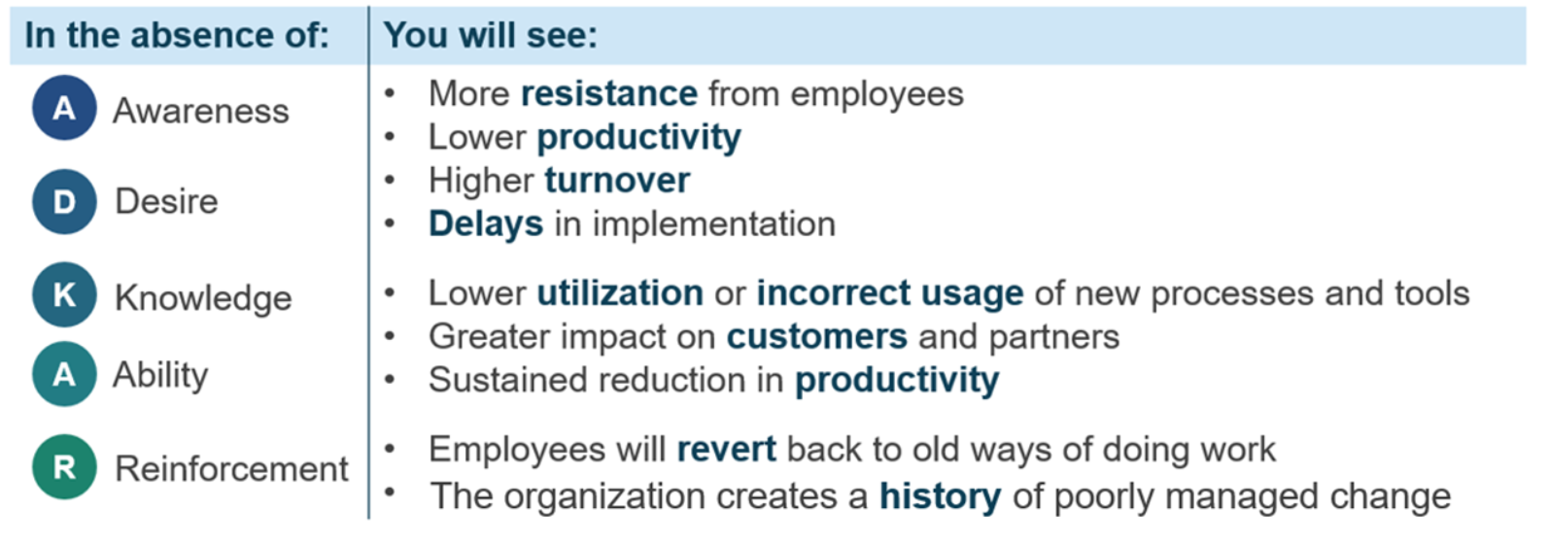
Image description:
In the absence of Awareness and/or Desire, you will see more resistance from employees, lower productivity, higher turnover, and delays in implementation. In the absence of Knowledge and/or Ability, you will see lower utilization or incorrect usage of new processes and tools, greater impact on customers and partners, and sustained reduction in productivity. In the absence of Reinforcement, you will see employees revert back to old ways of doing work, and the organization creating a history of poorly managed change.
Click here for additional content from OGDs and external resources

Celebrate!
The key to celebrating your new workplace is not to celebrate the space at all―you’re not celebrating aesthetics or even functionality. You’re celebrating people and the significant progress you’ve made together. But don’t wait until the end to celebrate; celebrating along the way during the transformation journey is beneficial. Celebrating early successes can bring the organization a long way!
Best practices:
- Continually showcase progress throughout the project. Keep an eye out for the achievement of major milestones and identify early successes―even if they may seem small.
- Organize ways to recognize groups and individuals that have achieved and contributed to the success of the new workplace (e.g. early adopters of new technology).
- Use staff meetings, recurrent team meetings and townhalls as an avenue for recognition of achievement (e.g. one year anniversary of move-in date).
- Ensure that key stakeholders are aware of these achievements and involve managers to award these recognitions.
- Share articles or media excerpts with employees.
- Recognize what employees have done together about particular problems that could not have been solved without the cooperation of all!
Click here for additional content from OGDs and external resources

Glossary
English | French
activity-based working (ABW)  Activity-based working (ABW) is a design concept that recognizes that through the course of any day, employees engage in many different activities and that they need and can choose different types of work settings to accommodate these activities. | travail axé sur les activités  Le travail axé sur les activités est un concept de design qui reconnaît que tout au long de la journée, les employés se livrent à de nombreuses activités différentes et qu'ils ont besoin et peuvent choisir différents types de cadres de travail pour s'adapter à ces activités.
activity-based workplace  Activity-based workplace is an environment that supports a new way of working and is based on the principle of activity-based working (ABW). | milieu de travail axé sur les activités (MTAA)  Le milieu de travail axé sur les activité (MTAA) est un environnement qui soutient une nouvelle façon de travailler et qui est basé sur le principe du travail axé sur les activité.
ADKAR Model  The Prosci ADKAR® Model is a goal-oriented change management model that guides individual and organizational change. Created by Prosci founder Jeff Hiatt, ADKAR is an acronym that represents the five tangible and concrete outcomes that people need to achieve for lasting change: awareness, desire, knowledge, ability and reinforcement.  By outlining the goals and outcomes of successful change, the ADKAR Model is an effective tool for planning change management activities, equipping your leaders facilitating change, and supporting your employees throughout the change. | Modèle ADKAR  Le modèle Prosci ADKAR® est un modèle de gestion du changement orienté vers un objectif qui guide le changement individuel et organisationnel. Créé par le fondateur de Prosci, Jeff Hiatt, ADKAR est un acronyme qui représente les cinq résultats tangibles et concrets que les gens doivent atteindre pour un changement durable : sensibilisation, volonté, connaissance, capacité et renforcement.  En décrivant les objectifs et les résultats d'un changement réussi, le modèle ADKAR est un outil efficace pour planifier les activités de gestion du changement, équiper vos dirigeants pour faciliter le changement et soutenir vos employés tout au long du changement.
champion  The champion advises and supports the project sponsor in decision making, and usually occupies an executive level role (ADM, DG, etc., as applicable). The champion must be an early adopter of the change, adapting quickly and advocating to other employees for the change. In addition, the champion must build employee morale, engage employees affected by the change and demonstrate desired behaviours. The champion brings the change vision to life. | champion  Le champion conseille et soutient le parrain du projet dans la prise de décision, et occupe généralement un rôle de niveau exécutif (SMA, DG, etc., selon le cas). Le champion doit être un premier adopteur du changement, s'adapter rapidement et défendre le changement auprès des autres employés. En outre, le champion doit renforcer le moral des employés, faire participer les employés touchés par le changement et faire preuve des comportements souhaités. Le champion donne vie à la vision du changement.
change agent  A change agent is someone who promotes and enables change to happen within any group or organization. A change agent's key tasks include actively engaging with employees, advocating support and interest for the project, and communicating the most current updates. They may also act as a two-way communicator between the project/change team and employees. His/her role goes beyond communicating the vision of the modernized workplace and the reasons behind it. As an employee undergoing the change himself/herself, the change agent is integral in spreading awareness amongst his/her colleagues. | agent du changement  Un agent du changement est une personne qui encourage et permet le changement au sein d'un groupe ou d'une organisation. Les principales tâches d'un agent du changement consistent à s'engager activement auprès des employés, à promouvoir le soutien et l'intérêt pour le projet, et à communiquer les dernières mises à jour. Il peut également faire office de communicateur entre l'équipe de projet/l'équipe du changement et les employés. Son rôle va au-delà de la communication de la vision du milieu de travail modernisé et des raisons qui la sous-tendent. En tant qu'employé subissant lui-même le changement, l'agent du changement fait partie intégrante de la sensibilisation de ses collègues.
change management program  The change management program is the group of related activities designed and managed to support employees through the change. It is the sum of your strategies and plans. | programme de gestion du changement  Le programme de gestion du changement est l'ensemble des activités connexes conçues et gérées pour soutenir les employés dans le cadre du changement. C'est la somme de vos stratégies et de vos plans.
change management strategy  A change management strategy serves as a launching point for organizations seeking to introduce workplace changes and wanting to ensure that the impacts on employees are managed successfully. It defines the approach needed to manage change given the unique characteristics of a project. It includes an understanding of the changes, a supporting structure to implement the strategy, and an analysis of the risks of the change and potential resistance to the change. | stratégie de gestion du changement  Une stratégie de gestion du changement sert de point de départ aux organisations qui cherchent à introduire des changements sur dans le milieu de travail et qui veulent s'assurer que les impacts sur les employés sont gérés avec succès. Elle définit l'approche nécessaire pour gérer le changement compte tenu des caractéristiques uniques d'un projet. Elle comprend une compréhension des changements, une structure de soutien pour mettre en œuvre la stratégie, et une analyse des risques du changement et de la résistance potentielle au changement.
change management team  The change management team’s role is to manage the people side of the change. The change management team develops change management related strategies and plans, and then implements them and measures their effectiveness and success. It assists employees in adopting the changes and provides support to managers and the project team. | équipe de gestion du changement  Le rôle de l'équipe de gestion du changement est de gérer le côté humain du changement. L'équipe de gestion du changement élabore des stratégies et des plans liés à la gestion du changement, puis les met en œuvre et mesure leur efficacité et leur réussite. Elle aide les employés à adopter les changements et fournit un soutien aux gestionnaires et à l'équipe de projet.
change manager  A change manager plays a key role in ensuring the workplace modernization project meets its objectives on time and on budget by increasing employee adoption and usage. This person focuses on the people side of change. The change manager works to drive faster adoption, higher ultimate utilization of and proficiency with the changes that impact employees. The change manager's primary responsibility is to create and implement a change management strategy and plans that maximize employee adoption and usage and minimize resistance. Key tasks may include leading a change management team, coaching senior leaders to fulfill their role of project sponsor or champion, providing support to supervisors and managers to help their employees through the change, supporting the project team, conducting impact analyses, assessing change readiness, identifying key stakeholders, leading change management activities, coordinating communication, engagement and training activities, identifying resistance and providing assistance to manage that resistance, defining and measuring success throught metrics, and monitoring change progress. | gestionnaire du changement  Un gestionnaire du changement joue un rôle clé pour s'assurer que le projet de modernisation du milieu de travail atteint ses objectifs dans les délais et le budget prévus en augmentant l'adoption et l'utilisation par les employés. Cette personne se concentre sur l'aspect humain du changement. Le gestionnaire du changement s'efforce de favoriser une adoption plus rapide, une meilleure utilisation finale et une meilleure maîtrise des changements qui ont un impact sur les employés. La principale responsabilité du gestionnaire du changement est de créer et de mettre en œuvre une stratégie et des plans de gestion du changement qui maximisent l'adoption et l'utilisation par les employés et minimisent la résistance. Les tâches principales peuvent inclure la direction d'une équipe de gestion du changement, l'accompagnement des cadres supérieurs pour qu'ils remplissent leur rôle de parrain ou de champion du projet, le soutien aux superviseurs et aux gestionnaires pour aider leurs employés à travers le changement, le soutien à l'équipe de projet, la réalisation d'analyses d'impact, l'évaluation de la préparation au changement, l'identification des principales parties prenantes, la direction des activités de gestion du changement, la coordination des activités de communication, de mobilisation et de formation, l'identification des résistances et l'aide à la gestion de ces résistances, la définition et la mesure du succès par le biais de mesures et le suivi des progrès du changement.
GCworkplace  GCworkplace is the term adopted by the Government of Canada for workplace modernization. It is based on the implementation of activity-based working (ABW), which is a way of working that offers all employees shared use of a variety of workpoints, allowing them to choose the optimal setting to perform their tasks and functions. It optimizes office space and is based on the seven dimensions of creating a flexible, healthy, efficient, inclusive, collaborative, green and technologically advanced digital space. GCworkplace is a modern, efficient and inclusive workplace which responds to the public service workforce’s needs and supports a flexible way of working. | Milieu de travail GC  Milieu de travail GC est le terme adopté par le gouvernement du Canada pour la modernisation du milieu de travail. Il est basé sur la mise en œuvre du travail axé sur les activités, qui est une méthode de travail offrant à tous les employés l'utilisation partagée de divers points de travail, leur permettant de choisir le cadre optimal pour accomplir leurs tâches et fonctions. Il optimise l'espace de bureau et repose sur les sept dimensions de la création d'un espace numérique flexible, sain, efficace, inclusif, collaboratif, écologique et technologiquement avancé. Un Milieu de travail GC est un lieu de travail moderne, efficace et inclusif qui répond aux besoins du personnel de la fonction publique et favorise un mode de travail flexible.
integrated project team  The workplace modernization integrated project team oversees and executes most workplace modernization activities related to the project, key enabling sectors (IM, IT, Security, HR, OHS, Facilities), transformation program, change management, etc. The team ensures timely and integrated project delivery and a user-centric solution. | équipe de projet intégrée  L'équipe de projet intégrée de la modernisation du milieu de travail supervise et exécute la plupart des activités de modernisation du milieu de travail liées au projet, aux principaux secteurs habilitants (GI, TI, Sécurité, RH, SST, Installations), au programme de transformation, à la gestion du changement, etc. L'équipe veille à ce que le projet soit exécuté de manière intégrée et en temps voulu et à ce que la solution soit centrée sur l'utilisateur.
project sponsor  The project sponsor’s role is to actively and visibly participate throughout the project, build a coalition of sponsorship with peers and managers and communicate directly with employees. This role is usually occupied by the person who is accountable for the project and who has influence on the individuals who implement the change. The project sponsor has the authority to provide the funding, resolve issues, approve major deliverables and provide high-level direction. The project sponsor has a clear vision, identified goals and measurable outcomes for the change initiative. | parrain du projet  Le rôle du parrain du projet est de participer activement et visiblement tout au long du projet, de constituer une coalition de parrainage avec ses pairs et les gestionnaires et de communiquer directement avec les employés. Ce rôle est généralement occupé par la personne qui est responsable du projet et qui a une influence sur les personnes qui mettent en œuvre le changement. Le parrain du projet a le pouvoir de fournir le financement, de résoudre les problèmes, d'approuver les principaux résultats et de fournir une orientation de haut niveau. Le parrain du projet a une vision claire, des objectifs identifiés et des résultats mesurables pour l'initiative de changement.
workplace change management  Workplace change management is a process for engaging with employees who are about to experience workplace change. Its goal is to help the people impacted by the change be properly equipped to understand, participate in and adopt the change successfully. | gestion du changement en milieu de travail  La gestion du changement en milieu de travail est un processus qui permet de s'engager auprès des employés qui sont sur le point de vivre un changement dans le milieu de travail. Son but est d'aider les personnes touchées par le changement à être correctement équipées pour comprendre, participer et adopter le changement avec succès.

Quick links

General
Workplace Change Management Playbook at a glance
Workplace Change Management Community of Practice
GCworkplace GCpedia page
GCworkplace GCconnex group
GCworkplace vision presentation
GCworkplace generic mailbox
GCworkplace Transformation Playbook
GCcoworking GCpedia page
GCworkplace testimonials GCpedia page
Workplace performance survey
Change Management Cloud
Project story collection
Sponsorship toolkit ZIP

Strategize
Change inventory and impact assessment
Change readiness assessment
ADKAR change-o-meter
Stakeholders map
Project readiness assessment tool
Guide to assessing the sponsor and champions, and Sponsorship assessment tool
“Notice of interest” e-mail template
Hiring a Change Manager through the Career Marketplace on GCconnex
Change management team 3Rs template
Roles, functions and key activities of a change manager guide
Statement of work–change management resource template
Evaluation criteria template
Change management strategy template
Change management strategy presentation template

Plan
CM/PM integrated plan template
Sponsorship roadmap
Communication plan template
Engagement plan template
Training plan template
Workplace performance modernization tracker
CM activity tracker

Implement
Message template - Project launch (Coming soon!)
Message template – Functional programming (Coming soon!)
Intranet page template
FAQ template
Getting the most out of GCworkplace
Fact Sheet–ABW
Fact sheet–Mobile and flexible
Fact sheet–Digital and collaborative
Fact sheet–Etiquette
Fact sheet–Well-being
Meeting in-a-box
ADKAR change-o-meter
Manager toolkit
Leadership toolkit
Sponsor Guide–Roles and Responsibilities
Change agent toolkit
QUIZ–Adaptability and flexibility
QUIZ–Change readiness
QUIZ–Change resilience
Being mobile–best practices for a manager
Managing reactions to change
Managing resistance to change
Dealing with difficult questions
Promoting resilience to change
ABW Workshop–Complete package
ABW workshop–Facilitator guide
ABW workshop–PowerPoint presentation
ABW workshop–Employee worksheet (bilingual)
ABW workshop–Vision board (bilingual PPT)
ABW workshop–GCworkplace workpoints vision board (Word)
ABW workshop–Score card
ABW workshop–Evaluation form

Measure
Workplace performance modernization tracker
Change readiness assessment
Feedback strategy options
ADKAR change-o-meter
CM activity tracker
Lessons learned template

ANNEX

Return to the workplace change management toolkit
This toolkit was designed to help the change manager or project team create the best possible employee experience when planning the return to the workplace (RTW). It offers a change management approach to follow based on the RTW plan being developed or implemented by your organization.
What is included:
- Change management toolkit to plan the return to the workplace (PPT 1.98 MB)
- Process to create an employee-centric approach for the RTW
- Examples of communication, engagement and training activities
- Links to reference material
- RTW PM-CM Integrated plan‒Change inventory and impact assessment (Excel 65.1 KB)
Download the Return to the workplace change management toolkit (ZIP 1.951KB)

