Table of Contents
February 2024 1
Capsule#8: Identifying objectively the language requirements of a position 1
September 2023 3
Capsule #7: The balance between official languages and Indigenous languages 3
June 2023 6
Capsule #6: Maintaining second official language proficiency 6
May 2023 8
Capsule #5: Language rights of the public vs employees’ rights 8
April 2023 10
Capsule #4: The language of supervision 10
February 2023 12
Capsule #3: The simultaneity of official languages in training and service offers 12
December 2022 14
Capsule #2: Communications in working groups 14
November 2022 16
Capsule #1: Bilingual meetings 16

To open the French version click here.

February 2024

Capsule#8: Identifying objectively the language requirements of a position
Hello,

We are pleased to present you this Official Languages Co-Champions’ capsule which addresses the topic of identifying the language requirements of a position.

This edition contains a wealth of information on why and how to identify the language requirements of a position. We suggest that you keep it handy and refer to it as often as necessary.

What the Act says
Section 91 of the Official Languages Act (the Act) states that the official language requirements must be established objectively on the basis of the functions related to the position.

The Treasury Board of Canada Secretariat’s Directive on Official Languages for People Management (the Directive) specifies that managers are responsible for objectively determining:
- whether the position requires the use of both languages or just one;
- the linguistic profile of bilingual positions.

Tips and tricks
Demonstrating objectivity when identifying the language requirements of a position is therefore an obligation of the Act and the question to ask is “How can we evaluate objectively?

These are the key elements of an objective evaluation:
- Documents with accurate information on the position.
  - A job description that adequately reflects the duties and responsibilities of the position.
  - An organization chart that properly represents the structure of the team.

- Determining the linguistic obligations of the work unit.
  - Identify whether the position is located in a designated bilingual region for language-of-work purposes.
  - Identify whether the team is responsible for providing employees from designated bilingual regions with personal or central services.
  - Identify whether the team is responsible for communicating or providing services to the public in both official languages.

- Evaluate the bilingual capacity of the team.
  - Identify the number of positions required, at the same group and level and with the same responsibilities, to guarantee the provision of comparable services in both official languages at all times.

- Evaluate the required level of proficiency in the second official language of bilingual positions.
  - Identify the tasks that the incumbent must perform in both official languages.
  - Determine the level of complexity of these tasks based on the Treasury Board Secretariat’s Qualification Standards in Relation to Official Languages.

Resource corner
An objective evaluation of the language requirements of a position must take a number of factors into consideration. Tools are available to support you in this task, such as:
- PSPC’s Reference guide for identifying the language requirements of a position
- The page on mySource: Identifying the language requirements of a position
- The Recommendation process for identifying the language requirements of a position at PSPC
- The Tool for the linguistic identification of positions of the Office of the Commissioner of Official Languages

Don’t forget! Subject matter experts are available to advise you, so don’t hesitate to contact your human resources specialists, including the Official Languages Program.

Challenge yourself!
Are you ready to test your knowledge? Would you be able to identify objectively the language requirements of a position?

Lucie Séguin (she-her)  Official Languages Co-Champion | Dominic Laporte (he-him)  Official Languages Co-Champion
TPSGC.ChampionsLO-OLChampions.PWGSC@tpsgc-pwgsc.gc.ca
________________________________________________________________________

September 2023

Capsule #7: The balance between official languages and Indigenous languages
Hello,
For this first capsule of the fall, we are offering you a capsule on how to create the right balance between official languages and Indigenous languages in the federal public service.
We wish to extend a warm thanks to the Diversity, Inclusion, Recognition, and Organizational Culture Directorate and PSPC’s Indigenous Circle of Employees for their support in the writing of this capsule.

**For this edition, the capsule is also available in Algonquin.

What the Act says
The Canadian Charter of Rights and Freedoms (16.1) (inserted into the Constitution Act, 1982) states that English and French are the official languages of Canada and have equality of status and equal rights and privileges as to their use in all institutions of the Parliament and Government of Canada. It also recognizes and affirms the existing rights of the Aboriginal Peoples of Canada (35 (1)).

In conjunction with the affirmation of the status of the official languages and the broadening of their use, the Official Languages Act specifies that the Government of Canada recognizes the importance of maintaining and enhancing the use of other languages and reclaiming, revitalizing and strengthening Indigenous languages.
In addition, the purposes of the Indigenous Languages Act are to:
- Support and promote the use of Indigenous languages, including Indigenous sign languages.
- Support the efforts of Indigenous peoples to reclaim, revitalize, maintain, and strengthen Indigenous languages.
Lastly, the United Nations Declaration on the Rights of Indigenous Peoples Act requires that all measures necessary be taken to ensure the laws of Canada are consistent with the Declaration, which gives the right to Indigenous peoples to revitalize, use, develop, and transmit to future generations, among others, their languages (article 13.1).

Tips and tricks
Cohabitation of official languages and Indigenous languages within the federal public service is therefore desired and indeed required by the two acts. This also goes hand-in with the creation of a respectful and inclusive workplace, one of the objectives of the federal public service.
Promoting Indigenous languages while respecting the legal obligations related to official languages can even result in the provision of better services to employees as well as to Canadians.
Here are a few things to consider to help you determine how to balance official languages and Indigenous languages in the workplace:
In bilingual regions for language-of-work purposes
How can we support efforts toward reclaiming, revitalizing and strengthening indigenous languages while complying with our obligations to...
- create and maintain a workplace conducive to the effective use of both official languages?
- respect the right of employees to be supervised in the official language of their choice?
- provide employees with access to work instruments and electronic systems in the official language of their choice?
- provide employees with central and personal services, as well as professional training and development, in the official language of their choice?
- ensure the equal quality of both official languages in written communications?

In designated bilingual offices
How can we support efforts toward reclaiming, revitalizing and strengthening indigenous languages while complying with our obligations to...
- ensure that members of the public can communicate and receive services in the official language of their choice?
- make the active offer to members of the public?

If you are considering showcasing Indigenous languages, we strongly encourage you to contact the Official Languages Program to get advice and guidance on official languages obligations.

Resource corner
To support you in the promotion of Indigenous languages in the workplace, several services are offered by:

The Translation Bureau:

- Indigenous language translation, revision and editing services
- Indigenous language conference interpretation services
- Indigenous languages – Glossaries, dictionaries and writing resources

The Canada School of Public Service:
- Territorial Acknowledgement

Statistics Canada:
- Indigenous languages across Canada

To learn more about Indigenous realities,
- discover PSPC’s Indigenous Circle of Employees
- consult the Indigenous languages website
- read the blog Indigenous languages: The road ahead by Gina Wilson, recipient of the Golden Quill of the Language Portal of Canada

Challenge yourself!
The balance between official languages and Indigenous languages is just starting to take shape, and will continue to do so thanks to everyone’s collaboration. We suggest that you talk about it with your colleagues and managers and share with us your potential initiatives at: tpsgc.questionslo-olqueries.pwgsc@tpsgc-pwgsc.gc.ca.

Lucie Séguin (she-her)  Official Languages Co-Champion | Dominic Laporte (he-him)  Official Languages Co-Champion
TPSGC.ChampionsLO-OLChampions.PWGSC@tpsgc-pwgsc.gc.ca
____________________________________________________________________________

June 2023

Capsule #6: Maintaining second official language proficiency
Hello:
As the summer begins, this edition of the Official Languages Co-Champions’ Capsule will focus on maintaining second official language proficiency.

The capsules will be on hiatus this summer and will return in September.
Read on and have a great summer!

What the Act says
As prescribed by the Directive on Official Languages for People Management, language training is offered to employees for:
- career development purposes (6.1.8)
- exceptional staffing situations when a bilingual position is staffed with a candidate who does not meet the language requirements (6.3.3.1)
The Public Service Employment Act states that official language proficiency is an essential qualification for a job.
While managers must offer language training to their employees in the above situations, maintaining second official language proficiency is a shared responsibility between the employee and the employer.

Tips and tricks

Employees
Practice makes perfect!
The best way to maintain proficiency in your second official language is to use it as much as possible in a variety of situations.
First, you should set clear objectives for each of the language skills (oral and reading comprehension, written and oral expression) and inform your manager of your objectives.
You can also use tools such as MsTeams backgrounds to indicate that you’re practising your second official language.
In addition to using your second official language as much as possible, you can explore the various resources available to help you practise your language skills.
Remember that resources include more than training; all potential interactions with your peers and any use of your second official language in your personal life (e.g. reading) also count!
Finally, you should check to see whether you’ve met your objectives and then set new ones. Constant practice is key.

Managers
Set the example

You can encourage your employees to maintain their second official language proficiency in many different ways:
- lead by example: use your second official language daily
- be transparent about and sensitive to the challenges of maintaining language proficiency
- tell employees about the resources available to them
- explore best practices that you can adopt within your team
- be tolerant of language errors
- discuss employees’ needs and objectives with them

Finally, creating a work environment that allows employees to use both official languages effectively is the best way to give them opportunities to maintain their second official language proficiency.
In regions designated as bilingual for language-of-work purposes, creating such an environment will also allow you to meet the obligations of the Act.

Resource corner
Add more strings to your bow!
- For more information on language training for career development purposes, check out PSPC’s Guideline on language training.
- For more information, go to the Language training page on MySource.
- For online tools to help employees learn or maintain their second official language, visit the Resources for learning the second official language page on MySource.
- Join an interdepartmental language interchange program (ILIP):
  - Participant registration form
  - Facilitator registration form

Challenge yourself!
Perseverance is the key to success!
Whether it’s during or after work hours, maintaining second official language proficiency requires time and effort. What routine could you get into over the summer to maintain your language proficiency that you could also continue to follow for the rest of the year?
What can you do as a manager to better support your employees in maintaining their second official language proficiency?
If you’d like to share some best practices with us, contact us at TPSGC.QuestionsLO-OLQueries.PWGSC@tpsgc-pwgsc.gc.ca.

Lucie Séguin
Official Languages Champion
TPSGC.ChampionsLO-OLChampions.PWGSC@tpsgc-pwgsc.gc.ca
___________________________________________________________________________________

May 2023

Capsule #5: Language rights of the public vs employees’ rights
Hello,
I am pleased to share with you the new edition of the capsules. In this edition, the objective is to make the difference between the language rights of the public and those of employees.

What the Act says
Federal institutions’ obligations in matters of communications with and services to the public are different from those relating to language of work.

The public’s rights
Part IV of the Official Languages Act (the Act) focuses on communications with and services to the public and requires that each bilingual-designated office serve members of the public in the official language of their choice.
These offices are established according to demand, location and/or the type of services. They may be located in a region designated as bilingual for language-of-work purposes or in a unilingual region.

The Directive on Official Languages for People Management (the Directive) requires that personal and central services be provided in the preferred official language of employees (clients) whose position is located in a region designated as bilingual for language-of-work purposes (section 6.1.7).

Employees’ rights
Part V of the Act deals with the language of work. In regions designated as bilingual for language-of-work purposes, federal institutions have the duty to ensure that the work environment is conducive to the effective use of French and English and accommodate the use of either language by its employees.

Section 6.1.6 of the Directive requires that all possible measures be taken to allow employees occupying a position in a region designated as bilingual for language-of-work purposes to use the official language of their choice for both oral and written communication.

Precedence of the public’s rights over employees’ rights
Lastly, the public’s right to communicate with and receive services in the official language of the public’s choice takes precedence over the language-of-work rights of employees (section 6.2.5 of the Policy on Official Languages).

Tips and tricks
To decide which official language to use, first remember that Part IV of the Act takes precedence over the right of employees to communicate in the official language of their choice.

That means that an employee in a bilingual-designated office must communicate and offer services in the official language chosen by the member of the public, notwithstanding their own official language preference and the linguistic designation of the region.

Similarly, in regions designated as bilingual for language-of-work purposes, employees have the right to receive personal and central services in the official language of their choice regardless of whether the services are provided by an employee in a region designated as bilingual or unilingual for language-of-work purposes.

In short, employees in bilingual regions can exercise their right to communicate in the official language of their choice except when they are serving clients.

There is no obligation for employees in unilingual regions to receive personal and central services in the official language of their choice. Services are offered in the language of their region.

Resource corner
- To see which offices are designated as bilingual for services to the public, see the Burolis directory.
- See the List of Bilingual Regions of Canada for Language-of-Work Purposes.
- For a definition of the term “members of the public,” see Appendix 2 of the Directive on Official Languages for Communications and Services.
- See the Fact sheets on official languages for information on personal and central services.

Challenge yourself!
If your position is in a bilingual-designated region, do you exercise your right to request personal and central services in the official language of your choice?
Do you provide services to the public? If so, have you taken the course on the Active Offer of Service available on Alto?
Would you like to find out more about your rights and obligations? Take the Official Languages and You course available on Alto.

Lucie Séguin
Official Languages Champion
TPSGC.ChampionsLO-OLChampions.PWGSC@tpsgc-pwgsc.gc.ca
______________________________________________________________________________

April 2023

Capsule #4: The language of supervision
Hello:

For this edition of the Official Languages Co-champions’ Capsule, the focus is on the rights and obligations with regards to language of supervision.

What the Act says
According to the Directive on Official Languages for People Management (6.1.2), managers and supervisors are responsible for supervising employees who occupy bilingual or either/or positions in bilingual regions in the employees’ preferred official language.
Employees who occupy unilingual positions in bilingual regions can also choose the official language in which they want to be supervised provided that their manager occupies a bilingual position in a bilingual region. Otherwise, the language of supervision is the language of an employee’s position.
In unilingual regions, the language of supervision is the region’s language of work, that is French in Quebec and English elsewhere in Canada, regardless of the linguistic identification of an employee’s position.

Tips and tricks

How do I determine my employees’ preferred official language?
- By asking them what their preference is when meeting with each of them for the first time.
- Employees’ preferred official language applies to both written and verbal communication. They have the right to choose the same official language for both modes of communication or a different official language for each mode.

How do I supervise employees in their preferred official language?
- By ensuring that all communication aimed at each employee, whether verbal or written, is in their official language of choice.

  - Communication may include, but is not limited to:
    - Assigning tasks;
    - Providing advice, guidance and feedback to employees;
    - Approving training, leave;
    - Completing employee performance evaluations.

Which official language should be used when assigning tasks that require answering a client?
- Managers must assign tasks based on employees’ preferred official language, if applicable. (Refer to the section called What the Act says for more details.)

**Managers are not responsible for translating clients’ request into employees’ preferred official language.
Clients’ right to receive services in the official language of their choice outweighs employees’ right to work in their preferred official language.

Resource corner
- See the eager beavers for depictions of issues that could arise if the official language for supervising employees is not known or respected. Please note that the text version of the image below is available on the web page.
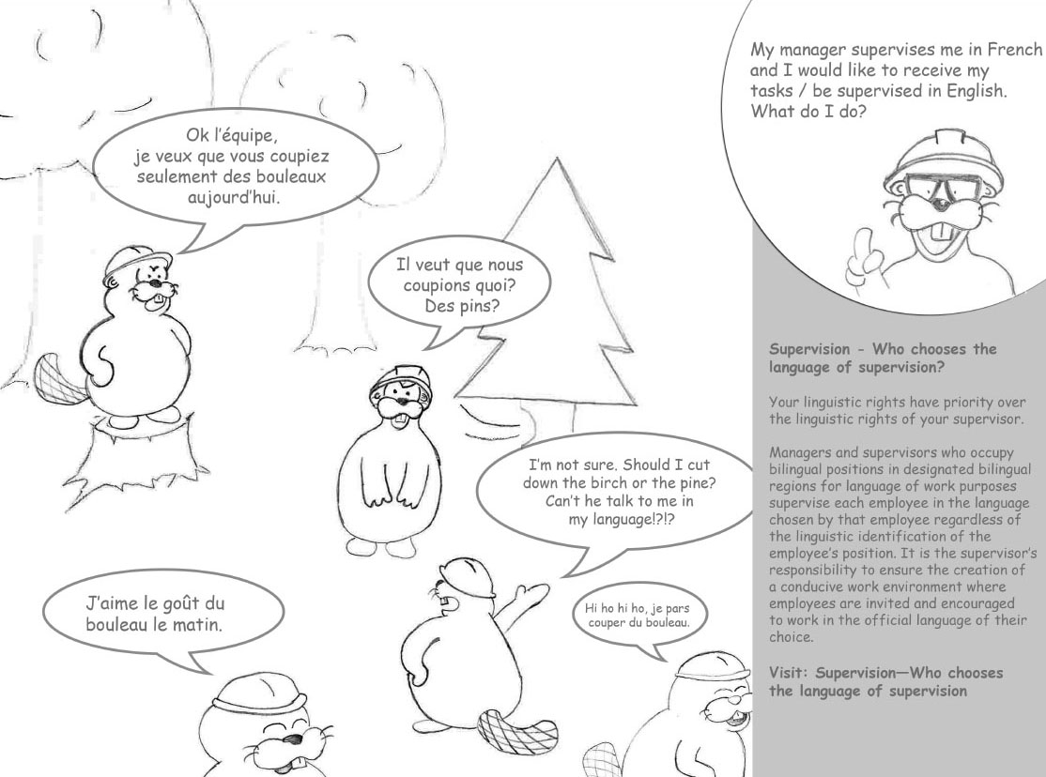

- To understand the six supervision scenarios possible, see Who Chooses the Language of Supervision on the intranet.
- For more information on Public Services and Procurement Canada’s language of work guidelines, including language of supervision, see the Official Languages Guidebook.

Challenge yourself!
As a manager, have you taken the time to ask each of your employees in which official language they want to be supervised?
As an employee, have you had the opportunity to tell your manager or supervisor in which official language you want to be supervised?
The Official Languages Program is here to help you. Please send your questions or comments to tpsgc.questionslo-olqueries.pwgsc@tpsgc-pwgsc.gc.ca.
You can also contact the email address above for an accessible version of this capsule.

Stéphan Déry & Lucie Séguin
Official Languages Co-champions
TPSGC.ChampionsLO-OLChampions.PWGSC@tpsgc-pwgsc.gc.ca
________________________________________________________________________

February 2023

Capsule #3: The simultaneity of official languages in training and service offers

Hello,
For the first Capsule of 2023, we would like you to be aware of what we mean by the simultaneity of official languages in training and service offers.

What the Act says
In Section 6.2.2 of the Policy on Official Languages, it is stated that designated bilingual offices must respect the equal status of both official languages by making communications and services available to the public in both official languages simultaneously.
The Policy on Official Languages (6.3.3) also states that in all designated bilingual regions, all measures must be taken to enable the institution’s employees to work and receive personal and central services, as well as training and professional development, in the official language of their choice.

Tips and Tricks

Members of the public
The way to indicate that services and communications are available in both official languages is through an active offer. Did you know that this is a requirement of the Official Languages Act? (section 28)
Whether it is by a verbal “Hello/Bonjour” or visual
the simultaneity of the offer enables members of the public to exercise their right to receive the service in the official language of their choice.

Federal public servants
A simultaneous offer is also an effective measure to enable employees to work and receive personal and central services, as well as training and professional development, in the official language of their choice. It’s important to remember that in addition to being simultaneous, the versions must be of equal quality in both official languages.

Consider the following scenario
A message in both official languages is sent to employees in a sector where some of them hold a position located in a designated bilingual region for language-of-work purposes. The purpose of this message is to inform them of a training session/service and it specifies the date and the language in which it will be provided. Regarding the availability in the other official language, the message indicates that the information will be provided at a later date.

Question
- Does this training/service offer allow employees to exercise their right to receive the training/service in the official language of their choice?

- The absence of a simultaneous offer imposes one official language to the detriment of the other official language and thus infringes on the employees’ rights to work in and choose the official language of their choice for training and services. Note that the absence of equal quality in both official languages will have the same repercussions.

Resource corner
- To confirm whether your office has linguistic obligations toward members of the public, please visit the Burolis site.
- To be aware of the designated bilingual regions, aside from the National Capital Region, please refer to the List of Bilingual Regions of Canada for Language-of-Work Purposes.
- Learn about the various services of the Translation Bureau that can help you strengthen the simultaneity of training/service offers while ensuring the equal quality of both official languages.
- Use one of PSPC’s MsTeams backgrounds or one of the Office of the Commissioner of Official Languages to illustrate the simultaneity of services in both official languages. Simply download the image to your computer and follow these steps.

Challenge yourself!
How will you plan your training/service offers so that they are produced simultaneously? Please share your ideas with us at tpsgc.questionslo-olqueries.pwgsc@tpsgc-pwgsc.gc.ca.

For an accessible version of the Official Languages Co-Champions’ Capsules, please contact us at tpsgc.questionslo-olqueries.pwgsc@tpsgc-pwgsc.gc.ca.

Stéphan Déry & Lucie Séguin
Official Languages Co-champions
TPSGC.ChampionsLO-OLChampions.PWGSC@tpsgc-pwgsc.gc.ca

December 2022

Capsule #2: Communications in working groups

Hello:
On November 10, we shared the first edition of the Official Languages Co-champions’ Capsule on bilingual meetings.
Today, we’re introducing the theme of communications in working groups.
- What the Act says
- Tips and Tricks
- Resource corner
- Challenge yourself!

What the Act says
The Directive on Official Languages for People Management (6.1.6) states that managers and supervisors are responsible for “taking all possible measures to create and maintain a work environment that allows employees to use the official language of their choice in bilingual regions for both oral and written communication purposes.”
Did you know that this means that employees whose positions are located in regions designated as bilingual have the right to communicate in the official language of their choice when participating in working groups?

Tips and Tricks
To establish a working group that respects employees’ linguistic rights, here are some questions employees should ask themselves:
- Are the members of the working group employees from a bilingual region?
- Yes. The members of the working group must establish a language of work. See question 2.
- No. The language of work is that of the region, meaning French in Quebec and English elsewhere in Canada.
- Some of them. All communications must be bilingual and for written documents, distributed simultaneously and of equal quality.

- Is the preferred official language the same for all members of the working group?
- No. All communications must be bilingual and for written documents, distributed simultaneously and of equal quality.
- Yes. An agreement among members of the working group to use one official language for communications and drafts is possible.
- I don’t know. All communications must be bilingual.

3. Will consultations take place with individuals outside of the working group?
- Yes. All communications must be bilingual and for written documents, distributed simultaneously and of equal quality.
- No. Communication follows the rules in question 1.

- Is the preferred official language for the individuals consulting the working group’s final products already known?
- Yes. The products should be sent in the recipient’s preferred official language.
- No. The products should be available simultaneously in both official languages, and of equal quality.
Think about it! “All communications” includes discussions among members of the working group and written documents.
Just like when holding bilingual meetings, communication in both official languages offers advantages to all participants:
- Optimal contribution from all participants, as most are more productive in the official language of their choice.
- An inclusive and respectful work environment.
- Opportunities to improve official second language proficiency by being exposed to both official languages.

Resource corner
- Check out the official languages fact sheet on working groups.
- Refer to the Treasury Board Secretariat’s Communication between regions table (see scenario C).
- The Treasury Board Secretariat has answers to your questions on creating a work environment conducive to the use of both official languages.

Challenge yourself!
The next time you’re in a working group, what will you do to make the work environment conducive to the effective use of both official languages? If you want to share your experiences with us, send us an email at tpsgc.questionslo-olqueries.pwgsc@tpsgc-pwgsc.gc.ca.

Stéphan Déry & Lucie Séguin
Official Languages Co-champions
TPSGC.ChampionsLO-OLChampions.PWGSC@tpsgc-pwgsc.gc.ca

November 2022

Capsule #1: Bilingual meetings

Hello:
We are pleased to present to you the first edition of the Official Languages Co-champions’ Capsule: an initiative that shines a spotlight on official languages requirements.
Each capsule will be divided into four sections:
- an explanation of the official languages requirements
- tips and tricks
- a resource corner
- a challenge to take up
The topic for this inaugural edition is bilingual meetings.

What the Act says
In regions designated bilingual, a work environment that is conducive to the effective use of both official languages must be created. This means, among other things, that meetings must be bilingual.
Consequently, the Directive on Official Languages for People Management (6.1.3) states that managers and supervisors are responsible for taking all necessary measures to enable employees to use the official language of their choice in meetings.
In unilingual regions, meetings are held in the language of work of the region, meaning French in Quebec and English elsewhere in Canada. However, even if the meeting is organized by a team located in a unilingual region, if there are participants from a bilingual region, they must be invited to use the official language of their choice.

Tips and tricks

Before the meeting
- Send the invitation in both official languages stating that the meeting will be bilingual.
- Attach all documents needed for the meeting simultaneously in both official languages.
- Appoint a co-chair if the person chairing the meeting would like some support to facilitate a bilingual meeting.
- If you are planning a presentation during the meeting, make sure the person in charge of the presentation knows their official languages obligations.
  - This includes the obligation to simultaneously provide documentation of equal quality in English and French.
  - If the person giving the presentation is unable to fulfill their language obligations, steps must be taken to ensure participants’ rights are respected. For example, they can use a co-presenter or ask the person chairing the meeting to help.

During the meeting
The person chairing the meeting must do the following:
- Make the opening remarks in both official languages.
- Tell participants at the start of the meeting that they can speak in the official language of their choice.
- Summarize what participants say throughout the meeting in the other official language.
- Switch from one official language to the other and ensure a balance between the two languages.

As participants:
- Speak in the official language of your choice: it’s your right!
  - The presence of unilingual individuals does not take away your right to use the official language of your choice.

After the meeting
- Provide meeting minutes of equal quality in both official languages simultaneously.

Resource corner
- Meet our eager beavers!
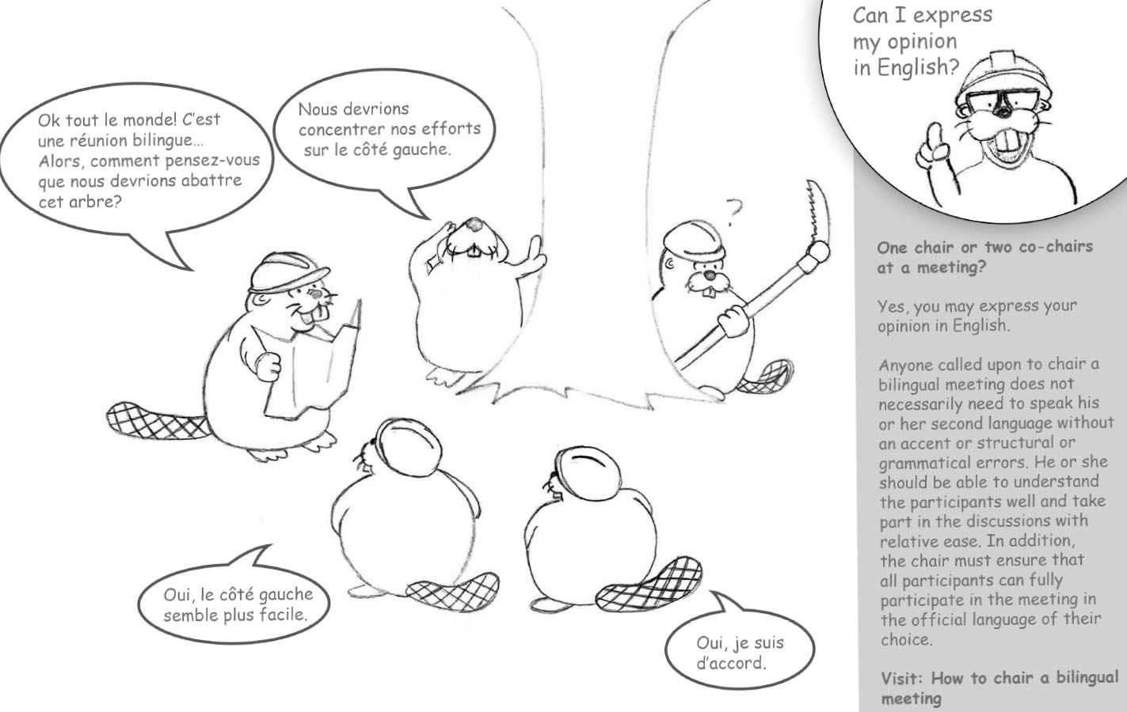

- Consult the intranet page: How to chair a bilingual meeting
- Want to see an example of a bilingual meeting? Watch this video from the Office of the Commissioner of Official Languages, Effective practices for chairing bilingual meetings - YouTube.

Challenge yourself!
Now it’s your turn! What are you going to do to ensure that your next meetings, when they must be, are bilingual from start to finish? Share your experiences with us at tpsgc.questionslo-olqueries.pwgsc@tpsgc-pwgsc.gc.ca.

Stéphan Déry & Lucie Séguin
Official Languages Co-champions
TPSGC.ChampionsLO-OLChampions.PWGSC@tpsgc-pwgsc.gc.ca

