Mentor Biographies

Employment Opportunity for Students with Disabilities 2022

Table of Contents
ALEKSANDRA LUCZAK (SHE/HER) 3
ANNE LOWRY (SHE/HER) 4
AVERILL FRANKES (SHE/HER) 5
CATHERINE [CATH] DUCHASTEL DE MONTROUGE (SHE/THEY) 6
CHRISTINA ANDERSON (SHE/HER) 7
DAN MARKELDAN (HE/HIM) 8
ELLEN SYRACOPOULOS (SHE/HER) 9
GRAHAM SPERO (HE/HIM) 10
JALANA MORTON (SHE/HER) 11
JASON DUNKERLEY (HE/HIM) 12
JEFFREY STARK (HE/HIM) 13
JENNIFER LUNDRIGAN (SHE/HER) 14
KENNETH AQUIN-ABBOUD (HE/HIM) 15
LAURA SMALLWOOD (SHE/HER) 16
MARIE-JEANNE NAHAS (SHE/HER) 17
MARYSE ALLAIN (SHE/HER) 18
NANCY OLDFORD (SHE/HER) 19
NOOR SIDDIQI (SHE/HER) 20
NUBA ILHAN 21
PIERRE LOSIER (HE/HIM) 22
RACHEL BOUTIN (SHE/HER) 23
ROCK BISSON PICARD 24
SARAH MAYES (SHE/HER) 25
SHAFIQ R. KHAN (HE/HIM) 26
SILVIA BASCUÑAN (SHE/HER) 27
SINEAD TUITE (SHE/HER) 28
TONY LABILLOIS (HE/HIM) 29
VANESSA WAKIL (SHE/HER) 30

ALEKSANDRA LUCZAK (SHE/HER)

Current Position and Department
Manager, Labour Relations and Human Resources Planning and Programs
Public Services and Procurement Canada

Language(s) of Communication
English

Areas of Expertise
- Dyslexia and work
- Maximizing your strengths through developing strategic thinking

Availability to Mentor
Monthly basis

Contact Details
aleksandra.luczak@pwgsc-tpsgc.gc.ca

ANNE LOWRY (SHE/HER)

Current Position and Department
Team Leader, Integrity Services Branch
Service Canada

Language(s) of Communication
English

Areas of Expertise
- Applying to Boards
- Requesting accommodation so you are successful at your job
- Plotting a career path

Availability to Mentor
Biweekly basis

Contact Details
anne.lowry@servicecanada.gc.ca
647-446-5765

AVERILL FRANKES (SHE/HER)

Current Position and Department
Team Lead, Strategic Operations and Recruitment
Public Services and Procurement Canada

Language(s) of Communication
English

Areas of Expertise
- Soft skills including leadership, people management, emotional intelligence, and working with others (including through a DEI lens)
- Time management skills including work planning, task delegation/prioritization
- Job-related skills including communication, project management, communication and project plans, data strategy/analysis, requirements gathering, MS Office tools

Availability to Mentor
Bi-weekly or monthly basis

Contact Details
averill.frankes@tpsgc-pwgsc.gc.ca
343-550-1831

CATHERINE [CATH] DUCHASTEL DE MONTROUGE (SHE/THEY)

Current Position and Department
HR Student, Education, Accessibility and Inclusion, Programs and Planning
Public Services and Procurement Canada

Language(s) of Communication
French and English

Areas of Expertise
- Navigating how to negotiate informal accommodations with your supervisors/managers and finding information on how to request accommodations
- The Accessible Canada Act and how furthers accessibility within the Public Service
- Getting organized to keep on top of work expectations

Availability to Mentor
1-2 times a month for a session of 30 minutes to an hour, schedule permitting.

Contact Details
catherine.duchasteldemontrouge@tpsgc-pwgsc.gc.ca
(Prefers written communication or video call)

CHRISTINA ANDERSON (SHE/HER)

Current Position and Department
Analyst/Researcher, Human Resources Reporting, Programs and Mental Health Division
Health Canada

Language(s) of Communication
English

Areas of Expertise
- Disability issues including self-advocacy, finding resources and accessing accommodations (physical disabilities, mental health, learning disabilities)
- Knowledge of Human Resources and onboarding practices for FSWEP, student bridging, casual and term contracts
- How to orient yourself within the Government of Canada as a new employee, how to set career goals, and how to network

Availability to Mentor
Bi-weekly or monthly basis

Contact Details
christina.anderson@hc-sc.gc.ca

DAN MARKELDAN (HE/HIM)

Current Position and Department
Senior Policy Analyst, Office for Disability Issues
Employment and Social Development Canada

Language(s) of Communication
English and French

Areas of Expertise
- Navigating and preparing for hiring and selection processes including the accommodation process
- Working in the policy domain (policy research, policy development, regulatory policy, program policy) as well as planning, reporting and evaluation
- Working in the area of diversity for federal government departments and organizations

Availability to Mentor
Monthly basis – the possibility of more frequent meetings, schedule permitting.

Contact Details
dan.markel@hrsdc-rhdcc.gc.ca

ELLEN SYRACOPOULOS (SHE/HER)

Current Position and Department
Business Analyst in Accessible Procurement, Accessibility, Accommodation and Adaptive Computer Technology
Shared Services Canada

Language(s) of Communication
English and French

Areas of Expertise
- Navigating the Government of Canada as a new employee
- Working remotely
- Personal relationships with colleagues, teamwork, and friendship

Availability to Mentor
Monthly basis

Contact Details
ellen.syracopoulos@ssc-spc.gc.ca

GRAHAM SPERO (HE/HIM)

Current Position and Department
Policy Analyst, Science and Parliamentary Infrastructure Branch
Public Services and Procurement Canada

Language(s) of Communication
English

Areas of Expertise
- The accessibility landscape of the public service
- Accessibility in the built environment
- Advancing disability and inclusion

Availability to Mentor
Bi-weekly basis

Contact Details
graham.spero@tpsgc-pwgsc.gc.ca

JALANA MORTON (SHE/HER)

Current Position and Department
Business Support Administrator, Real Estate Services
Public Services and Procurement Canada

Language(s) of Communication
English

Areas of Expertise
- Onboarding and resources
- Working as a new employee in the Government
- Honesty, support, and dedication to the mentee for a rewarding career

Availability to Mentor
Bi-weekly or monthly basis

Contact Details
jalana.morton@pwgsc-tpsgc.gc.ca
902-223-4376

JASON DUNKERLEY (HE/HIM)

Current Position and Department
Senior Analyst
Department of Public Services and Procurement Canada

Language(s) of Communication
English

Areas of Expertise
- Accessibility; briefing
- Government writing
- Health and Wellness

Availability to Mentor
Weekly basis

Contact Details
jason.dunkerley@tpsgc-pwgsc.gc.ca

JEFFREY STARK (HE/HIM)

Current Position and Department
Manager, Accessibility, Accommodation and Adaptive Computer Technology Program
Shared Services Canada

Language(s) of Communication
French and English

Areas of Expertise
- Advocacy, self-advocacy, and public speaking on topics in the disability space
- Inclusive, accessible information and communications technology
- Accessibility standards, guidelines, and best practices to ensure the elimination of systemic barriers
- Navigating challenges faced by persons with disabilities in the Government of Canada and beyond, including job accommodation and best practices across the Government of Canada and abroad

Availability to Mentor
Weekly or monthly basis

Contact Details
jeffrey.stark@ssc-spc.gc.ca

JENNIFER LUNDRIGAN (SHE/HER)

Current Position and Department
Senior Program Advisor, Grants and Contributions for Professional Arts Organizations
Canadian Heritage

Language(s) of Communication
English

Areas of Expertise
- Onboarding, navigation of the public service’s benefits/pay and help to identify available training and development opportunities
- Help people to identify their skills and their career goals
- Help new employees integrate into the virtual and in-person office culture

Availability to Mentor
Bi-weekly basis

Contact Details
Jennifer.lundrigan@pch.gc.ca
j_lundrigan@hotmail.com

KENNETH AQUIN-ABBOUD (HE/HIM)

Current Position and Department
Senior Advisor, Substance Use and Addictions Program
Health Canada

Language(s) of Communication
French and English

Areas of Expertise
- The Grants and Contributions process and the delivery of programs, particularly related to drug policy
- In policy development and stakeholder relations
- Employee network activities and the importance of employee networks in helping to build necessary competencies to reach career objectives

Availability to Mentor
Bi-weekly basis

Contact Details
kenneth.aquin-abboud@hc-sc.gc.ca
343-549-6037

LAURA SMALLWOOD (SHE/HER)

Current Position and Department
Director General, Corporate Planning, Performance and Risk
Global Affairs Canada

Language(s) of Communication
English

Areas of Expertise
- Working on global or environmental issues
- Accessing accommodations
- Growing your career

Availability to Mentor
Monthly Basis

Contact Details
laura.smallwood@international.gc.ca

MARIE-JEANNE NAHAS (SHE/HER)

Current Position and Department
Senior HR Advisor, Employment Equity, Diversity and Inclusion
Immigration and Refugee Board of Canada

Language(s) of Communication
French and English

Areas of Expertise
- Staffing process, recruitment, the hiring process, how to apply (tips and tricks)
- Team management
- Knowledge of accessibility standards, guidelines, and best practices to ensure the removal of systemic barriers

Availability to Mentor
Bi-weekly basis

Contact Details
marie-jeanne.nahas@irb-cisr.gc.ca
514-605-8995

MARYSE ALLAIN (SHE/HER)

Current Position and Department
Project Coordinator, Operations and Emergency Management Directorate
Public Services and Procurement Canada

Language(s) of Communication
French

Areas of Expertise
- Operational transformation regarding project coordination
- More than 8 years of experience in the field as an executive assistant in a director’s offices
- More than 5 years of experience as a documentation technician

Availability to Mentor
Weekly basis

Contact Details
maryse.allain@tpsgc-pwgsc.gc.ca

NANCY OLDFORD (SHE/HER)

Current Position and Department
HR Director
Public Service and Procurement Canada

Language(s) of Communication
French and English

Areas of Expertise
- How to apply to government jobs
- Excelling in job interviews
- Managing your career

Availability to Mentor
Monthly basis

Contact Details
nancy.oldford@pwgsc-tpsgc.gc.ca
902-478-8509

NOOR SIDDIQI (SHE/HER)
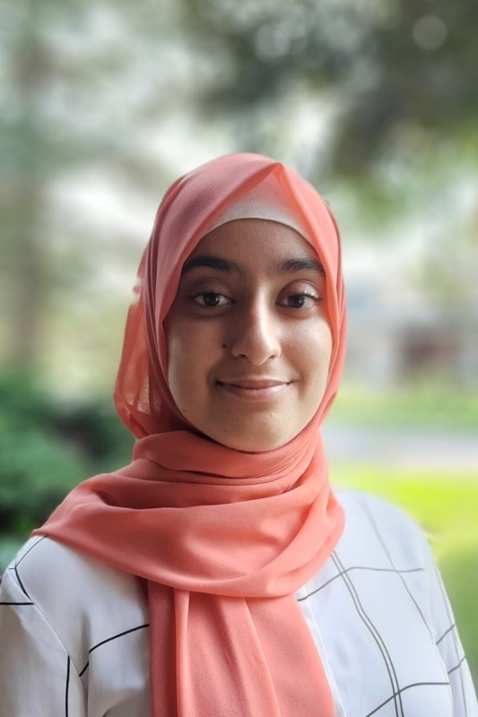

Current Position and Department
Application Development Analyst Programmer
Justice Canada

Language(s) of Communication
English

Areas of Expertise
- Technologies
- Post-secondary advice
- Working in the public service and the applying for government jobs

Availability to Mentor
Weekly basis

Contact Details
noor.siddiqi@justice.gc.ca
613-410-2504

NUBA ILHAN

Current Position and Department
Spectrum Management Officer
Innovation, Science and Economic Development Canada

Language(s) of Communication
English

Areas of Expertise
- Radio Licensing (Authorization and Compliance)
- Resume optimization for federal government positions
- Networking skills, social/life skills, work-life balance, accessibility in the workplace (guidance only), empathy and respect in the workplace, collaboration in the workplace

Availability to Mentor
Monthly basis

Contact Details
nuba.ilhan@ised-isde.gc.ca
250-301-3795

PIERRE LOSIER (HE/HIM)
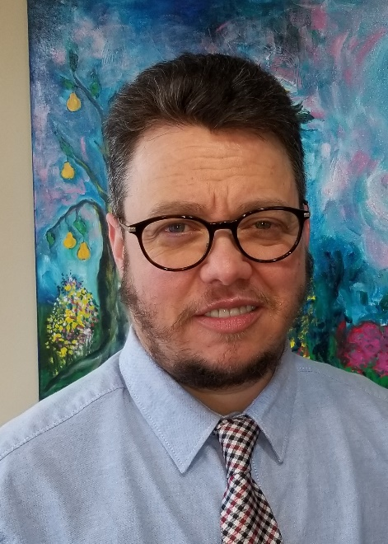

Current Position and Department
Chair, Persons with Disabilities Network
Public Services and Procurement Canada

Language(s) of Communication
French and English

Areas of Expertise
- Management, rules, roles, and responsibilities within the Federal Public Service
- Accessibility and Inclusion in the Federal Public Service
- Building career and networking opportunities
- Applying for a position, hiring processes, and showcasing your talents

Availability to Mentor
To be determined with mentee - based on aspirations, needs and long or short-term plan.

Contact Details
pierre.losier@tpsgc-pwgsc.gc.ca

RACHEL BOUTIN (SHE/HER)

Current Position and Department
Manager, Accessibility
Statistics Canada

Language(s) of Communication
French and English

Areas of Expertise
- Employment of People with Disabilities
- Accessibility
- Career

Availability to Mentor
Bi-weekly basis

Contact Details
rachel.boutin@statcan.gc.ca
514-234-9879

ROCK BISSON PICARD
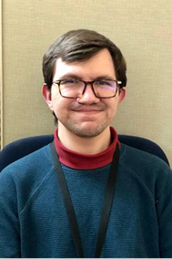

Current Position and Department
Information Management Business Analyst
Justice Canada

Language(s) of Communication
French and English

Areas of Expertise
- Time management
- Planning
- Note-taking

Availability to Mentor
Weekly basis

Contact Details
rock.bisson-picard@justice.gc.ca
343-551-3678

SARAH MAYES (SHE/HER)
Please note, Sarah does not have a lived experience with a disability. She is an active ally. She works in a program that works with organizations that serve persons with print disabilities. They are actively engaged in trying to identify and reduce access barriers to their program.

Current Position and Department
Manager, Special Projects, Canada Book Fund
Canadian Heritage

Language(s) of Communication
French and English

Areas of Expertise
- Grants and contribution programs
- Policy development
- Career development and staffing processes in government

Availability to Mentor
Monthly basis

Contact Details
sarah.mayes@pch.gc.ca

SHAFIQ R. KHAN (HE/HIM)
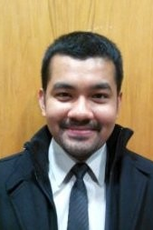

Current Position and Department
Equipment and Technical Support Engineer, Suffield Research Centre
Defence Research and Development Canada

Language(s) of Communication
English

Areas of Expertise
- Career development
- Leadership/Soft Skills
- Technical Development

Availability to Mentor
Bi-weekly basis (willing to start on a weekly basis and adjust based on needs)

Contact Details
Shafiqur.Khan@forces.gc.ca
For initial introductions, a Teams meeting will be arranged.

SILVIA BASCUÑAN (SHE/HER)

Current Position and Department
HR Advisor, Organizational Development
Crown-Indigenous Relations and Northern Affairs Canada / Indigenous Services Canada

Language(s) of Communication
French

Areas of Expertise
- Knowing and understanding my rights and resources as a person with a disability in the federal government
- How to effectively apply for jobs in the Federal Public Service
- Quick tips on career planning and progression

Availability to Mentor
Bi-weekly basis

Contact Details
silvia.bascunan@rcaanc-cirnac.gc.ca

SINEAD TUITE (SHE/HER)

Current Position and Department
Senior Director, Digital Research Infrastructure
Innovation, Science and Economic Development Canada

Language(s) of Communication
English

Areas of Expertise
- Policy development
- Stakeholder engagement
- Career development

Availability to Mentor
Monthly basis

Contact Details
sinead.tuite@canada.ca
343-998-2677

TONY LABILLOIS (HE/HIM)

Current Position and Department
Director, Public Sector Statistics Division, Economic Statistics Field
Statistics Canada

Language(s) of Communication
French and English

Areas of Expertise
- Career planning and leadership
- The Canadian Statistical System
- The Public Service

Availability to Mentor
Monthly basis

Contact Details
tony.labillois@statcan.gc.ca
613-293-6978

VANESSA WAKIL (SHE/HER)

Current Position and Department
Manager, Executive Learning and Development
Canada School of Public Service

Language(s) of Communication
English and French

Areas of Expertise
- Leading at the manager level
- Career pathways to becoming a manager in the federal public service
- How to expand your experience, grow and contribute to the federal public service through volunteering on committees, working groups, etc.

Availability to Mentor
Weekly basis

Contact Details
vanessa.wakil@csps-efpc.gc.ca

