Change Management Strategy
TEMPLATE
Date:
Prepared for:
Department/AGENCy:

Table of contents
About this document 4
Why do you need a change management strategy? 4
How we help 5
1. Executive summary 6
1.1 Background 6
1.2 The workplace vision 6
1.3 Strategic considerations 6
1.4 Sponsor, champions and project team 7
1.5 Governance 7
2. Assessment results 8
2.1 Change inventory and impact assessment 8
Results 8
Analysis 8
2.2 Stakeholders map 8
Results 8
Analysis 9
2.3 Change readiness assessment 9
Results 9
Analysis 9
2.4 ADKAR Change-o-meter 10
Results 10
Analysis 10
3. Change management strategy framework 10
3.1 Communication framework 11
3.2 Engagement framework 11
3.3 Training framework 11
3.4 Resistance management 11
4. Measuring 14
Annexes 15

About this document

This document is a template and reference tool for the change manager to use as a guide in developing the tailored change management strategy in support of changes associated with workplace modernization. The proposed sections can be completed with information specific to the organization.

Why do you need a change management strategy?
A change management strategy serves as a launching point for organizations seeking to introduce workplace changes that want to ensure that the impact on employees is managed successfully.
Workplace changes are opportunities to shape an organization’s future. Yet it must be noted that several people, teams, organizational structures and the overall culture are affected by workplace changes.
It must include an understanding of the organization embarking on this change: its culture, its leadership and its position regarding the change. This information feeds the strategy, in terms of what the best approach for managing these changes should be, what the priorities are and who needs to be engaged in supporting success.
A change management strategy defines the approach needed to manage change given the unique characteristics of a project. It includes an understanding of these unique characteristics, a support structure to implement the strategy and an analysis of the risks of and potential resistance to the change. In essence, your strategy articulates what you will do to raise awareness of, build desire for, show how to, enable and reinforce the change. This method of managing change is the Prosci® method using the ADKAR® model.
A change management strategy manages an upcoming change for each stakeholder segment. The strategy should be based on the results of a number of change assessment tools that show how unique each and every organization is.
Effective change management comes when the change management strategy represents the unique characteristics of the change and the people who are affected by the change. Some workplace transformation projects will require more robust and comprehensive change management while others may need a lighter touch. Change management is successful when leadership, project management and change management work together.

How we help

This template and the set of change management assessment tools that inform it were developed by the Workplace Change Management National Centre of Expertise and aim to get you started off on the right foot. The tools help to evaluate key variables related to the change and the results reveal key information that contribute to determining the best strategy for managing the change in your organization.

PSPC’s Workplace Change Management National Centre of Expertise offers organizations support in fleshing out their change management strategy by way of tools and assistance with information gathering as well as step-by-step advice and guidance.

1. Executive summary
Draft an executive summary once you’ve completed all the other sections of your strategy. The executive summary provides high-level conclusions, and includes an outline of your strategy and the most important elements that you want to highlight for the reader. This information can be reused for key messages and speaking points in senior management briefings on the change management strategy and future plans that flow from it.

1.1 Background
Provide some background on this change initiative. Explain the drivers and the decisions that led to the implementation of an initiative to modernize your workplace. Include some of the key milestones and timelines. This information should be available from the project team.

1.2 The workplace vision
In this section, you must integrate the workplace vision that has been developed to support the initiative. The vision (for the future end-state) is a very important element in workplace transformation that works in concert with change management to help the organization achieve the goal of workplace modernization.

1.3 Strategic considerations
In this section, you must answer the following questions: What is the nature of the change? Who is impacted? How are they impacted?

1.4 Sponsor, champions and project team
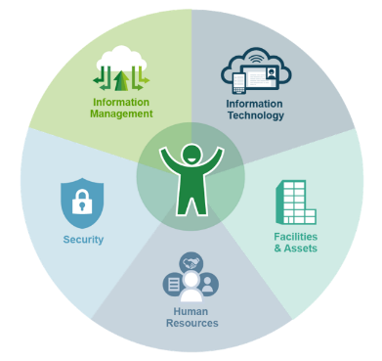
Having an integrated project team focused on the integrated workplace outcomes is a key to success. Leads (captains) for all the key enabling functions are required, each with the responsibility to deliver a set of actions under their functional area. The project manager (PM)/integrator (maestro) oversees the engagement and participation of the functional leads (captains) and ensures that the actions are being delivered in alignment with the integrated outcomes and in consideration of each other. The PM/integrator (maestro) is the sponsor’s agent.
Workplace integrated project delivery model
- Use our 3Rs document as a starting point
- Provide a short paragraph explaining the proposed workplace integrated project team structure as well as a picture if possible.
- Provide a short paragraph explaining how change management will be integrated into the project.
[Include the integrated project team structure as well as their roles and responsibilities here]

1.5 Governance
Existing organizational governance may be used to seek direction, support, approvals and resource allocation when appropriate, as well as to communicate status and discuss challenges. New governance should be considered to provide dedicated project steering and advisory support. These new governance bodies should be initiated by the integrated project office and supported by the change management team. The terms of reference, membership, roles and frequency of meetings should be clearly defined to ensure the items brought to their attention aligns with their mandates and maintains a high level of engagement, the quality thereof and commitment of the membership.
[Include your governance structure here]

2. Assessment results

This section is about what specifically is changing and its impacts on employees. These results will also help the integrated project team discuss, understand and articulate all the changes related to the workplace modernization projects and the impacts of those changes for the end-users. This will define the scope of change for the workplace modernization project.

2.1 Change inventory and impact assessment

Results
[Include your results here]

Analysis
Provide a list of those areas that are in need of attention (high, medium and low). Include what will be done to address the gaps and the changes.

2.2 Stakeholders map
The stakeholders map is a list of individuals or groups of employees who will be impacted by the change. From a change management perspective, the stakeholders of any change project are always all of the employees, but they can be separated into various categories based on their functions: employees, managers, senior managers, etc. From a project management perspective, the list of stakeholders would be slightly different, as it would also include the key stakeholders who will be involved as key enablers, such as IT, IM, Security, HR, Facilities, OHS, etc.

Results
[Include your results and the stakeholders map here]

Analysis
[Provide a short paragraph that summarizes the results]
- What will be the level of impact on each stakeholder?
- Who will be the most impacted by the change?
- What will be the challenges for each group?
- Who could stop or seriously undermine the change if they wanted to?
- Who can influence or have power over the project? (Do they hold a position of authority? Are they subject matter experts? Etc.)

2.3 Change readiness assessment
The organizational culture profile provides a framework to determine whether the key enabling cultural elements are in place for your organization to leverage culture to support successful change. Each organization has unique characteristics that make change management easy or challenging. Some organizations are ready, willing and able to change, while others are severely lacking change experience or have a bad history of change. Knowing which one you are dealing with is critical at the beginning of the journey.

Results
[Include your results here (graph)]

Analysis
[Provide a short paragraph that summarizes the results]

2.4 ADKAR Change-o-meter
The ADKAR Change-o-Meter provides a framework to determine whether the organization is ready to adopt the new workplace. A first assessment should be administered during the early stage to the project to gauge the level of awareness, desire, knowledge and ability towards the upcoming changes. It can be administered on a regular basis to check the variance and to adjust the strategy and plans. It can also be used for specific projects or groups.

Results
[Include your results here]

Analysis
[Provide a short paragraph that summarizes the results]

3. Change management strategy framework
In consideration and with an understanding of the above information, including the nature of the change—who is impacted and what the impacts are (results from the assessments)—list the high-level strategy and the five or six (or more as required) focus areas that will enable these impacts to be minimized or otherwise addressed.
Include what the focus area is, give it a meaningful title, describe it with its CM objectives and provide some examples of specific actions or activities that it encompasses. Include or develop strategic objectives that will guide the future activities.

3.1 Communication framework
A communication plan will be developed later. At this point, present a high-level communication framework that provides a roadmap for the future plan.
[Provide a short paragraph that summarizes the key elements of your framework]

3.2 Engagement framework
An engagement plan will be developed later. At this point, present a high-level engagement framework that will provide a roadmap for the future plan.
[Provide a short paragraph that summarizes the key elements of your framework]

3.3 Training framework
A training plan will be developed later. At this point, present a high-level training framework that will provide a roadmap for the future plan.
[Provide a short paragraph that summarizes the key elements of your framework]

3.4 Resistance management
Resistance during a workplace modernization project is inevitable but it is important to know how to manage it. First and foremost, you should determine the root cause: Where is the gap? Is it related to the awareness, desire, knowledge, ability or reinforcement of the change? This will provide an initial category for the problem. A plan to manage specific situations should be put in place depending on which building block of the ADKAR model the gap refers too.
When the resistance lies with an employee or group of employees, it is best addressed by direct supervisors or highest-level managers (as long as the supervisor was not identified as the root cause of the problem). The supervisor/manager should help you identify the problem to be addressed and why the problem needs to be addressed (the impact that it is having on the change). With this information, you will be able to establish the steps that need to be taken in order to mitigate the resistance. If specific tools or resources are required, ensure that the supervisor/manager is equipped with them. If the supervisor has not had formal training in change management, keep in mind that you will need to spend some time coaching them on the tools and processes for working with employees.
When managing resistance, you must identify how to manage the change for each stakeholder (i.e. employee, manager, executive), including who is responsible for managing resistance at the various employee levels (for example: Will the director or director general manage resistance for all employee levels, or will there be a designated chain of command?). Identify what is formally or informally known in the organization that might require specific resistance management:
  - Special points of resistance
  - Groups (middle managers, communities, etc.) involved with a history of resistance
  - Employee groups that may pose significant resistance
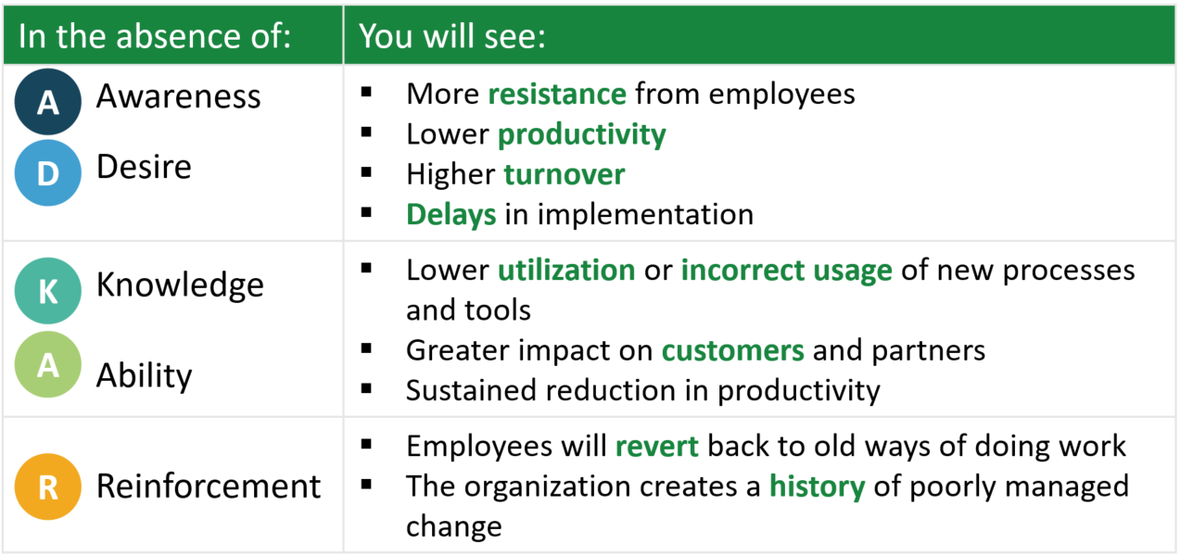
This section, will be an evergreen area that will need to evolve based on feedback, observations and information received.
To know learn more, please consult our document called Managing Resistance to Change

4. Measuring
Your strategy has a set of change management objectives, including to raise awareness, to build desire, etc. It will be important to articulate how you have attained these objectives. You will need to determine the key performance indicators that you will measure and how you will measure them. It is possible that, at this stage, you do not have those indicators, but they should be developed soon after as they will be needed to evaluate the performance of the plans (communication, engagement and training).
To know more, please consult the Measure phase of the CM Playbook

Annexes
Actual plans can be inserted here once they are defined

