INDIVIDUAL OPEN

Workstation (various configurations)

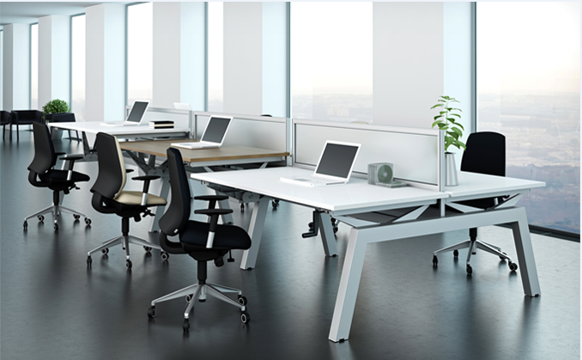

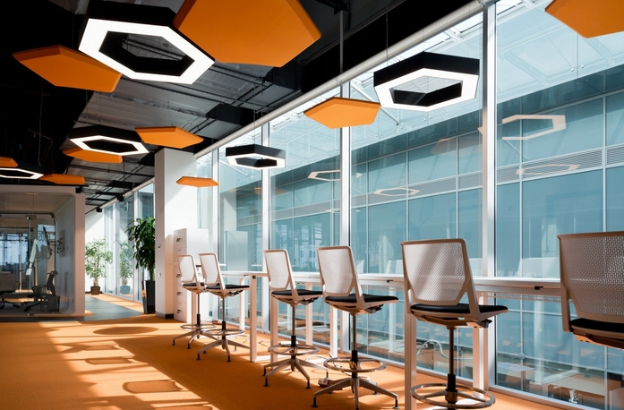

INDIVIDUAL OPEN

Touchdown

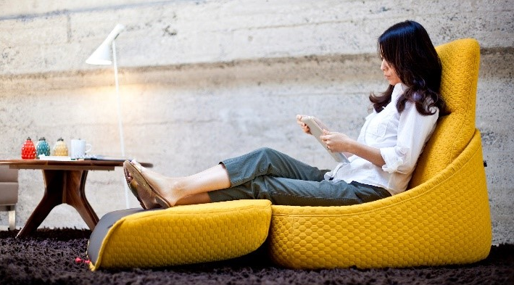

INDIVIDUAL SEMI-ENCLOSED

Reflection Point

[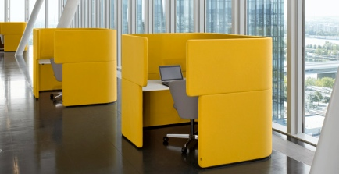](https://www.google.ca/url?sa=i&rct=j&q=&esrc=s&source=images&cd=&cad=rja&uact=8&ved=0ahUKEwi67daY56HSAhUm1oMKHaUaA0IQjRwIBw&url=https://www.pinterest.com/amyjstevenson/private-workspace/&psig=AFQjCNGFgfV28MdsBQm-zcwEqStvmsnNdQ&ust=1487787672539933)

INDIVIDUAL SEMI-ENCLOSED

[](https://www.google.ca/url?sa=i&rct=j&q=&esrc=s&source=images&cd=&cad=rja&uact=8&ved=0ahUKEwi67daY56HSAhUm1oMKHaUaA0IQjRwIBw&url=https://www.pinterest.com/amyjstevenson/private-workspace/&psig=AFQjCNGFgfV28MdsBQm-zcwEqStvmsnNdQ&ust=1487787672539933)

Focus Pod

INDIVIDUAL SEMI-ENCLOSED

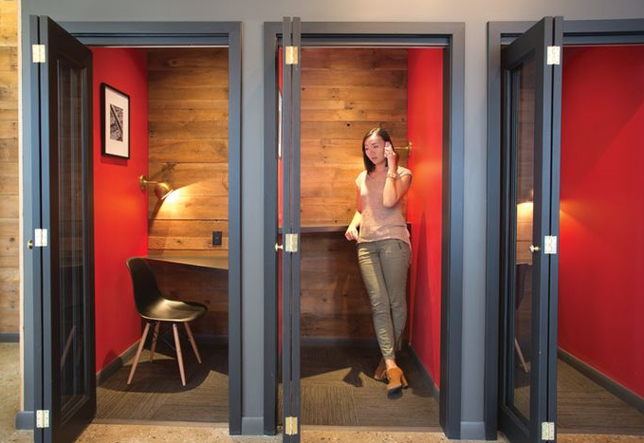

Phonebooth

INDIVIDUAL ENCLOSED

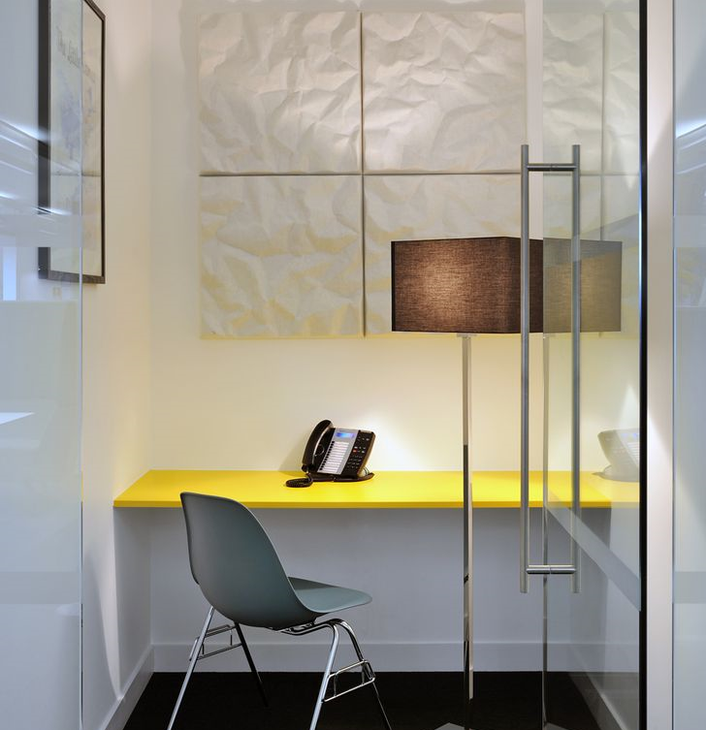

Focus Room

INDIVIDUAL ENCLOSED

INDIVIDUAL ENCLOSED

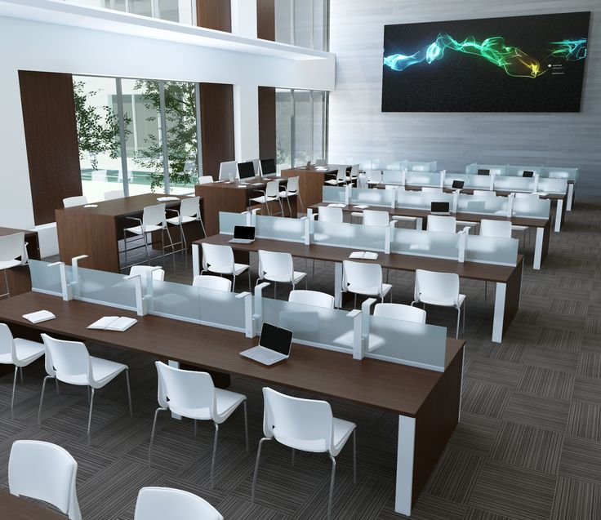

Study

COLLABORATIVE OPEN

Café/Kitchenette

COLLABORATIVE OPEN

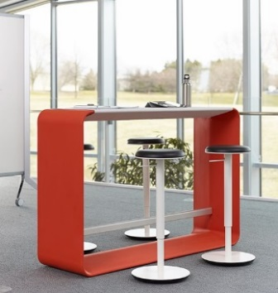

Collaborative Workpoint

Huddle OPEN

Chat Point

COLLABORATIVE OPEN

Huddle

COLLABORATIVE SEMI-ENCLOSED

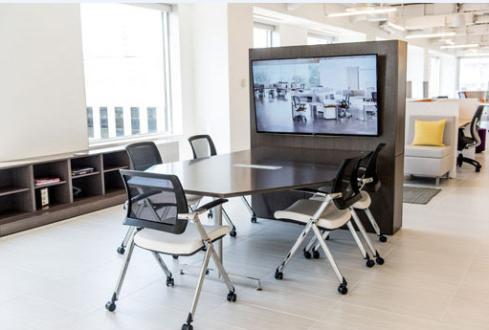

Teaming area



COLLABORATIVE SEMI-ENCLOSED

Lounge

COLLABORATIVE SEMI-ENCLOSED

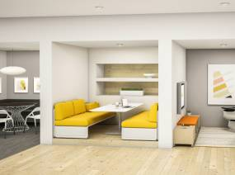

Enclave

COLLABORATIVE ENCLOSED

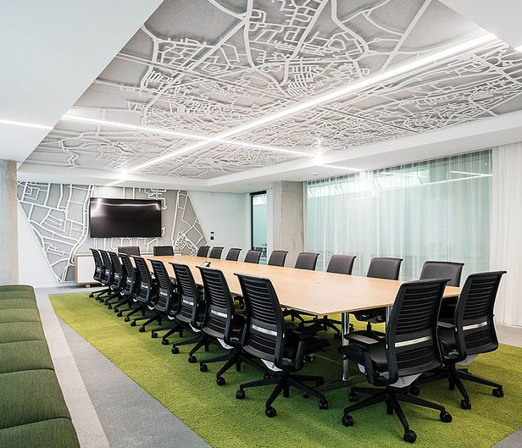

Meeting room

COLLABORATIVE ENCLOSED

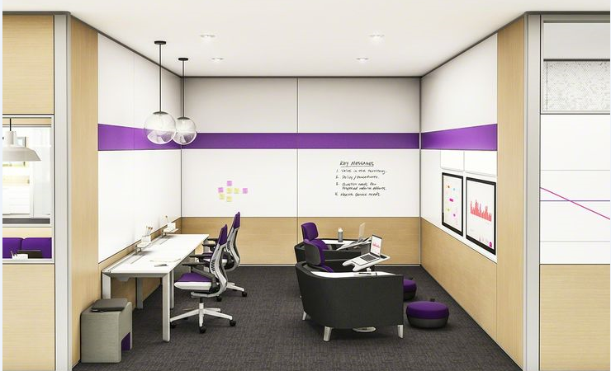

Dynamic project room

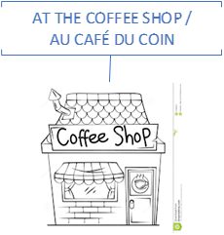

Coffee shop

INDIVIDUAL OPEN

INDIVIDUAL OPEN

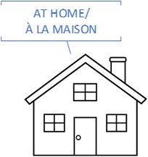

Home