**Reinvent Yourself, Reinvent the Public Service**

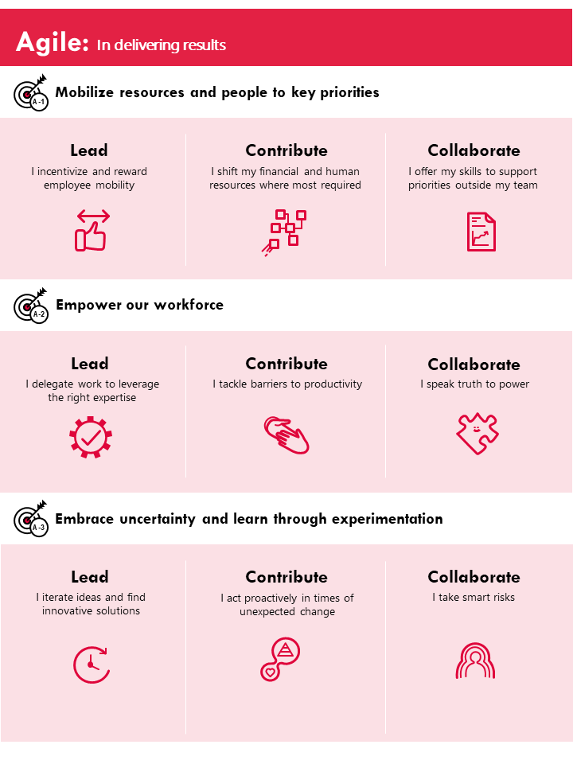

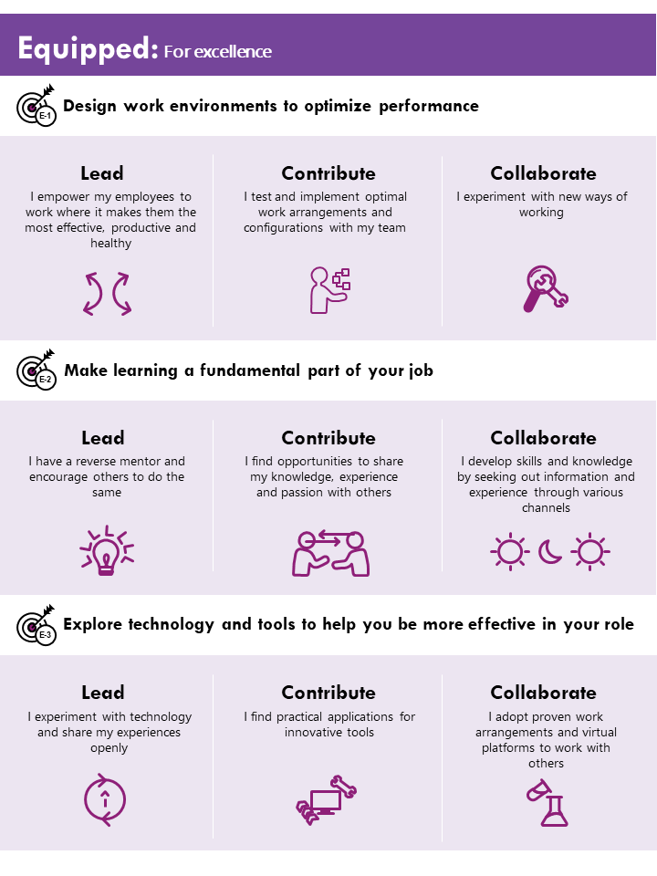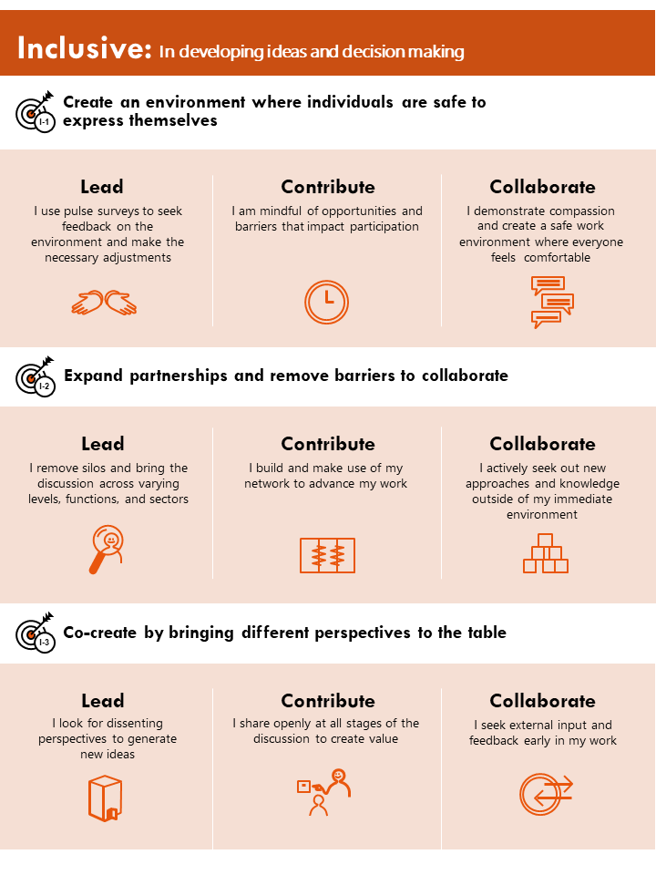



Collaborate

Collaborate

Contribute

Collaborate

Contribute

Contribute

Lead

Lead

Lead

________________________________________________________________________________________________________________________________________________________________________________________________________________________________________________________________________________________________________________________________________________________________________________________________________________________________________________________________________________________________________________________________________________________________________________________________________________________________________________________________________________________________________________________________________________________________________________________________________________________________________________________________________________________________________________________________________________________________________________________________