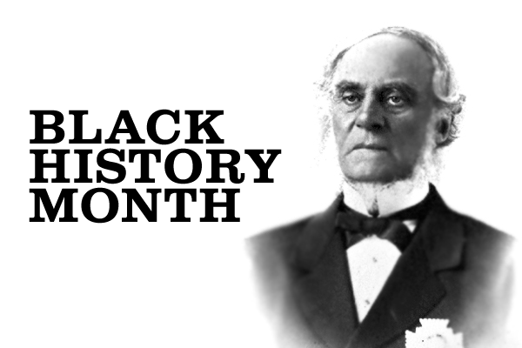
By Céline Ahodékon
From coast to coast to coast, in Canada, we see Canadians of African descent. But for some reason, how some came to land here isn’t clear – or rather, nobody talks about it. And worse, there are few Canadian history books to learn from.
During my first years in Canada, I was shocked when I asked people of my colour where they are from. I expected them to say Benin, Rwanda, Kenya or, at the very least, “somewhere in Africa”. To my great surprise, some answered “from Canada”. The connection of some Canadians of African descent to Canada is “hush, hush and shuuuuuu”! For some Canadians of African descendants, Canada is their only home. But for others, Canada is their adoptive home; they are immigrants to this land.
Anyway, it doesn’t matter where we are from or who was here first. What matters is – whether we are Canadian of African descent or African Canadians – our common ground is the mother continent: Africa. And, like other communities in Canada, people of African descent, both past and present, face human right struggles. But as the saying goes: “it doesn’t matter how you start a race, what matters is how you end it”. People of African descent have made – and continue to make – important contributions to Canada. They have emerged as community and political leaders in Canada. This article is too short to name them all, but there is one whose name makes Black History Month worthy of celebration at least in BC: Governor Douglas. In fact, celebrating Black History Month on the West Coast without giving homage to Governor James Douglas, the Father and Founder of British Columbia, is like baking rhubarb pie without sweetening; it will surely be sour!
Six-feet-tall, courageous and ambitious, “Black” Douglas, (as he was called in Fort Vancouver, Washington), was born in British Guyana. He was the son of an African Creole mother from Barbados and a Scottish father. A long-time Hudson Bay Company employee, James Douglas started his career as an apprentice and worked his way up: from chief factor to manager, and eventually to Governor of British Columbia.
Even though James Douglas faced many challenges, he never gave up. With determination, he stood strong and firm when faced with trials and dangers that arrived alongside the thousands of gold-seekers from California.
As James Douglas often said of himself, “it is the bold, resolute, strong, self-reliant man, who fights his own way through every obstacle and wins the confidence and respect of his fellows. As with men, so it is with nations.” During the gold rush in 1858, Douglas asserted British sovereignty on the mainland and Victoria by bringing British law and order. He demonstrated his authority and loyalty to British and went to create the colony of British Columbia and was appointed Governor of the new colony in the same year.
James Douglas’ sensitivity to his pairs enabled him to invite the very first large wave of black people from California to settle in British Columbia for a better life.
“Though still faced with intense discrimination, these pioneers enriched the political, religious and economic life of the colony.”
They even went on to form one of the earliest colonial militia units: the Victoria Pioneer Rifle, also known as the African Rifles.
No man had a greater influence on the early history of British Columbia than James Douglas. As the bishop said at his funeral in 1877, “James Douglas was the right man in the right place at the right time”.
It’s entirely possible that if James Douglas had not lived and stood firm to prevent a takeover by Americans, there might not be a British Columbia today. James Douglas may be gone, but his legacy lives forever! There are many roads, ports, bays and mountaintops in British Columbia that still bear his name today.
Friends, this is just one example among many of prominent Canadians of African descent’s contributions to our society. There are many more, past and present, who have changed the Canadian landscape. Black History Month provides an opportunity to share and learn about the experiences and contributions to society by Canadians of African ancestry. Reading books, watching video/films, participating in Black History Month celebration online events, organizing your own debate about any conciliatory subjects, or simply trying to cook African spicy food are some of the things you can do to celebrate with us!
Happy Black History Month everyone!
Céline Ahodékon on behalf of Federal Black Employee Caucus, BC Chapter.

