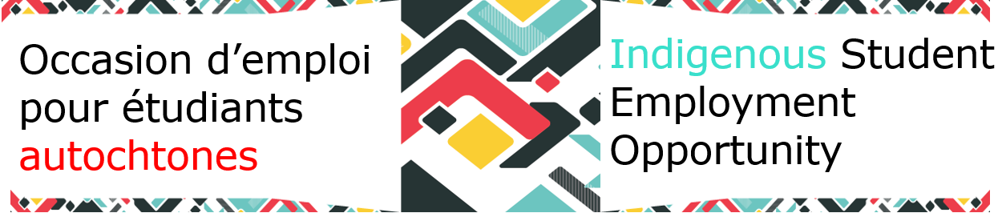

### Newsletter - Winter 2024

**Check out our Mentorship Program!**

The ISEO [Mentorship program](https://www.gcpedia.gc.ca/wiki/Indigenous_Student_Employment_Opportunity_-_MENTORSHIP) is a self-serve platform where students can browse through potential mentors to find their perfect fit! There are also templates, mentorship agreements, and conversation topics to help you get started.

**Information Toolkit for Indigenous Students**

We're thrilled to introduce our new [Information Toolkit](https://www.gcpedia.gc.ca/wiki/File:Information_Toolkit_for_ISEO_Students_June_5,_2023_e.docx) tailored just for you! Packed with invaluable resources, this toolkit is designed to empower you on your professional journey. Whether you're seeking career guidance, job opportunities, cultural support, or connections within the Indigenous community, this toolkit has you covered. Dive in and discover the tools to thrive in your role while honoring your heritage.Haut du formulaire

**Don’t miss these events!**

**February 15, 2024: Start Your Term Event**

* [GC Students](https://wiki.gccollab.ca/GCStudents_-_%C3%89tudiantsGC) and The [Federal Youth Network](https://wiki.gccollab.ca/Federal_Youth_Network) are pleased to invite student workers in the public service to this online event that will inform you about onboarding tools, employment conditions and networking. [Register](https://forms.office.com/Pages/ResponsePage.aspx?id=8uh8clanLkGkxpUgStaNhEmM_9DuBGtCk1ohtPsu1k9URTEwTU0zM1dQQkQxNE5MNTFHR0M0TEVURy4u) and join us for the French session from 10:00 a.m. to 12:00 p.m. (ET) and for the English session from 1:30 p.m. to 3:00 p.m. (ET)

**February 20, 2024: Wellness Sharing Circle**

* Join the Knowledge Circle for Indigenous Inclusion’s next virtual Circle being offered to First Nations, Inuit, and Métis employees in the public service. These Circles are an opportunity to connect and build kinship with each other. Join Jamie-Lee Voltz, the Circle lead between 1-3 PM (ET). [Register](https://can01.safelinks.protection.outlook.com/?url=https%3A%2F%2Fforms.office.com%2FPages%2FResponsePage.aspx%3Fid%3DCvRpeRDvrUypwuospgN0OusEqrSFe-VPk1TmkXkVwVNURVlPWlREV1dJMUhBTFNMQUIxR1NLV09DQi4u&data=05%7C02%7Ckaryne.montigny%40cfp-psc.gc.ca%7Cc222673ef4de455fc85c08dc2bfdb969%7C961b30aad4394bc7b6749c4a389b0be3%7C0%7C0%7C638433616170723088%7CUnknown%7CTWFpbGZsb3d8eyJWIjoiMC4wLjAwMDAiLCJQIjoiV2luMzIiLCJBTiI6Ik1haWwiLCJXVCI6Mn0%3D%7C0%7C%7C%7C&sdata=4Rc0TWbugjsHOZqdJmffwBso4xa3RfxAm43S2130C9s%3D&reserved=0) now!

**Indigenous Career Pathways (ICP)**

[ICP](https://www.gcpedia.gc.ca/wiki/Indigenous_Career_Pathways_%E2%80%93_List_of_Available_Indigenous_Talents) is a great way to market yourself to potential hiring managers if you have recently graduated or are about to.

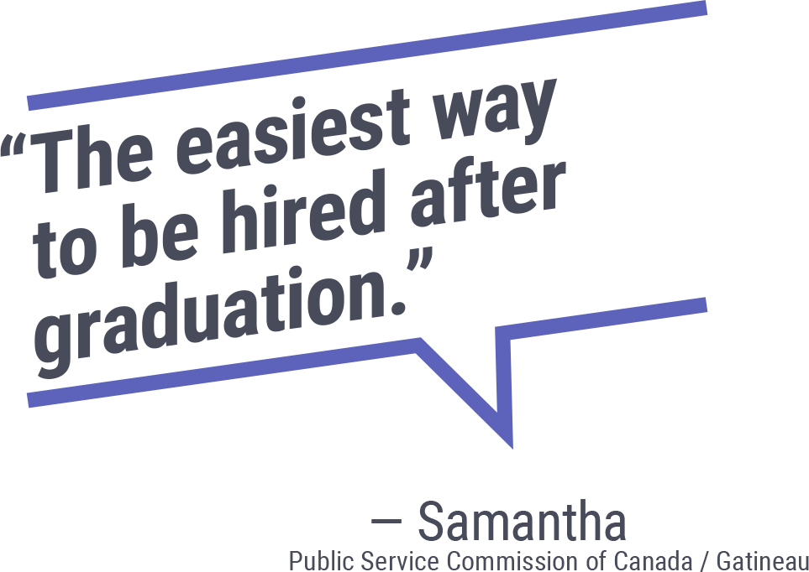A person smiling for the camera


[**CLICK HERE**](https://www.gcpedia.gc.ca/wiki/Indigenous_Student_Employment_Opportunity) **for more resources for you on GCpedia!**

### Events