Department of Fisheries and Oceans (DFO) | Ministère de Pêches et Océans (MPO)
Breakout Rooms in Microsoft Teams Meetings Guide
A user-focused guide for organizers on how to create and manage Breakout Rooms in scheduled Microsoft Teams meetings.
Lim, Natasha
Fisheries Management & Corporate Solutions (FMCS) | Gestion de la Pêche et Solutions Corporatives (GPSC)
Created: December 7, 2020
Last Modified: December 8,2020

Table of Contents
Breakout Rooms Overview 3
Create Breakout Rooms 3
Manually Assigning Participants to Breakout Rooms 4
To assign participants to a breakout room: 5
To change a participant’s breakout room: 6
Renaming Breakout Rooms 8
Add an Additional Breakout Room 8
Delete a Breakout Room 9
Options for Sending Participants to Breakout Rooms 9
Opening Breakout Rooms 10
Opening Breakout Rooms Simultaneously 10
Opening Breakout Rooms Individually 11
Send an Announcement to All Breakout Rooms 11
Joining a Breakout Room as an Organizer 12
Recording in Breakout Rooms 13
Sharing and Accessing Files in Breakout Rooms 15
Attendee Restrictions in Breakout Rooms 16
Closing Breakout Rooms 16
Closing Breakout Rooms Simultaneously 16
Closing Breakout Rooms Individually 17
After Closing Breakout Rooms 17
Re-opening Breakout Rooms Simultaneously 18
Re-opening Breakout Rooms Individually 18
Recreating Breakout Rooms 18

Breakout Rooms Overview
Breakout rooms are “mini meetings” or sessions within a scheduled meeting whereby the organizer can separate participants of the meeting into smaller groups for collaboration, brainstorming, training etc. These sessions can only be initiated by the organizer of the meeting, who must remain present during the course of the meeting. This function can currently only be utilized in the desktop client of the Microsoft Teams application (the web client currently does not support this feature). Please note that organizers can only assign participants to breakout rooms once they have joined the meeting.

Create Breakout Rooms
Reminder: To create breakout rooms you must be the organizer of the meeting and have the meeting open in the desktop application of Microsoft Teams.
To create breakout rooms as the meeting organizer:
- Join the Microsoft Teams meeting in the Microsoft Teams desktop application
- Click on the Breakout rooms icon in the call menu
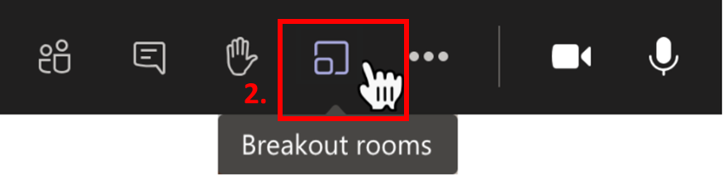
- Select the Number of Rooms you would like to create
  - Note: you can create up to 50 breakout rooms in a meeting
- Select How you would like to assign participants
  - Automatically – assigns the participants to breakout rooms automatically based on the number of participants (ex. Assign 40 participants into 4 rooms – 10 participants per room)
  - Manually – allows the organizer to place all of the participants in breakout rooms manually (ex. Assign specific people to specific rooms based on topic)
- Click Create Rooms
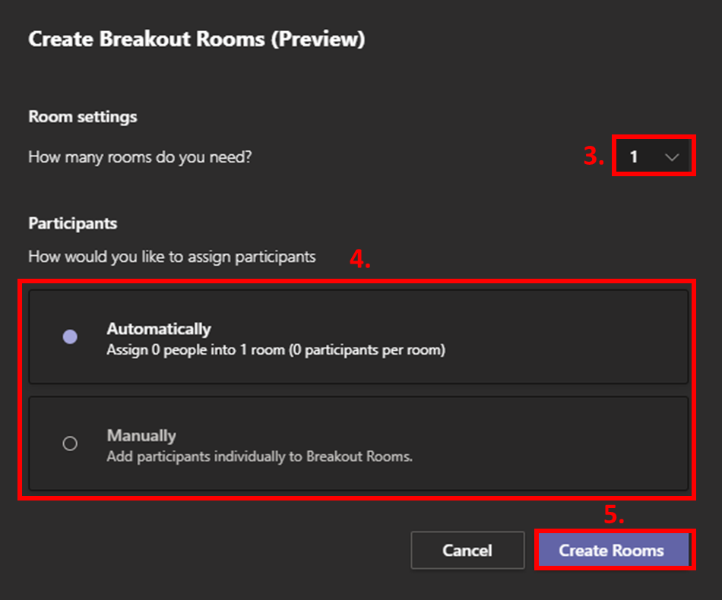
Once the rooms have been created they should indicate that they are Closed next to the room name. This means that they are not currently active and participants cannot yet join the sessions.

Manually Assigning Participants to Breakout Rooms
In order to assign participants to breakout rooms, they must be in the meeting. Participants will not be able to be added to breakout rooms until they join the meeting. Once assigned, participants can also be re-assigned to other breakout rooms.

To assign participants to a breakout room:
- Click on the icon beside Assign Participants to expand the drop-down menu
- Tick off the box next to the person’s name you wish to assign
- Select Assign
- Select the breakout room you wish to have the participant assigned to
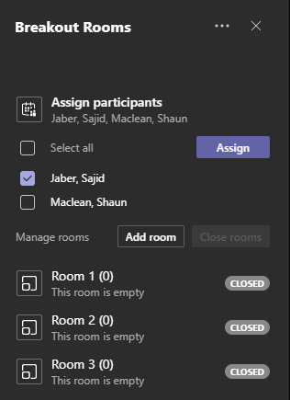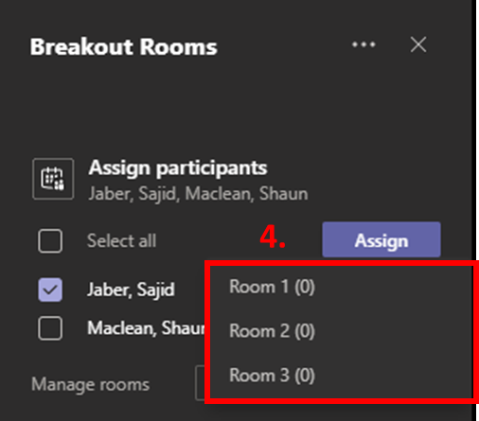
1.
2.
3.

To change a participant’s breakout room:
- Click on the Breakout room icon beside the name of the breakout room the participant is currently in
- Tick off the box next to the person’s name you wish to re-assign
- Select Assign
- Select the new breakout room you wish to have the participant assigned to
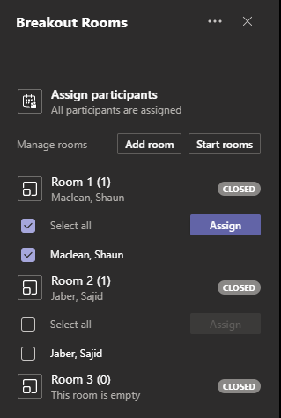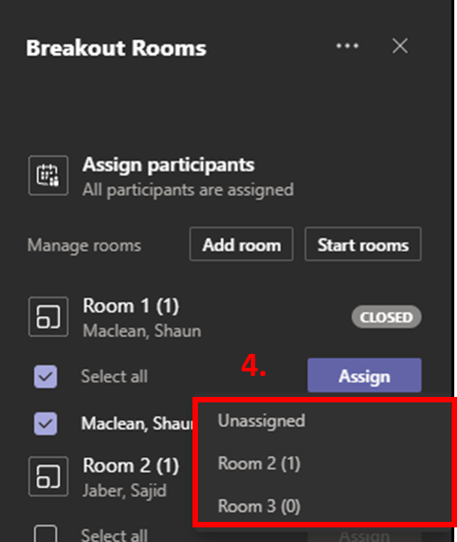
1.
2.
3.

Renaming Breakout Rooms
By default, created breakout rooms will be named numerically (ex. Room 1, Room 2, Room 3, etc.). These rooms can be renamed if desired to reflect the purpose or topic of the room (ex. Training, Communications, Project Management etc.).
To rename a breakout room:
- Click on the three dots for More options beside the name of the room you wish to rename
- Select Rename room
- Enter the desired Name for the room
- Click Rename room
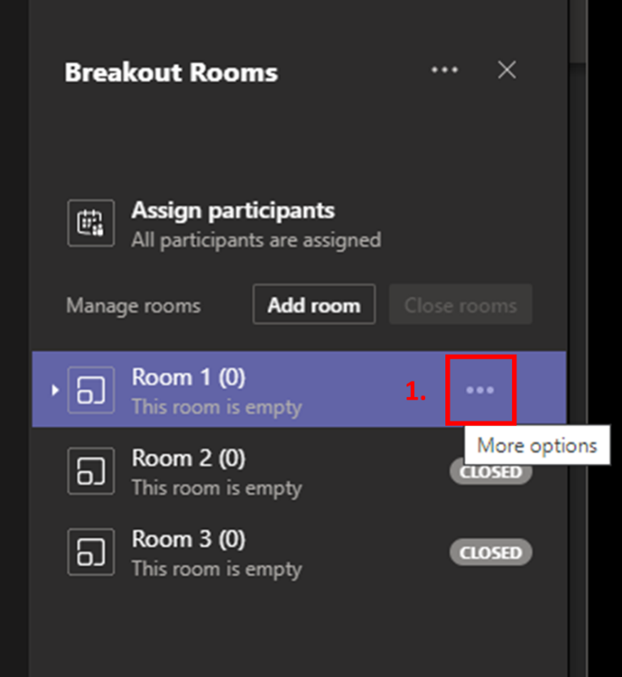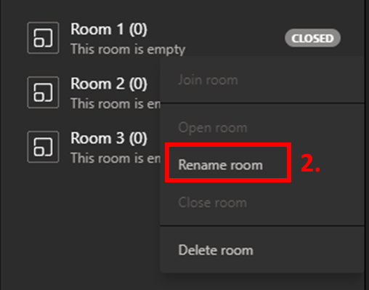
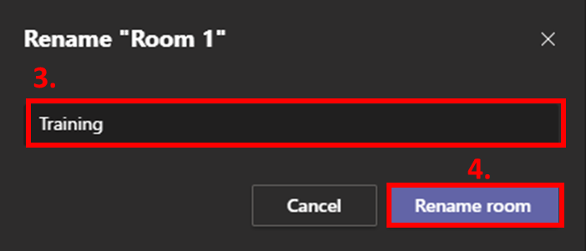

Add an Additional Breakout Room
Once breakout rooms have been created, the organizer can add more breakout rooms individually if more are required.
To add an additional breakout room:
- Click on Add room
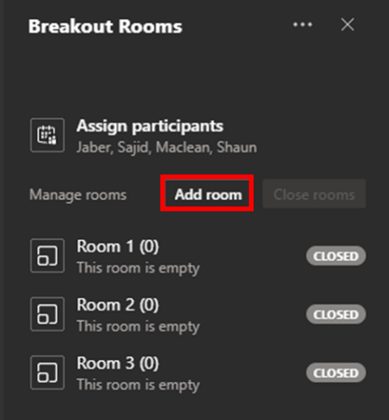

Delete a Breakout Room
Once breakout rooms have been created, the organizer can delete breakout rooms individually if they are not required.
To delete a breakout room:
- Click on the three dots for More options beside the name of the room you wish to delete
- Select Delete room
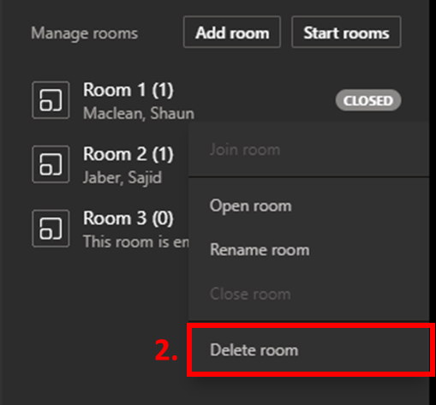

Options for Sending Participants to Breakout Rooms
Participants can join a breakout room optionally or automatically depending on the settings set by the organizer. By default this is set to automatically send participants to their respective breakout rooms once opened by the organizer.
To have participants join breakout rooms automatically upon the organizer opening the sessions:
- Click on the three dots for More options in the main Breakout Rooms panel
- Select Room settings
- Tick off the box that says “Automatically move people into opened rooms”
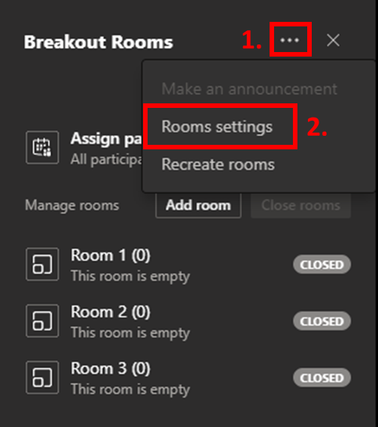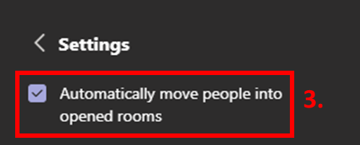
If this box is checked, the attendees will view a countdown before being placed into the breakout rooms once opened by the organizer.
If this box is unchecked, the attendees will receive a pop-up asking if they would like to join their designated breakout room session. Organizers will be able to view who has joined the breakout sessions from the Breakout Room panel.

Opening Breakout Rooms
Once the breakout rooms have been created and the settings for joining have been established, organizers can open/start all of the breakout rooms at the same time, or individually.

Opening Breakout Rooms Simultaneously
To open all of the breakout rooms simultaneously:
- Click on Start rooms from the Breakout Rooms panel
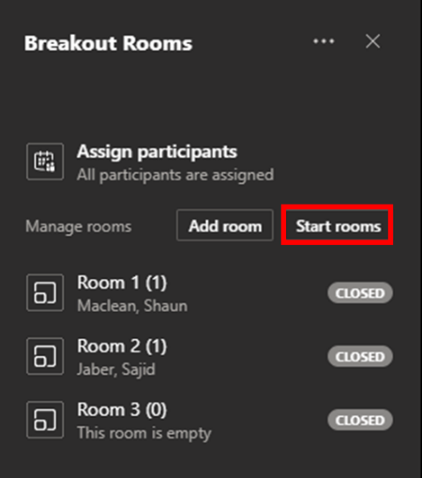

Opening Breakout Rooms Individually
To open any of the breakout rooms individually:
- Click on the three dots for More options beside the name of the room you wish to open
- Select Open room
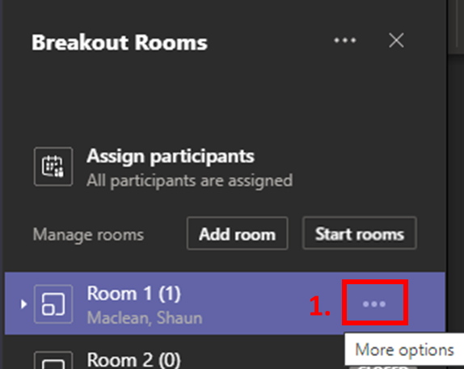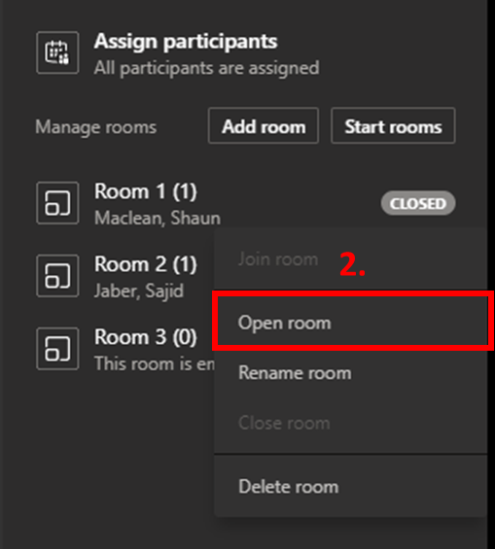

Send an Announcement to All Breakout Rooms
Once breakout rooms have been opened, the organizer can broadcast an announcement message via the meeting chat across all breakout rooms to keep participants informed of any updates, changes, or news during the sessions. Only the organizer can send breakout room announcements.
To create an announcement:
- Click on the three dots for More options in the main Breakout Rooms panel
- Select Make an announcement
- Write the desired announcement in the pop-up window
- Click Send
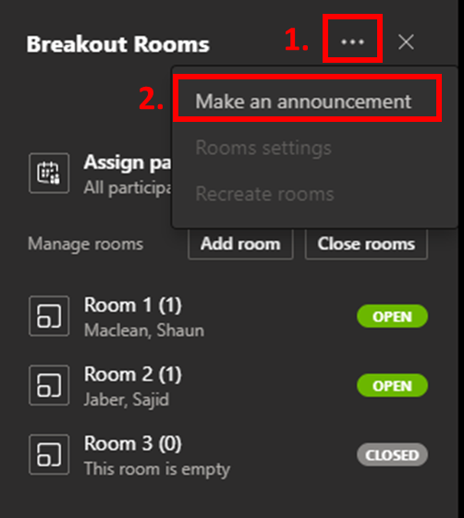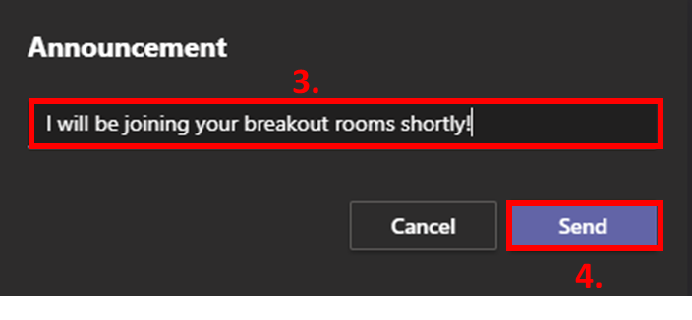
Anyone in any of the breakout rooms will be able to see this announcement (which will be sent as an important message), as well as reply to it. Announcements can also be made to individual breakout rooms by using the dedicated meeting chat for that particular breakout room.
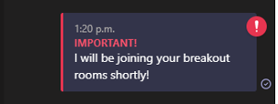

Joining a Breakout Room as an Organizer
Organizers cannot be in all breakout sessions at once, however they can switch between breakout rooms as necessary. Note that rooms can only be joined once they are opened.
To join a breakout room:
- Click on the three dots for More options beside the name of the room you wish to join
- Select Join room
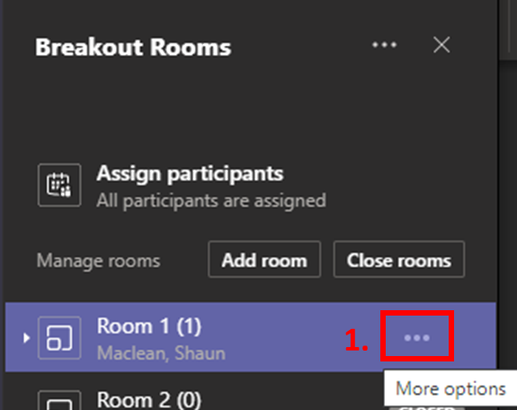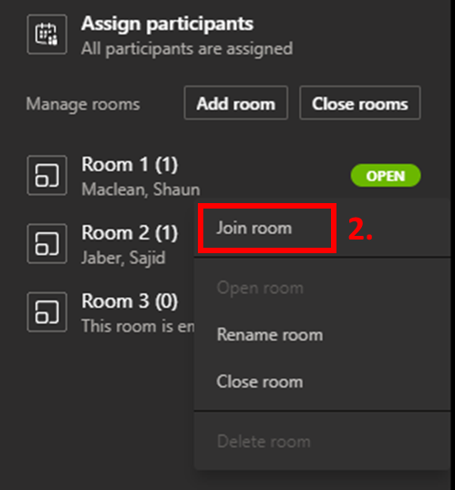
There is no warning or countdown when an organizer joins a meeting. If privacy within the breakout sessions is to be considered, it may be beneficial for the organizer to include a message that they will be joining prior to in the dedicated meeting chat for that particular breakout room.

Recording in Breakout Rooms
It is important to note that if recording is initiated in one meeting (main or breakout room), recording only occurs for that particular meeting. When recording is initiated in one meeting, it is not automatically initiated in any of the other meetings. To record all of the meetings, the organizer must join each of the meetings to initiate recording.
Reminder: Due to ATIP and Legal concerns, meeting recording permissions are no longer provided unless approved by your corresponding Assistant Deputy Minister (ADM)/Regional Director General (RDG)/Assisstant Commissioner (AC). There is now a process in place whereby clients have to request recording permissions indicating the intended purpose for this permission (ex. Training purposes) from their corresponding ADM/RDG/AC. Once written approval is obtained, it is submitted as a request through the IT Self Service assyst portal here http://assystlibreservice.ent.dfo-mpo.ca/assystnet/#services as a ticket under Microsoft Teams > Request recording permissions in Microsoft Teams with the written confirmation included as an attachment. Please see this communication for reference - https://intranet.ent.dfo-mpo.ca/mpo/en/node/4174.
To record a meeting or breakout room:
- Click on the three dots for More options in the call menu
- Select Start recording
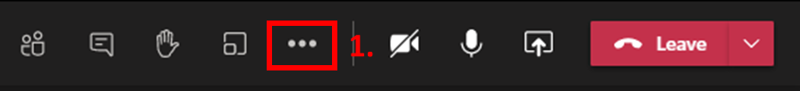
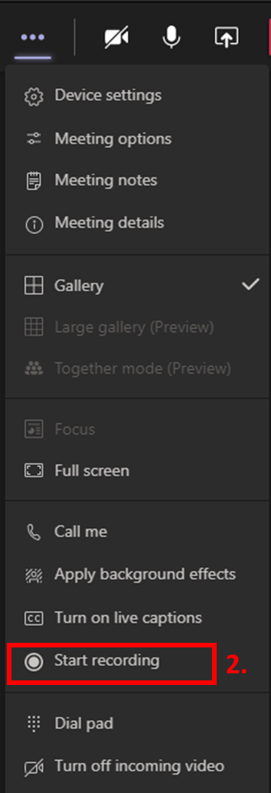
Once recording has finished the recording will be processed. Once this is completed the recording will be accessible in the meeting chat via Microsoft Stream or can be accessed in your web browser here https://web.microsoftstream.com/studio/videos under My content > Videos.

Sharing and Accessing Files in Breakout Rooms
While breakout rooms are open, participants can upload files to the breakout room chat (or the main meeting chat) as they would in a regular Teams meeting.
To add a file to the meeting:
- Click on the Meeting chat
- Click on the Paper clip to Attach
- Select whether you want to upload a file from OneDrive or from Your computer
- Select the file you wish to upload
- Click Share
- Click Send to send your message/file
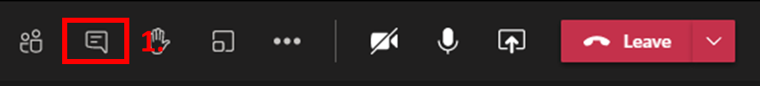
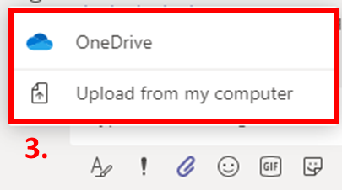
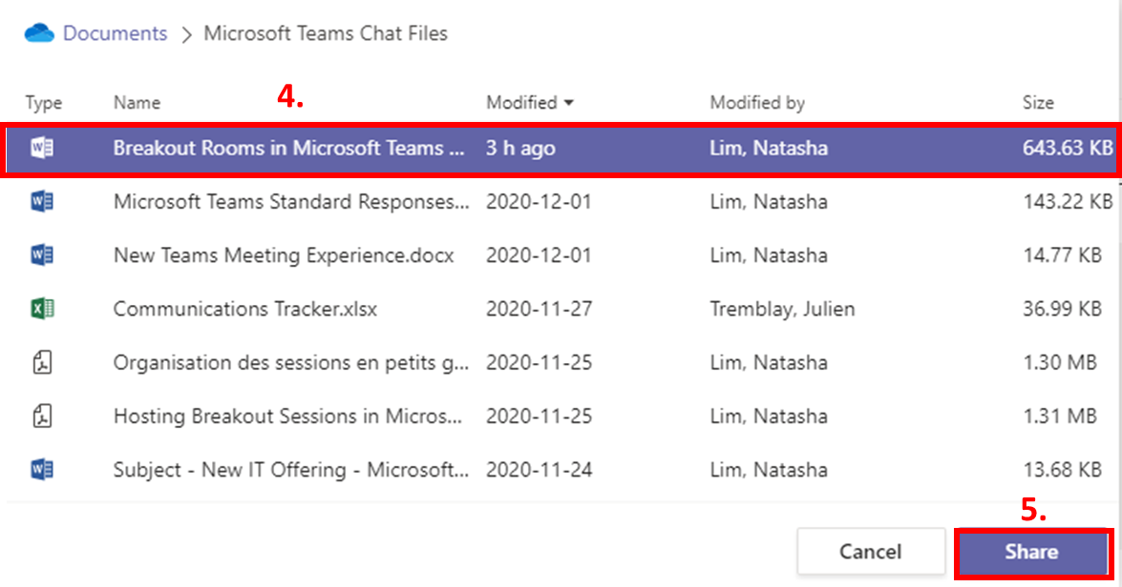
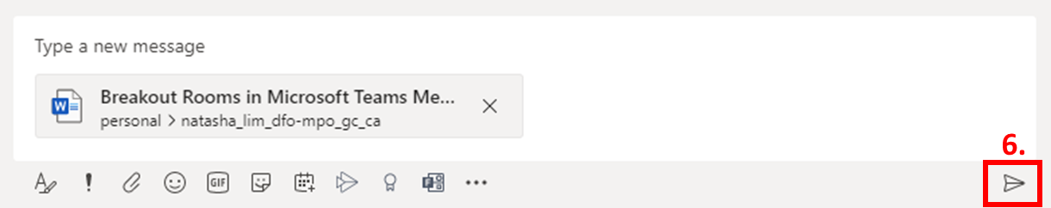

Please note that any messages or files sent in breakout rooms will be visible to the meeting organizer as well as any participants in the designated breakout room.
Once the breakout rooms are closed, participants will still be able to access any shared files and chat messages from their Recent chats, however they will not be able to add any further comments or files.

Attendee Restrictions in Breakout Rooms
- Meeting attendees cannot add or invite other participants to their breakout rooms
- Meeting attendees cannot access the meeting details to share with other participants

Closing Breakout Rooms
Once the time has come to end the smaller group sessions, the meeting organizer can close the breakout rooms, pulling the participants back into the main meeting. Breakout rooms can be closed at the same time, or individually.

Closing Breakout Rooms Simultaneously
To close all of the breakout rooms simultaneously:
- Click on Close rooms from the Breakout Rooms panel
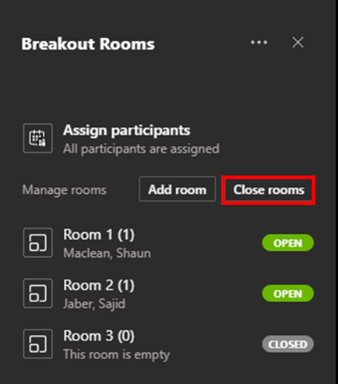

Closing Breakout Rooms Individually
To open any of the breakout rooms individually:
- Click on the three dots for More options beside the name of the room you wish to close
- Select Close room
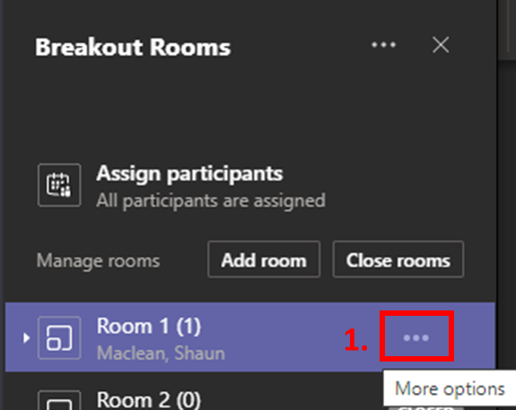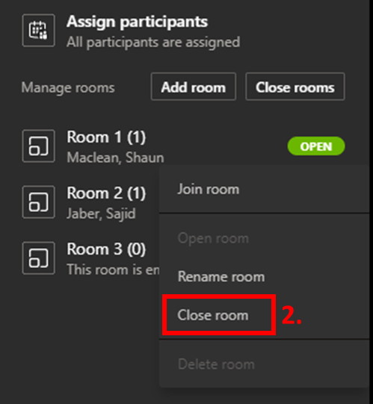

After Closing Breakout Rooms
Once the organizer has closed the breakout rooms, they can be re-opened if desired at the same time, or individually, using the same steps as previously stated. If re-opened, the breakout rooms will contain the same artifacts (shared files, whiteboards, etc.) as they previously had so that attendees can continue to work on existing content. Alternatively, the organizer can recreate rooms to generate new breakout rooms with no existing content.

Re-opening Breakout Rooms Simultaneously
To open all of the breakout rooms simultaneously:
- Click on Start rooms from the Breakout Rooms panel
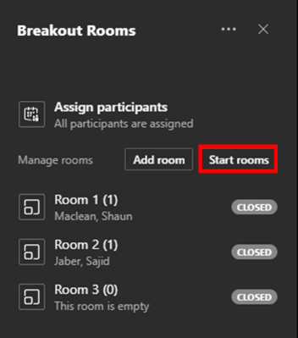

Re-opening Breakout Rooms Individually
To open any of the breakout rooms individually:
- Click on the three dots for More options beside the name of the room you wish to open
- Select Open room

Recreating Breakout Rooms
To recreate new breakout rooms with no existing content:
- Click on the three dots for More options in the main Breakout Rooms panel
- Select Recreate rooms
- Click Recreate
- This will bring you back to the original “Create Breakout Rooms” screen where you can complete the previously mentioned parameters for your breakout rooms
- Select the Number of Rooms you would like to create
  - Note: you can create up to 50 breakout rooms in a meeting
- Select How you would like to assign participants
  - Automatically – assigns the participants to breakout rooms automatically based on the number of participants (ex. Assign 40 participants into 4 rooms – 10 participants per room)
  - Manually – allows the organizer to place all of the participants in breakout rooms manually (ex. Assign specific people to specific rooms based on topic)
- Click Create Rooms
