Principles of Effective Workplace Storytelling

Serve Your Audience Take time to reflect on who is in your audience and consider their needs and goals. Your stories should prepare them for an action or outcome. Why are you telling this story? What do you want your audience to think, feel and do afterward?
Be Authentic Tell your stories or stories about real people who confront real challenges and feel real emotion. If a story is about someone else, don’t pretend it is your own. Instead focus on how and why the message resonates and has special meaning for you. Sometimes your characters will be things or concepts, such as departments, programs, policies and projects. When you do this, don’t overlook the human element. Your audience will care about people and emotional experiences more than ideas or objects.
Find the Struggle Do you or your team have a goal or a challenge? Does your policy or program struggle to produce results? This is where the story begins. Does your character or team achieve their goal or solve their problem? Does your idea, policy or program produce a positive outcome? This is where your story ends. All effective stories have conflict or tension. Find a struggle and you will find your story.
Keep it Simple Not every story is an epic adventure told using decorative language. A detailed chronology of events will quickly bore your audience as will too much description. Focus on meaningful moments. Then tell your story with only as much detail as you need to reveal the struggle and outcome.
Structure for Success Respect tried and true story structure with a clear beginning, middle and end. Start by giving your protagonist a goal or desire. Show them facing obstacles and challenges while pursuing their goal. Change is essential. Whether they win or lose, your protagonist and their situation should change or grow from all they have gone through.

1

Traditional 3-Act Story Structure
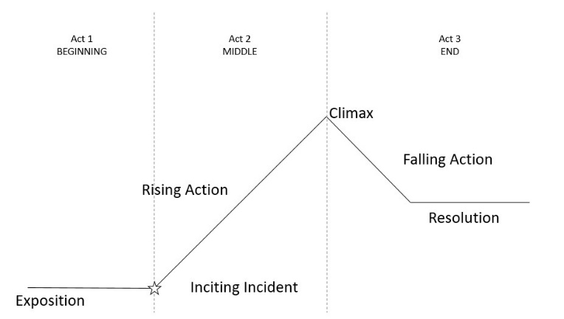
Exposition: Introduce the main character(s) and their situation
Inciting Incident: A problem or challenge confronts the main character and produces their goal
Rising Action: Your main character goes through some ups and downs while trying to achieve their goal
Climax: Your character succeeds, fails or a bit of both
Falling Action: Loose ends are tied up
Resolution: Your main character or their situation changes

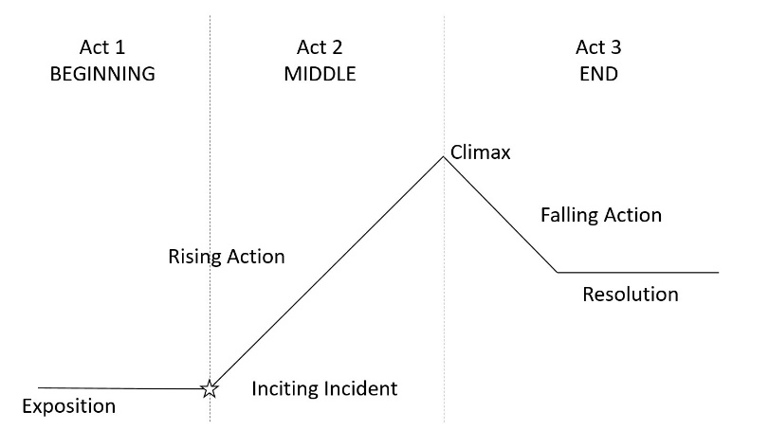

Do you need some ideas to get started?
Borrow from these popular story formulas
Quest: Tell how you went searching for a solution, resource or tool but kept hitting obstacles and challenges and how the journey, not the prize, made you grow and change. Goal - Struggle - Change

Voyage & Return: Tell how your team took a big risk, experimented, explored or tried something innovative and learned a valuable lesson in the process. Risk - Struggle - Change

Overcoming the Monster: Tell how your organization overcame a wicked problem to improve program and service delivery.
Problem - Struggle - Change

Follow us on Twitter @ GC_Transferable or email our team for more information at
csps.transferableskills-compentencestransferable.efpc@canada.ca

Images: "©my_stock/Adobe Stock"
2

