What can I find in the page tabs?

At the top of the Wiki home page you will find some useful tabs. These tabs relate to the particular page you are viewing. Some additional tabs are available only after you have logged in.

These tabs allow you to discuss/talk/comment on a page, edit a page, view a page's history, change your preferences, watch a page for changes, add pages to your favourites, and view your contributions on Wiki.

Default for all users (not logged in)

Main Page
Discussion: See what others may have written about the current page, or to add your own comments to the discussion thread.
Read: Enables you to view a page and read it.
View Source: Takes you directly to the source code of the page, and, if available, you may edit this code.
View History: Every editable page has an associated page history, which is accessed by clicking View history at the top of the page. The page history contains a list of the page's previous revisions, including who made the changes and the nature of the edit or change
Wiki search bar: Search for pages by typing keywords into the Wiki search bar.

Extra tabs for logged-in users

Language toggle: Allows you to select your language preferences.
Talk: The Talk tab will bring you to a page where you can create a new Talk post to share with the GCwiki community.
Preferences: This tab will bring you to your preference settings where you will see special tabs such as User Profile, Appearance, Editing, Recent Changes, and Watchlist. From here, you may also modify:
- Your basic information
- Internationalisation (language preferences).
- Signature
- Email options
Note: When making changes to your preferences, always click save at the bottom of the page to ensure that the changes are saved.
Watchlist: Click so you are notified when the page is changed and are kept aware of revisions.
Star (Favourites) Icon: By selecting the star tab, the page that you are visiting will be added to your Favourites.
My favourites: Click to easily add or remove a page from your list of favourites. These are pages you frequently visit. Unlike your watch pages, you will not receive notification when your favourites are edited.
Contributions: Allows you to view your contributions on GCwiki.
More: This tab reveals a drop-down menu that allows you to access Watch. When you select the Watch tab, the page that you are visiting will be added to your Watchlist.
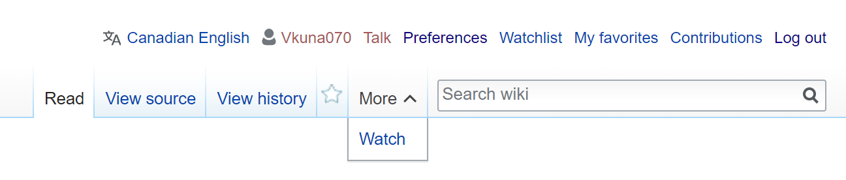

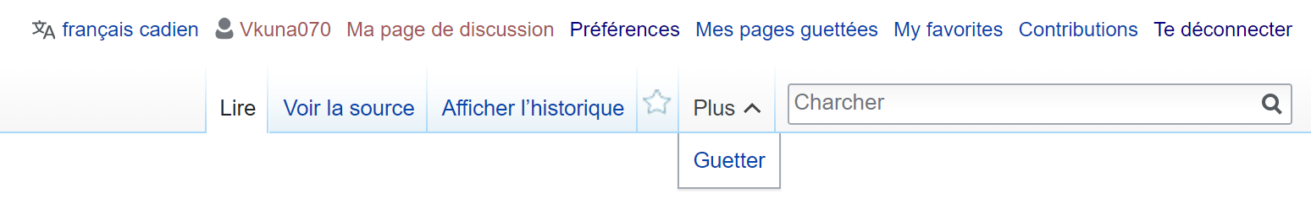

Extra tabs for discussion pages

Edit source: Select this tab if you wish to view and edit the page that you are visiting.
Add topic: adds a new section to a discussion page, without changing what is already there.

