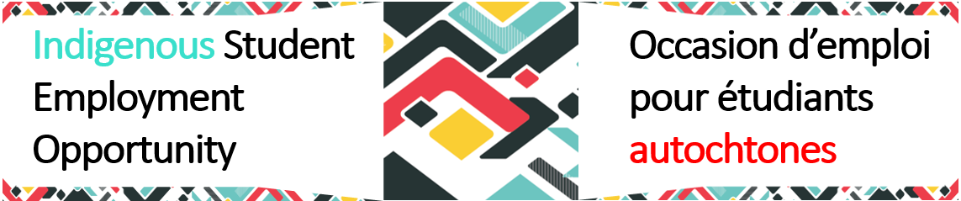

# ISEO Pulse –Summer 2025 Edition, June volume

*Supporting Indigenous students on their public service journey.*

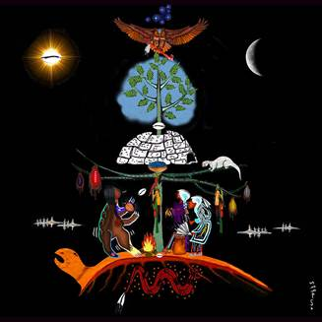**Welcome Message**

Welcome to the Summer 2025 edition of the **ISEO Pulse**! As we mark [National Indigenous Peoples Month](https://www.rcaanc-cirnac.gc.ca/eng/1466616436543/1534874922512), we honour the strength, diversity, and stories of First Nations, Inuit and Métis peoples. Our team is proud to walk alongside you as you grow your career in the federal public service.

***“We are not meant to walk our path alone. The ones who came before us left teachings so we could find our way and we carry the responsibility to guide those who come next.”*** -Anishinaabe teaching on mentorship and shared responsibility

“The Tree of Life," painting by Zhaawano Giizhik depicting the story of the Girl Who Walked the Bear Path.

This edition of the newsletter highlights resources, events, and inspiring voices to support you as you explore your professional path.

📚 Happy reading!

*- The ISEO team: Véronique, Karyne, Sylvie, Maggie and Laura*

**What’s New / Program Updates**

The ISEO team is continuing to support your journey with ongoing programming and resources designed to help you grow, connect, and prepare for your next steps in the federal public service.

### **Start Strong with the *ISEO Welcome Guide***

If you haven’t already, we invite you to explore the *ISEO Welcome Guide for Indigenous Students*, your go-to resource for navigating your work term with confidence. From onboarding tips and learning opportunities to cultural supports, networks, and wellness tools, the guide is packed with practical advice tailored to your experience as an Indigenous student in the federal public service.

Whether you're starting your very first placement or returning for another summer, this guide will help you feel grounded, connected, and prepared.

👉 Access the guide : [ISEO Students - Welcome Guide 2025](https://view.officeapps.live.com/op/view.aspx?src=https%3A%2F%2Fwiki.gccollab.ca%2Fimages%2F7%2F7f%2FISEO_Students_-_Welcome_Guide_2025_e.docx&wdOrigin=BROWSELINK).

### **Mentorship Tools to Guide Your Journey**

The ISEO Mentorship Program includes new and updated tools designed to make your experience even more meaningful. Whether you’re seeking guidance, career clarity, or simply someone who understands your journey, mentorship is a powerful way to feel supported and empowered. The latest tools include:

* A guide to set SMART objectives
* A guided mentorship reflection worksheet
* Tips to make the most of your mentor-mentee conversations

👉 Learn more and sign up: [ISEO Mentorship](https://www.gcpedia.gc.ca/wiki/Indigenous_Student_Employment_Opportunity_-_MENTORSHIP).

**A Look Back: What We’ve Done So Far**

It’s been a vibrant and inspiring start to Summer 2025! Here's a quick look at the ISEO events that have already brought us together:

**🗓️ June 11 – ISEO Summer Kick-Off event**  
We officially launched the season with a warm, culturally grounded event featuring opening and closing prayers, inspiring speakers, and a space for students across Canada to feel connected. This session emphasized the value of your voice, your identity, and your future in the federal public service.

**🧠 June 16 – An Inspiring Conversation on Mental Health**  
Led by Dr. Nadia Ferrara, this session offered strategies for well-being and resilience, grounded in cultural awareness and professional experience. It was a meaningful moment of reflection and practical advice a reminder that your wellness matters.

**🎯 June 25 – Goal-Setting Workshop**  
Students participated in an interactive session to explore what success means to them, define meaningful goals, and discover tools like the SMART framework and journaling. It was an empowering space to build intention and purpose into your career journey.

**Here’s what’s coming up:**

**🗓️** *July 9, 2025 (Tuesday)* 🕜 *1:30 p.m. to 2:30 p.m. EST | Bilingual*  
 **Mentorship Series: Inspiring Testimonies**

Join us for a dynamic mentoring session where public servants and students come together to foster professional growth and build meaningful connections. Through testimonials and open discussions, you'll gain insight, encouragement, and practical tips for navigating your career path.

**🗓️***July 23, 2025 (Wednesday)* 🕜 *1:30 p.m. to 2:30 p.m. EST | Bilingual*  
 **Indigenous Career Pathways & Employment Opportunities After Graduation**

This practical workshop will guide you through the next steps after graduation as you consider a career in the public service. You’ll learn how to leverage your experience and explore opportunities to stay connected with the federal public service. Topics include enrolling in the [Indigenous Career Pathways](https://www.gcpedia.gc.ca/wiki/Indigenous_Career_Pathways_%E2%80%93_List_of_Available_Indigenous_Talents#I_am_an_Indigenous_job_seeker_-_how_do_I_get_on_the_list.3F); building your network; preparing for assessments and more!

✨ **Your presence, engagement, and insights make these sessions truly special** ✨

We look forward to seeing you at the next events! Check out the [full programming](https://www.gcpedia.gc.ca/wiki/Indigenous_Student_Employment_Opportunity_-_EVENTS) and don’t miss out on these events – they were designed for you!

**Tips for Success**

🌟 **Mentor Spotlight: Mark Young -** **Indigenous Relations & Cultural Heritage Manager, Parks Canada**

With over 25 years of public service experience, beginning as a student in 1997, Mark Young brings a powerful blend of professional insight and cultural grounding to his work. A proud Cree public servant with roots in Opaskwayak Cree Nation and Mosakahiken Cree Nation, Mark has dedicated his career to bridging Indigenous and non-Indigenous worldviews within the federal public service. His advice is grounded in real-world experience and guided by core values drawn from his Cree heritage.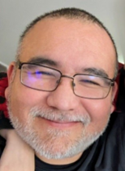 Whether you’re seeking direction, connection, or inspiration, Mark’s approach to leadership and reconciliation in action is a true model of success in the public service.

👉 You’d like to be matched with Mark, this summer? [Send us a message now](mailto:%20cfp.cea-icoe.psc@cfp-psc.gc.ca)!

**Tools & Resources**

**Connect, Grow, Belong: Why Networking Matters**

One of the best things you can do during your work term is to build your network. Connecting with other students, public servants, and professionals across departments helps you learn from others, discover new opportunities, and feel supported in your journey. Whether you're looking for mentorship, career advice, or simply people who "get it," networks can offer the guidance and encouragement you need.

We encourage you to explore the many student and youth networks available through the [Federal Youth Network Learning Hub](https://wiki.gccollab.ca/FYN_Learning_Hub_-_Carrefour_d%27apprentissage_du_RJFF). There, you’ll find national and regional groups offering events, resources, and learning sessions designed just for you.

**Upcoming Dates & Events open to all employees**

**GC Policy Hack**

A grey background with white text
The Federal Youth Network (FYN) is pleased to launch [***GC Policy Hack***](https://forms.office.com/pages/responsepage.aspx?id=8uh8clanLkGkxpUgStaNhEmM_9DuBGtCk1ohtPsu1k9UNVVBM0o3WFhGUE8xNUg0MjFOMkVPQ1lYWC4u&route=shorturl)! GC Policy Hack offers students and new public servants the opportunity to develop a policy solution for a federal government priority while receiving coaching from a policy leader in the GC. Running from July through August 2025, participants will be required to attend skills development workshops and use the skills acquired to formulate a policy solution which they will present to a panel of executives. Click the link above and send your registration form now!

**Federal Youth Network’s Career Showcase series**

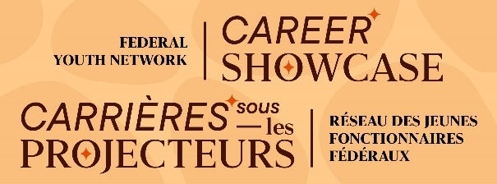Discover the many career paths available to you within the federal public service! The [***Career Showcase series***](https://wiki.gccollab.ca/Federal_Youth_Network/Home_ENG/Events/Departmental_Showcase) highlights different lines of work across the Government of Canada, from communications and policy development to project management and science. Whether you’re just beginning your public service career or considering a change, this series will inspire you to explore new opportunities and grow your network. Events are happening Tuesdays from **July 8 to August 19, 2025,** at 1:00 PM ET in English and 2:30 PM (ET) in French.

**Job board**

* [Student Guide Program in France (Winter 2026)](https://emploisfp-psjobs.cfp-psc.gc.ca/srs-sre/page01.html?poster=1802&lang=en): Veterans Affairs Canada employs students for approximately 4 months, 3 sessions a year. You will be working as a guide at the Canadian National Vimy Memorial and the Beaumont-Hamel Newfoundland Memorial, both located in northern France. Apply by September 8, 2025!
* [Student employment opportunities with the Canadian Security Intelligence Service](https://www.facebook.com/photo.php?fbid=1065745625696594&set=a.259055906365574&type=3&mibextid=wwXIfr&rdid=UHlCKop2Mfd14LWx&share_url=https%3A%2F%2Fwww.facebook.com%2Fshare%2F1BKq1xgFkj%2F%3Fmibextid%3DwwXIfr): CSIS is looking for dedicated and hard-working students who are interested in working in national security. Apply by July 25, 2025.
* [Student - Communications and Outreach](https://ocil.bamboohr.com/careers/25): the Commissioner of Indigenous languages is seeking to fill 2 student positions in Ottawa, Ontario to assist in the development and implementation of the Waves 2025 Global Language Summit outreach initiatives. Job advertisement open until positions are filled.
* [Natural Resources Canada's Student Re-Hire and Bridging Inventory](https://nrcan-rncan.hiringplatform.ca/23600-student-bridging-inventory/74069-resume-gathering/en): This inventory aims to connect hiring managers with students and graduates who have previously worked in the public service, with the goal of rehiring them as students, casual employees, or through the [student bridging mechanism](https://www.canada.ca/en/public-service-commission/services/appointment-framework/student-bridging.html), as indeterminate or term employees. Complete your application today!

**Stay Connected**

✨ We encourage you to ask questions, share your experiences, and to participate in upcoming events. Consider turning on your camera during the events. Seeing each other helps us feel more connected, makes the conversation more human, and creates a stronger sense of community, even in a virtual space. ✨

👉 You have questions for us? Contact us by email at [cfp.cea-icoe.psc@cfp-psc.gc.ca](mailto:cfp.cea-icoe.psc@cfp-psc.gc.ca).