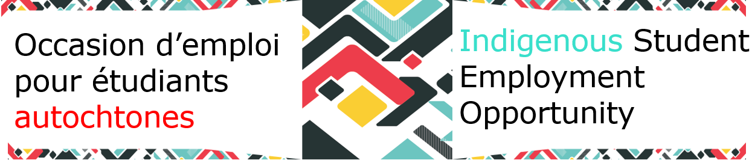



**[ICP](https://www.gcpedia.gc.ca/wiki/Indigenous_Career_Pathways_%E2%80%93_List_of_Available_Indigenous_Talents)**

**Check out these links for your job search needs**

[Jobs for Indigenous Peoples](https://www.canada.ca/en/public-service-commission/jobs/services/gc-jobs/jobs-indigenous-people.html)

[How to read a Job Advertisement](https://www.veterans.gc.ca/en/education-and-jobs/find-new-job/jobs-federal-government/how-read-job-advertisement)

Have you seen the[**Indigenous Student Information Toolkit**](https://wiki.gccollab.ca/images/1/13/Information_Toolkit_for_ISEO_Students_April_23%2C_2024_e.docx)?

It is a collection of useful resources to help you navigate all that the Government of Canada has to offer during your work term.

### NEWSLETTER

### Fall 2024

[**GC Students**](https://forms.office.com/pages/responsepage.aspx?id=8uh8clanLkGkxpUgStaNhEmM_9DuBGtCk1ohtPsu1k9URTEwTU0zM1dQQkQxNE5MNTFHR0M0TEVURy4u&route=shorturl)

[**Check out our Mentorship Program!**](https://www.gcpedia.gc.ca/wiki/Indigenous_Student_Employment_Opportunity_-_MENTORSHIP)

The Indigenous Student Employment Opportunity (ISEO) Mentorship Program is a platform where students can browse through potential mentors to find their perfect fit! There are also templates, mentorship agreements, and conversation topics to help you get started.

For more information, visit the [ISEO Mentorship](https://www.gcpedia.gc.ca/wiki/Indigenous_Student_Employment_Opportunity_-_MENTORSHIP) .

[**CLICK HERE**](https://www.gcpedia.gc.ca/wiki/Indigenous_Student_Employment_Opportunity) **for more ISEO information on GCpedia!**

*Click* [*here*](https://www.gcpedia.gc.ca/wiki/Indigenous_Student_Employment_Opportunity_-_EVENTS) *for more information on ISEO events.*

### Events