Identified User (IU) Instructions for Using Category 1 CST

Bid Solicitation and Resulting Contract Procedures
to acquire Workspaces furniture

Reference: Supply Arrangement for Workspaces, number E60PQ-140003

Contents
Welcome to the Instructions for Using Category 1 CST 3
Section 1 – Understanding your requirement 3
Developing the Requirement 3
Determining the Products Required 4
Section 2 – Understanding the CST 5
Section 3 – Using the CST to search 1A products 6
Step 1 – Open the Category 1 CST 6
Step 2 – Search Category 1A 6
Step 3 – Clearing Filters and Increasing the Search 15
Section 4 – Using the CST to Search 1B Products 15
Step 1 – Open the Category 1 CST 15
Step 2 – Search Category 1B 16
Step 5 – Clearing Filters and Increasing the Search 27
Section 5 – Obtaining the Search Results 28

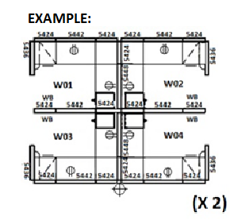
Welcome to the Instructions for Using Category 1 CST

This instruction document will describe the process of how to use the Category 1 CST to search for
interconnecting panel systems products and components to complete this illustrated example:

Section 1 – Understanding your requirement

Developing the Requirement

* For Category 1a requirements, the floor plan must be available in AutoCAD drawing file (.dwg). The space planning of the floor plan must utilize a 3” panel thickness.

Before beginning the CST search for panel systems furniture, Identified Users must first understand and determine which products are required to create their requirement. Once it is understood what is required to be purchased, a search for these items using the Category 1 CST can be completed efficiently. Here is a list of things you will need to know before you are able to perform the search:
- Each of the overall finished panel heights (this could be either Base Height (28”h-38”h), Work Surface Privacy Height (42”h-48”h), Seated Privacy Height (50”h-54”h), or a combination of these heights);
- How each side of each panel will be dressed (example: some panels may be all fabric on both sides, other panels may need electrical cut-outs on one side and/or both sides, other panels may require accessory rails and/or white boards). How each panel is dressed represents a panel type;
- How many panel types there will be for the entire requirement;
- Whether electrical outlets are required and if so, do these need to be above or below the work surface(s);
- The drawer and/or door configuration(s) of all storage items with drawers and/or doors, such as personal storage towers, pedestals, etc. (Example configurations: box/box/file drawers, file/file drawers, open or closed cupboards, left or right hinged doors, etc).

Once you have this understanding of your requirement you are ready to proceed with performing your search.

Determining the Products Required

Once the panel type(s) are determined (how each panel is dressed) for the requirement, the information can be organized as seen below in the form of a panel matrix. A panel matrix is a section view of a panel with the purpose of identifying the configuration of elements and element types on each side of a panel. Side 1 represents one side of the panel and Side 2 represents the opposite side of the same panel. This information is not limited to only the CST as it will also need to be provided to Bidders during the bidding period. This information to Bidders could be organized in one of two ways using either a Panel Matrix(ces) or a Typical Workstation(s). This information is available at Annex C of the Standard RFB document.

In the meantime for search purposes using the example detailed earlier, the organization of the panel type information will be organized using panel matrices. There are four (4) panel types required in our example and each is labelled below with a unique letter (A, B, C, and D). The unique letter corresponds to a location on the floor plan where it will be very important for Bidders to visualize where each panel type is expected to be located. The terminology used to describe the elements is terminology found within the CST and technical specifications of the SA. Identified by yellow high-lighted text are the areas of the panel matrices which need to be determined and identified by the Identified Users for selection within the CST. The template for the panel matrix diagram is available in MS Word format embedded inside the Standard Request for bid (RFB) at Annex C.

For the purpose of this instruction document, below are the panel matrices required to fulfill the illustrated example diagram above.

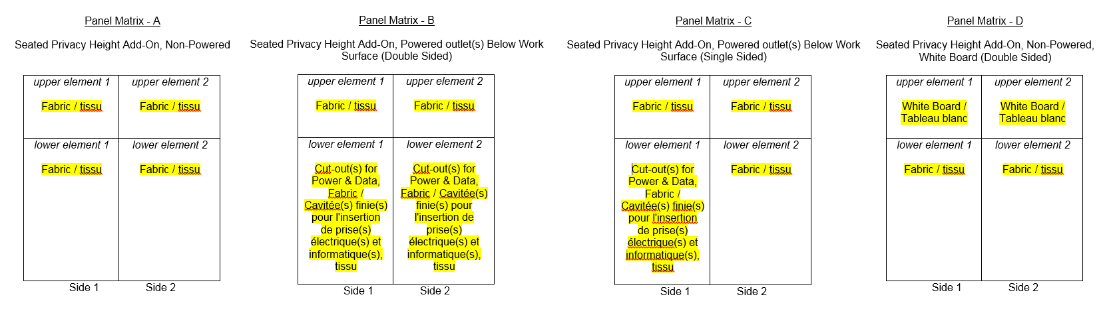

List of products from each 1A & 1B required to comprise our example of two pods of four:

Item | Qty | Category 1A Products
1 | 8 | 36”w Seated Privacy Height Panels, non-powered, fabric (Panel Matrix A)
2 | 24 | 24”w Seated Privacy Height Panels, non-powered, fabric (Panel Matrix A)
3 | 4 | 42”w Seated Privacy Height Panels, non-powered, fabric (Panel Matrix A)
4 | 4 | 24”w Seated Privacy Height Panels, non-powered, white board double sided (Panel Matrix B)
5 | 8 | 42”w Seated Privacy Height Panels, powered below the work surface (single sided), fabric (Panel Matrix C)
6 | 4 | 48”w Seated Privacy Height Panels, powered below the work surface (double sided), fabric (Panel Matrix D)
Item | Qty | Category 1B Products
1 | 4 | 24”w x 24”d x 54”h Personal Storage Towers, metal, right-hinged, box-box-file drawers (B/B/F), closed
2 | 4 | 24”w x 24”d x 54”h Personal Storage Towers, metal, left-hinged, box-box-file drawers (B/B/F), closed
3 | 8 | 24”d B/B/F Pedestals, metal, freestanding
4 | 8 | 24”d x 24”w work surface, panel mounted, rectangular
5 | 8 | 24”d x 42”w work surface, panel mounted, rectangular
6 | 8 | 24”d x 48”w work surface, panel mounted, rectangular
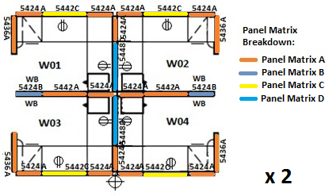

Section 2 – Understanding the CST

Ideally all requirements begin at the CST search to narrow down the products required to complete the overall requirement. It is not recommended to first obtain product quotes from Suppliers and then try to fit these quoted items into the CST. The Workspaces Supply Arrangement (SA) does not utilize manufacturer model codes to identify a product but rather a GoCUIC code per product. Each product under the SA is identified by a GoCUIC code within the CST, with the exception to Category 1A. The Category 1A CST is unique in the fact that there are no GoCUICs present. This is because each panel product is comprised of multiple components (each of these components is identified by its own GoCUIC) to create a fully assembled/dressed panel product. This is the reason it is not possible to limit each panel by only one of the various GoCUICs used to comprise the panel.

*Note that it is not the intended purpose of the CST to search for products provided in a quote from a supplier.

The CST accomplishes the following:
- Determines the Estimated Value (EV) of the requirement;
- Identifies which Tier the requirement falls into so that you may proceed accordingly using the terms and conditions of that respective Tier;

Section 3 – Using the CST to search 1A products

Step 1 – Open the Category 1 CST

Visit the Furniture Website and open the appropriate CST business Stream, either the General Stream or the PSAB Stream CST. Always use a new copy of the Category 1 CST to ensure you are benefiting from the most current information.

Step 2 – Search Category 1A

While Category 1 is broken down into 1A and 1B, the products from both form an entire Category 1 requirement.

When you open the CST, you will see the following three tabs at the bottom of the Excel spreadsheet: “Category 1A”, “Category 1B”, and “Result”. For your Category 1A (panels) requirements, click on the “Category 1A” tab. You will begin all searches starting at the very left side of the Excel CST and work your way towards the right side of the Excel CST filtering at each applicable column heading (#1 through to #7) and finally entering quantities at #8.

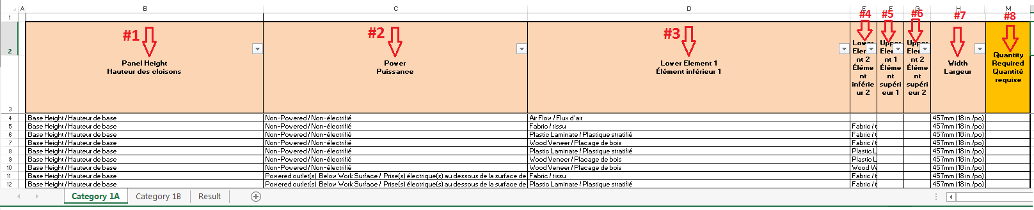

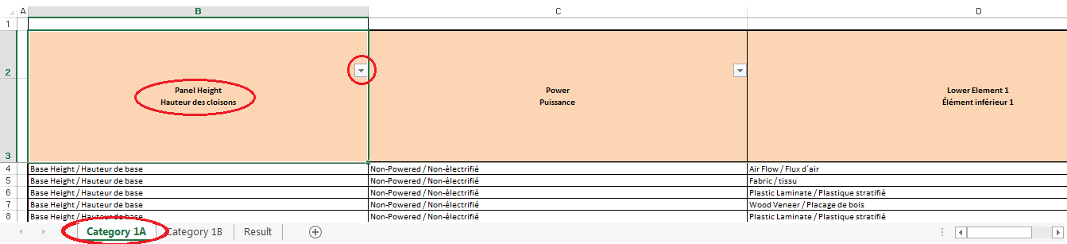

To begin let’s search for Panel Matrix A of our example floor plan. Click on the pull-down button (filter) located at the top of the “Panel Height” column heading on tab Category 1A.
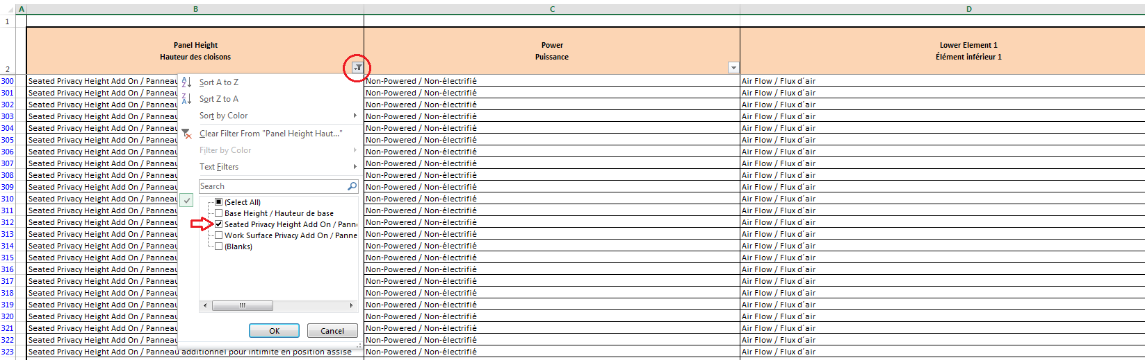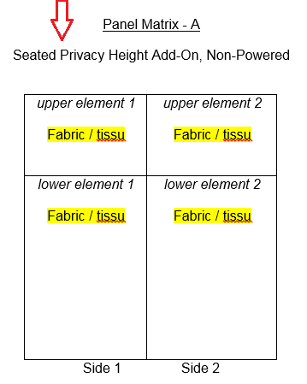

A drop down window will appear under the filter button. This filter offers the selection of all panel heights. Panel Matrix A is showcased at the right of the search image above. Panel Matrix A is described as Seated Privacy Height Add-On, therefore choose “Seated Privacy Height Add On” from the filter drop down window. After making this selection, all other panel heights which were not selected will disappear from the remaining options. This essentially is narrowing down the search as we move from filter to filter.

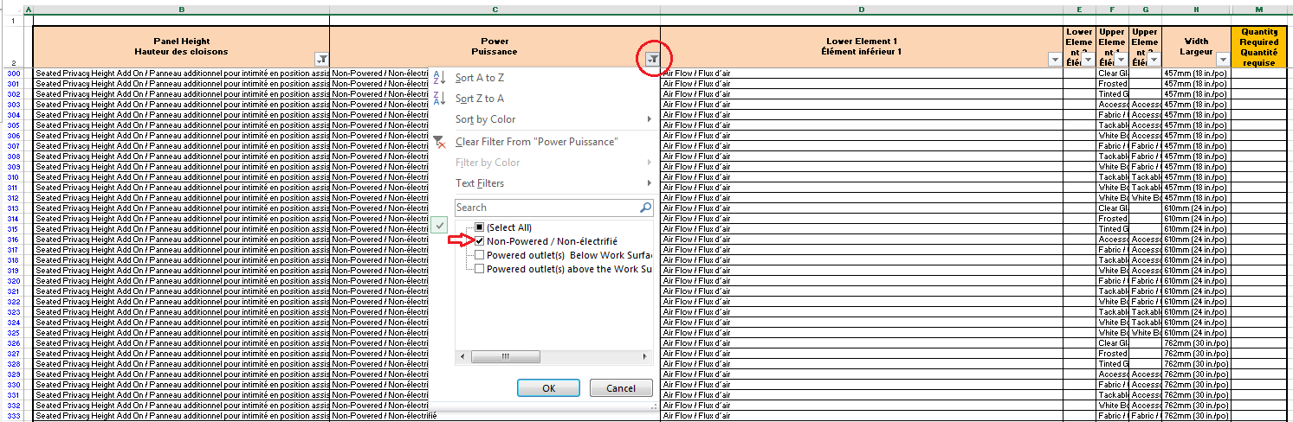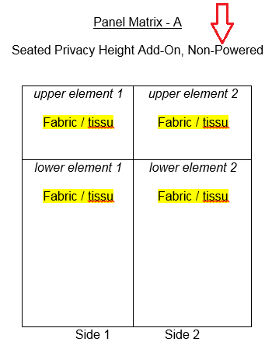

The next filter we will choose from is in the Power column. Panel Matrix A, at the right of the search image above, is described as Non-Powered. Therefore choose “Non-Powered” from the filter drop down window. After making all filter selections, again all other options which were not selected will disappear from the remaining options. Thus far we have narrowed down the search to only Seated Privacy Height Add-On, Non-Powered panels.
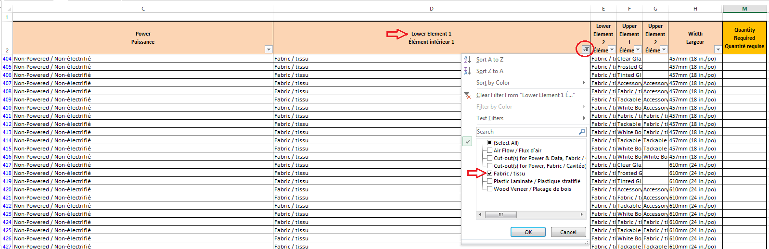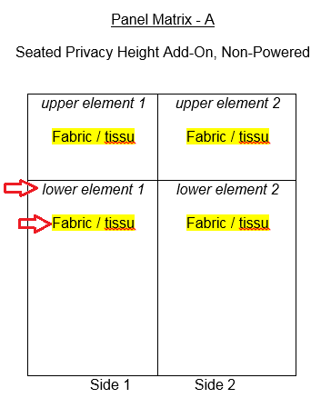

The next filter we will choose from will be our first panel element, Lower Element 1. Panel Matrix A, at the right of the search image above, shows the position of “lower element 1” which is at the bottom of side 1 of the panel. For our example requirement lower element 1 is described as “fabric” in Panel Matrix A, therefore choose “Fabric” from the filter drop down window.

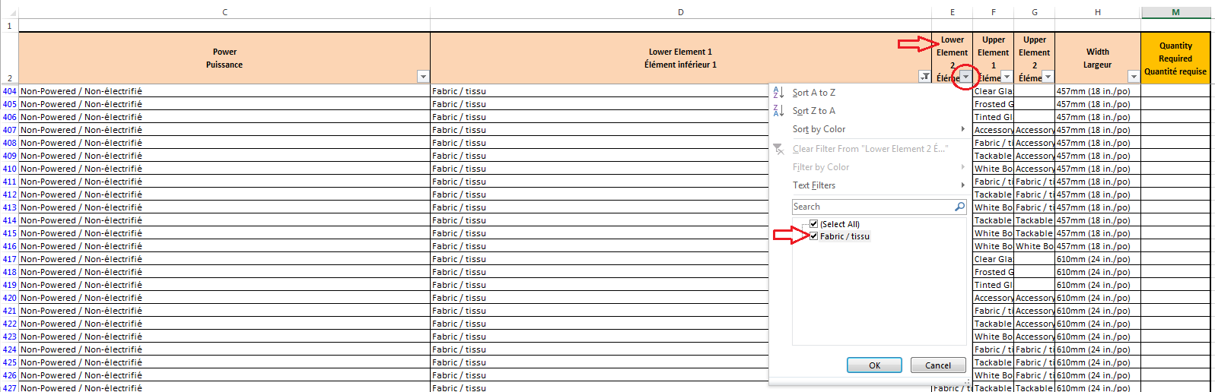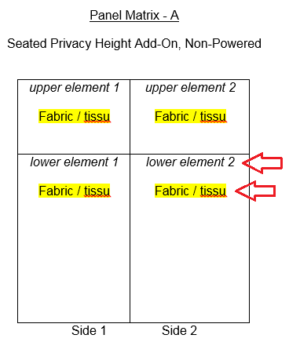

The next filter we will choose from will be Lower Element 2. Panel Matrix A, at the right of the search image above, shows the position of “lower element 2” which is at the bottom of side 2 of the panel. For our example requirement lower element 2 is described as “fabric” in Panel Matrix A, therefore choose “Fabric” from the filter drop down window.

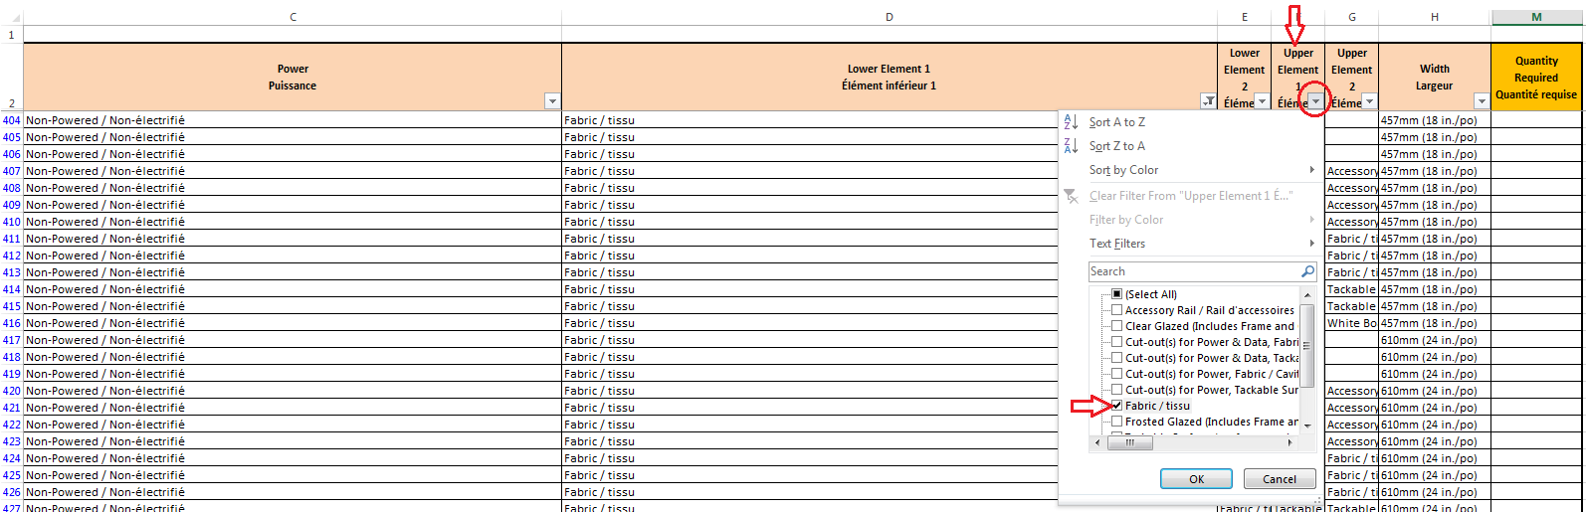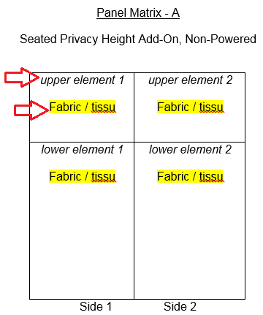
The next filter we will choose from will be our first upper panel element, Upper Element 1. Panel Matrix A, at the right of the search image above, shows the position of “upper element 1” which is at the top of side 1 of the panel. For our example requirement upper element 1 is described as “fabric” in Panel Matrix A, therefore choose “Fabric” from the filter drop down window.

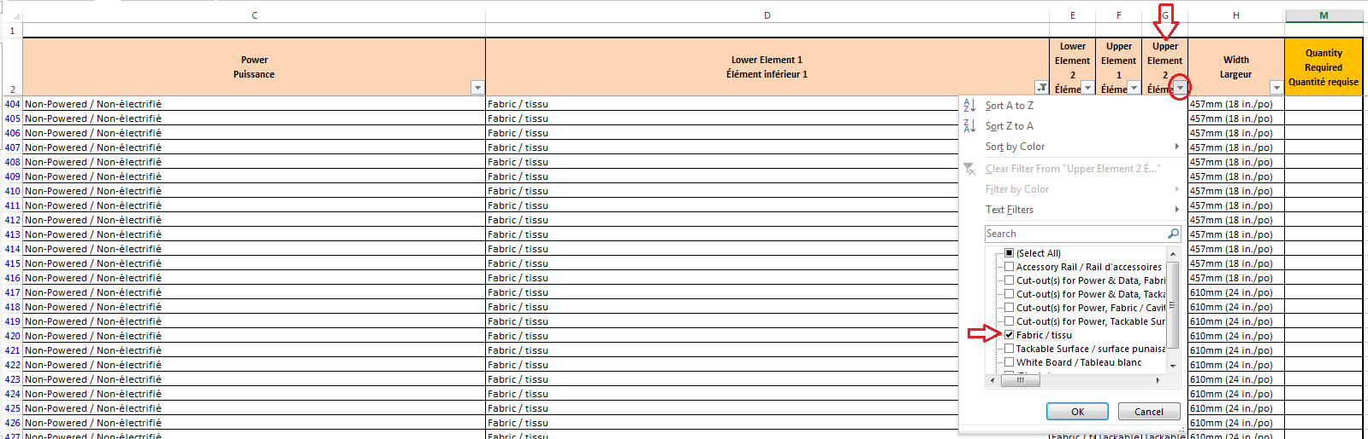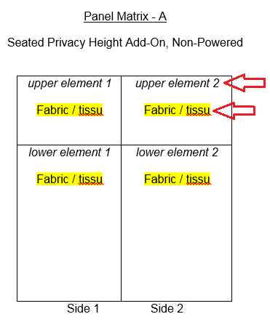
The next filter we will choose from will be our last panel element, Upper Element 2. Panel Matrix A, at the right of the search image above, shows the position of “upper element 2” which is at the top of side 2 of the panel. For our example requirement upper element 2 is described as “fabric” in Panel Matrix A, therefore choose “Fabric” from the filter drop down window.

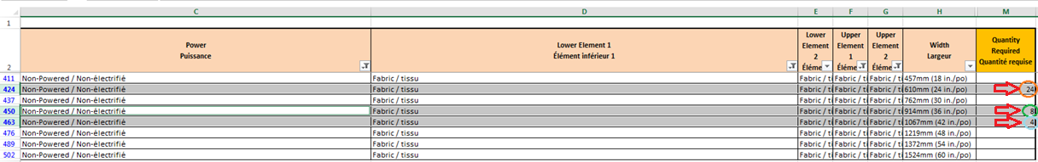
Now that we have completed the search for Panel Matrix A, we can choose the widths required. In the CST image above you will see that we require:
- 24 each panels at 24” wide;
- 8 each panels at 36” wide ;
- 4 each panels at 42” wide.

You can also see in the diagram below where each of these panels is located by the use of orange, light blue and green colouring. Also notice how the panel is identified with an “A” for each panel affected. This clearly identifies for Bidders which panels are Panel Matrix A. Quantities will be inserted into the CST for estimated purposes, however the floor plan is where the Bidders will gather the quantities. Bidders do not see the CST or the results.

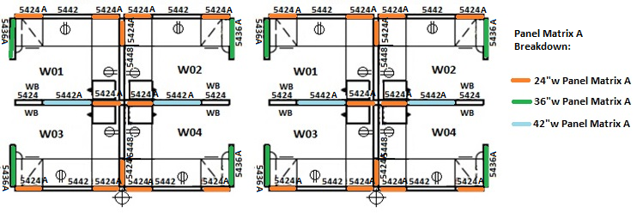
Now that we have searched and entered the quantities required for the first panel matrix (Panel Matrix A) these exact same steps can be repeated to search for the remaining panel matrices of the requirement.
(This instruction document illustrates the steps required to search for Panel Matrix A only. The steps to complete all remaining panel matrices will be the same and not illustrated in this instruction document).
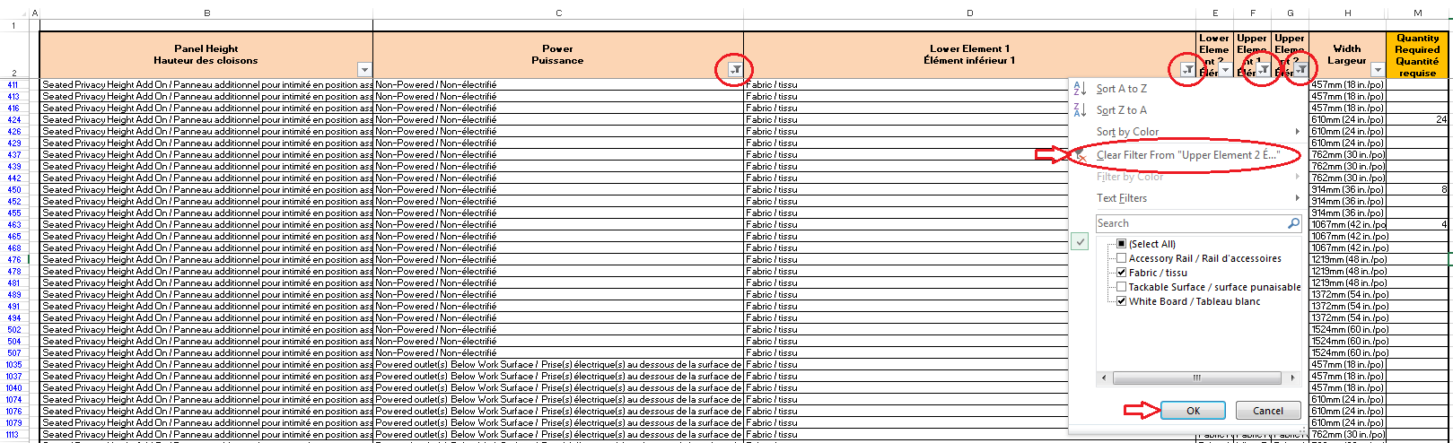

Step 3 – Clearing Filters and Increasing the Search

To search for each next panel matrix, you can clear the filters at the column headers so that you can begin fresh again with the next item to search. Clear each filter by simply clicking on the column headings filter pull-down button, choosing “Clear Filter From “_______”” and clicking “OK” to finish clearing the filter.

After clearing all the filters, the quantities previously entered will remain and your results will maintain what you’ve already searched for. If you delete the quantities however, the CST will not retain the information. You may clear the filters each time you need to search for a new item.

Section 4 – Using the CST to Search 1B Products

Step 1 – Open the Category 1 CST

Visit the Furniture Website and open the appropriate CST business Stream, either the General Stream or the PSAB Stream CST. Always use a new copy of the Category 1 CST to ensure you are benefiting from the most current information.

Step 2 – Search Category 1B

While Category 1 is broken down into Category 1A and Category 1B, the products from both form an entire Category 1 requirement.

When you open the CST, you will see the following three tabs at the bottom of the Excel spreadsheet: “Category 1A”, “Category 1B”, and “Result”. For your Category 1B requirements, click on the “Category 1B” tab. You will begin all searches starting at the very left side of the Excel CST and work your way towards the right side of the Excel CST filtering at each applicable column heading (#1 through to #11) and finally entering quantities at #12.

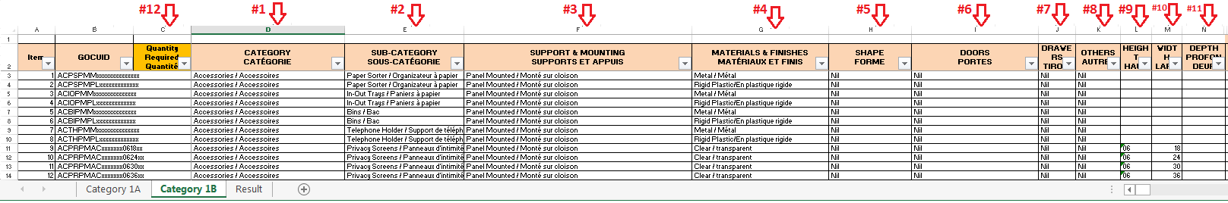
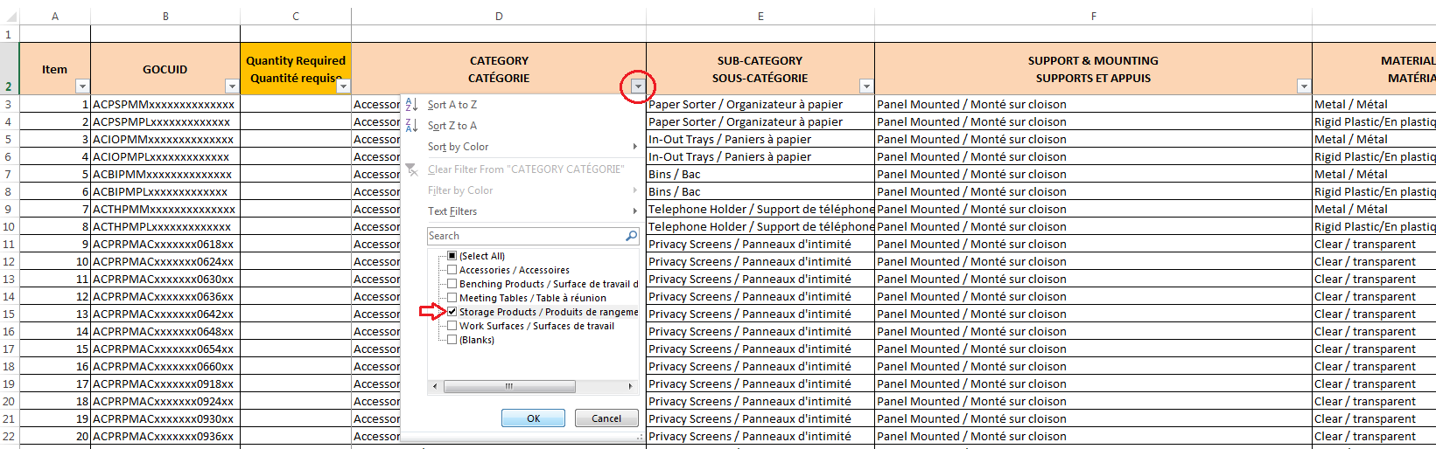

To begin, click on the pull-down button (filter) located at the top of the “Category” column heading on tab Category 1B. A drop down window will appear under the filter button. This filter offers the selection of all categories of products which complement the interconnecting panels from 1A.

For the purpose of this instruction document we will search for the 24”w x 24”d x 54”h Personal Storage Towers, metal, right-hinged, box-box-file drawers (B/B/F), closed. Therefore choose “Storage Products” from the filter drop down window. After making this selection, all other categories which were not selected will disappear from the remaining options. This essentially is narrowing down the search as we move from filter to filter.

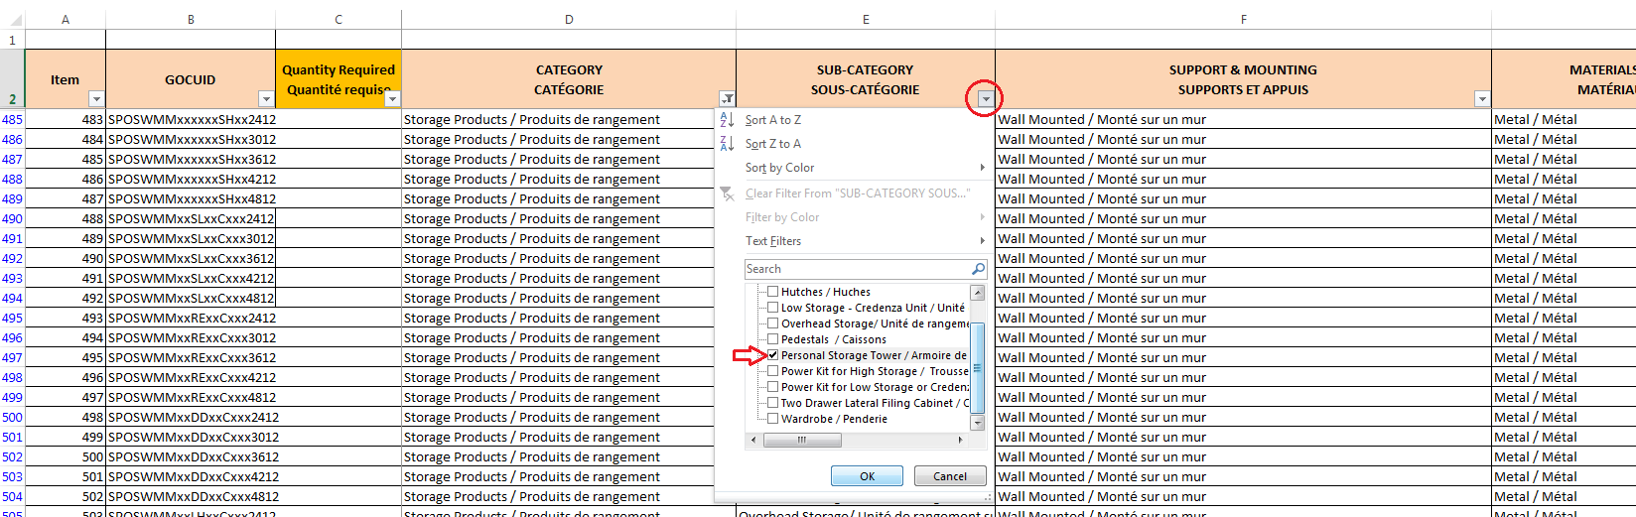

The next filter we will choose from will be “Sub-Category” and this offers the selection of all storage products. Select the “Personal Storage Tower” from the filter drop down window and click OK.
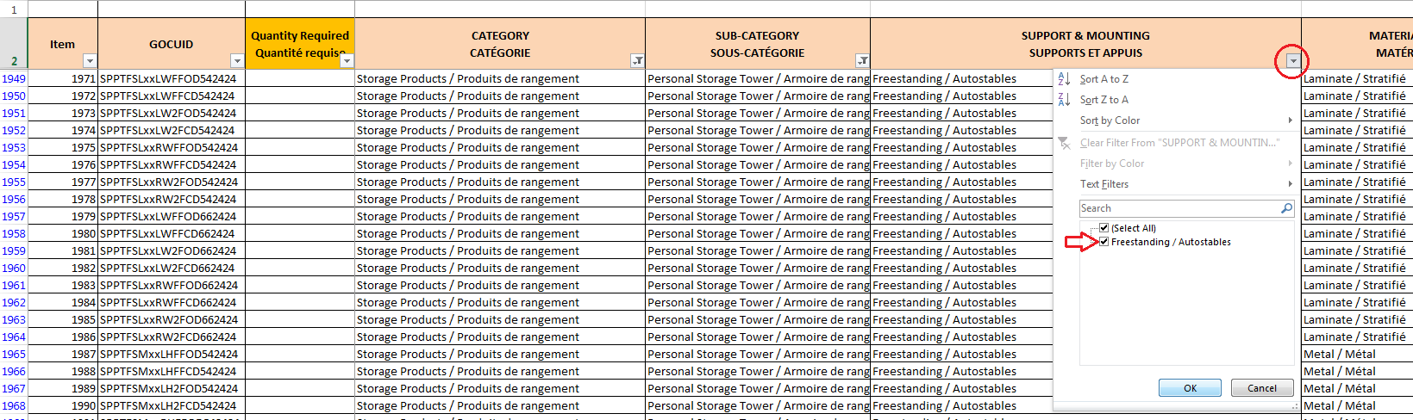

Next we will choose the “Support & Mounting” option available for personal storage towers. The only option available is “Freestanding” therefore we will select this and click OK.
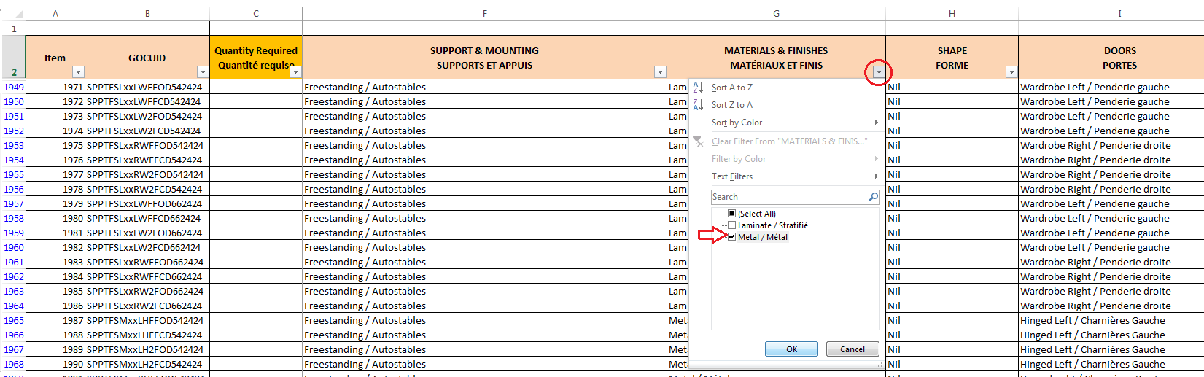

Next we will choose the “Materials & Finishes” for our personal storage tower. For this example we want metal products, therefore select “Metal” and click OK.
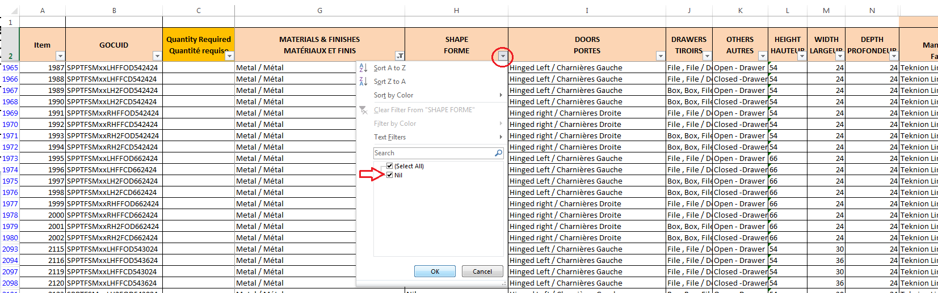

Next we will choose the “Shape” option available for personal storage towers. The only option available is “Nil” therefore we will select Nil and click OK.

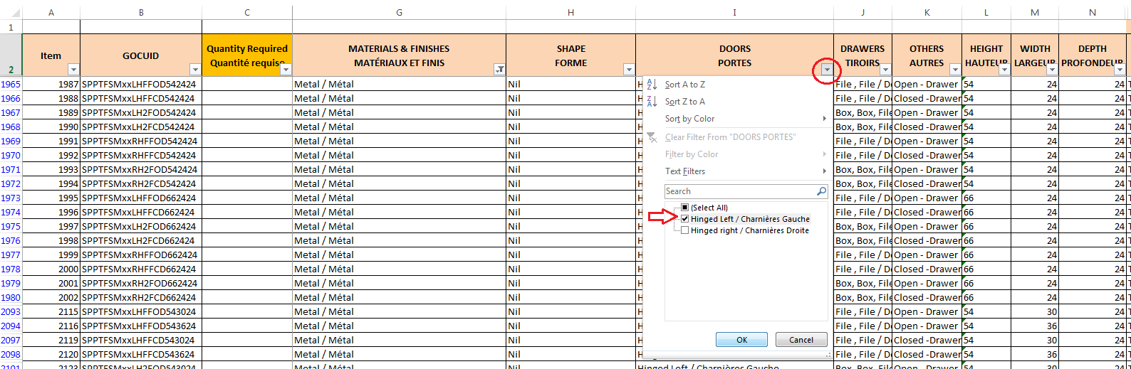

Next we will choose the “Doors” option available for personal storage towers. Indicated in the floor plan there are two styles of doors required, hinged left and hinged right. At this time in our search we can only select one style at a time, therefore we will choose “Hinged Left” and click OK. The other style of door (hinged right) would be a separately searched personal storage tower.

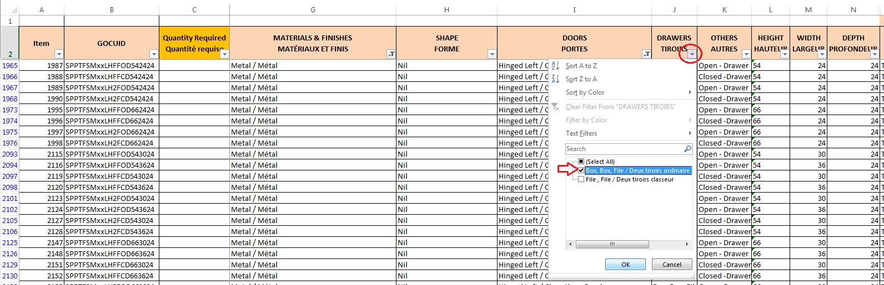

Next we will choose the “Drawers” option available for personal storage towers. For this example we want box/box/file style drawers, therefore select “Box, Box, File” click OK.

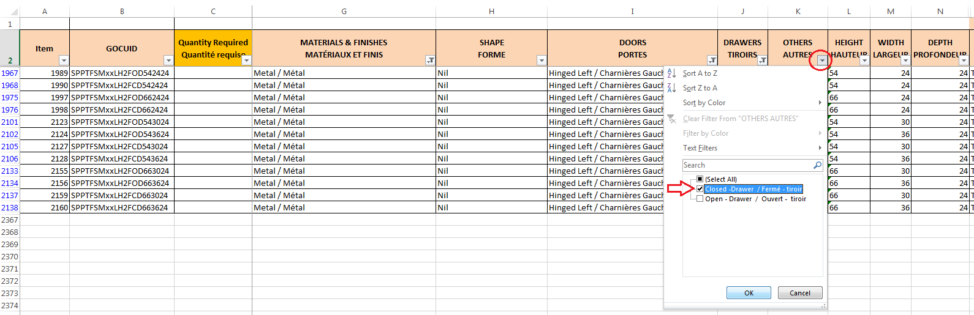

Next we will choose the “Others” option available for personal storage towers. The “Others” option chooses what we wish to have in the space above our drawers. For this example we want a closed door, therefore select “Closed-Drawer” and click OK.

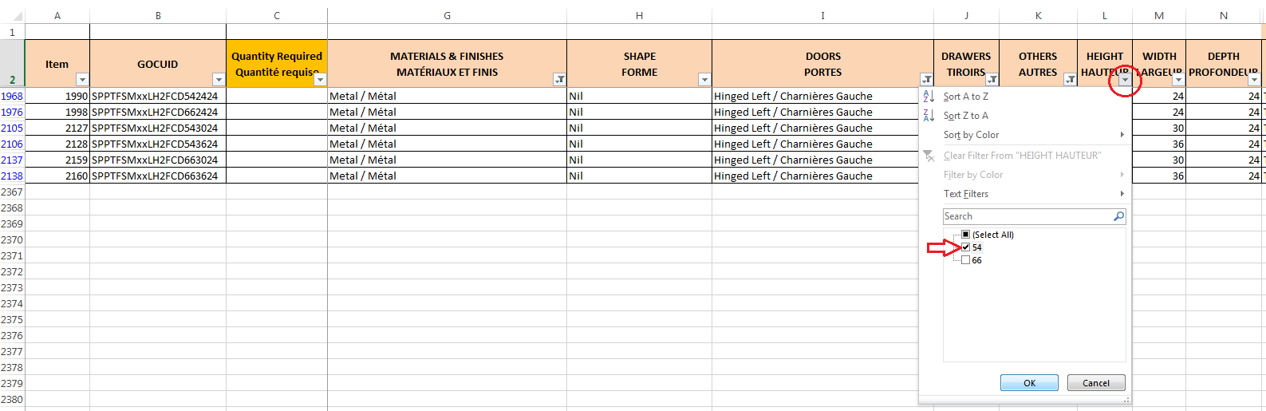

Next we will choose the “Height” for personal storage towers. For this example we want it to match the height of the Seated Privacy Height Add-On panels which is a maximum of 54” high. Therefore select “54” and click OK.

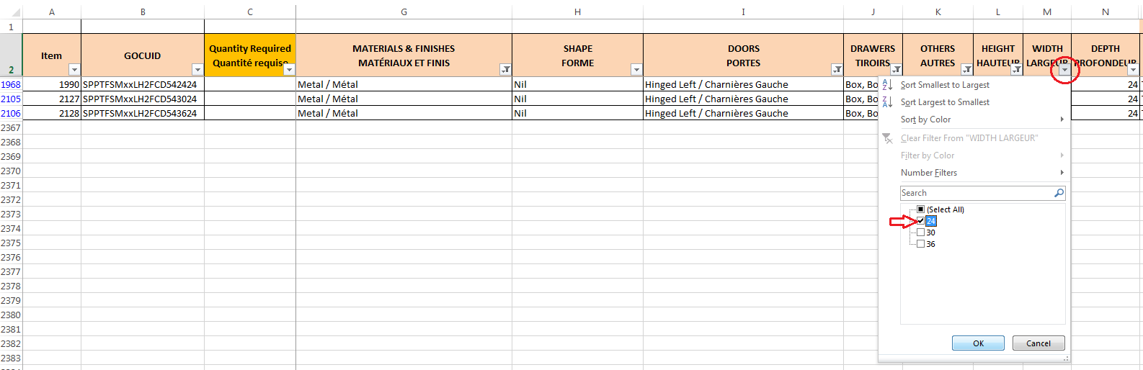

Next we will choose the “Width” for personal storage towers. For this example we want it to match the depth of the work surfaces which is 24” deep. Therefore select “24” and click OK.

What remains now is the product we need. Now we enter the quantity we require (4ea) and then we are able to increase our search for the next required item.

Now that we have searched and entered the quantities required for the first item of 1B products these exact same steps can be repeated to search for the remaining 1B products of the requirement. (This instruction document illustrates the steps required to search for the personal storage tower only. The steps to complete all remaining 1B products will be the same and not illustrated in this instruction document).

Step 5 – Clearing Filters and Increasing the Search

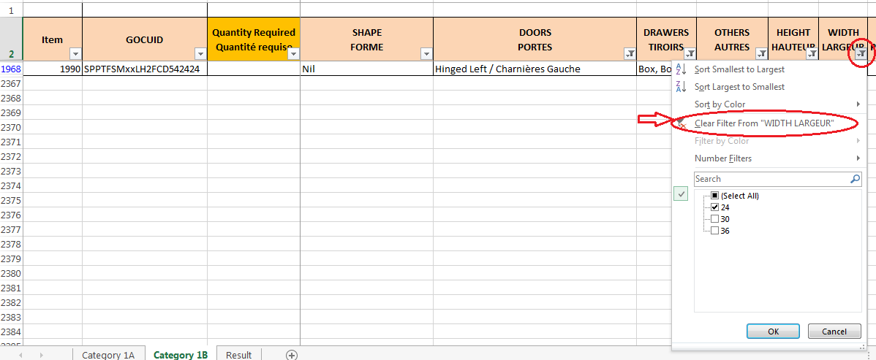
To search for each next item required, you can clear the filters at the column headers so that you can begin fresh again with the next item to search.

Clear each filter by simply clicking on the column headings filter pull down button, choosing “Clear Filter From “_______”” and clicking “OK” to finish clearing the filter.

After clearing all the filters, the quantities previously entered will remain and your results will maintain what you’ve already searched for. If you delete the quantities however, the CST will not retain the information. You may clear the filters each time you need to search for a new item.

Section 5 – Obtaining the Search Results
You are now ready to see your results on the “Results” tab. Click on the “Result” tab.

For this requirement we have selected “YES” to add both Delivery and Installation charges.

At the ceiling price table there are drop-down options for delivery and installation.

● If you indicate “YES” for delivery, the CST adds 3% to your ceiling price.

● If you indicate “YES” for installation, the CST adds 7% to your ceiling price.

The Estimated Value of our requirement is $33,164.08 and therefore falls into Tier 2. The CST indicates the tier to us by automatically highlighting the Tier in green. This means we must follow the business rules associated with requesting bids for purchases under Tier 2.

The CST will automatically add 3% for Hardware for all requirements, and will add Applicable Taxes (at an estimated tax rate of 15%) for all requirements.

The CST will sum all of these costs to give you the Estimated Value (EV) for your Category 1 requirement. (The values for delivery, installation and Applicable Taxes are estimates only. At the time of bidding, different values may be bid by SA Holders depending on the products and delivery locations.) The EV is used to determine the Tier (financial tier) for your Product Category. The buying process to follow depends on the Tier.

