Hiring a change manager through the Career Marketplace group on GCconnex

Using various platforms can help you find the perfect change manager for your organization. This document will guide you through the process of posting in the Career Marketplace group on GCconnex. Below you will find a suggested post that you should adapt based on your organization’s needs and the modernization project at hand.

Where do I find the GCconnex Career Martkeplace group?
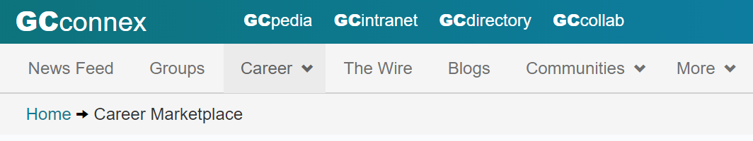
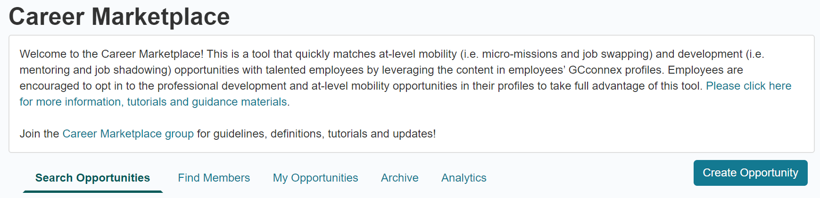

STEP 1: Poster information
Fill in your contact information and click “Next”.

STEP 2: Opportunity details
Bilingual opportunity title: Gestionnaire du changement / Change manager
Opportunity role: Select “Create an opportunity for others (offering)”
Type of opportunity: Select the type of opportunity that your organization is offering. In order to determine this, keep in mind the scope and size of your modernization project―it’s better to be over-prepared than overwhelmed!
Program area: Select the appropriate program area.
Group/level: Select the appropriate group and level.
Number of opportunities: Select the number of job opportunities that your organization has for this role.
Ideal start date: Choose your ideal start date.
Ideal completion date: Choose your ideal completion date.
Application deadline: Choose your application deadline; your HR group would be able to guide you on ideal application timelines.
Bilingual description of opportunity: You will find a sample post below. You can also use our roles, functions and key activities of a change manager guide to identify the experiences, skills and abilities of a good change manager.
The change manager plays a key role in ensuring the workplace modernization project meets its objectives by increasing employee adoption. This person focuses on the people side of change of a workplace modernization project which might include many changes from the various enabling sectors supporting the project such as changes to the new workspace, IT tools, systems and technology, business processes, etc. The primary responsibility is to create and implement a change management strategy and plans that maximize employee adoption and minimize resistance. The change manager works to drive faster adoption to increase benefit realization, value creation, ROI and the achievement of results.
While the change manager may or may not have supervisory responsibilities, he or she has to work with many others in the organization to succeed. The change manager acts as a coach for senior leaders and executives in helping them fulfill their role of change sponsor and champion. The change manager may also provide direct support and coaching to all levels of managers and supervisors as they help their direct reports through the transition. The change manager will also support the project team in integrating change management activities into their project plans.
******
Le gestionnaire du changement joue un rôle clé en veillant à ce que le projet de modernisation du milieu de travail atteigne ses objectifs en augmentant l'adoption et l'utilisation par les employés. Cette personne se concentre sur l'aspect humain du changement d'un projet de modernisation du milieu de travail, ce qui peut comprendre de nombreux changements provenant des divers secteurs habilitants qui soutiennent le projet, comme les changements au nouvel espace de travail, les outils, systèmes et technologies de TI, les processus opérationnels, etc. La responsabilité première consiste à créer et à mettre en œuvre une stratégie de gestion du changement ainsi que des plans qui maximisent l'adoption et l'utilisation par les employés et minimisent la résistance. Le gestionnaire du changement s'efforce d'accélérer l'adoption afin d’augmenter la réalisation des bénéfices, la création de valeur, le retour sur investissement et l'atteinte des résultats.
Bien que le gestionnaire du changement puisse avoir ou non des responsabilités de supervision, il ou elle doit travailler avec de nombreux autres membres de l'organisation pour réussir. Le gestionnaire du changement agit à titre de coach pour les cadres supérieurs en les aidant à remplir les rôles de parrain et de champion du changement. Le gestionnaire du changement peut également offrir un soutien et un encadrement directs aux gestionnaires et aux superviseurs de tous les niveaux qui aident leurs subordonnés directs pendant la transition. Le gestionnaire du changement aidera également l’équipe projet à intégrer les activités de gestion du changement dans leurs plans de projet.

STEP 3: Opportunity requirements
Skills: You will find a list of skills for a change manager below. You can also use our roles, functions and key activities of a change manager guide to identify the experiences, skills and abilities of a good change manager.
- Experience in applying change management principles, methodologies and tools to a workplace modernization project
- Experience with large-scale organizational change efforts
- Experience in providing advice to executives, clients and employees
- Exceptional communication skills, both written and verbal
- Excellent active listening skills
- Ability to clearly articulate messages to a variety of audiences
- Ability to establish and maintain strong relationships
- Ability to mobilize others and move toward a common vision or goal
- Flexible and adaptable; able to work in ambiguous situations
- Resilient and tenacious with a propensity to persevere
- Forward looking with a holistic approach
- Problem solving and root cause identification skills
- Able to work effectively with members of all levels in an organization
- Must be a team player and able to work with others
- Ability to recognize opportunities, issues and challenges at an organizational level
- Knowledge of how people go through a change and the change process
- Knowledge of change management principles, methodologies and tools

Time in hours: Include the time in hours that the change manager will work, per day, per week or per month.
The opportunity can be completed virtually: There are many benefits if the change manager can be onsite, even if only part-time.
Location: Select the location of work.
Security level: Select the security level based on your organization’s requirements.
Language requirements (optional): Here, you can select the level of written communication, written expression and oral proficiency that your change manger should ideally have.

All done! Now select “Create Opportunity” to complete the process.

