Job-aid: Using Breakout Room

Configure breakout sessions
- Go to the Breakout menu
- Select Breakout Session Assignment.

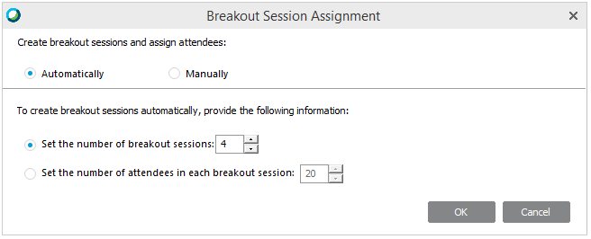
Automatic assignment
When selecting the automatic assignment option, WebEx will assign attendees to breakout sessions randomly. Simply indicate the maximum number of people you wish to assign per breakout room or the maximum number of breakout rooms you wish to fill.
To set max number of
People per group

To set number of groups
T

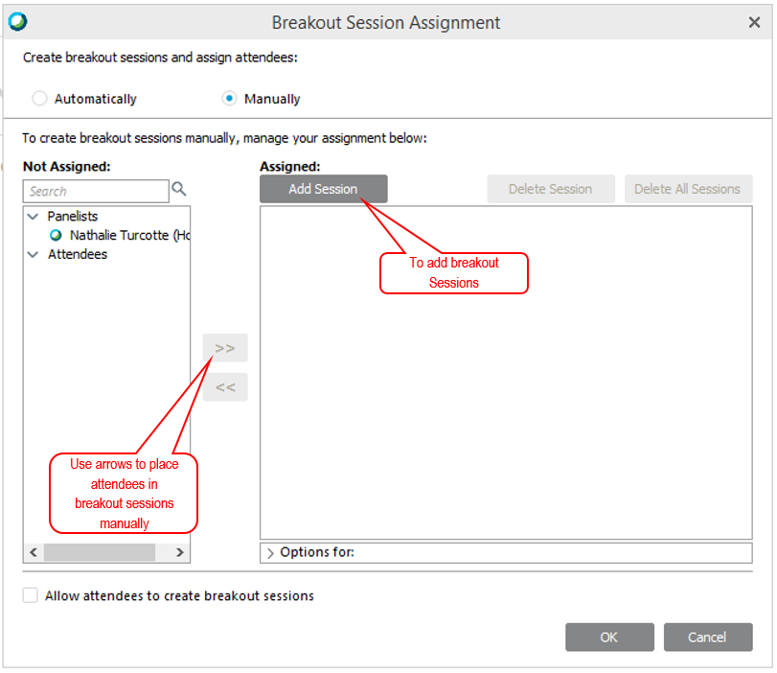

Manual assignment
If you wish to assign specific attendees together (for role-play activities as an example), select the manual assignment option, then create your breakout sessions and manually assign participants to each session.

The Breakout Menu explained
Though there are some buttons available within the interface for quick access to the breakout session functionalities. Know that you may also access all the functionalities in the Breakout menu.

Explanations for the breakout menu are provided below:

7
6
5
4
3
2
1
The Breakout Menu :
- To access the breakout session panel
- To launch breakout sessions when requested by facilitator
- Stop breakout sessions and bring participants back to plenary automatically
- To assign participants to breakout sessions manually or automatically
- To join any breakout session in progress
- To send a message to all presenters or all participants while they are in breakout sessions (pop-up)
- To ask breakout session presenters to share their content with the entire group.

Sharing breakout session content in the main session

- In the Breakout menu, click on Share Breakout Session Content.
- In the pop-up window which appears, select one presenter in the list and click OK. Inform that presenter that they will see a pop-up window asking them to share the content from their breakout session. Ask them to check the box next to the item they wish to share (i.e. Whiteboard_1) and click OK.

Troubleshooting

- Participant is stuck in main session: The Hosts needs to instruct the participants click “Yes” to all pop-ups inviting participants to join breakout sessions.
- Audio issues
  - Call-in user: The Host needs to resolve any call-in user issues before starting the breakout sessions, otherwise, the participant with the call-in user will stay in the main session.
  - Non-integrated teleconference line: The use of WebEx Audio is required for Breakout sessions in Training Centre.
- Participant leaves breakout rooms and needs to return: The participant can select the breakout session they wish to join in the Breakout Session panel and click join.

