Change management team 3Rs (roles, responsibilities and relationships) model

Function | Roles and responsibilities | Relationship
Project sponsor | The project sponsor’s role is to actively and visibly promote the change, help manage resistance and communicate with employees. This role is usually occupied by the person who is accountable for the project and who has influence on the individuals who implement the change. The project sponsor has the authority to provide the funding, resolve issues, approve major deliverables and provide high-level direction. The project sponsor has a clear vision, identified goals and measurable outcomes for the change initiative. | Collaborates with the champion and provides oversight to the integrated workplace modernization team
Champion | The champion advises and supports the project sponsor in decision making, and usually occupies an executive level role (ADM, DG, etc., as applicable). The champion must be an early adopter of the change, adapting quickly and advocating to other employees for the change. In addition, the champion must build employee morale, engage employees affected by the change and demonstrate desired behaviours. The champion brings the change vision to life. | Collaborates with the project sponsor
Workplace modernization integrated project team | The workplace modernization integrated project team oversees and executes most workplace modernization activities related to the project, key enabling sectors (IM, IT, Security, HR, OHS, Facilities), transformation program, change management, etc. The team ensures timely and integrated project delivery and a user-centric solution. | Reports to the project sponsor
Change management team | The change management team’s role is to manage the people side of the change. They are responsible for encouraging employees to adopt the changes and for providing support to managers and the project team. The change management team develops change management related strategies and plans, and then implements them and measures their effectiveness and success. | Supports the project sponsor, champion and integrated project team. Collaborates with the integrated project team at all times. Must be integrated with the project management team to ensure greater success of the project.
Committees, working groups, networks, etc. | There can be a variety of working groups, committees or networks that consist of employees who are considered change agents for an organization undergoing a workplace modernization. Change agents can be the first ones to adopt the change and they can also help manage resistance to the change by identifying any obstacles that could interfere with the implementation of the project. They typically occupy a liaison role with the change management team and the integrated project team. In doing so, change agents help the workplace modernization project’s vision become reality. | Support the change management team
Project management team | The project management team manages the workplace modernization project to ensure it is delivered on scope, on time and on budget. | Usually reports to the project sponsor and/or the integrated project team. Collaborates regularly with the change management team.
Committees, working groups, enabling sectors rep., etc. | As part of a workplace modernization project, it is important to have an extended project team, including members from the various key enabling sectors supporting the project (IM, IT, Security, HR, OHS, Facilities). This will ensure an integrated solution for the end users. Other committees or working groups can also be put in place to support specific projects within the integrated project or specific elements such as working group on business review processes, working group on e-signature deployment, etc. | Supports the project management team and the integrated project team

Integrate project team structure example

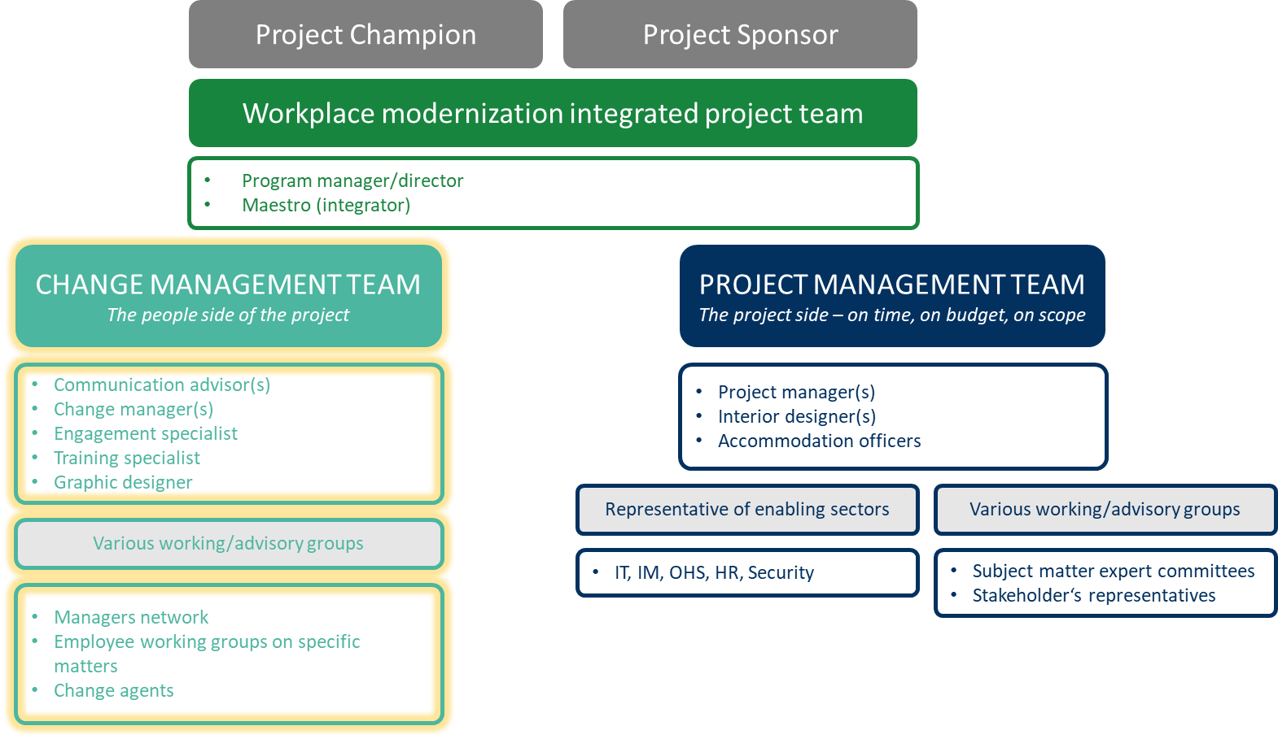
Determine and describe the change management team, functions and groups as part of your workplace modernization project. Also provide a short description of the roles and responsibilities and relationship for each individual. If you already know who the lead is for those teams, please identify them.
Function | Roles and responsibilities | Relationship | Lead
CHANGE MANAGEMENT TEAM
Name XXX | Describe roles and responsibilities | Describe relationship | Who?
Name XXX | Describe roles and responsibilities | Describe relationship | Who?
COMMITTEES, WORKING GROUPS, NETWORKS, ETC.
Name XXX | Describe roles, responsibilities, committee chairs and meeting occurrence | Describe relationship | Who?
Name XXX | Describe roles, responsibilities, committee chairs and meeting occurrence | Describe relationship | Who?

