OCHRO RET presents Show the Thing
Outcomes -- Session one: 2021.06.15

Re: Thanks for joining us last week
Thanks to everyone who joined us for our first “show the thing” session last week! Here’s a synopsis of what we covered, what we learned, and some next steps.

Our idea: Start to convene spaces for GC colleagues working on HR Experimentation to share their works in progress.
Our session last week was the first in what we hope will be a series. We’ll start by convening these approximately every couple of weeks, and adjust accordingly. Our Research and Experimentation team at OCHRO has some things to share and seek feedback on, and we’re excited to connect with colleagues and see what’s out there. What’s “show the thing?” We didn’t invent it, but than our #GCdigital colleagues for the inspiration to get started. To “show the thing” is to present work in progress. Not just to talk about it, but to present prototypes or early versions. It also means sharing early versions, getting feedback, and sharing things we’ve learned about our methods and results along the way. It helps us iterate and improve.

Session One: We shared some of the assumptions behind our work on the Research and Experimentation team, as well as our current thinking on a project evaluation framework.

Discussion #1: How might we support the GC HR ecosystem? Our assumptions
We’re a new team, so we wanted to share the assumptions that underpin our work, and signal check whether they make sense to others. What should OCHRO do, i.e., that only OCHRO can do? How might we best contribute to coherent and vibrant enterprise-wide practices?

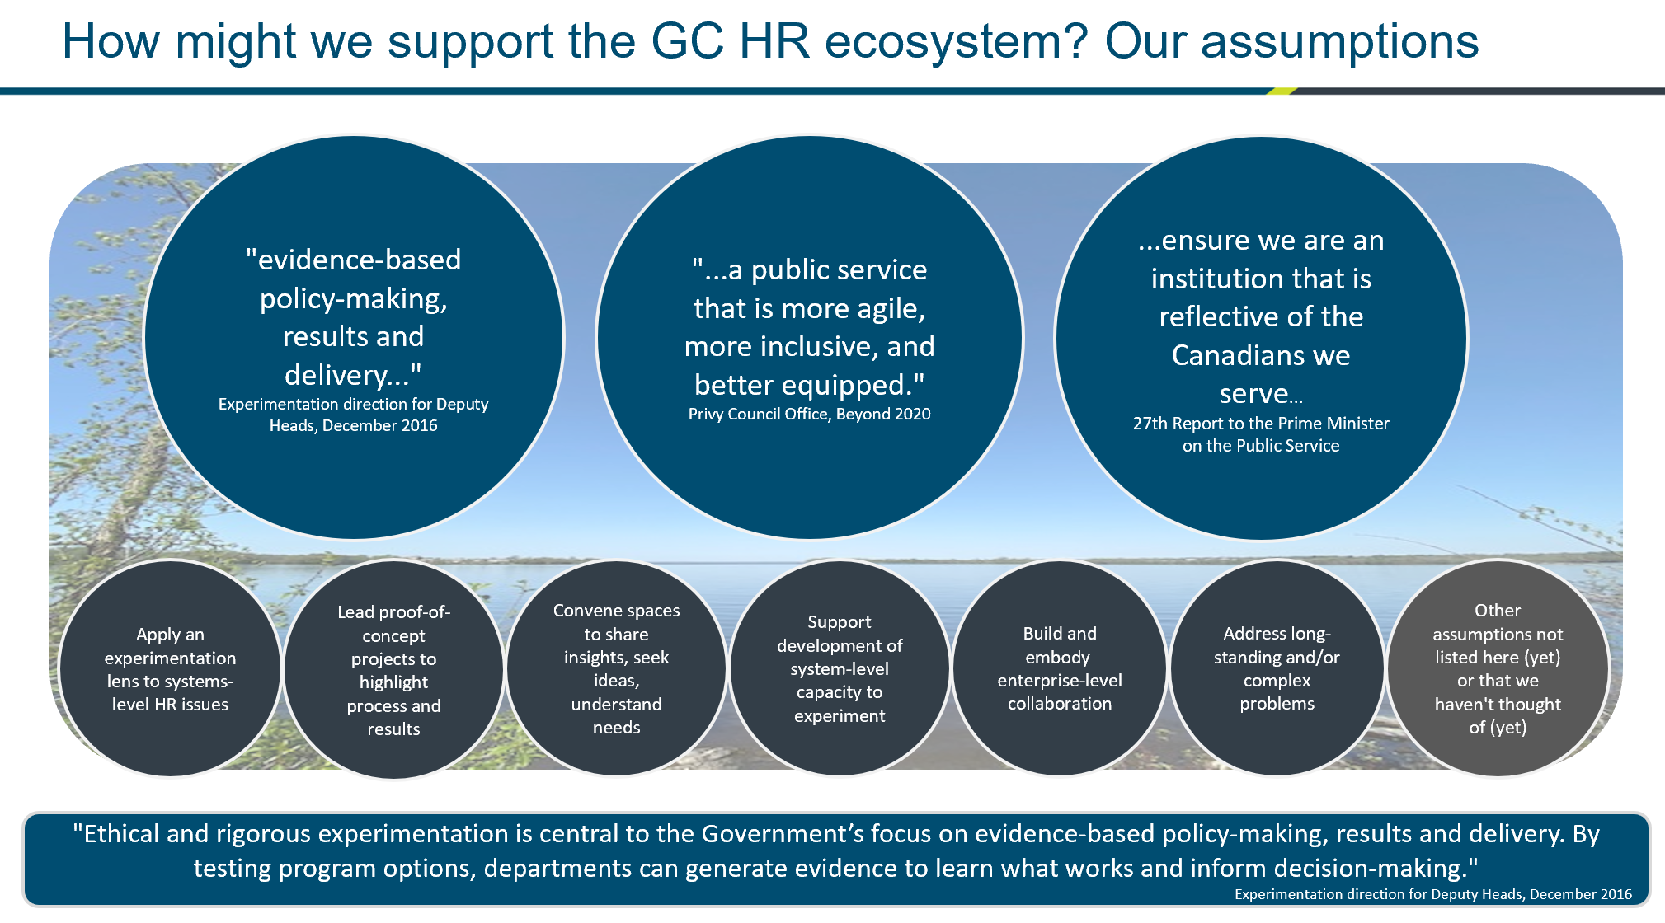

Participant feedback
How might we talk about the value of an enterprise approach? About OCHRO’s role within the enterprise? And about the leadership some larger and early-mover departments and experts have offered?
- “I think there is a desire to collaborate across the system. I am not sure people always know how. And I agree that a GoC approach is the way to go. I also think it is great that this group exists at OCHRO.”
- “​What about linkages with the HR council? (heads of HR), what do they talk about? Is there an opportunity to link with your work and evidence generation/learning?”
- ​ESDC: We share our newsletter and monthly events with HRC weekly/monthly. Very healthy collaboration on our part. We're very much pro our ADM (ESDC HR) sharing with her colleagues as Heads of HR. For example: EDSC Innovation RH - HR Innovation ESDC — wiki (gccollab.ca); GCCollab page
Do these assumptions make sense?
- “I think your assumptions are well-founded. Your team is OP* (to borrow a gaming term) in terms of skills and experience in research, design, and experimentation and sharing your collective knowledge across the ecosystem is valuable. Add this to the opportunity to collaborate and connect with others who are dedicated to innovation and focusing on people first and I can say our team certainly has an appetite for this kind of interaction and knowledge exchange.” *overpowered
Where might we add or adjust assumptions?

- “​I'd like to see something in the assumptions about learning. Experimentation is all about learning. It might be nice to see something in the basic assumptions about that.”
- “Maybe an assumption is what the role of leadership is? Thinking of servant leadership, versus some possible traditional ideas of leadership, and how that might be influencing how we look at our role and responsibility.”

Discussion #2: How might we decide which HR experimentation work to pursue?

Transitioning the federal public service to the future of work offers an abundant range of topics to consider for experimentation. We want to understand what kind of experiments would help the system. We have ideas. Colleagues and experts have also been generous with their ideas. We've got different ways of soliciting ideas, but we don't pretend to be the only source of them.
We want to build some kind of list, or compendium, that can be openly available and that colleagues can access. Once we get those ideas, we'd really like to do our part to test and scale the good ones across the GC.

Where we might best add value to the enterprise as a whole? How can we help amazing work taking place in departments?

We’ve been playing with setting out criteria for a while. This includes the format (should it be a scorecard? principles?) and how uniform can our approach be. Our first drafts built both on the GC Entrepreneur framework as well as similar work done at PHAC. Based on this, we condensed the more detailed set of criteria with a set of principles.

We dream of creating space for a Community of Practice to support GC practitioners, and to help us make decisions. We’re mindful that our senior management may also have projects to propose. We want to lean into that space. We hope these principles offer some transparency with regard to where we want to focus our efforts.

Research and Experimentation Project Principles v1.0
10 Principles | Description
- Relevance and alignment | The project aligns with organizational priorities (enterprise and OCHRO) and policy, legislation or regulation, and with Canada’s Digital Standards.
- Unique need | It is new, builds on enabling work, doesn’t duplicate other initiatives.
- Partner support | The project and process resonate with external and enterprise partners, and/or project sponsors are open to exploring collaboration.
- Feasibility | The project has a clear problem statement. RET and partners are positioned to scope and undertake the work.
- Openness | The project design, results, and lessons can be shared with colleagues across the GC and beyond? We can embody openness by default.
- Measurable benefits | Desired outcomes can be measured; offer a tangible benefit for people management ecosystem. Benefits accrue either immediately, incrementally, or offer potential for transformational change.
- Efficiency gains | The project improves efficiencies across processes or systems
- Sustainability | The project is potentially self-sustainable once complete.
- Scalability | The methodology, or overall initiative, can be scaled or replicated.
- Ethics and privacy | Any potential ethical and/or privacy considerations can be addressed.

Participant feedback

Do these principles make sense?
- “Overall, I really liked this framework. We talked about it in our team as a potential framework we can incorporate into future challenges for our Innovation Accelerator to help us ID if an idea is at a state of readiness to support advancing the idea through testing.”

Where might we add or adjust principles?
- Principles: ten is a lot. Here is an alternate example from NRCan
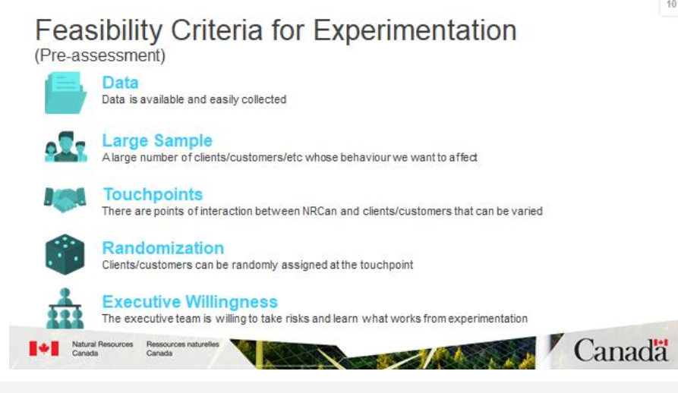
- ADD: Available data? (under feasibility)
- ​ADD: the system's readiness to resource given other priorities -- not sure whether or where you'd capture that
- Consider “the STOP approach (situation, target, options, proposal) with the broader optics of scalability, value for the enterprise, RoI, alignment with FoW, etc.”
- ​Gap: privacy expertise needed to talk about line of business ownership re: HR data...need privacy by design, understanding accountabilities. How are departmental privacy experts interpreting this, or where we need to nudge? ​Looking for OCHRO leadership on interpretation of rules/data. ​
- I think we should be talking about Rules as Code, everywhere ! Just to see what we can clarify and codify
- We build systems to improve data and that's a key problem. We need to think about data flow and stewardship that is agnostic of the system (read flavour) of the day.

What happens next?
- “Do you run the projects through the principles lens before you take on a project?”
- Do you have something you’d like to show? Please let us know!

Post everything above this line to GCWiki

Who joined us?

Amélie Fournier (OCHRO)
Andee Pittman (OCHRO)
Étienne Laliberté (ESDC)
Greg White (NRCan/ESDC)
Haris Khan (OCHRO)
Hope Harris (NRCan)
Jasmine Garcia Larouche (ESDC)
Jason Lawson (OCHRO) (host)
Jean-Francois Nault (OCHRO)
Kate Borowec (TBS/P&P)
Lauren Murphy (OCHRO)
McKenzie Krasilczuk (OCHRO)
Natasja Mackwood (CRA)
Nicola Bill (TBS/P&P)
Nicole Saulnier (OCHRO)
Octavia James (OCHRO)
Raissa Kakisingi (OCHRO)
Rodman Chan (TBS/P&P)
Stacey Ileleji (OCHRO)
Stephanie Percival (CRA)
Susan Johnston (OCHRO)(host)

What kinds of experimentation or project evaluation do you work on and/or are interested in?
- ​At CRA we're preparing to run an Innovation Accelerator. We'll be pairing idea submitters with experts and learning resources with the goal of helping them take their idea from concept to tested prototype.
- ​Human-centred design on the RET team.
- Curious about how to test small, practical things that help improve how people work together
- ​Experimentation and evidence-based decision making
- Data informed HR decisions
- ​Communicating process and results in a way that shows its effectiveness and importance
- Co-chair a community of practice that comprise innovative approaches (change mgt, leadership, design-thinking, LEAN). Lead on change mgt for classification conversions - occupational group modernization. Mindfulness
- Strategic advice on Future of Work approach and identifying projects to drive Future of Work initiatives
- How to establish / develop / implement multidisciplinary teams quickly and and w flexibility (and is it the actual policy or the culture that creates challenges in this space)
  - Resource (thanks to Stacey Ilelji): Classification with regard to multi-disciplinary teams (GCPedia).
- Mixed-method research, curious about GBA+ analysis
- I have a project on older workers I am spearheading in the GoC

