Workplace Transformation Program
A Guide for Change Agents
VERSION 1
Date: SEPTEMBER 2022

Guide for change agents – Workplace Transformation Program
Objectives & information
Objective: This guide is intended to inform change agents of the duties and responsibilities of their new role.
Who should use this: Change Agents who have volunteered to be a part of the integrated project team.
The French version of this document can be found here : FR version

WHAT IS A CHANGE AGENT NETWORK?
- A Change Agent Network is composed of appointed leaders, managers and representatives within the organization that have the capacity to actively participate in leading employees through the change.
- Change Managers request volunteers and nominations for Change Agents as part of the integrated project team. Move Captains and Working Group Leads are also good candidates to join a Change Agent Network.
- Ideally a Change Agent Network is composed of 1-2 representatives for each major branch, directorate, program, or field within the organization.
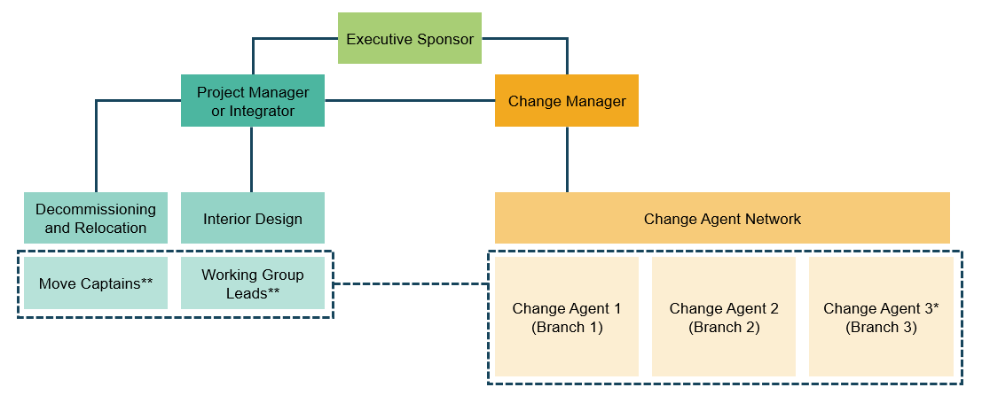
What are change agents and what do they do?
- Change Agents are early adopters of change—those who excited and optimistic about the change ahead. They understand and represent the interests of their colleagues going through the transition and will work with business leaders and change/project managers to facilitate a successful transition.
- Change Agents should be prepared to do the following:
- Share information about the change – act as on the ground representatives for questions related to the change initiative. Increase employee awareness of the change.
- Create a positive change environment – generate excitement for the change. Increase employee desire for the change.
- Provide the project team with business insights – receive feedback on how the business is adapting to the change during the transition. Attends all required Change Agent meetings.
- Support employee onboarding and learning with the change – learn how to use new tools and act as a subject matter expert—supporting other employees with their ability to use these new tools/processes.
- Raise unresolved issues to implement – identify and record potential barriers to the change and provide updates to the change manager.
- Challenge rumours with facts – clarify rumours with known project facts; otherwise, provide insight to the Change team.
- Cultivate new work habits and attitudes – reinforce new workplace etiquette and team norms.
- The following characteristics are required for Change Agents
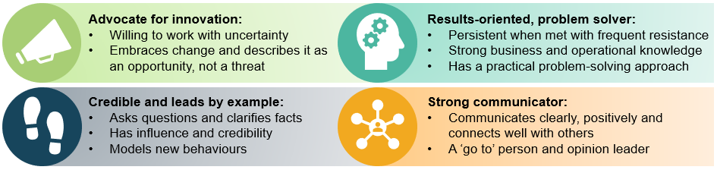
Best practices for change agents:
- Advocates:
  - Be open to the possibilities and the learning that change provides opportunities
  - Acknowledge that we cannot control the change, but we can control our attitudes and how we respond to the change
  - Frame the change as inventing the future instead of redesigning the past
  - Understand that each person experiences change different
- Communicates:
  - Explain the business reason for the change and how it will happen
  - Be clear and honest about what’s changing and why
  - Provide a channel for feedback and questions
  - Tell employees how it will impact them
  - When handling resistance, listen, empathize, discover needs and concerns, respond and check for understanding
- Participates:
  - Ask employees what they need (more information, help, support)
  - Capture when people are making assumptions and unknowingly producing rumours
  - Investigate reasons for resistance (i.e., lack of understanding, impact on work/mandate, past experiences with change, lack of commitment from leaders, fear of loss, and lacking ability or knowledge for change).

