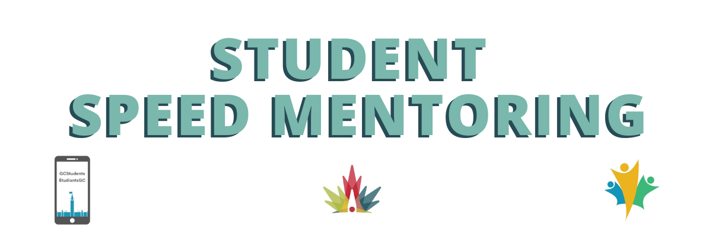

Mentor Instructions for Student Speed Mentoring

contacts
Scheduling or general event details: Emily Smith
Technical assistance:
Marc-André LeBlanc

How to connect:
- The Zoom link to access the event is provided to you in the calendar invite and/or email confirmation you will have received.
- If you use your work computer, please remember to disconnect from the VPN to avoid overloading the network. Feel free to join from a personal device if preferred as some Departments access to Zoom or ability to disconnect from the VPN is limited (i.e. IRCC, CBSA and CRA).
- Please login with your personal link, you have been sent this information by zoom directly. If you cannot find your personal link please reach out to Emily Smith.
  - When you join the meeting your name should appear as MENTOR # - NAME, if it does not right hand click on your picture and click rename to rename yourself to match this formatting.
- We have asked you to join 10 minutes before the mentors so that we can create the rooms and sort out any last-minute technical issues.

Event Layout:
- Once the speed networking starts, you will be prompted to "Join" your assigned breakout room, through a pop-up window.
- Participants will remain in the same room for the entire event and the Mentors will be moved from room to room during every 15 minute interval.
  - Mentors will be randomly assigned to breakout rooms and they will rotate through different breakout rooms whereas mentees remain in the same room for the duration of the event.
- You’ll have fifteen minutes to chat with your group. Keep an eye out for the raised hand function and chat throughout the sessions.
- We will broadcast a message when there are 2 minutes left to the round. When the 15 minutes are up, you, the mentor, will be prompted to join another breakout room.
  - There is no need to move yourselves or leave the “room”, we will take care of all of this. Please be patient with us when this happens as there could be a short delay.
  - If you accidentally leave your breakout room, you will be redirected to the main room where we will have admins standing by who can place you back into your breakout room.

Useful tips to succeed in your sessions:
- Be attentive and contribute to the conversation where possible and as appropriate but let the mentees lead the discussion by posing questions.
- The mentees are eager to hear from you, the mentor, and will be together for the entire event, so to save time consider just asking for their names and roles.
- Feel open to share your experiences and knowledge with everyone while being aware and allowing time for others to share their input as well.
- Try to mute your mic when you are not speaking but leave your camera on at all times to engage fully in the conversation.
- Remember to dress appropriately and remove anything in your surroundings you don’t wish to be in view of others.
- Ensure you utilize the mute function and consider using headphones to limit background noise from interfering with your conversation. We are all working virtually so no stress if something occurs that is out of your control.

Potential questions:
Check out some of our favourite questions on our wiki page:
2022 Student Speed Mentoring - wiki (gccollab.ca)
For quick reference, here are some example questions that may be asked:
- What motivates you most about your position?
- How did you gain leadership experience?
- What advice would you like to have heard when you started your career in the public service?
- How would you describe your leadership style?
- What is the greatest challenge you have faced in your career?
- Is there anything you would do differently if you could start your career over again?
- What is the best career advice you have received?
- What used to be your biggest weaknesses and how did you manage to improve yourself on theses?

