Digital Comptrollership Program
Business Process Owner Board
Terms of Reference
January 27, 2021

GC Docs: https://gcdocs.tbs-sct.gc.ca/gcdocs/llisapi.dll/link/48003876

TERMS OF REFERENCE
business Process OWnEr Board

Background
The Business Process Owner (BPO) Board is the senior-level governance body accountable for the business processes within the Coordinated Financial Management System (CFMS) Governance Model within the Digital Comptrollership Program. It was established on August 14th, 2020.

Mandate
The BPO Board’s mandate is to maintain business processes that are consistent and compliant with the GC standards, policies, guidelines, and solutions while leveraging SAP industry best practices.

Objectives
The Business Process Owner (BPO) Board, will assess and endorse changes based on new requirements, create working groups for requirements or innovation work and discuss upcoming changes to policies that could affect the GC Digital Core.

Scope
The BPO Board will be responsible to:
- review any recommended departmental requests that have been assessed by the DCP BPO team to determine whether they should be incorporated into the GC Digital Core,
- recommend departmental requests for approval by the Business Authority Steering Committee,
- prioritize the areas to explore potential opportunities/innovations to increase efficiencies in GC business processes, which may include upgrading or integrating existing software applications, and/or recommend training opportunities; and
- ensure BPO team uses the survey results to investigate and make recommendations on how to resolve the inefficiencies and make improvements to the GC Digital Core

Authority
The Business Process Owner Board is a decision-making body that decides if change requests impacting business processes should be approved by the Business Authority Steering Committee.

Membership
The BPO Board will consist of various business process stream co-leads and the following members:
- DCP BPO SME
- DCP BPO SAP Functional Experts
- DCP-ARB Technical Architect
- DCP-ARB Solution Architect
- DCP-CoE Member
- Host Cluster Business Owner
- Host Cluster SME
- Optional additional expert (Policy, Training expert, Security expert)

The stream co-leads must have relevant knowledge/experience as members of the BPO Board and therefore it is required for the representative to be proposed and DCP Executive Director and DCP Design Authority Director to accept the proposed representative.
Where a representative is not available for the monthly review and endorsement of decisions, a delegate from the stream may take their place.

Decision-Making Process
Attendance of applicable BPO co-leads is required for obtaining endorsement of any proposed departmental requests. Should a designated co-lead be unavailable to attend, they will identify a delegate to attend and endorse on their behalf.

Quorum must be met when there are items requiring a decision. Quorum is defined as at least half of the members (or delegate) being present. Should quorum not be met, items for decision will be deferred to the next meeting.

A 50% vote in favour or against is required for decisions to be binding and must be achieved prior to the escalation of any departmental requests to the BA Steering Committee for further consideration.

Meeting Frequency/Arrangements
There will be one BPO Board meeting for each stream (e.g. Finance, Procurement and Human Resources) each month and documentation will be made available to members a minimum of 2 business days prior to scheduled meetings.
Throughout the GC Digital Core Release 2 design and configuration, the cadence may differ based on the number of requests presented to the BPO Board for endorsement each month or as requested by a Board member.
Meeting coordination will be managed by the DCP - PMO.

Reporting Structure
The BPO board is accountable to the BA Steering Committee, and works with the Architecture Review Board and Center of Expertise to review departmental requests for changes impacting the GC Digital Core Template.

Resources and Budget
Meetings will be booked by the DCP/PMO via MS Teams. All board members time will be funded by their home departments.

Deliverables
Records of Decision

Intake Process
All requests are captured by the Program Management Office, which is responsible for ensuring the appropriate assessments are completed by the respective areas within the Design Authority (i.e. Business Process Owners, Architecture teams). These requests will then be presented to the applicable BPO Board for review and endorsement prior to packaging and presenting to the BA. Once the BA has approved a direction, the PMO communicates the decision/direction to the Center of Excellence (CoE) to action approval and/or initiate Minor release or Major release process.

Membership List
Business Process Stream | Co-Lead/Dept | Co-Lead/Dept
Finance and Budget | Monique Arnold, PSPC | Sophie Bainbridge, GAC
Financial Planning and Analysis | Michelle Baron, ISED | Shirley Carruthers, GAC
Project and Portfolio Management | Johanne Diotte, NRC | Dwayne Ross, RCMP
Travel and Expense Management | Hongchao Wang, HC | Karoline Poiré, IRCC
Real Estate Management | Denis Lemieux, PSPC | Elizabeth Tough, GAC
Grants Management | Paula Hadden-Jokiel, ISC
Procurement, Materiel Management | Karine Paré, ISED | Jimmy Fecteau, CBSA
Non-tax Revenue | Johanne Diotte, NRC | Pamela Rudiger-Prybylski, Justice
Asset Management | Davina Brown, PC
Human Resources
Receiver General | Jeffrey Lay, PSPC RG Treasury

Authorization

______________________________________________ ________________________
Yves Bacon Date
Assistant Comptroller General, Digital Comptrollership Program
Treasury Board of Canada Secretariat

______________________________________________ ________________________
Lynn Gibault Date
Executive Director, Digital Comptrollership Program
Treasury Board of Canada Secretariat

ANNEX

DCP Guiding Principles
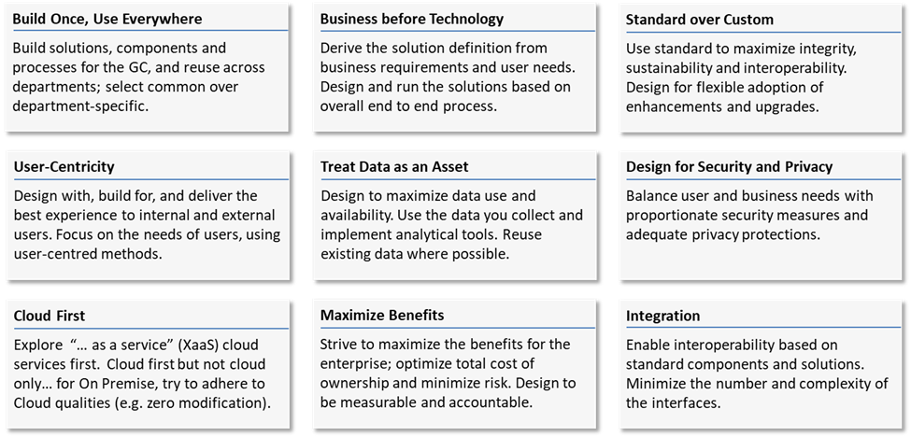

What is Digital Transformation?
- Gartner defines digitization as … “changing from analog to digital form… without any different-in-kind changes to the process itself”. Consider the use of electronic signatures: the process of obtaining the signature might not change, the only difference is that the document is signed online.
- Digitalization by contrast, involves changes to the process through digitization.
- Digital transformation refers to a complete rethinking of the organization’s processes with digitalization in mind. It is often difficult, however, to introduce digitization without some form of process change.
- In order to be successful, each function/department/organization, within the Minister of Digital’s overarching mandate, will require a “complete re-think” …
- The Digital Comptrollership Program is the organization tasked with defining this undertaking-- in collaboration with its partners--for financial management.

