  - TOOLKIT

Leadership
About this tool
PURPOSE: Provide you, the change manager, information, tools and resources to build a leadership toolkit adapted to your organization to ensure a leaders understand their vital role in the transition to a modern workplace and a new way of working.

AUDIENCE: All leaders

USE
- Workshops
- Emails
- Intranet

[Delete the above image and text when using this tool]

Contents
1. Your role as a leader 2
a. Overview 2
2. Key leadership competencies and workplace change management 2
3. Learning 3
a. Training 3
Managing change 3
4. Employee engagement and change management 3
5. Communications 3
a. Key messages 3
b. Frequently asked questions 3
c. Key milestones 4

Your role as a leader

Overview
Executives and senior leaders play an essential role in times of change. An organization looks to its leaders to be visible sponsors of the change and to demonstrate why the change is necessary. As a leader, you provide the authority and credibility necessary for a successful change. Prosci® has identified “a consistent set of roles for senior leaders and executives in times of change” which we have adapted for this toolkit:

Participate actively and visibly throughout the project
- Be present and be seen by employees from start to finish
- Show your support of the change by piloting new ways of working
- Recognize and reward individuals/teams that have taken extra steps to achieve change
- Identify the risks, challenges and impacts that may result from the workplace modernization

Build a coalition of sponsorship and manage resistance
- Bring together the right leaders and influencers to give the change credibility and priority
- Identify key stakeholders that can advocate for the change and legitimize it in their part of the organization
- Spread the vision to managers

Communicate directly with employees
- Engage directly with employees to showcase your support
- Communicate the business reasons for the change as well as the risks or costs of not changing
- Regularly discuss the vision in town halls, meetings and on the intranet
- Listen, understand and address employees’ concerns
- Communicate project milestones and recognize the hard work

Key leadership competencies and workplace change management
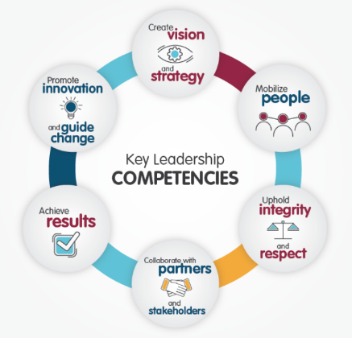
As a leader, you are already familiar with the key leadership competency profile and examples of effective and ineffective behaviours. The top key success factors for workplace change are identified below and can be directly linked to the key leadership competencies:
- Establish leadership and governance to develop and manage your workplace strategy
- Engage employees by way of activities, meaningful consultations and discussions at all levels on the issues that matter most
- Articulate a clear vision for the workplace that is aligned with the vision of the organization
- Empower and equip managers and supervisors to support their employees through the change
- Demonstrate active and visible leadership supporting the vision and the aspects of change throughout the life of the change initiative
Key Leadership Competencies
- Create opportunities to experience the change through pilots, pathfinders and demonstration spaces; seeing is believing and experiencing is knowing

Learning

Training

Managing change
- CSPS: Transformation in the Public Service: For Executives–Change Management
- CSPS: Leading Your Team through Change
- CSPS: Employee Engagement through Transformational Leadership

Employee engagement and change management
Promote the vision consistently and positively! Employees want to hear about the project from their leadership team, this creates a sense of trust and transparency throughout the organization. Reinforcing the vision doesn’t necessarily need to mean repeating a set of words; adopt the change yourself, positively influence others and acknowledge the early adopters. You hold an essential and influential role during a workplace modernization. By showing you understand and support the change, employees will be encouraged to do the same.
- Reinforce the path to the future workplace
- Highlight project milestones achieved
- Reward behaviours, recognize individuals/groups who are shifting towards workplace modernization
- Engage directly with employees by holding:
  - an all-staff meeting at project launch
  - town halls
  - stand-up meetings/brown bag lunches
  - coffee break chats
  - regular management meetings and/or by discussing standing agenda items

Communications

Key messages
[Include key messages and list of changes here]
Here are some examples of potential changes included in your workplace modernization project:
- Laptops/tablets and mobile phones will replace desktop computers and wired telephones for most employees
- Wi-Fi access to the network will be available on each modernized floor
- GCdocs will be used for corporate document storage; shared drives will be disabled
- Meeting rooms will be equipped with the latest technologies in order to enable collaboration and communication, including video conferencing
- Flexible, healthy and sustainable working environment that offers a mix of opened and collaborative, as well as enclosed and individual workpoints that support diverse needs will replace the traditional office or cubicle
- There will be a variety of workpoints (individual, collaborative, enclosed, semi-enclosed and open) [list the different workpoints here]

Frequently asked questions
[Refer to the FAQ template]
Here are some examples of potential questions that may come up:
- What will the workplace look like after these workplace changes have taken place?
- What are the goals of these workplace changes?
- Why and how are these workplace changes beneficial?
- How are these workplace changes funded?
- How will these workplace changes impact employees?
- Will these changes take into consideration individual needs or are they a one-size-fits-all model?
- Which technological tool will be available?

Key milestones
[Include the key milestones of the project]

